SWING

- Swing is a set of classes that provides more powerful and flexible components than are possible with the AWT.
- Swing components are an enhancement to the existing Abstract Window Toolkit (AWT) components. They are not intended to replace AWT components.
- Both types of components can be used in the same interface.
- Swing components range from basic controls such as buttons, check boxes, scrollbars, and sliders to complex widgets like text panes and editor panes.
Swing Features
- Many more built-in controls
  - Image buttons, tabbed panes, sliders,toolbars, color choosers ,HTML text areas, list,trees and tables.
- Increased customization of components
  - Border styles, text alignments, basic drawing features and Images can be added to almost any control.
- Many miscellaneous features
  - Built-in double buffering,tool-tips,dockable toolbars, keyboard accelarators, custom cursors, etc.
- The MVC (Model View Controller)-based architecture allows Swing components to be replaced with different data models and views.
  - Lightweight Components—Starting with the JDK 1.1, the AWT supports lightweight component development. For a component to qualify as lightweight, it cannot depend on any native system classes, also called “peer” classes.

  - Pluggable Look-and-Feel—This feature enables the user to switch the look-and-feel of Swing components without restarting the application. The Swing library supports a cross-platform look-and-feel—also called the Java look-and-feel—that remains the same across all platforms wherever the program runs.
Swing Vs AWT
- Naming Convention
  - All swing component begins with capital J and follow the format JXxx.E.g..,JFrame,JLabel.
- Use of paintComponents
  - Custom drawing code is in paintComponent,not paint.Double buffering turned on by default.
- New Look and Feel as default
  - With Swing,you have to explicitly set the native look.
- Light Weight Components
  - Most Swing components are lightweight: formed by drawing in the underlying window.

Swing Packages

- The Swing API is organized into a number of packages to support APIs for various categories such as components, pluggable look-and-feel, events, component borders, and so on.
- The package members (classes and interfaces) and their API methods are given in Appendix A, “JFC Swing Quick Reference.” The following is the list of package names in Swing:
  - javax.swing
  - javax.swing.border
  - javax.swing.colorchooser
  - javax.swing.event
  - javax.swing.filechooser
  - javax.swing.plaf
  - javax.swing.plaf.basic
  - javax.swing.plaf.metal
  - javax.swing.plaf.multi
  - javax.swing.table
  - javax.swing.text
  - javax.swing.text.html
  - javax.swing.tree
  - javax.swing.undo
THE JCOMPONENT CLASS

- The class JComponent is introduced to serve as the parent of Swing components.
- This is an abstract class and encapsulates the basic features and operations specific to Swing components.
- The AWT Container class is the parent of JComponent, as shown in Figure .
- Thus, the AWT lays the foundation for the Swing set of components.
- Swing provides many standard GUI components such as buttons, lists, menus, and text areas, which you combine to create your program's GUI.
- Swing provides containers such as windows and tool bars.
  - top level: frames, dialogs
  - intermediate level: panel, scroll pane, tabbed pane, ...
  - other Swing components: buttons, labels, ...

JComponent Features

- The class JComponent is the common location for various features of the Swing components. The following is a list of these features:
  - Accessibility support
  - Setting borders around components
  - Setting boundaries for components
  - Actions for control of multiple components from one point
  - Keystroke handling
  - Adding change listeners
  - Firing property change events
  - Aligning components in their display areas
  - Auto scrolling
  - Setting double buffering
  - Assigning dimensions for resizing behavior
  - Assigning ToolTips
  - Enabling request focus

SWING COMPONENTS

Component | Definition
JApplet | The Swing version of Applet
JButton | The Swing push button class
JCheckBox | The Swing checkbox class
JColorChooser | The Swing color choosers. Color choosers are ready-made dialog boxes with a color palette.
JComboBox | Encapsulates a combo box (combination of a drop-down list and text field)
JDesktopPane | This is a type of container to attach the internal frames in Swing.
JDialog | This class represents the Swing version of dialog boxes.
JFileChooser | dialog box that allows to open or save information content.
JFrame | add components in layers, add a menu bar, or paint over the component (through a component called a glass pane).

Component | Definition
JInternalFrame | Internal frames are attached to a main frame of an application.
JLabel | This class represents Swing labels that can display a piece of text as well as icons with suitable positioning.
JLayeredPane | This class represents the layered panes in Swing. Layered panes create the dimension along the depth of a component.
JList | The JList class represents components that can display a list of items in a user interface.
JMenu | The Swing version of Menu
JMenuBar | This class represents the menu bar over a Swing applet or frame.
JMenuItem | This class represents Swing menu items.
JOptionPane | This class represents the option panes in Swing.
JPanel | This class represents Swing panels that have the capability of double buffering along with the ability to group other components.

Component | Definition
JPasswordField | This class represents a text field that does not display text entered into it.
JPopupMenu | This class represents Swing pop-up menus that contain functionality to be accessed with a mouse click.
JProgressBar | This class represents progress bars in Swing.
JRadioButton | This class represents Swing radio buttons.
JScorllBar | Scrollbars are used to scroll a child component horizontally or vertically in a container.
JSlider | This class can be used to create slider objects that allow you to select specific values in a specified interval.
JTable | The JTable class represents Swing tables
JTextArea | This class represents text area components in Swing. Text area components allow the editing of multiline plain text. You can find the information in Chapter 11.
JTextPane | This class can be used to create sophisticated editors in Swing applications.
JTree | Encapsulates a tree-based control

Container

- Descendents of the java.awt.Container class
- Components that can contain other components.
- Use a layout manager to position and size the components contained in them.
- Components are added to a container using one of the various forms of its add method
  - Depending on which layout manager is used by the container
panel.add(component);
- Top-level container:
  - place for other Swing components to paint themselves
  - e.g., JFrame, JDialog, Japplet
- Intermediate container:
  - simplify positioning of atomic components
  - e.g., JPanel, JSplitPane, JTabbedPane

Swing Basic Containers

- Four new components have been introduced in Swing to deal with the complexities involved in mixing lightweight and heavyweight components in the same container. These new components are the content pane, the layered pane, the glass pane, and an optional menu bar.
- In addition, the root pane is a virtual container that contains the content pane, the layered pane, the glass pane, and the menu bar.

Root Pane

- Swing containers such as JApplet, JFrame, JWindow, JDialog, and JInternalFrame delegate their duties to the root pane that is represented by the class JRootPane.

- Note that JInternalFrame is a lightweight container; the others are heavyweight. Because a root pane is made up of a content pane, layered pane, glass pane, and menu bar, contents must be added to one of these root pane members, rather than to the root pane itself.
- The root pane and its members are all considered to be fundamental in Swing container design.

Content Panes

- The content pane actually sits on one of the layers of the layered pane. A layered pane contains several layers meant for displaying different Swing components, depending on their overlapping requirements. The content pane is located in a layer specified by the layered pane constant FRAME_CONTENT_LAYER.
- Most Swing components are added to the content pane. The following is typical code used to add a component to a content pane with a specific layout:
Container contentPane = swingContainer.getContentPane();
contentPane.setLayout(new SomeLayout());
contentPane.add(new SomeComponent());
Glass Panes

- The glass pane is a member of the root pane that is used to draw over an area that already contains some components.
- A glass pane can also be used to catch mouse events because it sits over the top of the content pane and menu bar.
- Because a glass pane is a member of the root pane, it already exists in a Swing container. However, the glass pane is not visible by default.

Top Level Container

- Every program that presents a Swing GUI contains at least one top-level container.
- A Top level container provides the support that Swing components need to perform their painting and event-handling.
- Swing provides three top-level containers:
  - JFrame (Main window)
  - JDialog (Secondary window)
  - JApplet (An applet display area within a browser window)

- To appear on screen, every GUI component must be part of a containment hierarchy, with a top-level container as its root.
- Each top-level container has a content pane that contains visible components in that top-level container’s GUI.

Don’t add a component directly to a top-level container.

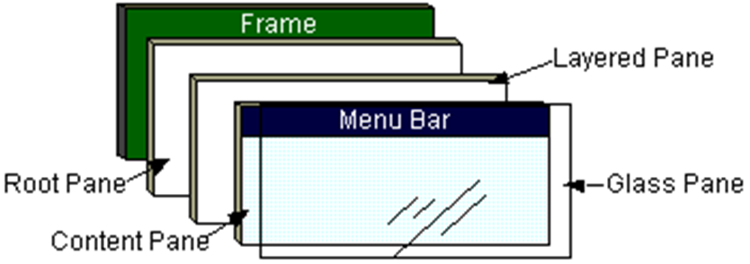

Frames

- A Swing frame is a container that functions as the main window for programs that use Swing components.
- Swing frames possess a title, a border, and buttons for iconifying, maximizing, and closing the frame.
- A Swing frame is represented by the class JFrame, which extends the AWT class Frame.
- Notice that the Swing frame is a heavyweight container, as is its parent. An instance of JFrame can take advantage of the features of both the JFrame and Frame classes.

JFrame Constructors

- Following is typical code used to implement a JFrame object and add a component to it:
- JFrame frame = new JFrame(); // create a frame object
- Container contentPane = frame.getContentPane(); // get the contentpane contentPane.setLayout(new SomeLayout()); // if you want to assigncontentPane.add(SomeComponent); // add the component

- Note that by default thecontent pane is set to border layout.A layout is the pattern used to display components in a container
  - Following are the constructors from the class JFrame:
public JFrame() - creates a new frame that is initially invisible and without a title.
public JFrame(String title) - creates an invisible frame with the specified title.
- You make the frames appear by invoking the method show().

JFrame Closing Behaviors

- When user selects window manager Close option for JFrame, has default behavior
  - Frame did nothing
  - JFrame hides itself
- setDefaultCloseOperation (operation)a
  - DO_NOTHING_ON_CLOSE
  - HIDE_ON_CLOSE
  - DISPOSE_ON_CLOSE
  - No EXIT_ON_CLOSE operation

Example

import javax.swing.*;
public class HelloWorldSwing
{
public static void main(String[] args)
{
JFrame frame = new JFrame("HelloWorldSwing");
final JLabel label = new JLabel("Hello World");
frame.getContentPane().add(label);
frame.setDefaultCloseOperation(JFrame.EXIT_ON_CLOSE);
frame.pack();
frame.setVisible(true);
}
}

Note : pack() causes a window to be sized to fit the preferred size and layouts of its sub-components


JDialog

- Every dialog is dependent on a frame
  - Destroying a frame destroys all its dependent dialogs.
  - When the frame is iconified, its dependent dialogs disappear from the screen.
  - When the frame is deiconified, its dependent dialogs return to the screen.
- A dialog can be modal. When a modal dialog is visible it blocks user input to all other windows in the program.
- To create custom dialogs, use the JDialog class directly.
- Swing provides several standard dialogs
  - JProgressBar, JFileChooser, JColorChooser, ...
- The JOptionPane class can be used to create simple modal dialogs
  - icons, title, text and buttons can be customized.

Example:

Object[] options = {"Yes!", "No, I'll pass", "Well, if I must"};
int n = JOptionPane.showOptionDialog( frame, "Duke is a cartoon mascot. \n" +
"Do you still want to cast your vote?", "A Follow-up Question",
JOptionPane.YES_NO_CANCEL_OPTION,
JOptionPane.QUESTION_MESSAGE,
null,
options,
options[2]);

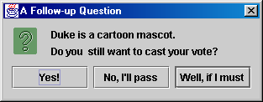

JApplet

- If using Swing components in an applet, subclass JApplet, not Applet
  - JApplet is a subclass of Applet
  - Sets up special internal component event handling, among other things
  - Can have a JMenuBar

Default LayoutManager is BorderLayout

import java.awt.*;
import javax.swing.*;
public class JAppletExample extendsJApplet
{
public void init()
{
WindowUtilities.setNativeLookAndFeel();
Container content =getContentPane();
content.setBackground(Color.white);
content.setLayout(new FlowLayout());
content.add(newJButton("Button 1"));
content.add(newJButton("Button 2"));
content.add(newJButton("Button 3"));
}
}

Output:

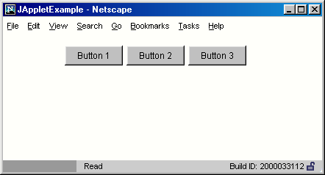

Intermediate Level Container

- Also known as panels or panes
- Simplify the positioning of other components.
  - JPanel
- Play a visible and interactive role in a program’s GUI
  - JScrollPane
  - JTabbedPane
- A panel’s default layout manager is FlowLayout.
  - Other layout managers can easily be set
panel.setLayout(new BorderLayout());
- By default, panels don’t paint anything except for their background.
- By default, panels are opaque.
  - An opaque panel can be set as a top-level container’s content pane.
  - transparent (non-opaque) panels draw no background.

Swing Equivalents of AWT Components

- JLabel - New features: HTML content images, borders
- JButton - New features: icons, alignment, mnemonics
- JPanel - New feature: borders
- JSlider - New features: tick marks and labels

JLabel

HTML content

- If text is "<html>...</html>", it gets rendered as HTML
- HTML labels only work in JDK 1.2.2 or later, or inSwing 1.1.1 or later.
- In JDK 1.2 the label string must begin with <html>, not<HTML>. It is case-insensitive in JDK 1.3 and 1.4.
- JLabel fonts are ignored if HTML is used. If you useHTML, all font control must be performed by HTML.
- You must use <P>, not <BR>, to force a line break.
- Other HTML support is spotty.

Other new features: images, borders

- labelText ="<html><FONT COLOR=WHITE>WHITE</FONT> and " +"<FONT COLOR=GRAY>GRAY</FONT> Text</html>";
- JLabel coloredLabel =new JLabel(labelText, Label.CENTER);
- labelText ="<html><B>Bold</B> and <I>Italic</I> Text</html>";
- JLabel boldLabel =new JLabel(labelText, JLabel.CENTER);
- labelText ="<html>The Applied Physics Laboratory is..." +"of the Johns Hopkins University." +"<P>" + ... "...</html>";

JLabel Example code

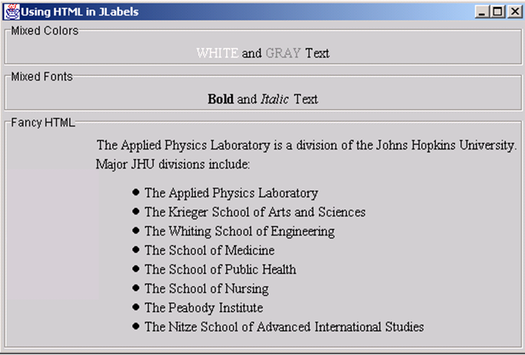

JButton

- Main new feature: icons
  - Create an ImageIcon by passing the ImageIconconstructor a String representing a GIF or JPG file(animated GIFs are supported!).
  - From an applet, call getImage(getCodeBase()…)normally, then pass resultant Image to ImageIcon.
  - 2.Pass the ImageIcon to the JButton constructor.
  - Alternatively, call setIcon.
  - In fact, there are 7possible images (rollover images, images for whenbutton is depressed, etc.)

- Other features
  - HTML content as with JLabel
  - Alignment: location of image with respect to text
  - Mnemonics: keyboard accelerators that let you use Alt-someChar to trigger the button.

Example

Import javax.awt.*;
import javax.swing.*;
public class JButtons extends JFrame
{
public static void main(String[] args)
{
new JButtons();
}
public JButtons()
{
super("UsingJButton");
WindowUtilities.setNativeLookAndFeel();
addWindowListener(new ExitListener());
Container content = getContentPane();
content.setBackground(Color.white);
content.setLayout(new FlowLayout());
JButton button1 = new JButton("Java");
content.add(button1);
ImageIcon cup = new ImageIcon(“images/cup.gif”);
JButton button2 =new JButton(cup);
content.add(button2);
JButton button3 =new JButton("Java",cup);
content.add(button3);
JButton button4 =new JButton("Java",cup);
button4.setHorizontalTextPosition(SwingConstants.LEFT);
content.add(button4);
pack();
setVisible(true);
}
}

Output

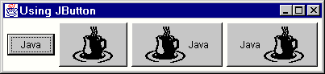

JPanel

- Borders
  - Create a Border object by callingBorderFactory.createXxxBorder.
  - Supply the Border object to the JPanel by means ofsetBorder.
JPanel p = new JPanel();
p.setBorder(BorderFactory.createTitledBorder("Java"));

Other features:–

- Layout manager settings
  - Can pass the layout manager to the JPanelconstructor.
- Setting preferred size
  - There is no JCanvas.If you want JPanel to act likeCanvas, call setPreferredSize.

Example:

public classSixChoicePanel extends JPanel
{
public SixChoicePanel(String title, String[] buttonLabels)
{
super(new GridLayout(3, 2));
setBackground(Color.lightGray);
setBorder(BorderFactory.createTitledBorder(title));
ButtonGroup group = new ButtonGroup();
JRadioButton option;int halfLength = buttonLabels.length/2;

for(int i=0; i<halfLength; i++)
{
option = new JRadioButton(buttonLabels[i]);
group.add(option);add(option);
option = new JRadioButton(buttonLabels[i+halfLength]);
group.add(option);
add(option);
}
}
}

Output

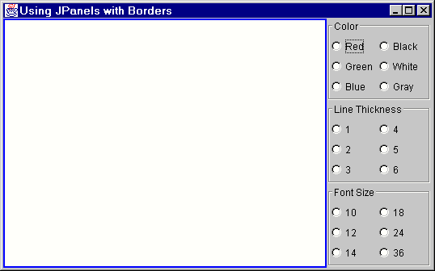

Jslider
- Basic Use
public JSlider()
public JSlider(int orientation)
public JSlider(int min, int max)
public JSlider(int min, int max, int initialValue)
public JSlider(int orientation, int min, int max,int initialValue)

New features: tick marks and labels

setMajorTickSpacing
setMinorTickSpacing
setPaintTicks
setPaintLabels (icons allowed as labels)
Example:

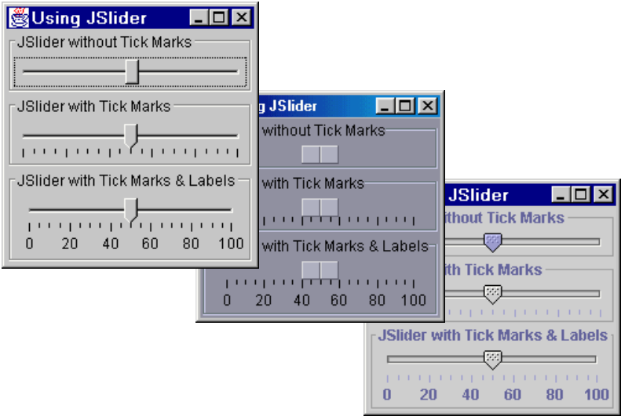

JColorChooser

- Open
–Call JColorChooser.showDialog
•First argument: parent component
•Second argument: title string
•Third argument: initially-selected Color
• Return value
–Selected Color if "OK" chosen
–null if "Cancel" chosen
- Button that lets you change color of window
- public void actionPerformed(ActionEvent e)
{
Color bgColor=JColorChooser.showDialog(this,"Choose Background
Color",getBackground());
if (bgColor != null)getContentPane().setBackground(bgColor);
}

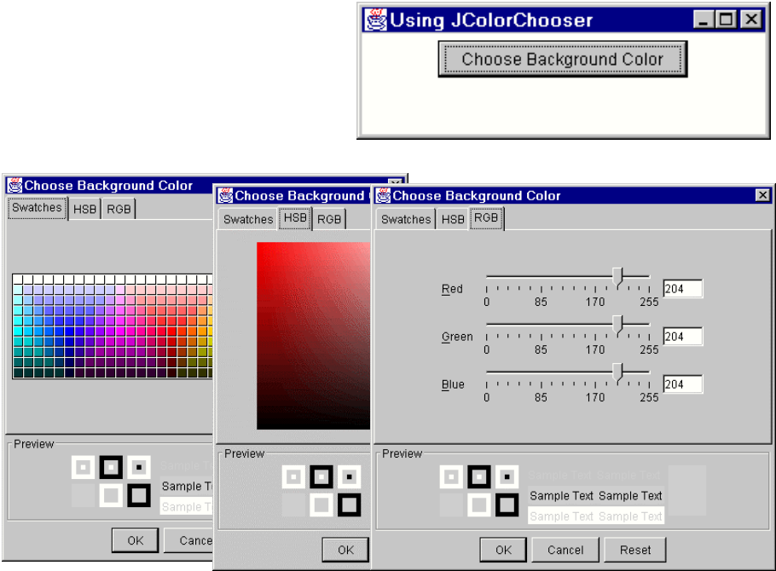

Internal frames

- MDI: Multiple Document Interface
  - Program has one large “desktop” pane that holds all otherwindows. The other windows can be iconified(minimized) and moved around within this desktop pane,but not moved outside the pane. Furthermore, minimizingthe desktop pane hides all the contained windows as well.
  - Examples: Microsoft PowerPoint, Corel Draw, BorlandJBuilder, and Allaire HomeSite
- Swing Support for MDI
  - JDesktopPane
- Serves as a holder for the other windows.
  - JInternalFrame
- Acts mostly like a JFrame, except that it isconstrained to stay inside the JDesktopPane.

Using JInternalFrame

- Main constructor
  - public JInternalFrame(String title,boolean resizable,boolean closeable,boolean maximizable,boolean iconifiable)
- Other useful methods
moveToFront
moveToBack
setSize (required!)
setLocation (required!)

Example:

import java.awt.*;
import java.awt.event.*;
import javax.swing.*;
public class JInternalFrames extends JFrame
{
public static void main(String[] args)
{
new JInternalFrames();
}
public JInternalFrames()
{
super("Multiple Document Interface");
WindowUtilities.setNativeLookAndFeel();
addWindowListener(new ExitListener());
Container content = getContentPane();
content.setBackground(Color.white);
JDesktopPane desktop = new JDesktopPane();
desktop.setBackground(Color.white);
content.add(desktop, BorderLayout.CENTER);
setSize(450, 400);

for(int i=0; i<5; i++)
{
JInternalFrame frame= new JInternalFrame(("Internal Frame " + i),true,
true, true, true);
frame.setLocation(i*50+10, i*50+10);
frame.setSize(200, 150);
frame.setBackground(Color.white);
frame.setVisible(true);
desktop.add(frame);
frame.moveToFront();
}
setVisible(true);
}
}

Output:

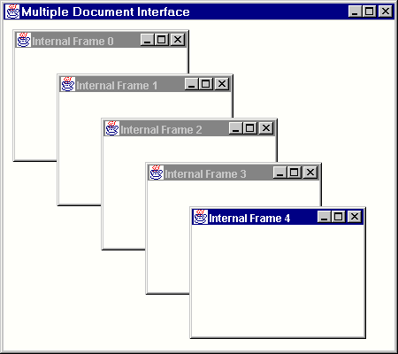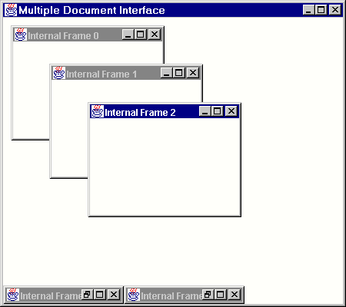

JOptionPane

- Very rich class with many options for different types of dialog boxes.
- Five main static methods
–JOptionPane.showMessageDialog
Icon, message, OK button
–JOptionPane.showConfirmDialog
Icon, message, and buttons:OK, OK/Cancel, Yes/No, or Yes/No/Cancel
–JOptionPane.showInputDialog (2 versions)
Icon, message, textfield or combo box, buttons
–JOptionPane.showOptionDialog
    - Icon, message, array of buttons or other components

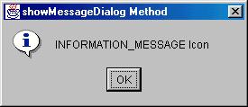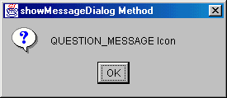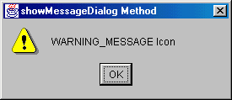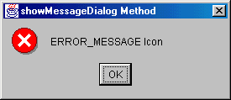
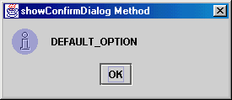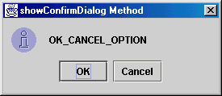
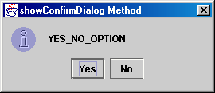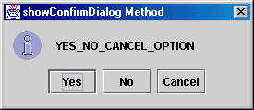

JToolBar

- Acts mostly like a JPanel for buttons
- Dockable: can be dragged and dropped

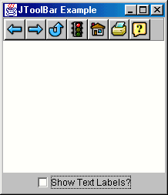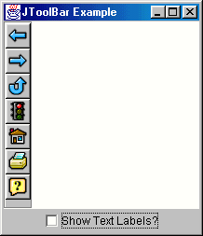

Layout Management

- The process of determining the size and position of components.
- Layout management can be done using absolute positioning
  - Size and position of every component within the container must be specified.
  - Does not adjust well when the top-level container is resized.
  - Does not adjust well to differences between users and systems, such as font size.
- Layout management is often performed using layout mangers
  - Components can provide size and position hints to layout managers, but layout managers have the final say on the size and position of those components.
- Layout hints
  - Minimum, preferred and maximum size
  - X axis alignment, Y axis alignment
- Customizing layout hints
  - Invoking setter methods: setMinimumSize, setAlignmentX, ...
  - Subclassing and overriding the getter methods: getMinimumSize, getAlignmentX, ...

Events

- Swing:
  - objects communicate by “firing” and “handling” events (event objects)
  - (conventional method call)
  - events are sent from a single source object to one or more registered listener objects
- Swing:
  - different event sources produce different kinds of events
e.g., a JButton object, when clicked, generates an ActionEvent object, which is handled by an ActionListener (an object whose class implements this interface)
- Listener classes in support of each event
- Each event has source(s) within Swing
- Class EventListenerList available to maintain list of all listeners
  - Responsibility of class maintaining list to provide type safety, and routine to notify all listeners
- Inherit Component/Container 1.1 events

Swing Events

AncestorEvent | ancestor added,moved,removed
ChangeEvent | State change
DocumentEvent | Document state change
DragEvent | Drag support
ListDatavent | contort changed,interval added or removed
ListSelectionEvent | List selection status change
MenuEvent | Menu selected/posted,deselected,  Cancelled
TableColumnModelEvent | Table column model charge
TableModelEvent | Table model change
TreeExpansionEvent | Tree expanded or collapsed
TreeModelEvent | Tree model change
TreeSelectionEvent | Tree selection status change

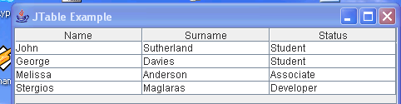

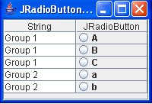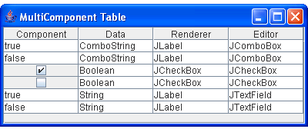

JTable

JTable - Purpose

• When data is 2 dimensional in nature JTable is the component of choice. JTable’s view is a tabular format. For example, a JTable would be used to display rows from a database.

JTable – Basic Capabilities

By running the example program you will see basic capabilities such as

– selecting a row
– resizing and moving columns
– resizing the table
– when table is resized vertically we get vertical scrollbar
» scrolling does not affect column header
– when resized horizontally space distributed to cells
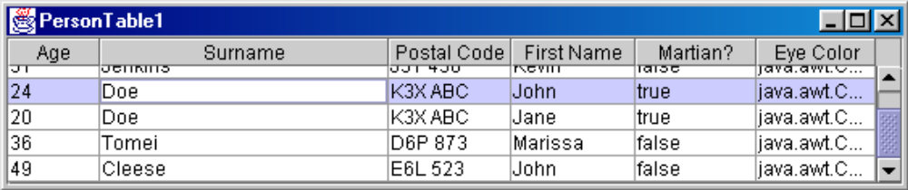

JTable – Basic Usage

• We typically begin by creating an array for the column names.

private Object[] columnNames = { "First Name", "Surname", "Postal Code", "Age", "Martian?", "Eye Color" };

• To populate the cells we create a 2 dimensional array of Objects.

private Object[][] cells = {{ "Sam", "Steel", "K2Y 123", new Integer(24), new Boolean(false), Color.gray},
{ "Kevin", "Jenkins", "J3T 456", new Integer(31), new Boolean(false), Color.black }, ……. };

Note: use of wrapper types. The table converts the objects toString()s

• Pass the column names and cell data to the constructor.
JTable table = new JTable(cells, columnNames);

// We get scrolling using JScrollPane
getContentPane().add(new JScrollPane(table), BorderLayout.CENTER);
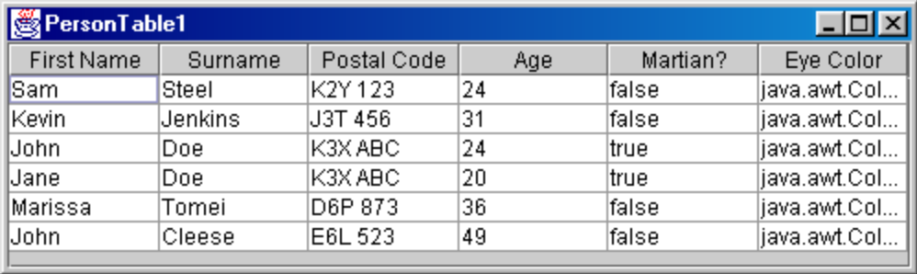

JTable – Abstract Table Model

• Using an array of objects is useful for prototyping but we will

usually extend the AbstractTableModel and pass it in the

constructor. JTable tbl = new JTable(myTableModel);
public class MultiplicationTableModel extends AbstractTableModel
{
public int getColumnCount() { return 10; }
public int getRowCount() { return 10;}
public Object getValueAt(int row, int col)
{
return new Integer(row*col);
}
}

Abstract Table Model permits looking up the value or computing it at run-time. We extend
javax.swing.table.AbstractTableModel

JTable – RMI File Viewer

• Let’s see how we can make use of this in our application.
• We can replace the JList with a JTable and display

information such as file size. We probably also want to know if the “file” is a directory so that we can retrieve the contents of the directory.

• Think about how this might be designed starting from the server side all the way to the client side presentation.
• Focus on

– the data/model required
– how it would be populated
– how it would be sent from server to client
– what model we would use on the client side

JTable – RMI File Viewer

• After you have thought about the design for a few minutes take note of your ideas.

JTable – Design for project
Here is the first part of the solution.
• We know that attributes of a file are available from a
java.io.File.

For example:

File f = new File(“c:\somedir\somefile”);
boolean b;
b = f.exists();
b = f.isDirectory();
b = f.isHidden() ;

JTable – Design for project

Here is one solution.

• Attributes of a file are available from a java.io.File.
• On the server we can collect all of the File objects for a directory using

private File[] getDirInfo(String dirName) {
File[] theFiles; // information about files in a directory
File f = new File(dirName);
if( f.exists() && f.isDirectory() ) {
File[] theFiles = f.listFiles();
}
return theFiles;
}

Then we could send this collection to the client.
What is the potential problem here? (Think of client side)

- We could return a collection of File object however
  - they are not Remote objects
- the client will get a copy of the File object.
- When the client executes a method such as

f.isDirectory()
or f.canRead()

the method goes to the local file system to determine the information. This will obviously not return info about the file on the remote/server system. What do you think the solution to this problem might be?

JTable – FileInfo

• A solution is to collect the required attributes on the server side then send a copy to the client.
• We create application objects of type FileInfo

/*

Contains a subset of the attributes of a File such that they
can be conveniently shipped across a network or stored in a stream using serialization.
*/
public class FileInfo implements java.io.Serializable
{
}

public class FileInfo implements java.io.Serializable
{
private String name;
private boolean isDir;
private long lastModified; // etc. for more attributes
public FileInfo(File theFile)
{
name = theFile.getName();
isDir = theFile.isDirectory();
lastModified = theFile.lastModified(); // etc. for more attributes
}
public String getName() { return name; }
public boolean isDirectory() { return isDir; }
public long lastModified() { return lastModified; } …
};

JTable – FileTableModel

• To see how attributes of a file can be collected into a table model and displayed in a JTable see the example displays attributes of a LOCAL file in a JTable.
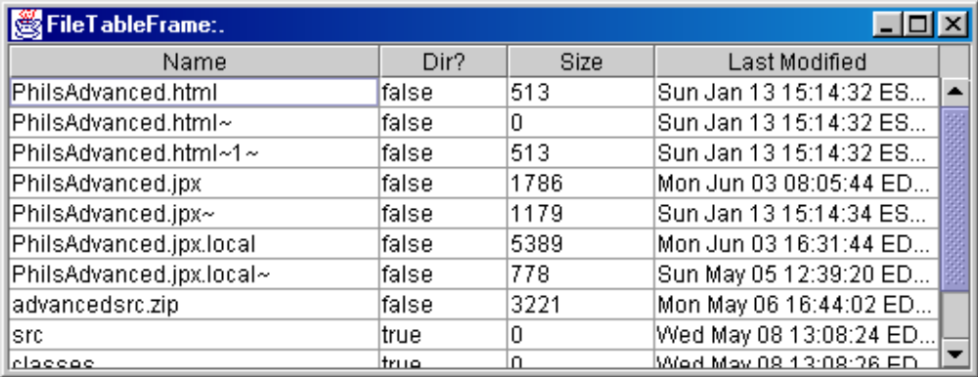

JTable – Design for project

Here is one solution.
• When the client requests a directory listing the server
will return a collection of FileInfo objects.
• Eventually we want to display the info in a JTable.
• What is the next step? (JTable specifics ..)

JTable – FileInfoTableModel

• Recall that the information in a JTable is in a TableModel.
• Earlier we saw how to extend an AbstractTableModel to

create a MultiplicationTableModel. Perhaps a quick review is required.

• Our solution is to use the FileInfo collection, retrieved from the server, to populate a FileInfoTableModel which extends the

AbstractTableModel.

• FileInfoTableModel must implement following methods:

public int getRowCount();
public int getColumnCount();
public Object getValueAt(int row, int column);

• To get column names other than the default A,B,C … override

public String getColumnName(int c)

JTable – Selection Modes

Same as for JList

• TheListSelectionModel can be set to one of 3 modes.
– JTable and JList use the ListSelectionModel.

• SINGLE_SELECTION
– only 1 item can be selected

• SINGLE_INTERVAL_SELECTION
– one contiguous interval can be selected

• MULTIPLE_INTERVAL_SELECTION
– anything can be selected using the shift and Ctrl keys
– this is the default mode.

myJTable.setSelectionMode(ListSelectionModel.SINGLE_SELECTION);

JTable – Selection Settings

• In addition to the selection mode, JTable supports enabling and disabling of row and columns selection. void setRowSelectionAllowed(boolean rowSelectionAllowed) Sets whether the rows in this model can be selected. void setColumnSelectionAllowed ( boolean
columnSelectionAllowed)
Sets whether the columns in this model can be selected. If you need to work with columns then you will want to learn about the ColumnModel.

JTable – Getting selections

Essentially the same as for JList
• You can call JTable methods such as:

int getSelectedRow()
Returns the index of the first selected row, -1 if no row is selected.

int[] getSelectedRows()
Returns the indices of all selected rows.

• Listen to events from the ListSelectionModel.

This is the same model that is used by JList.

– The event that is generated is a ListSelectionEvent. Therefore the listener we must implement is the ListSelectionListener interface.

JTable – Resizing

• One of the basic capabilities of JTable is to resize automatically resize all columns when the user resizes the table. You will probably want to change the default auto resize behavior.

• To change the auto resize mode use: public void setAutoResizeMode(int mode)

• Default auto resize can prove problematic with users. If the user has carefully resized individual columns then the entire table is resized then the additional space will be distributed amongst the columns, thus changing the users settings. To turn it off: myJTable.setAutoResizeMode(JTable.AUTO_RESIZE_OFF); See the JTable docs for other modes.

• SwingClient_Prototype4 demonstrates two of the modes.

JSplitPane

Easy to use.

JSplitPane splitter = new JSplitPane(JSplitPane.HORIZONTAL_SPLIT, true);
splitter.setLeftComponent(listScroller);
splitter.setRightComponent(fileDisplayScroller);
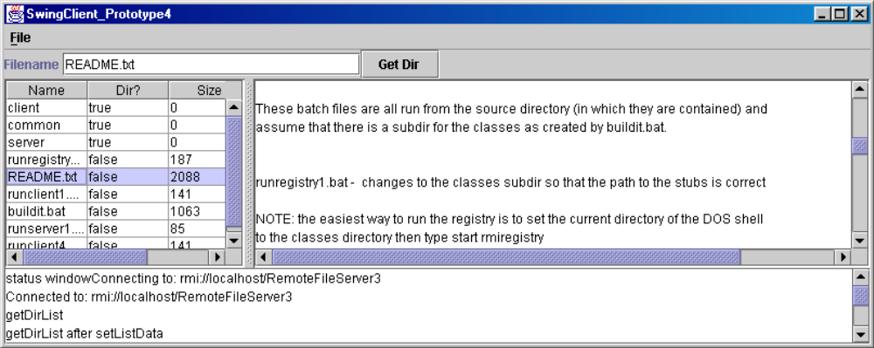
getContentPane();.add(splitter, BorderLayout.CENTER);

