Result and Analysis

Method description:

Our approach is almost exactly as written in the slide, and the data used is also in accordance with the closing price data of the global ETF data and the fama-french three-factor data as instructed by the guide. First, the closing price data is converted into return data. When estimating the return and risk, Use the daily frequency to perform two regressions on the time series, and calculate the beta coefficient of each ETF index and the coefficient of the three-factor model. Estimate risks and returns based on a three-factor model. Then construct the optimization model of return and risk according to the weekly frequency, and then re-regress every week, calculate the new risk matrix and return vector, and then add the target beta constraint for optimization. After constructing a portfolio in each period, calculate the return rate of the portfolio, draw a backtest curve based on the S&P index, and calculate a series of evaluation indicators such as average return and variance. All programming is done using python, the executable code and data are in the attachment.

Result:

1. before the crisis(2007.5.1-2008.3.1)
   1. Take the 60-day interval to estimate the expected return and the 40-day interval to estimate the expected risk as an example，set beta range from -1.5 to 1.5.

cumulated daily Profit and Loss (PnL):

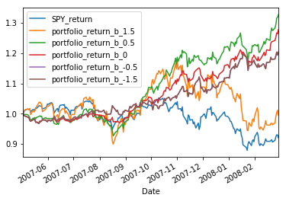

Before the crisis started, all the portfolios performed better than the market SPY_return. It can be seen that when the beta is 0.5, the portfolio performs best. When the beta is 1.5, the portfolio risk appetite is strong and highly correlated with the market portfolio trend, but the performance is poor. When the beta is negative, the investment portfolio has little relationship with the market portfolio trend. When the beta is 0, the portfolio CAR curve is relatively smooth, indicating that its fluctuation is small. The above conclusion is in line with the CAPM theory.

1.2 Plot and analyze the distribution of daily Returns.

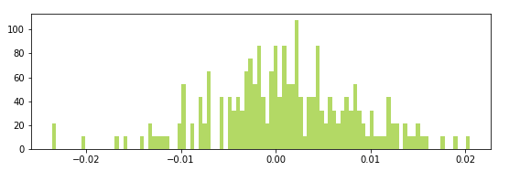

The return almost obeys the normal distribution, the return is concentrated near the mean, the skewness is negative, and it is slightly biased in the negative direction.

1.3 Consider the sensitive of beta

|  |  |  |  |  |  |  |
| --- | --- | --- | --- | --- | --- | --- |
|  | $$S_{40}^{60}（-1.5）$$ | $$S_{40}^{60}（-0.5）$$ | $$S_{40}^{60}（0）$$ | $$S_{40}^{60}（0.5）$$ | $$S_{40}^{60}（1.5）$$ | SP500 |
| Cumulated Return | 0.201 | 0.201 | 0.278 | 0.327 | -0.044 | -0.090 |
| Daily Mean Arithmetic / , Daily Min Return | 0.228 | 0.228 | 0.298 | 0.349 | 0.033 | -0.083 |
| Max period Drawdown | 0.048 | 0.048 | 0.048 | 0.088 | 0.201 | 0.164 |
| Volatility | 0.014 | 0.014 | 0.012 | 0.023 | 0.076 | 0.032 |
| Sharpe Ratio | 1.741 | 1.741 | 2.448 | 2.158 | 0.048 | -0.574 |
| Skewness | -0.252 | -0.252 | -0.084 | -0.206 | -0.224 | -0.237 |
| ,Kurtosis | 0.556 | 0.556 | 0.418 | 0.536 | 0.126 | 0.319 |

As we have mentioned, when the target beta is 0.5, the cumulative return of the portfolio and the average annualized return are the highest, but the Sharpe ratio is when the target beta is 0, achieving a good result of 2.448. It can be seen that when the absolute value of the target beta becomes larger, the variance becomes larger and the maximum drawdown becomes larger, especially when the beta is 1.5, the effect is poor.

1.4 Consider the sensitive of length of period.

In the analysis of 1.3, we can see that when the target beta is 0.5, the portfolio performs best. Therefore, when testing the sensitivity of the estimated return and estimated risk to the results, we set the target beta to 0.5.

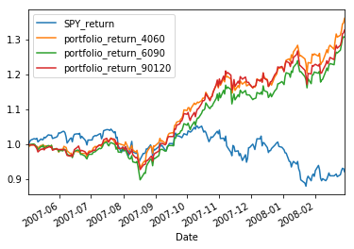

|  |  |  |  |  |
| --- | --- | --- | --- | --- |
|  | $$S_{40}^{60}（0.5）$$ | $$S_{60}^{90}（0.5）$$ | $$S_{90}^{120}（0.5）$$ | SP500 |
| Cumulated Return | 0.365 | 0.301 | 0.328 | -0.090 |
| Daily Mean Arithmetic / , Return | 0.379 | 0.331 | 0.349 | -0.083 |
| Max period Drawdown | 0.048 | 0.052 | 0.051 | 0.164 |
| Volatility | 0.024 | 0.025 | 0.023 | 0.032 |
| Sharpe Ratio | 2.33 | 1.978 | 2.15 | -0.574 |
| Skewness | -0.216 | -0.279 | -0.205 | -0.237 |
| ,Kurtosis | 0.593 | 0.619 | 0.536 | 0.319 |

Judging from the cumulative return curve, before the crisis began, the ST group, that is, the portfolio with a shorter period of estimation interval, performed best. It is not difficult to understand that the macro environment and risk structure of the market can be assumed to remain unchanged in the short term, but it will definitely change in the long term. In other words, short-term estimates can better characterize the risk structure and return structure. Therefore, it is reasonable to achieve better performance. In addition, historical experience has shown that stocks have a momentum effect in the short-term and a reversal effect in the long-term. Therefore, it is indeed a better way in the short term. From the table, we can see that Sharpe indicator and the max drawdown and other indicators also confirm our views.

1. during the crisis(2008.3.1-2011.1.1)

2.1 Take the 60-day interval to estimate the expected return and the 40-day interval to estimate the expected risk as an example，set beta range from -1.5 to 1.5.

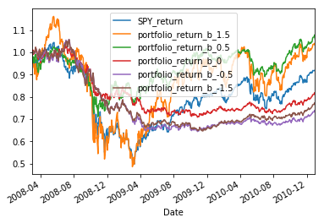

First of all, we pay attention to the changes in the market's investment portfolio. Since April 2008, the Standard 500 Index has fallen all the way and reached its lowest point in April 2009. Since then, with the promulgation of a series of rescue policies, US stocks have gradually recovered and are ahead of the world in terms of time. Therefore, we can see a deep V-shaped curve. Generally speaking, only when the target beta is 1.5 and 0.5, the investment portfolio surpassed the market portfolio, but they also encountered a serious drawdown in the early stage of the economic crisis. The other three portfolios may be dragged down by the slow recovery of the global market and underperform. market portfolio.

2.2 Plot and analyze the distribution of daily Returns.

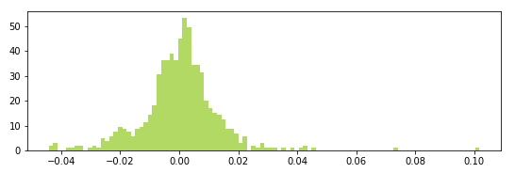

The return almost obeys the normal distribution, the return is concentrated near the mean, the skewness is negative, and it is slightly biased in the negative direction.

2.3 Consider the sensitive of beta

|  |  |  |  |  |  |  |
| --- | --- | --- | --- | --- | --- | --- |
|  | $$S_{40}^{60}（-1.5）$$ | $$S_{40}^{60}（-0.5）$$ | $$S_{40}^{60}（0）$$ | $$S_{40}^{60}（0.5）$$ | $$S_{40}^{60}（1.5）$$ | SP500 |
| Cumulated Return | -0.235 | -0.278 | -0.190 | 0.061 | 0.033 | -0.082 |
| Daily Mean Arithmetic Return | -0.084 | -0.099 | -0.066 | 0.040 | 0.113 | 0.017 |
| Max period Drawdown | 0.388 | 0.391 | 0.311 | 0.307 | 0.582 | 0.524 |
| Volatility | 0.018 | 0.018 | 0.014 | 0.041 | 0.204 | 0.094 |
| Sharpe Ratio | 0.126 | 0.166 | -0.392 | 0.716 | 0.384 | 0.387 |
| Skewness | -0.252 | -0.252 | -0.084 | -0.206 | -0.224 | -0.237 |
| ,Kurtosis | 3.471 | 3.572 | 2.915 | 7.896 | 6.789 | 8.843 |

We can clearly see that in the economic crisis, the mean and volatility of investment returns are not as good as before the crisis, but the previous conclusions are still valid. One is that the greater the target beta value, the greater the variance index and the maximum retracement index. This is decided by economic implications of Beta. In addition to volatility, due to the drastic changes in the stock market, the kurtosis is also significantly higher than before the crisis. Thanks to the rapid recovery of the US stock market, the 0.5beta value portfolio still achieved the largest Sharpe ratio and the smallest "maximum drawdown", which confirmed our determination to finally set the target beta estimate to 0.5.

2.4 Consider the sensitive of length of period.

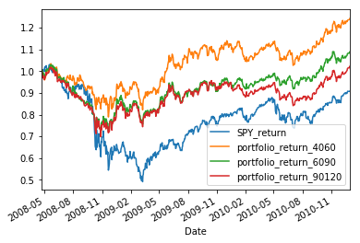

|  |  |  |  |  |
| --- | --- | --- | --- | --- |
|  | $$S_{40}^{60}（0.5）$$ | $$S_{60}^{90}（0.5）$$ | $$S_{90}^{120}（0.5）$$ | SP500 |
| Cumulated Return | 0.365 | 0.301 | 0.328 | -0.082 |
| Daily Mean Arithmetic Return | 0.098 | 0.046 | 0.022 | 0.017 |
| Max period Drawdown | 0.307 | 0.321 | 0.332 | 0.524 |
| Volatility | 0.034 | 0.037 | 0.038 | 0.094 |
| Sharpe Ratio | 0.417 | 0.141 | 0.014 | 0.387 |
| Skewness | 0.351 | 0.800 | 1.098 | -0.237 |
| ,Kurtosis | 3.743 | 6.459 | 10.546 | 8.843 |

We have explained in detail why the short-term is better than the long-term in the previous analysis. There is nothing else in this picture except to verify our previous conclusions.

1. after the crisis(2011.1-2018.6.1)

3.1 Take the 60-day interval to estimate the expected return and the 40-day interval to estimate the expected risk as an example，set beta range from -1.5 to 1.5.

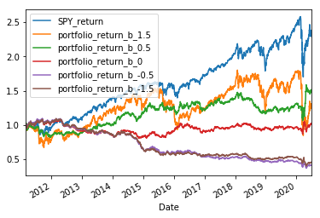

After the economic crisis, the U.S. stock market has ushered in a bull market for nearly a decade, and the S&P index has doubled. If we pay attention to the Nasdaq index, the result will be even more amazing. Until 2020, there was a huge gap in the impact of the epidemic. During this period, the performance of US stocks was significantly better than that of the global market, which fully demonstrated the resilience and vitality of the US economy as a global hegemon. Therefore, none of our portfolios have been able to beat the S&P index after the economic crisis, and the higher the target beta value, that is, the more relevant the S&P index, the better its performance. Unfortunately, portfolios that are less involved in the US market perform poorly. Not surprisingly, the 0.5 portfolio was sometimes surpassed by the 1.5 portfolio, but the 0.5 portfolio still achieved the highest cumulative return.

3.2 Plot and analyze the distribution of daily Returns.

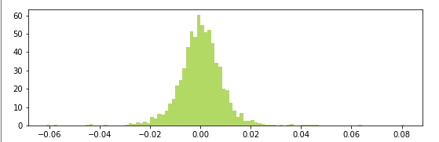

3.3 Consider the sensitive of beta

|  |  |  |  |  |  |  |
| --- | --- | --- | --- | --- | --- | --- |
|  | $$S_{60}^{90}（-1.5）$$ | $$S_{60}^{90}（-0.5）$$ | $$S_{60}^{90}（0）$$ | $$S_{60}^{90}（0.5）$$ | $$S_{60}^{90}（1.5）$$ | SP500 |
| Cumulated Return | -0.551 | -0.590 | 0.017 | 0.498 | 0.266 | 1.321 |
| Daily Mean Arithmetic / , Daily Min Return | -0.084 | -0.099 | -0.066 | 0.040 | 0.113 | 0.106 |
| Max period Drawdown | 0.634 | 0.665 | 0.254 | 0.279 | 0.531 | 0.371 |
| Volatility | -0.078 | -0.088 | 0.007 | 0.053 | 0.030 | 0.094 |
| Sharpe Ratio | 0.126 | 0.166 | -0.392 | 0.716 | 0.384 | 0.495 |
| Skewness | -0.350 | -0.360 | -0.045 | -0.077 | -1.227 | -0.650 |
| ,Kurtosis | 4.550 | 5.231 | 4.411 | 15.562 | 16.135 | 15.120 |

When taget beta is 0.5,everything is fine.

3.4

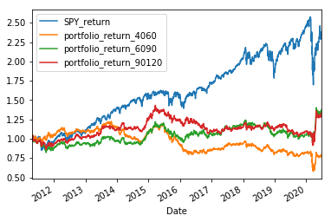

|  |  |  |  |  |
| --- | --- | --- | --- | --- |
|  | $$S_{40}^{60}（0.5）$$ | $$S_{60}^{90}（0.5）$$ | $$S_{90}^{120}（0.5）$$ | SP500 |
| Cumulated Return | -0.224 | 0.360 | 0.317 | 1.321 |
| Daily Mean Arithmetic / , Daily Min Return | -0.014 | 0.043 | 0.039 | 0.106 |
| Max period Drawdown | 0.279 | 0.321 | 0.285 | 0.375 |
| Volatility | 0.034 | 0.037 | 0.038 | 0.094 |
| Sharpe Ratio | -0.216 | 0.164 | 0.139 | 0.495 |
| Skewness | 0.047 | 0.263 | -1.23 | -0.650 |
| ,Kurtosis | 26.19 | 7.871 | 13.828 | 15.12 |

We were surprised to find that in the longer period after the economic crisis, the 4060 portfolio that performed well in the first two experiments performed the worst. After careful consideration, I found that the conclusion is reasonable. In the first two intervals, the market fluctuated repeatedly and market styles continued to change. In the following ten years, market style changes have slowed down, and the macro environment has basically been in a easy monetary environment, so a longer period of estimation is more advantageous. Based on this consideration, we used an estimated interval of 6090 in the final full-period model.

4、whole period

After three rounds of experiments in different periods. Our final target beta is 0.5, and the interval lengths of estimated risk and estimated return are 60 and 90 respectively. The results are shown in the figure below.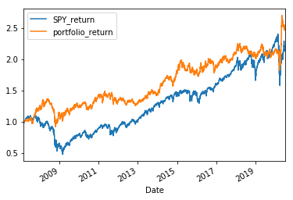

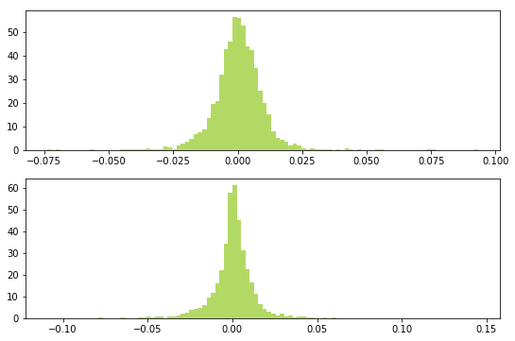

|  |  |  |
| --- | --- | --- |
|  | $$S_{60}^{90}（0.5）$$ | SP500 |
| Cumulated Return | 1.497 | 1.151 |
| Daily Mean Arithmetic return | 0.080 | 0.079 |
| Max period Drawdown | 0.307 | 0.524 |
| Volatility | 0.024 | 0.043 |
| Sharpe Ratio | 0.390 | 0.284 |
| Skewness | 0.405 | -0..031 |
| ,Kurtosis | 9.803 | 14.949 |

In the complete data from 2007 to the present, we see that the portfolio using our estimates always outperforms the market portfolio, even though it is recognized that the market portfolio has performed very well in the past decade. The return of the investment portfolio is stable and upward, with little volatility. Even under the extreme circumstances of the economic crisis and the impact of the covid-19 epidemic, the maximum drawdown is acceptable. Therefore, The portfolio is worth the investment. The only shortcoming is when the position is adjusted weekly. If the transaction cost is considered, the return may be greatly reduced. This is also the direction for continued improvement in the future.