|  |  |  |  |
| --- | --- | --- | --- |
|  | Fmax | Slack | End Point TNS |
| Slow 85°C | 444.44 MHz | -1.250 | -15.533 |
| Slow 0°C | 425.45 MHz | -1.356 | -16.797 |
| Fast 85°C | N/A | -0.218 | -1.447 |
| Fast 0°C | N/A | -0.197 | -1.158 |

b_sync[3] to result[14]

Slack = -1.250

Clock Skrew = -0.072

Data Delay = 2.008

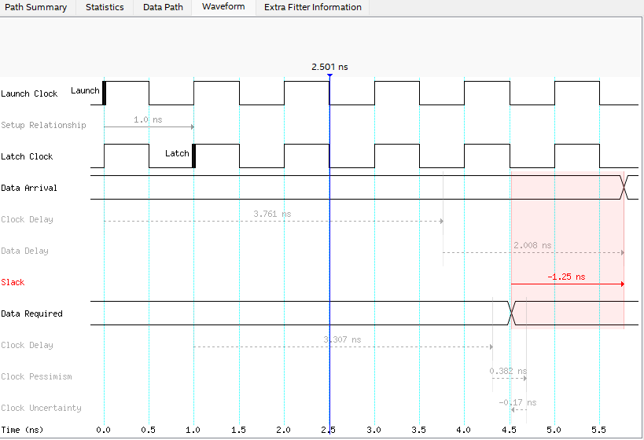

|  |  |  |  |
| --- | --- | --- | --- |
|  | Fmax | Slack | End Point TNS |
| Slow 85°C | 386.25 MHz | 17.411 | 0.000 |
| Slow 0°C | 372.58 MHz | 17.316 | 0.000 |
| Fast 85°C | N/A | 18.585 | 0.000 |
| Fast 0°C | N/A | 18.621 | 0.000 |

b_sync[3] to result[14]

Slack = 17.509

Clock Skrew = -0.058

Data Delay = 2.263

