**LAB EXERCISE -1**

**Aim:** To write program to count the number of characters, words, spaces, end of lines in a given input file.

**CODE:**

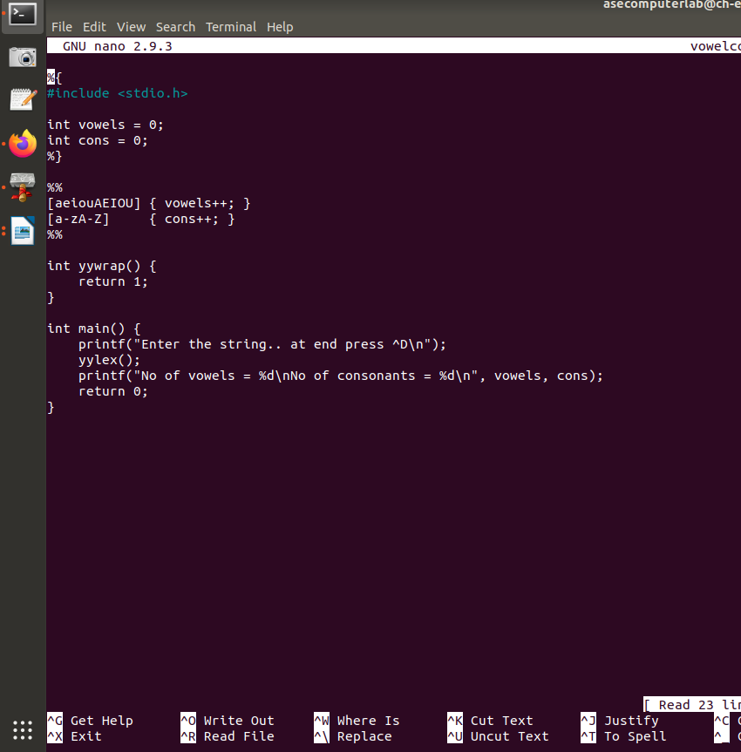

**Output:**

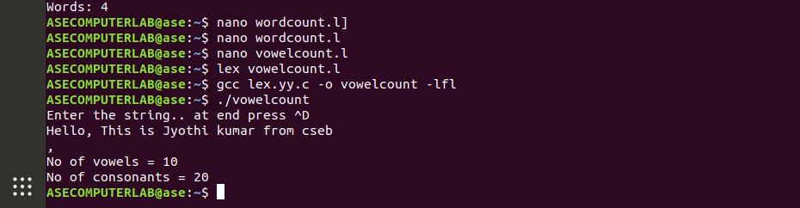

**2.Aim:**

Program to count the number of characters, words, spaces, end of lines in a given input file

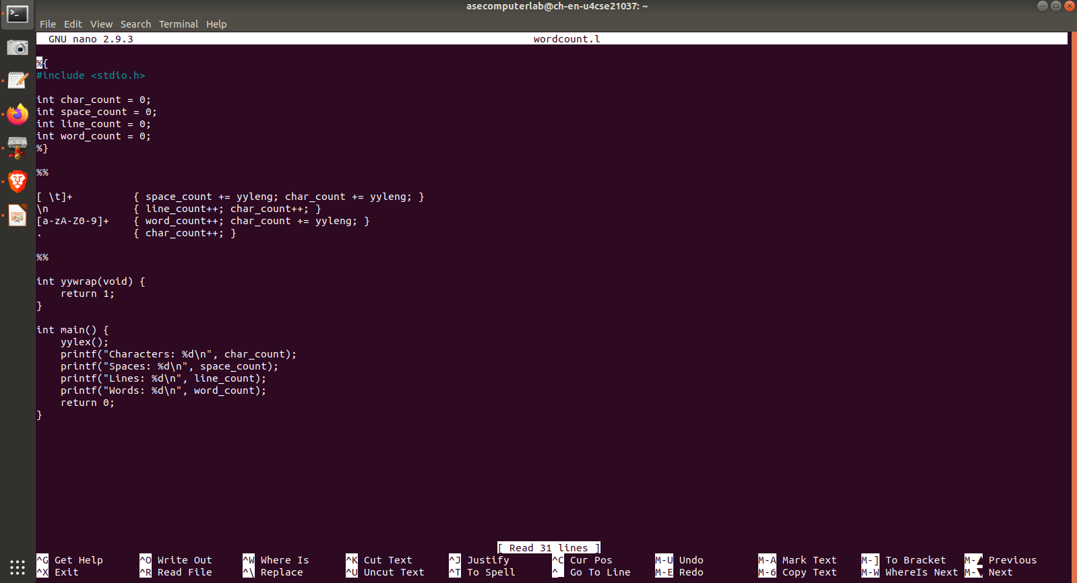**Code:**

**Output:**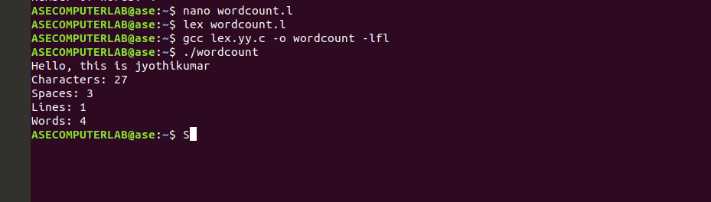

3**.Aim**: To write program to count no of: a) +ve and –ve integers b) +ve and –ve fractions

**Code:**

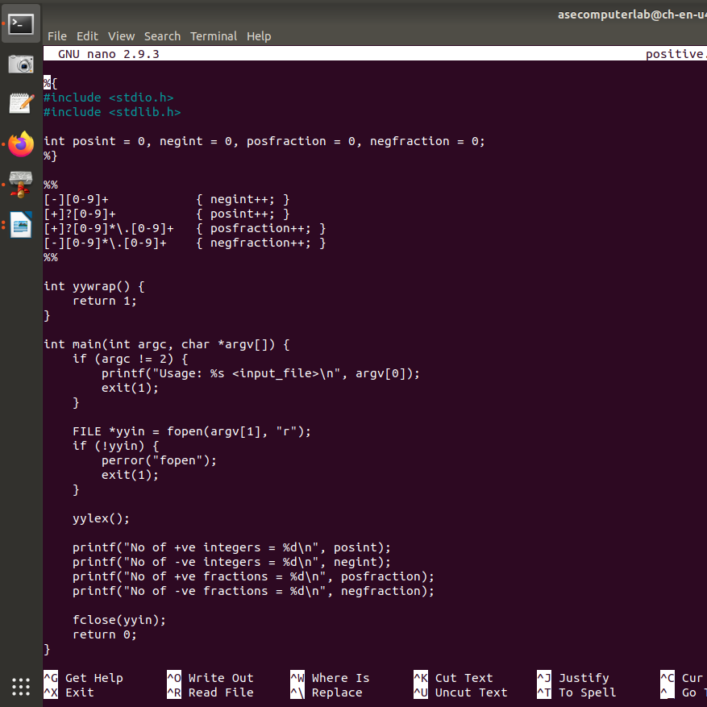

**Output:**

