RaceDay Portfolio of Evidence
Part 1 — System Planning and Database
Prepared planning specification for the RaceDay event management system

1. Introduction and Scope
RaceDay is a web-based event management system for running, walking and cycling events. Organisers create and manage events, define age or distance categories, view participant enrolments and record finishing results. Participants register, sign in, maintain their own profile, browse events, enrol in a category and view their own results. Part 1 defines the data model, API contract and SQL schema before implementation.

2. Roles and Access Control
Role | Allowed actions | Restrictions
Public | Register as Participant; log in | Cannot access protected data or choose the Organiser role.
Participant | View/update own profile; view events/categories; enrol; view own results | Cannot create/edit/delete events or categories, view all enrolments, or record results.
Organiser | Manage own events and categories; view enrolments for own events; record results | Cannot manage events owned by another Organiser or view another Participant’s private profile/results.
Security decision: public registration always creates a Participant account. Organiser accounts are provisioned through a controlled administrator/development process so a public request cannot grant elevated privileges. Passwords are stored as secure hashes, never plaintext. Part 2 uses a server-side session storing user ID and role, and checks role plus resource ownership on protected operations.

3. Section A — Entity Relationship Diagram
The ERD contains six entities. Primary keys (PK), foreign keys (FK), unique constraints and relationship cardinalities are shown in the PNG diagram and Mermaid source in the docs folder.
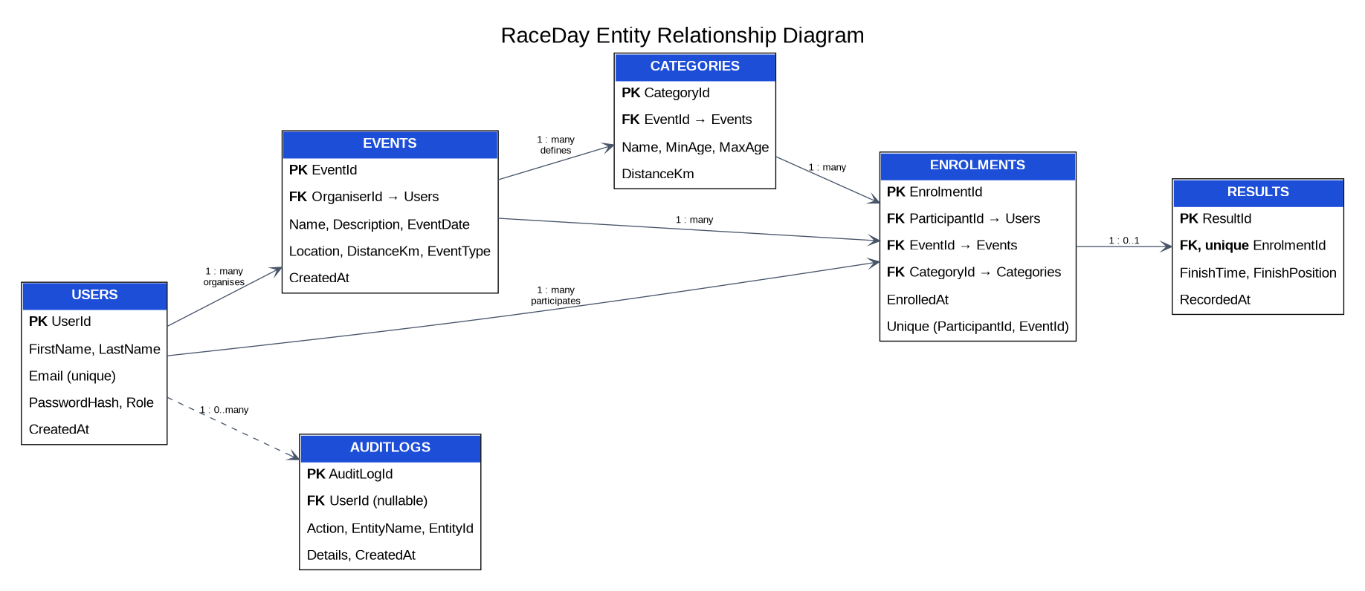
Relationship | Cardinality and business rule
Users → Events | One-to-many: one Organiser can create multiple Events; each Event has one Organiser.
Events → Categories | One-to-many: each Event can define multiple categories.
Users → Enrolments | One-to-many: a Participant can enrol in multiple events.
Events → Enrolments | One-to-many: an Event can have multiple enrolments.
Categories → Enrolments | One-to-many: a Category can be selected by multiple participants.
Enrolments → Results | One-to-zero-or-one: a result is optional until recorded; unique EnrolmentId prevents duplicates.
Users → AuditLogs | One-to-many optional: an audit record may have a nullable UserId.

4. Entity and Constraint Summary
Entity | Attributes and rules
Users | UserId PK; FirstName; LastName; Email UNIQUE; PasswordHash; Role; CreatedAt. Role limited to Organiser or Participant.
Events | EventId PK; OrganiserId FK → Users; Name; Description; EventDate; Location; DistanceKm; EventType; CreatedAt. Distance must be positive; EventType is Run, Walk or Cycle.
Categories | CategoryId PK; EventId FK → Events; Name; MinAge; MaxAge; DistanceKm. Category names are unique per event; age ranges and distance are validated.
Enrolments | EnrolmentId PK; ParticipantId FK → Users; EventId FK → Events; CategoryId FK → Categories; EnrolledAt. ParticipantId + EventId is unique.
Results | ResultId PK; EnrolmentId FK UNIQUE → Enrolments; FinishTime; FinishPosition; RecordedAt. Finish position must be positive.
AuditLogs | AuditLogId PK; nullable UserId FK → Users; Action; EntityName; EntityId; Details; CreatedAt.

5. Section B — REST API Endpoint Plan
The complete endpoint specification is maintained in docs/API-Endpoint-Plan.md. The following table summarises the planned route groups. The implemented API must match these routes and the access-control rules.
HTTP method | Route | Purpose | Role
POST | /api/auth/register | Create Participant account | Public
POST | /api/auth/login | Validate credentials and create server-side session | Public
POST | /api/auth/logout | Clear current session | Logged-in
GET | /api/auth/session | Check current session and role | Logged-in
GET / PUT | /api/users/me | View/update own profile | Logged-in
GET | /api/events and /api/events/{id} | Browse events and details | Logged-in
POST / PUT / DELETE | /api/events[/{id}] | Create/update/delete own events | Organiser
GET / POST | /api/events/{eventId}/categories | List/create event categories | Logged-in / Organiser
PUT / DELETE | /api/categories/{id} | Update/delete category | Organiser, owner only
POST | /api/events/{eventId}/enrolments | Enrol in selected category | Participant
GET | /api/events/{eventId}/enrolments | View event enrolments | Organiser, owner only
GET | /api/users/me/enrolments | View own enrolments | Participant
POST | /api/enrolments/{id}/result | Record finish time and position | Organiser, owner only
GET | /api/users/me/results | View own results | Participant

6. Section C — SQL Database Script
The runnable SQL Server script is docs/RaceDayDb.sql. It creates RaceDayDb and all six tables in dependency order, defines primary and foreign keys, NOT NULL/UNIQUE/CHECK/DEFAULT constraints, and inserts sample data for two Organisers, two Participants, three Events, three Categories per Event, sample Enrolments and example Results. Seeded accounts intentionally have non-working placeholder password hashes; real login accounts must be registered through the API.
Important: the script drops and recreates the six tables before creating them. Run it only on a clean development database or after backing up any data you need.

7. Part 2 Implementation and Testing Plan
- Create the ASP.NET Core Web API and use Entity Framework Core with SQL Server; keep entity relationships consistent with this ERD and SQL script.
- Implement registration, login, logout and session status. The server-side session stores user ID and role; protected routes reject unauthenticated requests.
- Enforce Organiser and Participant roles at the API level and enforce event ownership for updates, deletion, enrolment lists, categories and results.
- Use Swagger in Development and document endpoint purpose, inputs, outputs and likely status codes.
- Test unauthenticated access, successful registration/login, invalid passwords, role rejection, and logout. Expand tests to cover event CRUD, categories, enrolment and results.
- Use GitHub Actions to restore, build and run tests on each push and pull request. Capture a real green build screenshot only after the workflow passes.

8. Rubric Evidence Checklist
☐ Part 1 planning files (ERD PNG/PDF, endpoint plan and SQL script) are committed inside /docs before Part 2 code.
☐ SQL script runs without errors on a clean SQL Server instance; six tables and sample data are verified.
☐ API build succeeds and all endpoint routes match the approved endpoint plan.
☐ Both roles are tested; session stores user ID and role; passwords are hashed; ownership and role checks work.
☐ Swagger exposes and describes every endpoint and protected endpoints are testable using the session cookie.
☐ All tests pass locally and in GitHub Actions.
☐ At least 20 meaningful commits exist in the student’s own GitHub repository.
☐ README contains full setup/run steps, role explanation, actual green-build screenshot and actual unlisted YouTube link.
☐ Video clearly demonstrates API endpoints, authentication, Swagger, unit tests, database integration and code structure.
Prepared as a project planning and implementation aid. Before submission, verify the application in your own environment and replace all evidence placeholders with genuine screenshots, test results, repository links and video URL.

