**Instructions:**

**Step 1:** Go to your Udemy course and open your Notes. Make sure you have them in your preferred sorting order (the most logical is All lectures and Sort by oldest).

**Step 2:** Open the browser developer tools (Right-click anywhere and choose “Inspect")

Then, in the Elements tab, search for the <div> with the attribute data-purpose="bookmarks--container". You can search for it quickly by hitting Ctrl+F (Windows) or Cmd+F (Mac) and searching for "bookmarks--container".

**Step 3:** Right-click on the <div>, select “Copy”, and select “Copy outerHTML”. This will copy both the <div> and all its children. See image demonstration below.

**(scroll down to see rest of instructions)**

**Step 4:** Open my provided HTML file in a code-editor. Search for the portion labelled

***START REPLACING HERE*** and ending with ***END REPLACING HERE***. Delete the example code currently there and replace it with what we copied in **Step 3**. See the image demonstration below:

**Step 5.** That’s it; you’re done. Open the HTML file in your browser and your notes will be there, styled just like they are on Udemy thanks to the style.css file I created.  
You’ve successfully stored your Udemy notes :)  
  
  
**(scroll down to see rest of instructions)**

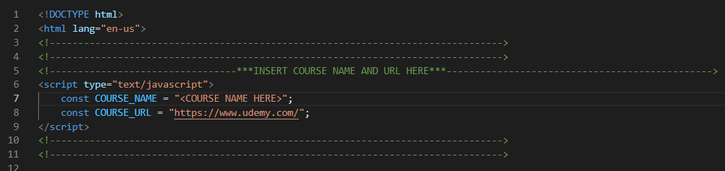**Step 6 (optional):** At the very top of the file is a <script> tag. Between the double quotes, replace type the course name and course URL. COURSE_NAME will change the text displayed in the browser tab and at the top of the notes to match the name of your course, and COURSE_URL will make it so that clicking on the course name at the top of your notes takes you to the specified URL (if left unchanged, it just links to the Udemy homepage by default).