Before we jump right in, I would start by asking some specific questions for easier understanding of the system.
- What language does the system use ?
- English
- How many transportations does the system include ?
- Only one and it is bus
- How many type of payment is applying for the machine ?
- There are two types: card and Momo(digital wallet)

So, first of all I will draw a Use Case modelling diagram, which will show use how to system response to every case, or in our specific situation. The customer will firstly chose 1 way of paying, then he/she get to one in two different path, but each will lead to chosing a destination. After select one, they will now officially pay and the ticket will be print out.
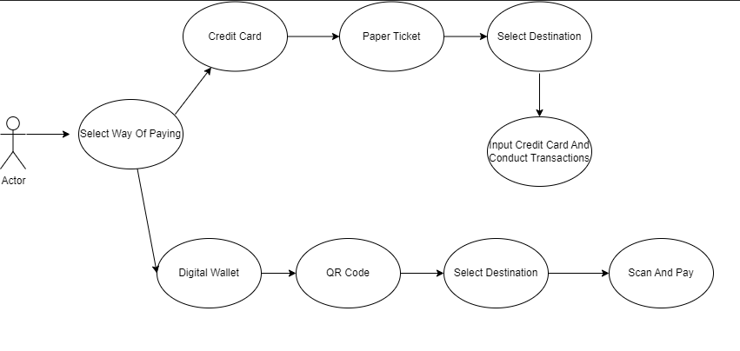
Next we draw Activity Diagram in order to show cleary what going inside the program. When the customer start, the machine will request he/she to chose the payment method, then they will input the desired information. After that, a table showing destination information will be asked. Then the customer chose and pay for the ticket. Now, the machine will send the money to the third party, it is either bank or whoever responsible for Momo. Then after the payment is valid, the ticket will be return to the customer and the program will come to and end with the “Thank You” dialog.
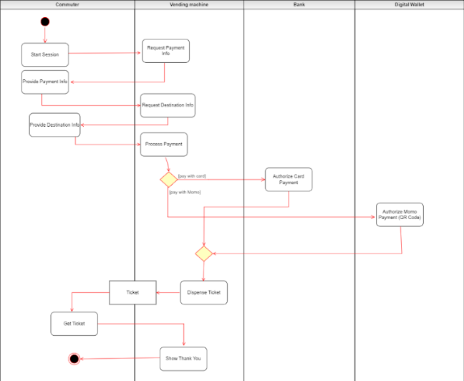
Lastly is sequence diagram, I do not know what to talk so let it here.
