Design Documentation

CSCD602: Advanced Software Engineering

Capstone Project Coursework — Group Capstone Project, Individual Submission

University of Ghana, Department of Computer Science
Group Name: Architects

Project Title: HealthEasy-G HMS
Student:
Ernest Nketia Asubonterng (Lead)

Student ID: 22424715

Software architecture, Ollama clinical assistant and GSTG rule engine, Next.js App Router, PostgreSQL and Prisma, HeFRA/GHS compliance, multi-facility management
Table of Contents
Group Members 4
Design Documentation 5
1. Design Principles 5
2. System Architecture 5
2.1 Architectural Style 5
2.3 Responsibility of Each Layer 7
2.4 Request Lifecycle 7
3. Technology Architecture 8
3.1 Deployment Topology 8
3.2 Technology Choices and Justification 8
4. Use-Case Model 10
4.1 Use-Case Diagram — Patient Administration and Clinical Care 10
4.2 Use-Case Diagram — Diagnostics, Pharmacy and Revenue 10
4.3 Use-Case Specification — Conduct Consultation 10
4.4 Use-Case Specification — Dispense Medicine 11
5. Class Design 12
5.1 Domain Model 12
5.2 Security Class Design 13
6. Sequence Diagrams 14
6.1 Staff Authentication 14
6.2 Consultation and Order Fan-Out 15
6.3 Dispensing with Atomic Stock Deduction 16
6.4 Access Denial — the DPC Rule in Action 17
7. Activity Diagrams 18
7.1 Out-Patient Journey End to End 18
7.2 Laboratory Order to Verified Result 19
8. Data Design 20
8.1 Entity-Relationship Diagram 20
8.2 Database Design Decisions 20
8.3 Data Dictionary — Selected Tables 21
Patient 21
PharmacyBatch 22
AuditLog 22
9. Component Design 23
9.1 Component Diagram 23
9.2 Component Responsibilities 23
10. User-Interface Design 24
10.1 Design Language 24
10.2 Screen Inventory 24
10.2 Responsive Behaviour 25
10.7 Accessibility 25
11. Design Rationale — Decisions Worth Defending 26

Group Members
# | Group Member | Student ID | Major Contribution
1 | Ernest Nketia Asubonterng (Lead) | 22424715 | Software architecture, Ollama clinical assistant and GSTG rule engine, Next.js App Router, PostgreSQL and Prisma, HeFRA/GHS compliance, multi-facility management
2 | Nana Kwabena Asare | 22424817 | Clinical EMR consultation and ICD-10 diagnosis engine
3 | Casper Kosi Asense | 22425080 | Master Patient Index, Ghana Card and NHIS validation
4 | Aubrey Owusu Amoah | 22424666 | PACS radiology orders and diagnostic workflows
5 | Thomas Nii Armah Okai | 22425782 | Pharmacy FEFO stock control and prescription dispensing
6 | Abubakari Zubeiru | 22425115 | Inpatient bed management and DPC audit-log compliance
7 | Frank Tandoh | 22425049 | Responsive layouts, design system and accessibility

Design Documentation
Project: HealthEasy — HealthEasy-G Hospital Management System Group: Architects Course: CSCD602 Advance Software Development, University of Ghana Document version: 1.0

1. Design Principles
Four principles governed every design decision. They are stated here because the rest of this document is best read as their consequence.
1. The server is the only authority. Anything the browser sends can be forged. Identity, role and every authorisation decision are therefore established server-side from a signed session cookie. Client-side guards exist only to give the user a useful message.
2. One boundary for each concern. Access policy is declared in exactly one file. Storage-to-presentation conversion happens in exactly one file. Date parsing and formatting happen in exactly one file. This is deliberate: a rule that exists in one place can be audited; a rule scattered across twenty-four route handlers cannot.
3. Fail closed. An endpoint with no declared policy is denied, not permitted. An unrecognised enum falls back to the safest value. A write that cannot complete is reported, never silently dropped.
4. Derive rather than store. Waiting time, stock status, licence expiry status and DHIMS2 attendance figures are computed from their underlying facts at read time. A stored copy is a copy that can disagree with reality.

2. System Architecture

2.1 Architectural Style
The system uses a layered architecture within a serverless deployment model. Next.js App Router provides both the presentation layer (React Server and Client Components) and the application layer (Route Handlers) in one deployable unit, with Prisma as the data-access layer over PostgreSQL.
A layered style was chosen over microservices because the domain is a single bounded context — one hospital’s operations — with heavily interconnected data. Splitting patient, clinical, pharmacy and billing into separate services would have introduced distributed transactions across boundaries that must be atomic (dispensing and stock deduction; claim batching and claim stamping), for no compensating benefit at this scale.2.2 Layered View
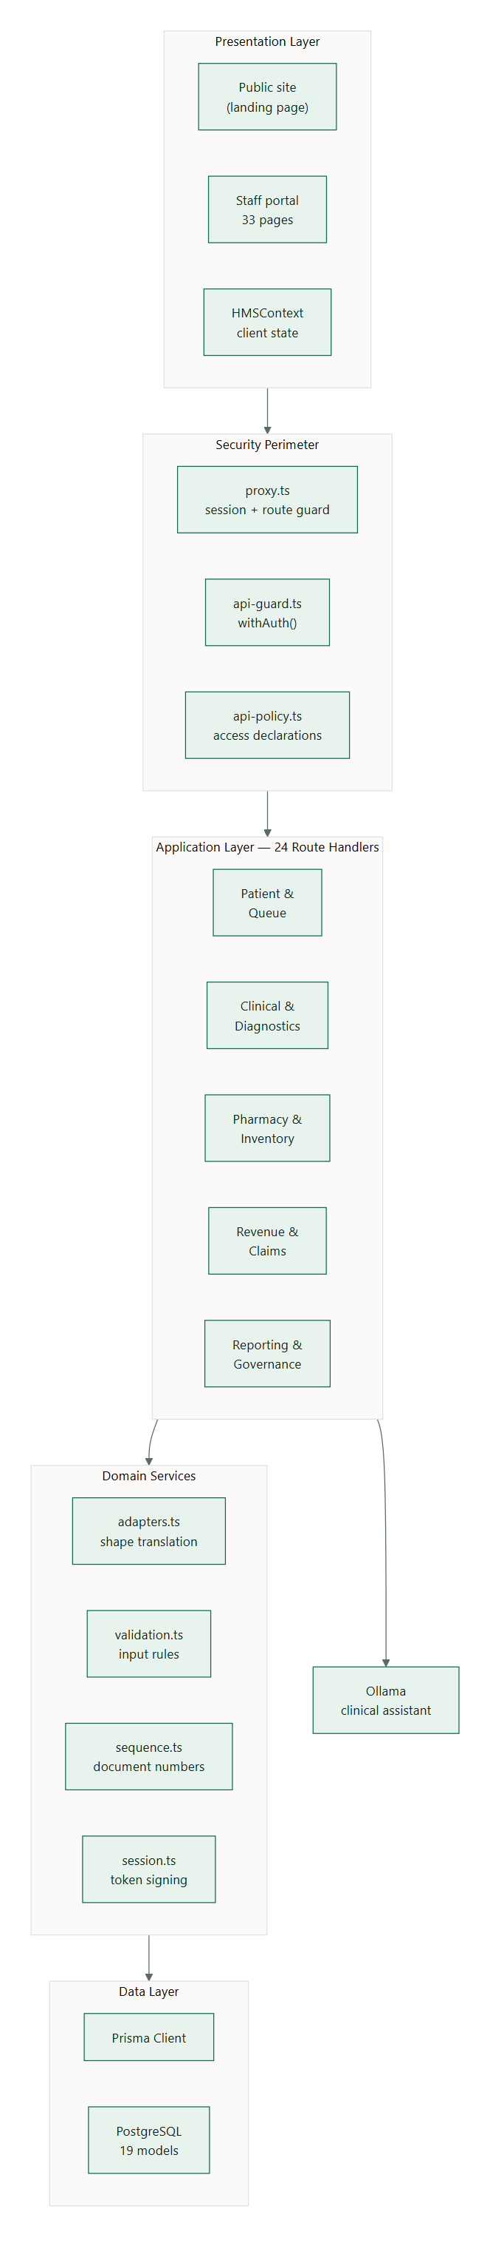

2.3 Responsibility of Each Layer
Layer | Responsibility | Must not
Presentation | Render state, collect input, explain outcomes | Make authorisation decisions of record
Security perimeter | Establish identity; permit or deny | Contain business logic
Application | Orchestrate a use case end to end | Bypass the perimeter
Domain services | Enforce invariants that outlive any one handler | Depend on HTTP
Data | Persist and retrieve | Contain policy

2.4 Request Lifecycle
Every request follows the same path. This is what makes the security model reviewable.
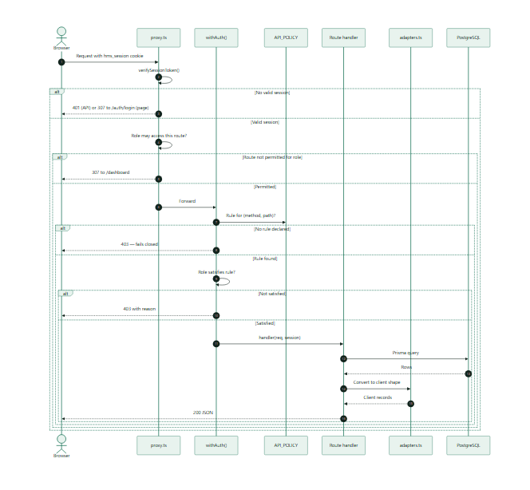

3. Technology Architecture

3.1 Deployment Topology
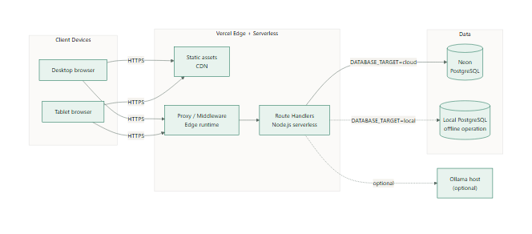

3.2 Technology Choices and Justification
Concern | Choice | Justification | Alternative rejected
Framework | Next.js 16 App Router | Server and client code in one deployable; server components keep data access off the client; native middleware for a security perimeter | Separate React SPA + Express API — two deployments, duplicated types, and a perimeter that must be re-implemented
Language | TypeScript (strict) | Compile-time detection of shape mismatches, which is precisely the class of defect that plagued the early codebase | JavaScript — the storage/presentation mismatch would have remained invisible
ORM | Prisma 5 | Generated types keep the schema and code in step; parameterised queries eliminate injection; first-class migrations | Raw SQL — faster but forfeits type safety and migration tracking
Database | PostgreSQL | Relational integrity, transactions, native date and enum types, JSON columns for genuinely variable structures (ICD lists, order arrays) | MongoDB — clinical data is highly relational; referential integrity would move into application code
Session | HMAC-SHA256 signed cookie via Web Crypto | Stateless, verifiable at the edge, no session store; identical code in Edge and Node runtimes | JWT library — an unnecessary dependency for one signing scheme; server-side sessions — needs a store, defeats edge verification
Passwords | bcrypt, 10 rounds | Deliberate slowness; well-understood; widely reviewed | Plain SHA — unusable for passwords
Styling | Tailwind CSS 4 | Utility classes keep style local to markup; dark mode by variant rather than a second stylesheet | CSS modules — more files, harder theme consistency
Clinical AI | Ollama + rule-engine fallback | No paid API; runs offline; the fallback is deterministic and auditable | Hosted LLM API — cost, and a hard dependency on connectivity
Testing | Node built-in test runner + tsx | Zero additional dependencies; runs the TypeScript sources directly | Jest — heavier configuration for no gain at this size
Hosting | Vercel | First-class Next.js support, preview deployments, required by the coursework | Self-hosted — no benefit for an assessed project

4. Use-Case Model

4.1 Use-Case Diagram — Patient Administration and Clinical Care
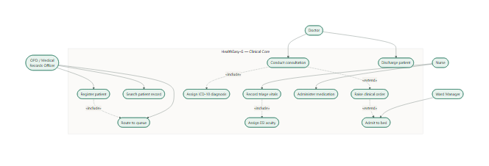

4.2 Use-Case Diagram — Diagnostics, Pharmacy and Revenue
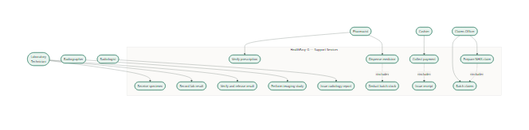

4.3 Use-Case Specification — Conduct Consultation
Field | Detail
Identifier | UC-06
Actor | Doctor
Goal | Record a clinical encounter and raise the orders arising from it
Preconditions | Doctor is authenticated; patient exists in the MPI; patient is in the doctor’s queue
Trigger | Doctor selects a patient from the consultation queue
Main flow | 1. System presents the patient’s demographics, allergies, chronic conditions, latest vitals and previous encounters.2. Doctor records presenting complaint, history, examination and plan.3. Doctor assigns one or more ICD-10 diagnoses.4. Doctor raises orders (laboratory, radiology, prescription, admission, procedure).5. Doctor signs the encounter.6. System persists the encounter attributed to the doctor’s session identity.7. For each order the system creates the departmental work item and a billing line.8. For an insured patient with covered items the system prepares an NHIS claim line.9. System advances the queue entry to Completed.
Alternative flows | 4a. Doctor requests decision support: system returns prescribing suggestions restricted to stocked medicines with allergy conflicts flagged.7a. A departmental work item fails to create: the encounter is retained and the specific failure is reported to the doctor.
Postconditions | Encounter is on the patient’s record; work items exist in the receiving departments; charges are raised
Requirements | FR-EMR-01 … FR-EMR-07, FR-AI-01 … FR-AI-06

4.4 Use-Case Specification — Dispense Medicine
Field | Detail
Identifier | UC-07
Actor | Pharmacist
Goal | Issue prescribed medicine and keep the stock ledger truthful
Preconditions | Pharmacist is authenticated and holds DISPENSE_MEDICINE; a prescription exists
Main flow | 1. Pharmacist selects the prescription.2. System presents stock in First-Expiry-First-Out order.3. Pharmacist selects a batch and quantity.4. System opens a transaction.5. System verifies the batch exists, holds sufficient quantity, and has not expired.6. System writes the dispense record attributed to the pharmacist.7. System decrements the batch conditionally on sufficient stock still being present.8. System commits.9. System writes an audit entry.
Exception flows | 5a. Batch unknown → 404, no change.5b. Insufficient stock → 409 stating quantity held and requested.5c. Batch expired → 409 stating the expiry date.7a. A concurrent dispense depleted the batch → the conditional update matches nothing, the transaction rolls back, and the pharmacist is asked to retry.
Postconditions | Either both the dispense record and the stock deduction exist, or neither does
Requirements | FR-PHM-03 … FR-PHM-06

5. Class Design

5.1 Domain Model
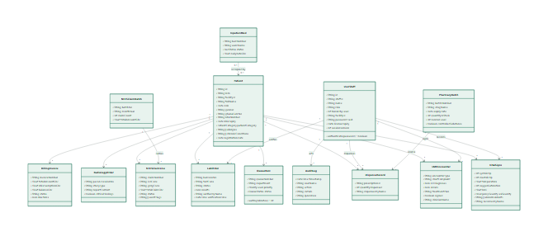

5.2 Security Class Design
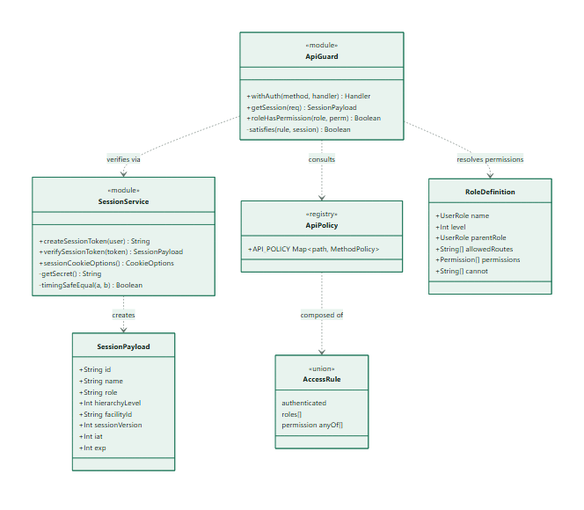

6. Sequence Diagrams

6.1 Staff Authentication
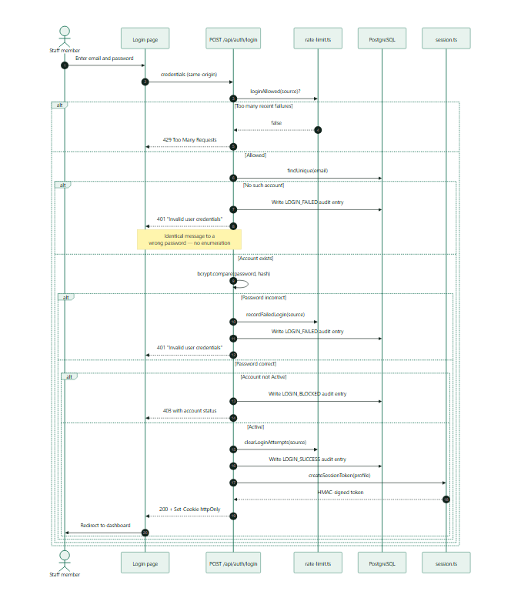

6.2 Consultation and Order Fan-Out
This is the sequence that makes the record “follow the patient”. One clinical action produces work items in three other departments.
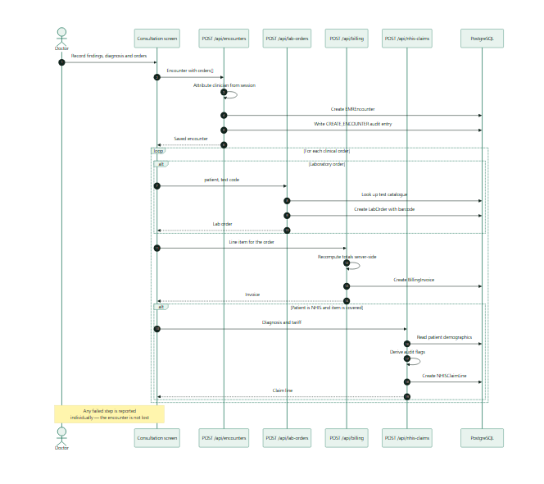

6.3 Dispensing with Atomic Stock Deduction
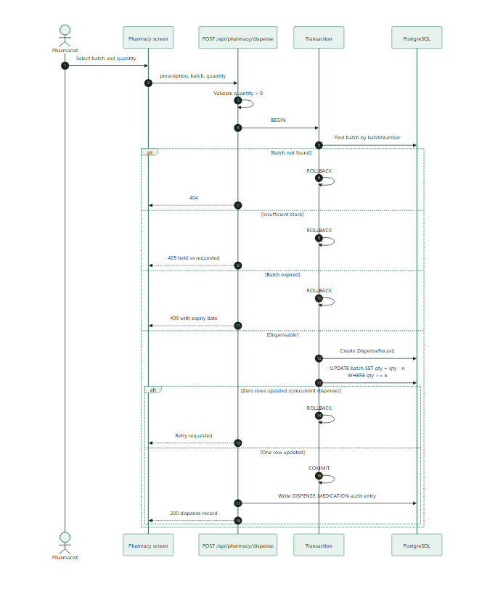

6.4 Access Denial — the DPC Rule in Action
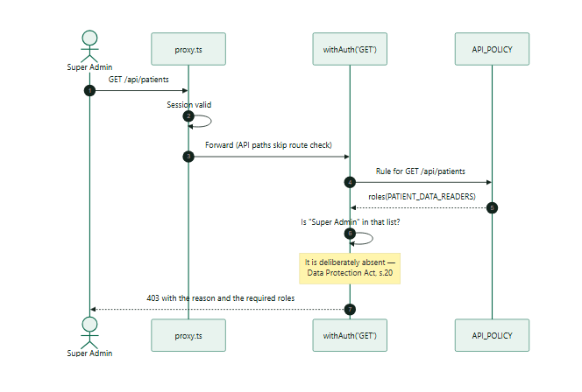

7. Activity Diagrams

7.1 Out-Patient Journey End to End
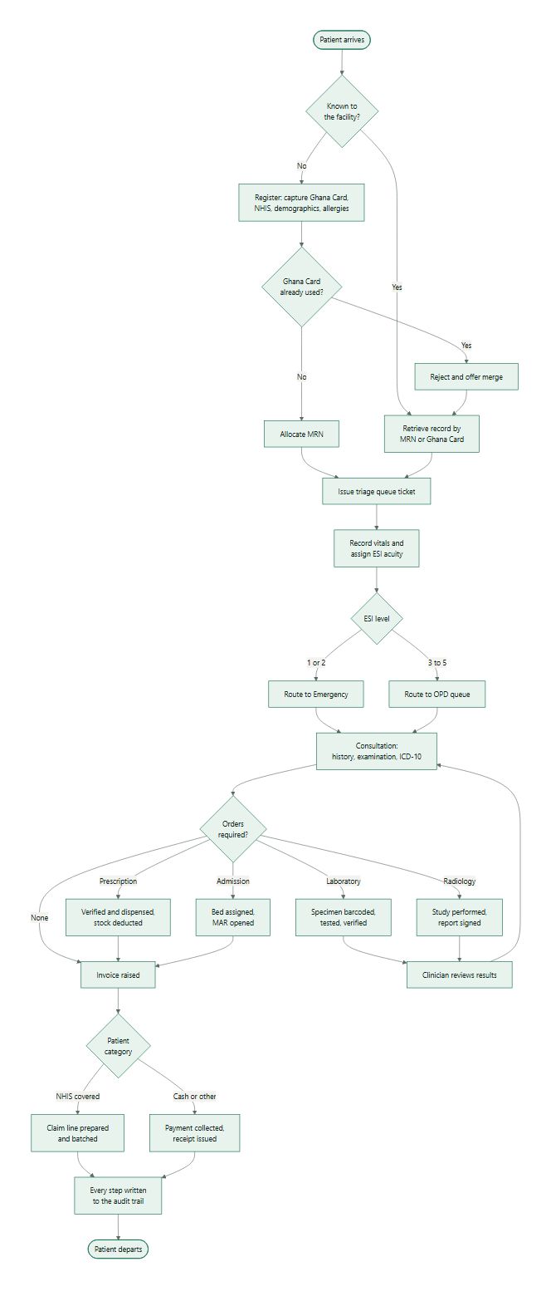

7.2 Laboratory Order to Verified Result
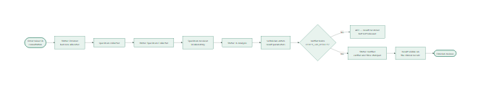7.3 NHIS Claim Lifecycle
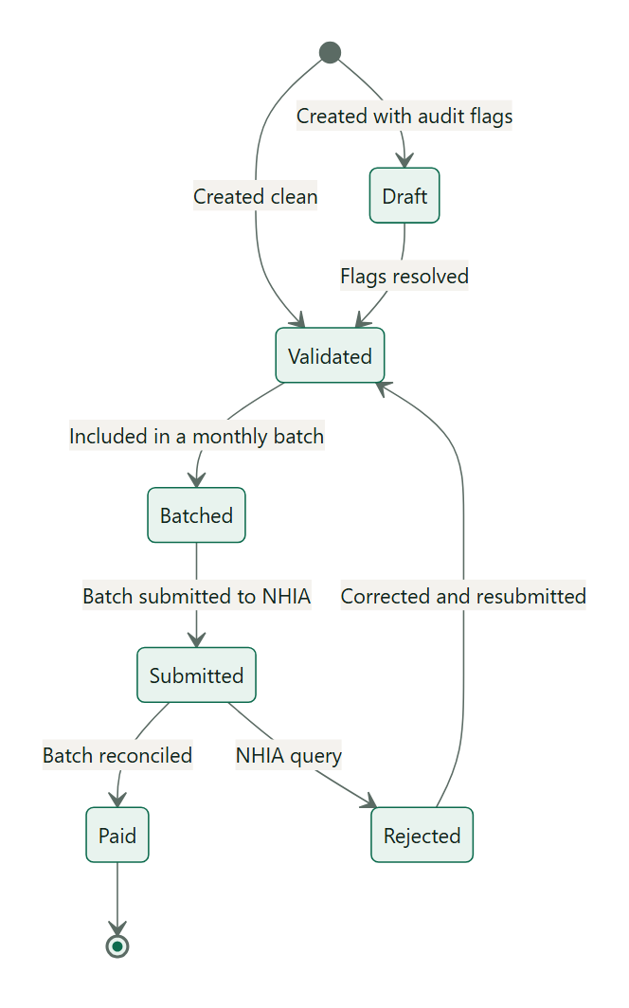

8. Data Design

8.1 Entity-Relationship Diagram
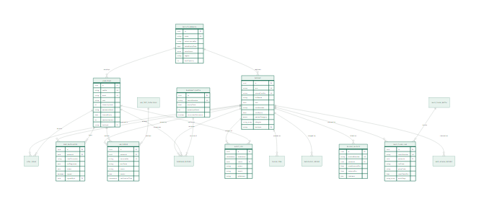

8.2 Database Design Decisions
Uniqueness as the integrity mechanism. ghanaCardNo, mrn, staffId, email, batchNumber, barcodeNo, invoiceNumber, claimNumber and pacsAccessionNo all carry unique constraints. Document numbers are allocated by generating a candidate and letting the unique index settle collisions, with retry — because two clerks registering simultaneously would otherwise produce the same number from a count() + 1.
Native date types. Every date is a PostgreSQL DATE or TIMESTAMP. Dates were initially stored as text, which made every comparison lexical: '2026-9-1' sorts after '2026-10-01', so an expiry check or a month filter silently returned the wrong rows. Migration 20260814000000_dates_and_session_security converts them in place.
Enumerations in the database. PatientCategory, QueueStatus, BedStatus, PriorityLevel, EmergencySeverity, LicenseStatus and LicensingBody are PostgreSQL enums, so an invalid value cannot be stored at all.
JSON where structure is genuinely variable. icdDiagnoses, orders, results and lineItems are JSON columns. Each is a list whose length and shape vary per record and which is always read as a whole. Normalising them would add four tables and four joins for no query benefit.
Cascade on patient deletion. Clinical children cascade from Patient. Audit entries do not — the trail must outlive the record it describes.
Derived, not stored. Stock status, waiting minutes, licence expiry status and DHIMS2 attendance are computed at read time. A stored status column drifts from the quantity and expiry it claims to describe.

8.3 Data Dictionary — Selected Tables

Patient
Column | Type | Constraint | Description
id | uuid | PK | Surrogate key
mrn | text | unique, not null | Medical Record Number, HG-YYYY-NNNN
facilityId | text | not null | Registering facility
fullName | text | not null | Legal name
dob | date | not null | Date of birth
gender | text | not null | Male / Female / Other
ghanaCardNo | text | unique, not null | National identity number — the duplicate-prevention key
nhisNumber | text | nullable | NHIS membership number
nhisStatus | text | nullable | Active / Expired / Pending Verification
nhisExpiry | date | nullable | Card expiry
patientCategory | enum | not null | CASH / NHIS / CORPORATE / PRIVATE_INSURANCE / EXEMPTED
allergies | text[] | not null | Known drug allergies
chronicConditions | text[] | not null | Ongoing conditions
bloodGroup | text | default O+ | ABO/Rh group
registrationDate | date | default today | First registration
consentSigned | boolean | default true | Data-processing consent

PharmacyBatch
Column | Type | Constraint | Description
batchNumber | text | unique, not null | Manufacturer batch identifier
drugName | text | not null | Generic (INN) name
brandName | text | default '' | Trade name
dosageForm | text | default Tablet | Tablet, capsule, injection, etc.
strength | text | default '' | e.g. 500mg
expiryDate | date | not null | Drives FEFO order and dispensing refusal
quantityInStock | integer | not null | Units held
reorderLevel | integer | default 50 | Low-stock threshold
controlledSubstance | boolean | default false | Restricted handling

AuditLog
Column | Type | Constraint | Description
timestamp | timestamp | default now | When
userId | uuid | FK, nullable | Actor; nullable so a failed sign-in by an unknown email can still be logged
userName | text | not null | Actor name at the time of the action
role | text | not null | Role held at the time
action | text | not null | e.g. DISPENSE_MEDICATION
patientId | uuid | FK, nullable | Subject, where applicable
details | text | not null | Human-readable description
ipAddress | text | default 127.0.0.1 | Source address

9. Component Design

9.1 Component Diagram
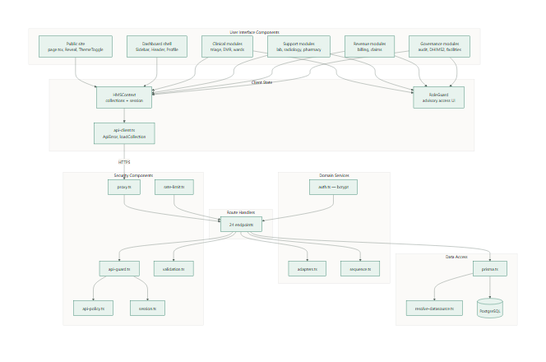

9.2 Component Responsibilities
Component | Responsibility | Depends on
proxy.ts | Reject unauthenticated traffic; enforce role route access | session.ts, rbac.ts
api-guard.ts | Wrap handlers; apply policy; convert thrown errors to responses | api-policy.ts, session.ts
api-policy.ts | Declare who may call each endpoint and method | rbac.ts
session.ts | Sign and verify session tokens; cookie options | Web Crypto
rate-limit.ts | Throttle repeated failed sign-in attempts | —
validation.ts | Type, length and range checks on request input | —
adapters.ts | Convert Prisma rows to client records and back | Prisma types, hms.ts
sequence.ts | Allocate collision-free document numbers | Prisma error codes
prisma.ts | Provide a single client bound to the resolved datasource | resolve-datasource.ts
resolve-datasource.ts | Choose local or cloud PostgreSQL | Environment
HMSContext | Hold loaded collections; expose actions; surface failures | api-client.ts
api-client.ts | HTTP with typed errors; treat 403 as an empty collection | —
RoleGuard | Explain denied access in the interface | HMSContext, rbac.ts

10. User-Interface Design

10.1 Design Language
Aspect | Decision
Default theme | Light, with a persisted dark option
Public site type | Newsreader (serif display) with Manrope (sans body) — an editorial voice that distinguishes the product from generic dashboard templates
Portal type | Manrope throughout, optimised for dense tabular reading
Brand colour | Deep clinical green #0d6b4e; a single accent rather than a multi-hue palette
Status colours | Amber for waiting, green for in-progress or complete, rose for critical, stone for neutral
Layout | Sidebar navigation with a sticky header; content on a 12-column responsive grid
Density | High on worklists, low on data-entry forms
Motion | Scroll reveals on the public site only; suppressed under prefers-reduced-motion

10.2 Screen Inventory
Screen | Route | Primary roles
Public landing | / | Anonymous
Sign in | /auth/login | All
Operational dashboard | /dashboard | All (content varies by role)
Patient registration | /patient-registration | OPD / Medical Records
Patient flow and queues | /patient-flow | Front desk, clinical, diagnostics
Triage | /triage | Nurse, Ward Manager
EMR consultation | /emr-consultation, /emr-consultation/[id] | Doctor
Emergency | /emergency | Doctor, Nurse, Ward Manager
Wards and beds | /wards-beds | Ward Manager, Nurse
Laboratory | /laboratory | Laboratory Technician
Radiology | /radiology | Radiographer, Radiologist
Pharmacy | /pharmacy | Pharmacist, Store Keeper
Billing and cashier | /billing-cashier | Cashier, Finance
NHIS claims | /nhis-claims | Claims Officer, Finance
Inventory and procurement | /inventory-procurement | Store Keeper, Procurement
Hospitals management | /hospitals-management | Super Admin, Director
Facility configuration | /facility-config | Super Admin, Hospital Admin, HR
DHIMS2 reports | /dhims2-reports | Director, Records, Auditor
Security audit | /security-audit | Auditor, Super Admin

10.2 Responsive Behaviour
Breakpoint | Layout
< 640 px | Single column; sidebar becomes a sheet; tables scroll horizontally within their container
640–1024 px | Two-column cards; sidebar collapsible
1024–1280 px | Three-column cards; sidebar persistent
> 1280 px | Full grid with a secondary information column

10.7 Accessibility
- Semantic elements (nav, header, main, dl, table) rather than generic containers.
- All interactive controls reachable and operable by keyboard.
- aria-label on icon-only controls; aria-expanded on disclosure controls.
- Error regions marked role="alert".
- Text contrast meets WCAG AA in both themes.
- Motion suppressed under prefers-reduced-motion.

11. Design Rationale — Decisions Worth Defending
Why route access is derived from allowedRoutes rather than duplicated. The role catalogue already declares which modules each role may open. The perimeter reads that same declaration, so the navigation a user sees and the routes they may load cannot disagree.
Why the policy table uses role lists for reads and permissions for writes. Reads define a data-protection boundary that a reviewer must be able to check at a glance — an explicit list of roles is auditable. Writes correspond to professional authority, which the permission catalogue already models.
Why 403 becomes an empty collection in the client. A cashier has no laboratory worklist. Treating that as an error would fill the interface with alarming messages about normal conditions. Genuine failures still propagate.
Why totals are recomputed on the server. An invoice header that disagrees with its line items is a billing dispute. The client is a convenience, not a source of truth.
Why the audit trail takes identity from the session. An audit trail that accepts an actor name from the request body records whatever the caller claims. It would be evidence of nothing.

