Consolidated Project Documentation
  - PulseTriage — Telehealth Appointment & Urgency Auto-Triage System
Ernest Nketia Asubonteng (22424715)
CSCD 602 Advanced Software Engineering · University of Ghana
Table of Contents

CONSOLIDATED PROJECT DOCUMENTATION
Field | Detail
Student | Ernest Nketia Asubonteng — 22424715
Course | CSCD 602 Advanced Software Engineering
Examiner | Prof. Solomon Mensah
Live application | https://pulsetriage.vercel.app
Repository | https://github.com/NketiaAsubontengErnest/pulsetriage
Companion documents. To keep this document within a readable length, four subjects are specified in depth elsewhere and are only summarised here. Nothing is duplicated between them.
Document | Holds the detail for
SRS.docx | The full requirement catalogue (§6 here summarises it)
Testing_Report.docx | Test cases and executed results (§11)
Technical_Debt_Plan.docx | Debt register and repayment plan (§12)
User_Manual.docx | Operating instructions for each role (§14)
Deployment_and_Source_Links.txt | URLs, credentials, walkthrough (§13)

1. Project Title
PulseTriage — A Telehealth Appointment and Urgency Auto-Triage System
A web application that assesses the clinical urgency of a patient's symptoms before an appointment is booked, so that an outpatient queue is ordered by clinical need rather than by who contacted the clinic first.

2. Problem Statement
In a conventional outpatient department, the order in which patients are seen is decided by the order in which they arrive or telephone. Clinical urgency plays no part until a clinician is physically in the room with the patient. Four consequences follow.
Urgency is invisible at the point of scheduling. A patient with exertional chest pain and a patient collecting a repeat certificate occupy identical positions in the queue. The clinic has no signal that would let it distinguish them, because no assessment has taken place.
The clinician starts the consultation uninformed. History-taking begins at the appointment. Time that could have been spent on examination is spent on questions the patient has already answered to a receptionist.
Telephone scheduling loses slots. Two callers can be promised the same slot because no shared, authoritative record of availability exists at the moment of the promise.
Prioritisation decisions leave no trace. When a patient asks why they waited, or a clinical governance review asks how a case was handled, there is no record of the reasoning.
The consequence is not merely inconvenience. A patient whose condition is deteriorating waits behind patients whose conditions are not, and nobody in the system knows.

2.1 Why Software Is an Appropriate Response
The decision "how urgent is this?" is rule-governed, repeatable and currently performed inconsistently by people under time pressure. That is a good fit for software: a deterministic rule engine applies the same standard to every patient and can explain its reasoning afterwards. Scheduling against a single authoritative record eliminates the double-booking that telephone scheduling cannot prevent.
What software must not do here is decide clinical outcomes. The system prioritises and schedules; the clinician diagnoses and treats.

3. Aim and Objectives

3.1 Aim
To design, build, test and deploy a working telehealth system that orders outpatient care by assessed clinical urgency, delivers the patient's case history to the clinician before the consultation, and records the basis of every prioritisation decision.

3.2 Objectives
# | Objective | Met by
O-1 | Elicit, analyse and prioritise requirements before writing code | §5, SRS.docx
O-2 | Produce a defensible effort estimate and let it govern scope | §7
O-3 | Design the architecture, data model and interfaces before implementation | §9
O-4 | Implement a deterministic, explainable triage engine | §10.2
O-5 | Guarantee that a red-flag presentation cannot result in a booking | §10.2, FR-2.6
O-6 | Bind scheduling to real clinician availability and make double-booking impossible | §10.3
O-7 | Deliver a working two-way video consultation | §10.4
O-8 | Test the system at unit, integration, system and acceptance levels | §11
O-9 | Identify technical debt honestly and plan its repayment | §12
O-10 | Deploy publicly and verify the running system | §13

4. Stakeholders

4.1 Stakeholder Register
Stakeholder | Interest | Influence | What they need from the system
Patient | Primary user | Low | To be seen in proportion to how unwell they are; to understand what is happening
Clinician | Primary user | High | A queue ordered by need; the case history before the consultation opens
Platform administrator | Operator | High | Control of who may practise on the platform; visibility of activity
Clinic management | Sponsor | High | Shorter waits for urgent cases without additional staff
Clinical governance | Assurance | High | Evidence of why each case was prioritised as it was
Data protection officer | Compliance | Medium | Confidence that personal health data is confined and auditable
Examiner | Assessor | High | Evidence of engineering method, not only a working artefact
Maintainer (future) | Successor | Low | A codebase and a debt register they can act on

4.2 Analysis
Two stakeholders shape the design most strongly and pull in opposite directions.
The patient is the least technically skilled user and the most likely to be anxious or unwell. They need the interface to be unambiguous and to fail safe. The clinician is time-pressured and needs density: as much clinical context as possible, as close to the consultation as possible.
Where the two conflict, the patient's clarity takes precedence, because the patient bears the risk of misunderstanding. This produced two concrete decisions: an EMERGENCY result removes the booking control entirely rather than merely warning, and the clinician's dense clinical panel is placed beside the consultation rather than in the patient's path.
Clinical governance is the stakeholder most often forgotten in a student project and is the reason the audit trail exists at all: a prioritisation decision that cannot be reconstructed cannot be defended.

5. Requirements Analysis

5.1 Elicitation Approach
With no live client available inside the examination window, requirements were derived from four substitute sources, in descending order of weight:
- Documented triage practice. The concept of a red-flag short-circuit — where certain findings bypass scoring entirely — is taken from established emergency-triage practice. The specific rule content here is illustrative and is not clinically validated; this is stated in the interface itself.
- Problem decomposition. Each consequence in §2 was traced to the requirement that addresses it (§5.2).
- Stakeholder role analysis. Each register entry in §4.1 was asked what it must be able to do, producing the user-class actions in the SRS.
- Regulatory context. The Ghana Data Protection Act and WCAG 2.1 AA supplied non-functional constraints.
The weakness of this approach is honestly stated: requirements derived without a real clinician carry the risk that the rule content is plausible rather than correct. This is recorded as a limitation (§17), not glossed over.

5.2 From Problem to Requirement
Problem (§2) | Requirement response | Key IDs
Urgency invisible at scheduling | Assess before booking; score and tier every case | FR-2.1 – FR-2.5
Dangerous presentations queued | Red flags short-circuit and suppress booking | FR-2.6, NFR-5, NFR-6
Clinician starts uninformed | Deliver the intake record to the clinician's workspace | FR-5.1 – FR-5.3
Slots double-booked | Bind slots to published hours; make duplication impossible | FR-3.1 – FR-3.6
No record of reasoning | Persist every assessment; append an audit row per action | FR-2.8, FR-8.5

5.3 Prioritisation (MoSCoW)
Requirements were prioritised against two questions: does patient safety depend on it? and is the system coherent without it? A "yes" to either makes it a Must.
Priority | Count | Treatment
Must | 45 | Delivered in this release
Should | 12 | Delivered where the schedule permitted
Could | 4 | First to be dropped
Won't | 8 | Explicitly out of scope; listed in SRS.docx §4.2
Two worked examples show the rule in use.
FR-2.6 (red-flag suppression) is a Must. A patient with a red flag who is offered a booking may wait at home instead of going to hospital. The failure mode is harm, so no other consideration outranks it.
FR-7.4 (showing agreement between AI models) is a Could. It improves a clinician's ability to judge a suggestion, but its absence changes nothing about safety or coherence — the clinician still reviews every suggestion before signing.

6. Software Requirements Specification (Summary)
The complete specification is SRS.docx. It is written as a pre-implementation document: it states what the system shall do, and deliberately contains no report of what was built or tested.
It defines 61 functional requirements across nine groups and 24 non-functional requirements across six categories, each with a stated verification method.
Group | Subject | Count
FR-1 | Account and access management | 10
FR-2 | Symptom triage and safety screening | 12
FR-3 | Clinician availability and scheduling | 10
FR-4 | Payment | 6
FR-5 | Clinical workflow | 6
FR-6 | Video consultation | 7
FR-7 | AI-assisted documentation and support | 6
FR-8 | Administration and governance | 7
FR-9 | Notification and enquiry | 4
NFR | Performance, safety, security, reliability, usability, maintainability | 24
Two requirements are singled out in the SRS as carrying disproportionate weight:
- FR-2.6 — the red-flag short-circuit. The only safety-critical requirement.
- FR-3.6 — exactly one appointment may result from concurrent attempts on a single slot, enforced by the database rather than by application logic.

7. Software Effort Estimation

7.1 Technique Selected, and Why
Use Case Points (UCP) was selected.
Technique | Why not chosen
COCOMO II | Calibrated on lines of code; no reliable size estimate exists before construction, and its industry productivity constants assume a team
Function Point Analysis | Strong for transaction-heavy data systems, but weakly expressive for interaction-heavy features such as a video consultation room
Story points | Relative, not absolute; requires a team velocity that a solo first-time project does not have
Expert judgement | No comparable prior project to anchor against
UCP was chosen because the requirements were already expressed as role-based interactions, because it accounts explicitly for technical and environmental factors — both unusual here — and because it yields absolute person-hours that can be compared against a fixed 48-hour budget.

7.2 Calculation
Unadjusted Actor Weight. Three human actors through a graphical interface (complex, weight 3); one external inference API (simple, weight 1).
UAW = (3 × 3) + (1 × 1) = 10
Unadjusted Use Case Weight. Twenty use cases classified by transaction count.
Class | Criterion | Count | Weight | Subtotal
Simple | ≤ 3 transactions | 10 | 5 | 50
Average | 4–7 transactions | 8 | 10 | 80
Complex | > 7 transactions | 2 | 15 | 30
 |  |  | UUCW | 160
UUCP = UAW + UUCW = 10 + 160 = 170
Technical Complexity Factor. Thirteen factors rated 0–5. Security (5), usability (5), performance (4) and concurrency (4) rated high; training needs (1) and reusability (2) low.
TFactor = 44 → TCF = 0.6 + (0.01 × 44) = 1.04
Environmental Complexity Factor. Eight factors. Requirement stability (4) and motivation (5) rated high; process familiarity (3) moderate, reflecting a first formal application of the method.
EFactor = 24 → ECF = 1.4 − (0.03 × 24) = 0.68
UCP = 170 × 1.04 × 0.68 = 120.2

7.3 Estimated Effort and Duration
Productivity factor | Basis | Person-hours | Person-days (8 h)
20 h/UCP | Karner's original industry figure | 2,404 | 301
15 h/UCP | Experienced team, familiar stack | 1,803 | 225
5 h/UCP | Aggressive: solo, no coordination, no formal QA | 601 | 75
Estimated duration at the industry figure: approximately 15 person-months.
Budget available: 48 hours.
The shortfall is a factor of 50. This is the single most important number in the project, and it is reported rather than concealed.

7.4 Assumptions and Constraints
Assumptions. One developer throughout; requirements stable once baselined; the technology stack is already familiar; no time for formal review cycles; AI pair-programming assistance is available.
Constraints. 48 hours fixed and non-negotiable; one person; no budget, so free tiers only; no payment provider; no clinical advisor; no second developer to review code.

7.5 How the Estimation Governed Scope
The estimate did not predict how long the work would take — it demonstrated that the full specification was unbuildable in the window. Its value was in forcing three decisions before any code was written.
Decision 1 — Build Must only, and say so. Everything below Must was moved to a later release and recorded in SRS.docx §4.2 as an explicit exclusion, so that absence reads as a decision rather than an oversight.
Decision 2 — Simulate where integration cost dominates. Payment settlement and message delivery are each small in logic and large in integration: merchant onboarding, gateway credentials, webhook handling, an SMS provider. Both were simulated behind interfaces shaped for the real thing. This bought roughly a day of the 48 hours and is logged as debt TD-11 and TD-12.
Decision 3 — Spend the saved time on safety, not on breadth. The hours released were spent on the red-flag short-circuit and its tests, and on making double-booking impossible at the database level. Both are places where a defect causes harm rather than annoyance.
Observed outcome. The delivered scope corresponds to an effective productivity of about 0.4 h/UCP, against the 20 h/UCP industry figure. That ratio is not a claim of fifty-fold personal productivity; it reflects AI-assisted implementation, a familiar stack, the absence of coordination overhead, and — most of all — the deliberate substitution of simulated components and documented debt for production hardening. The debt is the unpaid remainder of the estimate, and Technical_Debt_Plan.docx prices it.

8. System Analysis

8.1 Analysis of the Existing Process
Step today | Actor | Weakness
Patient telephones or attends | Patient | No assessment occurs
Receptionist offers next free slot | Receptionist | Ordered by arrival; availability held informally
Patient waits | Patient | Position unrelated to clinical need
Clinician takes history | Clinician | History-taking begins at the appointment
Notes filed | Clinician | Prioritisation reasoning not recorded

8.2 Analysis of the Proposed Process
Step | Actor | Improvement
Patient completes guided assessment | Patient / engine | Urgency established before scheduling
Engine screens red flags | Engine | Dangerous presentations diverted to emergency care
Slots generated from published hours | System | Availability authoritative; duplication impossible
Queue ordered by tier | System | Clinician sees the sickest patient first
Intake record shown in consultation | Clinician | Consultation opens informed
Every action appended to audit trail | System | Reasoning reconstructable

8.3 Feasibility
Dimension | Assessment
Technical | Feasible. No component requires unavailable technology; WebRTC removes the need for a media server
Economic | Feasible. Built entirely on free tiers; no licence cost
Operational | Partly feasible. Depends on clinicians maintaining their published hours (assumption A-3)
Legal | Conditional. Not deployable with real patient data until TD-01 and TD-03 are closed
Schedule | Feasible only for the reduced scope defined in §7.5
The legal row is the significant one and is stated plainly in the deployment notes: the demonstrator must not receive real personal or medical data.

9. System Design
Eight diagrams were produced. All are in Supporting_Files/images/, with editable Mermaid sources and mermaid.live links in Supporting_Files/diagrams/.
Five are reproduced below. Three supporting views — the class diagram, the component/deployment diagram and the data-flow diagram — are referenced rather than embedded, to keep this document within its page budget. No diagram is reproduced in any other document.

9.1 System Architecture
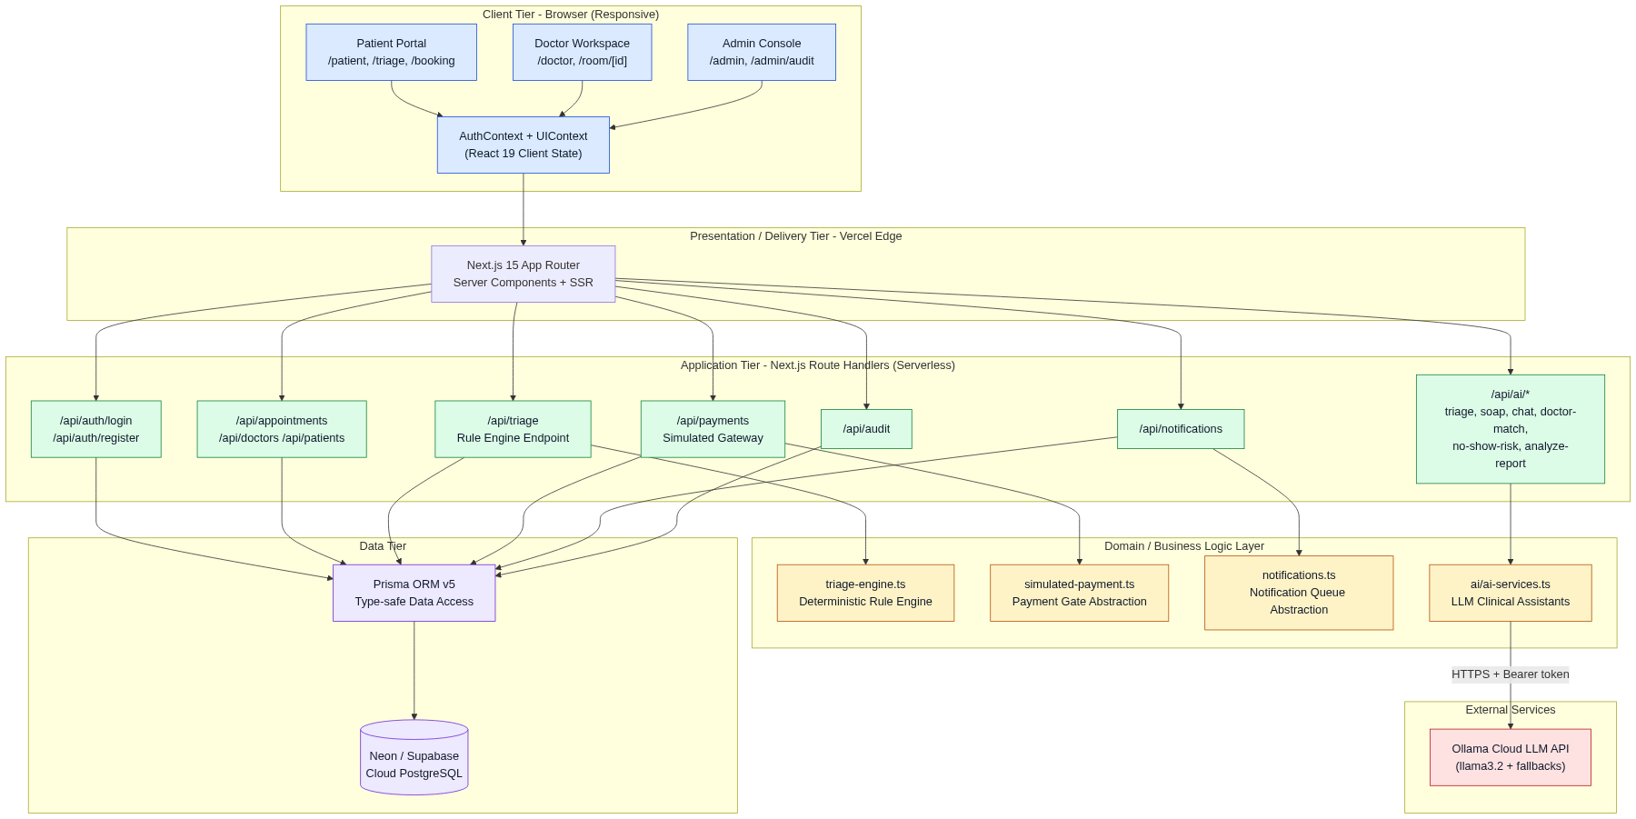
A three-tier arrangement inside one deployable unit. The browser holds presentation and the WebRTC peer connection; serverless route handlers hold application logic and are the only component that touches the database; managed PostgreSQL is the system of record.
Two design rules are visible in the diagram and matter more than the boxes:
- The rule engine has no outbound dependency. Triage is pure computation over rule data. It cannot fail because a network call failed (FR-2.12).
- Inference is on a side branch. The inference API touches only advisory features. No clinical or scheduling path passes through it (NFR-16).

9.2 Use Case Diagram
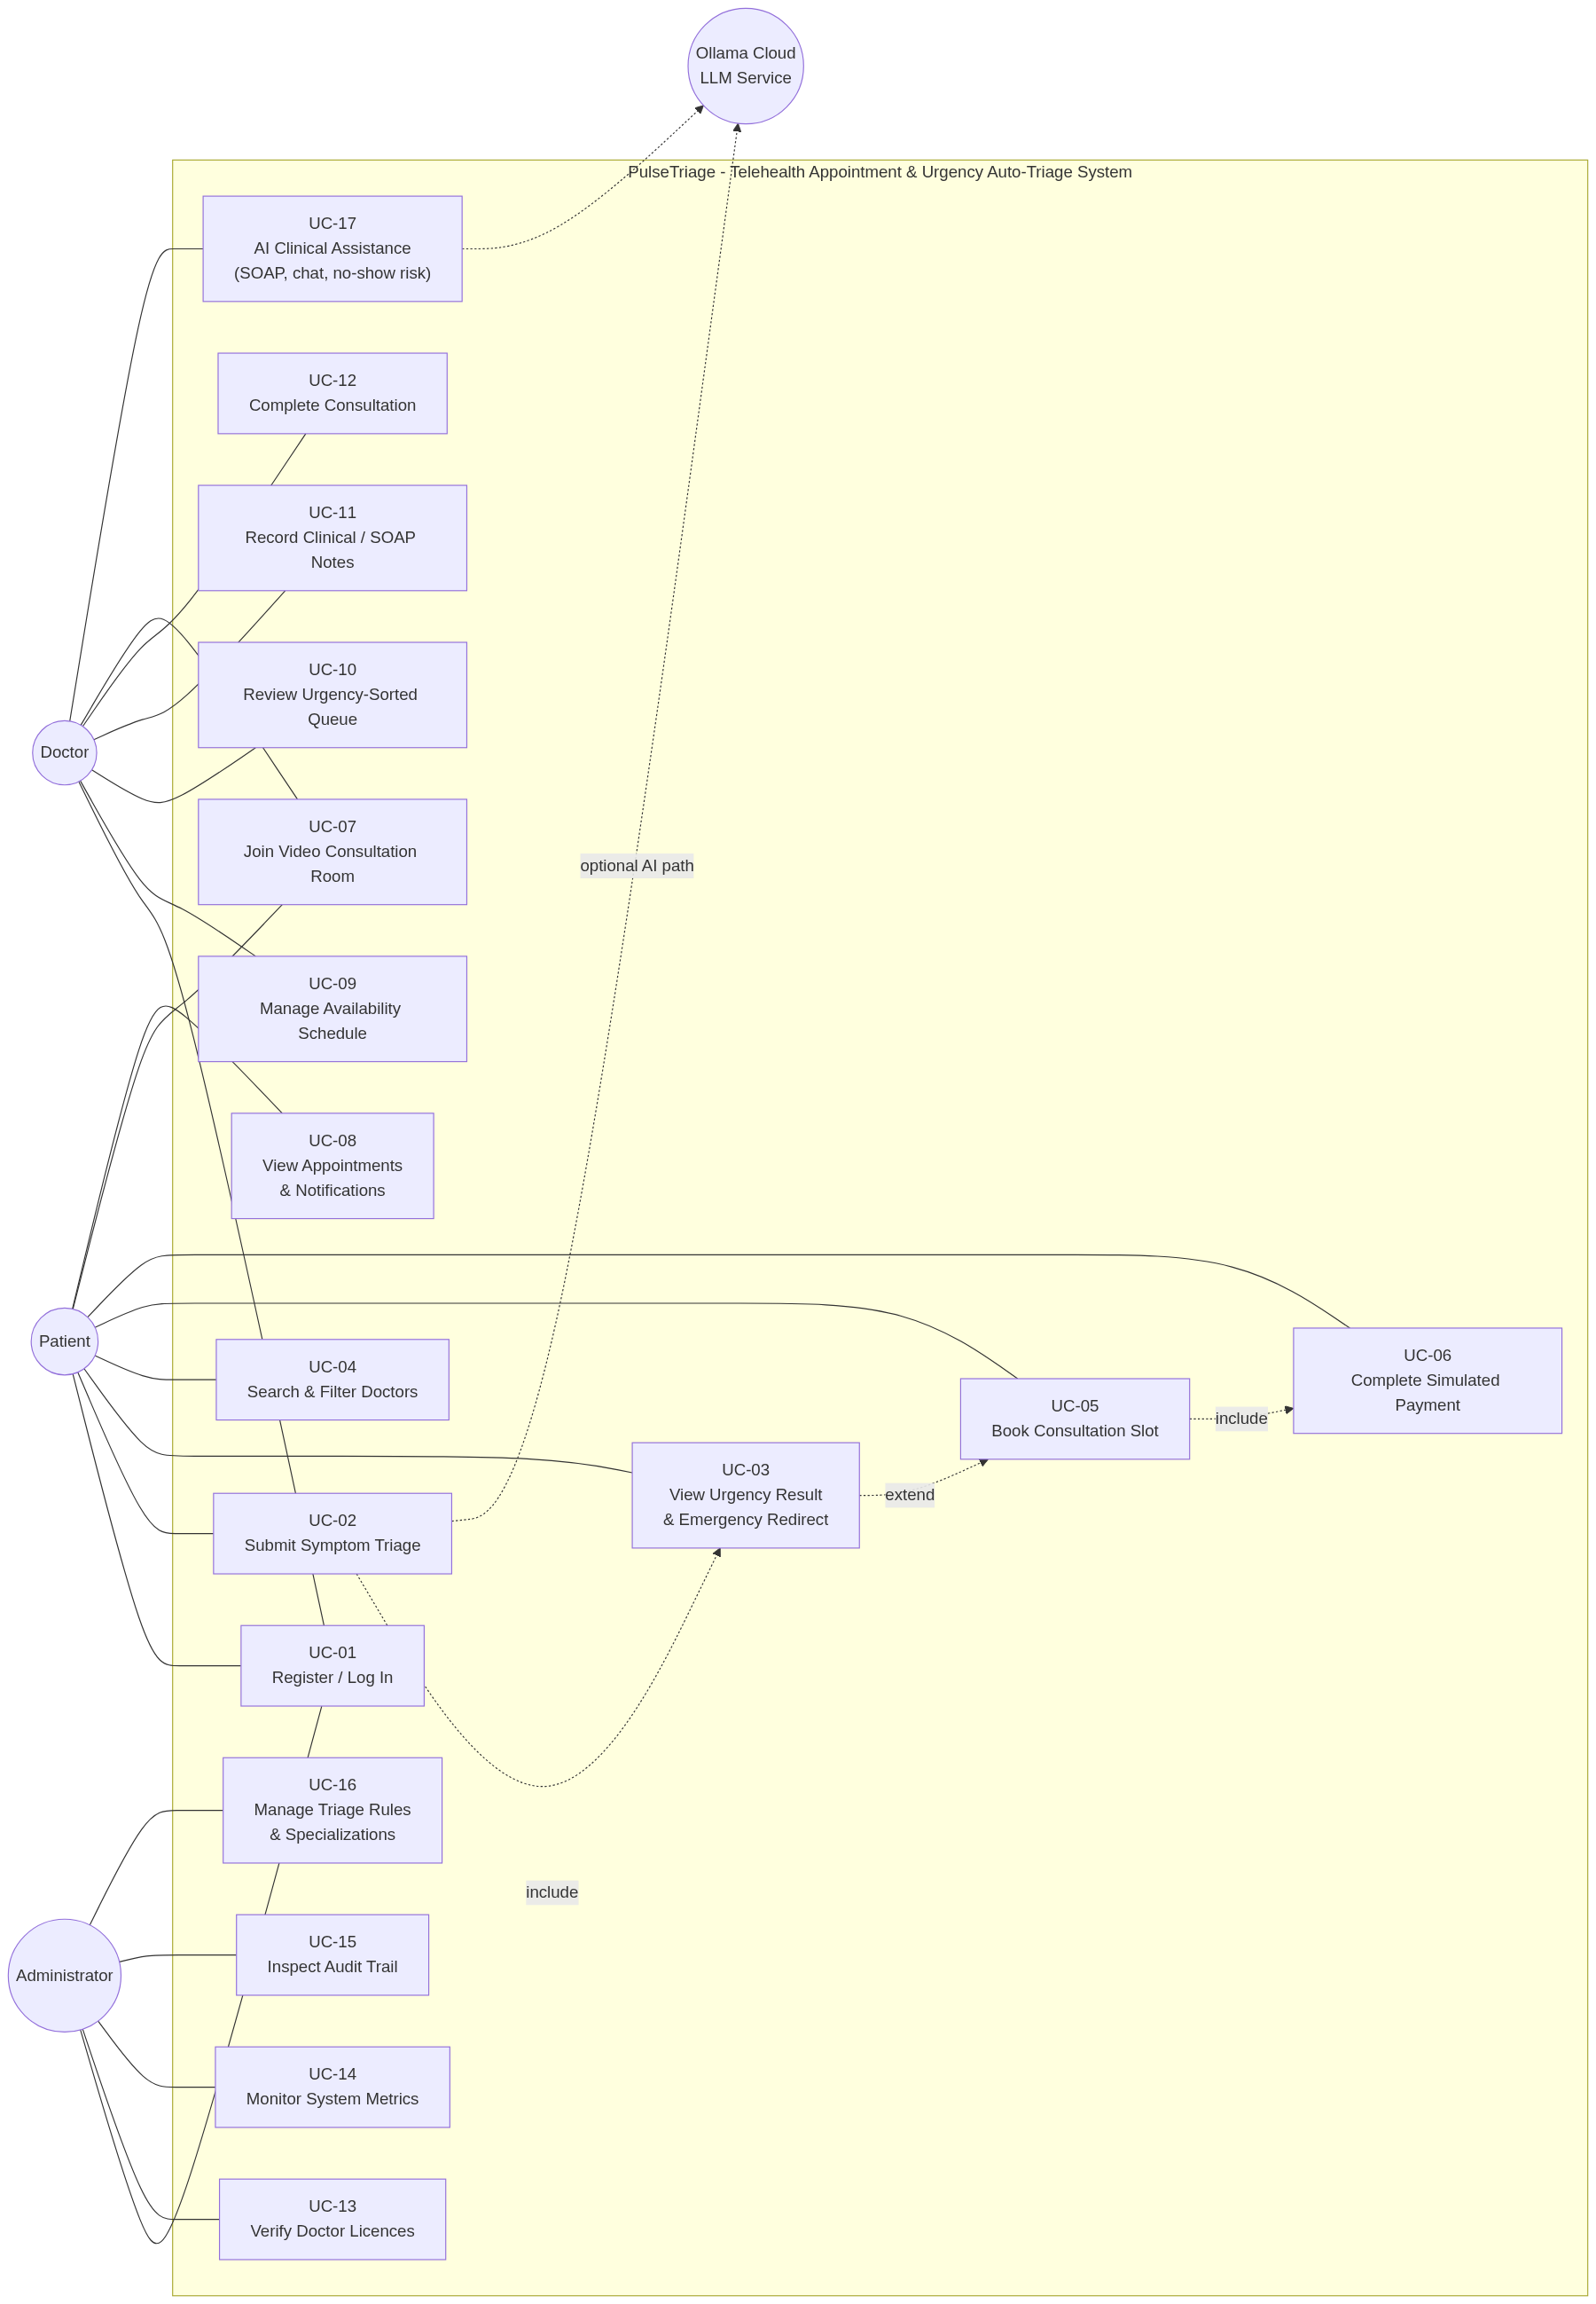
Three human actors and one system actor across the twenty use cases counted in §7.2. The «extend» from Submit Triage to Emergency Redirect is the diagrammatic form of FR-2.6: it is an alternative path that terminates the flow, not a decoration on the normal path.

9.3 Entity–Relationship Diagram
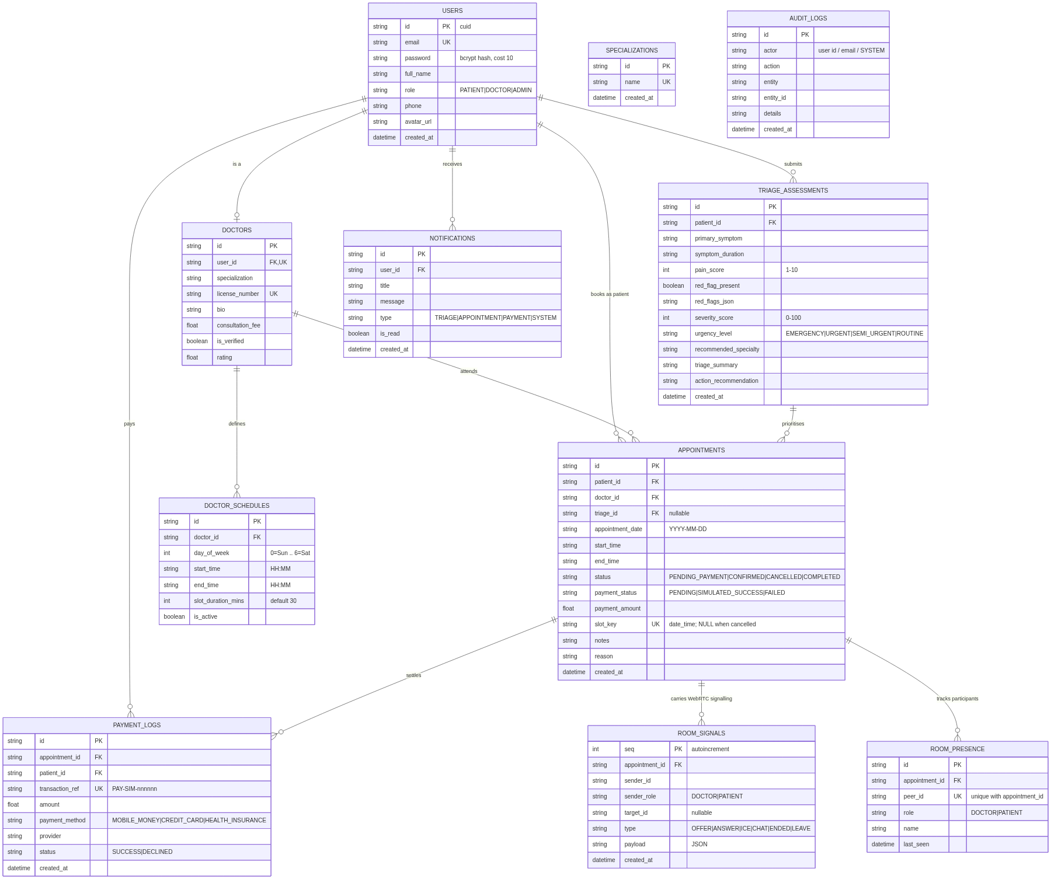
Eleven entities. Three features of the model deserve comment.
appointments.slot_key holds "<date>_<start_time>" while an appointment occupies a slot, and NULL once cancelled. A unique constraint on (doctor_id, slot_key) makes a duplicate booking impossible; because PostgreSQL permits many NULLs in a unique index, cancellation genuinely releases the slot. This is how FR-3.6 is met in the database rather than in application code.
room_signals and room_presence carry WebRTC offer/answer/ICE exchange and participant heartbeats. Using the database as the signalling channel removes the need for a websocket server that serverless hosting would not sustain.
audit_logs has no update or delete path in the application.

9.4 Class Diagram
See Supporting_Files/images/04-class-diagram.png.
Domain types, the rule engine and the service modules. The engine is a pure function of (TriageInput, DynamicTriageRule[]) → TriageResult, which is what makes FR-2.9 (identical output for identical input) testable without a database.

9.5 Sequence Diagram — Triage to Confirmed Booking
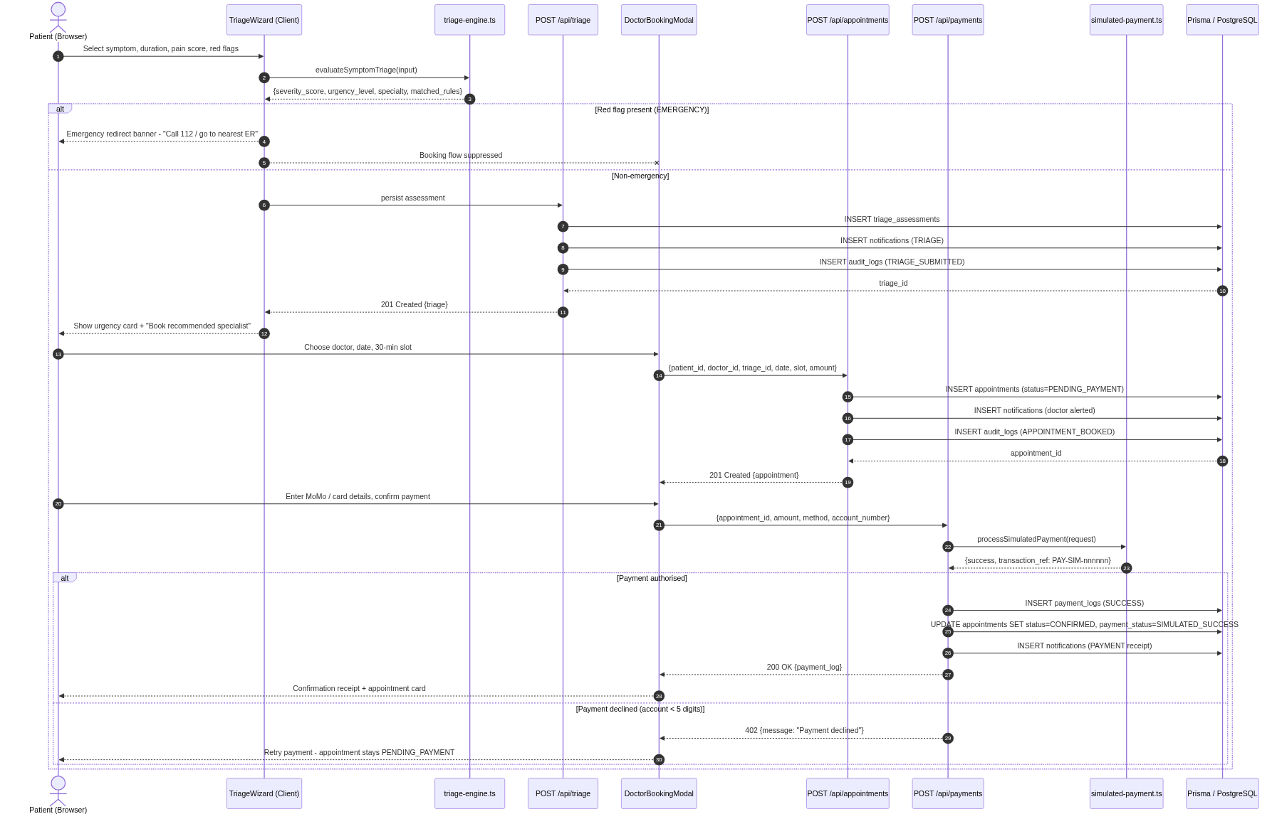
The primary path. The interaction worth tracing is the booking write: the server re-checks availability, then performs the insert inside a transaction that also writes the clinician's notification and the audit row. A failure at any point leaves none of the three.

9.6 Activity Diagram — Triage Evaluation
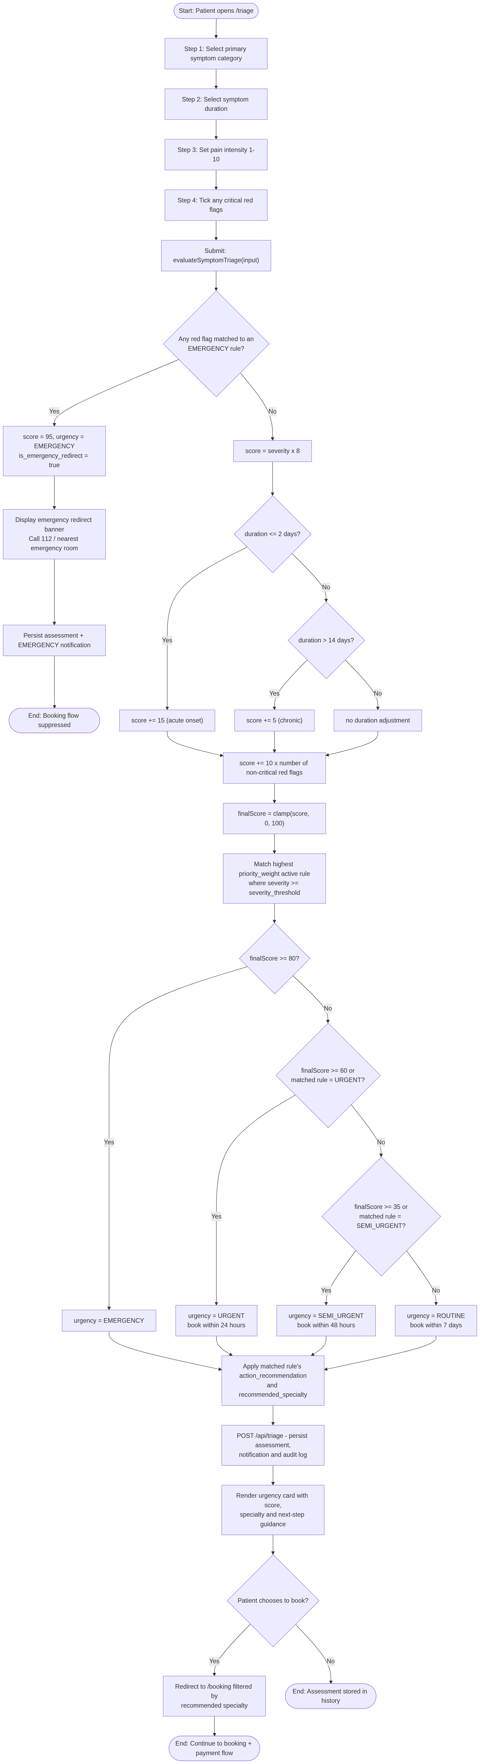
The decision structure of the engine, showing the red-flag branch terminating before the scoring path is reached.

9.7 Component and Deployment Diagram
See Supporting_Files/images/07-component-deployment.png.
Components and their deployment onto the serverless platform, the managed database and the browser.

9.8 Data-Flow Diagram (Level 1)
See Supporting_Files/images/08-dfd-level1.png.
Five processes and six data stores, showing where personal health information comes to rest — the basis of the data-protection assessment in §8.3.

9.9 Interface Design
No separate wireframes were produced. The interface was designed directly in code against a written design system, and the running application is the artefact. The system defines semantic colour tokens, a serif/sans type pairing, a 4/8-pixel spacing scale, and one focus treatment applied everywhere.
Three interface rules follow from requirements rather than taste:
Rule | Requirement
An EMERGENCY result presents no booking control anywhere on the view | FR-2.6
Colour never carries meaning alone; an icon or text accompanies it | UI-6
Every field has a visible label and its error message sits beside it | UI-4, UI-5

10. Implementation

10.1 Technology Stack and Justification
Layer | Choice | Why
Framework | Next.js 15 (App Router), React 19 | One project for interface and API; first-class serverless deployment
Language | TypeScript 5.7 | Compile-time checking substitutes for the code review a solo project lacks
Styling | Bootstrap 5.3 + a hand-written CSS layer | Accessible primitives out of the box; no build step to configure
ORM | Prisma 5.22 | Declarative schema, generated types, reproducible migration
Database | PostgreSQL (Neon) | Free managed tier; partial-unique-index behaviour needed for slot_key
Media | Native WebRTC | Peer-to-peer; no media server to run or pay for
Inference | Ollama Cloud | Multiple models behind one API; advisory use only
Hosting | Vercel | Zero-configuration deployment from the repository

10.2 Triage Engine
Rules are data, not branches. Each carries a condition, weight, priority and active flag, so a rule can be changed without touching evaluation logic (NFR-22).
Evaluation is ordered: critical red flags are tested first and terminate the computation at score 95 with tier EMERGENCY. Only if no critical flag is present does scoring proceed — severity × 8, plus an onset bonus, plus 10 per remaining red flag, capped at 100 — followed by banding at the fixed boundaries.
The engine is a pure function with no I/O, which is why its 22 unit tests need no database and run in under a second.

10.3 Scheduling and the Concurrency Guarantee
Bookable slots are generated from the clinician's published consulting hours by one shared module used by three callers: the clinician's availability manager, the patient's booking picker, and the server-side booking guard. Before this module existed, those three disagreed with one another.
The concurrency guarantee has two layers. The server re-checks availability and performs the insert inside a transaction; underneath, the unique constraint on (doctor_id, slot_key) makes a duplicate physically impossible. The first layer produces a friendly message; the second is what makes the guarantee true.

10.4 Consultation Room
Media is peer-to-peer WebRTC. Signalling — offer, answer, ICE candidates, chat — is exchanged by polling a database-backed room endpoint, which avoids a websocket server that the hosting model would not support.
Two implementation decisions came from defects found in testing. Camera and microphone are acquired independently, because requesting both together meant a camera already held by another application also cost the user their microphone. The remote participant's audio plays through a dedicated <audio> element rather than the video element, because browsers refuse to autoplay a video carrying sound — the earlier arrangement silenced the consultation to keep the picture.

10.5 Security Controls Implemented
Control | Implementation
Password storage | bcrypt, cost 10; never returned by any endpoint
Password policy | ≥ 8 characters with upper, lower, digit and symbol; enforced on client and server
Transport | HTTPS throughout
Input validation | Server-side validation on every write path
Secret management | Environment variables only; automated scanner plus a pre-commit hook
Data integrity | Multi-record writes wrapped in transactions
Least exposure | The consultation endpoint returns the patient brief only to the clinician's poll
Controls not implemented are listed in §17 and priced in Technical_Debt_Plan.docx. The most significant is that API routes do not verify the caller's identity server-side.

10.6 Scale of the Delivered System
Measure | Value
Application pages | 25
API route handlers | 26
React components | 15
Database entities | 11
Lines of TypeScript/TSX | ≈ 16,800
Automated tests | 44, all passing

11. Testing (Summary)
Full detail, including every test case with expected and actual results, is in Testing_Report.docx.
Level | Approach | Result
Unit | 44 automated tests over the rule engine, scheduling arithmetic and note composition | 44 / 44 pass
Static | tsc --noEmit across the codebase | 0 errors
Integration | API routes exercised against the live database | Pass
System | End-to-end journeys per role | Pass
Acceptance | Scenario walkthroughs against the acceptance criteria | Pass
Performance | 30,000-evaluation latency harness (NFR-1) | Within budget
Security | 9 probes against the deployment | 4 pass, 5 fail as expected
The five failing security probes are not surprises. They are the evidence for defects D-01 and D-05 — the absence of server-side authorisation — and they are reported as failures rather than adjusted away.

12. Technical Debt (Summary)
Full detail is in Technical_Debt_Plan.docx, which records each item as Debt → Cause → Impact → Priority → Proposed Resolution.
Classification | Count | Meaning
Critical — immediate attention | 3 | Blocks any real-patient deployment
Scheduled for resolution | 9 | Accepted now; dated for a named release
Acceptable temporarily | 5 | Proportionate to a demonstrator; revisit if scope grows
The three critical items are the absence of server-side authorisation (TD-01), credentials remaining in Git history (TD-02), and unsigned session state in browser storage (TD-03). Together they are why §8.3 records the legal feasibility as conditional.
Debt closed during the examination period is listed in Deployment_and_Source_Links.txt §7.

13. Deployment
The application is deployed on Vercel and builds automatically from the main branch. The database is managed PostgreSQL on Neon, reached over TLS with the connection string supplied as an environment variable.
Item | Value
Live application | https://pulsetriage.vercel.app
Administrator entry point | https://pulsetriage.vercel.app/admin
Repository | https://github.com/NketiaAsubontengErnest/pulsetriage
Credentials for every role, a suggested twelve-minute walkthrough, and instructions for reproducing the build locally are in Deployment_and_Source_Links.txt.
Deployment verification. After each deployment the following are checked: the application responds; authentication succeeds for each role; a triage evaluation returns the expected tier; a booking writes to the database; and GET /api/ai/health reports whether the inference layer is reachable. That last endpoint exists because the most likely production failure is a missing environment variable, and a diagnostic that says so is worth more than a generic error.

14. User Manual (Summary)
User_Manual.docx is the operating guide, written for readers who have not used the system before. It covers signing in, the patient journey from assessment to consultation notes, the clinician's queue and consultation workspace, administrative functions, and a troubleshooting section.
It is deliberately free of implementation detail: it explains what the reader sees and what to do next, not how the system works internally.

15. Maintenance Strategy

15.1 The Four Maintenance Types
Type | What it covers here | Trigger | Target response
Corrective | Defects in delivered behaviour | Report or monitoring | Safety-related: same day. Others: next release
Adaptive | Change in an external dependency — hosting, database, browser APIs, inference provider | Provider notice | Before the deprecation date
Perfective | Improvements to what already works: performance, usability, refactoring | Metrics or feedback | Scheduled into releases
Preventive | Work that stops future faults: dependency updates, debt repayment, test coverage | Monthly cycle | Continuous

15.2 Routine Activities
Cadence | Activity
Continuous | Automated tests and type check on every push
Weekly | Review audit trail and error logs for anomalies
Monthly | Dependency audit; patch security advisories
Quarterly | Review the debt register; re-prioritise; accessibility spot-check
Annually | Review the clinical rule content with a qualified advisor

15.3 Security and Dependency Maintenance
Security is treated as continuous rather than periodic. The secret scanner runs in the pre-commit hook, so a credential cannot be committed without deliberate override. Dependency advisories are reviewed monthly, and any advisory rated high or critical is patched out of cycle.
The annual clinical review in the table above is the most important recurring item and the easiest to neglect: rule content that is merely plausible ages badly, and nothing in the software will report that it has.

15.4 Scalability Path
The current arrangement — serverless functions, one managed database, WebRTC peer-to-peer media — scales horizontally on the application tier without change, because the application holds no server-side session state. The two limits that would be reached first are database connection exhaustion under serverless fan-out (addressed by connection pooling) and the polling-based signalling channel (addressed by moving to a managed real-time service). Neither is near at demonstration scale.

16. Future Evolution
Release | Theme | Contents
v1.1 | Make it safe to hold real data | Server-side authorisation on every route (TD-01); signed, expiring sessions (TD-03); credential rotation and Git history purge (TD-02); rate limiting on authentication and inference (TD-17)
v1.2 | Make it operationally real | Live payment provider; e-mail and SMS delivery; scheduled reminder dispatch; persisted administrator rule edits (TD-04)
v1.3 | Make it defensible | Independent WCAG 2.1 AA audit; clinical validation of rule content; comprehensive PHI read auditing (TD-08); decimal money type (TD-14)
v2.0 | Extend the clinical model | Multi-clinic tenancy; clinician-to-clinician referral; outcome analytics comparing assigned tier against clinical outcome
The v1.3 outcome analytics deserve emphasis. The system currently assumes its tiers are correct. Measuring assigned tier against actual outcome is the only way to discover whether the triage model is right, and until that exists every claim about its accuracy is unevidenced.
A full technical-debt repayment schedule, mapping each item to one of these releases, is in Technical_Debt_Plan.docx §3.

17. Limitations
Stated plainly, because a limitation concealed is a defect waiting to be found by someone else.
Clinical. The rule content is illustrative and has not been reviewed by a qualified clinician. It demonstrates a mechanism, not a validated instrument. The interface says so; this document says so; it should not be inferred otherwise.
Security. API routes do not verify the caller's identity server-side. Role separation is enforced in the browser only, which means a determined caller can reach data belonging to another user. The deployment must therefore not receive real personal or medical data. This is the single most serious limitation.
Functional. Payments are simulated. Notifications are in-application only. Administrator rule edits do not reach the patient-facing engine. Reminders are written at booking rather than dispatched at the reminder time.
Quality assurance. There is no automated end-to-end browser test suite; system and acceptance testing were performed manually. Accessibility has been designed for and measured for contrast, but not audited with assistive technology. There is no load testing beyond the rule-engine harness.
Process. One developer, no code review, no independent tester. Requirements were derived without a real user. The 48-hour constraint means every judgement in this document was made once, quickly, and not revisited by anyone else.

18. Conclusion
PulseTriage delivers a working telehealth system that assesses clinical urgency before scheduling, guarantees that a red-flag presentation cannot produce a booking, binds appointments to real clinician availability with a database-level guarantee against duplication, and carries a two-way video consultation with the patient's record beside it. Forty-four automated tests pass, the system is deployed publicly, and every action it takes is recorded.
The engineering claim worth making is not that the system is complete — it is not, and §17 says where. It is that the incompleteness is known, priced and scheduled. The effort estimate showed at the outset that the full specification was fifty times larger than the available budget. Scope was cut deliberately rather than by attrition, the substitutions were made behind interfaces shaped for their replacements, and what was traded away was written down as debt with a resolution and a release attached.
The most valuable output of the exercise is therefore not the running application. It is the demonstration that a project can be delivered under a severe constraint without pretending the constraint had no cost.

19. References
- IEEE Std 830-1998, Recommended Practice for Software Requirements Specifications. IEEE, 1998.
- Karner, G. Resource Estimation for Objectory Projects. Objective Systems SF AB, 1993.
- Boehm, B. et al. Software Cost Estimation with COCOMO II. Prentice Hall, 2000.
- Cunningham, W. "The WyCash Portfolio Management System." OOPSLA '92 Experience Report, 1992.
- Kruchten, P., Nord, R. and Ozkaya, I. Managing Technical Debt: Reducing Friction in Software Development. Addison-Wesley, 2019.
- Sommerville, I. Software Engineering, 10th edn. Pearson, 2015.
- Pressman, R. and Maxim, B. Software Engineering: A Practitioner's Approach, 9th edn. McGraw-Hill, 2020.
- W3C. Web Content Accessibility Guidelines (WCAG) 2.1. W3C Recommendation, 2018.
- OWASP Foundation. OWASP Top 10: 2021. https://owasp.org/Top10/
- Manchester Triage Group. Emergency Triage, 3rd edn. BMJ Books, 2014.
- Republic of Ghana. Data Protection Act, 2012 (Act 843).
- Fowler, M. Refactoring: Improving the Design of Existing Code, 2nd edn. Addison-Wesley, 2018.
- Newman, S. Building Microservices, 2nd edn. O'Reilly, 2021.
- Nielsen, J. Usability Engineering. Morgan Kaufmann, 1993.

End of Consolidated Project Documentation.

