Github link

<https://github.com/NkhensileMthombeni/IMAD5112_Assignment-1/upload>

Youtube link

<https://youtu.be/_03eHrRcGWk?si=Cs9_ZRg5A2RFFzcL>

[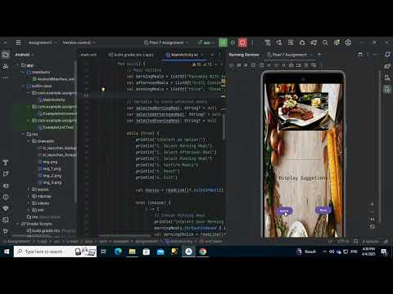](https://youtu.be/_03eHrRcGWk?si=Cs9_ZRg5A2RFFzcL)