**Talent-Taggers API**

Tools required – Postman, or any tool to make API requests.

URL: http://localhost/

**Step1**: Authentication.

Request-type – POST

1. Go to “Headers” tab of the request, select “Content-Type” as “KEY” and “application/Json” as the “VALUE”.

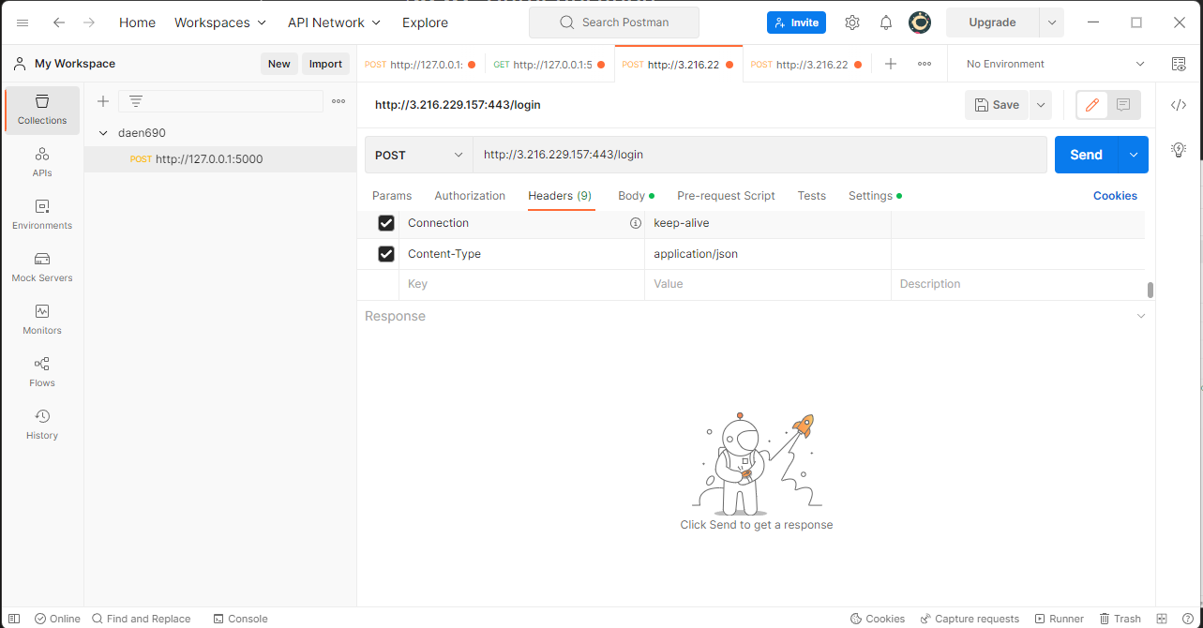

1. Go to the “Body” tab of the request and select “raw” and paste the below text in the text field.

{

"username":"test",

"password":"test"

}

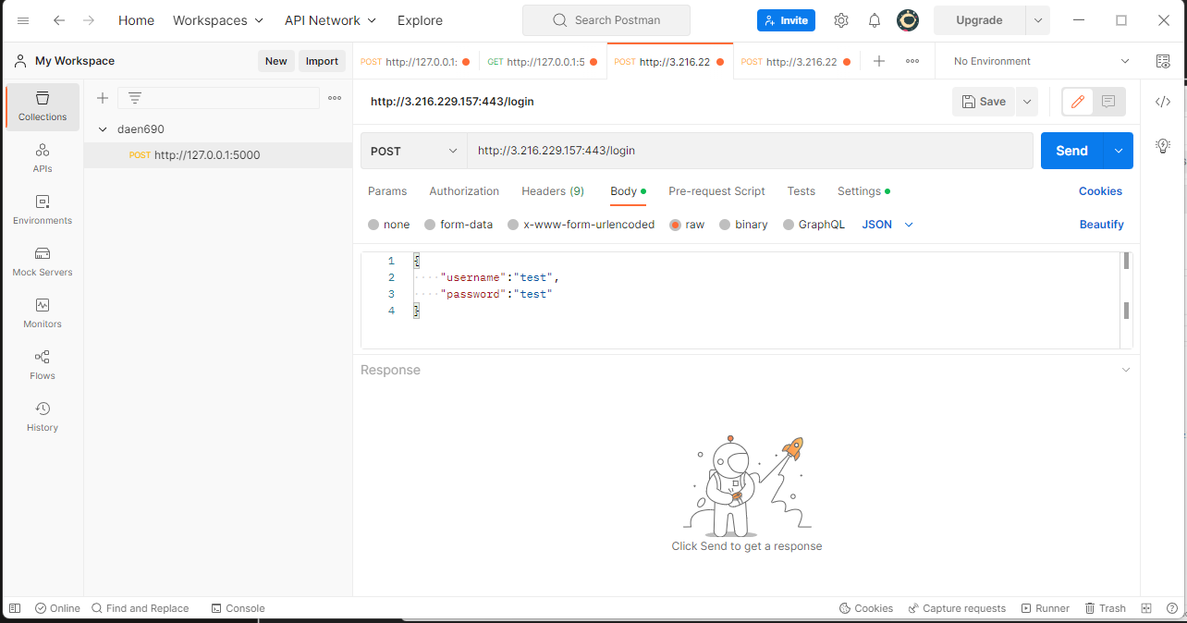

Click on “Send” button and API will return with an “access_token”, this token can now be used to make request to the API. Save the “access_token” for the next step.

**Step2**: Make request.

Request-type – POST

1. Go to Authorization tab of the request and select Type as “Bearer Token” and paste the “access_token” in the “Token” field.

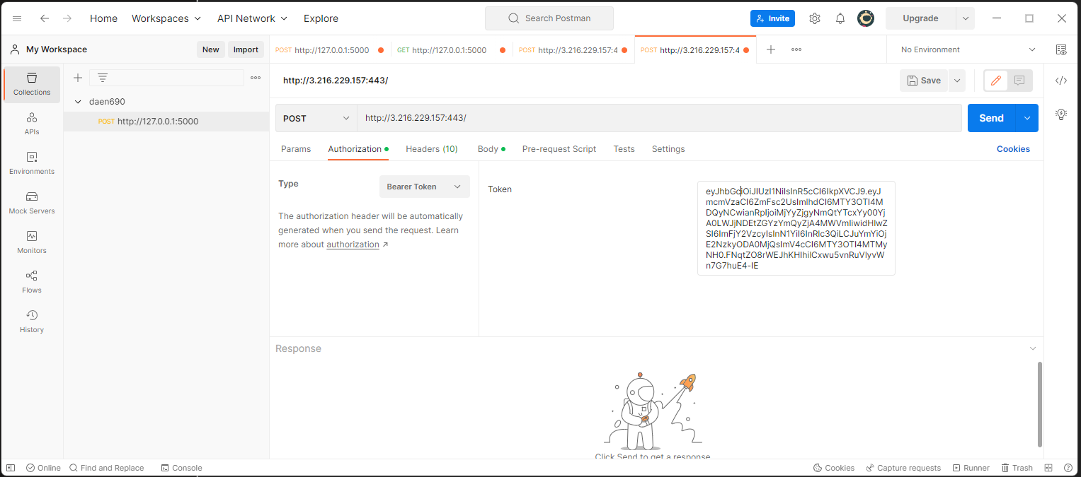

1. Now in the “Body” tab of the request select “form-data” and set “KEY” as “resume” and the field type for “KEY” should be file. For the “VALUE” select resume file in pdf or docx file from your computer.

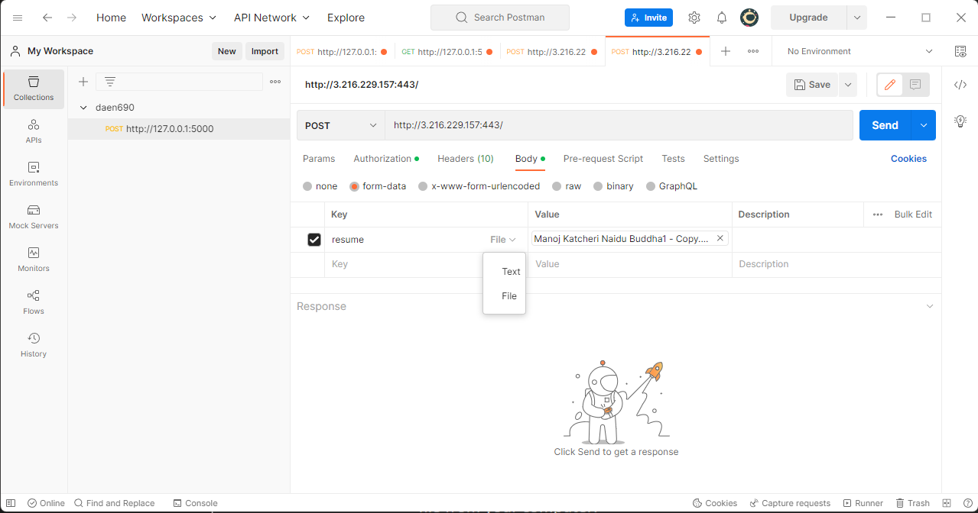

1. Now click the send button. API will respond with all the extracted skills from the resume in JSON (Java Specified Object Notation) format. The keys in the JSON response are skills and the value is number of times the skill is repeated in a resume.

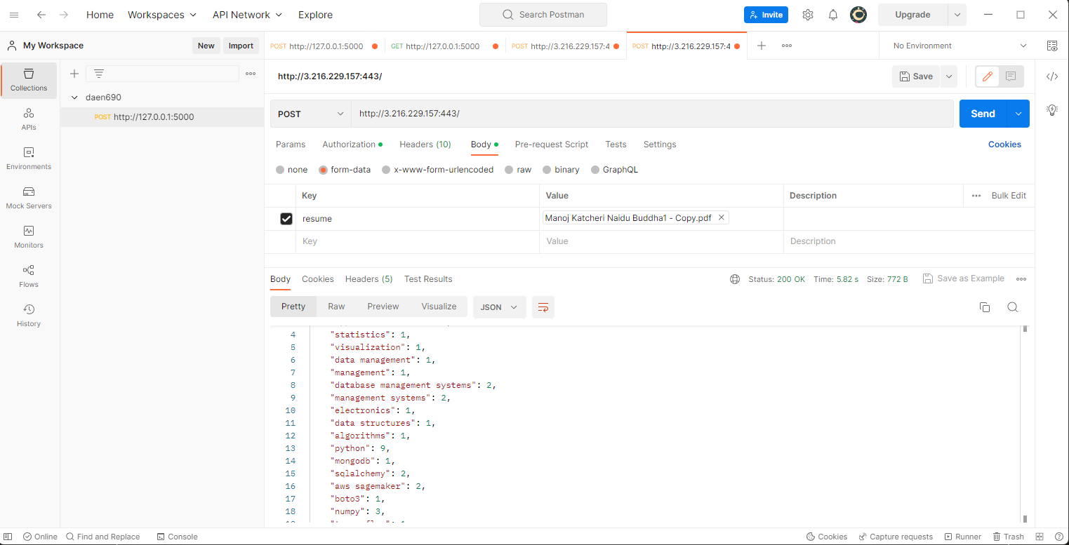

Facing any issues in accessing the API? Please contact us via email – [mbuddha@gmu.edu](mailto:mbuddha@gmu.edu).