ST10444685
Siyabonga Nkomazana
INSY7213
Information Systems 2C
Assignment 2

Question 1
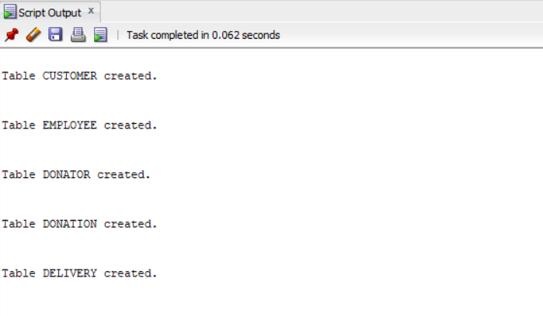

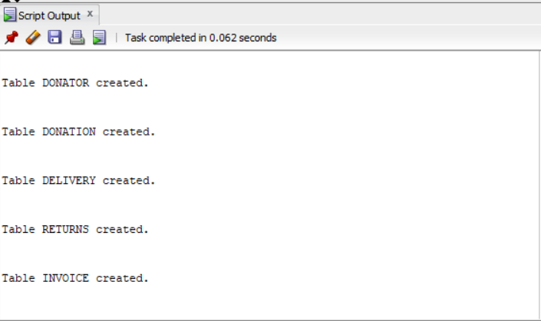
Question 2
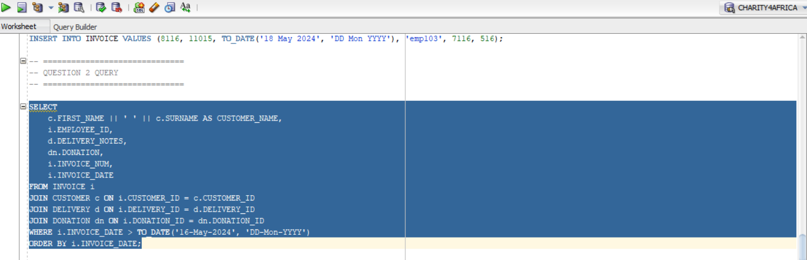
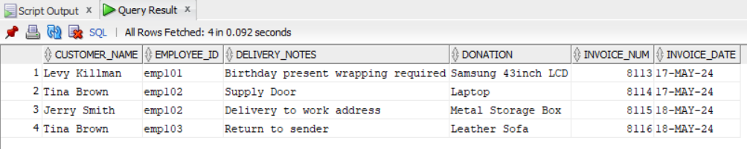
Question 3

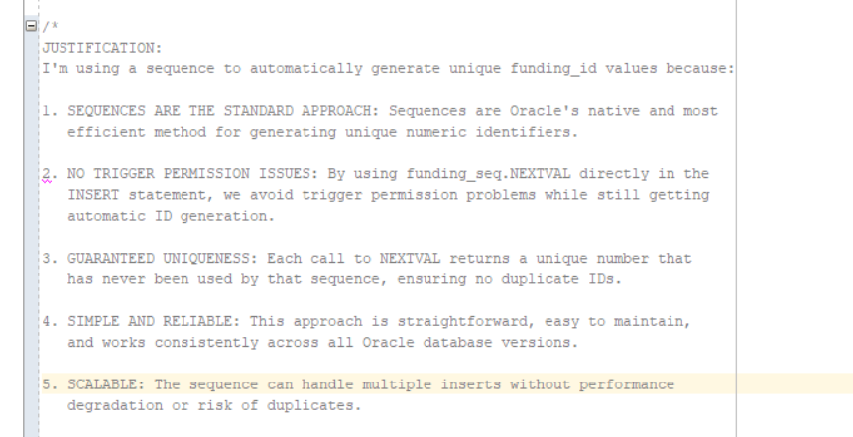
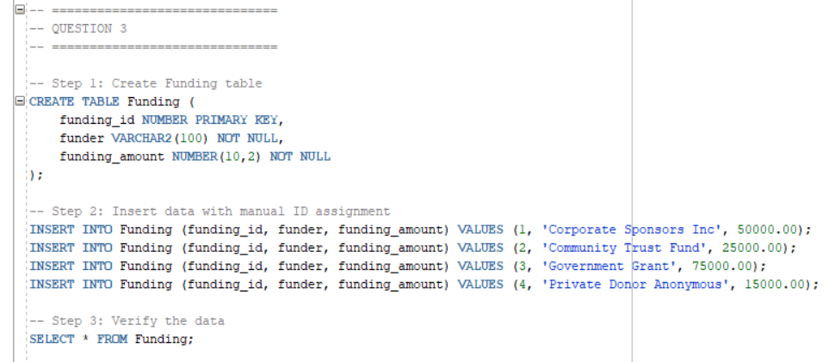
Question 4
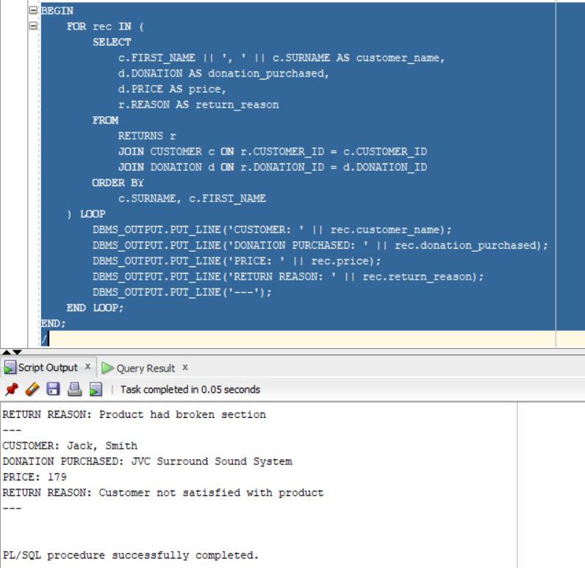
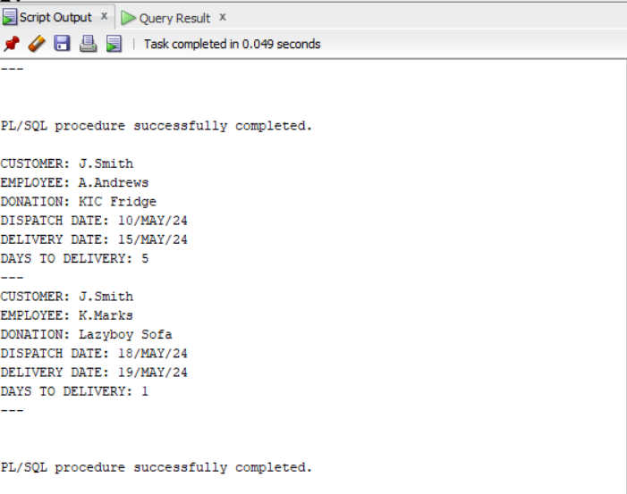
Question 5

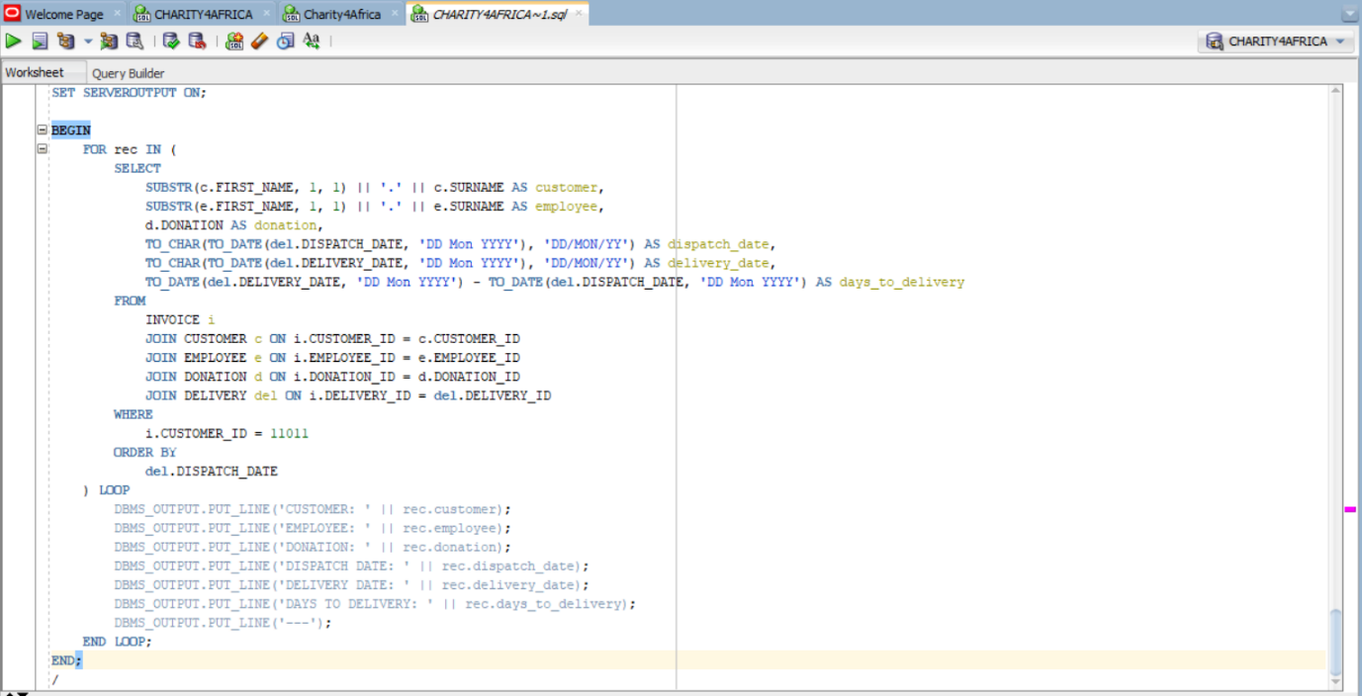

Question 6
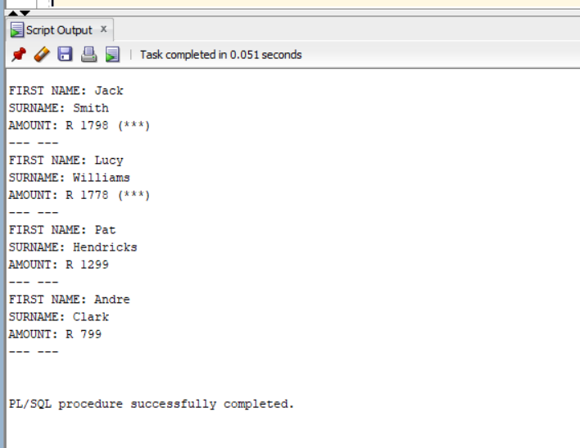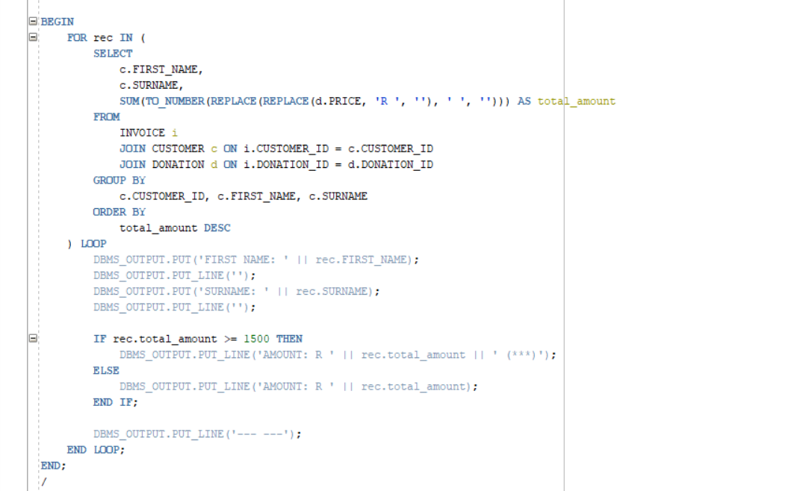

Question 7
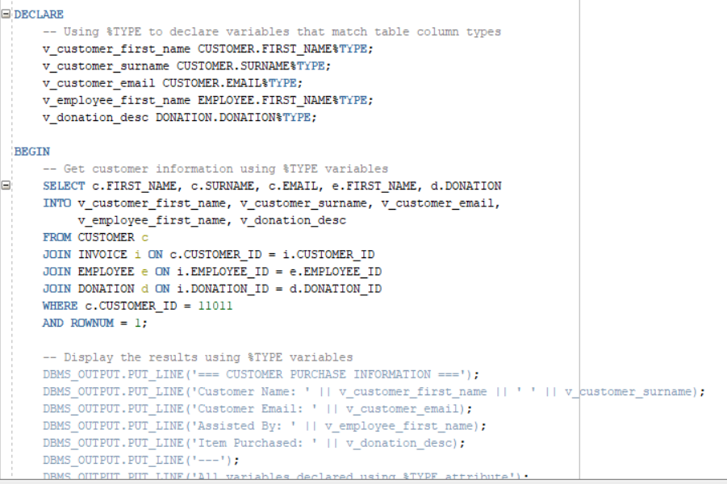
7.1

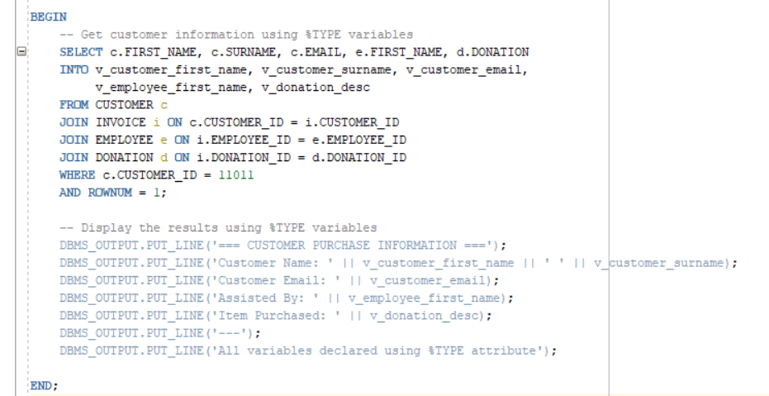

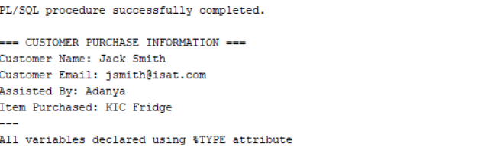
7.2
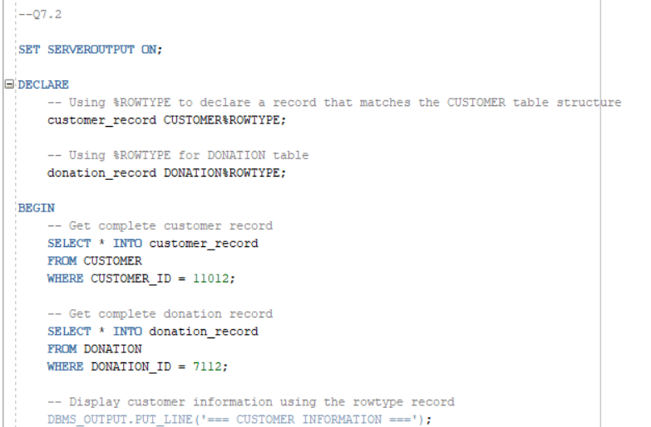

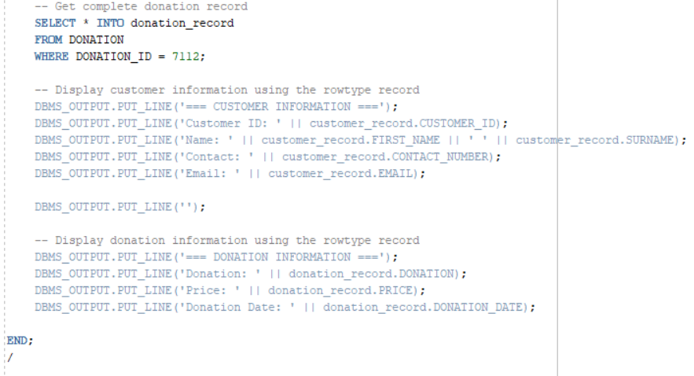
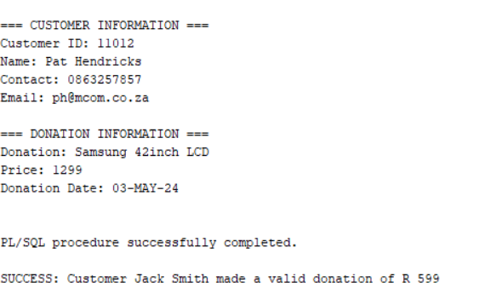
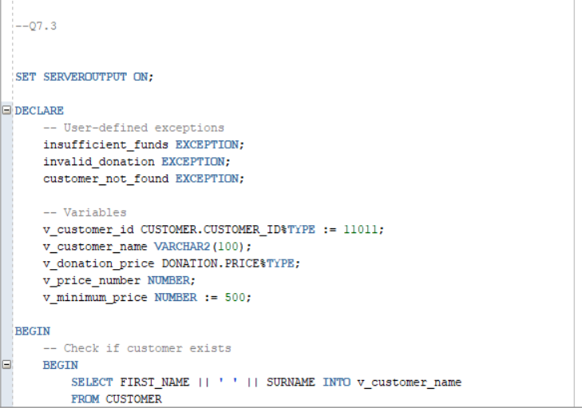
7.3

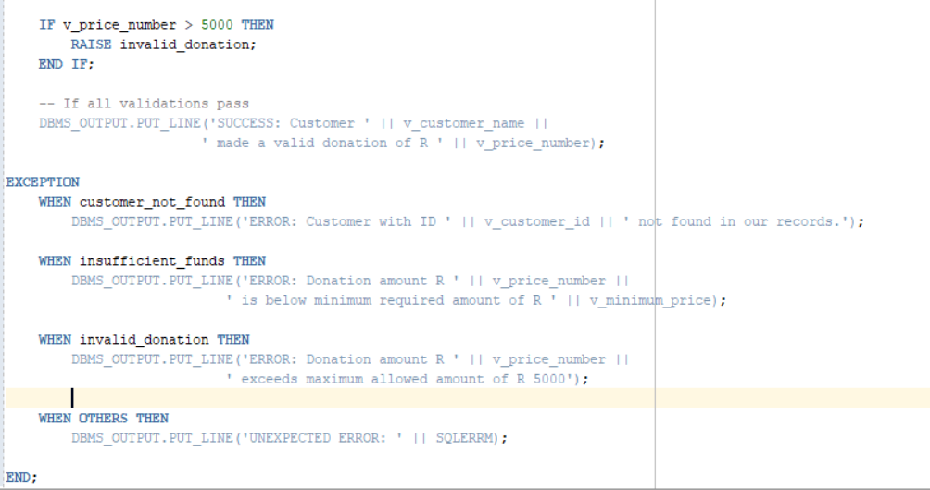
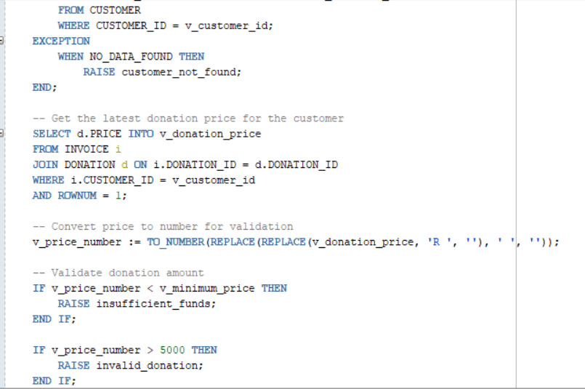
Question 8

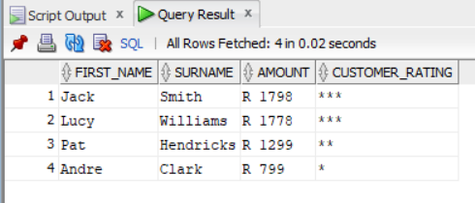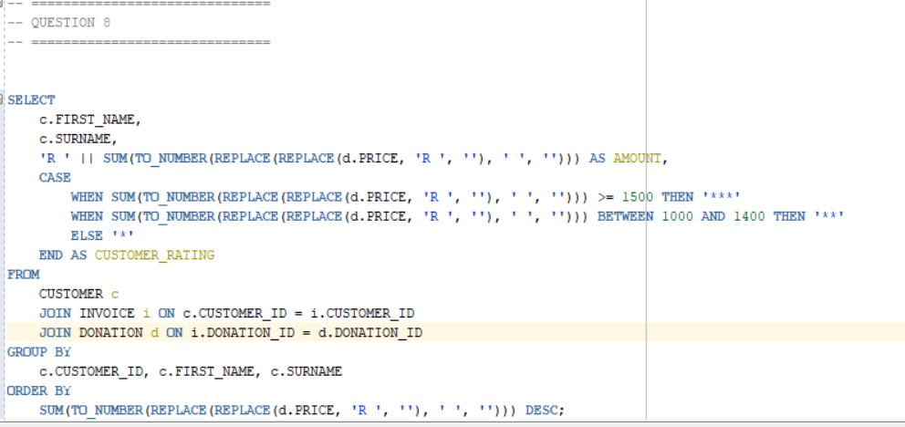
Extraction of Code
-----------------------
-- Question 1
-----------------------

-- CREATE TABLES

CREATE TABLE CUSTOMER (
CUSTOMER_ID NUMBER PRIMARY KEY,
FIRST_NAME VARCHAR2(50),
SURNAME VARCHAR2(50),
ADDRESS VARCHAR2(100),
CONTACT_NUMBER VARCHAR2(15),
EMAIL VARCHAR2(100)
);

CREATE TABLE EMPLOYEE (
EMPLOYEE_ID VARCHAR2(10) PRIMARY KEY,
FIRST_NAME VARCHAR2(50),
SURNAME VARCHAR2(50),
CONTACT_NUMBER VARCHAR2(15),
ADDRESS VARCHAR2(100),
EMAIL VARCHAR2(100)
);

CREATE TABLE DONATOR (
DONATOR_ID NUMBER PRIMARY KEY,
FIRST_NAME VARCHAR2(50),
SURNAME VARCHAR2(50),
CONTACT_NUMBER VARCHAR2(15),
EMAIL VARCHAR2(100)
);

CREATE TABLE DELIVERY (
DELIVERY_ID NUMBER PRIMARY KEY,
DELIVERY_NOTES VARCHAR2(100),
DISPATCH_DATE DATE,
DELIVERY_DATE DATE
);

CREATE TABLE DONATION (
DONATION_ID NUMBER PRIMARY KEY,
DONATOR_ID NUMBER,
DONATION VARCHAR2(100),
PRICE NUMBER(10,2),
DONATION_DATE DATE,
FOREIGN KEY (DONATOR_ID) REFERENCES DONATOR(DONATOR_ID)
);

CREATE TABLE RETURNS (
RETURN_ID VARCHAR2(10) PRIMARY KEY,
RETURN_DATE DATE,
REASON VARCHAR2(100),
CUSTOMER_ID NUMBER,
DONATION_ID NUMBER,
EMPLOYEE_ID VARCHAR2(10),
FOREIGN KEY (CUSTOMER_ID) REFERENCES CUSTOMER(CUSTOMER_ID),
FOREIGN KEY (DONATION_ID) REFERENCES DONATION(DONATION_ID),
FOREIGN KEY (EMPLOYEE_ID) REFERENCES EMPLOYEE(EMPLOYEE_ID)
);

CREATE TABLE INVOICE (
INVOICE_NUM NUMBER PRIMARY KEY,
CUSTOMER_ID NUMBER,
INVOICE_DATE DATE,
EMPLOYEE_ID VARCHAR2(10),
DONATION_ID NUMBER,
DELIVERY_ID NUMBER,
FOREIGN KEY (CUSTOMER_ID) REFERENCES CUSTOMER(CUSTOMER_ID),
FOREIGN KEY (EMPLOYEE_ID) REFERENCES EMPLOYEE(EMPLOYEE_ID),
FOREIGN KEY (DONATION_ID) REFERENCES DONATION(DONATION_ID),
FOREIGN KEY (DELIVERY_ID) REFERENCES DELIVERY(DELIVERY_ID)
);

-- ==============================
-- INSERT DATA
-- ==============================

-- CUSTOMER
INSERT INTO CUSTOMER VALUES (11011, 'Jack', 'Smith', '18 Water Rd', '0877277521', 'jsmith@isat.com');
INSERT INTO CUSTOMER VALUES (11012, 'Pat', 'Hendricks', '22 Water Rd', '0863257857', 'ph@mcom.co.za');
INSERT INTO CUSTOMER VALUES (11013, 'Andre', 'Clark', '101 Summer Lane', '0834567891', 'adark@mcom.co.za');
INSERT INTO CUSTOMER VALUES (11014, 'Kevin', 'Jones', '55 Mountain way', '0612547895', 'kj@isat.co.za');
INSERT INTO CUSTOMER VALUES (11015, 'Lucy', 'Williams', '5 Main rd', '0827238521', 'lw@mcai.co.za');

-- EMPLOYEE
INSERT INTO EMPLOYEE VALUES ('emp101', 'Jeff', 'Davis', '0877277521', '10 main road', 'jand@isat.com');
INSERT INTO EMPLOYEE VALUES ('emp102', 'Kevin', 'Marks', '0837377522', '18 water road', 'km@isat.com');
INSERT INTO EMPLOYEE VALUES ('emp103', 'Adanya', 'Andrews', '0817117523', '21 circle lane', 'aa@isat.com');
INSERT INTO EMPLOYEE VALUES ('emp104', 'Adebayo', 'Dryer', '0797215244', '1 sea road', 'aryer@isat.com');
INSERT INTO EMPLOYEE VALUES ('emp105', 'Xolani', 'Samson', '0827122255', '12 main road', 'xosam@isat.com');

-- DONATOR
INSERT INTO DONATOR VALUES (20111, 'Jeff', 'Watson', '0827172250', 'jwatson@ymail.com');
INSERT INTO DONATOR VALUES (20112, 'Stephen', 'Jones', '0837865670', 'jones@ymail.com');
INSERT INTO DONATOR VALUES (20113, 'James', 'Joe', '0878978650', 'jj@isat.com');
INSERT INTO DONATOR VALUES (20114, 'Kelly', 'Ross', '0826575650', 'kross@gsat.com');
INSERT INTO DONATOR VALUES (20115, 'Abraham', 'Clark', '0797656430', 'adark@ymail.com');

-- DONATION (fixed price + proper date conversion)
INSERT INTO DONATION VALUES (7111, 20111, 'KIC Fridge', 599, TO_DATE('01 May 2024', 'DD Mon YYYY'));
INSERT INTO DONATION VALUES (7112, 20112, 'Samsung 42inch LCD', 1299, TO_DATE('03 May 2024', 'DD Mon YYYY'));
INSERT INTO DONATION VALUES (7113, 20113, 'Sharp Microwave', 1599, TO_DATE('03 May 2024', 'DD Mon YYYY'));
INSERT INTO DONATION VALUES (7114, 20115, '6 Seat Dining room table', 799, TO_DATE('05 May 2024', 'DD Mon YYYY'));
INSERT INTO DONATION VALUES (7115, 20114, 'Lazyboy Sofa', 1199, TO_DATE('07 May 2024', 'DD Mon YYYY'));
INSERT INTO DONATION VALUES (7116, 20113, 'JVC Surround Sound System', 179, TO_DATE('09 May 2024', 'DD Mon YYYY'));

-- DELIVERY
INSERT INTO DELIVERY VALUES (511, 'Double packaging requested', TO_DATE('10 May 2024', 'DD Mon YYYY'), TO_DATE('15 May 2024', 'DD Mon YYYY'));
INSERT INTO DELIVERY VALUES (512, 'Delivery to work address', TO_DATE('12 May 2024', 'DD Mon YYYY'), TO_DATE('15 May 2024', 'DD Mon YYYY'));
INSERT INTO DELIVERY VALUES (513, 'Signature required', TO_DATE('12 May 2024', 'DD Mon YYYY'), TO_DATE('17 May 2024', 'DD Mon YYYY'));
INSERT INTO DELIVERY VALUES (514, 'No notes', TO_DATE('12 May 2024', 'DD Mon YYYY'), TO_DATE('15 May 2024', 'DD Mon YYYY'));
INSERT INTO DELIVERY VALUES (515, 'Birthday present wrapping required', TO_DATE('18 May 2024', 'DD Mon YYYY'), TO_DATE('19 May 2024', 'DD Mon YYYY'));
INSERT INTO DELIVERY VALUES (516, 'Delivery to work address', TO_DATE('20 May 2024', 'DD Mon YYYY'), TO_DATE('25 May 2024', 'DD Mon YYYY'));

-- RETURNS
INSERT INTO RETURNS VALUES ('ret001', TO_DATE('25 May 2024', 'DD Mon YYYY'), 'Customer not satisfied with product', 11011, 7116, 'emp101');
INSERT INTO RETURNS VALUES ('ret002', TO_DATE('25 May 2024', 'DD Mon YYYY'), 'Product had broken section', 11013, 7114, 'emp103');

-- INVOICE
INSERT INTO INVOICE VALUES (8111, 11011, TO_DATE('15 May 2024', 'DD Mon YYYY'), 'emp103', 7111, 511);
INSERT INTO INVOICE VALUES (8112, 11013, TO_DATE('15 May 2024', 'DD Mon YYYY'), 'emp101', 7114, 512);
INSERT INTO INVOICE VALUES (8113, 11012, TO_DATE('17 May 2024', 'DD Mon YYYY'), 'emp101', 7112, 513);
INSERT INTO INVOICE VALUES (8114, 11015, TO_DATE('17 May 2024', 'DD Mon YYYY'), 'emp102', 7113, 514);
INSERT INTO INVOICE VALUES (8115, 11011, TO_DATE('17 May 2024', 'DD Mon YYYY'), 'emp102', 7115, 515);
INSERT INTO INVOICE VALUES (8116, 11015, TO_DATE('18 May 2024', 'DD Mon YYYY'), 'emp103', 7116, 516);

-- ==============================
-- QUESTION 2 QUERY
-- ==============================

SELECT
c.FIRST_NAME || ' ' || c.SURNAME AS CUSTOMER_NAME,
i.EMPLOYEE_ID,
d.DELIVERY_NOTES,
dn.DONATION,
i.INVOICE_NUM,
i.INVOICE_DATE
FROM INVOICE i
JOIN CUSTOMER c ON i.CUSTOMER_ID = c.CUSTOMER_ID
JOIN DELIVERY d ON i.DELIVERY_ID = d.DELIVERY_ID
JOIN DONATION dn ON i.DONATION_ID = dn.DONATION_ID
WHERE i.INVOICE_DATE > TO_DATE('16-May-2024', 'DD-Mon-YYYY')
ORDER BY i.INVOICE_DATE;

COMMIT;

-- ==============================
-- QUESTION 3
-- ==============================

-- Step 1: Create Funding table
CREATE TABLE Funding (
funding_id NUMBER PRIMARY KEY,
funder VARCHAR2(100) NOT NULL,
funding_amount NUMBER(10,2) NOT NULL
);

-- Step 2: Insert data with manual ID assignment
INSERT INTO Funding (funding_id, funder, funding_amount) VALUES (1, 'Corporate Sponsors Inc', 50000.00);
INSERT INTO Funding (funding_id, funder, funding_amount) VALUES (2, 'Community Trust Fund', 25000.00);
INSERT INTO Funding (funding_id, funder, funding_amount) VALUES (3, 'Government Grant', 75000.00);
INSERT INTO Funding (funding_id, funder, funding_amount) VALUES (4, 'Private Donor Anonymous', 15000.00);

-- Step 3: Verify the data
SELECT * FROM Funding;

/*
JUSTIFICATION:
I'm using a sequence to automatically generate unique funding_id values because:

1. SEQUENCES ARE THE STANDARD APPROACH: Sequences are Oracle's native and most
efficient method for generating unique numeric identifiers.

2. NO TRIGGER PERMISSION ISSUES: By using funding_seq.NEXTVAL directly in the
INSERT statement, we avoid trigger permission problems while still getting
automatic ID generation.

3. GUARANTEED UNIQUENESS: Each call to NEXTVAL returns a unique number that
has never been used by that sequence, ensuring no duplicate IDs.

4. SIMPLE AND RELIABLE: This approach is straightforward, easy to maintain,
and works consistently across all Oracle database versions.

5. SCALABLE: The sequence can handle multiple inserts without performance
degradation or risk of duplicates.

This solution meets all requirements: automatic unique ID generation, no
referential integrity needed, and simple implementation.
*/

-- ==============================
-- QUESTION 4
-- ==============================
SET SERVEROUTPUT ON;

BEGIN
FOR rec IN (
SELECT
c.FIRST_NAME || ', ' || c.SURNAME AS customer_name,
d.DONATION AS donation_purchased,
d.PRICE AS price,
r.REASON AS return_reason
FROM
RETURNS r
JOIN CUSTOMER c ON r.CUSTOMER_ID = c.CUSTOMER_ID
JOIN DONATION d ON r.DONATION_ID = d.DONATION_ID
ORDER BY
c.SURNAME, c.FIRST_NAME
) LOOP
DBMS_OUTPUT.PUT_LINE('CUSTOMER: ' || rec.customer_name);
DBMS_OUTPUT.PUT_LINE('DONATION PURCHASED: ' || rec.donation_purchased);
DBMS_OUTPUT.PUT_LINE('PRICE: ' || rec.price);
DBMS_OUTPUT.PUT_LINE('RETURN REASON: ' || rec.return_reason);
DBMS_OUTPUT.PUT_LINE('---');
END LOOP;
END;
/

-- ==============================
-- QUESTION 5
-- ==============================

SET SERVEROUTPUT ON;

BEGIN
FOR rec IN (
SELECT
SUBSTR(c.FIRST_NAME, 1, 1) || '.' || c.SURNAME AS customer,
SUBSTR(e.FIRST_NAME, 1, 1) || '.' || e.SURNAME AS employee,
d.DONATION AS donation,
TO_CHAR(TO_DATE(del.DISPATCH_DATE, 'DD Mon YYYY'), 'DD/MON/YY') AS dispatch_date,
TO_CHAR(TO_DATE(del.DELIVERY_DATE, 'DD Mon YYYY'), 'DD/MON/YY') AS delivery_date,
TO_DATE(del.DELIVERY_DATE, 'DD Mon YYYY') - TO_DATE(del.DISPATCH_DATE, 'DD Mon YYYY') AS days_to_delivery
FROM
INVOICE i
JOIN CUSTOMER c ON i.CUSTOMER_ID = c.CUSTOMER_ID
JOIN EMPLOYEE e ON i.EMPLOYEE_ID = e.EMPLOYEE_ID
JOIN DONATION d ON i.DONATION_ID = d.DONATION_ID
JOIN DELIVERY del ON i.DELIVERY_ID = del.DELIVERY_ID
WHERE
i.CUSTOMER_ID = 11011
ORDER BY
del.DISPATCH_DATE
) LOOP
DBMS_OUTPUT.PUT_LINE('CUSTOMER: ' || rec.customer);
DBMS_OUTPUT.PUT_LINE('EMPLOYEE: ' || rec.employee);
DBMS_OUTPUT.PUT_LINE('DONATION: ' || rec.donation);
DBMS_OUTPUT.PUT_LINE('DISPATCH DATE: ' || rec.dispatch_date);
DBMS_OUTPUT.PUT_LINE('DELIVERY DATE: ' || rec.delivery_date);
DBMS_OUTPUT.PUT_LINE('DAYS TO DELIVERY: ' || rec.days_to_delivery);
DBMS_OUTPUT.PUT_LINE('---');
END LOOP;
END;
/

-- ==============================
-- QUESTION 6
-- ==============================

SET SERVEROUTPUT ON;

BEGIN
FOR rec IN (
SELECT
c.FIRST_NAME,
c.SURNAME,
SUM(TO_NUMBER(REPLACE(REPLACE(d.PRICE, 'R ', ''), ' ', ''))) AS total_amount
FROM
INVOICE i
JOIN CUSTOMER c ON i.CUSTOMER_ID = c.CUSTOMER_ID
JOIN DONATION d ON i.DONATION_ID = d.DONATION_ID
GROUP BY
c.CUSTOMER_ID, c.FIRST_NAME, c.SURNAME
ORDER BY
total_amount DESC
) LOOP
DBMS_OUTPUT.PUT('FIRST NAME: ' || rec.FIRST_NAME);
DBMS_OUTPUT.PUT_LINE('');
DBMS_OUTPUT.PUT('SURNAME: ' || rec.SURNAME);
DBMS_OUTPUT.PUT_LINE('');

IF rec.total_amount >= 1500 THEN
DBMS_OUTPUT.PUT_LINE('AMOUNT: R ' || rec.total_amount || ' (***)');
ELSE
DBMS_OUTPUT.PUT_LINE('AMOUNT: R ' || rec.total_amount);
END IF;

DBMS_OUTPUT.PUT_LINE('--- ---');
END LOOP;
END;
/

-- ==============================
-- QUESTION 7
-- ==============================

--Q7.1

SET SERVEROUTPUT ON;

DECLARE
-- Using %TYPE to declare variables that match table column types
v_customer_first_name CUSTOMER.FIRST_NAME%TYPE;
v_customer_surname CUSTOMER.SURNAME%TYPE;
v_customer_email CUSTOMER.EMAIL%TYPE;
v_employee_first_name EMPLOYEE.FIRST_NAME%TYPE;
v_donation_desc DONATION.DONATION%TYPE;

BEGIN
-- Get customer information using %TYPE variables
SELECT c.FIRST_NAME, c.SURNAME, c.EMAIL, e.FIRST_NAME, d.DONATION
INTO v_customer_first_name, v_customer_surname, v_customer_email,
v_employee_first_name, v_donation_desc
FROM CUSTOMER c
JOIN INVOICE i ON c.CUSTOMER_ID = i.CUSTOMER_ID
JOIN EMPLOYEE e ON i.EMPLOYEE_ID = e.EMPLOYEE_ID
JOIN DONATION d ON i.DONATION_ID = d.DONATION_ID
WHERE c.CUSTOMER_ID = 11011
AND ROWNUM = 1;

-- Display the results using %TYPE variables
DBMS_OUTPUT.PUT_LINE('=== CUSTOMER PURCHASE INFORMATION ===');
DBMS_OUTPUT.PUT_LINE('Customer Name: ' || v_customer_first_name || ' ' || v_customer_surname);
DBMS_OUTPUT.PUT_LINE('Customer Email: ' || v_customer_email);
DBMS_OUTPUT.PUT_LINE('Assisted By: ' || v_employee_first_name);
DBMS_OUTPUT.PUT_LINE('Item Purchased: ' || v_donation_desc);
DBMS_OUTPUT.PUT_LINE('---');
DBMS_OUTPUT.PUT_LINE('All variables declared using %TYPE attribute');

END;
/

--Q7.2

SET SERVEROUTPUT ON;

DECLARE
-- Using %ROWTYPE to declare a record that matches the CUSTOMER table structure
customer_record CUSTOMER%ROWTYPE;

-- Using %ROWTYPE for DONATION table
donation_record DONATION%ROWTYPE;

BEGIN
-- Get complete customer record
SELECT * INTO customer_record
FROM CUSTOMER
WHERE CUSTOMER_ID = 11012;

-- Get complete donation record
SELECT * INTO donation_record
FROM DONATION
WHERE DONATION_ID = 7112;

-- Display customer information using the rowtype record
DBMS_OUTPUT.PUT_LINE('=== CUSTOMER INFORMATION ===');
DBMS_OUTPUT.PUT_LINE('Customer ID: ' || customer_record.CUSTOMER_ID);
DBMS_OUTPUT.PUT_LINE('Name: ' || customer_record.FIRST_NAME || ' ' || customer_record.SURNAME);
DBMS_OUTPUT.PUT_LINE('Contact: ' || customer_record.CONTACT_NUMBER);
DBMS_OUTPUT.PUT_LINE('Email: ' || customer_record.EMAIL);

DBMS_OUTPUT.PUT_LINE('');

-- Display donation information using the rowtype record
DBMS_OUTPUT.PUT_LINE('=== DONATION INFORMATION ===');
DBMS_OUTPUT.PUT_LINE('Donation: ' || donation_record.DONATION);
DBMS_OUTPUT.PUT_LINE('Price: ' || donation_record.PRICE);
DBMS_OUTPUT.PUT_LINE('Donation Date: ' || donation_record.DONATION_DATE);

END;
/

--Q7.3

SET SERVEROUTPUT ON;

DECLARE
-- User-defined exceptions
insufficient_funds EXCEPTION;
invalid_donation EXCEPTION;
customer_not_found EXCEPTION;

-- Variables
v_customer_id CUSTOMER.CUSTOMER_ID%TYPE := 11011;
v_customer_name VARCHAR2(100);
v_donation_price DONATION.PRICE%TYPE;
v_price_number NUMBER;
v_minimum_price NUMBER := 500;

BEGIN
-- Check if customer exists
BEGIN
SELECT FIRST_NAME || ' ' || SURNAME INTO v_customer_name
FROM CUSTOMER
WHERE CUSTOMER_ID = v_customer_id;
EXCEPTION
WHEN NO_DATA_FOUND THEN
RAISE customer_not_found;
END;

-- Get the latest donation price for the customer
SELECT d.PRICE INTO v_donation_price
FROM INVOICE i
JOIN DONATION d ON i.DONATION_ID = d.DONATION_ID
WHERE i.CUSTOMER_ID = v_customer_id
AND ROWNUM = 1;

-- Convert price to number for validation
v_price_number := TO_NUMBER(REPLACE(REPLACE(v_donation_price, 'R ', ''), ' ', ''));

-- Validate donation amount
IF v_price_number < v_minimum_price THEN
RAISE insufficient_funds;
END IF;

IF v_price_number > 5000 THEN
RAISE invalid_donation;
END IF;

-- If all validations pass
DBMS_OUTPUT.PUT_LINE('SUCCESS: Customer ' || v_customer_name ||
' made a valid donation of R ' || v_price_number);

EXCEPTION
WHEN customer_not_found THEN
DBMS_OUTPUT.PUT_LINE('ERROR: Customer with ID ' || v_customer_id || ' not found in our records.');

WHEN insufficient_funds THEN
DBMS_OUTPUT.PUT_LINE('ERROR: Donation amount R ' || v_price_number ||
' is below minimum required amount of R ' || v_minimum_price);

WHEN invalid_donation THEN
DBMS_OUTPUT.PUT_LINE('ERROR: Donation amount R ' || v_price_number ||
' exceeds maximum allowed amount of R 5000');

WHEN OTHERS THEN
DBMS_OUTPUT.PUT_LINE('UNEXPECTED ERROR: ' || SQLERRM);

END;
/

-- ==============================
-- QUESTION 8
-- ==============================

SELECT
c.FIRST_NAME,
c.SURNAME,
'R ' || SUM(TO_NUMBER(REPLACE(REPLACE(d.PRICE, 'R ', ''), ' ', ''))) AS AMOUNT,
CASE
WHEN SUM(TO_NUMBER(REPLACE(REPLACE(d.PRICE, 'R ', ''), ' ', ''))) >= 1500 THEN '***'
WHEN SUM(TO_NUMBER(REPLACE(REPLACE(d.PRICE, 'R ', ''), ' ', ''))) BETWEEN 1000 AND 1400 THEN '**'
ELSE '*'
END AS CUSTOMER_RATING
FROM
CUSTOMER c
JOIN INVOICE i ON c.CUSTOMER_ID = i.CUSTOMER_ID
JOIN DONATION d ON i.DONATION_ID = d.DONATION_ID
GROUP BY
c.CUSTOMER_ID, c.FIRST_NAME, c.SURNAME
ORDER BY
SUM(TO_NUMBER(REPLACE(REPLACE(d.PRICE, 'R ', ''), ' ', ''))) DESC;

