Growth and yield responses of maize (*Zea mays L*.) to different nitrogen levels in agriculture

Thulisile Nkomo (3650805)

13 May 2019

**1. Abstract**

The purposes of this study was to investigate the different effects of urea fertiliser on the growth of maize (*Zea mays L*.) at a greenhouse in South Africa. The experiment ran through two consecutive season between the years 2004 – 2005. The samples were arranged in the plot area was 20cm², each plot contained seven ridges and those ridges were 6 m in length and 60 cm apart. The treatments consisted of three nitrogen levels, control treatment (25 kg/ha) , treatment 1 (50 kg/ha) and treatment 2 (100 kg/ha). The results showed that the growth of the maize was affected by the treatments (p < 0.05). Treatment 2 observed significantly highest values. The ANOVA test indicated that there was a significant difference in the dataset. The findings of the study concluded that treatment 1 with the highest nitrogen level showed better performance of maize crop in terms of growth.

**Keywords**: Maize (*Zea mays L*.), Nitrogen levels, Grain Yields, Treatment groups.

**2. Introduction**

Maize (*Zae mays L*.) is the most important grain crop in South Africa and is produced throughout the country under diverse conditions (Du Plessis, 2013). It is ranked as third major cereal crop after rice and wheat. It has a wide range of uses including human food, industrial processed food such as starch and forage to feed animals (El-Murtanda et al, 2011). Crop productivity in smallholder farms in southern Africa is low due to soil infertility decline, insufficient and inappropriate fertiliser applications, unreliable rainfall and labour constraints (Thierfelder et al, 2015). Because maize plant is an important forage for many dairy and beef animals, the leaf area and canopy structures are important growth parameters for forage production (El-Murtanda et al, 2011). The success of maize production is dependent on correct application of production inputs that will sustain the environment and agricultural production (Du Plessis, 2013). Several methods can be applied to improve crop management promoting sustainable yields of maize. These methods include mulching, no-tillage and crop rotation (Cook et al 2005; Thierfelder et al, 2015). This study aims to find a nitrogen fertilizer that promotes the most plant growth for sustainable crop production.

Nitrogen plays an important role in crop growth and yield. It has high association with dark green colour of stem and leaves, vigorous growth, branching, leaf production and size enlargement. (Shah et al, 2009). It has been observed that addition of nitrogen fertilizer in maize resulted in greater values of plant height, leaf area, number of leaves and stem diameter, fresh and dry forage yield were also increased due to addition of nitrogen. Leaf to stem ratio was also found to be increased by nitrogen (El-Murtanda et al, 2011). A study done by Heisey and Mwangi (1996) mentioned that Africa had the lowest use in fertilizers and hence low maize production. Fertilizers have been vital in increasing crop production worldwide. A study done by Khalifa (1981) showed that nitrogen fertilizers from both the sites that they sampled from significantly affected plant growth parameters during the two seasons.

The main objective of this study was to investigate the influence of different nitrogen sources on growth and yield of maize (*Zae mays L*.) under irrigation and which of those treatments are the best suitable for farming. It is hypothesised that the treatment with the highest dosage will have the most effect on the plant growth.

**3. Materials and Methods**

3.1. *Glasshouse experiment*

The experiment was conducted for two seasons between the years 2004-2005 and 2006. Growth and yield experiments were conducted using three different treatments that consisted of the same nitrogen source but different dosages. The nitrogen fertilizer used was urea which has a NPK (Nitrogen-Phosphorous-Potassium) ratio of 46-0-0. There was the control stimulating maize growth. Treatment 1 added fertilization with 50kg/ha of urea, and treatment 2 added fertilization with 100kg/ha of urea. The soil type used was generally sandy clay loam, non-saline and non-sodic with pH (7.8). The treatments were arranged in a completely randomised block design with four replications.

Seeds were sown during the first week of November for the two consecutive seasons. The plot area was 20cm², each plot contained seven ridges and those ridges were 6 m in length and 60 cm apart. Different doses of nitrogen fertilizers were applied once at sowing before irrigation. Crop was irrigated eight times in each season between the intervals of 10-14 days.

3.2. *Yield*

Fresh weight forage was determined from measuring growth attributes such as plant height, stem diameter, number of leaves, leaves area and leaf area index. The plants were chosen and removed from each plot randomly after 45, 60, 75 and 90 days of sowing.

3.3. *Statistical analysis*

All statistical analysis was carried out on **R** **Studio** version 2.15.1. The least statistical significance P > 0.05 was used to compare means of each nitrogen dosage for the variables measured, this was done using an ANOVA test.

**4. Results**

**Table 1**. Effect of three different dosages of urea fertilizer content on maize grain yield in agriculture cropping systems from ANOVA test.

|  |  |  |  |  |  |  |  |  |  |  |  |  |  |
| --- | --- | --- | --- | --- | --- | --- | --- | --- | --- | --- | --- | --- | --- |
| *Analysis of Variance Table* | | | | |  | |  | |  | |  | |  |
|  |  |  |  | |  | |  | |  | |  | |  |
| Response: weight | | |  |  | |  | |  | |  | |  | |
| Df Sum Sq Mean Sq | | | | | | | F value | | | | Pr(>F) | |  |
| group 2 3.7663 1.8832 | | | | | | | 4.8461 | | | | 0.01 | |  |
| Residuals 27 10.4921 0.3886 | | | | | | | | |  | |  | |  |

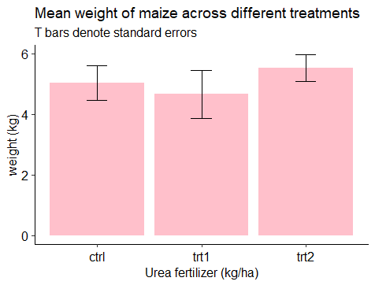

**Fig 2**. Mean weight of maize at different treatments (control treatment, treatment 1 and treatment 2). T-bars denote standard errors.

When maize grain yield was predicted using an ANOVA test, the p-value for the F-statistics came out to the value of 0.01591 (i.e 1.6 %). ANOVA of treatment groups showed a nearly significant plant growth effect (F= 4.8461, d.f.= 2, P = 0.01) (Fig. 2).

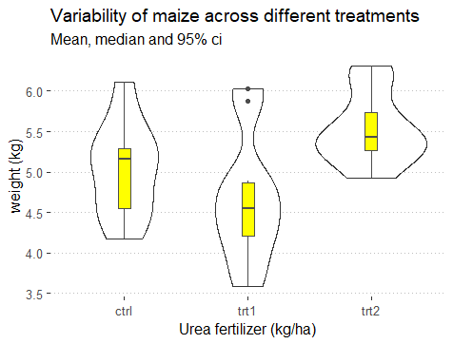

**Fig. 1**. A violin plot showing the variability of maize grain yield (kg/ha ) across years using three different treatments in a greenhouse. Boxplots show the mean (fat line), median (slim line), the mean value above the boxplot, the 95% confidence interval and the outliers.

The effect of both the control treatment, treatment 1 and treatment 2 on maize grain yield was studied to find out differences in the level of responses of maize to different dosages of urea fertilizer (Fig. 1 and Table 1). Overall, treatment condition 2 gives higher yields in general in much less variance. Treatment 1 seems to have reduced growth relative to the control treatment and has an outlier value (Fig 1).

**5. Discussion**

The study demonstrated the effectiveness of different dosages of nitrogen fertilizer for promoting growth and yield of maize under greenhouse conditions. Application of treatment 2 (100 kg /ha of urea) significantly increased the growth of and yield of maize, this is known by comparison to the control treatment. Treatment 1 had an opposite effect on the growth rate of plants, reducing it. Findings of this paper are supported by results of other scientists who reported that increased dosage of urea leads to high yields of maize (Vanlauwe et al, 2001). A study done in the journal of Academic Research Journal of Agricultural Science and Research showed that the N fertiliser with the highest level observed significantly the highest maize grain yield in comparison to other N fertilizers which had lower levels (Matusso, 2016). The increased yield when using treatment 2 in maize could be explained by the fact that higher rates of nitrogen could cause a rapid cell division and elongation (Matusso, 2016).

The p value suggests weak statistical support to reject the null hypothesis which suggest that the treatment has an effect on growth of the plant. This could then suggest a larger sample size to be used in the next research study to strengthen the statistical support.

Maize weight when treatment 2 was used increased significantly with increase in nitrogen level while treatment 1 led to the decrease in weight. For agricultural systems trying to get maximum yields of maize it would be advisable to use treatment 2 as a fertiliser

**References**

Amin, Mohamed El-Murtada Hassan. "Effect of different nitrogen sources on growth, yield and quality of fodder maize (Zea mays L.)." *Journal of the Saudi Society of Agricultural Sciences* 10.1 (2011): 17-23.

Du Plessis, Jéan. *Maize production*. Pretoria, South Africa: Department of Agriculture, 2003.

Khalifa, N. A., et al. "Effect of time of nitrogen application on an open-pollinated variety of corn (Zea mays L.)." *Annals of agricultural science (Moshtohor)* (1981).

Matusso, Jossias Mateus Materusse. "Growth and Yield Response of Maize (Zea mays L.) to Different Nitrogen Levels in Acid Soils." *African Fertilizer Agribusiness Partnerships, Chimoio-Moazabique Corresponding Author. E-mail: matujossias@ gmail. com Accepted* 14 (2016).

Shah, Syed Talat Hussain, et al. "Growth and yield response of maize (Zea mays L.) to organic and inorganic sources of nitrogen." *Pak. J. Life soc. sci* 7.2 (2009): 108-111.

Heisey, Paul W., and W. M. Mwangi. *Fertilizer use and maize production in sub-Saharan Africa*. CIMMYT, 1996.

Thierfelder, Christian, Rumbidzai Matemba-Mutasa, and Leonard Rusinamhodzi. "Yield response of maize (Zea mays L.) to conservation agriculture cropping system in Southern Africa." *Soil and Tillage Research* 146 (2015): 230-242.

Vanlauwe, Bernard, et al. "Maize yield as affected by organic inputs and urea in the West African moist savanna." *Agronomy journal* 93.6 (2001): 1191-1199.