**RESEARCH PROPOSAL**

**The Impact of Modern Technology on Student Learning Experiences in Higher Education**

Table of Contents

1. Project Title 2

2. Significance/Contribution to the discipline/Research Problem 2

3. Aims and Objectives 3

4. Research Questions 4

5. Methodology / Development Strategy 4

6. Development Process and Resources 7

7. Ethical Considerations and Risk Assessment 10

8. Artefact Outputs 12

9. Timeline of Proposed Activities 12

10. Key Literature 14

11. References 15

# **Project Title**

The Impact of Modern Technology on Student Learning Experiences in Higher Education.

# **Significance/Contribution to the discipline/Research Problem**

The utilisation of modern technology has been observed to have a positive effect on higher education on a broader scale, as it has led to an increase in the availability of learning opportunities, the provision of equal educational opportunities to all, and the promotion of lifelong learning (Sanchez & Aleman, 2001)(UNESCO, 2021).

This study delves into the implications of modern technology on the student learning experience within higher education institutions. It will provide comprehensive information on the following topics: educational improvement; student involvement and motivation; decision-making; problem-solving; student-centred approaches; and future-oriented preparation.

Furthermore, the study will contribute to the body of scholarly knowledge by consolidating different perspectives and research findings; and serve as a foundation for future research into the incorporation of modern technology in higher education institutions. Ultimately, its importance lies in its ability to inform educational strategies; inform policy decisions; enhance student experiences; and provide valuable insight into existing and future research efforts.

Modern educational technologies have demonstrated their potential to be beneficial in the classroom and in the classroom experience. To ensure the success of modern technology-based education, it is essential to have digital literacy and to have the necessary institutional infrastructure in place to facilitate the transition from the traditional learning spaces to technology-enabled learning platforms (Okoye et al., 2023).

# **Aims and Objectives**

This study seeks to gain a comprehensive understanding of the complexities and advantages of incorporating modern technology into higher education institutions, as well as its influence on student learning experiences. Additionally, it is intended to provide practical advice and guidance to decision-makers and higher education institutions to maximise the efficacy of technology integration within higher education institutions.

Key objectives of the study include:

* To assess the current level of technology integration within higher education institutions.
* To explore the various types of technologies employed and their role in classroom instruction, as well as the impact of modern technology on student involvement and motivation.
* To explore the factors that can contribute to or detract from student participation when incorporating modern technology into the educational system.
* To identify the challenges that students face when using modern technology for educational purposes, such as accessibility, digital illiteracy, and technological obstacles.
* To provide recommendations and guidance for educators and educational institutions to improve student learning experiences through the integration of modern technology.

# **Research Questions**

The research questions for the study are as follows:

* How does modern technology in higher education influence student engagement, motivation, and academic performance?
* What strategies and teaching methods are most effective in incorporating modern technologies such as gamification, simulation, and online learning platforms into higher education?
* What are the student perceptions and attitudes towards the integration of modern technology in their learning experiences?
* What are the challenges faced by students and their learning experiences pertaining to the incorporation of modern technology?

# **Methodology / Development Strategy**

For the purpose of this study, a mixed methods design (Creswell, 1999) will be used. A mixed methods design is a process of collecting, analysing, and combining or ‘mixing’ at some point of the research process both quantitative data and qualitative data within a single study to gain a more complete understanding of a research problem (Creswell, 1999).

The reason for mixing is that quantitative and qualitative methods alone are not enough to understand the trends and details of the situation effectively. For example, a complex question such as how modern technology in higher education institutions affects student engagement, motivation, and academic performance. When combined, the quantitative and qualitative methods are complementary and allow for a more comprehensive analysis (Dawadi, 2021).

By combining qualitative and quantitative data, one can gain a comprehensive, contextualised understanding of the data, while the other can provide a more general, externally valid insight. The advantages of the former are often outweighed by the disadvantages of the latter (George, 2023). For instance, a study conducted solely on quantitative data is unlikely to capture the student's learning experiences, so the addition of qualitative data enhances and complements the quantitative findings. Conversely, a study conducted purely on qualitative data is often not sufficiently generalisable, as it only reflects the student's learning experience. Therefore, the addition of quantitative data can confirm the qualitative findings.

According to Schoonenboom & Johnson (2017), Mixed method research designs can be divided into four main categories: triangulation, embedded, explanatory, and exploratory. In this study, we will use the explanatory model, which involves the collection of quantitative data first, followed by the collection of qualitative data. This approach was developed to gain a more comprehensive understanding of the study by combining the quantitative data with the qualitative data, thus providing a better understanding and explanation.

Schoonenboom & Johnson (2017), states that the explanatory design, also referred to as sequential design, is a combination of two-staged mixed methods. Initially, quantitative data is collected and analysed, followed by qualitative data. During the explanatory design, the researcher identifies specific quantitative findings that require further explanation.

In order to examine the quantitative data in greater detail, qualitative information will be collected from participants that could be used to elucidate the findings. In this study, the primary emphasis will be placed on the quantitative data. The explanatory design is widely recognized as the simplest of the mixed methodology designs. The advantages of an explanatory research design structure, which is characterised by its two-stage implementation:

* This structure allows for the researcher to apply the two methods in a separate stage, while simultaneously collecting a single data type at a time.
* The final report is presented in two distinct stages, allowing the reader to gain a comprehensive understanding of the findings.

This study is based on perceptions from student participants, it therefore draws on a variety of mixed-method design studies, such as Guillot's (2003). Guillot's (2003) design was used to measure the perceptions of both teachers and students in higher education when it comes to online instructional methodology. In addition, the mixed-method design study by Almekhlafi & Almeqdadi (2010) was used to explore the perception of teachers in the United Arab Emirates school classroom when it comes to technology integration. All of these studies were conducted with the aim of obtaining valid and reliable data.

The research design of the study is outlined in Figure 5.1. This study will employ a mixed-method approach, utilising a questionnaire and an interview as research instruments to generate quantitative and qualitative data. The questionnaire data will be analysed using descriptive statistics, while the interview results will be coded and analysed to corroborate the questionnaire results.

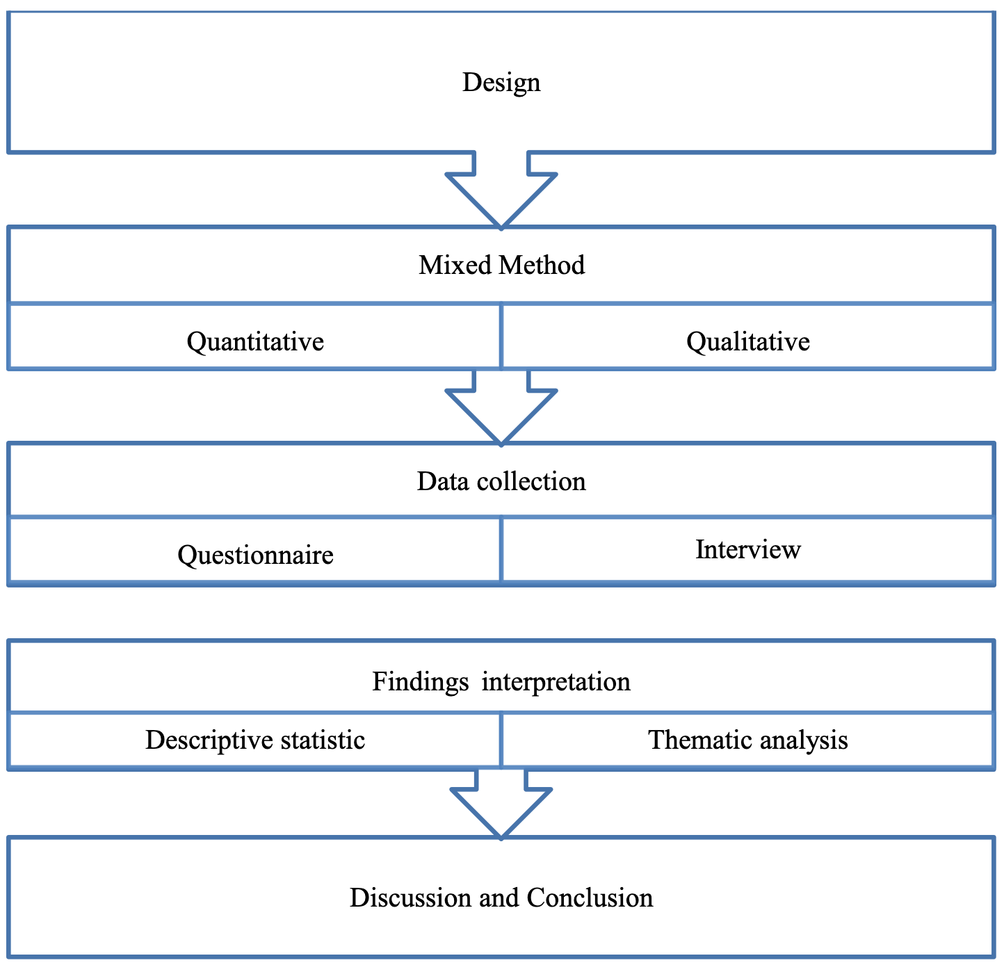

Figure 5.1: Research Design (Basir, 2015).

# **Development Process and Resources**

Quantitative Data Collection and Analysis

* Design and conduct surveys for students on the use of technology, its benefits and drawbacks, and their preferences. Utilize Likert scale and closed-end questions. Conduct a pilot survey to validate the survey tool and evaluate its reliability. Depending on the results, survey items may require revision.
* Process data using descriptive analysis and inferential test to identify, describe, summarise, and analyse student responses, as well as to derive patterns and correlations.

Qualitative Data Collection and Analysis

* Prepare semi-structured interview guides. Tailor questions to gather in-depth insights into students participants’ learning experiences and attitudes regarding modern technology integration in their higher education institutions.
* Conduct interviews and record responses and transcribing them for analysis.
* Carry out coding and thematic analysis are used to break down, compare, comprehend, and classify data in order to identify common themes.

Interpretation and Reporting

* Integrate the results of surveys and interviews to create a comprehensive report and use triangulation techniques to verify and confirm data from a variety of sources.
* Compare data across different educational institutions, fields, and participant populations to recognize similarities and disparities.
* Prepare a research report and provide practical recommendations to educators, institutes, and policy makers based on the findings.

Figure 6.1. Below depicts the development process for an explanatory sequential mixed-method research design, it captures the phase, procedures, and product output.

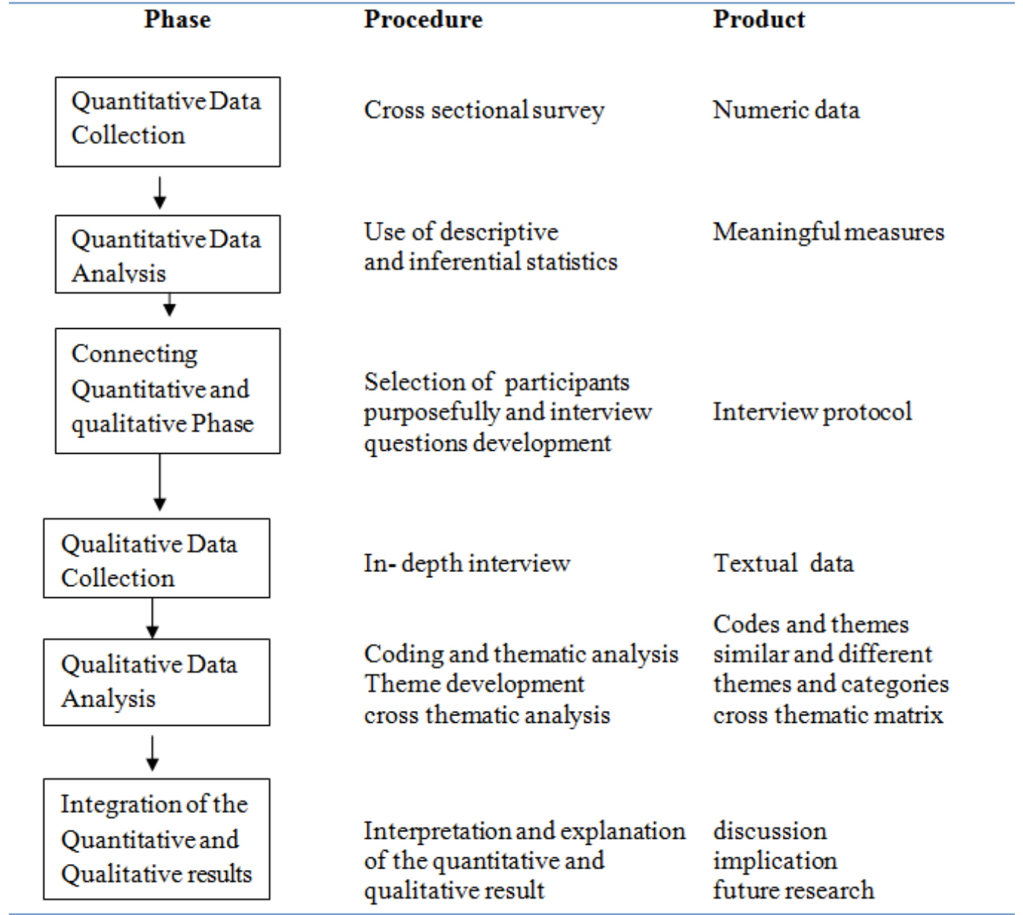

Figure 6.1. Explanatory Sequential Research Design (Subedi, 2016).

Key Resources

* Ethics committee or review board to ensure that research is conducted in accordance with ethical guidelines and regulations.
* Participants of the interviews and surveys related to the study.
* Technological resources which comprise of survey platform, data analysis software, communication tools, and recording equipment,

# **Ethical Considerations and Risk Assessment**

Ethical considerations must be taken into account when conducting mixed methods research, which involves both quantitative and qualitative research. Quantitative considerations may include obtaining consent, maintaining anonymity of respondents, avoiding unethical methods, safeguarding vulnerable populations, being cognisant of potential power limitations in data collection, respect for diverse cultures, not divulging confidential information, and concealing participant identities (Subedi, 2016).

Subedi (2016) further states that in an Explanatory Mixed-Model, researchers may begin their research with a large quantitative database. In order to conduct qualitative interviews with those individuals, an identifier needs to be associated with the quantitative database. Some individuals may not wish to have their quantitative data disclosed. Consequently, the unauthorized use of names constitutes an ethical issue with mixed methods.

Ethical aspects are of the utmost importance in any research process, particularly when human subjects are involved. In order to conduct a research project on the incorporation of modern technology into higher education and evaluating student learning experiences, for this reason, this study will adhere to the following ethical principles and standards:

* The ethical aspects of the research will be taken into consideration at each stage of the study.
* In accordance with the Institutional Review Board's regulations, permission must be obtained and an informed consent documents and processes followed.
* The anonymity of participants will be protected by numerically coding each questionnaire and keeping responses confidential.
* All study data including the survey will be stored in a locked file cabinet and electronic files should be password protected, encrypted, and destroyed after an appropriate period of time.

Potential Risks and Mitigation Strategies of the study have been identified and adhered to are as follows:

* Risks associated with the safeguarding of data include access by unauthorised individuals, data breaches and cyber-attacks, which may compromise the data of participants and research subjects. To mitigate these risks, it is recommended to implement encryption, secure storage of data and effective access controls. Additionally, it is important to regularly update security measures and software to protect against cyber threats.
* Risks of ethical violations may arise, such as questions of informed consent, breaches of confidentiality, or dissatisfaction of participants. To mitigate these risks, it is essential to adhere to ethical guidelines that guarantee informed consent and confidentiality.

Risks associated with technology failures during the collection of data, such as crashes of the survey platform or audio recording issues, can arise. To mitigate these risks, it is important to ensure that technology platforms are reliable and tested. Additionally, it is beneficial to have backup plans in place, such as alternate survey tools and additional recording devices.

* Risks associated with time constraints that may impede the comprehensive collection, evaluation, and reporting of data. To mitigate these risks, it is essential to establish a realistic timeline for the project. Additionally, it is important to regularly assess progress and modify strategies as necessary.

# **Artefact Outputs**

The main artefacts, that will be developed from the study will comprise of:

* Research Proposal Document
* Research Paper – comprising of literature review etc.
* Ethical review documents which include informed consent forms, and approval letters from respective ethical committee boards

# **Timeline of Proposed Activities**

|  |  |  |  |
| --- | --- | --- | --- |
| Research Title | Researcher | START DATE | END DATE |
| The Impact of Modern Technology on Student Learning Experiences in Higher Education | N Mlambo | 01 /11/ 2023 | 30/06/ 2024 |

|  |  |  |  |  |  |  |  |  |  |  |  |  |  |  |  |  |  |  |  |  |
| --- | --- | --- | --- | --- | --- | --- | --- | --- | --- | --- | --- | --- | --- | --- | --- | --- | --- | --- | --- | --- |
|  |  | | | | | | | | | | | | | | | | | | | |
| **MONTH** | **November 2023** | | | | | **December 2023** | | | | | **January 2024** | | | | | **February 2024** | | | | |
| **WEEK** | **1** | **8** | **15** | **22** | **29** | **6** | **13** | **20** | **27** | **-** | **3** | **10** | **17** | **24** | **31** | **7** | **14** | **21** | **28** | **-** | |
| **ACTIVITY** | **1** | **2** | **3** | **4** | **5** | **6** | **7** | **8** | **9** | **-** | **10** | **11** | **12** | **13** | **14** | **15** | **16** | **17** | **18** | **-** | |
| **Study Preparation** |  |  |  |  |  |  |  |  |  |  |  |  |  |  |  |  |  |  |  |  | |
| Develop Study Objections, and Rationale |  |  |  |  |  |  |  |  |  |  |  |  |  |  |  |  |  |  |  |  | |
| Compile Literature Review |  |  |  |  |  |  |  |  |  |  |  |  |  |  |  |  |  |  |  |  | |
| Develop and Pilot Documentation |  |  |  |  |  |  |  |  |  |  |  |  |  |  |  |  |  |  |  |  | |
| Obtain Ethical Approval |  |  |  |  |  |  |  |  |  |  |  |  |  |  |  |  |  |  |  |  | |

|  |  |  |  |  |  |  |  |  |  |  |  |  |  |  |  |  |  |  |  |  |  |  |  |
| --- | --- | --- | --- | --- | --- | --- | --- | --- | --- | --- | --- | --- | --- | --- | --- | --- | --- | --- | --- | --- | --- | --- | --- |
|  |  | | | | | | | | | | | | | | | | | | | | | | |
| **MONTH** | **March 2024** | | | | | **April 2024** | | | | | | **May 2024** | | | | | | **June 2024** | | | | | |
| **WEEK** | **6** | **13** | **20** | **27** | **-** | **3** | **10** | **17** | **24** | **-** | **1** | | **8** | **15** | **22** | **29** | **5** | | **12** | **19** | **26** | **-** |
| **ACTIVITY** | **19** | **20** | **21** | **22** | **-** | **23** | **25** | **25** | **26** | **-** | **27** | | **28** | **29** | **30** | **31** | **32** | | **33** | **34** | **35** | **-** |
| **Data Collection and Analysis** |  |  |  |  |  |  |  |  |  |  |  | |  |  |  |  |  | |  |  |  |  |
| Collect Quantitative Data |  |  |  |  |  |  |  |  |  |  |  | |  |  |  |  |  | |  |  |  |  |
| Analyse Quantitative Data |  |  |  |  |  |  |  |  |  |  |  | |  |  |  |  |  | |  |  |  |  |
| Collect Qualitative Date |  |  |  |  |  |  |  |  |  |  |  | |  |  |  |  |  | |  |  |  |  |
| Analyse Qualitative Data |  |  |  |  |  |  |  |  |  |  |  | |  |  |  |  |  | |  |  |  |  |
| Integrate Quantitative and Qualitative Date |  |  |  |  |  |  |  |  |  |  |  | |  |  |  |  |  | |  |  |  |  |
| **Reporting and Dissemination** |  |  |  |  |  |  |  |  |  |  |  | |  |  |  |  |  | |  |  |  |  |
| Analyse and Interpret Findings |  |  |  |  |  |  |  |  |  |  |  | |  |  |  |  |  | |  |  |  |  |
| Compile Report and Recommendations |  |  |  |  |  |  |  |  |  |  |  | |  |  |  |  |  | |  |  |  |  |
| Prepare and Submit Final Research Study |  |  |  |  |  |  |  |  |  |  |  | |  |  |  |  |  | |  |  |  |  |

# **Key Literature**

Below is the Key Literature that will be incorporated and aid in achieving the research objectives

Literature to provide insight on historical background:

(Fahmy, 2004).

(Muttappallymyalil et al., 2016).

Literature to provide insight on the theoretical frameworks and foundations.

(Chugh et al., 2023).

(Marikyan & Papagiannidis, 2023).

(Almaiah et al., 2019).

(Chao, 2019).

(Sprenger & Schwaninger, 2021).

(Yawen & Moyan, 2021).

(Tambum et al., 2020).

(Santos & Castro, 2021).

(Hamam & Hysaj, 2021).

(Handayani et al., 2023).

Literature to provide insight on modern technology and its influence on student engagement and motivation.

(Schindler et al., 2017).

(D’Angelo, 2018).

(Bond et al., 2020).

Tugun (2020).

(Greve & Tan, 2021).

(Ahalt & Fecho, 2015).

Aljawarneh (2020).

(Bhaskar, 2023).

# 

Literature to provide insight on the challenges of modern technology in higher education institutions.

(Almaiah et al., 2020).

(García-Morales, 2021).

(Schmidt & Tang, 2020)

(Krishnamurthy, 2020).

(Marinoni et al., 2020).

(Cavus et al., 2022).

(Jensen, 2019).

(Dong et al.,2020).

(European University Association, 2020).

Literature to provide insight on students’ perceptions on modern technology in higher education.

(Bahja et al., 2022).

(D’Angelo, 2018).

(Al-Rawashdeh, 2021).

(Yang & Cornelius, 2004).

# **References**

Abad-Segura, E., González-Zamar, M., Infante-Moro, J. & García, G. (2020) Sustainable Management of Digital Transformation in Higher Education: Global Research Trends. Sustainability 202012(5): 2107. Available from: <https://doi.org/10.3390/su12052107> [Accessed 11 October 2023].

Al-Rawashdeh, A., Mohammed, E., Al-Arab, A., Alara, M. & Al-Rawashdeh, B.(2021) Advantages and Disadvantages of Using e-Learning in University Education: Analyzing Students’ perspectives. *The electronic journal of e-Learning* 19(3):107-117. Available from: <https://academic-publishing.org/index.php/ejel/article/view/2168/1961> [Accessed 11 October 2023].

Ahalt, S. & Fecho, K. (2015) Ten Emerging Technologies for Higher Education. RENCI, University of North Carolina at Chapel Hill. Available from: <http://dx.doi.org/10.7921/G0PN93HQ> [Accessed 15 October 2023].

Aljawarneh, S. (2020) Reviewing and exploring innovative ubiquitous learning tools in higher education. *Journal of Computing in Higher Education* 32:57–73. Available from: <https://link.springer.com/article/10.1007/s12528-019-09207-0> [Accessed 13 October 2023].

Almaiah, M., Alamri, M. & Al-Rahmi, W. (2019) Applying the UTAUT Model to Explain the Students’ Acceptance of Mobile Learning System in Higher Education. *IEEE Access*. 7: 174673-174686. Available from: <https://www.semanticscholar.org/paper/Applying-the-UTAUT-Model-to-Explain-the-Students%E2%80%99-Almaiah-Alamri/5edf22e2bb075c287a3edb4b692c46d10bb447fc> [Accessed 12 October 2023].

Almaiah, M., Al-Khasawneh, A. & Althunibat, A. (2020) Exploring the critical challenges and factors influencing the E-learning system usage during COVID-19 pandemic. *Education and Information Technologies* (25): 5261–5280 . Available from: <https://doi.org/10.1007/s10639-020-10219-y> [Accessed 15 October 2023].

Almekhlafi, A. & Almeqdadi, F. (2010) Teachers’ Perceptions of Technology Integration in the United Arab Emirates School Classrooms. *Educational Technology & Society*. (13)1:165-175. Available from: <https://citeseerx.ist.psu.edu/viewdoc/download;jsessionid=7E06F3DD9A860BA7D75AA767CC0652BC?doi=10.1.1.183.5403&rep=rep1&type=pdf> [Accessed 18 October 2023].

Basir, B. (2015) Afghanistan students’ perceptions of the use of online tools for enhancing learning. *Core*. Available from: <https://core.ac.uk/display/159185726?utm_source=pdf&utm_medium=banner&utm_campaign=pdf-decoration-v1> [Accessed 17 October 2023].

Bhaskar, P. & Choudhary, S. (2023) Impact of Technology on Teaching-Learning in Higher Education. *Conference proceedings: Impact of Technology on Teaching-Learning in Higher Education*. Available from: <https://www.researchgate.net/publication/371732734_Impact_of_Technology_on_Teaching-Learning_in_Higher_Education> [Accessed 15 October 2023].

Bahja, M., Kuhail, M. & Hammad, R. (2022) Embracing Technological Change in Higher Education. Higher Education - New Approaches to Accreditation, Digitalization, and Globalization in the Age of Covid.

Bond, M. et al. (2020) Mapping research in student engagement and educational technology in higher education: a systematic evidence map. International Journal of Educational Technology in Higher Education (17)2 (2020). Available from: <https://educationaltechnologyjournal.springeropen.com/articles/10.1186/s41239-019-0176-8> [Accessed 14 October 2023].

Cavus, N., Mrwebi , S., Ibrahim, I., Modupeola, T. & Reeves, A. (2022) Internet of Things and Its Applications to Smart Campus: A Systematic Literature Review. *International Journal of Interactive Mobile Technologies (iJIM)* 16(23):17–35. Available from: <https://doi.org/10.3991/ijim.v16i23.36215> [Accessed 14 October 2023].

Chao, C. (2019) Factors Determining the Behavioral Intention to Use Mobile Learning: An Application and Extension of the UTAUT Model. *Frontiers in Psychology* (10). Available from: <https://www.frontiersin.org/articles/10.3389/fpsyg.2019.01652> [Accessed 12 October 2023].

Chugh, R., Turnbull, D., Cowling, M., Vanderburg, R. & Vanderburg, M. (2023) Implementing educational technology in Higher Education Institutions: A review of technologies, stakeholder perceptions, frameworks and metrics.

Creswel, J. (1999) Mixed-Method Research: Introduction and Application. Handbook of Educational Policy. Available from: <https://www.sciencedirect.com/science/article/pii/B978012174698850045X> [Accessed 18 October 2023].

D’Angelo, C. (2018) The Impacts of technology Integration. Technology and Curriculum: Summer 2018. University of Ontario Institute of Technology.

Dawadi, S., Shrestha, S. & Giri, R. (2021) Mixed-Methods Research: A Discussion on its Types, Challenges, and Criticisms. J*ournal of Practical Studies in Education*. 2(2):25-36. Available from: <https://files.eric.ed.gov/fulltext/ED611786.pdf> [Accessed 18 October 2023].

Dong, Z., Zhang, Y., Yip, C., Swift, S. & Beswick, K. (2020) Smart campus: definition, framework, technologies, and services. *IET Smart Cities* 2: 43-54. Available from: <https://doi.org/10.1049/iet-smc.2019.0072> [Accessed 15 October 2023].

European University Association. (2020) EUA 2020: Preliminary Results of the EUA Survey on Digitally Enhanced Learning at European Higher Education Institutions. Available from: <https://eua.eu/downloads/publications/briefing_european%20higher%20education%20in%20the%20covid-19%20crisis.pdf> [Accessed 16 October 2023].

Fahmy, M. (2004) Thinking about technology effects on higher education. *The Journal of technology studies* (30)1. Available from: <https://www.researchgate.net/publication/242392026_Thinking_About_Technology_Effects_on_Higher_Education> [Accessed 11 October 2023].

García-Morales,V., Garrido-Moreno, A. & Martín-Rojas, R. (2021) The Transformation of Higher Education After the COVID Disruption: Emerging Challenges in an Online Learning Scenario. *Frontiers in Psychology*. Available from: <https://doi.org/10.3389/fpsyg.2021.616059> [ Accessed 13 October 2023].

George, T. (2023) Mixed Methods Research. Definition, Guide & Examples. *Scribbr*. Available from: <https://www.scribbr.com/methodology/mixed-methods-research> [Accessed 18 October 2023].

Greve, K., Tan, A. (2021) Reimagining the role of technology in higher education: the new normal and learners’ likes. *Compass: Journal of Learning and Teaching 14*(3). Available from: <https://journals.gre.ac.uk/index.php/compass/article/view/1231> [Accessed 16 October 2023].

Guillot, F. (2003) Teacher and student perceptions of online instructional methodology in higher education: an explanatory mixed-method study. Available from: <https://repository.lsu.edu/cgi/viewcontent.cgi?article=1155&context=gradschool_dissertations> [Accessed 18 October 2023].

Hamam, D. & Hysaj, A. (2021) Technological Pedagogical and Content Knowledge (TPACK): Higher Education Teachers’ Perspectives on the Use of TPACK in Online Academic Writing Classes. *Communications in Computer and Information Science*. Available from: <https://www.researchgate.net/publication/352936448_Technological_Pedagogical_and_Content_Knowledge_TPACK_Higher_Education_Teachers%27_Perspectives_on_the_Use_of_TPACK_in_Online_Academic_Writing_Classes> [Accessed 12 October 2023].

Handayani, S., Hussin, M. & Norman, M. (2023) Technological Pedagogical Content Knowledge (TPACK) Model in teaching: A Review and Bibliometric Analysis. *Pegem Journal of Education and Instruction* (13)3: 176–190. Available from: <https://www.pegegog.net/index.php/pegegog/article/view/2174> [Accessed 11 October 2023].

Jensen, T. (2019) Higher Education in the Digital Era: The Current State of Transformation Around the World. *International Association of Universities (IAU)*. Available from: <https://www.iau-aiu.net/IMG/pdf/technology_report_2019.pdf> [Accessed 16 October 2023].

Krishnamurthy, S. (2020) The future of business education: a commentary in the shadow of the Covid-19 pandemic. *Journal of Business Research*. 117:1–5. Available from: <https://www.sciencedirect.com/science/article/pii/S0148296320303192?via%3Dihub> [Accessed 16 October 2023].

Marikyan, D. & Papagiannidis, S. (2023) Unified Theory of Acceptance and Use

of Technology: A review. Available at

<https://open.ncl.ac.uk/theory-library/unified-theory-of-acceptance-and-use-of-technology.pdf> [Accessed 13 October 2023].

Marinoni, G., Van't Land, H. & Jensen, T. (2020) The Impact of Covid-19 on Higher Education Around the World. IAU Global Survey Report. Available from: <https://www.iau-aiu.net/IMG/pdf/iau_covid19_and_he_survey_report_final_may_2020.pdf> [Accessed 15 October 2023].

Muttappallymyalil, J., Mendis, S., John, L., Shanthakumari, N., Sreedharan, J. & Shaikh, R. (2016) Evolution of technology in teaching: Blackboard and beyond in Medical Education. *Nepal journal of epidemiology* 6(3):588–592. Available from: <https://doi.org/10.3126/nje.v6i3.15870> [Accessed 13 October 2023].

Okoye, K., Hussein, H., Arrona-Palacios, A. *et al.* Impact of digital technologies upon teaching and learning in higher education in Latin America: an outlook on the reach, barriers, and bottlenecks. *Education and Information Technologies* 28, 2291–2360 (2023). Available from: <https://link.springer.com/article/10.1007/s10639-022-11214-1#Abs1> [Accessed 18 October 2023].

Sanchez, J. & Aleman, E. (2001) Teachers’ opinion survey on the use of ICT tools to support attendance-based teaching. *Computers & Education* (56)3:911-915 Available from: <https://www.sciencedirect.com/science/article/pii/S036013151000326X?via%3Dihub> [Accessed 18 October 2023].

Santos, J. & Castro, R. (2021) Technological Pedagogical content knowledge (TPACK) in action: Application of learning in the classroom by pre-service teachers (PST). *Social sciences & Humanities Open* (3)1.Available from: <https://www.sciencedirect.com/science/article/pii/S2590291121000061?via%3Dihub> [Accessed 12 October 2023].

Schindler, L., Burkholder, G., Morad, O. & Marsh, C. (2017) Computer-based technology and student engagement: a critical review of the literature. *International Journal of Educational Technology in Higher Education* *14*(1): 25. Available from: <https://educationaltechnologyjournal.springeropen.com/articles/10.1186/s41239-017-0063-0> [Accessed 17 October 2023].

Schmidt, J. & Tang, M. (2020) Digitalization in Education: Challenges, Trends and Transformative Potential. Führen und Managen in der digitalen Transformation. *Springer Gabler, Wiesbaden*. Available from: <https://doi.org/10.1007/978-3-658-28670-5_16> [Accessed 15 October 2023].

Schoonenboom, J. & Johnson, R. (2017) How to Construct a Mixed Methods Research Design. *Kolner Zeitschrift fur Soziologie und Sozialpsychologie*, *69*(2):107–131. Available from: <https://doi.org/10.1007/s11577-017-0454-1> [Accessed 18 October 2023].

Sprenger, D. & Schwaninger, A, (2021) Technology acceptance of four digital learning technologies (classroom response system, classroom chat, e-lectures, and mobile virtual reality) after three months’ usage. *International Journal of Education Technology in Higher Education* (18) 8. Available from: <https://educationaltechnologyjournal.springeropen.com/articles/10.1186/s41239-021-00243-4> [Accessed 14 October 2023].

Subedi, D. (2016) Explanatory Sequential Mixed Method Design as the Third Research Community of Knowledge Claim. *American Journal of Educational Research* (4)7:570-577. Available from: <https://www.researchgate.net/publication/316546967_Explanatory_Sequential_Mixed_Method_Design_as_the_Third_Research_Community_of_Knowledge_Claim> [Accessed 19 October 2023].

Tugun, V. et al. (2020) The Opinions of Technology Supported Education of University Students. *International Journal of Emerging Technologies in Learning* 15(23): 4-14. Available from: <https://www.researchgate.net/publication/347616217_The_Opinions_of_Technology_Supported_Education_of_University_Students> [Accessed 16 October 2023].

UNESCO. (2021) Global Education Coalation. Available from: <https://www.unesco.org/en/global-education-coalition> [Accessed 18 October 2023].

Yang, Y. & Cornelius, L. (2004) Students' Perceptions towards the Quality of Online Education: A Qualitative Approach. *Association for Educational Communications and Technology*. Available from: <https://www.researchgate.net/publication/234583616_Students%27_Perceptions_towards_the_Quality_of_Online_Education_A_Qualitative_Approach> [Accessed 13 October 2023].

Yawen, S. & Moyan, L. (2021) Applying Technology Acceptance Model in Online Entrepreneurship Education for New Entrepreneurs. *Frontiers in Psychology* (12). Available from: <https://www.frontiersin.org/articles/10.3389/fpsyg.2021.713239> [Accessed 15 October 2023].