**Research Proposal Review**

**Title: The Impact of Modern Technology on Student Learning Experiences in Higher Education Institutions**

For the purpose of this study, a mixed methods design (Creswell, 1999) will be used. A mixed methods design is a process of collecting, analysing, and combining or ‘mixing’ at some point of the research process both quantitative data and qualitative data within a single study to gain a more complete understanding of a research problem (Creswell, 1999).

The reason for mixing is that quantitative and qualitative methods alone are not enough to understand the trends and details of the situation effectively. For example, a complex question such as how modern technology in higher education institutions affects student engagement, motivation, and academic performance. When combined, the quantitative and qualitative methods are complementary and allow for a more comprehensive analysis (Dawadi, 2021).

By combining qualitative and quantitative data, one can gain a comprehensive, contextualised understanding of the data, while the other can provide a more general, externally valid insight. The advantages of the former are often outweighed by the disadvantages of the latter (George, 2023). For example, solely quantitative studies will most likely struggle to incorporate the learning experiences of the students, so adding qualitative data deepens and enriches the quantitative results. In contrast, solely qualitative studies are often not very generalisable, only reflecting the learning experiences of the students, so adding quantitative data can validate the qualitative findings

According to Schoonenboom & Johnson (2017), Mixed method research designs can be divided into four main categories: triangulation, embedded, explanatory, and exploratory. In this study, we will use the explanatory model, which involves the collection of quantitative data first, followed by the collection of qualitative data. This approach was developed to gain a more comprehensive understanding of the study by combining the quantitative data with the qualitative data, thus providing a better understanding and explanation.

Schoonenboom & Johnson (2017), states that the explanatory design, also referred to as sequential design, is a combination of two-staged mixed methods. Initially, quantitative data is collected and analysed, followed by qualitative data. During the explanatory design, the researcher identifies specific quantitative findings that require further explanation.

In order to examine the quantitative data in greater detail, qualitative information will be collected from participants that could be used to elucidate the findings. In this study, the primary emphasis will be placed on the quantitative data. The explanatory design is widely recognized as the simplest of the mixed methodology designs. The advantages of an explanatory research design structure, which is characterised by its two-stage implementation:

* This structure allows for the researcher to apply the two methods in a separate stage, while simultaneously collecting a single data type at a time.
* The final report is presented in two distinct stages, allowing the reader to gain a comprehensive understanding of the findings.

This study is based on perceptions from student participants, it therefore draws on a variety of mixed-method design studies, such as Guillot's (2003). Guillot's (2003) design was used to measure the perceptions of both teachers and students in higher education when it comes to online instructional methodology. In addition, the mixed-method design study by Almekhlafi & Almeqdadi (2010) was used to explore the perception of teachers in the United Arab Emirates school classroom when it comes to technology integration. All of these studies were conducted with the aim of obtaining valid and reliable data.

The research design of the study is outlined in the below figure 1. This study will employ a mixed-method approach, utilising a questionnaire and an interview as research instruments to generate quantitative and qualitative data. The questionnaire data will be analysed using descriptive statistics, while the interview results will be coded and analysed to corroborate the questionnaire results.

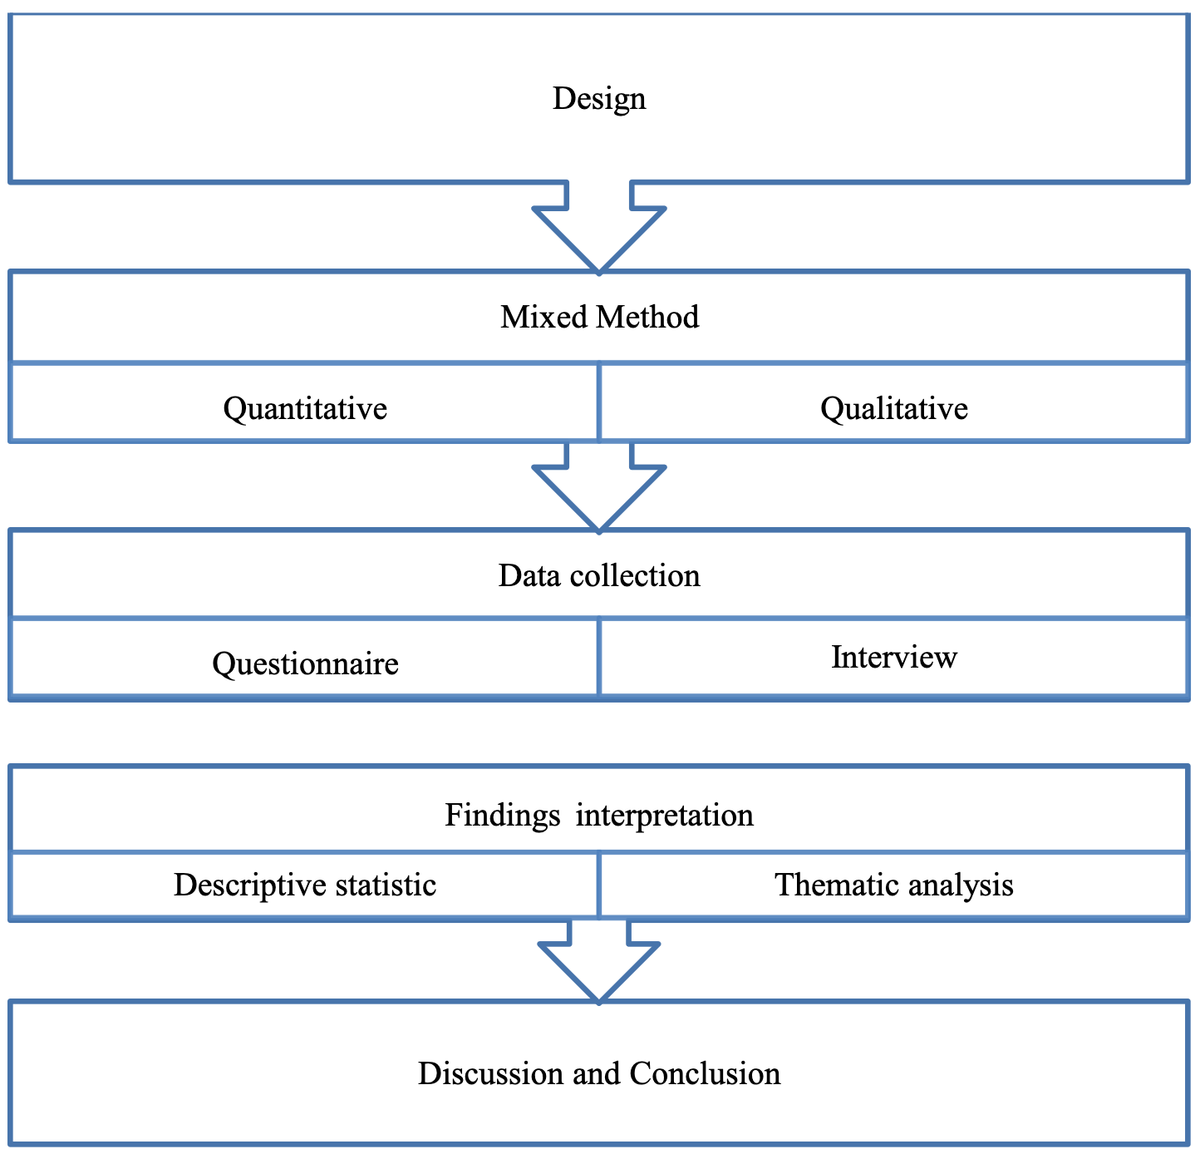

Figure 1: Research Design (Basir, 2015).

**References**

Almekhlafi, A. & Almeqdadi, F. (2010) Teachers’ Perceptions of Technology Integration in the United Arab Emirates School Classrooms. *Educational Technology & Society*. (13)1:165-175. Available from: <https://citeseerx.ist.psu.edu/viewdoc/download;jsessionid=7E06F3DD9A860BA7D75AA767CC0652BC?doi=10.1.1.183.5403&rep=rep1&type=pdf> [Accessed 18 October 2023].

Basir, B. (2015) Afghanistan students’ perceptions of the use of online tools for enhancing learning. *Core*. Available from: <https://core.ac.uk/display/159185726?utm_source=pdf&utm_medium=banner&utm_campaign=pdf-decoration-v1> [Accessed 17 October 2023].

Creswel, J. (1999) Mixed-Method Research: Introduction and Application. Handbook of Educational Policy. Available from: <https://www.sciencedirect.com/science/article/pii/B978012174698850045X> [Accessed 18 October 2023].

Dawadi, S., Shrestha, S. & Giri, R. (2021) Mixed-Methods Research: A Discussion on its Types, Challenges, and Criticisms. J*ournal of Practical Studies in Education*. 2(2):25-36. Available from: <https://files.eric.ed.gov/fulltext/ED611786.pdf> [Accessed 18 October 2023].

George, T. (2023) Mixed Methods Research. Definition, Guide & Examples. *Scribbr*. Available from: <https://www.scribbr.com/methodology/mixed-methods-research> [Accessed 18 October 2023].

Guillot, F. (2003) Teacher and student perceptions of online instructional methodology in higher education: an explanatory mixed-method study. Available from: <https://repository.lsu.edu/cgi/viewcontent.cgi?article=1155&context=gradschool_dissertations> [Accessed 18 October 2023].

Schoonenboom, J. & Johnson, R. (2017) How to Construct a Mixed Methods Research Design. *Kolner Zeitschrift fur Soziologie und Sozialpsychologie*, *69*(2):107–131. Available from: <https://doi.org/10.1007/s11577-017-0454-1> [Accessed 18 October 2023].