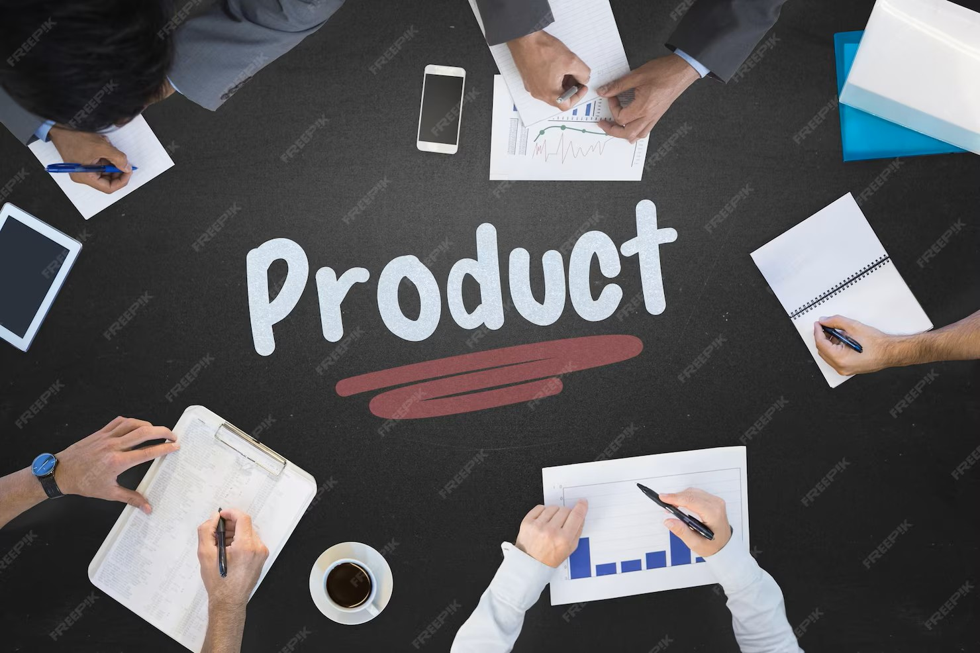

MyPanic

January 2026

Product Definition
  - Outline & Product Plan

MyPanic Safety System

Product Definition, Development Strategy, Manufacturing Plan, and Implementation Roadmap

Version 1
Project Specification Document
Date: January 2026
Prepared For: MyPanic Team

1. EXECUTIVE SUMMARY
MyPanic is a hybrid safety ecosystem consisting of:
- A mobile app, providing proactive, context-aware personal safety features, intelligent ride monitoring, community safety intelligence, and automated escalation logic.
- A wearable panic trigger (MyPanic Clip Alarm), a Bluetooth-enabled physical trigger that instantly activates the app’s safety protocols, designed for rapid, discrete activation.
Together, these products function as a connected, preventive, and responsive safety solution tailored for women’s everyday contexts (rides, meet-ups, transit, public spaces) and extend beyond reactive SOS apps by adding context awareness, predictive risk indicators, and community intelligence.
Primary objectives:
- Deliver a fully functioning MVP within a 6-month cycle.
- Establish local manufacturing and supply partnerships.
- Validate solution with pilots on university campuses and community organisations.
- Prepare for volume production by 12-15 months.

- PRODUCT FEATURES (DETAILED)

2.1 MyPanic App - Functional Specifications

Core MVP functionalities (Version 1):
- Instant SOS Activation
  - Via app button and via Bluetooth Clip Alarm trigger.
  - Sends live GPS location to trusted contacts.

- Trusted Contacts Module
  - Add/edit emergency contacts.
  - Customisable alert methods (SMS fallback, push).

- Live Tracking Session
  - Real-time location sharing link for responders.

- Ride Track
  - Users share ride service trip link.
  - Monitors route deviations, long stops, and unusual movement indicators.
  - Flags WHEN matched against community-reported drivers or risk patterns.

- Safety Trails
  - Users can pre-register meet-ups with expected check-ins.
  - Auto escalation on missed confirmations.
  - AI-powered Movement and routine analysis

- Incident Vault
  - Secure storage of profile links, screenshots, notes, and session metadata.

- Automatic Escalation Logic
  - Sensor fusion (GPS, accelerometer, BLE disconnect) triggers if user unresponsive.

Innovative context-aware features (Version 1/1.1):

- Auto Snatch Detection
  - Uses motion and Bluetooth state to infer forced phone removal.

- Nearby Sister Awareness
  - Silent proximity notifications to other opted-in MyPanic users within a set radius.
  - No identity revealed unless consented.

Planned (post-MVP) features:

- Driver/ride risk scoring based on aggregated flags.
- Integration with SafePoint Network (partner safe locations).
- Pattern analysis and risk heatmaps.

2.2 MyPanic Clip Alarm - Functional Specifications

Primary purpose:
A discreet, wearable panic trigger that sounds a loud siren alarm and instantly activates the core safety workflow in the app, even when the phone is locked or in a pocket.
Key functions:

- Bluetooth connection to paired smartphone (BLE)
- Single/double press logic to trigger SOS
- Haptic feedback on activation
- Low-power design for extended battery life
- QR printed on device linking to the user’s emergency profile (viewable on web when scanned)

Form factor targets:

- Clip-on design (bag/clothing)
- Lightweight (<30g)
- Simple LED/haptic indication

3. DEVELOPMENT ROADMAP & MILESTONES
This timeline is based on a dedicated small team (project manager, firmware engineer, app devs, designer) and local manufacturing partnerships for early prototyping.

Phase | Duration | Key Activities | Deliverables
Phase A - Planning & Specification | 2 weeks | Detailed requirements, hardware spec, software spec, risk analysis | Functional spec documents
Phase B - Hardware Design & Prototyping | 6 weeks | Select BLE module, design PCB, battery/switch/housing design | Prototype PCBs, initial firmware
Phase C - App MVP Development | 8 weeks (parallel) | Build core app features, API, ride track logic | Beta app build (Android first, then iOS)
Phase D - Hardware Integration & Firmware | 6 weeks | BLE pairing, SOS triggers, sensor integration | Firmware v0.9
Phase E - Local Fabrication & Assembly | 4 weeks | Prototype assembly via local EMS partners | 5-10 prototype units
Phase F - Testing & Validation | 6 weeks | Functional, stress, usability, field testing | Test reports, UX feedback
Phase G - Iteration & Quality Improvements | 4 weeks | Bug fixes, hardware adjustments | Release candidate MVP
Phase H - Pilot Deployment | 8 weeks | Campus/NGO pilot, monitoring | Pilot performance report
Total Duration: 6 months from start to pilot launch.

4. DEVICE COMPONENTS & PROCUREMENT
4.1 Critical Hardware Components
Component | Purpose
BLE SoC (Bluetooth Low Energy module) | Wireless link to phone
Microcontroller unit | Handles input & BLE communication
Rechargeable battery | Power source
Button + switch | User trigger
Haptic motor | Feedback
LED indicator | Status
Passive parts (resistors, caps) | Standard electronics
PCB board | Mounting and connections
Enclosure | Housing

Estimated approximate costs per unit (prototype quantities):

- BLE SoC: R35–R80
- MCU tier: R25–R60
- Battery + charge circuit: R30–R80
- Button & haptics: R15–R30
- PCB & assembly: R40–R120
- Enclosure (3D print prototype) R20–R60

Local procurement available from electronics stores like Leobot Electronics and Hobbytronics. (Leobot Electronics)

4.2 South African Component & PCB Sourcing
Local suppliers include:

- Deman Manufacturing - electronic components, SMT assembly, PCB procurement and supply. (deman-mfg.co.za)
- Leobot Electronics - microcontrollers, modules, sensors. (Leobot Electronics)
- Hobbytronics - basic electronic components and prototyping parts. (hobbytronics.co.za)
- Rabtron - components, tools, microcontrollers. (rabtron.co.za)

For PCBs:
- Repro Supplies - local PCB manufacture and assembly in Boksburg. (Repro Supplies)
- Procircuit - PCB supply and assembly services in Cape Town. (Procircuit)

EMS Partners for assembly/testing:
- Microtronix Manufacturing (Johannesburg) - turnkey assembly and quality control. (Microtronix Manufacturing)
- Jemstech (Centurion) - EMS for prototypes and low to medium volume. (jemstech.co.za)
- Production Logix (Pinetown) - high-standard PCB assembly and turnkey services. (Production Logix - Your design, on track)

These partners can provide:

- PCB assembly
- Surface mount technology (SMT)
- Through-hole assembly
- Proto and volume manufacturing

5. REQUIRED PARTIES & RESPONSIBILITIES

5.1 Internal Project Team

- Product Manager: Oversees planning, milestones, budget management
- Hardware Engineer: Designs hardware, selects components, liaises with EMS partner
- Firmware Engineer: To Write embedded software for Clip Alarm
- Mobile App Developers: Build app features (Android, iOS)
- UX/UI Designer: App interface, interaction design
- QA/Test Engineers: Verify hardware and software quality

5.2 External Partners

- EMS / PCB Assembly Partner: Repro Supplies / Deman / Microtronix / Procircuit / Jemstech for manufacturing
- Component Distributors: Deman / Leobot / Hobbytronics / Rabtron for parts
- Enclosure Fabricator: Local 3D printing shops or injection mould tooling partners
- Testing Labs (optional): For EMC/EMI testing if scaling beyond MVP

6. DESIGN & DEVELOPMENT FLOW

- Product requirements - hardware spec - schematic design
- PCB layout - fabrication - SMT assembly - prototype units
- Firmware development - BLE + feature integration
- App backend API + frontend builds
- Hardware and app integration testing
- Field testing with minor user group
- Iteration - pilot production - pilot deployment

7. TESTING & QUALITY
Levels of testing required:
- Functional prototype test
- BLE pairing reliability
- Activation latency tests
- Stress & environmental (drops, heat)
- Battery test under real usage
- App stability across devices
- Usability testing with female participants
Quality standards will be documented, and the production runs must include inspection reports (optical, functional).

8. PILOT DEPLOYMENT PLAN

Target groups:
- University campuses
- Women’s organisations
- Night-shift worker cohorts

Pilot scope:

- 50-100 Clip devices
- App release to limited participants
- User feedback collected through surveys
- Usage data analytics

Pilot duration: 8-12 weeks

- SCALE & PRODUCTION

After successful pilot:
- Refine BOM for cost reduction
- Move to injection moulded enclosure
- Scale EMS partner production for units 500-5,000
- Bulk component procurement for lower per-unit cost

10. RISKS & MITIGATION

Risk | Mitigation
BLE pairing instability | Firmware refinement & test devices
High local component cost | Blend local + international procurement
Manufacturing delays | Multiple EMS partners
Firmware bugs | Continuous integration + automated testing
Data privacy concerns | Secure design + compliance

11. COMPLIANCE & CERTIFICATION (LATER PHASE)
For scaling after MVP:
- Product safety standards
- FCC/CE for exporting
- EMC/EMI compliance

