Chat Application Report

App Developers:

Student Numbers - Names:
WDMDIL001 – Dillon Woodman
MTHNTU003 – Ntuthuko Mthiyane
GMDNKO003 – Nkosi Gumede

Brief Overview of Chat Application:

The chat application performs basic chat application functionality allowing communication between two clients and more, connected via sockets linked by a server following TCP protocol for communicating. Functionalities include: Reliable TCP Protocol socket connections from any client to server, allows for servers with different Ip addresses and different port numbers but default settings of these variables are provided to speed up connection. Helpful Instructions appear in the start of chat (when a client logs in) to inform the client how to make private messages (@UserName & Message), exit chat room ('/exit' command) and how to send a file to another user (sendFile @Client2 /home/username/Pictures/fileDirectory.jpg). Also, throughout chat session a user may enter '/help' command to display the instructions again. After each message sent by a user, the date and time that the message was sent and name of the user will appear next to the message. As expected, for public messages all clients logged on in the chat room at the time will be able to see the messages. However, for private messages only the user that the message is intended for will see the message. The latter is achieved as mentioned above by using the '@UserName' to specify to which user the message should be sent to. To leave '/exit' command is used by the leaving client and a message from the server will follow to confirm to the leaving client and those still in the chat room, that the client has logged out of the chat room. Also all other clients in the chat room will be notified of the client that has logged out. For further demonstrations on the ChatApp's functionality refer to the screen shots below of a live simulation of the chat application. The App developers (mentioned above) student numbers are used as user names in the chat application.

Screen Shots demonstrating ChatApp Functionalities :

Screen shot 1- setting up the server:(below) helpful messages displayed when entering wrong information. Allows user to continue with default settings or change it.
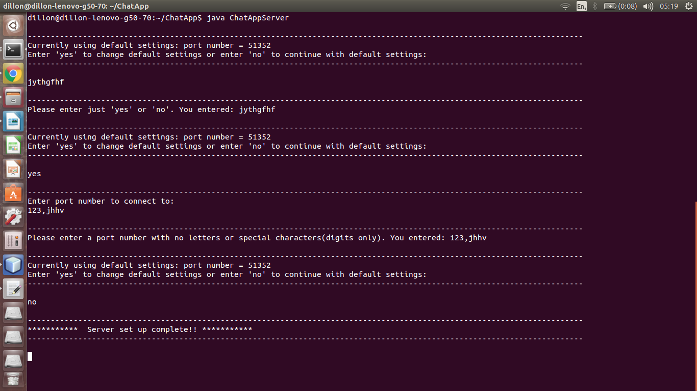
Screen shot 2- setting up the Client:(below) helpful messages displayed when entering wrong information(same as with server). Allows user to continue with default settings or change it. Ask name of user, displays welcome message and instructions for chat app.

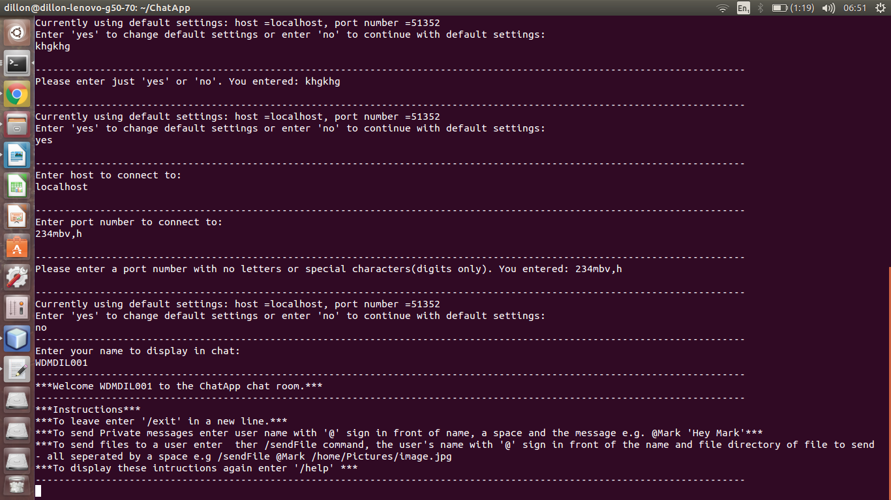

Screen shot 3- Multiple chats:(below) when new user in chat room it shows to the other clients. Public chat shown below in the screen shot as well as date time format when displaying messages.
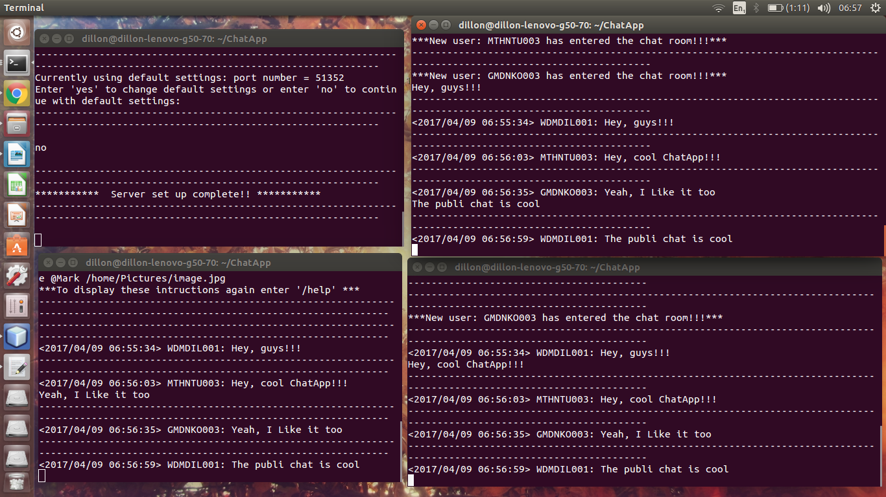
Screen shot 4- Private chats:(below) : Private chat example between top right client and bottom right client but bottom left client messages does not update.

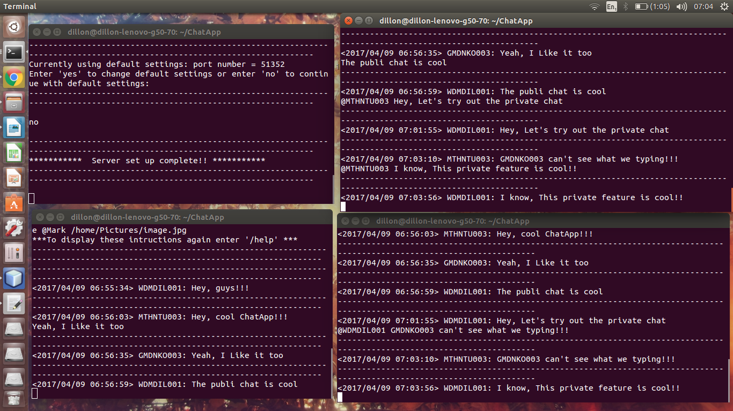
Screen shot 5- '/help' command:(below) Top right client calling '/help' command and list of instructions that appeared at the start of app is displayed. Also only displayed on the terminal that called the '/help' command.
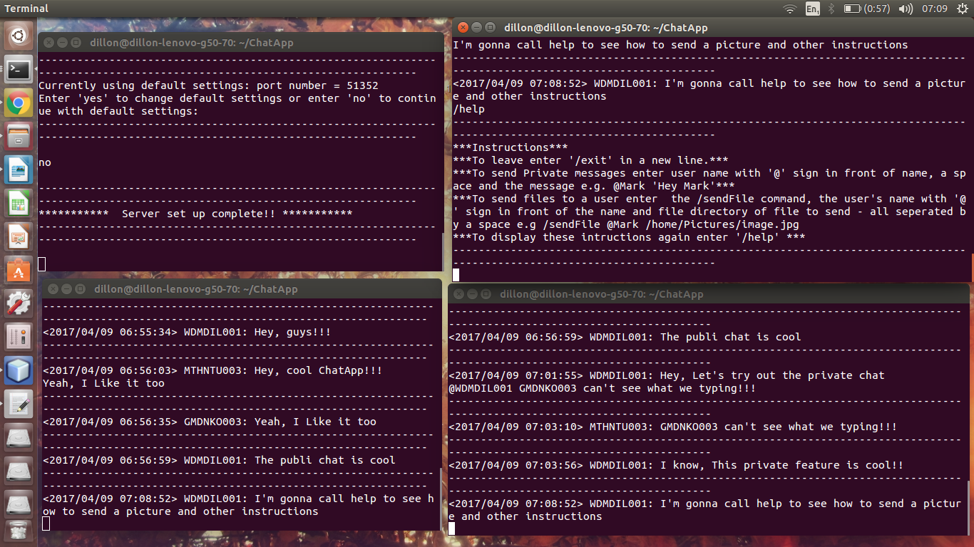
Screen shot 6- Sending Pictures:(below) : Picture (or any file) can be sent, follow the format for sending like top right client and messages update when server and intended client received the file, the size of the file and file name is also shown as it's being relayed through to the intended client. Server messages shows that the file that was saved on server has been deleted(more on this below) and requests are made by server for receiving client if s/he wants the file(picture) . Final messages showing that receiving client gets a folder created and file(picture) is in it and the sending client is notified that receiving client got the file(picture).
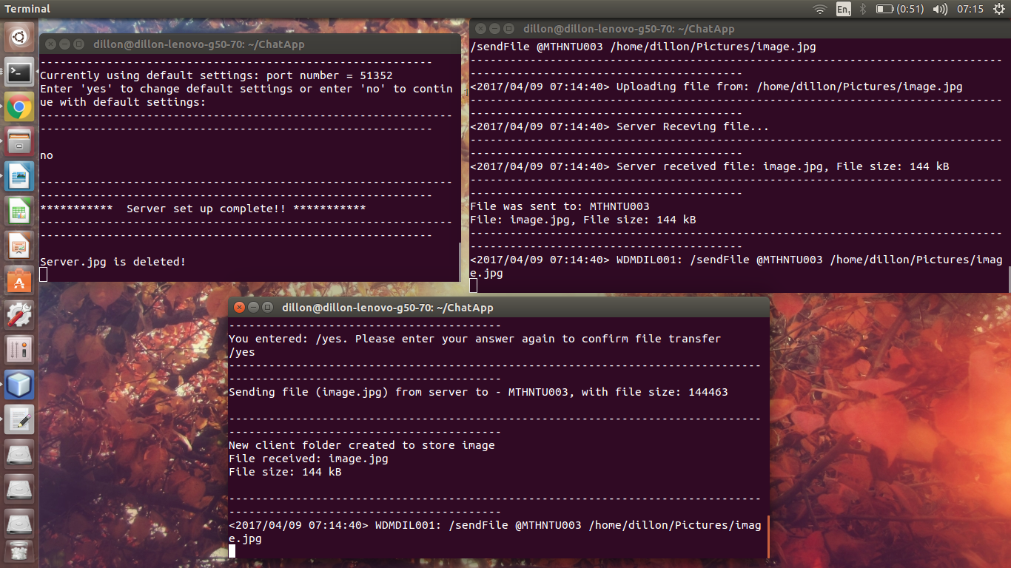
Screen shot 7- '/exit' command:(below) : As shown, the '/exit' command allows users to leave chat room. A message is displayed to both the leaving client's terminal and the other client's still in the chat room that the leaving client has logged out.
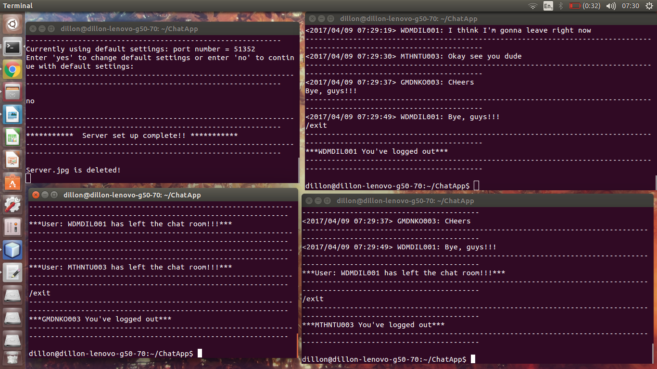

Functionality taking into account some bandwidth issue:

When sending the file from client 1 to client 2 over the server, the server temporally saves a each file it relays between clients. Once the receiving client fully receives the file or does not accept the file then the server deletes the file in it's file storage folder. To let the server delete the file was implemented because firstly keeping files of users without the permission of the user is illegal. Also, since multiple clients could send files at a time the server would then store several files causing it's storage folder to become more and more clogged. This would affect bandwidth as the speed of sending future files will decrease with more files filling up it's storage folder. Thus, it was decided to delete the file once sent or not accepted.

