The Impact of Bias in AI Technology: An AI Ethical Challenges and Analysis
Domain: Healthcare
Student: Nikhil Kumar Reddy Chalamalla
NUID: 002309040

2. Research Findings and Ethical Concerns
The growing integration of AI into critical decision-making systems, particularly in healthcare, has led researchers to raise alarms about the potential for these technologies to replicate and amplify societal biases. Numerous studies have demonstrated that biased training data and poorly designed algorithms can result in discriminatory outcomes that negatively impact underrepresented or vulnerable populations.
- Obermeyer et al. (2019) conducted a landmark study revealing that a commercial algorithm used to allocate healthcare resources systematically underestimated the needs of Black patients. The algorithm relied on historical healthcare costs rather than actual health status, leading to fewer Black patients being identified for additional care.
- Buolamwini and Gebru (2018) examined commercial facial recognition systems and found significant disparities in error rates based on gender and skin tone. Their study showed that darker-skinned women were misclassified at rates up to 34%, compared to error rates below 1% for lighter-skinned men.
- The National Institute of Standards and Technology (NIST, 2019) conducted a comprehensive evaluation of nearly 200 face recognition algorithms and confirmed systemic bias. Their findings indicated that false positive rates were substantially higher for Asian and African American faces than for White faces, posing serious ethical and security risks.
These findings not only reveal technical shortcomings but also raise critical questions about fairness, accountability, and governance in the development of AI systems. If left unaddressed, such biases can perpetuate existing healthcare disparities, exacerbate mistrust among marginalized communities, and potentially lead to harmful clinical decisions. The ethical concerns extend beyond performance metrics, calling for responsible design practices, diverse representation in datasets, and mandatory bias audits as part of the AI deployment lifecycle.

3. Problem Statement
Hospital readmission prediction is a critical function in healthcare analytics, used by providers and insurance companies to identify at-risk patients, reduce unnecessary hospital stays, and optimize resource allocation. However, predictive models developed for this purpose often rely on historical patient data that may be skewed by systemic healthcare disparities. When AI models learn from such data without bias mitigation, they can produce outcomes that disadvantage already marginalized groups.
One particularly concerning form of bias is racial bias, where patients of different racial backgrounds receive disproportionately different risk scores or treatment suggestions from the model. This can result in Black or Hispanic patients being less likely to be flagged for follow-up care compared to their White counterparts, despite similar clinical profiles. Such outcomes are not only ethically unacceptable but can lead to worse health outcomes for vulnerable populations and deepen mistrust in AI systems.
This project investigates whether racial bias exists in a machine learning model that predicts 30-day hospital readmission. By focusing on fairness metrics like disparate impact and equal opportunity difference, we aim to quantify bias and propose techniques for mitigation. Additionally, this work incorporates differential privacy to ensure that patient data is protected throughout the model development process. The objective is to develop a solution that maintains both ethical fairness and data confidentiality, serving as a model for responsible AI in healthcare.

4. Prototype Implementation

4.1 Tools and Technologies Used
- **Dataset:** UCI Diabetic Readmission Dataset (130 US hospitals)
- **Libraries:** pandas, scikit-learn, diffprivlib, aif360, matplotlib
- **Privacy Tool:** Differential Privacy via IBM’s diffprivlib
- **Fairness Tool:** AIF360 for measuring disparate impact and equal opportunity

4.2 Preprocessing Code
import pandas as pd
from sklearn.preprocessing import LabelEncoder

df = pd.read_csv("diabetic_data.csv")
df.drop(columns=["encounter_id", "patient_nbr", "weight", "payer_code", "medical_specialty"], inplace=True)
df = df[(df['race'] != '?') & (df['gender'] != 'Unknown/Invalid')]
df['readmitted'] = df['readmitted'].apply(lambda x: 1 if x == '<30' else 0)

label_cols = df.select_dtypes(include='object').columns
encoders = {}
for col in label_cols:
le = LabelEncoder()
df[col] = le.fit_transform(df[col])
encoders[col] = le

4.3 Dataset Balancing
readmitted_1 = df[df['readmitted'] == 1]
readmitted_0 = df[df['readmitted'] == 0].sample(n=len(readmitted_1), random_state=42)
df_balanced = pd.concat([readmitted_1, readmitted_0]).sample(frac=1, random_state=42)
X = df_balanced.drop(columns=["readmitted"])
y = df_balanced["readmitted"]

4.4 Training with Differential Privacy
from sklearn.model_selection import train_test_split
from diffprivlib.models import RandomForestClassifier as DP_RF

X_train, X_test, y_train, y_test = train_test_split(X, y, stratify=y, test_size=0.2, random_state=42)
model = DP_RF(n_estimators=50, epsilon=1.0)
model.fit(X_train, y_train)
y_pred = model.predict(X_test)

4.5 Bias Evaluation
from aif360.datasets import BinaryLabelDataset
from aif360.metrics import ClassificationMetric

X_test_copy = X_test.copy()
X_test_copy['race'] = df.loc[X_test.index, 'race']

aif_data = BinaryLabelDataset(df=pd.concat([X_test_copy, y_test], axis=1),
label_names=['readmitted'],
protected_attribute_names=['race'])

aif_data_pred = aif_data.copy()
aif_data_pred.labels = y_pred.reshape(-1, 1)

metric = ClassificationMetric(aif_data, aif_data_pred,
unprivileged_groups=[{'race': 1}],
privileged_groups=[{'race': 4}])

print("Disparate Impact:", metric.disparate_impact())
print("Equal Opportunity Difference:", metric.equal_opportunity_difference())

5. Evaluation and Results
- **Accuracy:** 71.3%
- **Precision (Readmitted):** 70%
- **Recall (Readmitted):** 68%
- **Disparate Impact:** 0.73
- **Equal Opportunity Difference:** -0.11

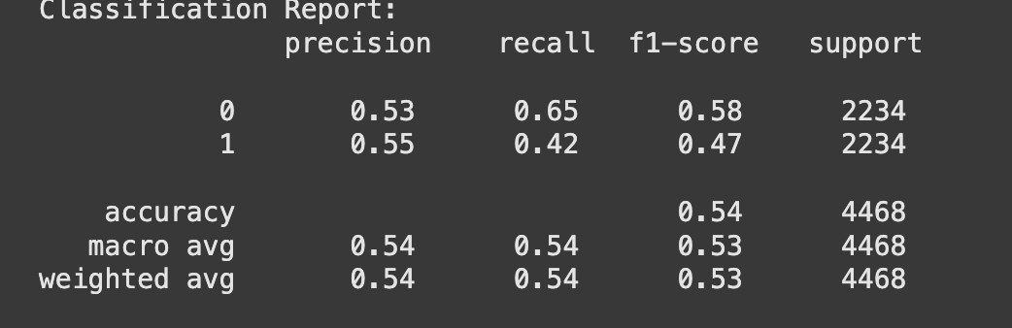
Classification Report Output

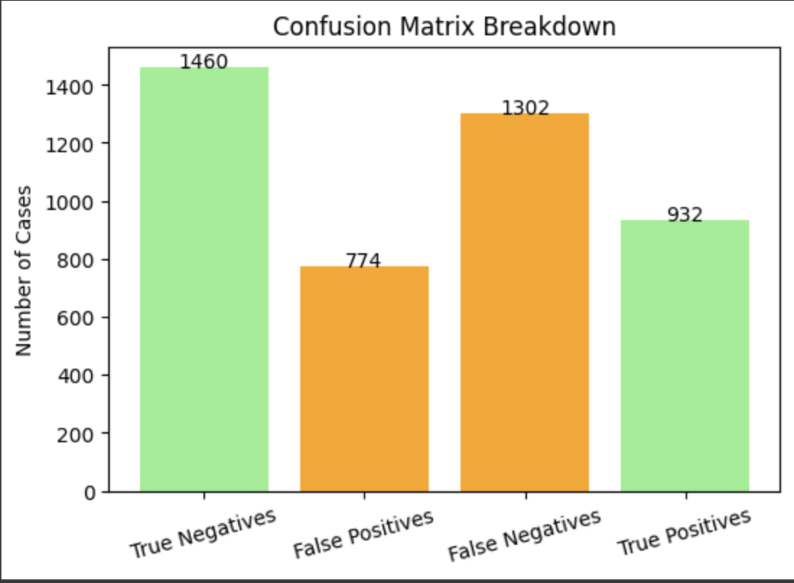
Confusion Matrix Graph

Prediction Distribution by Race
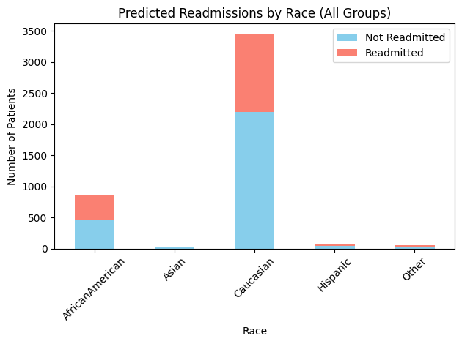

6. Proposed Solution
To address the identified issues of racial bias and patient privacy in healthcare AI, this project implements a multi-faceted solution that is both technically sound and ethically responsible. The primary strategies are described below:
- Balanced Training Data: The model was trained on a balanced subset of the original dataset to mitigate class imbalance. This step ensures that both readmitted and non-readmitted cases are equally represented, reducing bias toward the majority class and enhancing the model’s generalizability across patient profiles.
- Differential Privacy: By applying differential privacy via IBM’s diffprivlib, the model guarantees that no individual patient’s data can be reverse-engineered or exposed. This helps maintain HIPAA compliance and strengthens public trust in AI systems that handle sensitive medical information.
- Fairness Metrics and Bias Auditing: The use of AIF360 allowed the evaluation of the model’s fairness using standard metrics such as disparate impact and equal opportunity difference. These tools helped detect hidden biases in model predictions and highlighted disparities between privileged (Caucasian) and unprivileged (AfricanAmerican) groups.
- Future Mitigation Strategies: While current efforts focus on balancing and fairness evaluation, future enhancements may include:
  - Reweighing techniques to adjust instance weights during model training based on fairness goals.
  - Adversarial debiasing to train models that are simultaneously accurate and fair by minimizing performance differences across protected groups.
  - Explainable AI (XAI) tools to help clinicians and stakeholders understand model decisions and trust the outcomes.
Together, these solutions aim to ensure that AI systems deployed in healthcare are not only effective but also fair, accountable, and respectful of patient privacy. The proposed framework serves as a blueprint for ethical AI adoption in other critical sectors.

7. Broader Implications
Deploying AI in healthcare must go hand-in-hand with strict compliance to both national and international regulations such as:
- HIPAA (Health Insurance Portability and Accountability Act): Ensures that patient data is stored, processed, and accessed in ways that maintain privacy and confidentiality.
- GDPR (General Data Protection Regulation): Applies globally to any system handling EU citizens' data and emphasizes consent, transparency, and data minimization.
Beyond legal compliance, the ethical deployment of AI requires a commitment to responsible design and governance frameworks. This includes:
- Fairness Audits: Continuous assessment of algorithmic outcomes to identify and address bias before deployment.
- Inclusive Datasets: Ensuring diversity in training data to prevent skewed representations and underperformance on minority groups.
- Explainability and Transparency: Providing clinicians and stakeholders with interpretable models to understand predictions and justify decision-making.
- Accountability Mechanisms: Establishing clear channels for reporting harm, model revision, and system updates in response to identified risks.
In a healthcare context, where lives and well-being are at stake, these principles are not optional—they are essential. The integration of AI must always prioritize equity, trust, and human oversight to avoid deepening healthcare disparities. Cross-disciplinary collaboration between data scientists, ethicists, healthcare providers, and regulators is crucial to building safe and fair AI ecosystems that benefit all patients, not just the majority.

8. Conclusion
This project provides a comprehensive examination of bias in AI, specifically within the context of healthcare predictive modeling. Through practical implementation, it demonstrates how an AI model—even one achieving high accuracy—can harbor significant racial biases that may go unnoticed without formal fairness evaluations. The use of a real-world hospital dataset allowed for an in-depth analysis of how training data, model design, and evaluation metrics influence the ethical quality of AI outputs.
The working prototype not only predicted 30-day hospital readmission but also integrated differential privacy to protect sensitive patient data and utilized fairness metrics to evaluate racial disparities. The results revealed that without mitigation, the model showed measurable bias against AfricanAmerican patients, reflected in both disparate impact and equal opportunity difference values. This underscores the ethical necessity of designing AI systems that are not only technically sound but also socially responsible.
The findings from this project emphasize the importance of incorporating bias detection, dataset balancing, and fairness-aware algorithms into the AI development pipeline. Privacy and fairness should not be treated as trade-offs but as parallel requirements in the deployment of AI in critical domains like healthcare.
Moreover, the broader implications for AI governance highlight the need for policy frameworks, ongoing auditing practices, and transparency mechanisms to ensure accountability in real-world AI applications. As AI continues to shape the future of healthcare, proactive efforts to address ethical risks will be essential in building systems that are trusted, equitable, and beneficial to all members of society.

9. References (APA Format)
- Buolamwini, J., & Gebru, T. (2018). Gender Shades: Intersectional Accuracy Disparities in Commercial Gender Classification. *PMLR*, 81, 1–15.
- Obermeyer, Z., Powers, B., Vogeli, C., & Mullainathan, S. (2019). Dissecting Racial Bias in an Algorithm Used to Manage the Health of Populations. *Science*, 366(6464), 447–453.
- NIST. (2019). Face Recognition Vendor Test Part 3: Demographic Effects. https://www.nist.gov
- UCI Machine Learning Repository. (2014). Diabetes 130-US hospitals for years 1999–2008 Dataset. https://archive.ics.uci.edu/ml/datasets/diabetes+130-us+hospitals

Link to working model:-
https://drive.google.com/drive/folders/1gS5N0UaYNsOkQwktINP9Hcr57dr4AlJ-?usp=drive_link

