Itgalpura, Rajanukunte, Bengaluru - 560064

**School of Engineering**

A Project Report on

**LINE FOLLOWING DELIVERY ROBOT USING RASPBERRY-PI**

Submitted in partial fulfillment of the requirement for the course

Innovative Project Raspberry-pi using Python (**CSE 1003**)

By

Naveen k s

Under the supervision of

**Guide name: MS. TULIKA DUTTA**

**Designation: ASSISTANT PROFESSOR**

**Department: COMPUTER SCIENCE**

Dec-2022

**Abstract:**

**Line Following is one of the most important aspects of robotics. A Line Following Robot is an autonomous robot which is able to follow either a black line that is drawn on the surface consisting of a contrasting color. It is designed to move automatically and follow the line. The robot uses arrays of IR sensors to identify the line, thus assisting the robot to stay on the track. The array of two IR sensor makes its movement precise and flexible. The robot is driven by DC gear motors to control the movement of the wheels. The Raspberry-pi interface is used to perform and implement algorithms to control the speed of the motors, steering the robot to travel along the line smoothly. This project aims to implement the algorithm and control the movement of the robot by proper tuning of the control parameters and thus achieve better performance. It can be used industrial automated equipment carriers, small household applications, tour guides in museums and other similar applications, etc.**

**Hardware, Software and tools use:**

1. Raspberry-pi.
2. IR Sensor(2Nos).
3. DC Gear Motor.
4. L298D Motor Drive.
5. Chaises.
6. Power Bank.
7. Breadboard.
8. Jumper Wires.

**Software:**

1. import RPi.GPIO as IO
2. import time
3. IO.setwarnings(False)
4. IO.setmode(IO.BCM)
5. IO.setup(2,IO.IN) #GPIO 2 -> Left IR out
6. IO.setup(3,IO.IN) #GPIO 3 -> Right IR out
7. IO.setup(4,IO.OUT) #GPIO 4 -> Motor 1 terminal A
8. IO.setup(14,IO.OUT) #GPIO 14 -> Motor 1 terminal B
9. IO.setup(17,IO.OUT) #GPIO 17 -> Motor Left terminal A
10. IO.setup(18,IO.OUT) #GPIO 18 -> Motor Left terminal B
11. while 1:
13. if(IO.input(2)==True and IO.input(3)==True): #both while move forward
14. IO.output(4,True) #1A+
15. IO.output(14,False) #1B-
16. IO.output(17,True) #2A+
17. IO.output(18,False) #2B-
18. elif(IO.input(2)==False and IO.input(3)==True): #turn right
19. IO.output(4,True) #1A+
20. IO.output(14,True) #1B-
21. IO.output(17,True) #2A+
22. IO.output(18,False) #2B-
23. elif(IO.input(2)==True and IO.input(3)==False): #turn left
24. IO.output(4,True) #1A+
25. IO.output(14,False) #1B-
26. IO.output(17,True) #2A+
27. IO.output(18,True) #2B-
28. else:  #stay still
29. IO.output(4,True) #1A+
30. IO.output(14,True) #1B-
31. IO.output(17,True) #2A+
32. IO.output(18,True) #2B-

**Block diagram & Description:**

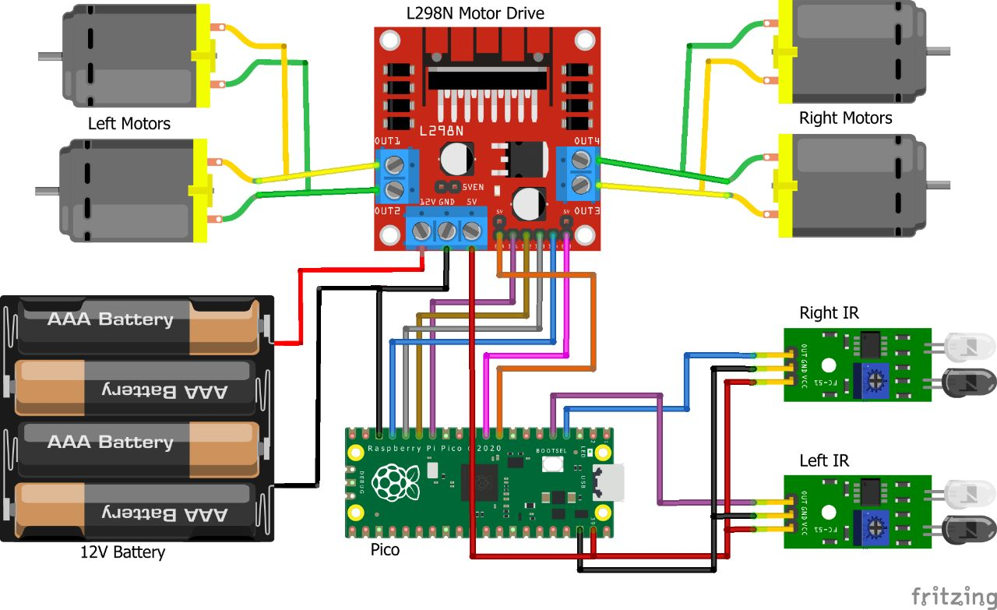

As you can see the circuit involves two IR sensor and a pair of motors connected to the Raspberry pi. The complete circuit is powered by a Mobile Power bank (represented by AAA battery in the circuit above).

As shown in the picture the top left corner pin of the PI is the +5V pin, we use this +5V pin to power IR sensors as shown in the circuit diagram (red wired). Then we connect the ground pins to the ground of the IR sensor and Motor Driver module using black wire. The yellow wire is used to connect the output pin of the sensor 1 and 2 to the GPIO pins and 3 respectively.

To drive the Motors, we need four pins (A,B,A,B). This four pins are connected from GPIO14,4,17 and 18 respectively. The orange and white wire together forms the connection for one motor. So we have two such pairs for two motors.

The motors are connected to the L293D Motor Driver module as shown in the picture and the driver module is powered by a power bank. Make sure that the ground of the power bank is connected to the ground of the Raspberry Pi, only then your connection will work.

**Results (Model’s image):**

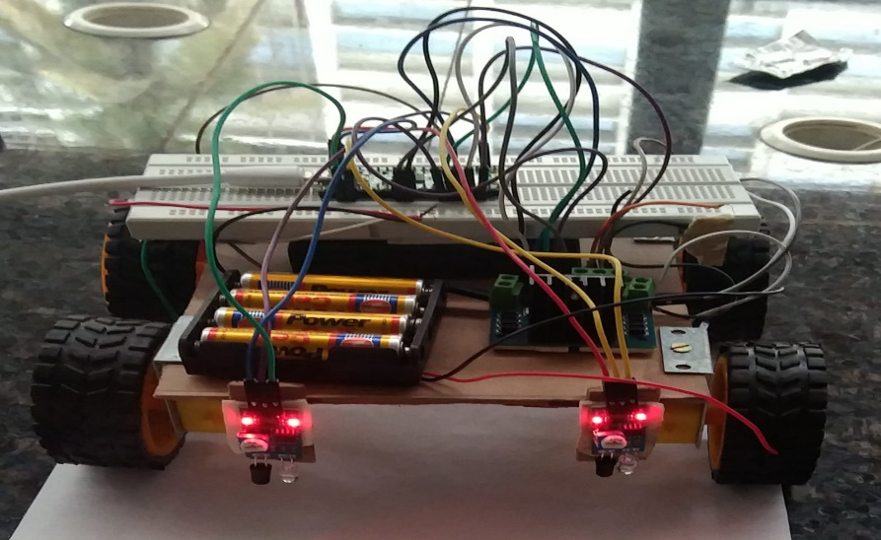

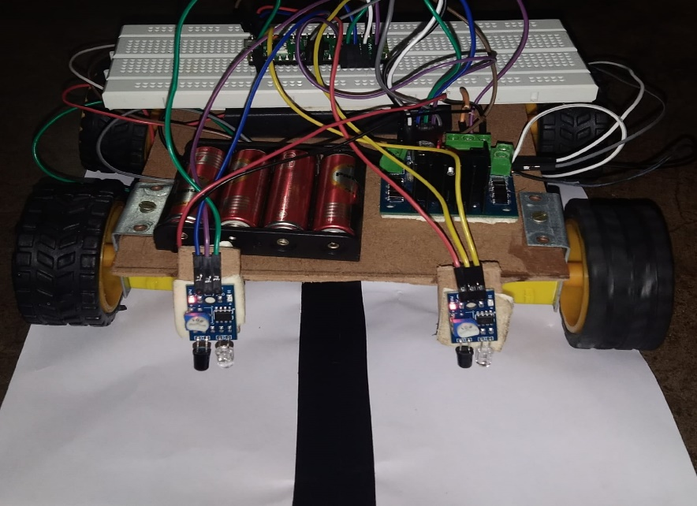

Line Follower Robot is able to track a line with the help of an IR sensor. This sensor has a IR Transmitter and IR receiver. The IR transmitter (IR LED) transmits the light and the Receiver (Photodiode) waits for the transmitted light to return back. An IR light will return back only if it is reflect by a surface. Whereas, all surfaces do not reflect an IR light, only white the color surface can completely reflect them and black color surface will completely observe them.

Now we will use two IR sensors to check if the robot is in track with the line and two motors to correct the robot if its moves out of the track. These motors require high current and should be bi-directional; hence we use a motor driver module like L293D. We will also need a computational device like Raspberry Pi to instruct the motors based on the values from the IR sensor .

These two IR sensors will be placed one on either side of the line. If none of the sensors are detecting a black line them they PI instructs the motors to move forward . Working of Raspberry Pi Line Follower Robot. If left sensor comes on black line then the PI instructs the robot to turn left by rotating the right wheel alone.Turning left to line follower robot using Raspberry Pi.If right sensor comes on black line then the PI instructs the robot to turn right by rotating the left wheel alone.Turning right to line follower robot. If both sensors comes on black line, robot stops.

**Challenges faced:**

* **The interaction was limited to online ,the communication was not efficient leading to delay in the selection of the project . Even the selected project at first was selected by another group causing further delay.**
* **Before the selection of the project title we have to know everything about the project title . It leads to delay in the selection of project.**
* **Challenge faced while executing the code for the project.**
* **Too many titles are there in the projects title list so it is hard to select the suitable title early.**

**Conclusion:**

**A Line Follower follows a black line wherever it goes. It used proximity sensors or IR sensors.A proximity sensor is a sensor able to detect the presence of nearby objects without any physical contact. A proximity sensor often emits an electromagnetic field or a beam of electromagnetic radiation (infrared, for instance), and looks for changes in the field or return signal.This sensor has a IR Transmitter and IR receiver. The IR transmitter (IR LED) transmits the light and the Receiver (Photodiode) waits for the transmitted light to return back. An IR light will return back only if it is reflect by a surface It can be used industrial automated equipment carriers, small household applications, tour guides in museums and other similar applications, etc.**