STUDY OF SIMILAR:
In order to design and develop the Easy Food Network platform effectively, it is essential to study existing systems that offer similar services in food donation and waste management. Platforms like Feeding America, Zomato Feeding India, No Food Waste, and Food Rescue US provide valuable insights into how online food redistribution networks operate. Feeding America is a large non-profit network that connects surplus food providers with food banks across the country, focusing heavily on logistics and large-scale distribution. However, Easy Food Network is different in its approach by directly connecting individual donors, delivery personnel, and NGOs through a unified digital platform with real-time tracking.
Zomato Feeding India operates by collecting food donations from restaurants and events to feed underprivileged communities, but it does not offer individual donor tracking or transparent delivery status. Easy Food Network fills this gap by ensuring visibility at every step. No Food Waste mainly focuses on minimizing food waste in Indian cities through food recovery vans. In contrast, Easy Food Network introduces a structured, user-driven model where donors can register, schedule donations, and track deliveries. Food Rescue US depends largely on volunteer drivers for pickups without real-time monitoring, while Easy Food Network uses delivery agents integrated with a tracking system for better efficiency.
Overall, studying these platforms helps shape Easy Food Network’s structure. While borrowing the strengths of existing systems, Easy Food Network introduces a transparent, scalable, and tech-driven model that empowers donors, delivery personnel, and NGOs to work together efficiently to reduce food wastage and hunger.

FEASIBILITY STUDY

2.2.1 Technical Feasibility

Technical feasibility assesses whether the proposed Easy Food Network project can be successfully implemented from a technical perspective.

Technical Expertise:

The project requires skills in HTML, PHP, JavaScript, and MySQL database management. Ensuring that the development team possesses expertise in web development, server management (XAMPP setup), and database design is crucial for the project's technical feasibility.

Hardware and Software Requirements:

It is essential to ensure that the specified hardware and software environments for both server-side and client-side (such as Windows 10 OS, XAMPP server, and MySQL Workbench) are available, properly configured, and compatible with the project's needs. Adequate RAM, processor capacity, and internet connectivity are necessary for optimal system performance.

2.2.2 Economic Feasibility

Economic feasibility assesses whether the Easy Food Network project is financially viable. Key considerations include:

Development Costs:

The development phase requires investment in basic hardware infrastructure, open-source software tools (XAMPP, MySQL), and potential professional services if needed for development, testing, or deployment.

Operational Costs:

Ongoing costs involve web server hosting, domain registration, database maintenance, and occasional system upgrades or support services. As the platform scales, costs for additional delivery coordination or logistics support may also arise.

2.2.3 Operational Feasibility

Operational feasibility evaluates whether the proposed Easy Food Network system can be smoothly integrated into real-world operations and meet organizational goals.

User Adoption:

The platform is designed to be user-friendly and intuitive for all stakeholders — donors, delivery personnel, and NGOs. Initial user training or awareness campaigns can further boost adoption. As food donation is a socially responsible activity, it is expected that potential users will be willing and motivated to adopt and actively use the application to contribute to reducing food wastage and fighting hunger.

OBJECTIVE OF PROPOSED SYSTEM

The objectives of the proposed system are as follows:

Facilitate Seamless Communication

The system aims to establish real-time communication between donors, delivery personnel, and NGOs. By integrating instant notifications and updates, the platform ensures that all stakeholders are kept informed throughout the donation and delivery process, minimizing miscommunication and delays.

Simplify the Donation Process

To encourage food donations, the system will provide an intuitive, user-friendly interface that allows individuals, businesses, and restaurants to easily initiate and manage donations. The goal is to make the act of donating surplus food quick, accessible, and hassle-free.

Enable Real-Time Tracking and Transparency

The platform will offer end-to-end tracking of food donations, from pickup to final delivery. This real-time visibility builds trust and accountability by ensuring that donors and NGOs can monitor the status and location of each donation.

Optimize Delivery Management

Efficient logistics management is key to reducing food spoilage. The system will automatically assign delivery personnel based on availability and location, ensuring timely collection and distribution of donated food items.

Maintain Accurate Records and Reports

A robust backend system will record all donation transactions and logistics activities. This ensures a transparent, auditable trail of data that can be used for reporting, analytics, and compliance with regulatory standards.

Encourage Community Participation

By lowering the barrier to entry for donors and streamlining the process, the system aims to foster a culture of giving and social responsibility. Community members will find it easy to contribute and make a tangible difference.

Reduce Food Wastage

Timely pickups and efficient distribution logistics will help minimize spoilage of perishable food items. The system is designed to respond quickly to donation requests and ensure food reaches those in need promptly.

Support Scalability and Growth

As the network expands, the platform will be equipped to handle increasing volumes of donors, NGOs, and delivery tasks. A modular, scalable architecture ensures that system performance remains optimal with growing usage.

Integrate Chatbot Support

To improve user engagement and support, a chatbot system will be implemented for instant query resolution and feedback collection. This reduces support overhead while enhancing the user experience.

Build a Sustainable Food Redistribution Network

The overarching goal is to create a long-term, reliable, and transparent solution to combat food insecurity. By connecting surplus food sources with distribution channels and recipients, the system contributes meaningfully to alleviating hunger and supporting vulnerable communities.

USERS OF THE SYSTEM

2.4.1 Admin

The Admin serves as the central authority of the Easy Food Network system, responsible for managing operations, ensuring smooth interaction between donors, delivery personnel, and NGOs.Admins ensure system security, resolve user conflicts, and maintain the transparency and integrity of the platform.

Key functionalities include:

Secure login and authentication.

Managing (viewing, verifying, updating, deleting) user profiles such as Donors, NGOs, and Delivery Personnel.

Assigning delivery personnel to specific food donations.

Monitoring all donation records and delivery activities.

Generating analytical reports on donation trends and delivery efficiency.

Managing user feedback and implementing platform improvements.

Facilitating communication between stakeholders to ensure seamless coordination.

2.4.2 Donor

Donors include individuals, restaurants, businesses, and organizations who offer surplus food for redistribution via the Easy Food Network platform.They play a key role in minimizing food waste and contributing to hunger relief.

Key functionalities include:

User registration and secure login.

Submitting details of available surplus food for donation.

Real-time tracking of food pickups and deliveries.

Viewing donation history and generating reports.

Receiving notifications on successful deliveries.

Providing feedback on the donation and delivery process.

2.4.3 Delivery Personnel

Delivery personnel are the bridge between donors and NGOs, ensuring safe and timely food transportation.They are tasked with collecting food from donors and delivering it to the designated NGOs.

Key functionalities include:

Secure registration and login.

Viewing assigned pickup and delivery tasks.

Updating statuses at each stage (picked up, delivered).

Receiving real-time notifications for new assignments.

2.4.4 NGO

NGOs (Non-Governmental Organizations) are the recipients and distributors of donated food.They ensure the food reaches the underprivileged and manage internal accountability.

Key functionalities include:

User registration and secure login.

Receiving food donations from delivery personnel.

Confirming and updating Admins about received donations.

Providing feedback on donation quality and quantity.

Maintaining a record of donation history for transparency and reporting.

SYSTEM REQUIREMENTS

3.1.1 Functional Requirements of Easy Food Network System

The functional requirements of the Easy Food Network System cover key operations needed to facilitate smooth interactions among Admins, Donors, Delivery Personnel, and NGOs.

A. User Registration and Authentication

Secure registration and login functionality for Admins, Donors, Delivery Personnel, and NGOs.

Password protection and role-based access control for different user types.

Email or phone verification during registration for authentication.

B. Donor Functionality

Donors can create, view, and update their profiles.

Donors can submit food donation details including type, quantity, and pickup location.

Donors can track the status of donations (e.g., pending, picked up, delivered).

Donors receive notifications when a donation is picked up or successfully delivered.

Donors can view donation history and submit feedback.

C. Delivery Personnel Functionality

Delivery Personnel can log in to view assigned pickups and deliveries.

They can update the status of food collection and delivery in real-time.

Receive alerts for new assignments and changes in delivery schedules.

Can communicate directly with Admin for issue resolution.

D. NGO Functionality

NGOs can receive donations and confirm the receipt in the system.

They can provide feedback on donation quality and quantity.

Maintain donation history for internal records and reporting.

E. Admin Functionality

Admins can manage user accounts (view, verify, update, or delete profiles).

Assign delivery personnel to specific food donations.

Monitor donation and delivery statuses via an Admin Dashboard.

Generate reports on donation trends, delivery statistics, and user feedback.

Oversee communication between stakeholders for streamlined operations.

Manage system improvements based on feedback collected.

3.1.2 Non-Functional Requirements of Easy Food Network System

Non-functional requirements describe the overall system quality, including performance, security, and usability aspects.

A. Performance

The system should respond to common actions (e.g., login, update, submit) within 2 seconds under normal load.

Efficient handling of concurrent operations without noticeable delay.

B. Scalability

Capable of accommodating an increasing number of users (Donors, NGOs, Delivery Personnel).

Handle growing donation entries and delivery operations without performance degradation.

C. Security

End-to-end encryption for user data and donation records.

Secure authentication mechanisms to prevent unauthorized access.

Regular security audits and compliance with data protection standards.

D. Usability

Clean, intuitive interface with easy navigation for all types of users.

Minimal training required for first-time users.

E. Maintainability

Modular and well-documented codebase for easy maintenance and upgrades.

Bug tracking and patch management for consistent performance.

F. Reliability

99.9% uptime with automatic failover and system recovery features.

Robust error handling to ensure uninterrupted operations.

G. Accessibility

Cross-platform compatibility: accessible via desktop, tablet, and mobile devices.

Optimized for low-bandwidth environments.

TABLE STRUCTURE

    - Table Name: User_table
Column Name | Datatype | Constraint | Description
User_Id | VARCHAR(20) | Primary Key | User ID
Name | VARCHAR(20) | Not Null | User Name
Email_id | VARCHAR(60) | Not Null | User Email
Mobile_no | Integer(10) | Not Null | User Mobile
Password | Text | Not Null | User Password

Table Name: Admin_Table

Column Name | Datatype | Constraint | Description
User_Id | VARCHAR(20) | Primary Key | User ID
Name | VARCHAR(20) | Not Null | User Name
Email_id | VARCHAR(60) | Not Null | User Email
Mobile_no | INTEGER(10) | Not Null | User Mobile
Password | TEXT | Not Null | User Password

Table Name: Orders_Table

Column Name | Datatype | Constraint | Description
Order_Id | INTEGER | Primary Key | Food Id
User_Id | INTEGER | Foreign Key | User Id
Delivery_Person_Id | INTEGER | Foreign Key | Delivery Person Id
Food_Type | VARCHAR(10) | NOT NULL | Food Type
Quantity | INTEGER | NOT NULL | Food Quantity
Date | DATETIME | NOT NULL | Deliver Date
Admin_Id | INTEGER | Foreign Key | Assigned to NGO or Organization

Table Name: Food_Details_Table

Column Name | DATATYPE | Constraint | Description
Order_Id | INTEGER | Primary Key | Food Id
User_Id | INTEGER | Foreign Key | User Id
Delivery_Person_Id | INTEGER | Foreign Key | Delivery Person Id

Table Name: Feedback_Table

Column Name | Datatype | Constraint | Description
FId | Varchar(20) | Primary Key | Feedback Id
User_Id | INTEGER | Foreign Key | User Id
Message | Text | Not Null | Feedback Message

Table Name: Delivery_Person_Table

Column Name | Datatype | Constraint | Description
Delivery_Person_Id | VARCHAR(20) | Primary Key | Delivery Person ID
Name | VARCHAR(20) | NOT NULL | Delivery Person Name
Email_id | VARCHAR(60) | NOT NULL | Delivery Person Email
Mobile_no | VARCHAR(10) | NOT NULL | Delivery Person Mobile_no
Password | INTEGER | NOT NULL | Delivery Person Password
City | VARCHAR(10) | NOT NULL | Delivery Person City

USE CASE DIAGRAM

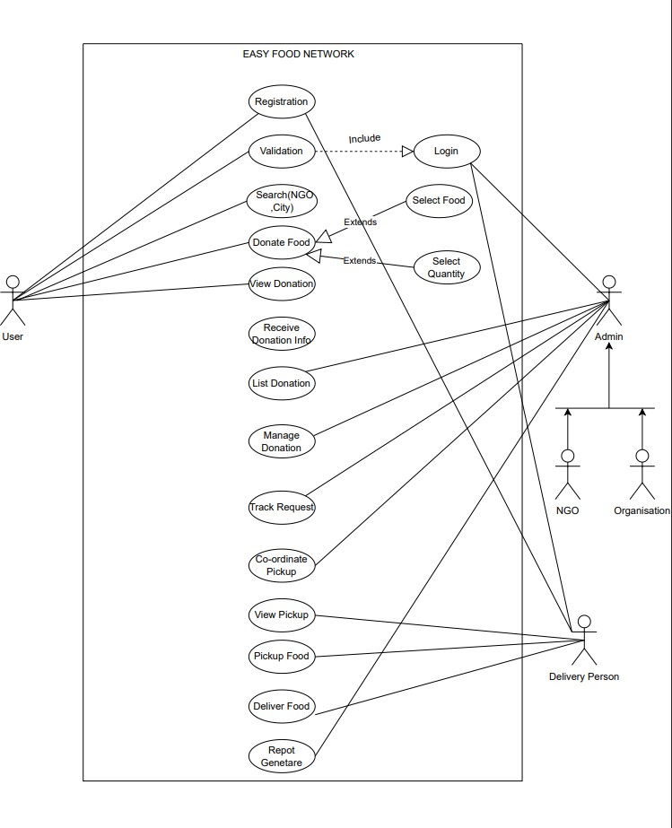

CLASS DIAGRAM

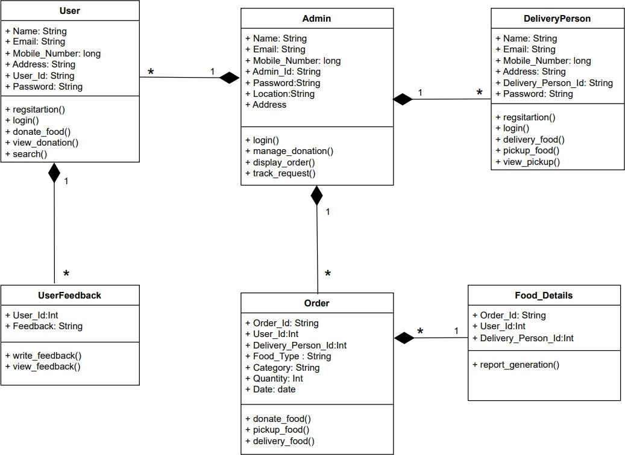

ENTITY RELATIONSHIP DIAGRAM

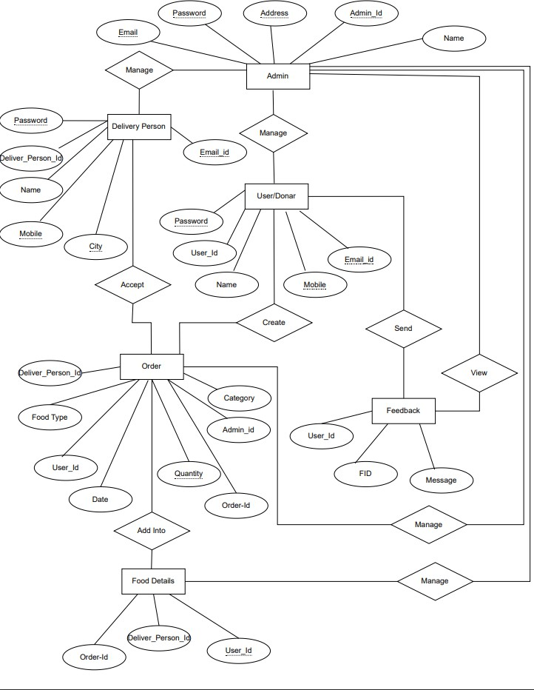

DEPLOYMENT DIAGRAM

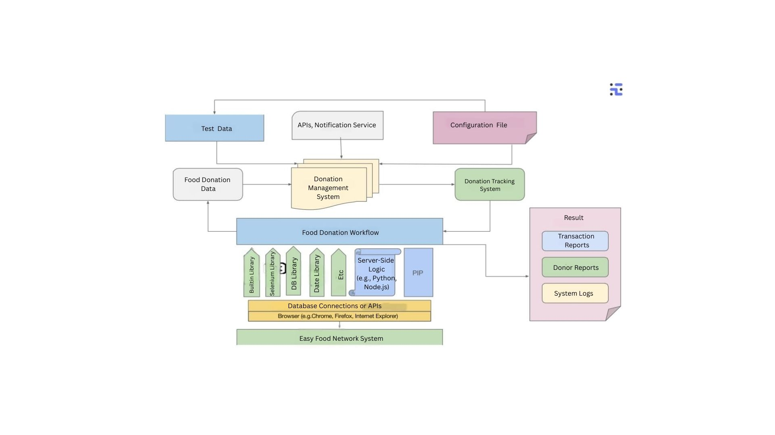

ACTIVITY DIAGRAM

User

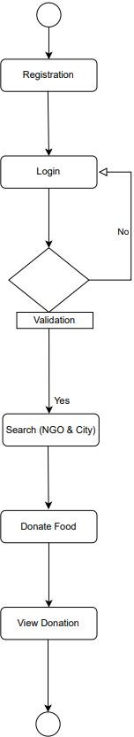

DELIVERY PERSON

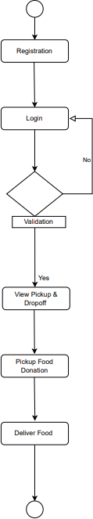

3.7.3 ADMIN
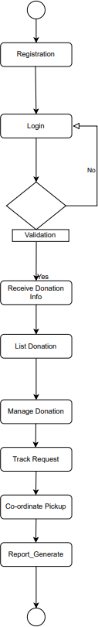

  - SEQUENCE DIAGRAM

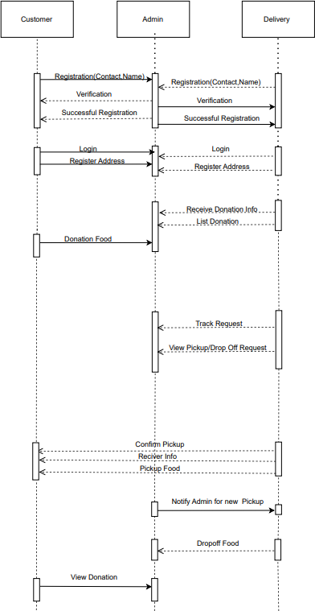

  - MODULE HIERARCHY DIAGRAM

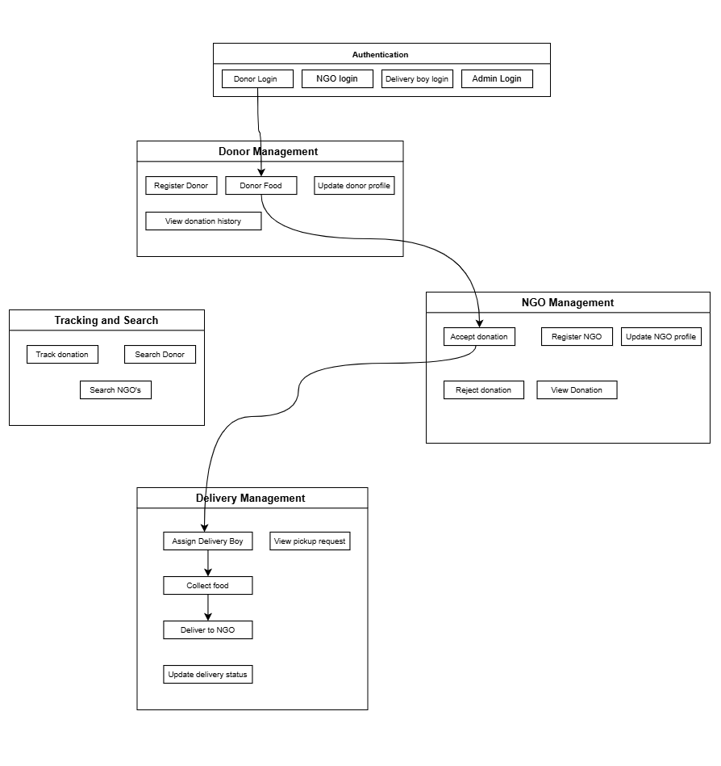

  - SAMPLE INPUT AND OUTPUT SCREENS

    - User Interface Screens

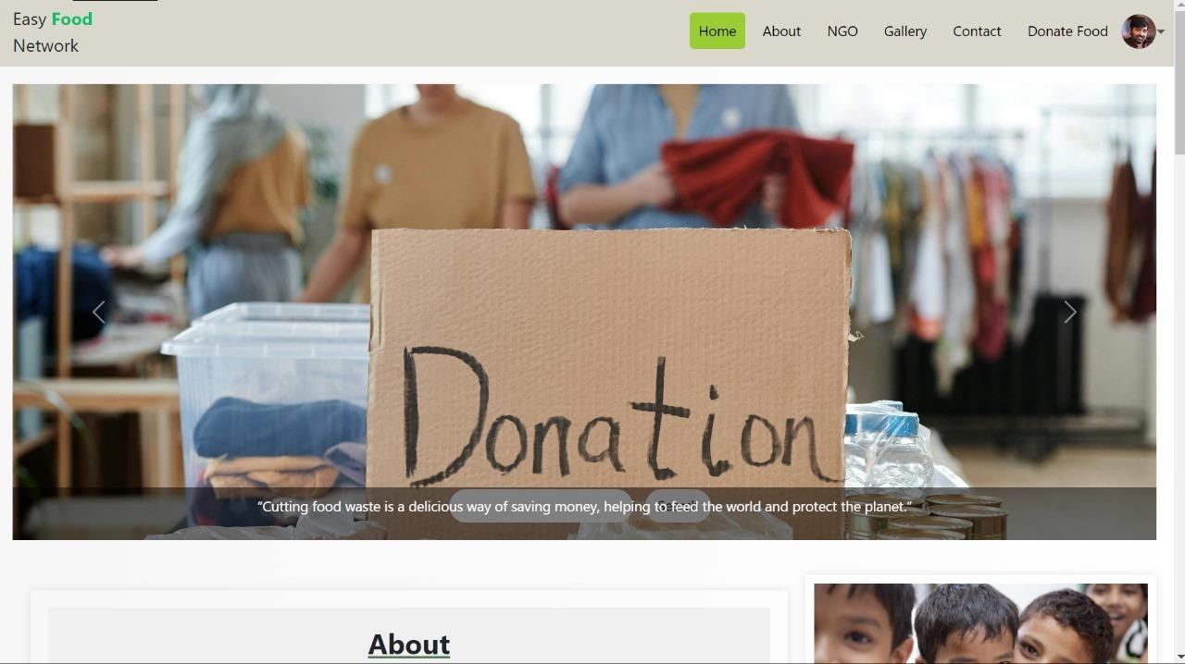

    - Registration Page

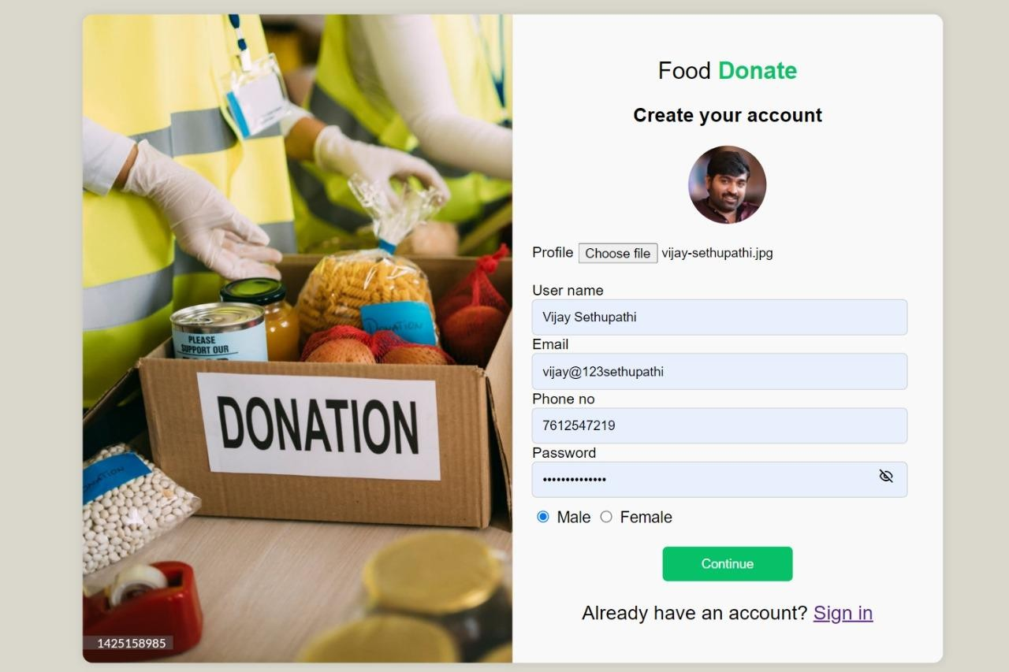

    - Login Page

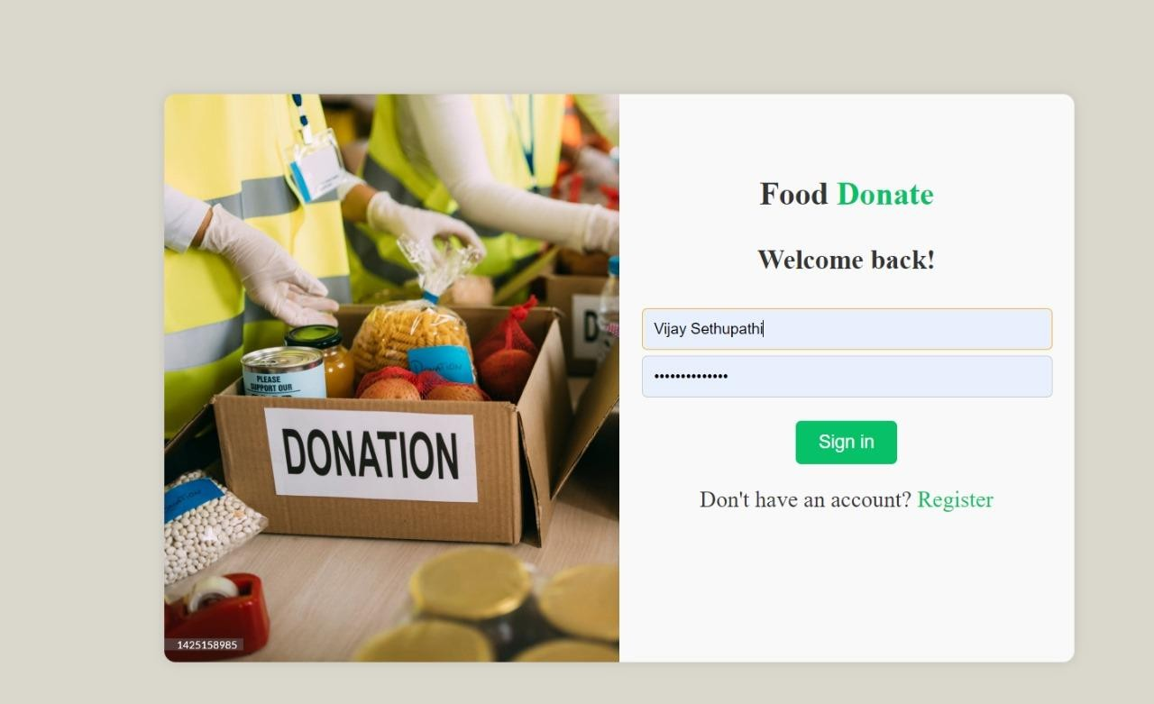

    - Recent Order

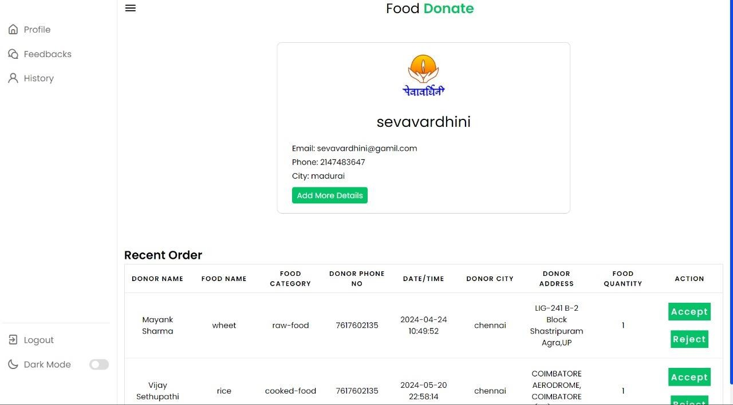

    - Profile

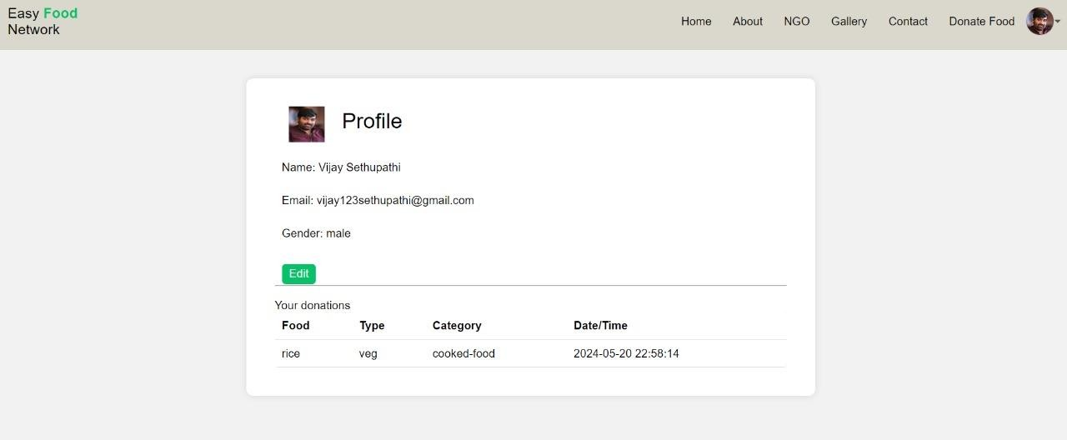

    - Admin Page

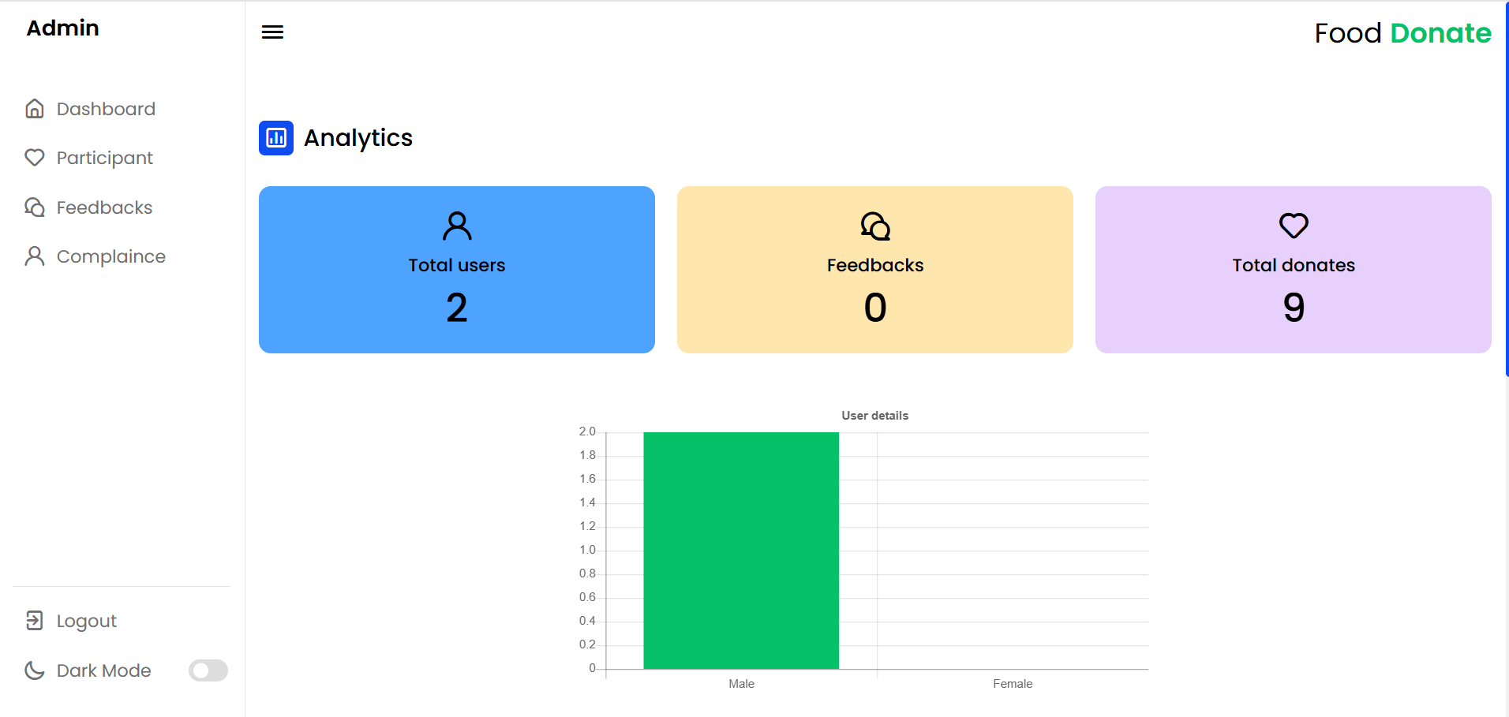

    - Delivery Hisory Page

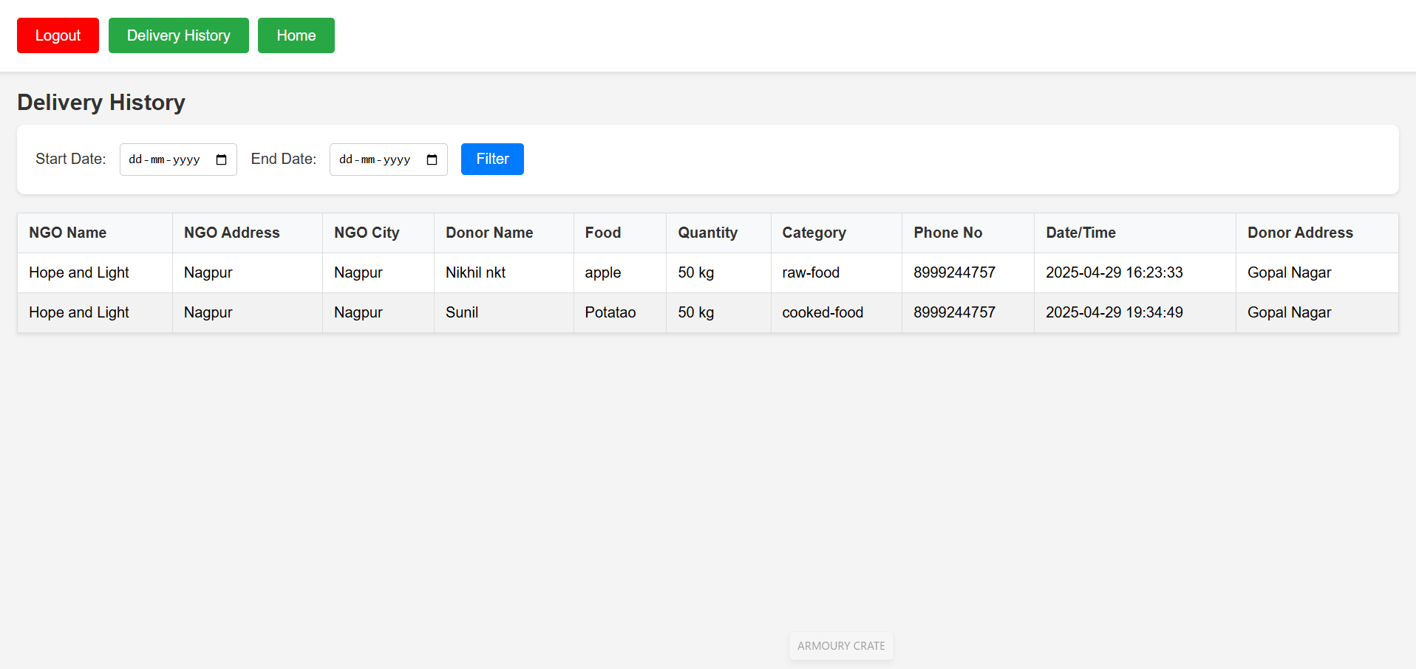

    - Food Donation Page

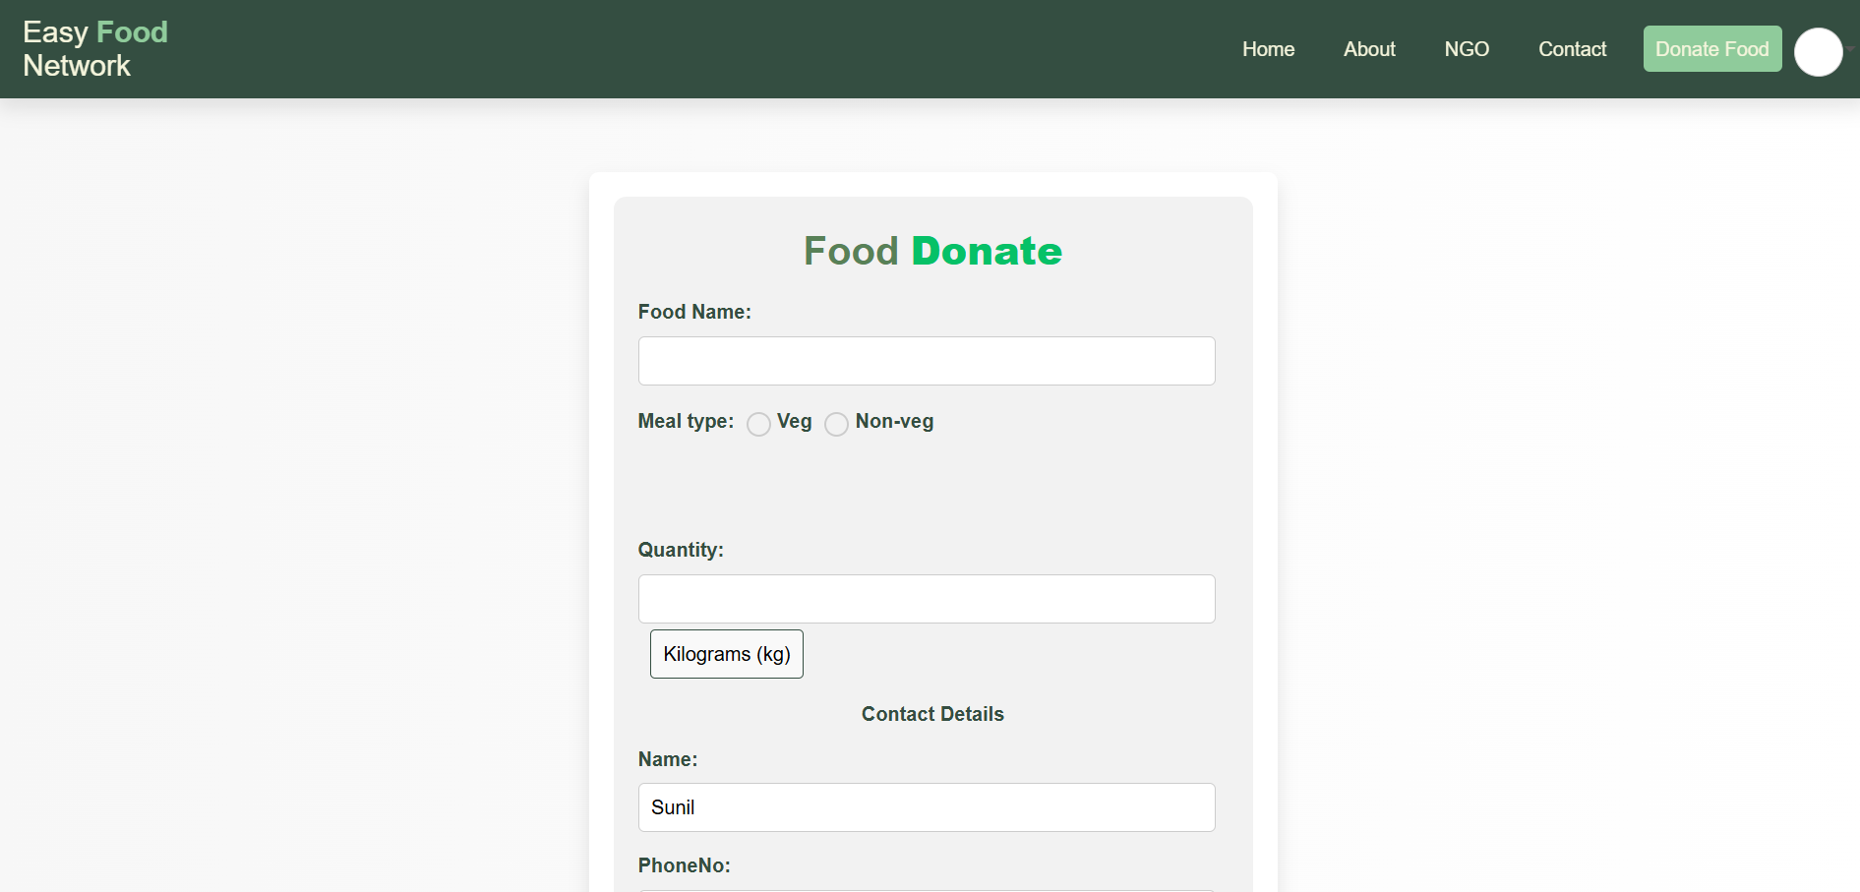

    - Home Page

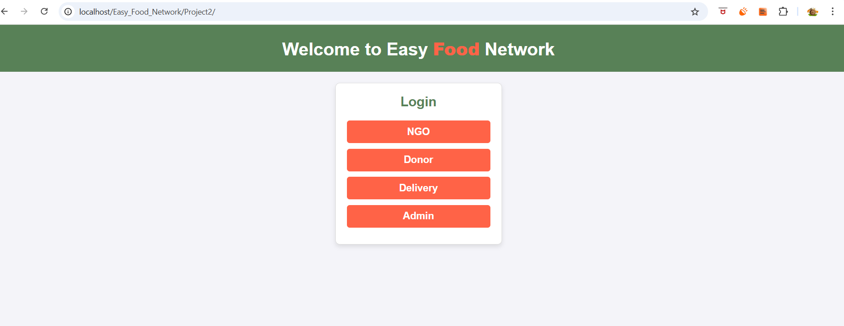

    - NGO Profile Page

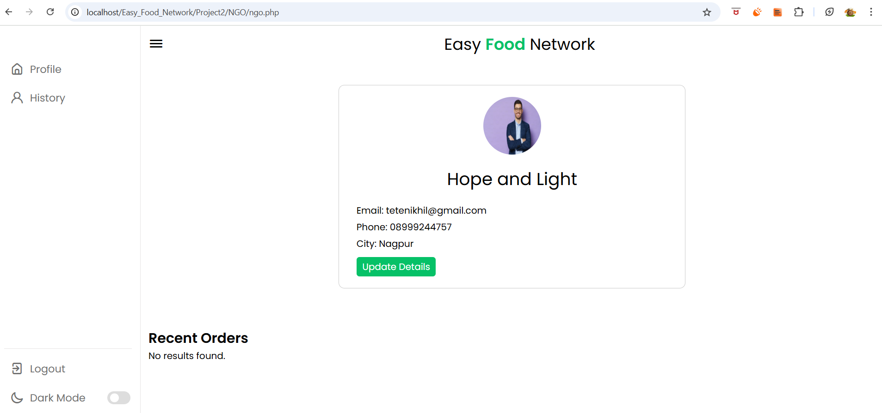

    - NGO History Page

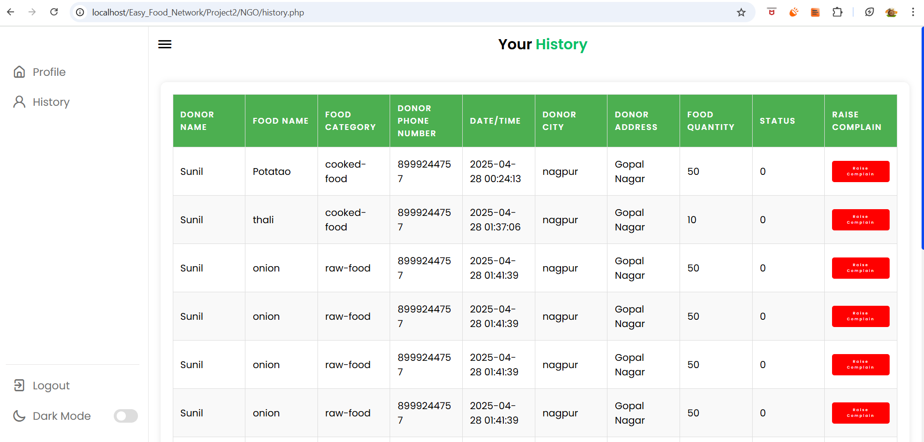

    - About Us Page

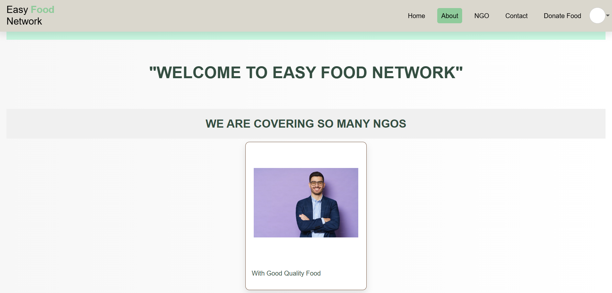

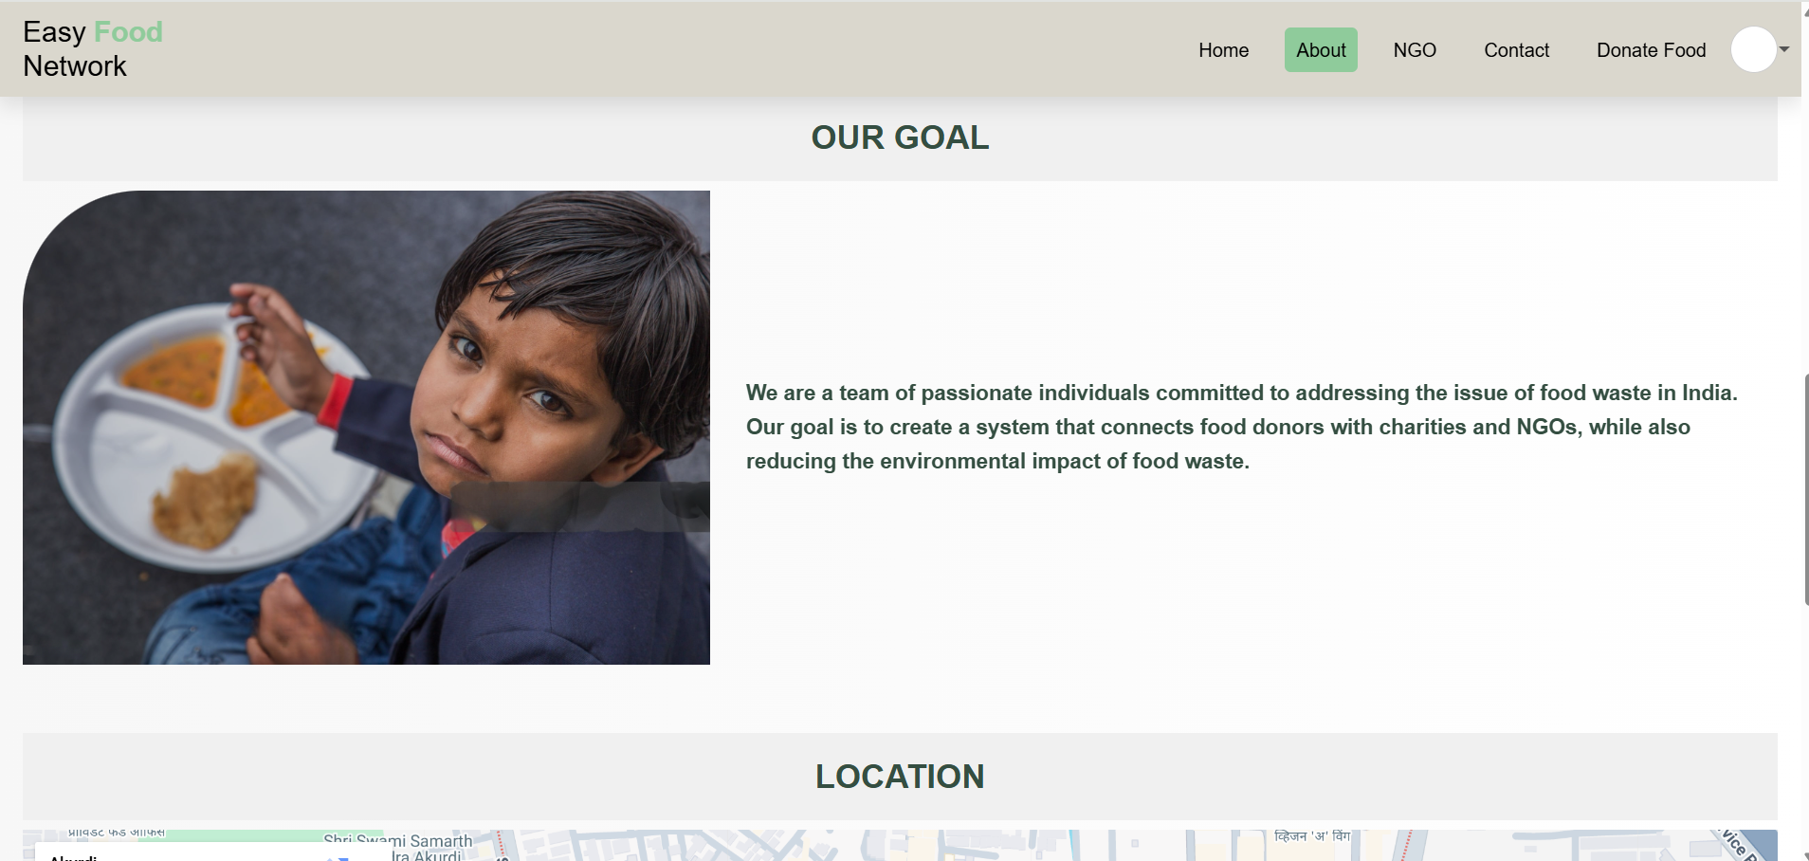

    - Contact Us Page

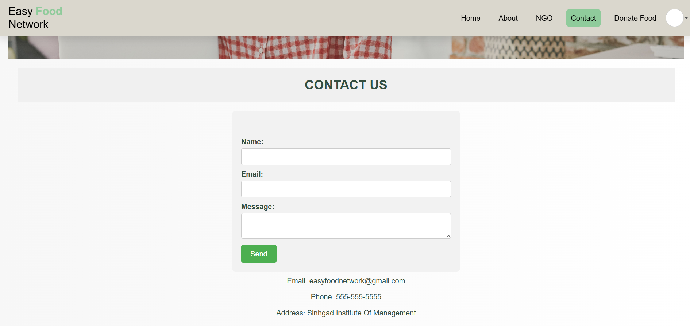

    - ChatBot Support Page

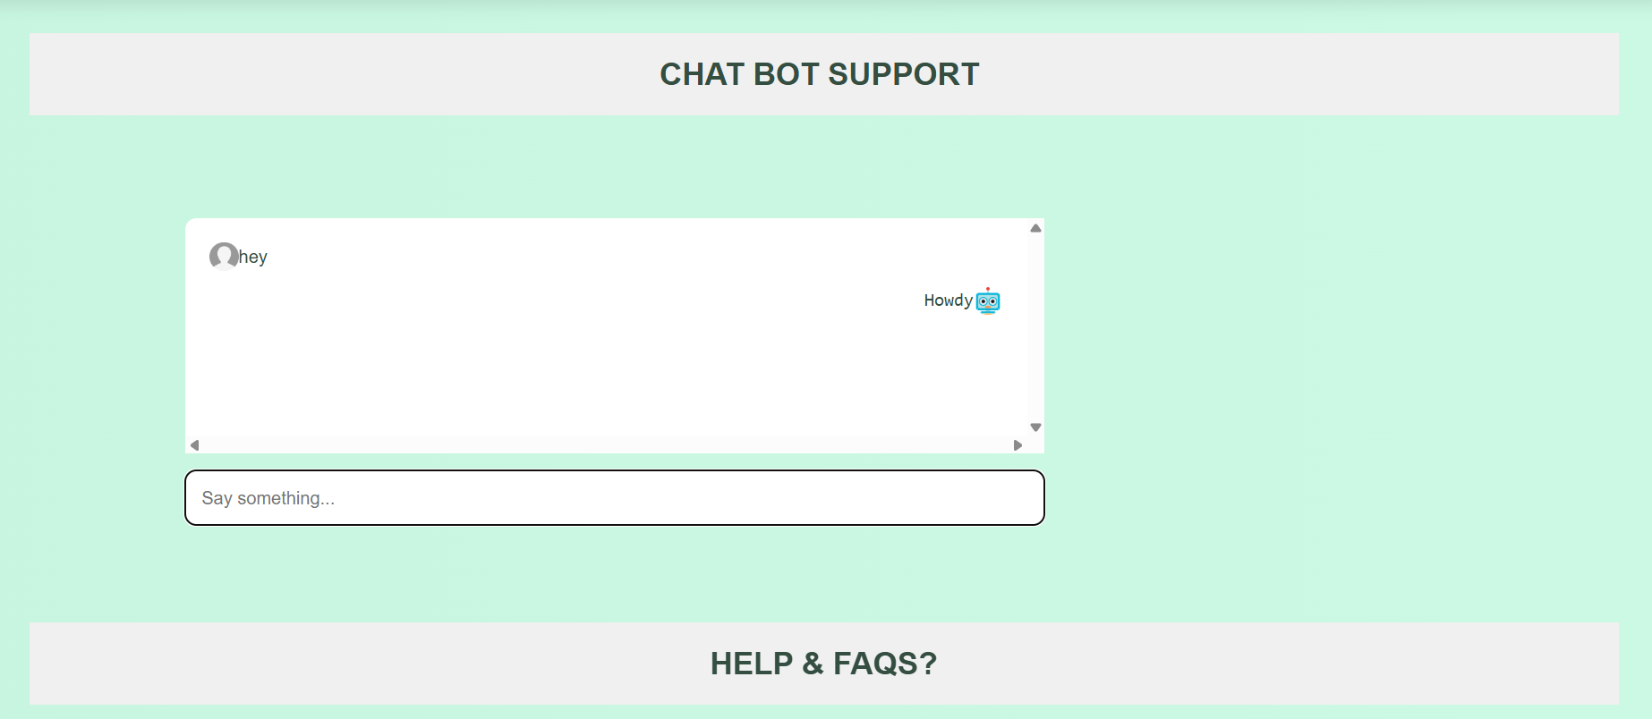

4.1 CODE SNIPPETS

NGO Login:
<?php
include '../connection.php';
$msg = 0;
session_start();
if (isset($_POST['signin'])) {
$email = mysqli_real_escape_string($connection, $_POST['email']);
$password = mysqli_real_escape_string($connection, $_POST['password']);

$sql = "SELECT * FROM ngo WHERE email='$email'";
$result = mysqli_query($connection, $sql);
$num = mysqli_num_rows($result);

if ($num == 1) {
$row = mysqli_fetch_assoc($result);
if (password_verify($password, $row['password'])) {
$_SESSION['ngo_email'] = $email;
$_SESSION['ngo_id'] = $row['id'];
$_SESSION['ngo_name'] = $row['name'];
$_SESSION['ngo_phone'] = $row['phone'];
$_SESSION['ngo_city'] = $row['city'];
header("location:ngo.php");
exit;
} else {
$msg = 1;
}
} else {
$msg = 2;
}
}
?>
<!DOCTYPE html>
<html lang="en">

<head>
<meta charset="UTF-8">
<meta name="viewport" content="width=device-width, initial-scale=1.0">
<title>Signin</title>
<style>
/* Import Google Fonts */
@import url('https://fonts.googleapis.com/css2?family=Poppins:ital,wght@0,200;0,300;0,500;0,700;0,800;1,400;1,600&display=swap');

/* Global Styles */
:root {
--navcolor: #dad7cd;
--navfont: black;
--green: #588157;
--light-green: #8FCB9B;
--dark-green: #344E41;
--brown: #6F4E37;
--beige: #F5F5DC;
--box-shadow: 0 .5rem 1rem rgba(0, 0, 0, 0.1);
--font-family: 'Roboto', 'Poppins', 'Oxygen', 'Ubuntu', 'Cantarell', 'Fira Sans', 'Droid Sans', 'Helvetica Neue', Arial, Helvetica, sans-serif;
}
.txt_field input:focus~span::before,
.txt_field input:valid~span::before {
width: 100%;
}
}
<?php if ($msg == 2) {
echo "<h1 id='error-message' style='postion:fixed;top:0;z-index:10000; text-align: center;'>Account does not exist</h1>"
;
echo "<script>
setTimeout(function () {
var errorMessage = document.getElementById('error-message');
if (errorMessage) {
errorMessage.style.display = 'none';
}
}, 5000); // 5 seconds
</script>";
} ?>
<div class="center">
<h1>NGO Login</h1>

<form method="post">
<div class="txt_field">
<input type="email" name="email" required />
<span></span>
<label>Email</label>
</div>
<div class="txt_field">
<input type="password" name="password" required />
<span></span>
<label>Password</label>
</div>
<div class="icon">
<i class="uil uil-eye-slash showHidePw"></i>
</div>
<?php
if ($msg == 1) {
echo ' <i class="bx bx-error-circle error-icon"></i>';
echo '<p class="error">Password not match.</p>';
}
?>
<br>
<!-- <div class="pass">Forgot Password?</div> -->
<input type="submit" value="Login" name="signin">
<div class="signup_link">Not a member? <a href="ngosignup.php">Signup</a></div>

</form>

</div>
</body>

NGO Registration:
<?php
include '../connection.php';

if ($_SERVER["REQUEST_METHOD"] == "POST" && isset($_POST['signup'])) {
// Retrieve form data
$ngo_name = $_POST['ngo_name'];
$ngo_email = $_POST['ngo_email'];
$ngo_phone = $_POST['ngo_phone'];
$ngo_city = $_POST['ngo_city'];
$ngo_address = $_POST['ngo_address'];
$ngo_password = $_POST['ngo_password'];

// Hash the password
$ngo_password_hashed = password_hash($ngo_password, PASSWORD_DEFAULT);

// Process uploaded photo
if (isset($_FILES['ngo_photo']['tmp_name']) && $_FILES['ngo_photo']['tmp_name'] != "") {
$photo_tmp = $_FILES['ngo_photo']['tmp_name'];
$photo_data = addslashes(file_get_contents($photo_tmp)); // Convert image to binary data
} else {
$photo_data = "";
}

// Check if the NGO email already exists
$check_query = "SELECT email FROM login WHERE email = '$ngo_email' UNION SELECT email FROM ngo WHERE email = '$ngo_email'";
$result = mysqli_query($connection, $check_query);
$num = mysqli_num_rows($result);
if ($num > 0) {
echo "<h1 id='message' style='position:absolute; z-index:1; top:0px; width:100%; text-align:center; color:red; display:none;'>Account already exists</h1>";
echo "<script>
document.getElementById('message').style.display = 'block';
setTimeout(function() {
window.location.href = 'ngosignup.php';
}, 3000); // Redirect after 3 seconds
</script>";
} else {
$sql = "INSERT INTO ngo (name, email, phone, city, address, password, photo) VALUES ('$ngo_name', '$ngo_email', '$ngo_phone', '$ngo_city', '$ngo_address', '$ngo_password_hashed', '$photo_data')";

if (mysqli_query($connection, $sql)) {
echo "<script>alert('NGO registered successfully.'); window.location.href = 'ngosignin.php';</script>";
exit(); // Prevent further execution
} else {
echo "Error: " . $sql . "<br>" . mysqli_error($connection);
}
}
}
mysqli_close($connection);
?>

<!DOCTYPE html>
<html lang="en">

<head>
<meta charset="UTF-8">
<meta name="viewport" content="width=device-width, initial-scale=1.0">
<title>NGO Registration</title>
<style>
/* Import Google Fonts */
@import url('https://fonts.googleapis.com/css2?family=Poppins:ital,wght@0,200;0,300;0,500;0,700;0,800;1,400;1,600&display=swap');

/* Global Styles */
:root {
--navcolor: #dad7cd;
--navfont: black;
--green: #588157;
--light-green: #8FCB9B;
--dark-green: #344E41;
--brown: #6F4E37;
--beige: #F5F5DC;
--box-shadow: 0 .5rem 1rem rgba(0, 0, 0, 0.1);
--font-family: 'Roboto', 'Poppins', 'Oxygen', 'Ubuntu', 'Cantarell', 'Fira Sans', 'Droid Sans', 'Helvetica Neue', Arial, Helvetica, sans-serif;
}
<div class="center">
<h2>NGO Registration Form</h2>
<div class="circular-image" id="previewImage" style="background-image: url('../default.png');"></div>

<form action="" method="post" enctype="multipart/form-data" onsubmit="return validateForm()">
<div class="txt_field">
<input type="file" id="ngo_photo" name="ngo_photo" accept="image/*" onchange="previewPhoto()" required>
<br><br>
<span></span>
</div>
<div class="txt_field">
<input type="text" id="ngo_name" name="ngo_name" required oninput="checkForm()">
<input type="hidden" id="hiddenName" name="ngo_name" />
<span></span>
<label class="hide">NGO Name</label>
</div>

<div class="txt_field">
<input type="email" id="ngo_email" name="ngo_email" required oninput="checkForm()">
<input type="hidden" id="hiddenEmail" name="ngo_email" />
<span></span>
<label class="hide">Email</label>
</div>

<div class="txt_field" id="otpField" style="display:none; margin-bottom: 25px;">
<input type="text" name="otp" id="otp" placeholder="Enter OTP" required>
<span></span>
<label for="otp" style="top: -10px; font-size: 12px;">OTP</label>
</div>

<button type="button" id="sendBtn">Send OTP</button><br>
<button type="button" id="verifyBtn">Verify</button><br>

<div class="txt_field" style="display:none;">
<input type="tel" id="ngo_phone" name="ngo_phone" required>
<span></span>
<label>Phone Number</label>
</div>

<div class="txt_field" style="display:none;">
<select id="ngo_city" name="ngo_city" style="padding:10px; padding-left: 20px;" required>
<option value="mumbai">Mumbai</option>
<option value="pune">Pune</option>
<option value="nagpur">Nagpur</option>
<option value="nashik">Nashik</option>
<option value="thane">Thane</option>
<option value="aurangabad">Aurangabad</option>
<option value="solapur">Solapur</option>
<option value="ratnagiri">Ratnagiri</option>
<option value="kolhapur">Kolhapur</option>
<option value="satara">Satara</option>
<option value="sangli">Sangli</option>
<option value="nanded">Nanded</option>
<option value="amravati">Amravati</option>
<option value="akola">Akola</option>
<option value="jalgaon">Jalgaon</option>
<option value="dhule">Dhule</option>
<option value="beed">Beed</option>
<option value="latur">Latur</option>
<option value="parbhani">Parbhani</option>
<option value="jalna">Jalna</option>
<option value="osmanabad">Osmanabad</option>
<option value="chandrapur">Chandrapur</option>
<option value="buldhana">Buldhana</option>
<option value="yavatmal">Yavatmal</option>
<option value="wardha">Wardha</option>
<option value="washim">Washim</option>
<option value="gondia">Gondia</option>
<option value="gadchiroli">Gadchiroli</option>
<option value="raigad">Raigad</option>
<option value="sindhudurg">Sindhudurg</option>
<option value="palghar">Palghar</option>
<option value="hingoli">Hingoli</option>
</select><br><br>
</div>
<div class="txt_field" style="display:none;">
<input type="text" id="address" name="ngo_address" required>
<span></span>
<label for="address">Address</label>
</div>

<div class="txt_field" style="display:none;">
<input type="password" id="ngo_password" name="ngo_password" minlength="8" maxlength="15" required>
<span></span>
<label for="ngo_password">Password</label>
</div>

<input type="submit" name="signup" id="signupBtn" value="Signup">

<div class="signup_link">Already a member? <a href="ngosignin.php">Sign in</a></div>
</form>
</div>

<script>
function previewPhoto() {
const preview = document.getElementById('previewImage');
const fileInput = document.getElementById('ngo_photo');
const file = fileInput.files[0];
const reader = new FileReader();

reader.onloadend = function () {
preview.style.backgroundImage = `url(${reader.result})`;
}

if (file) {
reader.readAsDataURL(file);
} else {
preview.style.backgroundImage = "url('../default.png')";
}
}

function validateForm() {
var email = document.getElementById('ngo_email').value;
var password = document.getElementById('ngo_password').value;
var username = document.getElementById('ngo_name').value;

if (password.length < 8 || password.length > 15) {
alert("Password must be between 8 and 15 characters long.");
return false;
}
return true;
}

function checkForm() {
const email = document.getElementById('ngo_email').value.trim();
const username = document.getElementById('ngo_name').value.trim();
const sendBtn = document.getElementById('sendBtn');

sendBtn.disabled = !(email && username);
}

function hideLabels() {
const labels = document.querySelectorAll('label.hide');
labels.forEach(label => {
const input = label.previousElementSibling;
if (input && input.type === 'hidden') {
label.style.display = 'none';
}
});
}

document.getElementById('sendBtn').addEventListener('click', function () {
const email = document.getElementById('ngo_email').value.trim();
const username = document.getElementById('ngo_name').value.trim();

if (!email || !username) {
alert('Please enter your email and username.');
return;
}

// Validate username format
const usernameRegex = /^[a-zA-Z\s]*$/; // Allow only alphabets and spaces
if (!usernameRegex.test(username)) {
alert("Username should not contain special characters or numbers.");
return;
}

// Validate email format
const emailRegex = /^[^\s@]+@[^\s@]+\.[^\s@]+$/;
if (!emailRegex.test(email)) {
alert("Please enter a valid email address.");
return;
}

document.getElementById('hiddenEmail').value = email;
document.getElementById('hiddenName').value = username;

fetch('otp_handler.php', {
method: 'POST',
headers: {
'Content-Type': 'application/x-www-form-urlencoded'
},
body: `action=send_otp&email=${email}&name=${username}`
})
.then(response => response.json())
.then(data => {
if (data.status === 'success') {
document.getElementById('verifyBtn').style.display = 'block';
document.getElementById('sendBtn').style.display = 'none';
document.getElementById('ngo_email').disabled = true;
document.getElementById('ngo_name').disabled = true;
document.getElementById('otpField').style.display = 'block';
alert(data.message);
} else {
alert(data.message);
}
})
.then(hideLabels); // Call hideLabels after the fetch completes
});

document.getElementById('verifyBtn').addEventListener('click', function () {
const otp = document.getElementById('otp').value.trim();

if (!otp) {
alert('Please enter the OTP.');
return;
}

fetch('otp_handler.php', {
method: 'POST',
headers: {
'Content-Type': 'application/x-www-form-urlencoded'
},
body: `action=verify_otp&otp=${otp}`
})
.then(response => response.json())
.then(data => {
if (data.status === 'success') {
document.getElementById('verifyBtn').style.display = 'none';
document.getElementById('signupBtn').style.display = 'block';
document.getElementById('otp').disabled = true;
document.querySelectorAll('.txt_field, .radio').forEach(div => {
div.style.display = 'block';
});
alert(data.message);
} else {
alert(data.message);
}
});
});

document.addEventListener("DOMContentLoaded", hideLabels); // Initial call to hideLabels when the page loads

</script>
</body>

</html>

Foood Donation:

<?php
session_start();
if (empty($_SESSION['uname'])) {
header("location: signin.php");
exit();
}

$emailid = $_SESSION['uemail'];
$connection = mysqli_connect("localhost", "root", "", "demo");

if (isset($_POST['submit'])) {
$foodname = mysqli_real_escape_string($connection, $_POST['foodname']);
$meal = mysqli_real_escape_string($connection, $_POST['meal']);
$category = mysqli_real_escape_string($connection, $_POST['image-choice']);
$quantity = mysqli_real_escape_string($connection, $_POST['quantity']);
$quantity_unit = mysqli_real_escape_string($connection, $_POST['quantity-unit']);
$phoneno = mysqli_real_escape_string($connection, $_POST['phoneno']);
$district = mysqli_real_escape_string($connection, $_POST['district']);
$address = mysqli_real_escape_string($connection, $_POST['address']);
$name = mysqli_real_escape_string($connection, $_POST['name']);
$ngos = $_POST['ngos']; // Array of selected NGOs

// Prepare the NGOs for insertion into the database
$ngos_list = implode(',', array_map(function ($ngo) use ($connection) {
return mysqli_real_escape_string($connection, $ngo);
}, $ngos));

$query = "INSERT INTO food_donations (email, food, type, category, phoneno, location, address, name, quantity, ngos) VALUES ('$emailid', '$foodname', '$meal', '$category', '$phoneno', '$district', '$address', '$name', '$quantity $quantity_unit', '$ngos_list')";

$query_run = mysqli_query($connection, $query);
if ($query_run) {
echo '<script type="text/javascript">alert("Data saved")</script>';
header("location: delivery.html");
exit();
} else {
echo '<script type="text/javascript">alert("Data not saved")</script>';
}
}
?>
<!DOCTYPE html>
<html lang="en">

<head>
<meta charset="UTF-8">
<meta http-equiv="X-UA-Compatible" content="IE=edge">
<meta name="viewport" content="width=device-width, initial-scale=1.0">
<title>Food Donate</title>
<link rel="stylesheet" href="fooddonateform.css">
<style>
/* Import Google Fonts */
@import url('https://fonts.googleapis.com/css2?family=Poppins:ital,wght@0,200;0,300;0,500;0,700;0,800;1,400;1,600&display=swap');

/* Global Styles */
:root {
--navcolor: #dad7cd;
--navfont: black;
--green: #588157;
--light-green: #8FCB9B;
--dark-green: #344E41;
--brown: #6F4E37;
--beige: #F5F5DC;
--box-shadow: 0 .5rem 1rem rgba(0, 0, 0, 0.1);
--font-family: 'Roboto', 'Oxygen', 'Ubuntu', 'Cantarell', 'Fira Sans', 'Droid Sans', 'Helvetica Neue', Arial, Helvetica, sans-serif;
}

* {
margin: 0;
padding: 0;
list-style: none;
text-decoration: none;
box-sizing: border-box;
}

<body>
<?php include 'navbar.php'; ?>

<div class="container">
<div class="regformf">
<form action="" method="post">
<p class="food_donate_logo">Food <b style="color: #06C167;">Donate</b></p>
<div class="input">
<label for="foodname">Food Name:</label>
<input type="text" id="foodname" name="foodname" required />
</div>
<div class="radio">
<label for="meal">Meal type:</label>
<input type="radio" name="meal" id="veg" value="veg" required />
<label for="veg">Veg</label>
<input type="radio" name="meal" id="Non-veg" value="Non-veg">
<label for="Non-veg">Non-veg</label>
</div>
<br>
<div class="input">
<label for="food">Select the Category:</label>
<br><br>
<div class="image-radio-group">
<input type="radio" id="raw-food" name="image-choice" value="raw-food">
<label for="raw-food">
<img src="img/raw-food.png" style="width:150px; height:100px; border:2px solid black;"
alt="raw-food">
</label>
<input type="radio" id="cooked-food" name="image-choice" value="cooked-food" checked>
<label for="cooked-food">
<img src="img/cooked-food.png" style="width:150px; height:100px; border:2px solid black;"
alt="cooked-food">
</label>
<input type="radio" id="packed-food" name="image-choice" value="packed-food">
<label for="packed-food">
<img src="img/packed-food.png" style="width:150px; height:100px; border:2px solid black;"
alt="packed-food">
</label>
</div>
</div>
<br>
<div class="input">
<label for="quantity" class='quantity'>Quantity:</label>
<input type="number" id="quantity" name="quantity" required />
<select id="quantity-unit" name="quantity-unit" required>
<option value="kg">Kilograms (kg)</option>
<option value="lbs">Pounds (lbs)</option>
<option value="L">Liters (L)</option>
<option value="gal">Gallons (gal)</option>
<option value="portions">Portions</option>
<option value="pieces">Pieces</option>
</select>
</div>
<b>
<p style="text-align: center;">Contact Details</p>
</b>
<br>
<div class="input">
<div>
<label for="name">Name:</label>
<input type="text" id="name" name="name"
value="<?php echo htmlspecialchars($_SESSION['uname']); ?>" required />
</div>
<br>
<div>
<label for="phoneno">PhoneNo:</label>
<input type="text" id="phoneno" name="phoneno" maxlength="10" pattern="[0-9]{10}" required />
</div>
</div>
<div>
<label for="district" id="dislab">District:</label>
<select id="district" name="district" style="padding:10px; padding-left: 20px;" required>
<option value="mumbai">Mumbai</option>
<option value="pune">Pune</option>
<option value="nagpur">Nagpur</option>
<option value="nashik">Nashik</option>
<option value="thane">Thane</option>
<option value="aurangabad">Aurangabad</option>
<option value="solapur">Solapur</option>
<option value="ratnagiri">Ratnagiri</option>
<option value="kolhapur">Kolhapur</option>
<option value="satara">Satara</option>
<option value="sangli">Sangli</option>
<option value="nanded">Nanded</option>
<option value="amravati">Amravati</option>
<option value="akola">Akola</option>
<option value="jalgaon">Jalgaon</option>
<option value="dhule">Dhule</option>
<option value="beed">Beed</option>
<option value="latur">Latur</option>
<option value="parbhani">Parbhani</option>
<option value="jalna">Jalna</option>
<option value="osmanabad">Osmanabad</option>
<option value="chandrapur">Chandrapur</option>
<option value="buldhana">Buldhana</option>
<option value="yavatmal">Yavatmal</option>
<option value="wardha">Wardha</option>
<option value="washim">Washim</option>
<option value="gondia">Gondia</option>
<option value="gadchiroli">Gadchiroli</option>
<option value="raigad">Raigad</option>
<option value="sindhudurg">Sindhudurg</option>
<option value="palghar">Palghar</option>
<option value="hingoli">Hingoli</option>
</select>
<br><br>

<div>
<div class="input">
<div>
<label for="NGO">NGOs:</label>
<div class="dropdown">
<button class="dropbtn" required>Select Options</button>
<div class="dropdown-content" id="ngo-dropdown">
<label class="dropdown-item"><input type="checkbox" id="select-all"> All</label>
<?php
// NGO Name SELECT
$query = "SELECT * FROM ngo WHERE confirm=1";
$result = mysqli_query($connection, $query);
if ($result) {
while ($row = mysqli_fetch_assoc($result)) {
?>
<label class="dropdown-item ngo-item"
data-city="<?php echo htmlspecialchars($row['city']); ?>">
<input type="checkbox" name="ngos[]"
value="<?php echo htmlspecialchars($row['name']); ?>">
<?php echo htmlspecialchars($row['name']);?>(
<?php echo htmlspecialchars($row['city']); ?>)
</label>
<?php
}
}
?>
</div>
</div>
</div>
<br>

<div>
<label for="address" style="padding-left: 10px;">Address:</label>
<input type="text" id="address" name="address" required /><br>
</div>
</div>
<div class="btn">
<button type="submit" name="submit">Submit</button>
</div>
</form>
</div>
</div>

<script>
document.getElementById('select-all').addEventListener('change', function () {
var checkboxes = document.querySelectorAll('.ngo-item input[type="checkbox"]');
var district = document.getElementById('district').value.toLowerCase();
var checked = this.checked;

// Check if there are NGOs available for the selected district
var ngosAvailable = false;
checkboxes.forEach(function (checkbox) {
var item = checkbox.closest('.ngo-item');
if (item.getAttribute('data-city').toLowerCase() === district) {
ngosAvailable = true;
checkbox.checked = checked;
}
});

// If no NGOs available, show a pop-up message
if (!ngosAvailable) {
alert('No NGOs available for the selected district. Please choose a different location.');
this.checked = false;
}
});

document.getElementById('district').addEventListener('change', function () {
var selectedDistrict = this.value.toLowerCase();
var ngoItems = document.querySelectorAll('.ngo-item');
ngoItems.forEach(function (item) {
if (item.getAttribute('data-city').toLowerCase() === selectedDistrict) {
item.style.display = 'block';
} else {
item.style.display = 'none';
}
});

// Uncheck "All" checkbox when district changes
document.getElementById('select-all').checked = false;
});

// Trigger change event on page load to filter NGOs based on the default selected district
document.getElementById('district').dispatchEvent(new Event('change'));
</script>
</body>

</html>
Payment:
import React, { useState, useEffect } from 'react';
import { FontAwesomeIcon } from '@fortawesome/react-fontawesome';
import {
faTimes,
faMoneyBillWave,
faCheckCircle,
faCopy,
faSpinner,
faQrcode,
faMobileAlt,
faShieldAlt,
faLock,
faInfoCircle,
faExclamationTriangle,
faCreditCard,
faWallet
} from '@fortawesome/free-solid-svg-icons';
import '../css/Payment.css';

const Payment = ({ bid, onClose, onPaymentComplete }) => {
const [paymentStatus, setPaymentStatus] = useState('pending');
const [upiId, setUpiId] = useState('');
const [copied, setCopied] = useState(false);
const [paymentMethod, setPaymentMethod] = useState(null);
const [paymentError, setPaymentError] = useState('');
const [paymentSuccess, setPaymentSuccess] = useState(false);
const [timer, setTimer] = useState(30);
const [showReceipt, setShowReceipt] = useState(false);

const totalAmount = bid.projectDetails?.bidAmount || 0;
const paymentAmount = totalAmount * 0.10;

useEffect(() => {
// Auto-fill UPI ID if available in bid details
if (bid.freelancerDetails?.upiId) {
setUpiId(bid.freelancerDetails.upiId);
}
// Countdown timer for payment completion
let interval;
if (paymentStatus === 'processing') {
interval = setInterval(() => {
setTimer(prev => {
if (prev <= 1) {
clearInterval(interval);
setPaymentStatus('timeout');
return 0;
}
return prev - 1;
});
}, 1000);
}

return () => {
if (interval) clearInterval(interval);
};
}, [bid, paymentStatus]);
const handleUpiSubmit = (e) => {
e.preventDefault();
setPaymentError('');

if (!upiId.includes('@')) {
setPaymentError('Please enter a valid UPI ID');
return;
}
if (!paymentMethod) {
setPaymentError('Please select a payment method');
return;
}
initiateUpiPayment(paymentMethod);
};
const initiateUpiPayment = (method) => {
setPaymentStatus('processing');
setPaymentError('');
// Format amount to 2 decimal places
const formattedAmount = paymentAmount.toFixed(2);
// Create payment details object
const paymentDetails = {
bidId: bid.id,
amount: paymentAmount,
upiId: upiId,
timestamp: new Date().toISOString(),
status: 'initiated',
method: method
};
localStorage.setItem(`payment_${bid.id}`, JSON.stringify(paymentDetails));
// Create UPI payment link with required parameters
const upiParams = new URLSearchParams({
pa: upiId,
pn: bid.freelancerDetails?.fullName || 'Freelancer',
am: formattedAmount,
cu: 'INR',
tn: 'SkillUp Payment - 10% Project Fee'
});
let paymentUrl;
switch(method) {
case 'gpay':
paymentUrl = `tez://upi/pay?${upiParams.toString()}`;
break;
case 'phonepe':
paymentUrl = `phonepe://pay?${upiParams.toString()}`;
break;
case 'paytm':
paymentUrl = `paytmmp://pay?${upiParams.toString()}`;
break;
default:
paymentUrl = `upi://pay?${upiParams.toString()}`;
}

  - TEST STRATEGY
The Test Strategy for the Easy Food Network application will focus on ensuring the system works as intended, meeting all functional and non-functional requirements for both the donor and NGO platforms.
Key Elements:
- Test Coverage: The test strategy will cover functional testing for donation and delivery processes, non-functional testing for performance, usability, and security, and integration testing to ensure smooth interaction between the donor, NGO, and delivery boy systems.
- Testing Scope: The testing scope will include:
  - Functional Testing: Verification of donation flow, food acceptance by NGO, and delivery process.
  - Usability Testing: Ensuring that the user interfaces for donors, NGOs, and delivery boys are intuitive and easy to navigate.
  - Performance Testing: Checking the system's response time and behavior under heavy traffic or load.
  - Security Testing: Validating that sensitive information (e.g., personal and financial data) is securely handled.
  - Compatibility Testing: Ensuring the application works across different devices, browsers, and operating systems.
Test Objectives:
- Ensure the correctness of data between the donor, NGO, and delivery boy.
- Validate system performance under various loads.
- Verify the user interface and experience.
Approach: We will use manual testing for functional aspects, automated testing for regression testing, and performance testing tools (like JMeter) for load testing.

  - Unit Test Plan

Unit testing will focus on the individual components of the Easy Food Network system to ensure that each function works as expected.
Test Objectives:
- Validate the correctness of each module (e.g., donor donation module, NGO food acceptance module, delivery scheduling module).
- Ensure that each component handles edge cases and inputs correctly (e.g., empty fields, invalid addresses).
Unit Testing Scope:
- Donor Module: Test the process of donating food, including form validation and successful submission.
- NGO Module: Verify that NGOs can accept food donations and manage their inventory effectively.
- Delivery Module: Ensure delivery boy scheduling and tracking is working, including location accuracy.
Testing Methods:
- Test cases for positive and negative scenarios: E.g., valid/invalid donation amounts, valid/invalid addresses for delivery.
- Mock objects and dependency injection to test components in isolation.

  - Acceptance Test Plan

Acceptance Testing will confirm that the application meets the business requirements and is ready for delivery.
Acceptance Testing Types:
- User Acceptance Testing (UAT): Conducted with real users to ensure the system meets their needs. The donors, NGOs, and delivery boys will validate the workflow, user interface, and overall user experience.
- Business Acceptance Testing (BAT): Focuses on validating the application against business rules, including ensuring the donation process is smooth and timely.
- Alpha Testing: Done internally by the QA team to identify major bugs or issues before releasing it to users.
- Beta Testing: The system will be tested by a select group of external users to identify any issues that were not found in alpha testing.
Acceptance Criteria:
- Functional Correctness and Completeness: Ensure all features (food donation, acceptance, delivery scheduling) work as described in the requirements.
- Data Integrity: Validate that donor and NGO data is accurately stored and processed.
- Data Conversion: Ensure any imported/exported data is accurate.
- Usability: Verify that the system is user-friendly and easy to navigate.
- Performance: The system must perform well under expected load and traffic.
- Confidentiality and Availability: Ensure user data is secure and the system is available at all times.
- Scalability: The system should be able to handle an increasing number of users or transactions.
- Installability and Upgradability: The system should be easy to install and upgrade without disrupting user activities.

  - Test Cases and Test Script

    - Test Cases for NGO Registration:

Id | Scenario | Sr No | Action | Expected Output | Actual Output | Result
TC-R1 | Valid Registration | 1 | User fills valid registration form. | Account created successfully | Account Created successfully | Pass
TC-R2 | Duplicate Email | 2 | User tries to register with an existing email. | Error:Email already registered | Error:Email already registered | Pass
TC-R3 | Weak Password | 3 | User enters a weak password. | Error:Password too weak | Error: Password too weak | Pass
TC-R4 | Empty Fields | 4 | User submits an empty registration form. | Error:Required fields missing | Error:Required fields missing | Pass
TC-R5 | Invalid Email Format | 5 | User enters an invalid email format. | Error:Invalid email format | Error: Invalid email format | Pass

    - Test Cases for NGO Login:

Id | Scenario | Sr No | Action | Expected Output | Actual Output | Result
TC-L1 | Valid Login | 1 | User enters valid credentials (email and password) | User should be logged in successfully | User:Logged in successfully | Pass
TC-L2 | Invalid Email | 2 | User enters an invalid email format | Error: Invalid email format | Error:Invalid email format | Pass
TC-L3 | Incorrect Password | 3 | User enters valid email but incorrect password | Error: Incorrect password | Error:Incorrect password | Pass
TC-L4 | Empty Fields | 4 | User submits the login form with empty fields | Error: Fields cannot be empty | Error:Fields cannot be empty | Pass
TC-L5 | Account Not Registered | 5 | User tries to log in with an email that is not registered | Error: Account does not exist | Error:Account does not exist | Pass

    - Test Cases for NGO Profile:

Id | Scenario | Sr No | Action | Expected Output | Actual Output | Result
TC-P1 | View NGO Profile | 1 | User logs in and views their profile. | The system should display the correct NGO profile details. | Profile details should be shown accurately. | Pass
TC-P2 | Edit NGO Profile | 2 | User updates details such as name, address, contact number, etc. | The system should save and display the updated details. | All updated details should be reflected in the profile. | Pass
TC-P3 | Upload NGO Logo | 3 | User uploads a logo for their NGO profile. | The logo should be uploaded successfully and displayed. | Logo is successfully uploaded and shown in the profile. | Pass
TC-P4 | Update Contact Information | 4 | User updates the contact number and email address. | The system should save and display the updated contact details. | Contact info should be updated correctly in the profile. | Pass
TC-P5 | Change Password | 5 | User changes the password from the profile settings. | The password should be updated successfully. | Password should be updated and saved. | Pass

    - Test Cases for Admin Registration: .

Id | Scenario | Sr No | Action | Expected Output | Actual Output | Result
Tc-R1 | Valid registration | 1 | Admin fills valid registration form | Account created successfully | Account created successfully | Pass
Tc-R2 | Duplicate email | 2 | Admin tries to register with existing email | Error: Email already registered | Error: Email already registered | Pass
Tc-R3 | Weak password | 3 | Admin enters weak password | Error: Password too weak | Error: Password too weak | Pass
Tc-R4 | Empty fields | 4 | Admin submits empty registration form | Error: Required fields missing | Error: Required fields missing | Pass
Tc-R5 | Invalid email format | 5 | Admin enters invalid email | Error: Invalid email format | Error: Invalid email format | Pass

    - Test Cases for Admin Login:

Id | Scenario | Sr No | Action | Expected Output | Actual Output | Result
Tc-L1 | Valid login | 1 | Admin enters valid credentials | Login successful | Login successful | Pass
Tc-L2 | Valid login | 2 | Admin enters valid credentials | Login successful | Login successful | Pass
Tc-L3 | Valid login | 3 | Admin enters valid credentials | Login successful | Login successful | Pass
Tc-L4 | Valid login | 4 | Admin enters valid credentials | Login successful | Login successful | Pass
Tc-L5 | Valid login | 5 | Admin enters valid credentials | Login successful | Login successful | Pass

    - Test Cases for Admin Profile:

Id | Scenario | Sr No | Action | Expected Output | Actual Output | Result
Tc-P1 | View profile | 1 | Admin opens profile page | Profile data displayed | Profile data displayed | Pass
Tc-P2 | Edit profile | 2 | Admin updates name and skills | Profile updated | Profile updated | Pass
Tc-P3 | Invalid phone | 3 | Admin enters letters in phone field | Error: Invalid phone number | Error: Invalid phone number | Pass
Tc-P4 | Upload profile pic | 4 | Admin uploads a valid image | Image uploaded successfully | Image uploaded successfully | Pass
Tc-P5 | Delete profile info | 5 | Admin deletes skill info | Skill removed | Skill removed | Pass

    - Test Case for Admin To Participant, Feedbacks and Complaince :

    - Test Cases for Food Donationt:

Id | Scenario | Sr No | Action | Expected Output | Actual Output | Result
TC-FD1 | Valid Food Donation | 1 | Donor fills in the food donation form with valid details (food type, quantity, and recipient). | The donation should be successfully recorded and a confirmation displayed. | Donation is successfully recorded and confirmed. | Pass
TC-FD2 | Missing Food Type | 2 | Donor submits the donation form without selecting the food type. | Error: Food type is required. | Error: Food type is required. | Pass
TC-FD3 | Invalid Quantity | 3 | Donor enters a negative value for food quantity. | Error: Quantity must be a positive number. | Error: Quantity must be positive. | Pass
TC-FD4 | Empty Donation Form | 4 | Donor submits the donation form with empty required fields. | Error: All required fields must be filled. | Error: All required fields must be filled. | Pass
TC-FD5 | Successful Donation Entry | 5 | Donor submits a valid food donation form with complete details. | The system should display a successful donation confirmation. | Donation is successfully recorded and confirmed. | Pass

    - Test Case for Contact and chatBot:

Id | Scenario | Sr No | Action | Expected Output | Actual Output | Result
TC-AP1 | Admin Views All Feedbacks | 1 | Admin logs into the system and views all feedbacks submitted by participants. | Admin should be able to view all submitted feedbacks in an organized list. | Feedbacks are displayed correctly in the system. | Pass
TC-AP2 | Admin Responds to Feedback | 2 | Admin selects a feedback and provides a response. | Admin’s response should be successfully recorded and visible in the system. | Admin response is successfully recorded. | Pass
TC-AP3 | Admin Marks Feedback as Resolved | 3 | Admin marks a feedback issue as resolved after responding to it. | The feedback should be marked as resolved in the system and no further actions should be allowed. | Feedback is marked as resolved and the system updates correctly. | Pass
TC-AP4 | Admin Receives Complaint from Participant | 4 | Admin receives a complaint submitted by a participant regarding system issues. | Complaint should be recorded and displayed in the admin dashboard. | Complaint recorded and displayed properly in the dashboard. | Pass
TC-AP5 | Admin Resolves a Complaint | 5 | Admin takes action to resolve a complaint and marks it as resolved. | The complaint should be marked as resolved and updated in the system. | Complaint resolved and status updated correctly. | Pass

    - Test Case For Delivery Login

Test Case ID | Scenario | Step No. | Action | Expected Output | Actual Output | Result
TC-DL1 | Valid Login | 1 | Delivery user enters correct email and password. | User is redirected to the delivery dashboard. | Delivery dashboard is displayed. | Pass
TC-DL2 | Invalid Password | 2 | Delivery user enters correct email but wrong password. | Error message: "Invalid credentials". | Error message is displayed. | Pass
TC-DL3 | Invalid Email Format | 3 | Delivery user enters malformed email and clicks login. | Error message: "Enter a valid email address". | Validation message shown. | Pass
TC-DL4 | Empty Fields | 4 | Delivery user clicks login without entering any credentials. | Prompt to enter email and password. | Prompt appears. | Pass
TC-DL5 | Session Expiry Handling | 5 | Delivery user logs in and remains idle for 30+ minutes. | Session should expire and redirect to login page. | Redirects after timeout. | Pass
TC-DL6 | SQL Injection Attempt | 6 | User tries to input `' OR '1'='1` in email or password field. | Input is rejected or sanitized; no login occurs. | System rejects login attempt. | Pass

    - Test cases For Delivery Acceptance:

Id | Scenario | Sr No | Action | Expected Output | Actual Output | Result
TC-DA1 | Valid Delivery Acceptance | 1 | Delivery person clicks on "Accept" for a new delivery assignment. | The system should confirm the delivery acceptance and update the status to "Accepted." | Delivery status updated to "Accepted." | Pass
TC-DA2 | Delivery Acceptance with Missing Info | 2 | Delivery person attempts to accept delivery without viewing all required details. | Error: Please review all delivery details before accepting. | Error message displayed for missing required details. | Pass
TC-DA3 | Delivery Acceptance with Invalid Info | 3 | Delivery person accepts a delivery with invalid or incorrect details (e.g., wrong address). | Error: Invalid delivery details. | Error message displayed for invalid details. | Pass
TC-DA4 | Delivery Acceptance Timeout | 4 | Delivery person does not accept the delivery within the allotted time. | The delivery should be marked as expired or declined. | Delivery marked as expired after timeout. | Pass
TC-DA5 | Successful Update After Delivery Acceptance | 5 | After accepting the delivery, the delivery person updates the delivery status (e.g., "On the way"). | The system should update the status and reflect the changes. | Status updated successfully after delivery acceptance. | Pass
TC-DA6 | Accepting Delivery with Insufficient Resources | 6 | Delivery person attempts to accept a delivery without the necessary resources (e.g., vehicle). | Error: Insufficient resources to accept this delivery. | Error message for insufficient resources. | Pass
TC-DA7 | Re-Accepting a Previously Declined Delivery | 7 | Delivery person attempts to accept a delivery that was previously declined. | Error: Delivery already declined and cannot be re-accepted. | Error message displayed for re-accepting declined delivery. | Pass
TC-DA8 | Delivery Acceptance Notification | 8 | Delivery person accepts a delivery. | The system should send a notification to the admin and/or recipient confirming the acceptance. | Notification sent to admin and recipient successfully. | Pass
4.1 Test Script

*** Settings ***
Library SeleniumLibrary
Suite Setup Open Browser To Login Page
Suite Teardown Close Browser
Test Setup Go To Home Page
Test Teardown Capture Page Screenshot

*** Variables ***
${URL} http://localhost/easyfood
${BROWSER} Chrome
${VALID_USER} donor@example.com
${VALID_PASS} donor123
${ADMIN_USER} admin@example.com
${ADMIN_PASS} admin123
${DELIVERY_USER} delivery@example.com
${DELIVERY_PASS} delivery123
${FOOD_ITEM} Cooked Rice
${QUANTITY} 5
${CATEGORY} Cooked
${FOOD_TYPE} Veg
${FEEDBACK_MESSAGE} This platform is very helpful!
${INVALID_EMAIL} invalid-email
${SHORT_PASSWORD} 123

*** Test Cases ***

Valid User Registration
Go To ${URL}/register
Input Text id:name John Doe
Input Text id:email john@example.com
Input Text id:password password123
Input Text id:mobile 900000213
Click Button id:register
Page Should Contain Registration Successful

User Registration with Existing Email
Go To ${URL}/register
Input Text id:name John Duplicate
Input Text id:email ${VALID_USER}
Input Text id:password password123
Input Text id:mobile 9988776655
Click Button id:register
Page Should Contain Email already exists

Invalid Registration with Short Password
Go To ${URL}/register
Input Text id:name Short Pass
Input Text id:email short@example.com
Input Text id:password ${SHORT_PASSWORD}
Click Button id:register
Page Should Contain Password too short

Invalid Registration with Blank Fields
Go To ${URL}/register
Click Button id:register
Page Should Contain All fields are required

Login with Valid Credentials
Go To ${URL}/login
Input Text id:email ${VALID_USER}
Input Text id:password ${VALID_PASS}
Click Button id:login
Page Should Contain Welcome

Login with Invalid Password
Go To ${URL}/login
Input Text id:email ${VALID_USER}
Input Text id:password wrongpass
Click Button id:login
Page Should Contain Invalid credentials

Login with Empty Fields
Go To ${URL}/login
Click Button id:login
Page Should Contain Email and Password are required

Make a Valid Food Donation
Go To ${URL}/donate
Input Text id:food_name ${FOOD_ITEM}
Input Text id:quantity ${QUANTITY}
Select From List By Value id:category ${CATEGORY}
Select From List By Value id:food_type ${FOOD_TYPE}
Click Button id:submit
Page Should Contain Donation submitted successfully

Make a Donation with Empty Fields
Go To ${URL}/donate
Click Button id:submit
Page Should Contain Food name is required
Page Should Contain Quantity is required

Make a Donation with Invalid Quantity
Go To ${URL}/donate
Input Text id:food_name Bread
Input Text id:quantity -5
Select From List By Value id:category Raw
Select From List By Value id:food_type Non-Veg
Click Button id:submit
Page Should Contain Quantity must be a positive number

Feedback Submission
Go To ${URL}/feedback
Input Text id:message ${FEEDBACK_MESSAGE}
Click Button id:submit
Page Should Contain Thank you for your feedback

Feedback Submission with Empty Message
Go To ${URL}/feedback
Click Button id:submit
Page Should Contain Feedback message is required

Navigate to About Page
Click Link id:about
Page Should Contain About Easy Feed

Navigate to Contact Page
Click Link id:contact
Page Should Contain Contact Us

Admin Login and Dashboard View
Go To ${URL}/admin/login
Input Text id:email ${ADMIN_USER}
Input Text id:password ${ADMIN_PASS}
Click Button id:login
Page Should Contain Admin Dashboard

View All Donations as Admin
Click Link id:view_donations
Page Should Contain All Food Donations
Page Should Contain ${FOOD_ITEM}

Filter Donations by Category
Select From List By Value id:category_filter Cooked
Click Button id:filter
Page Should Contain Cooked

View Feedback Submissions
Click Link id:view_feedback
Page Should Contain Feedback Messages
Page Should Contain ${FEEDBACK_MESSAGE}

Delivery Login and Assigned Tasks
Go To ${URL}/delivery/login
Input Text id:email ${DELIVERY_USER}
Input Text id:password ${DELIVERY_PASS}
Click Button id:login
Page Should Contain Delivery Dashboard

Mark Delivery as Completed
Click Link id:view_tasks
Click Button id:mark_delivered_1
Page Should Contain Status updated to Delivered

Logout Functionality
Click Link id:logout
Page Should Contain You have been logged out

Contact Form with Valid Inputs
Go To ${URL}/contact
Input Text id:name User One
Input Text id:email user@example.com
Input Text id:message Please contact me.
Click Button id:submit
Page Should Contain Thank you for contacting us

Contact Form with Invalid Email
Go To ${URL}/contact
Input Text id:name Invalid Email
Input Text id:email ${INVALID_EMAIL}
Input Text id:message Testing
Click Button id:submit
Page Should Contain Enter a valid email address

Search for Donation in History
Go To ${URL}/donation-history
Page Should Contain ${FOOD_ITEM}

Update Profile Information
Go To ${URL}/profile
Input Text id:name John Updated
Click Button id:update
Page Should Contain Profile updated successfully

Reset Password Request
Go To ${URL}/reset-password
Input Text id:email ${VALID_USER}
Click Button id:submit
Page Should Contain Password reset link sent

Reset Password with Invalid Email
Go To ${URL}/reset-password
Input Text id:email fakeuser@invalid.com
Click Button id:submit
Page Should Contain Email not registered

*** Keywords ***

Open Browser To Login Page
Open Browser ${URL}/login ${BROWSER}
Maximize Browser Window

Go To Home Page
Go To ${URL}

Submit Valid Feedback
Go To ${URL}/feedback
Input Text id:message ${FEEDBACK_MESSAGE}
Click Button id:submit
Page Should Contain Thank you for your feedback

Submit Contact Request
Go To ${URL}/contact
Input Text id:name Test User
Input Text id:email testuser@example.com
Input Text id:message Test message for contact
Click Button id:submit
Page Should Contain Thank you for contacting us

5.5 Test Script Result

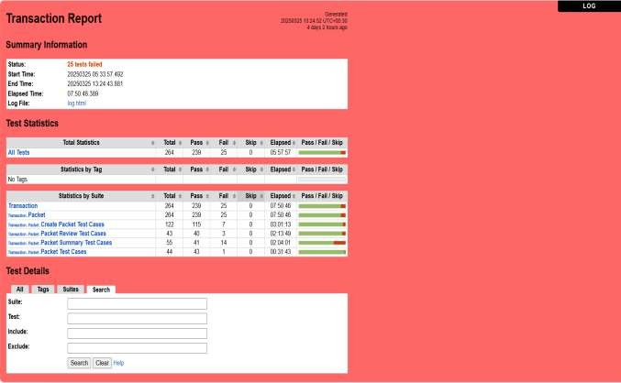

  - Defect Report and Test Log

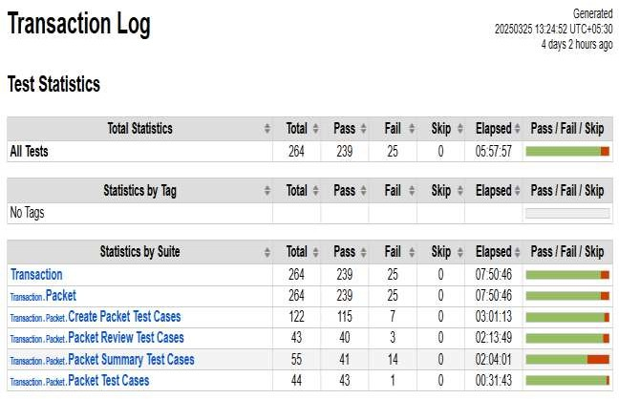

- Limitations of Proposed System

Dependence on Internet Connectivity
- Limitation: The system heavily relies on internet connectivity to manage real-time updates, donation tracking, and delivery assignments.
- Impact: In areas with poor internet access or during network outages, the system may become inefficient or unavailable, leading to delays in food donations and deliveries.

2. Limited Coverage of Delivery Areas
- Limitation: The system may be limited by geographical coverage for both donors and delivery boys.
- Impact: If the system doesn't have enough delivery boys in certain regions or the area is too far from the NGO, the delivery might be delayed or not possible, reducing the effectiveness of the network in those areas.

3. Food Quality Control
- Limitation: The system cannot guarantee the quality of donated food, especially perishable items.
- Impact: There is a risk that donated food may be spoiled or unsafe for consumption when it reaches the NGO, which can harm the reputation of the system and lead to waste.

4. Limited Real-Time Tracking
- Limitation: If GPS tracking or other real-time monitoring features are not implemented, there could be a lack of visibility into the delivery process.
- Impact: Donors, NGOs, or the system administrators may not be able to track the status of a food donation or delivery in real-time, potentially causing delays or confusion.

- Proposed Enhancement

1. Offline Mode for Low Connectivity
- Enhancement: Develop an offline mode feature that allows the system to function with limited functionality when internet access is unavailable. Once the connection is restored, data can be synchronized automatically.
- Benefit: This ensures that food donations and deliveries can still be processed in areas with unreliable internet access, reducing delays and ensuring continued operations.

2. Expanded Delivery Area Coverage
- Enhancement: Integrate a system for dynamically assigning delivery boys to areas based on real-time availability and proximity to donors/NGOs, with a priority routing system for high-demand areas.
- Benefit: This will help address the geographical limitation, ensuring that more regions are covered and increasing the efficiency of the system by optimizing delivery routes.

3. Food Quality Monitoring System
- Enhancement: Implement food quality monitoring protocols, such as temperature sensors for perishable goods and an expiration tracker for donated food items.
- Benefit: This will help ensure that food is safe and of good quality when it reaches the NGO, improving the trust in the system and reducing waste.

4. Real-Time GPS Tracking and Notifications
- Enhancement: Implement GPS tracking for both the donor and delivery boy to provide real-time updates. Push notifications can alert donors, delivery boys, and NGOs of the status of the donation and delivery.
- Benefit: This will improve visibility, allowing all parties to track the status of food donations and deliveries, reducing confusion and improving efficiency.

- Conclusion

The Easy Feed Network project aims to provide a seamless and efficient platform for food donations, connecting donors with NGOs and delivery boys to ensure food reaches those in need. By addressing key challenges such as internet dependency, limited delivery area coverage, food quality control, and scalability, the system strives to offer a reliable service that can expand and scale as needed.

The proposed enhancements—ranging from offline functionality and real-time tracking to stronger security measures and volunteer management—are designed to tackle these challenges, improving the overall user experience and operational efficiency. The integration of advanced features like data analytics, automated data entry, and an incentive program for delivery boys will enhance system performance, ensuring timely deliveries and increasing engagement across all parties.

As the system continues to evolve, it has the potential to make a significant impact in the fight against food waste and hunger by ensuring that donated food reaches NGOs safely and efficiently. By addressing limitations, improving operational processes, and enhancing user engagement, the Easy Feed Network will contribute to a more sustainable and effective food donation ecosystem, ultimately benefiting both the donors and the recipients.

- Bibliography

• Kumar, S. (2020). Building Scalable Web Applications with Cloud Infrastructure. Wiley Publishing.
- This book provides insights on cloud infrastructure and scalability, which is crucial for ensuring the system can handle an increasing number of users and data.

• Smith, J. (2019). Food Donation and Distribution Systems: Best Practices. Springer.
- This resource outlines best practices in food donation and distribution, which helped inform the approach to ensuring safe and efficient food delivery in the Easy Feed Network project.

• Brown, R., & Lee, P. (2021). Security in Food Donation Systems: A Comprehensive Guide. Oxford University Press.
- Provides guidance on implementing security measures in food donation systems, which directly influenced the development of the security protocols in the Easy Feed Network.

• Nguyen, T. (2021). Machine Learning for Error-Free Data Entry. MIT Press.
- This book explains how machine learning can be used to automate and enhance data entry processes, which was a key enhancement for the Easy Feed Network system.

• Raj, P., & Sharma, R. (2022). Real-Time GPS Tracking for Logistics and Delivery Systems. Routledge.
- A detailed exploration of how GPS tracking technologies can be implemented in logistics systems to provide real-time delivery updates, an enhancement considered for the Easy Feed Network.

• Food Donation Guidelines and Best Practices
http://www.usda.gov/food-donation-guidelines
• Logistics and Delivery Systems in Charitable Organizations
http://www.feedingamerica.org/research/cost-of-food-insecurity
• Food Safety and Regulatory Standards
http://www.fda.gov/food/food-safety
• Real-Time Tracking for Delivery Logistics
http://www.fleetcomplete.com/solutions/gps-tracking/
• Volunteer Management and Engagement in Nonprofits
http://nonprofithub.org/volunteer-management/
• Scalable Web Solutions for High Traffic Systems
http://aws.amazon.com/blogs/compute/scaling-web-applications/
• Improving Donor Retention for Charitable Systems
http://www.networkforgood.com/resource/donor-retention/
• Food Security and Donation Impact
http://www.fao.org/food-security/en/
• Security Measures for Online Donation Systems
http://www.thebalancesmb.com/how-to-ensure-the-security-of-online-donations-2501967
• Data Analytics in Nonprofit Systems
http://ssir.org/articles/entry/how_nonprofits_can_use_data_analytics_to_drive_impact

- User Manual

      - Home Page

The Home Page of the Easy Food Network serves as the main dashboard after a successful login and is customized based on the user's role. For Donors, it provides quick access to donate food, view donation history, and manage profile details. NGOs see available food donations, can accept items, and confirm delivery once received. Delivery Boys use their home page to track assigned pickups, update delivery status, and view performance. Admins access tools to manage users, assign delivery tasks, and monitor donation activity. The home page features a clean interface with navigation menus and real-time status updates for efficient workflow.



- Registration Page

The Donor Registration Page allows new users to sign up and become part of the Easy Food Network. Donors must provide essential information such as their name, email, phone number, address, and a secure password. Once the form is completed and submitted, the system validates the inputs and creates a donor account. After successful registration, the donor can log in to access the donation features. Clear instructions and error prompts help ensure all required fields are properly filled



- Login page

The Donor Login Page allows registered donors to securely access their account on the Easy Food Network. To log in, the donor must enter their registered email and password, then select “Donor” from the role dropdown menu. After successful authentication, the donor is directed to their personalized dashboard where they can donate food, track donation status, and manage their profile. If login details are incorrect, the system displays an appropriate error message prompting the user to re-enter valid credentials



- Food Donation Page

The Food Donation Page enables donors to submit details about excess food they wish to donate. Donors must fill out a form including information such as food type, quantity, pickup address, and any special instructions. Once the form is submitted, the donation request is recorded in the system and made visible to admins and nearby NGOs. A delivery boy is later assigned to collect the food. Clear field labels and validation help ensure accurate and complete information is provided before submission.



- Profile

The Donor Profile Page allows donors to view and update their personal information such as name, email, phone number, address, and password. This page helps keep donor details up to date for accurate communication and pickup coordination. Donors can make edits, save changes, and ensure their contact information reflects their current location and preferences. The page includes validation to prevent incomplete or incorrect data entries.



- Recent Donation History

The Recent Donation History Page provides donors with a record of their previously made food donations. Each entry includes key details such as donation date, food items, quantity, pickup status, and delivery confirmation. This page helps donors track the status of each donation and review their overall contribution history. The information is displayed in a clear, tabular format for easy reference and transparency.

