This is a link of my Project for Project 1

<https://public.tableau.com/profile/nkululeko#!/vizhome/Project1_15812529794670/KeyIndicatorsDashboard>

**Below are the screenshots of my project**

**Dashboard Description**

1. A geographic map showing countries field. Color the map based on Income column from the secondary dataset.
   1. Include a filter of income group to the dashboard

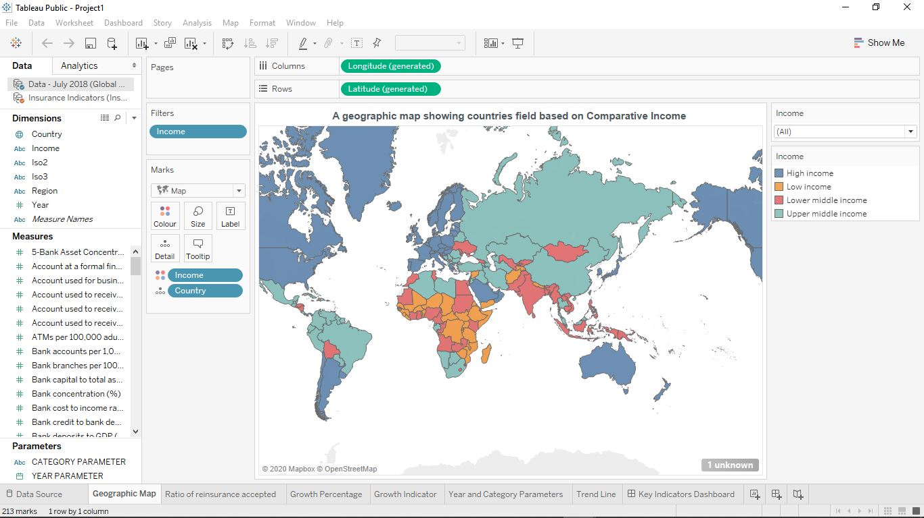

**Include a webpage to show data from world bank webpage driven by an URL action from geography graph.**

1. **The country names in the map will act as the trigger**[**https://data.worldbank.org/country/<country>?view=chart**](https://data.worldbank.org/country/afghanistan?view=chart)

It is included on the dashboard

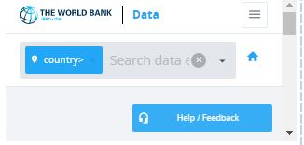

**Create a KPI Table to show the comparison between the selected period and the prior period to the selected one.**

1. **Create two parameters for Year Selection and Category Selection.**
2. **Category Parameter to have Life Insurance Share, Market Share, Penetration, Ratio of Reinsurance Accepted & Retention Ratio**
3. **Create a calculated field to calculate the Growth %.**
4. **Create a table to show these values as shown.**
5. **Title to be updated based on the category selection**

**A Category Parameter is created**

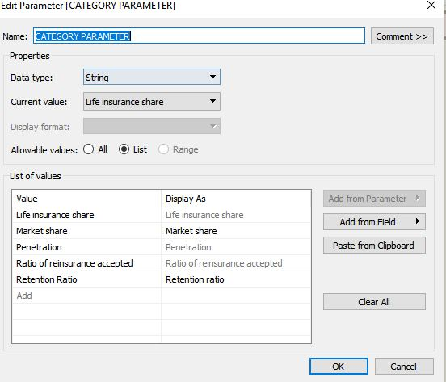

**A YEAR PARAMETER is also created**

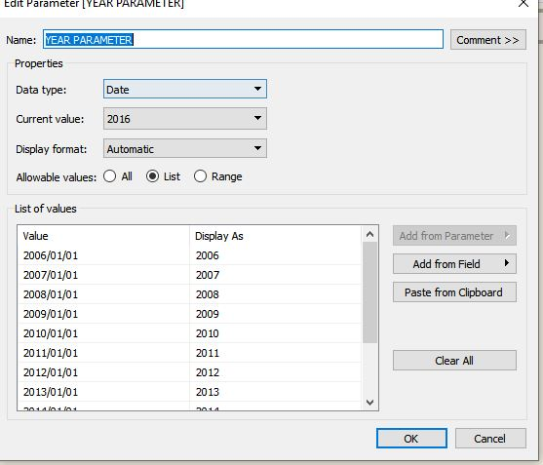

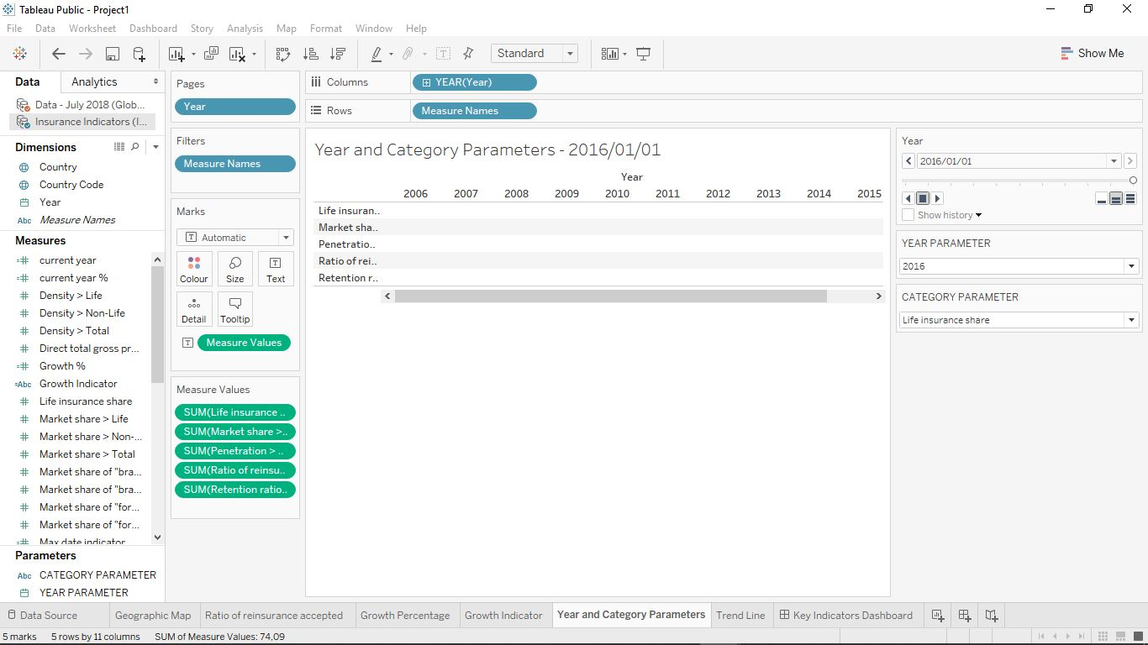

A Calculated-Field Growth % is created

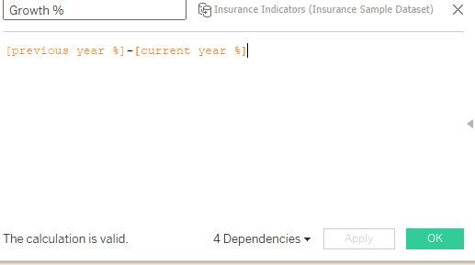

A table showing Growth Percentage

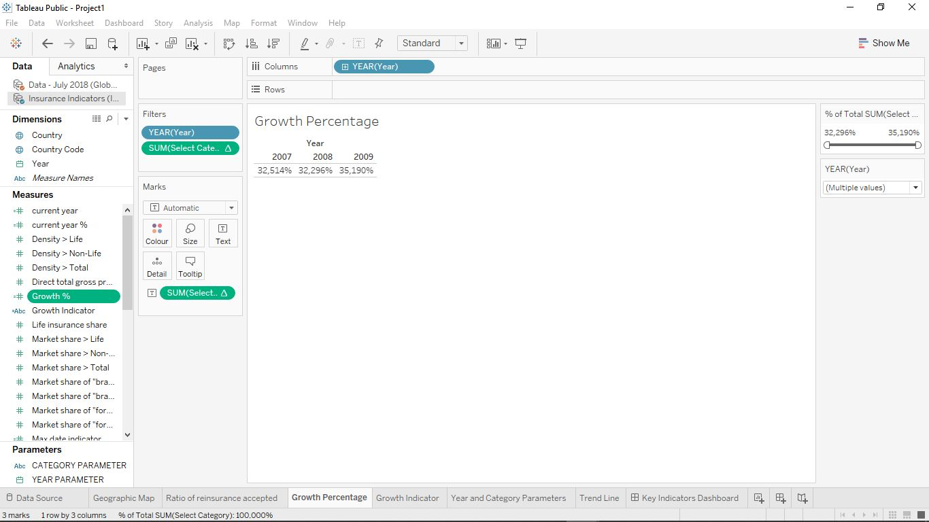

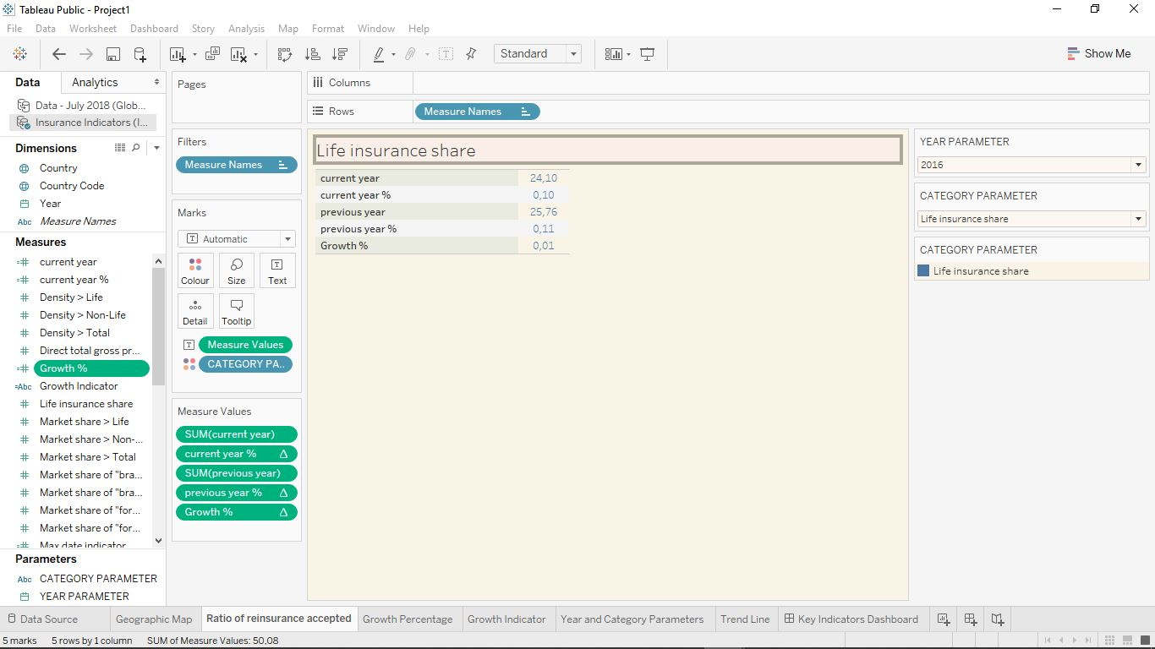

A title updated based on Category Selection

**Create Growth Indicator Shapes based on the Growth %.**

1. **Growth indicator to display Negative, No Change and Positive as values and corresponding shapes against it.**

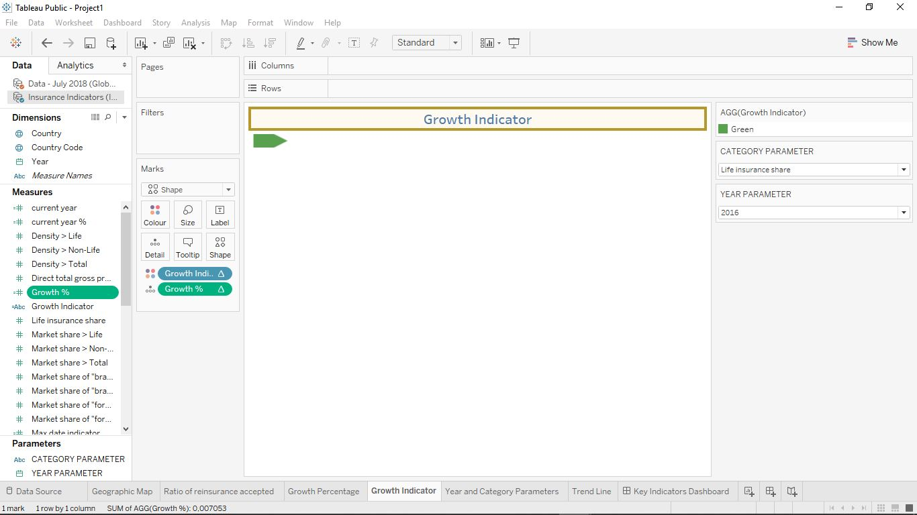

**Create a trend line to show the selected category values.**

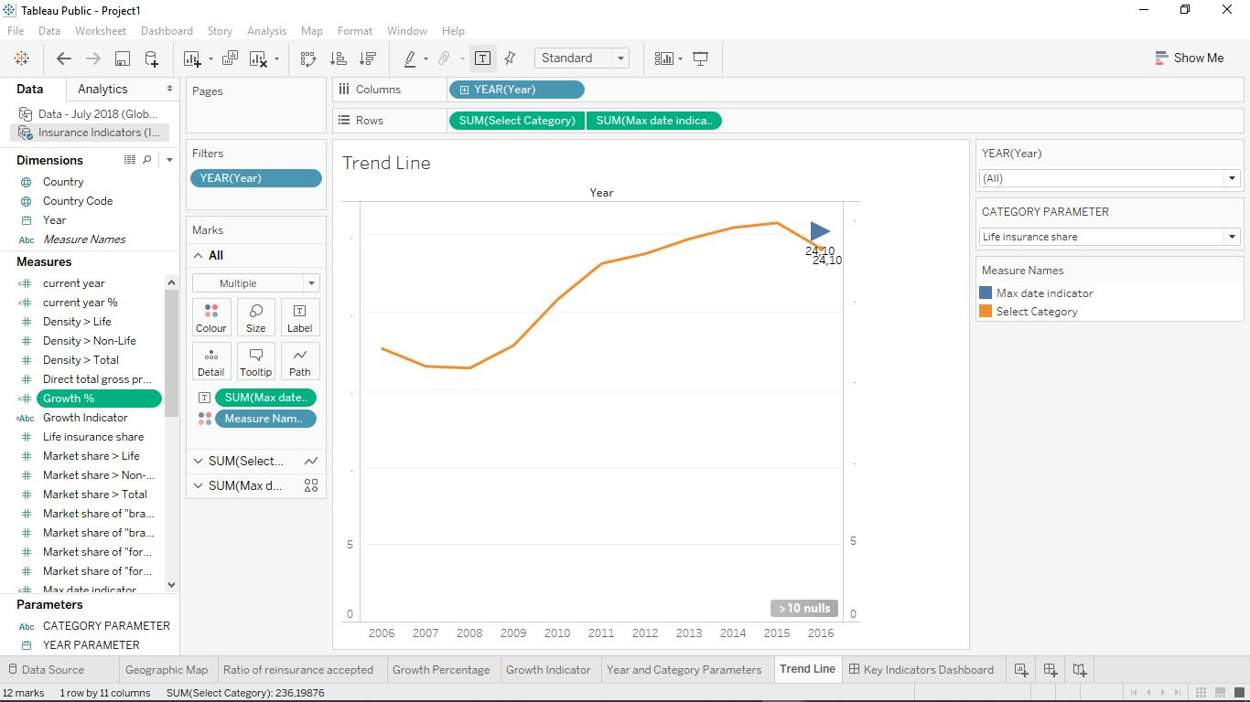

1. **Dashboard filter for income group to be applied for all charts with the filter action enabled in the map as well**
2. **Formatting to be done appropriately**

