This a link of my project for Project 2

<https://public.tableau.com/profile/nkululeko#!/vizhome/Project2Assignment/SalesPerfomanceAnalysis>

Below are the Screenshots for the project

**Analysis Tasks**

**1.Use the Saved Sample – Superstore dataset.**

This is the used Sample -Superstore dataset.

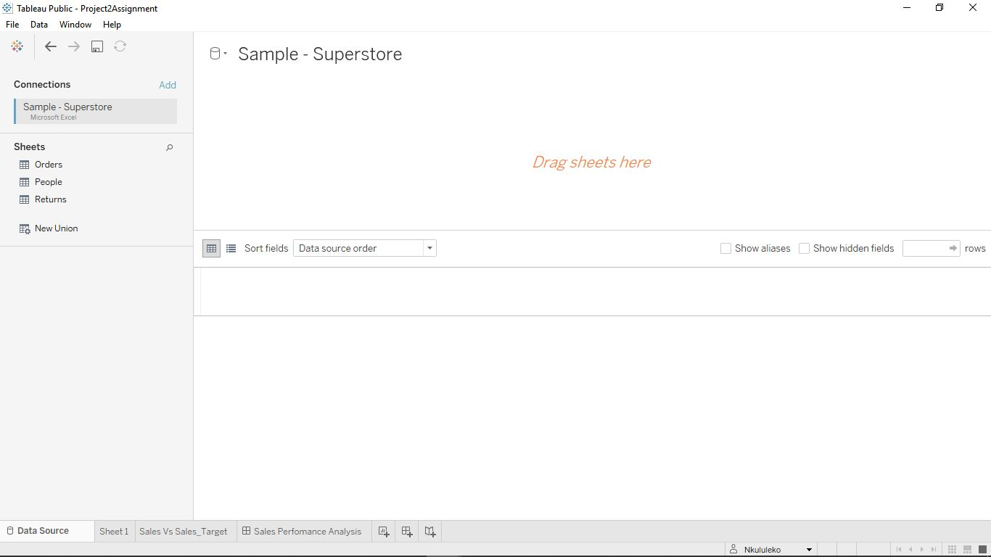

This is the Orders table of the Sample-Superstore dataset.

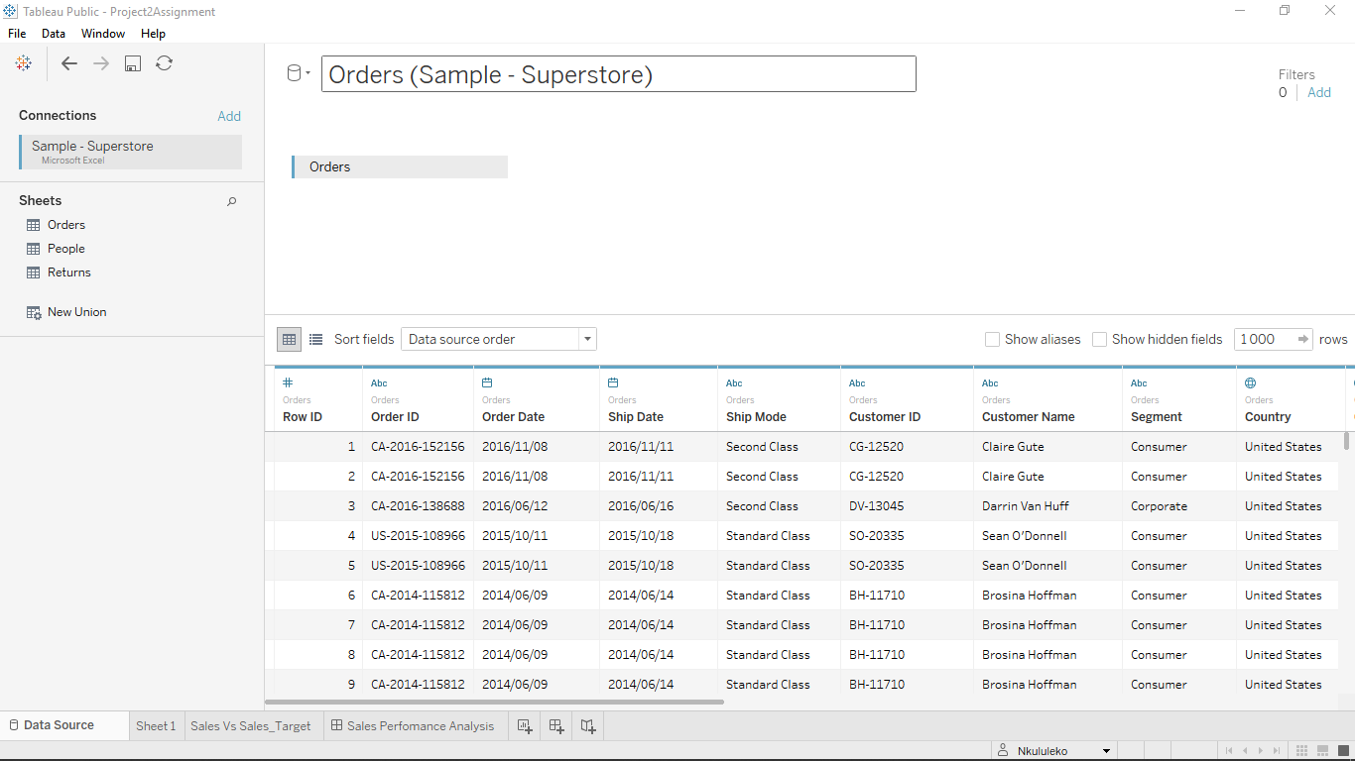

**2.Create a bullet chart with Category and Segment dimensions and Sales measures.**

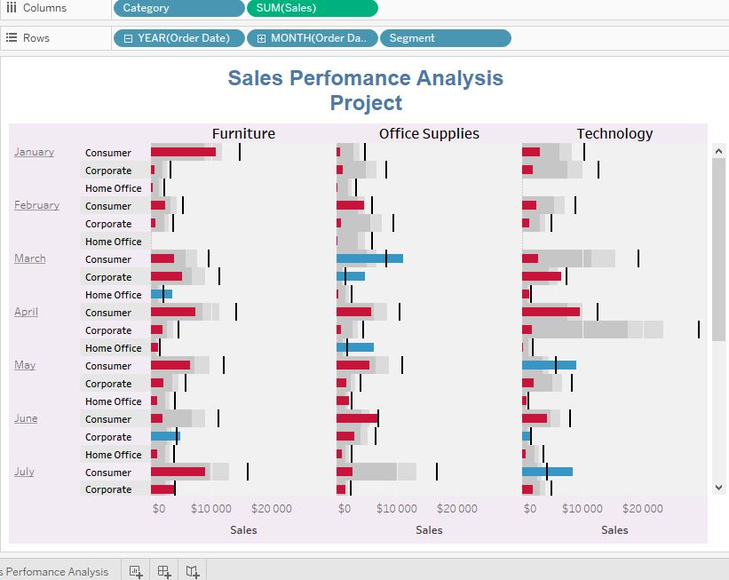

**3.Blend the data with the Saved Sample - Sales Target data set to bring in the Sales Target measure.**

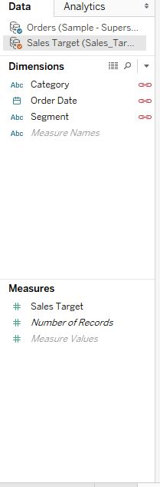

**4.Color code the chart to identify Categories and Segments that are above or below target.**

We will first create a Calculated-Field Sales vs Target.

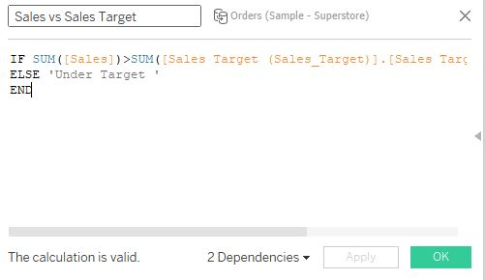

We then copy and paste the AGG(Sales vs Target) to the Colour,and SUM([Sales Target (Sales_Target)].[Sales Target]) to Details

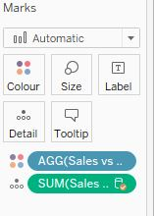

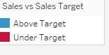

The Sales vs Sales Target is now displayed with 2 colour coding options with Blue as Above Target and Red as Under Target.

**Add a filter so that the user can select one, more than one, or all years.**

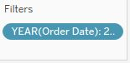

We copy and paste the Year(Order Date) to the filters section

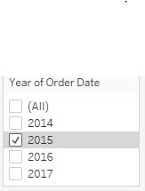

A list of years checkboxes are now available to be checked or selected as an option.

**Create a dashboard with this view.**

