**Heroku**

Just so you don’t spend over 3 hours trying to push a web app to heroic after pushing it to your GitHub. Here I’d be showing you practically how to push your web app to heroku, change the branch and push the same code to your GitHub repository.  
  
I had just deployed a flask CRUD app to heroku, <https://flaskcrudmanagerapp.herokuapp.com/>

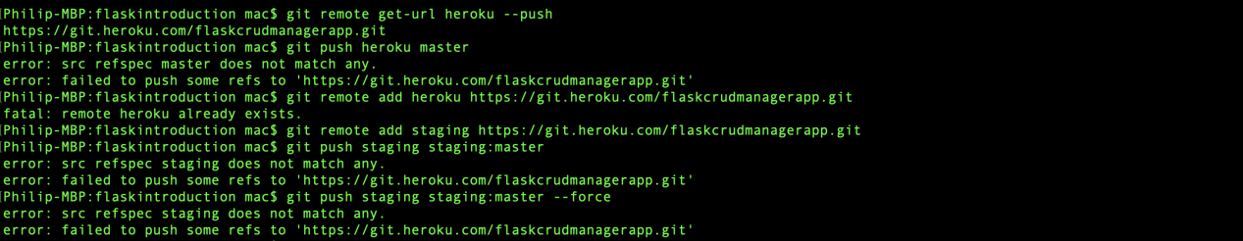

And the master branch was heroku.

I made several commit changes afterwards, pretty much to show it’s a working app

 I pushed into production and have modified multiple times.

But I just thought to have my web app in my GitHub repository, at least. So I had to create a new GitHub repository, then I added a new origin to the main branch. Meanwhile I had checked the list of remote repo links. You can see clearly in the picture above that I have heroic and an origin alongside.

Most importantly, origin was push as the MAIN Branch. Literally where the problem unknowingly started.

**Heroku**

Just so you don’t spend over 3 hours trying to push a web app to heroic after pushing it to your GitHub. Here I’d be showing you practically how to push your web app to heroku, change the branch and push the same code to your GitHub repository.  
  
I had just deployed a flask CRUD app to heroku, <https://flaskcrudmanagerapp.herokuapp.com/>

And the master branch was heroku.

I made several commit changes afterwards, pretty much to show it’s a working app

 I pushed into production and have modified multiple times.

But I just thought to have my web app in my GitHub repository, at least. So I had to create a new GitHub repository, then I added a new origin to the main branch. Meanwhile I had checked the list of remote repo links. You can see clearly in the picture above that I have heroic and an origin alongside.

Most importantly, origin was push as the MAIN Branch. Literally where the problem unknowingly started.