**MZUMBE UNIVERSITY**



**FACULTY OF SCIENCE AND TECHNOLOGY**

**COMPUTING SCIENCE STUDIES DEPARTMENT**

**PRACTICAL TRAINING REPORT**

**Name of Student:** GODLOVE STAHIMILI NKYA

**Registration Number:**

**Year of Study:**  2021/2022

**Academic Year:**  Two (2)

**Programme:**  BSc. ICTM

**Company Name:** KIBAHA DISTRICT COUNCIL

**Organization Physical Address:** P. O BOX 30153 PWANI.

**Supervisor’s Name:** MR. PASCHAL P. BILALI

**MU Supervisor** MR WAMBURA

**ACKNOWLEDGEMENT**

I would like to thanks GOD who gave me enough strength and good physical and mental Health during my all-time days of field. Also, much thanks to my MU supervisor **MR WAMBURA** for supervision and cooperation they give to me may God bless you and all of the staff member for their support in my field. I would like to acknowledge my lovely family and my fellow students who we worked together and helped each other by exchanging ideas, views and skills to assigned tasks during the entire practical period at the field station.

This report is an individual work accomplished with a compilation of effort and support from many parties. l wishes to take this opportunity to express my deeply thanks to the enter staff of **KIBAHA DISTRICT COUNCIL** for their cooperation during the whole period of my field course I would like to thanks District ICT officer (DICTO) **MR. PASCHAL P. BILALI**, for the great support and for their cooperation by teaching me many things in software, networking, graphics and maintenance during my field period. I was in this department, so I thanks again for their hospitality.

Also, thanks to my other workers that I walked together in **KIBAHA DISTRICT COUNCIL** from different department, like District community development officer **MRS. SHUKURU LUSANJALA**, Community Development Officer **MR. FRANK ALEX MTAVANGU** and so many other they give me too much support and I live with them like brothers and sisters in a few days and the support that I get from them in my carrier.

I’m **GODLOVE STAHIMILI NKYA** declare that the contents of this technical report are the original copy and also original designs of what I went through in my all woks of my field practical training under the supervision of **MR. PASCHAL P. BILALI** who is the District ICT officer (DICTO) in KIBAHA DC. also, any of what explained within this report is true information especially in al task that I was done.

**ABSTRACT**

This report aims to provide the description of attained objective and knowledge obtained from practical training at **KIBAHA DISTRICT COUNCIL**

The main assigned task to my field was the following:

* Windows 7, window 10 and window 11 installation
* Application Software installation
* Printer Drivers installation
* Printer Troubleshooting
* Cable termination
* Computer troubleshooting
* Data backup and data entry
* Configuration of computing system
* Network cable management
* Computer maintenance

**ABBREVIATION**

**Abbreviations Word in full**

CPU Central Processing Unit

ICT Information and Communication Technology

IP Internet Protocol

IPT Industrial Practical Training

SMPS Switch Mode Power Supply

USB Universal Serial Bus

LAN Local Area Network

ZIF Zero Insertion Force

CD Compact Disc

PC Personal Computer

RAM Random Access Memory

DICTO District Information Communication Technology officer

TABLE OF CONTENTS

**CHAPTER ONE**

**INTRODUCTION**

**1.About Kibaha District Council (DC)**

The name Kibaha comes from the word “Kibaha” at Zaramo word meaning “**It is here** “. Kibaha District Council is located 40 kilometers from Dar es Salaam City along the main road to Morogoro. The District Council is located between 6-8 Southern Hemisphere and Longitude 38.0 to 39.05 East. The north borders Bagamoyo District, and the South borders Kisarawe District, the East border Kibaha Town Council, and the West border Bagamoyo District and Morogoro District.

Kibaha District Council consists of a total of 2 Divisions and 14 Wards. Mtambani. With a total of 25 Villages and 100 Suburbs. Kibaha District Council has an area of ​​124,217.755 Hectares equivalent to 1992.18 square kilometers.

The District Council is located between 6-8 Southern Hemisphere and Longitude 38.0 to 39.05 East. The north borders Bagamoyo District, and the South borders Kisarawe District, the East border Kibaha Town Council, and the West border Bagamoyo District and Morogoro District.

According to the 2012 Housing Census, Kibaha District Council has a total of 17,124 households with a population of about 70,209, an increase of 2.2 percent.

**1.1The vision of Kibaha District Council**

The District comprise many numbers of opportunity suitable for resources exploitation investors from Tanzania and around the global are warmly welcome to share with us the huge virgin potentiality as we expect win- win situation. In summary the investigation opportunity under agriculture sector include large faming of various crop such as cashew nuts, coconuts, groundnuts, fruit such as orange, mango and pineapple, paddy, sorghum, cassava and oil crops.

**1.3 COMPUTER ASSEMBLE AND DISASSEMBLE**

**TOOLS USED FOR COMPUTER**



Figure 1: shows the tools used

* 1. **A technician uses many tools to diagnose and repair computer problems:**

• Straight-head screwdriver, large and small.

• Phillips-head screwdriver, large and small.

• Tweezers or part retriever.

• Needle-nosed pliers.

• Wire cutters.

• Chip extractor.

• Hex wrench set.

• Torx screwdriver.

**1.5 STEPS TO PERSONAL COMPUTER DISASSEMBLY AND ASSEMBLY**

1. The Parts of a Computer

2. How to Disassemble a Computer

3. How to Assemble a Computer

**1.6 PARTS OF COMPUTER SYSTEM**

The computer system is made up of following external devices:

• CPU cabinet

• Monitor

• Keyboard

• Mouse

• Printer/scanner

• UPS



Figure 2: Computer system

**1.7 HOW TO DISASSEMBLE A COMPUTER**



Figure 3: parts of computer system

**Step 1: Detach the Power Cable**

The disassembling of the computer system starts with externally connected device detachment. Make sure the computer system is turned off, if not then successfully shut down the system and then start detaching the external devices from the computer system. It includes removing the power cable from electricity switchboard, then remove the cable from SMPS (switch mode power supply) from the back of the CPU Cabinet. Do not start the disassembling without detaching the power cable from the computer system. Now remove the remaining external devices like keyboard, mouse, monitor, printer or scanner from the back of CPU cabinet.

**Step 2: Remove the Cover**

The standard way of removing tower cases used to be to undo the screws on the back of the case, slide the cover back about an inch and lift it off. The screwdrivers as per the type of screw are required to do the task.

**Step 3: Remove the Adapter Cards**

Make sure if the card has any cables or wires that might be attached and decide if it would be easier to remove them before or after you remove the card. Remove the screw if any that holds the card in place. Grab the card by its edges, front and back, and gently rock it lengthwise to release it.

**Step 4: Remove the Drives**

Removing drives is easier. There can be possibly three types of drives present in your computer system, Hard disk drive, CD/DVD/Blu-ray drives, floppy disk drives (almost absolute now a day). They usually have a power connector and a data cable attached from the device to a controller card or a connector on the motherboard. CD/DVD/Blu-ray drive may have an analog cable connected to the sound card for direct audio output.

The power may be attached using one of two connectors, a Molex connector or a Berg connector for the drive. The Molex connector may require to be wiggled slightly from side to side and apply gentle pressure outwards. The Berg connector may just pull out or it may have a small tab which has to be lifted with a screwdriver.

Now pull data cables off from the drive as well as motherboard connector. The hard disk drive and CD/DVD drives have two types of data cables. IDE and SATA cables. The IDE cables need better care while being removed as it may cause the damage to drive connector pins. Gently wiggle the cable sideways and remove it. The SATA cables can be removed easily by pressing the tab and pulling the connector straight back.

Now remove the screws and slide the drive out the back of the bay.

**Step 5: Remove the Memory Module**

Memory modules are mounted on the motherboard as the chips that can be damaged by manual force if applied improperly. Be careful and handle the chip only by the edges. SIMMs and DIMMs are removed in a different way:

• **SIMM** - Gently push back the metal tabs while holding the SIMM chips in the socket. Tilt the SIMM chip away from the tabs until a 45% angle. It will now lift out of the socket. Put SIMM in a safe place.

• **DIMM** - There are plastic tabs on the end of the DIMM sockets. Press the tabs down and away from the socket. The DIMM will lift slightly. Now grab it by the edges and place it safely. Do not let the chips get dust at all.

**Step 6: Remove the Power Supply**

The power supply is attached into tower cabinet at the top back end of the tower. Make sure the power connector is detached from the switchboard. Start removing the power connector connected to motherboard including CPU fan power connector, cabinet fan, the front panel of cabinet power buttons and all the remaining drives if not detached yet.

Now remove the screws of SMPS from the back of the cabinet and the SMPS can be detached from the tower cabinet.

**Step 7: Remove the Motherboard**

Before removing all the connectors from the motherboard, make sure you memorize the connectors for assembling the computer if required, as that may require connecting the connectors at its place. Remove the screws from the back of the motherboard and you will be able to detach it from the cabinet. Now remove the CPU fan from the motherboard. The heat sink will be visible now which can be removed by the pulling the tab upward. Finally, the processor is visible now, which can be removed by the plastic tab which can be pulled back one stretching it side way.

**1.8 HOW TO ASSEMBLE A COMPUTER**

The assembling of the computer system is exactly the opposite of disassembling operation. Before starting assembling the computer system, make sure you have the screws and a screwdriver for those.

**Step 1: Mount the Processor**

The first step for assembling the computer system starts with mounting the processor on the processor socket of the motherboard. To mount the process, you don't need to apply any force. The special ZIF (zero insertion force) sockets are usually used to prevent any damage to the processor pins. Once the processor is mounted, the heat sink will be attached on top of the processor. The CPU fan is also attached on top of the heat sink.

**Step 2: Fix the Motherboard in the Tower Case**

Now the motherboard is to be fixed vertically in the tower case and the screws are fixed from behind of the motherboard.

**Step 3: Connect the Power Supply**

Now line up the power supply at the top back end of the cabinet and screw it. The power connectors for motherboard power supply and CPU fan power supply are to be connected. If the

cabinet cooling FAN is required then it is to be screwed at the back-end grill of the cabinet and its power connector is to be connected from SMPS.

**Step 4: Install the Drives**

Install the CD/DVD drives at the top front end of the cabinet and screw it. Install the Hard disk drive and floppy disk drive below CD/DVD drive and screw it. Make sure once screwed there is no vibration in either of the CD/DVD, hard disk or floppy disk drives.

**Step 5: Connect Cables**

Now select the appropriate data cable and connect one end of the cable to its drive socket and another end at its appropriate connector on the motherboard. For SATA hard disk drive or CD/DVD drives use SATA cable and its power cable, else use IDE data cable. Do the proper jumper settings as per the usage requirement.

**Step 6: Mount the Memory Modules**

It is time now to mount the memory modules on the motherboard by aligning the RAM to its socket on the motherboard and press it downward. Make sure the side tab are fixed into the RAM notch. If not, you may still have to press a bit.

**Step 7: Install the Internal Cards**

Install the internal cards to its socket and attach the cables or power cable to it. The selection of right socket or slot is required as per the type of socket.

**Step 8: Cover the Tower**

Cover the tower by placing it and pressing towards front side and screw it.

**Step 9: Connect the External Devices and Power** Connect the external devices with CPU at its appropriate socket. It includes mouse and keyboard at PS2 or USB connectors. Monitor at the video output socket. Connect the power cable to the back of tower in SMPS. Plug in the power cable to the electric board.

So; assembling and disassembling is very important in order to avoid different fault like for computer cause:

• No display in monitor

This problem occurs due to fail of good connection from motherboard.

UPS (**Uninterruptible Power Supply**) A device that provides battery backup when the electrical power fails or drops to an unacceptable voltage level. Small UPS systems provide power for a few minutes; enough to power down the computer in an orderly manner, while larger systems have enough battery for several hours.



Figure 4: show computer and uninterruptible power supply

**1.9 Advantages of Using UPS**

**Uncertain Data Loss Can Be Prevented:**

Computer Systems are not featured with battery like laptops. So when there is a power cut, you may lose the data on your system. As such, UPS can keep your system running and you get good time to store or save your data and then shut down your system safely.

**Emergency Power Supply**

Whenever there is a power spike or a blackout, UPS stands as the reliable alternate power source. You can resume your work by using UPS in case of long power cuts.

**Protects the Voltage Sensitive Device from Bad Electricity**

You can observe power fluctuations in direct alternating current which ultimately lead to degradation of the gadgets. UPS provides stable output by controlling the power fluctuations.

**Provides Surge Protection**

When there is a power surge, UPS detects the bad power supply and stops direct power supply. It then provides stable power from its own stock. It ultimately prevents possible cause of damage on devices due to the power supply interruptions.

**Maintains Battery Life**

You can keep working on the operational mode even when there is a power cut as it maintains constant charging once you connect a UPS to a battery.

**Huge Power Back Up in the Industries**

Various firms rely on UPS and connect it with their gadgets and machines. It can hugely affect their work output if there is a power disruption and therefore UPS is the essential need when it comes to smooth operation at work.

**Parts of a Computer and Their Functions**

Here is a complete list of all the common computer hardware components and common peripherals used with them

**1. The computer case**

This is the part that holds all of the internal components to make up the computer itself.

It is usually designed in such a manner to make fitting a motherboard, wiring, and drives as easy as possible. Some are designed so well that it is easy to make everything look tidy and presentable too.

**2. Motherboard**

The motherboard is the main board that is screwed directly inside the computer case. All other cards and everything else plug directly into the motherboard, hence its name.



Figure 5: Motherboard

The CPU, RAM, drives, power supply, and more all get connected to it.

**4. CPU: Central Processing Unit**

The CPU is basically like the brain of a computer. It processes all the information on a computational level.



Figure 6: CPU

It takes information from the RAM and processes it to perform the tasks required from the computer.

There are so many different types of processors. The top manufacturers of computers are Intel, AMD, and NVidia.

**5. RAM: Random Access Memory**

RAM is a data storage device that can provide fast read and write access.

RAM is also volatile, which means that it loses all the stored data when power is lost.



Figure 7: Random Access Memory

**6. PSU: Power Supply Unit**

A power supply mounts inside the computer case. This converts the AC mains supply from the wall socket and supplies the correct DC voltages to all the components inside the computer.

 Figure 8: power supply

**7. Monitor**

A monitor is what you use to visualize the graphics data sent from the computer’s graphics card.

There are various types of monitors on the market. The most commonly used is a LED-backlit LCD monitor.



Figure 9: Monitor

**8.Keyboard -**

A keyboard is one of the ways to communicate with a computer. Typing a key from the keyboard sends a small portion of data to tell the computer which key was pressed.



Figure 10: Keyboard

The computer can use this information in many ways. An example could be a command or a character that can be used in a document.

**9. Hard Disk Drive**

A hard drive is found in most computers. It’s usually a mechanical drive that stores all the data.

Apart from storing data, it can also be used as a boot drive to run the operating system from it.

** **

Figure 11: Hard Disk Drive

**CHAPTER TWO**

**2. TASKS PERFORMED AND LESSONS LEARNT**

**2.1 Duties Undertaken**

This chapter Explain about the task performed during practical training at **KIBAHA DISTRICT COUNCIL** hat start 9th August 2022 to 17th October 2022. During my practical training, I was assigned different activities to perform associated IT issues. Some of the task I was assigned was already learned at my course at Mzumbe university but other was not. This was very interesting me because I learn more things which improve my knowledge.

**Task assigned**

1. **Windows installation**

First Window is a collection of programs known as an operating system (OS) that controls a personal computer, Sometimes OS is called the mother of computer because it controls all part of computer hardware and software.

During practical training we are practicing on how to install this software and to practice installing window 11, window 10 and window 7 in different computers. For example, the following are the stapes to show how to install window 10 in computer

1. We need to check if device meets the Windows 10 system requirements.

**CPU:** GHz or faster processor

**RAM:** 1GB for windows 10 32 bits or 2GB for windows 10 64 bits.

**Storage:**32GB of space or more.

**GPU:**DirectX 9 compatible or later with WDDM 1.0 driver.

**Display:** 800x600 resolution or higher

1. **Create USB installation media/ bootable device,** there are application software that can boot device like RUFUS, power ISO, winUSB and UNetbootin. But in **KIBAHA DISTRICT COUNCIL** they use much RUFUS and the following are stapes to boot device by using RUFUS application

* Open the program with a double-click
* Select your USB drive in “**Device**”
* Select “**Create a bootable disk using**” and the option “**ISO Image**”
* Right-click on the **CD-ROM symbol** and **select the ISO file**
* Under “**New volume label**”, you can enter whatever name you like for your USB drive
* You’ll receive the warning “**ALL DATA ON THIS DEVICE WILL BE DESTROYED”,** which you can confidently confirm with “**OK**”– at this point, you’ve ideally already saved any important files from the USB drive
* Click on “**Start**”
* As soon as the green bar is full, click on “**Finish**”
* Eject your bootable USB drive with “**Safely eject hardware**”

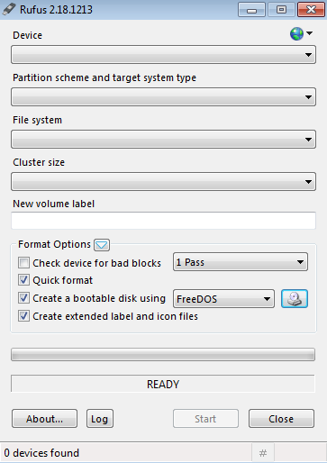

Figure 12: shows RUFUS software for booting flash device

1. **Use your installation media.**Insert your installation media into your device and then **access the computer’s BIOS or UEFI**. These are the systems that allow you to control your computer’s core hardware. The process of accessing these systems is unique to each device, but the manufacturer’s website should be able to give you a helping hand here. Generally, you'll need to **press the F2, F12 or Delete keys** as your computer boots up.
2. **Change your computer's boot order.**Once you have access to your computer’s BIOS/UEFI you’ll need to locate the settings for boot order. You need the Windows 10 installation tool to be higher up on the list than the device’s current boot drive: this is the SSD or HDD that your existing OS is stored on. You should **move the drive with the installer files to the very top of the boot order menu**. Now, when you restart your device the Windows 10 installer should load up first.

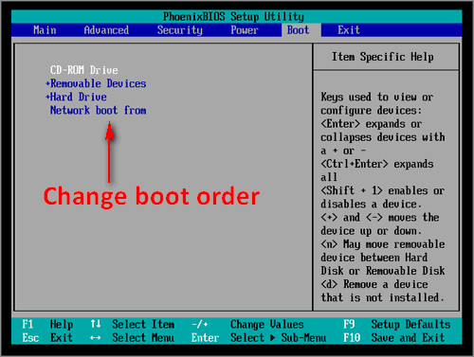

Figure 13: shows the boot order in BIOS setting

1. **Restart your device.** Save your settings in the BIOS/UEFI and reboot your device.
2. **Complete the installation.**Your device should now load up the Windows 10 installation tool on restart. This will guide you through the rest of the installation process
3. **Application Software installation**

This is the process of setting up a program in a computer, is the one of experience and skilled I acquired how to install different programs in computer including Microsoft package, printer drivers, CCTV camera, Team viewer, Kaspersky antivirus software, google chrome and so many other applications. But some of application needs the security verification code and to configure it which I get support from my supervisor my Mr. Pascal B. Bilali and they give us brief explanation on how to use that software.

1. **Printer Drivers installation**

I learn on how to install drivers of printer in computer, this process is done within a few minutes, for examples the following are the stapes on how to install HP printer to the computer.

Stapes on installing printer (hp printer) driver using the windows Built-in

1. Set windows update to automatically download driver software
2. Connect your printer to computer
3. Install the print driver with the Add s printer wizard
4. **Computer troubleshooting**

Troubleshooting is the process of identifying, planning and resolving a problem, error or fault within a software or computer system. It enables the repair and restoration of a computer or software when becomes faulty, unresponsive or acts in an abnormal way. Ata CHEMICOTEX industries limited there are different problems that happen to workers computer as follows: -

1. **No display or black screen in monitor**

The recommendations we take to fix the problem to different computer as follow

* Either monitor is not on
* Computer is sleep
* Loose or improper connections in Data cable or power cable
* Try different cable
* Hardware issue

1. **Power supply does not turn on the computer**

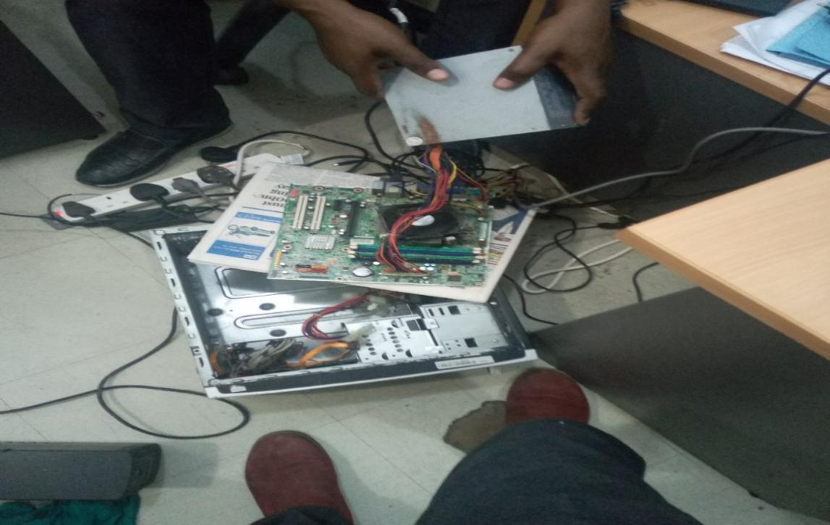

Figure 14: shows computer that is opened for troubleshooting the power supply

1. Computer running slow

**The recommendations we take to fix the problem to different computer as follow**

* Reboot the computer
* Delete Temp files
* Scan for virus
* Scan for malware
* Update the operating system
* Disable browser plug-in
* Update drivers
* Memory (RAM) upgrade
* Hard drive Upgrade
* Make sure the computer processor is not overheating
* Erase computer start over

1. Computer motherboard failure

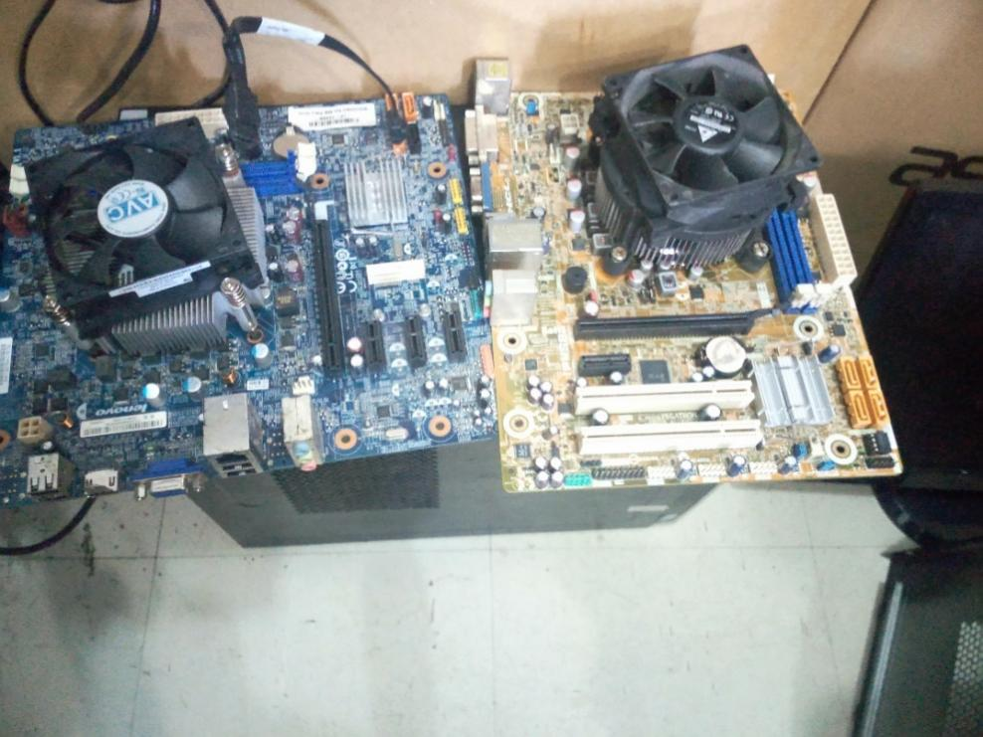

Figure 15: shows two motherboards ready for troubleshooting

1. **Mouse not detect on computer window**

If you have ever tried to add a new mouse, printer or other hardware to your computer, you will know that finding the right driver to make the device work can be time-consuming. It is difficult and sometimes very frustrating tracking down the correct driver for a single device, not to mention the often dozens of hardware devices connected to your computer.

1. **Blue screen error**

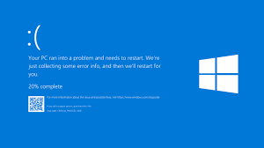

Figure 7: which shows the error that detect in computer window

**CHAPTER THREE**

1. **INTERPRETATION AND ANALYSIS**

**3.1 Improvement of Existing Skills**

* Ethernet cable Termination

During my field practical my skills was improved more because I was learned and practice much to terminate the network cable Also, I was learned to connect these Ethernet cables to the devices such as switch, hub, printer, computer and other networking device.

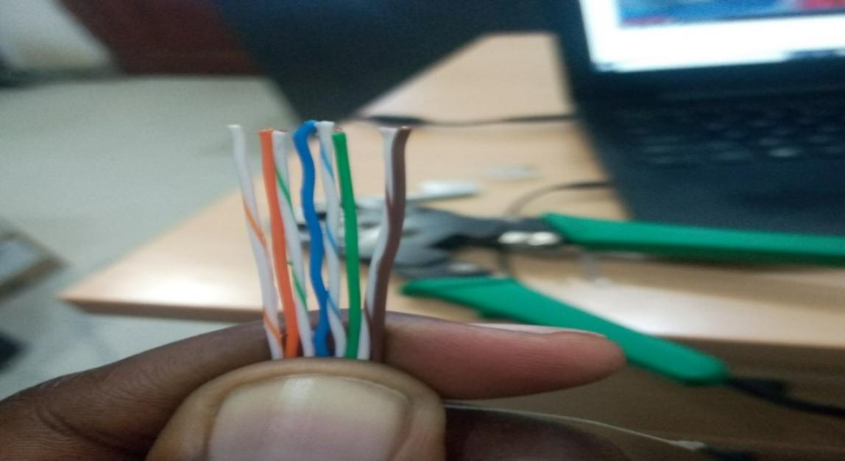

Figure 14: shows the network wire arrangement

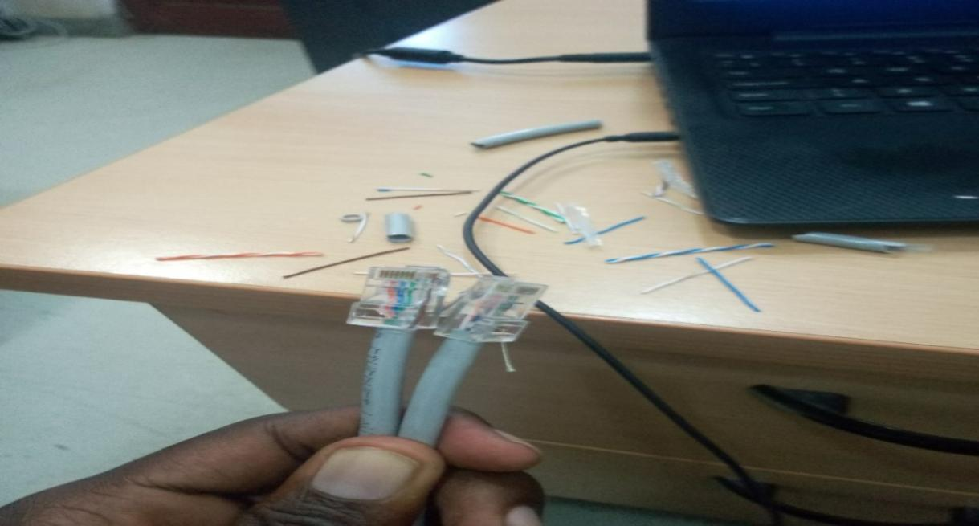

Figure 15: shows the network cable which is ready for use

* Installing the printer drive

I improve my skills on installing the printer driver because during my course I learn theoretical but, in my field, we trained practical on how to install that software/ drives in printer. So this help to improve my skills because now I know both theoretical and practical to install drives.

* Troubleshoot computer with different problems and to use different troubleshooting tool to solve those problems like gun

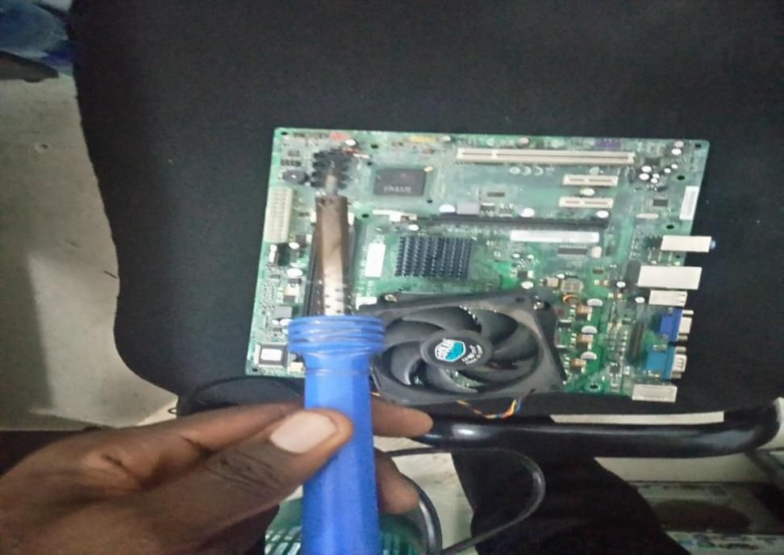

Figure 16: shows the troubleshooting tool (gun) and motherboard

**3.2 New Skills Learnt**

1. **Configuration of N-computing devices**

This is the device which help to create visual desktop which enable multiple uses to simultaneous share a single operating system instance. So, in my field I learned on how to connect and configure n-comping devices

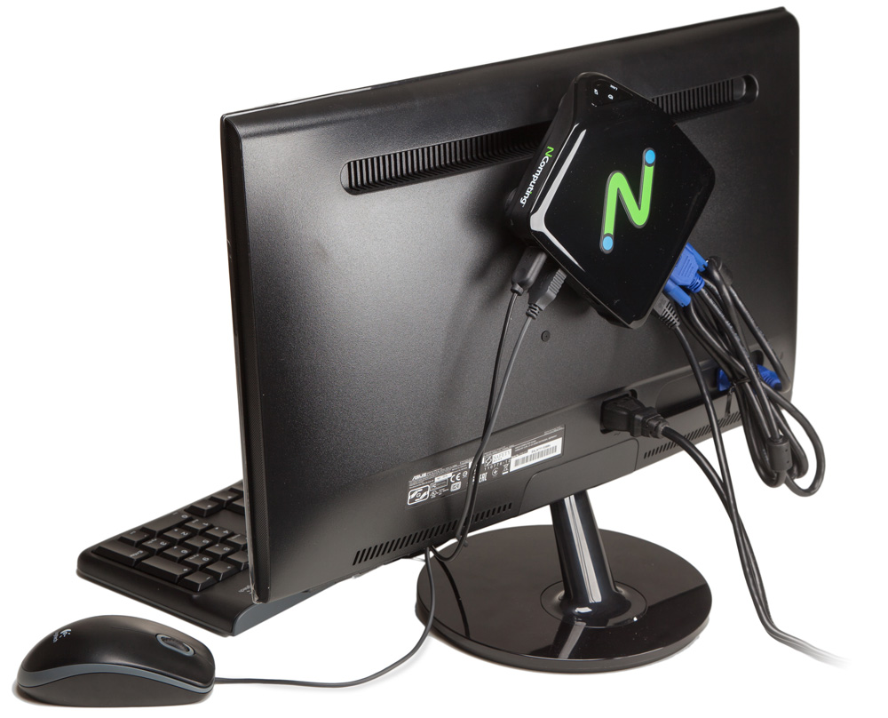

Figure 17: shows the computer which has N-computing device connected

1. **Network printer configuration**

I learned new skills to connect the computers in network to share one printer in the same area so as everyone in the network can print his/her document in the same printer. For example, the following are steps of connecting computer in the network printer in the window 10

* Turn on your printer and make sure it is connected to the network.
* Open the Control Panel.
* Click the Devices and Printers icon or View devices and printers link, depending on the view type you are using in the Control Panel.
* In the Devices and Printers window, click the Add a printer link in the menu bar at the top.
* Add printer in Windows 10
* Let Windows scan for the printer. If detected, select the printer and click Next. If the printer is not listed, click the printer that I want isn't listed and skip to add the printer by name or TCP/IP address.

1. **Connection of wireless printer to computer**.

Also, I learn how to connect a printer in a computer by doing printer installation and connecting one printer to more than one computer in case there is only one printer. Wireless printers can be assigned a static IP address through Dynamic Host Configuration Protocol (DHCP), an interface used to automatically allocate IP addresses to devices that connect to a network. The static IP address remains with the wireless printer and cannot be assigned to other devices, reducing device conflicts on the network.

**Here are procedures:**

* + Confirm that the printer is powered on and connected to the local wireless network.
  + Click "Start then Control Panel then Hardware and Sound then Devices and Printers."
  + Click "Add a printer" and choose "Add a Network, Wireless or Bluetooth Printer" from the options.
  + Select the printer from the list of detected devices. If the printer doesn't appear, click "The Printer That I Want Isn't Listed" and select "Add a Printer Using a TCP/IP Address or Hostname." Enter the static IP address assigned to the printer, then click "Next."
  + Create a name for the printer or use the default name. Click "Next" and "Finish" to install the wireless printer to the computer.
  + Right-click the printer and select "Printer Properties" from the context menu. Click the "Ports" tab, and then click "Add Port."
  + Select "Standard TCP/IP Port" from the list of available port types. Click "New Port" and "Next."

**CHAPTER FOUR**

**4.GAPS IN SKILLS AND ANALYSIS**

**4.1 Gap in Skills and Technologies**

1. **Scarce of the resources to doing work**

The scarcity of resources such as flash, compact disc, toolkit, case and USB, was also a big challenge, during working time, field members were to settle for a while to wait for a person to complete the task so that another can use the resource acquired, this leads to many tasks not complete at a time like to install window and software in the computers it need resource like USB drive.

1. **Inadequate knowledge on some assigned tasks:**

Some tasks which I was assigned it is the first time for me to do such kind of task so I haven’t enough knowledge of doing such kind of task. Which makes me to ask for help to my local supervisor to assist me well on such activity. Tonner cartridge installation at the first time

1. **Long distance from where I live and the place of work.**

There also a challenge on distance from where I lived to place, I worked because the offices   
they were sent away for the expansion of the city so that the city would not be rebuilt well. So, this becomes the challenge to me because sometimes it led me to take motor vehicles (boda-boda) in order to reach on time at work.

Also, I spend too much cost from where I live to place that I have worked because I used one bus to reach at work and motor vehicle (boda boda).

**CHAPTER FIVE:**

1. **CONCLUSION AND RECOMMENDATIONS**

**5.1CONCLUTION**  
Serious thanks to the **KIBAHA DISTRICT COUNCIL** for accepting me to receive training at their office. Because I have been a rounded in many offices to apply for training, I missed but **KIBAHA DISTRICT COUNCIL** received me without any problem and learn many skills, and feel comfortably to ask where there is a problem and much cooperation, they give me during all the time.

It is very important for organizations and other institutions not to be reluctant to accept students to do their practical training due to unknown reasons, also to tolerate all situation concerning academic matter shown by the student, for the case that we are still learning, they should not treat the student equally as other workers to the company or organization. I would also like to give advice to my fellow students who are going to field to go and study and not to do damages or any other thing that is not good to the organization because they are going to destroy things which lead to the dismissal of students who will come to claim it in the future.

**5.2 RECOMMENDATION**

Mainly I would like a to recommend that: to make this program more successful, student has to be given a guideline of what has to be covered during the practical training period and handover it to the internal supervisor because most of organizations only offer routine works to students. However, if they would have their guideline, it would somehow force internal supervisors to give them some works to perform accordingly. This is because as we grow older, we are given some that are completely out of line with our profession so when the college gives us guidance it will help us to work from that guidance.

**Other recommendations are:**

* Supervisors should know the area of interest of different students so as to enable students to work fully and tackle those tasks accordingly.
* Assigned tasks should not rely on a single field of study since ICT covers a wide range of fields such as networking, programming, database management, web design, etc.
* Supervisors should give clear explanations and guidelines about the task so that students perform the confidently and in time.
* All required tools and resources to complete a specific task should be available in satisfactory amount so that to accomplish the assigned tasks effectively, efficiently and in time.
* Assigned tasks should be within student’s level of coverage
* Supervisors should know the area of interest of different students so as to enable students to work fully and tackle those tasks accordingly.
* Among those eight weeks of field practical training, at least the first 2 weeks should be used for learning and making things clear about the tasks to be done so as to accomplishment of assigned tasks could be easy.

**For ITs department at MZUMBE**

* The department should concentrate much on teaching practically than theoretically. This will build students which are experts and can perform their tasks without any fear.
* The department should enable every practical training supervisor to link with the students and Industrial Supervisors at the beginning of practical training. So that students facing problems in their PT stations can get help early.
* The department should make more efforts in finding Practical training stations for their students. This will help Students to get a good working experience and skills from big companies. But also, to reduce more suffering to get field.

**REFFERENCES**

**WEBSITES.**

<https://kibahadc.go.tz/>

<https://site.mzumbe.ac.tz/>

<https://www.howtogeek.com/197559/how-to-install-windows-10-on-your-pc>

<https://www.techopedia.com/>

**BOOKS.**

Simon mort (1992). Professional Report Writing. Published by Routledge (2017)

Olivia sanborne (2014). How to Write a Report. Published by Clark publication