# Guess-number-game
The player have to guess a number randomly generated, and the player has helpful messages base on older guesses.

Created with:
HTML5/CSS3/JQuery

User Interface:
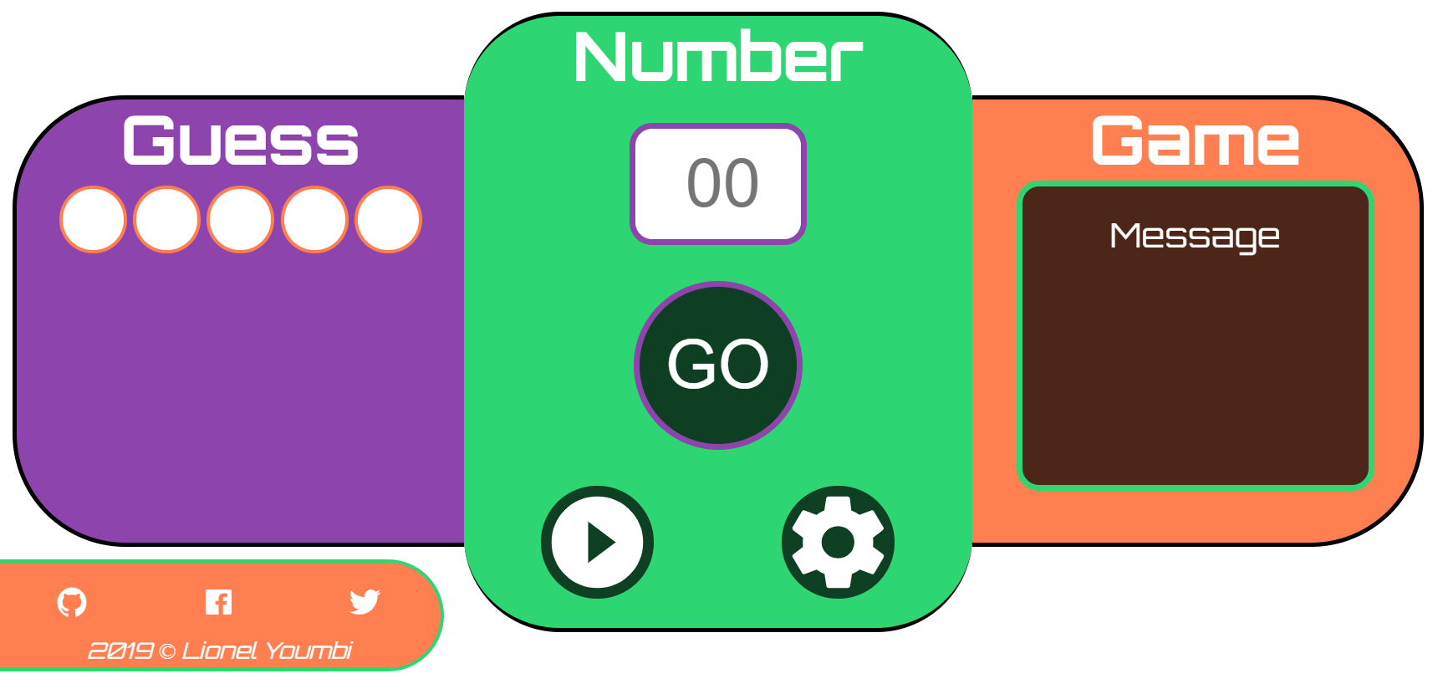

The player can set the maximum number of guesses and the highest number that can be guessed.
