Designing Adaptive LLM Scaffolding for Burmese-Speaking
STEM Learners
Nay Lin Htet
¹ Master of Information Technology Student, Faculty of Science, University of Auckland

Abstract
Burmese-speaking learners may face difficulties understanding specialized English STEM terminology and concepts. Direct translation may not provide sufficient technical context or educational support. The SLR and SSR identify fragmented capabilities across multilingual language support, terminology handling, conceptual explanation, personalization, and LLM-based interaction. This research applies Task–Technology Fit and Scaffolding Theory to develop three conceptual artefacts and three corresponding system artefacts: an Adaptive STEM Scaffolding System Framework, an Adaptive STEM Scaffolding Logical Architecture, and the Burmese STEM AI proof-of-concept system. The implemented system identifies STEM concepts and context, provides bilingual structured explanations, collects learner-reported understanding, adapts support within bounded interaction, and preserves learning history. The contribution is positioned primarily as an Improvement in Design Science Research by integrating established capabilities into a task-aligned educational Information System for Burmese-speaking STEM learners. The prototype demonstrates technical feasibility but does not yet establish improved learning outcomes.

Keywords: Adaptive STEM Scaffolding, STEM Terminology Support, Burmese-Speaking Learners, Large Language Models, Bilingual Learning, Educational Information Systems

1. Introduction
Burmese-speaking learners may face difficulties understanding specialized English STEM terminology when language barriers and unfamiliar technical concepts occur together. The SLR and SSR indicate that existing research provides useful capabilities in multilingual support, terminology handling, conceptual explanation, personalization, and LLM-based interaction, but these capabilities remain fragmented across separate approaches. This research therefore focuses on designing an Information System that integrates context-sensitive Burmese/English terminology support, conceptual explanation, structured scaffolding, and learner-responsive adaptation. Building on Task–Technology Fit and Scaffolding Theory, the design phase translates the conceptual artefacts into system artefacts and an executable Burmese STEM AI proof of concept.

2. Newly Proposed System Artefacts
The conceptual design knowledge is translated into three complementary system artefacts: (1) the Adaptive STEM Scaffolding System Framework, (2) the Adaptive STEM Scaffolding Logical Architecture, and (3) the Burmese STEM AI Proof-of-Concept System. Together, they operationalize the conceptual artefacts as system functions, logical responsibilities, and executable behavior.

Figure 1
Progression from Conceptual Artefacts to System Artefacts
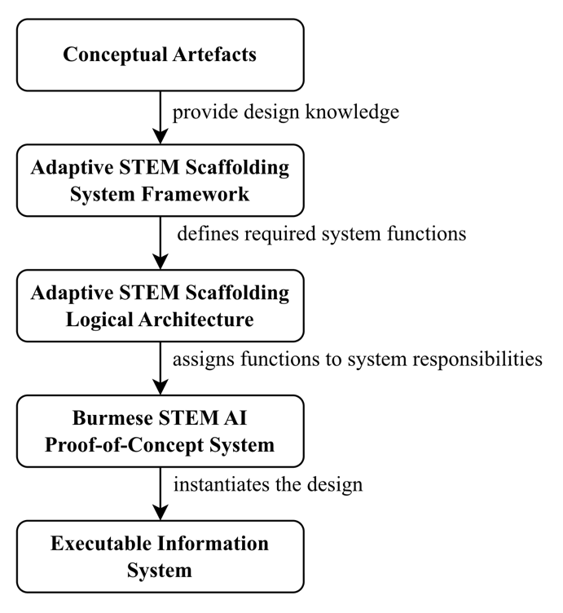
Note. Arrows represent the progression from conceptual design knowledge to system functions, logical responsibilities, proof-of-concept instantiation, and an executable Information System.

TTF is operationalized through three study-specific fit dimensions: language-support fit, concerning context-sensitive Burmese/English terminology support; conceptual-support fit, concerning explanations and examples for STEM understanding; and adaptive-interaction fit, concerning adjustment of support according to learner-reported understanding. These dimensions connect technological capabilities to the requirements underlying RQ1–RQ3 (Goodhue & Thompson, 1995).

The artefacts therefore address three corresponding issues: insufficient terminology and language support, insufficient conceptual learning support, and insufficient structured and adaptive scaffolding.

2.1. System Artefact 1: Adaptive STEM Scaffolding System Framework
The first system artefact is the Adaptive STEM Scaffolding System Framework, which translates the Context-Aware Adaptive STEM Scaffolding Framework into an operational system process. It specifies how a learner's natural-language STEM inquiry is transformed into context-sensitive, structured, and adaptive educational support.

Figure 2
Adaptive STEM Scaffolding System Framework
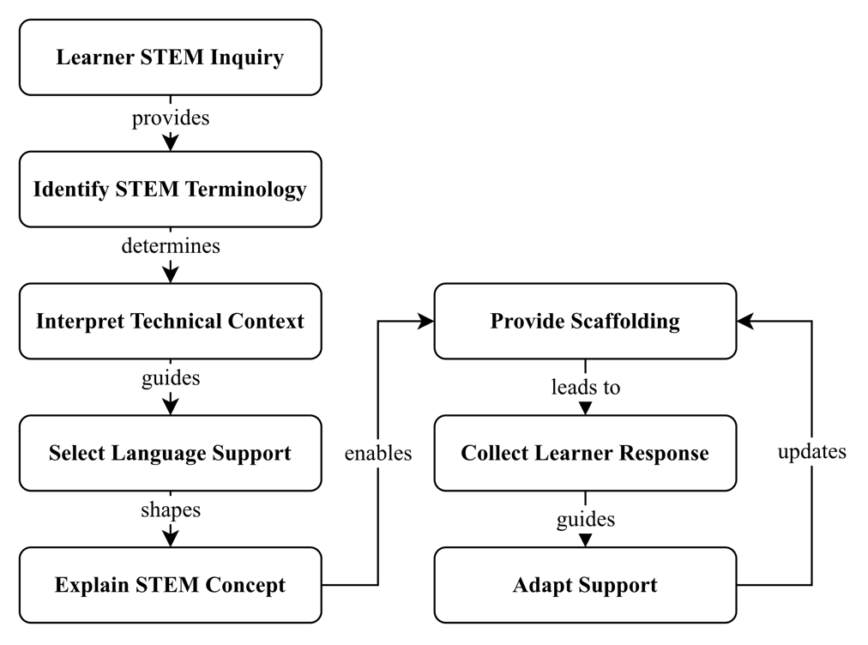
Note. Arrows represent required sequencing and guidance relationships; the feedback loop shows how learner response guides adaptation and updates subsequent scaffolding.

Identify STEM Terminology establishes the principal specialized concept in the learner's inquiry. This is informed by Automatic Term Extraction research, which distinguishes specialized domain terminology from ordinary vocabulary (Tran et al., 2026). Interpret Technical Context then considers the concept within its relevant STEM discipline rather than treating it as an isolated word (He et al., 2025).

The context guides Select Language Support, which determines whether a concept should be explained in Burmese, retain its English technical term, or use a bilingual combination. In a study of LLM-based scientific translation, some participants considered technical terms to be over translated and preferred familiar terminology to remain untranslated in English (Kleidermacher & Zou, 2026, p. 3932). The framework therefore does not require automatic translation of every STEM term. Explain STEM Concept instead combines appropriate language support with explanation of the underlying technical meaning. This is consistent with evidence that native-language technical support can facilitate learners' access to technical concepts (Athukorala & De Silva, 2025, p. 166) and with structured multilingual educational interaction reported by Kuzu (2026).

Provide Scaffolding structures assistance through explanations, examples or analogies, technical detail, reflective prompts, and hints. Collect Learner Response and Adapt Support form a feedback loop governed by the scaffolding characteristics of contingency and fading. Contingency adjusts support to learner need, while fading reduces support as competence increases (van de Pol et al., 2010). Accordingly, uncertainty can trigger simpler, additional, or alternative scaffolding, whereas stronger self-reported understanding allows support to fade and the interaction to progress towards completion.

The framework also introduces explicit sequencing constraints and decision points. Terminology identification precedes technical-context interpretation; context interpretation guides language-support selection; language support shapes conceptual explanation; and explanation precedes learner-facing scaffolding. Adaptation occurs only after a learner response has been collected. The principal decision points are therefore language-support selection, where the system determines the appropriate Burmese/English strategy, and learner-response evaluation, where the system determines whether support should increase, change form, fade, or conclude.
This artefact provides direct PIRQOA traceability: RQ1 is addressed through terminology identification, context interpretation, and language selection; RQ2 through conceptual explanation and scaffolding; and RQ3 through learner response and adaptation. It operationalizes the concepts, relationships, and process defined by the three conceptual artefacts.

The Task-Aligned LLM Scaffolding Model is carried forward as five evaluable propositions: P1, the low-resource language barrier hinders STEM understanding; P2, LLM-based scaffolding reduces this language barrier; P3, LLM-based scaffolding supports STEM understanding; P4, scaffolding leads to a learner response; and P5, the learner response guides the next stage of scaffolding. The proposed system mainly instantiates P2–P5 through context-sensitive language support, conceptual explanation, learner-response collection, and adaptive scaffolding.

2.2. System Artefact 2: Adaptive STEM Scaffolding Logical Architecture
The second artefact is the Adaptive STEM Scaffolding Logical Architecture. Whereas the framework specifies what the system must do, the architecture assigns these functions to four logical responsibility layers: User-Facing, Application/Scaffolding, AI/LLM, and Data/Persistence.

The User-Facing Layer sends learner questions, understanding responses, follow-up requests, preferences, and history actions to the Application/Scaffolding Layer. The application layer acts as the central coordinator: it interprets the learner's task and determines what terminology, language, explanation, or adaptation support is required.

The Application/Scaffolding Layer connects to the AI/LLM Layer through bounded generation requests. The LLM can generate concept and context interpretations, bilingual explanations, examples, hints, adapted support, and concept-scoped follow-up responses, but it does not independently control the learning workflow. The application controls session state, learner responses, adaptation limits, follow-up scope, and lifecycle decisions. This separation supports TTF by using LLM capabilities for defined learner tasks rather than exposing unrestricted generative functionality (Goodhue & Thompson, 1995).

Figure 3
Adaptive STEM Scaffolding Logical Architecture and Information Flow
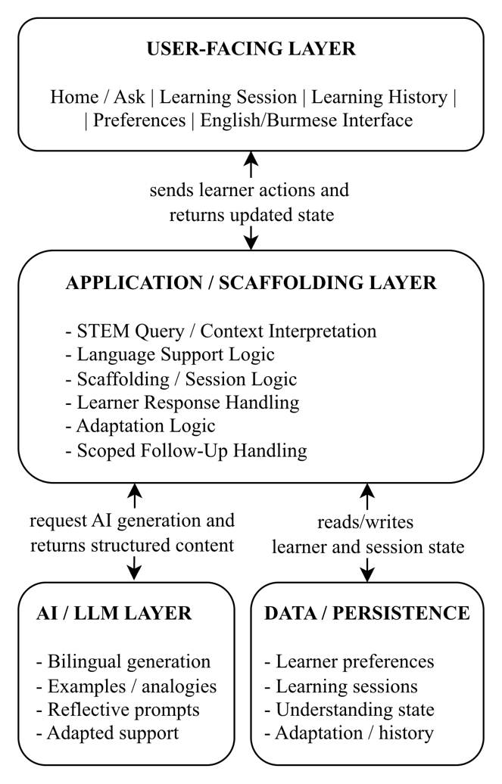
Note. Arrows represent information and control flows between layers; all learner, LLM, and persistence interactions are mediated by the Application/Scaffolding Layer.

The Application/Scaffolding Layer also connects to Data/Persistence to store and retrieve learner preferences, learning sessions, self-reported understanding, adaptation state, follow-ups, and session status. There is no direct learner-to-LLM or learner-to-database connection; interactions pass through the application logic so that the scaffolding process remains controlled.

This architecture operationalizes the conceptual artefacts by assigning terminology and context interpretation, language support, conceptual explanation, learner response, and adaptation to explicit system responsibilities. Consequently, the architecture supports RQ1–RQ3 and their associated objectives, while preventing the requirements from becoming disconnected technical features. The LLM remains an enabling technological component within the Information System rather than the research artefact itself.

2.3. System Artefact 3: Burmese STEM AI Proof-of-Concept System
The third artefact is Burmese STEM AI, an executable proof of concept that instantiates the Adaptive STEM Scaffolding System Framework and Logical Architecture. It demonstrates the feasibility of the proposed design through three primary screens: Home/Ask, STEM Learning Session, and Learning History. Figures 4–8 present a single demonstration scenario showing the complete learner journey from submitting a STEM inquiry to receiving structured and adaptive support, asking a follow-up question, and reviewing the saved learning session.

In the demonstration scenario, a Burmese-speaking learner begins by entering “Explain about Carbon Fiber technology” through the Home/Ask screen. The learner is not required to identify the specialized terminology or relevant STEM domain manually. Instead, the system interprets the inquiry and initiates the terminology, context, and language-support process associated with RQ1.

Figure 4
Burmese STEM AI Home/Ask Interface
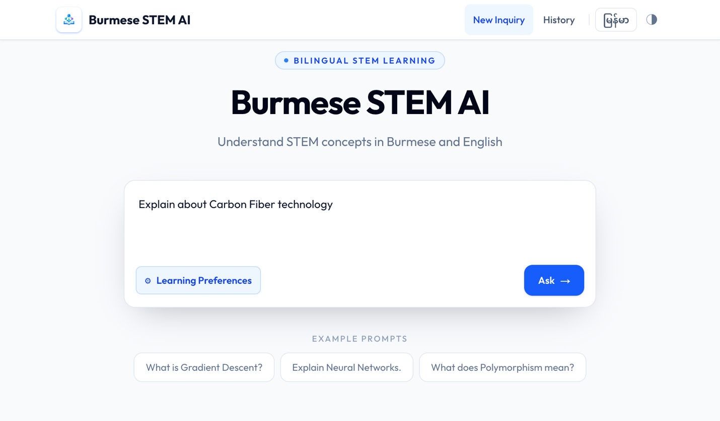
Figure 5
Structured STEM Learning Session: Three Forms of Educational Support and a Reflective Prompt
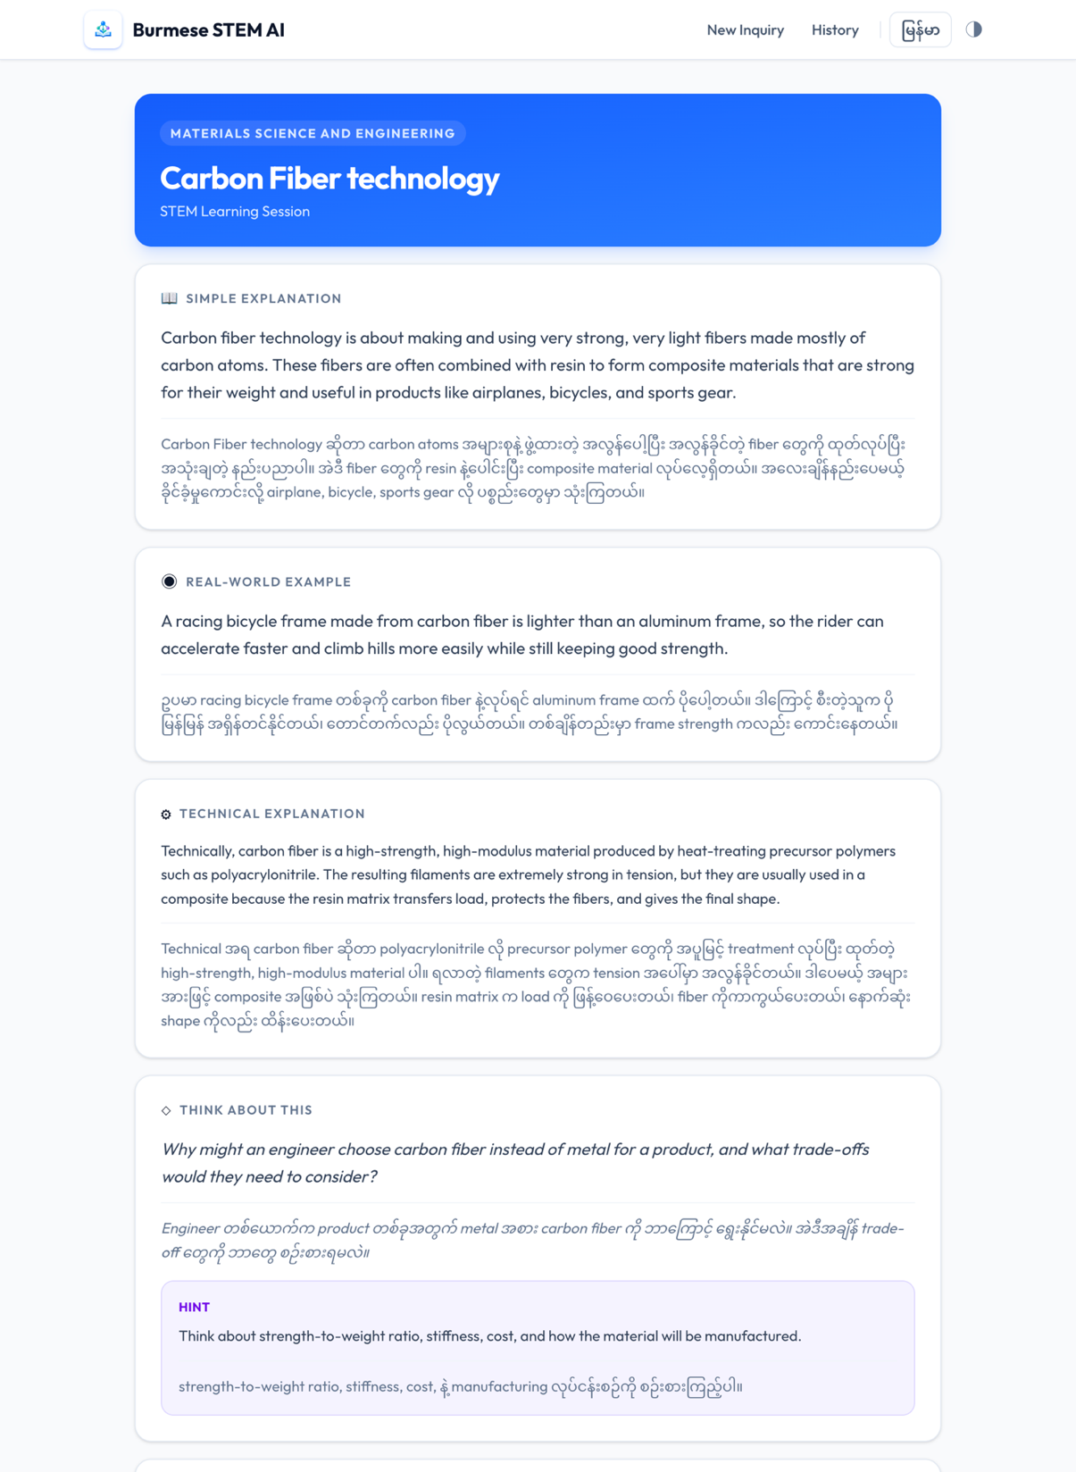

The resulting STEM Learning Session identifies Carbon Fiber technology within Materials Science and Engineering and provides structured bilingual scaffolding. The session separates the generated support into a Simple Explanation, Real-World Example or Analogy, Technical Explanation, Reflective Prompt, and optional Hint. Burmese explanations retain useful English STEM terminology where appropriate. This operationalizes the requirements underlying RQ1 and RQ2 by supporting technical terminology in context while providing conceptual assistance beyond direct translation (Athukorala & De Silva, 2025, p. 166; Kleidermacher & Zou, 2026, p. 3932). The screenshot demonstrates this progression through a simple description of carbon fiber, a bicycle example, a more technical materials-science explanation, and a reflective question about material-selection trade-offs.

The learner then reports understanding through High, Medium, or Needs Support. These values represent self-reported understanding rather than objective learning performance. The response guides subsequent scaffolding according to contingency and fading: Medium or Needs Support indicates uncertainty and can trigger clarification, simpler wording, additional Burmese explanation, another example, or an alternative analogy, while High understanding allows support to fade and the learner to progress towards completion (van de Pol et al., 2010). This instantiates the Learner Response → Updated Scaffolding relationship and directly addresses RQ3 and the objective of developing adaptive scaffolding (Wood et al., 1976).

Figure 6
Adapted Scaffolding Following Learner Response
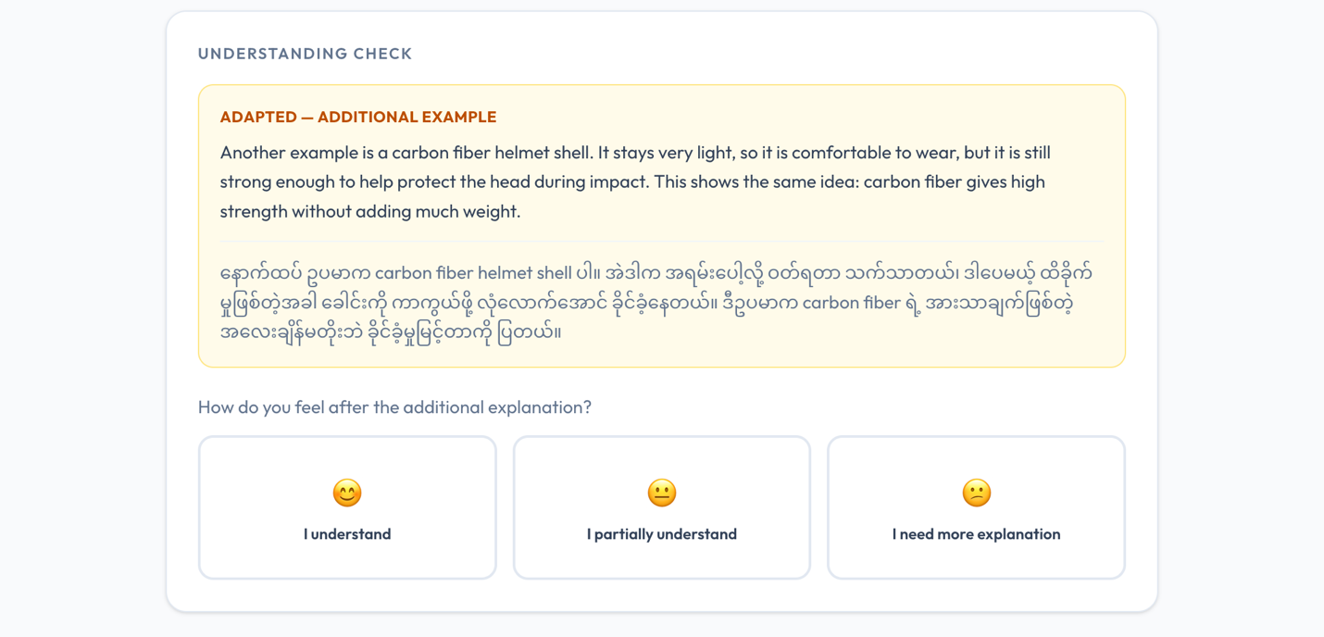
Figure 6 demonstrates this adaptive behavior through an additional carbon-fiber example generated after the learner response. The system therefore changes the form of assistance rather than simply repeating the original explanation.

The proof-of-concept limits adaptation to two rounds. This is an implementation boundary for demonstrating controlled adaptation, not a claim that two rounds are pedagogically optimal. The system also provides a concept-scoped follow-up capability so that learners can request further clarification while remaining within the active STEM concept. In Figure 7, the learner asks whether Carbon Fiber technology is useful in building spacecraft, and the system responds specifically within the context of the current concept. This provides learner-directed clarification without turning the system into an unrestricted general-purpose chatbot.

Figure 7
Concept-Scoped Follow-Up Question
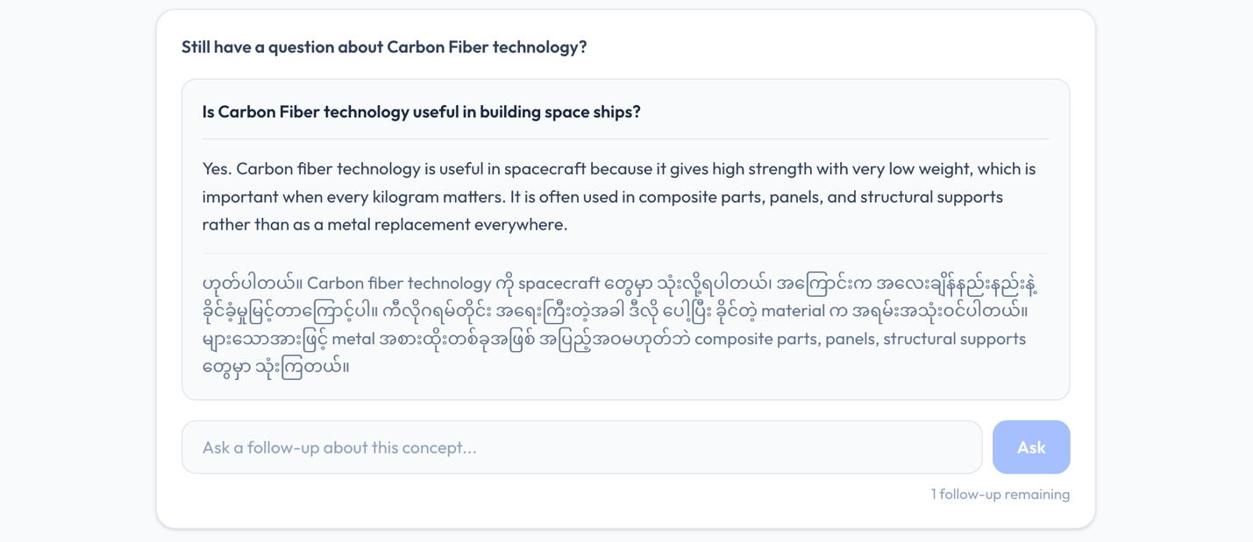

Finally, the Learning History screen retains previous concepts, STEM domains, understanding states, and session status. Figure 8 shows the Carbon Fiber technology session recorded alongside other previous learning sessions and provides the option to resume it. Persistence therefore allows learners to review or continue previous learning sessions without requiring a conventional login account.

Figure 8
Burmese STEM AI Learning History Interface
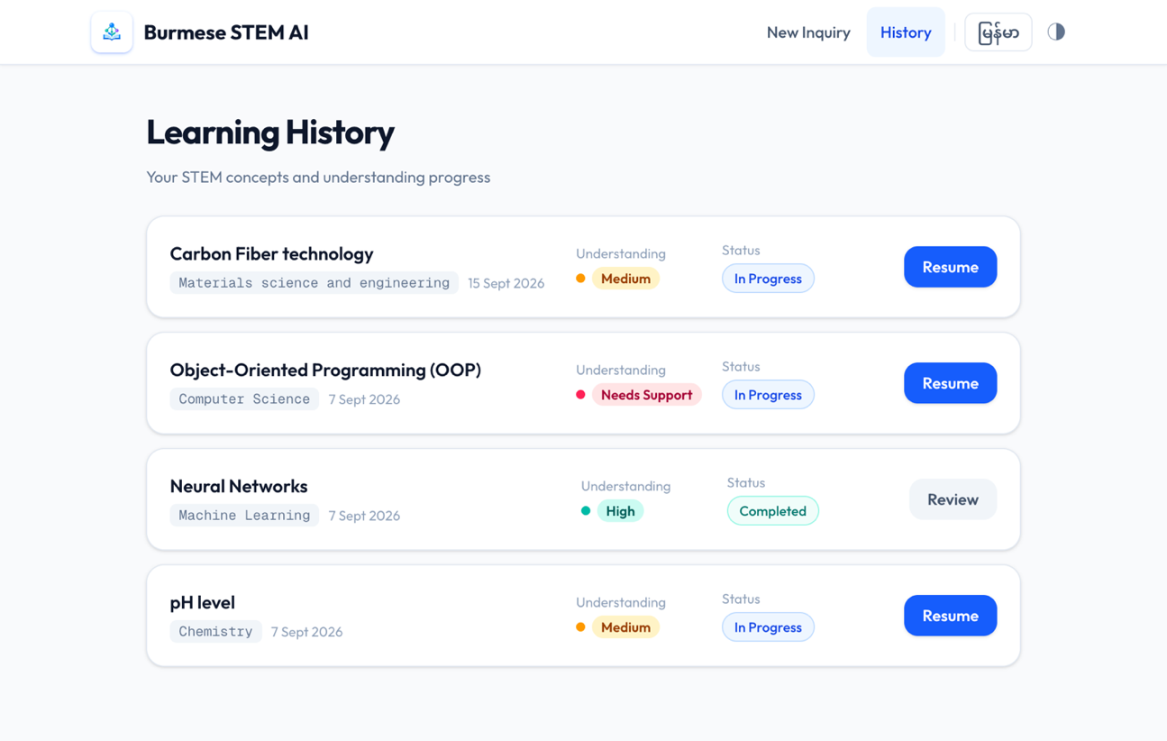

Together, Figures 4–8 demonstrate the complete proof-of-concept scenario: learner inquiry → terminology and context interpretation → structured bilingual explanation → learner response → adapted support → concept-scoped follow-up → learning history. This sequence provides learner-visible evidence that the system framework and logical architecture have been instantiated as executable behavior. Terminology-sensitive language support addresses RQ1, conceptual scaffolding addresses RQ2, and learner-response-driven adaptation addresses RQ3, while the prototype operationalizes the concepts, relationships, and adaptive process established by the conceptual artefacts.

3. Novelty and Originality
The novelty of the proposed artefacts does not arise from inventing a new LLM, translation method, terminology-extraction technique, or scaffolding mechanism in isolation. Instead, the contribution lies in integrating capabilities that the SLR and SSR found to be distributed across separate research and system streams into a coherent Information System for Burmese-speaking STEM learners. Translation-oriented research provides knowledge about multilingual support, specialized terminology, and contextual translation, while educational research provides knowledge about conceptual explanation, learner interaction, personalization, and structured assistance. However, within the reviewed corpus, these capabilities were not integrated into a single approach combining specialized STEM terminology identification, context-aware low-resource language support, conceptual explanation, and structured adaptive LLM interaction for the target learning context.

Table 1
Comparison of Reviewed Systems and Proposed System Advance
Reviewed system | Existing capability | Limitation relevant to this research | Proposed advance
Sinhala Java Programming Assistance Tool (Athukorala & De Silva, 2025) | Native-language technical assistance and explanation | Sinhala/Java specific; no reported separate terminology-identification stage | Terminology-sensitive support across broader STEM inquiries
Kazakh Educational Dictionary (Rakhimova et al., 2024) | Structured multilingual vocabulary resources | General vocabulary; limited adaptive interaction | Integrates terminology, conceptual explanation, and adaptive scaffolding
Interactive Video Learning Framework (Zhang & Pang, 2025) | Multilingual content and interactive LLM assistance | Video-centered; specialized STEM terminology not central | Places terminology and concept scaffolding at the center of the workflow
SingLing (Sakunkoo et al., 2025) | Contextual multilingual learning and personalization | Language acquisition rather than STEM learning | Applies contextual multilingual assistance to specialized STEM concepts
Vidyālaya (Nair et al., 2026) | Bilingual interaction, personalization, and structured learning | Technical STEM terminology is not a central function | Integrates bilingual learning with terminology-sensitive STEM scaffolding

For terminology support, Automatic Term Extraction research provides knowledge for distinguishing specialized domain terms from ordinary vocabulary (Tran et al., 2026). Scientific translation research further demonstrates that technical terminology may require contextual treatment rather than automatic translation; some participants preferred familiar technical terminology to remain in English when translation made it less familiar (Kleidermacher & Zou, 2026, p. 3932). Educational studies meanwhile demonstrate the value of multilingual explanation, structured interaction, feedback, and personalized support (Athukorala & De Silva, 2025; Kuzu, 2026; Nair et al., 2026). The proposed advance therefore lies in organizing these complementary capabilities around one task-aligned scaffolding process rather than treating them as independent functions.

The SSR further demonstrates this fragmentation at the system level. The Java Programming Assistance Tool for Sinhala Native Speakers provides native-language technical learning support through Sinhala interaction, translation, code-related assistance, and explanation, but is specific to Sinhala and Java and does not report a separate terminology-identification stage (Athukorala & De Silva, 2025). The Children's Educational Dictionary for Kazakh provides structured textual, visual, and audio vocabulary resources but focuses primarily on general vocabulary rather than specialized STEM concepts and does not report adaptive conversational scaffolding (Rakhimova et al., 2024).

The Interactive Video Learning Framework combines LLM-generated summaries, multilingual subtitles, mind maps, and real-time question answering, but its design is centered on video learning rather than systematic support for specialized STEM terminology (Zhang & Pang, 2025). SingLing demonstrates contextual multilingual learning and personalization through code-switched song lyrics but focuses on language acquisition rather than technical STEM understanding (Sakunkoo et al., 2025). Vidyālaya combines bilingual interaction, LLM capabilities, speech technologies, personalized feedback, and structured learning activities for Telugu learners, but its central objective is language learning rather than domain-specific STEM terminology scaffolding (Nair et al., 2026).

The proposed system aligns with these prior systems by retaining useful capabilities such as native-language interaction, structured explanation, personalization, and LLM-supported learning. It enhances them by integrating terminology identification, technical-context interpretation, selective English/Burmese language support, conceptual explanation, reflective scaffolding, learner-response collection, and bounded adaptation within one controlled learning process. This comparison establishes the basis for the proposed integrated design.

Based on this contrast with the SLR and SSR findings, the proposed artefact is positioned primarily as an Improvement contribution within the Design Science Research knowledge-contribution framework of Gregor and Hevner (2013). Improvement is appropriate because both the problem domain and substantial solution knowledge already exist. Multilingual translation, terminology extraction, educational scaffolding, personalization, and LLM-supported interaction are established capabilities; therefore, claiming Invention would overstate the contribution. The advance instead comes from configuring and operationalizing existing technological and pedagogical knowledge into a more integrated solution for the identified Burmese STEM-learning problem (Gregor & Hevner, 2013).

The originality claim is therefore deliberately bounded. It is not claimed that no other system globally can translate STEM terminology or provide educational explanations. Rather, within the reviewed SLR and SSR corpus, no examined system demonstrated the same integrated combination of terminology-sensitive low-resource language support, conceptual STEM explanation, structured scaffolding, learner-response-driven adaptation, and controlled LLM interaction for Burmese-speaking STEM learners. The contribution is consequently the coherent integration and operationalization of established capabilities into a task-aligned system artefact addressing the identified research problem.

4. Design Rationale
The design rationale follows a traceability principle in which each major system feature is derived from an identified problem, issue, requirement, theoretical principle, or conceptual artefact rather than being added solely because the technology permits it. The central design problem is that Burmese-speaking learners may require more than direct translation to understand specialized English STEM terminology and concepts. The PIRQOA therefore establishes three requirements: context-sensitive terminology and language support, conceptual explanation beyond translation, and structured and adaptive learner support. Task–Technology Fit (TTF) provides the primary Information Systems design principle by requiring technological capabilities to correspond to identifiable learner tasks (Goodhue & Thompson, 1995). Scaffolding Theory complements this by explaining why learner assistance should be structured and adjusted according to learner needs (Wood et al., 1976).

Table 2
Traceability from Research Problems and Requirements to Major System Features
System Feature | Problem / Issue / Requirement Served | Conceptual Artefact Basis
Terminology and context identification | Issue: Insufficient terminology/language support  Requirement: Identify terminology and technical context  RQ1: STEM terminology support | STEM Terminology Identification; Context-Aware Adaptive STEM Scaffolding Framework
Burmese/English language support | Issue: Insufficient terminology/language support  Requirement: Context-sensitive Burmese support while preserving useful English terms  RQ1: Multilingual STEM terminology support | Context-Sensitive Language Support
Structured explanations, examples, reflection and hints | Issue: Insufficient conceptual learning support  Requirement: Explanation and examples beyond direct translation  RQ2: Conceptual STEM understanding | Conceptual Explanation; Structured Scaffolding
Understanding response and adapted support | Issue: Insufficient adaptive scaffolding  Requirement: Collect learner response and adjust assistance  RQ3: Structured and adaptive support | Learner Response → Updated Scaffolding; Adaptive Support; Scaffolding characteristics: contingency and fading (van de Pol et al., 2010)
Concept-scoped follow-up | Issue: Insufficient structured scaffolding  Requirement: Clarification within the active STEM concept  RQ3: Learner-responsive support | Structured Scaffolding; Context-Aware Adaptive STEM Scaffolding Framework
Learning history and learner preferences | Issue: Limited continuity and personalization  Requirement: Preserve session state and apply learner preferences  RQ3: Adaptive and task-aligned support | Task-Aligned LLM Scaffolding Model; Adaptive Support; Task–Technology Fit
The natural-language STEM inquiry was selected as the entry point because the learner's task is to understand a STEM concept rather than operate a specialized terminology tool. The system therefore performs STEM terminology identification and technical-context interpretation internally. These functions address the requirement underlying RQ1 by locating the principal concept and establishing its disciplinary meaning. Automatic Term Extraction research supports distinguishing specialized terminology from ordinary vocabulary (Tran et al., 2026), while contextual interpretation is important because technical meaning can depend on domain and instructional context (He et al., 2025). These features directly operationalize STEM Terminology Identification and the first stages of the Context-Aware Adaptive STEM Scaffolding Framework.

The Burmese/English language-support strategy exists because automatically translating every specialized term may not provide the most useful learning support. In scientific translation, some participants reported that translated technical terminology became less familiar and preferred familiar terminology to remain in English (Kleidermacher & Zou, 2026, p. 3932). The system therefore allows Burmese explanation while retaining useful English STEM terminology when appropriate. This design addresses the terminology and language-support requirement and operationalizes Context-Sensitive Language Support. Learner preferences for language and explanation level further support TTF by allowing assistance to correspond more closely to the learner's task and preferred form of support.

The structured Learning Session addresses RQ2 and the requirement to provide conceptual assistance beyond translation. Rather than returning a single generated response, the system separates support into a Simple Explanation, Real-World Example or Analogy, Technical Explanation, Reflective Prompt, and optional Hint. Athukorala and De Silva (2025, p. 166) report that native-language programming assistance helped Sinhala-speaking learners focus on technical concepts and programming logic rather than the additional language barrier. Kuzu (2026) similarly demonstrates the importance of structuring multilingual LLM interaction around learning activities. These features operationalize Conceptual Explanation and Structured Scaffolding.

The learner-understanding response and adaptation mechanism address RQ3. The learner reports High, Medium, or Needs Support, and this response guides subsequent assistance. This implements the conceptual relationship Learner Response → Updated Scaffolding and follows Scaffolding Theory by allowing assistance to change according to learner need (Wood et al., 1976). Personalized feedback and structured learning activities demonstrated by Nair et al. (2026) provide additional support for learner-responsive interaction. The maximum of two adaptation rounds is deliberately an implementation boundary rather than a theoretical claim about optimal learning; it demonstrates controlled adaptation while preventing an uncontrolled interaction loop.

The concept-scoped follow-up allows learners to request clarification while keeping interaction aligned with the active STEM concept. This choice preserves learner flexibility without turning the artefact into an unrestricted chatbot. Similarly, Learning History maintains session continuity so that learners can review or resume previous scaffolding. Preferences and history are persisted anonymously because conventional authentication is unnecessary for demonstrating the research contribution. Features such as a quiz engine, teacher dashboard, social functionality, and full Learning Management System capabilities are excluded because they do not directly address the identified research requirements. This maintains TTF by limiting functionality to capabilities that contribute to the target learner tasks.

Consequently, the prototype is not a collection of independent LLM features. Each major capability can be traced from the identified problems and issues → requirements → theoretical principles and conceptual artefacts → system functions and learner-visible features. This traceability minimizes unexplained design “magic” and provides a defensible rationale for both what the system includes and what it deliberately excludes.

5. Technical Soundness and Feasibility
The technical feasibility of the proposed artefacts is demonstrated through an implemented and deployable proof-of-concept Information System, rather than through conceptual diagrams alone. The implemented interfaces presented in Figures 4–8 provide learner-visible evidence of the prototype instantiation, while Figure 9 presents the technical deployment architecture. Systems development can contribute to Information Systems research by demonstrating that proposed design knowledge can be instantiated as a functioning system (Nunamaker et al., 1990). The implementation therefore provides evidence that the Adaptive STEM Scaffolding System Framework and Logical Architecture can be translated into executable behavior.

Figure 9
Proof-of-Concept Deployment Architecture
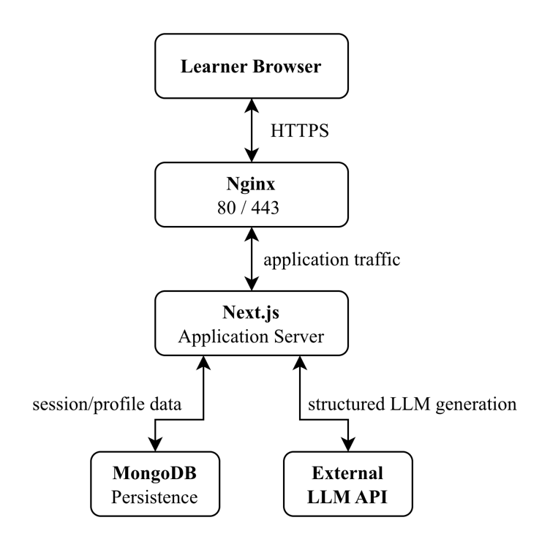
Note. Arrows represent production communication paths between the learner browser, reverse proxy, application server, persistence service, and external LLM service.

The application is implemented using Next.js 16, React 19, TypeScript, Tailwind CSS 4, and next-intl, with MongoDB 7 and Mongoose 9 providing persistence. LLM-assisted generation is performed server-side using the OpenAI Responses API. Docker and Docker Compose provide reproducible application and database environments, while the production deployment uses Nginx and Certbot for HTTPS access. The implementation intentionally remains a small monolithic web application because the proof of concept does not require the operational complexity of microservices, message queues, Kubernetes, or other distributed infrastructure. This keeps the technical architecture proportionate to the research scope.

A central technical design decision is the separation between application-controlled workflow and LLM-generated content. When a learner submits a question, application services validate the inquiry, determine the required operation, request structured content from the LLM, validate the returned response, persist the resulting session, and expose it to the user interface. Separate services manage initial sessions, session lifecycle, learner preferences, adaptation, and follow-up interactions. The adaptation service maps the learner's response to a support strategy and enforces the adaptation limit, while the follow-up service validates whether a question remains related to the active concept.

LLM output is constrained technically rather than accepted as unrestricted free text. Initial explanations, adaptations, and follow-up responses are generated using structured-output schemas and validated before being incorporated into the learning session. Provider calls occur only on the server, preventing the API credential from being exposed to the browser, and requests use a 20-second timeout with controlled provider-error handling. This maintains consistency between the Logical Architecture and implementation: the LLM generates requested educational content, while the application controls learner state, adaptation rounds, follow-up scope, persistence, and lifecycle transitions.

The persistence model also reflects the research design. MongoDB separates anonymous learner profiles from learning sessions. Profiles store learning preferences without requiring names, email addresses, passwords, or other conventional account information. A learning session stores the original inquiry, identified concept and STEM domain, bilingual explanations, reflective prompt, hint, self-reported understanding, lifecycle status, adaptations, follow-ups, and a learner-preference snapshot. This representation allows the application to reconstruct genuine previous learning sessions and supports Review and Resume functionality rather than presenting static interface examples.

The adaptive process is additionally enforced through application state. A session begins as in_progress, with no understanding response and adaptation round zero. Responses of high, medium, or needs_support determine the subsequent support strategy, while the adaptation round is incremented and prevented from exceeding two. Continued difficulty after the bounded adaptation process can produce a review_recommended status. These transitions are enforced through service and API logic as well as represented in the interface. The adaptive behavior is therefore controlled by reproducible application logic rather than relying entirely on unpredictable LLM decisions.

The proof of concept has also been deployed to an AWS EC2 environment, providing stronger feasibility evidence than local execution alone. The production environment uses Docker Compose to run Nginx, Next.js, MongoDB, and Certbot. Public HTTPS requests enter through Nginx, while the application and database remain inside the internal Docker network; only ports 80 and 443 are publicly exposed.

The deployed proof-of-concept system is publicly accessible at https://burmesestemai.serveirc.com/. The GitHub repository provides the implementation source code, available at https://github.com/Nlhmmh/burmese_stem_ai_research. A demonstration video showing a complete learner scenario and the end-to-end proof-of-concept workflow is available at https://drive.google.com/drive/folders/16fkMYiHQj4K9qTBOexPOnay0k-ZXJnxE?usp=drive_link.

The deployment process builds and starts MongoDB and Next.js, configures Nginx, obtains an HTTPS certificate, redirects HTTP traffic to HTTPS, performs renewal checks, and verifies the application endpoint. Together with the implemented interfaces shown in Figures 4–8, the deployment provides concrete instantiation evidence that the proposed system artefacts are technically implementable, consistent with the role of systems development as a research method described by Nunamaker et al. (1990).

The prototype nevertheless remains a research proof of concept rather than a production-ready educational platform. The core learning loop is implemented, but automated schema, API, adaptation, LLM-contract, and UI tests have not yet been completed; current verification relies on ESLint and successful production builds. Keyboard and dialog accessibility, mobile review, Burmese typography review, preference synchronization, retry behavior, and some error localization also require further hardening. These limitations do not prevent demonstration of the proposed system behavior, but they define technical work required before broader learner evaluation or production use.

Taken together, the implemented prototype shown in Figures 4–8, the deployment architecture in Figure 9, the persistent data model, controlled adaptation logic, and deployed application provide concrete instantiation evidence consistent with Nunamaker et al. (1990). The implementation establishes technical feasibility and internal consistency, while claims about educational effectiveness remain appropriately reserved for later empirical evaluation.

6. Conclusion
This research develops three connected system artefacts: the Adaptive STEM Scaffolding System Framework, the Adaptive STEM Scaffolding Logical Architecture, and the Burmese STEM AI proof-of-concept system. Together, they operationalize terminology-sensitive Burmese/English support, conceptual explanation, structured scaffolding, learner response, and bounded adaptation within a coherent Information System. The contribution is positioned primarily as an Improvement because it integrates established technological and pedagogical capabilities in a configuration not identified within the reviewed SLR and SSR corpus. The implemented and deployed prototype demonstrates technical feasibility and traceability from research requirements to system behavior, while educational effectiveness remains a matter for later empirical evaluation.

References
Athukorala, K. S. N., & De Silva, D. I. (2025). Bridging language barriers in programming education: Java programming assistance tool for Sinhala native speakers. International Journal of Computer Theory and Engineering, 17(3), 151–169. https://doi.org/10.7763/IJCTE.2025.V17.1378
Goodhue, D. L., & Thompson, R. L. (1995). Task-technology fit and individual performance. MIS Quarterly, 19(2), 213–236. https://doi.org/10.2307/249689
Gregor, S., & Hevner, A. R. (2013). Positioning and presenting design science research for maximum impact. MIS Quarterly, 37(2), 337–355. https://doi.org/10.25300/MISQ/2013/37.2.01
He, J., Wang, F., Li, S., Lei, Y., Zhu, J., & Lv, L. (2025). A comparative study on the translation capabilities of multimodal large language models with independent intellectual property rights—taking cross-cultural online education scenarios as an example. Proceedings of the 2025 2nd International Conference on Big Data and Digital Management, ICBDDM ’25, 834–839. https://doi.org/10.1145/3768801.3768938
Kleidermacher, H. C., & Zou, J. (2026). Science across languages: Assessing LLM multilingual translation of scientific papers. In V. Demberg, K. Inui, & L. Marquez (Eds.), Findings of the Association for Computational Linguistics: EACL 2026 (pp. 3932–3947). Association for Computational Linguistics. https://doi.org/10.18653/v1/2026.findings-eacl.204
Kuzu, T. E. (2026). AI-supported translanguaging processes in primary school: Empirical insights into ChatGPT’s role in multilingual interactions. Technology, Knowledge and Learning. https://doi.org/10.1007/s10758-026-09974-7
Nair, P. C., Reddy, A. C., & Hemasri, M. (2026). Vidyālaya: AI-powered Telugu language learning platform. Procedia Computer Science, 283, 1386–1395. https://doi.org/10.1016/j.procs.2026.06.216
Nunamaker, J. F., Jr., Chen, M., & Purdin, T. D. M. (1990). Systems development in information systems research. Journal of Management Information Systems, 7(3), 89–106. https://doi.org/10.1080/07421222.1990.11517898
Rakhimova, D., Karibayeva, A., Karyukin, V., Turarbek, A., Duisenbekkyzy, Z., & Aliyev, R. (2024). Development of a children’s educational dictionary for a low-resource language using AI tools. Computers, 13(10), 253. https://doi.org/10.3390/computers13100253
Sakunkoo, J., Sakunkoo, A., & Sakunkoo, P. (2025). SingLing: Learning languages by singing code-switched lyrics. Adjunct Proceedings of the 38th Annual ACM Symposium on User Interface Software and Technology, UIST Adjunct ’25, 1–3. https://doi.org/10.1145/3746058.3758393
Tran, H. T. H., Martinc, M., Caporusso, J., Delaunay, J., Doucet, A., & Pollak, S. (2026). Recent advances in automatic term extraction: A comprehensive survey. ACM Computing Surveys, 58(9), 226:1-226:35. https://doi.org/10.1145/3787584
van de Pol, J., Volman, M., & Beishuizen, J. (2010). Scaffolding in teacher–student interaction: A decade of research. Educational Psychology Review, 22(3), 271–296. https://doi.org/10.1007/s10648-010-9127-6
Wood, D., Bruner, J. S., & Ross, G. (1976). The role of tutoring in problem solving. Journal of Child Psychology and Psychiatry, 17(2), 89–100. https://doi.org/10.1111/j.1469-7610.1976.tb00381.x
Zhang, C., & Pang, G. (2025). An interactive video learning framework enhanced by large language models. Proceedings of the 2025 International Conference on Educational Technology and Artificial Intelligence, ETAIC ’25, 458–463. https://doi.org/10.1145/3766557.3766635

