头图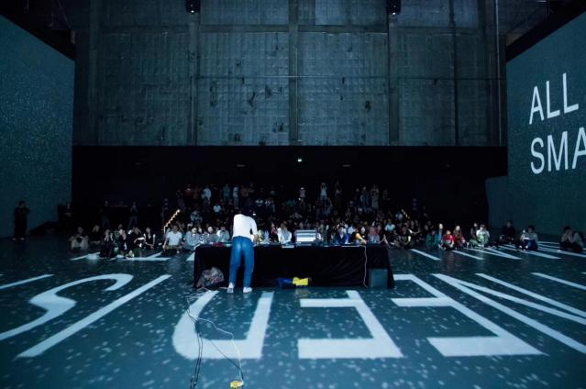

沉浸投影区观众在观赏图像景观

Immersive projection area audience watching the image landscape

01

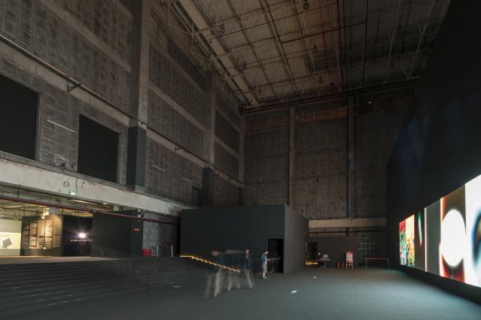

改变展示尺度的影像覆盖两个空间的体量转换

The volume conversion of the two scales covered by the image with changing display scale

#李城在《未答复的问题》

#Sung-Jae Lee「The Unanswered Questions」

02

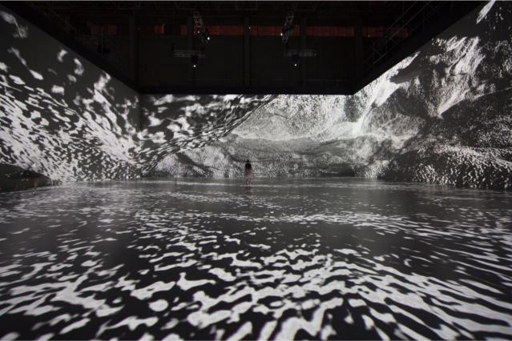

沉浸投影区观众在观赏图像景观

Immersive projection area audience watching the image landscape

#IN_K毕振宇&冯昊 《{[（Emergence）]}》

#IN_K & FENG HAO「{[（Emergence）]}」

03

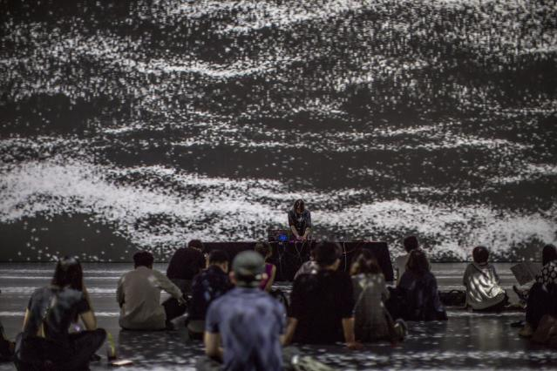

沉浸投影区观众在观赏图像景观

Immersive projection area audience watching the image landscape

#IN_K毕振宇&冯昊 《{[（Emergence）]}》

#IN_K & FENG HAO「{[（Emergence）]}」

04

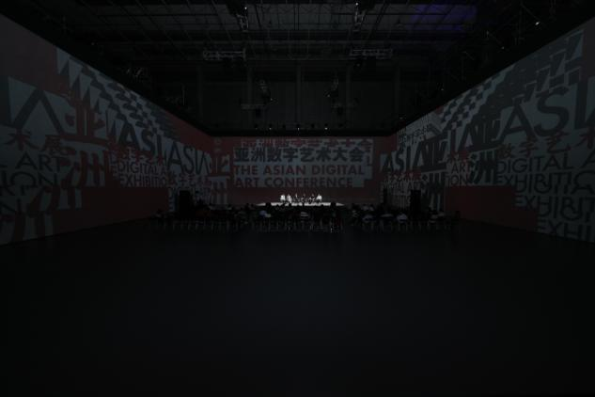

沉浸投影区在会议期间作为论坛场所使用

Immersive projection area is used as a forum place during the meeting

05

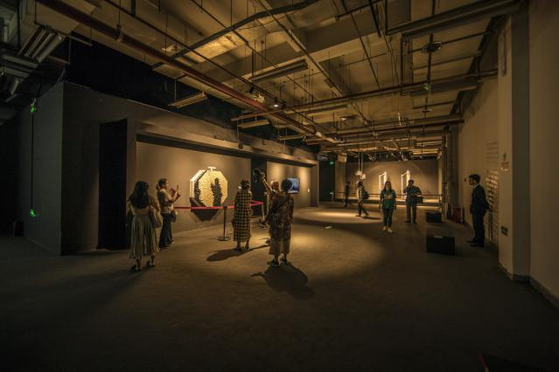

建立在工业库房中的数字装置

Digital device built in industrial warehouse

#丹尼·罗金《自私的基因镜像》&《毛球镜》

#Daniel Rozin「Selfish Gene Mirrors」&「Pom Pom Mirror」

06

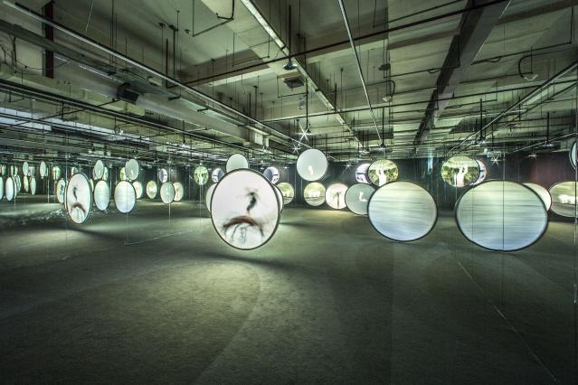

压缩空间下的多频影像同步

Multi-frequency image synchronization in compressed space

#吴俊勇《千月》

#JunYong Wu「Thousands of Moon」

07

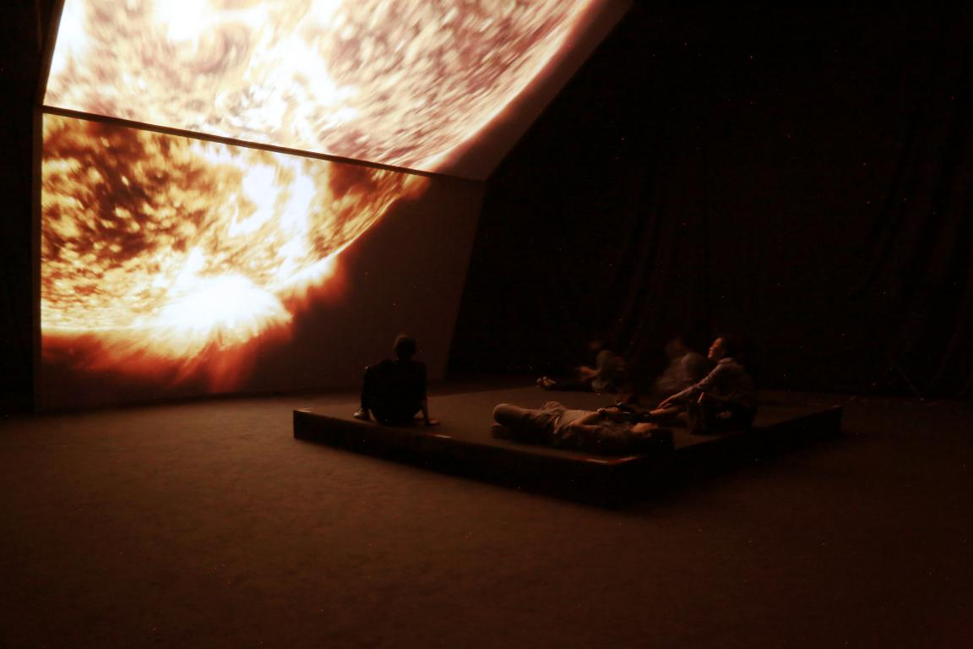

沉浸氛围作品呈现

Presentation of immersive works

#黑川良一《反向折叠》

#Ryoichi Kurokawa「unfold」

08

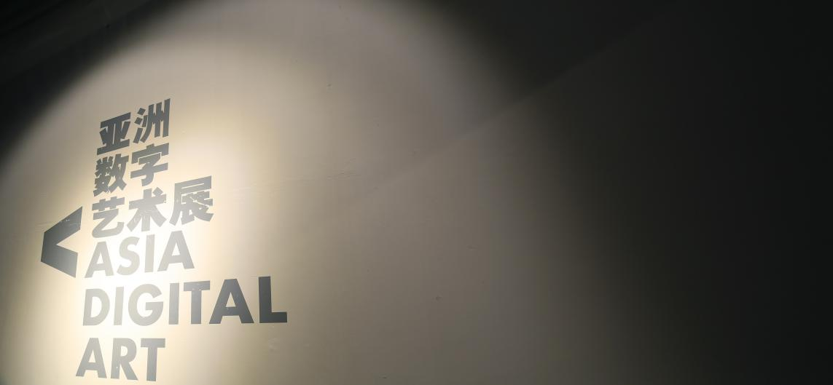

传统丝版印刷在空间导视中的应用

Application of screen printing in space guidance

09

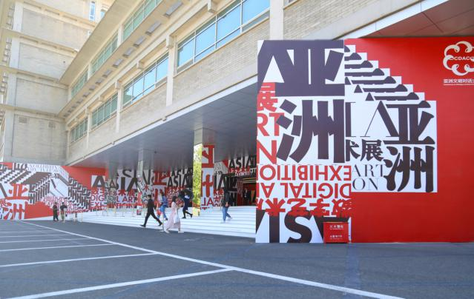

展览主入口对于旧建筑的保留与主形象应用

The main entrance of the exhibition preserves the old buildings and the application of the main image

#刘世豪 视觉图形设计

#Graphic Design by ShiHao Liu

10

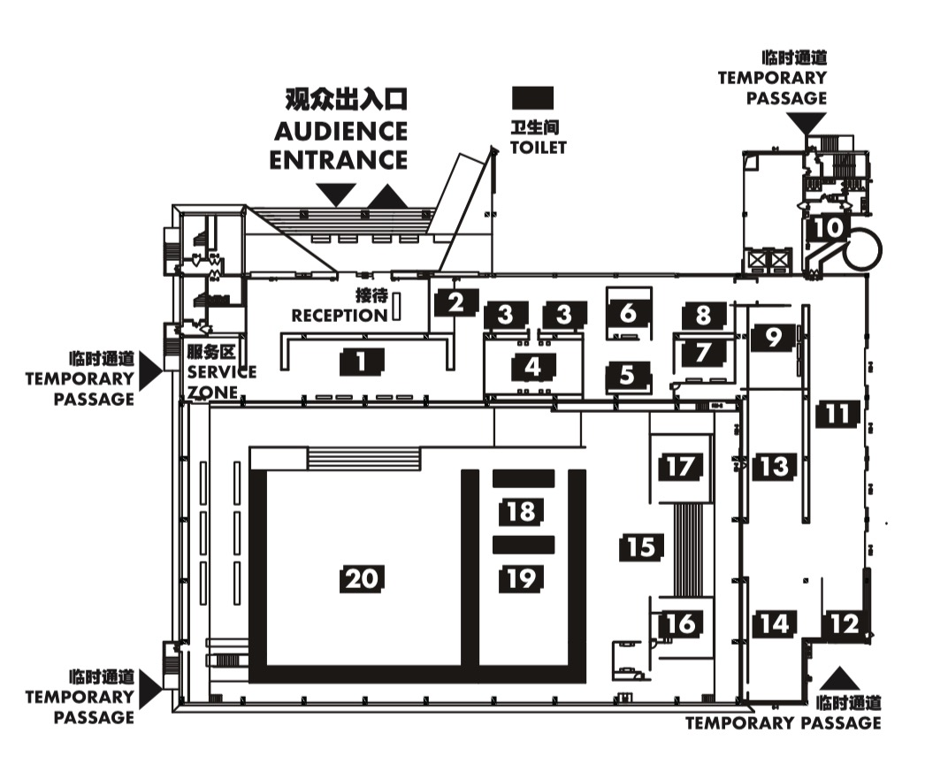

展览空间平面图

Exhibition plan

备注说明：

图片来源于网络。

图片中所包含艺术家作品仅用于亚洲数字艺术展空间设计展示使用，如用于其他用途须联系设计师或艺术家。

The picture comes from the Internet.

The works of the artists included in the picture are only used for the design and display of the Asian Digital Art Exhibition Space. If they are used for other purposes, they must contact the designer or artist