需求文档
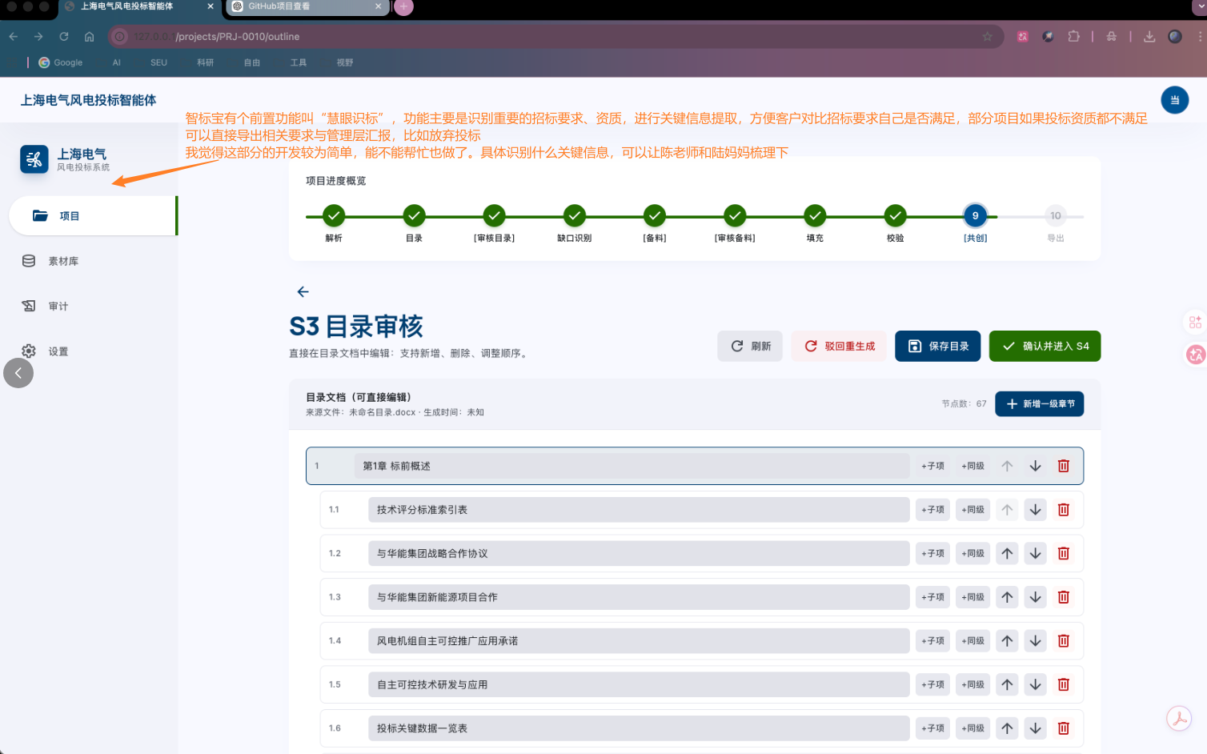

https://www.doubao.com/thread/wa058efab806644f7

