Model Evaluation Result

Project: MelaninCare AI Prototype v1

Validation Accuracy: 0.44 (44%)

Description:

This result represents the model’s performance on unseen validation data. The moderate accuracy demonstrates the feasibility of AI-based skin analysis while also revealing limitations in current datasets, particularly the underrepresentation of diverse skin tones.
This prototype forms part of an ongoing research effort to develop inclusive AI solutions for dermatological assessment in melanin-rich populations.

Date: April 2026

Model Code

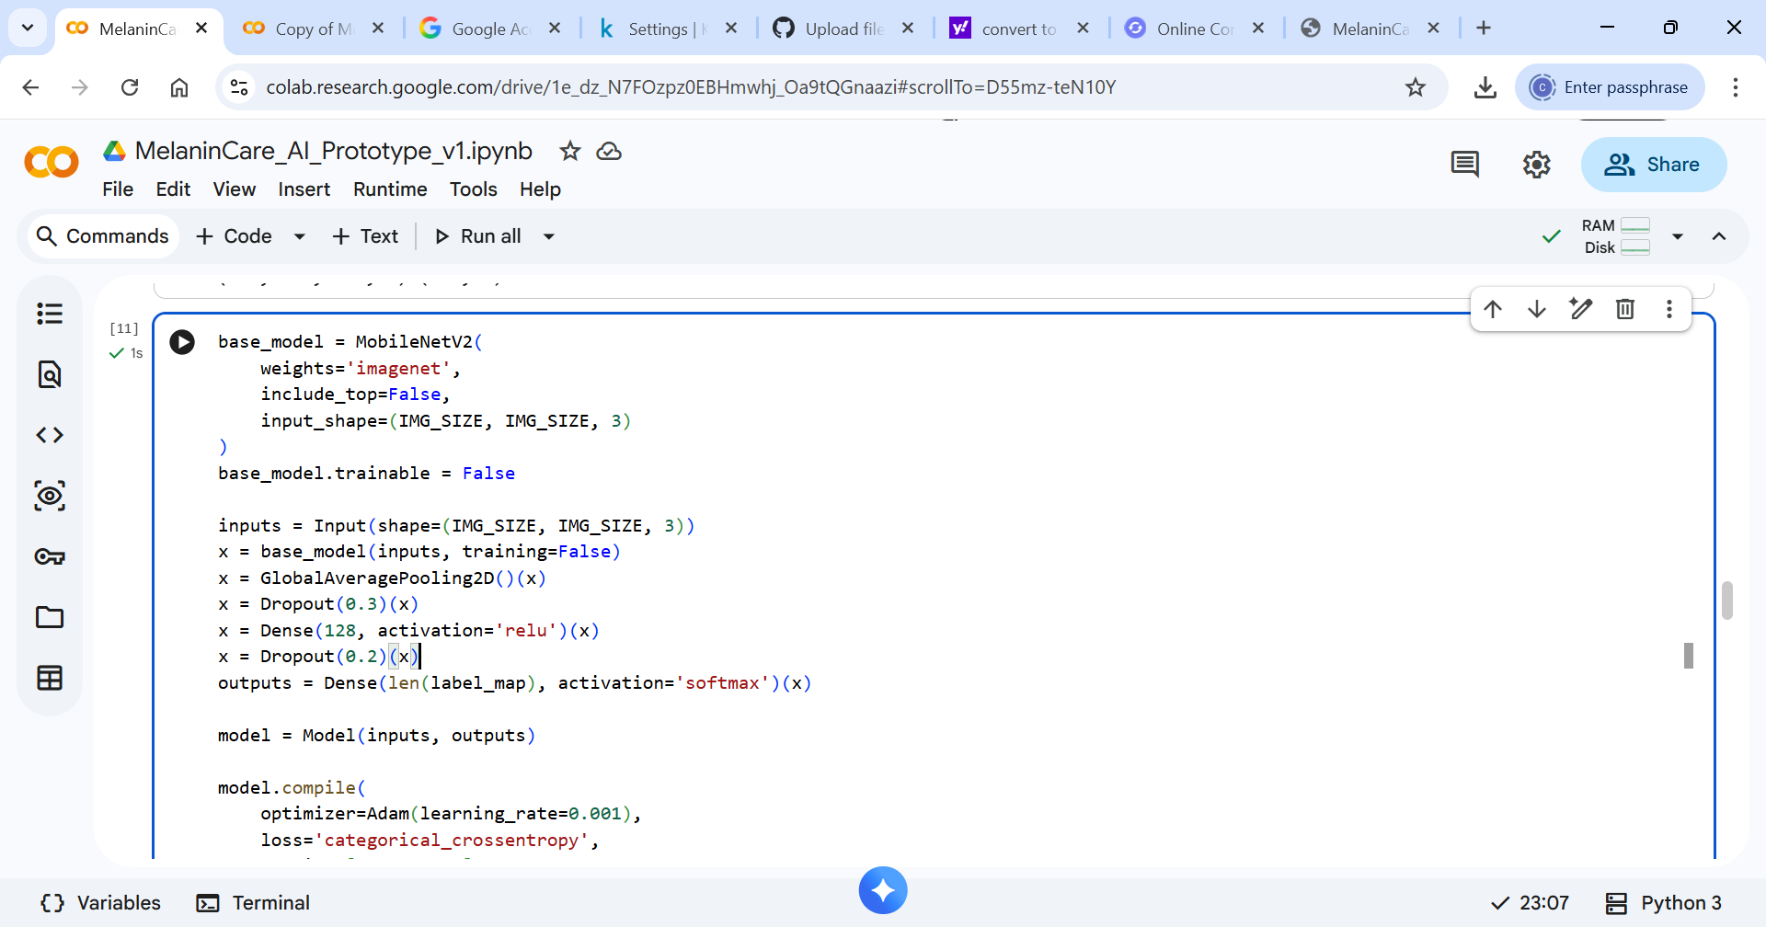

Model Summary

