**Description of the idea for the program**

Lake Forest Library is looking for an Adult Services Librarian. It is the public library and it serves the community of Lake Forest. Lake Forest Library is located at 360 E. Deerpath, Lake Forest, Illinois, a community located thirty miles north of Chicago on Lake Michigan. Lake Forest was founded in 1861 and developed under the leadership of Lake Forest College (then Lind University) and Presbyterian Church.

Mission of Lake Forest Library is “Inspiring lifelong, promoting the free and respectful exchange of ideas, and building community”. And Vision is “We believe passionately in the transformative power of ideas and the future of libraries, enabling everyone in the community to fulfill the universal desire to learn, explore, and belong”.

One of the duties and responsibilities for an Adult Services Librarian, Lake Forest Library looking for, is to develop and present innovative programs and activities, like Book Discussion or Technology classes.By using Design Thinking Process for innovative and relevant programs, I propose the idea of Online Book Clubs as well as enhance in-person Book Clubs. These Book Clubs also include fun activities and games at the end of discussion. Activities or games can be done or played before, during or after the Discussion. It depends upon the need of the situation.  Tea and light snacks to be served to users to get them refreshed after the discussion in order to celebrate and encourage readers to participate in the programs.

Looking at different libraries like New York Public Library, Billerica Library and Northampton’s Public Library as the process in Design Thinking, I came up with programs like Online Book Clubs, traditional Book Clubs, and Reading Challenge Programs. Technology is used to enhance Physical Book Club as well as to start Online Book Club. A web page with virtual space is provided to the users in Online Book Club. Technology can also be used to enhance physical Book Clubs. It can be used in creative ways for library communities to discover and talk more about the books.

Book Discussion Groups categorize in different sections like Sci-Fic Book Discussion, Social Justice Book Discussion, Crime- Fiction Book Discussion and Mystery Book Discussion.

A social justice book club includes books to think and talk about inequality and injustice in the U.S. and around the world. It includes fiction and nonfiction books about race, gender, immigration, poverty and criminal justice issues.

The Mystery Book Group discusses a variety of mystery genres, such as historical, legal/medical and police/PI, and others. Similarly, Sci-Fi Book Discussion talks about science fiction books and Crime- Fiction Discussion group talks about Crime Fiction books.

There are many other types of Book Clubs which can also be implemented depending upon the needs of library users after successful implementation and evaluation of the project like Silent Book Club, Poetry Book Club, The Any Book Club, The Make Something Book Club, Living Women Book Club, Walking Book Club, Timeless Book Club and many more other Book Clubs.

Another innovative programs can be included to make library users to love books and enjoy reading is Reading Challenge Program. Reading Challenge Program is also one of the relevant programs to be used by readers who enjoy to read. It can be done throughout the year. Like Summer Reading Challenge, Fall Reading Challenge, Winter Reading and Spring Reading Challenge. We can also add challenge like reading for 300mins for specific given time period.

**Project Plan**

**Goal of the project**

Goal of this Program is to increase the number of users participating in-person Book Clubs or Online Book Clubs in the Lake Forest Library. Book Clubs are used to promote a love for literature in a positive and nurturing environment. They enhance empathy and share diversity of opinion. This program helps patrons to participate in specific type of book club depending upon their nature of interest reading online as well as in-person. In the modern connected and ever busy age, Virtual interaction are becoming more popular due to conflicts in scheduling, mobility issues, and other factors. A lot of people are moving for online conversation. So, the Online Book Discussion Club will be very helpful and can be accessed and used by a lot of people to discover and talk more about the books. So, goal of the program is to increase library users to participate in the Book Clubs.

**Stakeholders**

Stakeholders are individuals or organizations who are actively involved in the project or whose interests may be positively or negatively affected as a result of successful project completion.

In this program, there are many internal and external stakeholders such as young adults, adults, staffs, people who have interest in library services, management, interest groups, suppliers, and others.

**Number of team members needed**

Number of team members required to implement this project is four. Two of 4 members of the team, help with traditional Book Club Discussion and other 2 members help with Virtual Book Discussions.

**Budget**

 Budget is the financial expression of the library’s plan and objectives. So, before a budget can be formulated, a plan for library services must be developed and goals and objectives must be established. Budgets for In-person and Virtual Book Club Discussion-$500

Budget in this project, needs for book collection, technology for the services and refreshments as follows.

|  |  |
| --- | --- |
| Expenditure | Estimation of the cost |
| Book Collection | $0-$100 |
| Staff salary | $200 |
| Use of technology for the services | $0-$150 |
| Advertisement | $50 |
| Refreshment | $50 |

**Outcomes**

Outcomes are intended results of the project. It measures project management and effectiveness.

In-person and virtual Book Club Discussion Outcomes are

* Interaction between club members to share diversity of their opinion.
* Promote a love for books and positive attitude towards reading.
* Discussion help users with critical thinking.
* An increase in flow of library users for this service

**Assessment Plan**

A project assessment for a program is an evaluation work process to decide whether the program is successful or not. It is end to end analysis of a project’s scope, scale, objectives, and impacts.

There are 5 tools for evaluating the success of a project. They are Survey, Observation, Case study, Focus Group and Interview.

A survey is a data collection tool or list of questions used to gather information about the programs.

Observations are the research techniques where participants of the programs are observed on the basis of their behavior.

Case Studies are common methods based on an in-depth investigation of a single individuals, groups, or events.

A Focus Groups is a group interview involving a small number of demographically similar people or participants who have experiences.

An interview is generally a qualitative research technique which involves asking open-ended questions to converse with participants and collect elicit data about the subject.

Here, in this program about categorized In-Person Book Clubs and Virtual Book Clubs, Assessment can be done by Survey, Observations and Interview after 6 months of start of the program. The assessment helps to understand if library users are happy with the program and have positive response towards the program.

Survey and Interview are done at the end of book club discussion with the participants. Observations are done though out the progress to find if attendance of participants are increasing or not.

Survey questions for the library users will be as follows.

* Are you planning to attend to the next book club session?
* Do you feel library should provide refreshment at the end of the discussion?
* Are you going to tell your friends to join the club?
* Do you like the categories of Book Clubs provided (Sci-Fic Book Discussion, Social Justice Book Discussion, Crime- Fiction Book Discussion and Mystery Book Club)?
* Do you want any other category to be added in Book Club? If yes, please suggest which one?

Similarly, interviews questions will be

* Do you like and dislike about the programs?
* What do want to see other categorizes of books to be included for book club discussion?
* Which one works for you In-person or virtual Book Clubs?
* Do you think games and activities at the end of the discussion are helpful?

Taking the interview of the users who attended the in-person or virtual book clubs and asking them about the programs and taking their feedback helps to understand whether the program is successful or not. After that, all the data of surveys, interviews and observations will be analyzed by the members of the library. And if there is positive response In-person and Virtual Book Club be continued in the Lake Forest Library. Also, after the analysis of data, we can find, if there is any other specific book clubs in demand, we can add it to the list of categorizes of the book clubs.

**Project Management**

Design thinking is a process for creative problem solving. It is a flexible process that can implemented in a variety of ways to accommodate unique library cultures. Here, Design thinking process is used to design and develop innovative programs for Lake Forest Library. That is categorized in-person Book Club and Virtual Book Club. And Gantt Chart is used for monitoring

Project’s progress.

Gantt Chart is a chart of lists of activities displayed against time. It is useful for planning and scheduling projects. It helps to assess how long a project would take, and determine the resources needed.

Gantt Chart for project management of Book Discussion In-Person Book Club and Virtual Book Club as follows.

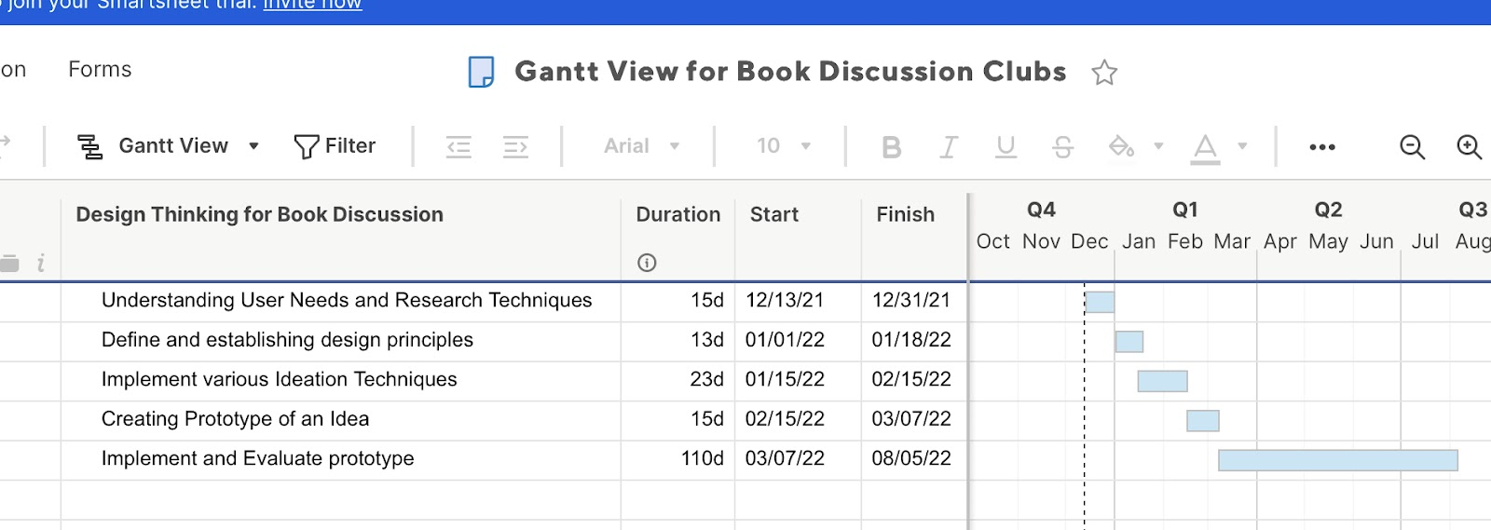

 Understanding User needs and Research Techniques helps to understand a problem from user’s perspective. In this first stage, we gather all the information. It needs 1about 5 days for completion of work starting from Dec 13, 2021. Defining and establishing design principles will help to articulate design principles and is very important stage. It needs 13 days of work. It will start from Jan 1, 2022. Implementing various Ideation Techniques requires about 23 days. Ideation of this program explains different ways to solve the problem. It will start from Jan 15, 2022. Creating Prototype of an Idea requires 15 days. It will start on Feb 15, 2022.

Implementing and Evaluating is one of the most important steps to check if the program is successful or not. It needs 120 days. By surveying, interviewing and observing the library users, 6 months after the start of the program, the outcome of the program is analyzed. It will start after studyig the prototype. If the program of In-person or Virtual Book Club is successful, then it will continue in the Lake Forest Library.

Design Thinking Process helps to create innovative and relevant Book Discussion Program. It includes different types of Book Clubs including fun activities at the end of the Discussion