

Dipen Shah

Mohan Raj Nandagopal

**Table of Contents**

|  |  |  |
| --- | --- | --- |
| **S. No** | **Section** | **Page Number** |
| 1 | Introduction | 3 |
| 2 | Detailed Description of Functionality | 4 |
| 3 | Wireframes | 6 |
| 4 | Screen Capture | 9 |
| 5 | Color Scheme | 14 |
| 6 | Potential Future Functionality | 15 |

**Introduction**

Survey Time is a web application which allows the users to register themselves in the application and create their own survey. The application also allows anonymous user to take a survey that has been registered by the registered user.

Survey Time allows the users to create , Edit, Modify a particular survey and also lets the user to view the statistics of the survey.

**Functionality**

1. **Users can sign up and register a new account** – To sign up, a user must provide its first name, last name, email-id, user name and password.
2. **Registered users can create new surveys** – A user can enter up to 3 questions in a survey and create answer options for it. A user may follow any schema for their answer options and may have as much number of options as required.
3. **Registered users can edit and remove surveys** – Registered users can edit and remove their surveys. However they cannot do the same for surveys created by other users. To do so, a user must go to survey list and choose their survey they wish to manage.
4. **Registered users can view their survey statistics** - Registered users can view their survey stats which includes the total number of responses submitted to the survey and the valid answers submitted.
5. **Anonymous users can answer surveys** – Users can answer surveys without registering or log in . Anonymous users are provided with a list of surveys along with the name of the person who created it and the date on which it was created and posted.
6. **Registered users can answer surveys** – Registered users can also answer surveys. Users are provided with a list of surveys along with the name of the person who created it and the date on which it was created and posted.

**Wireframes**

**Home Page**

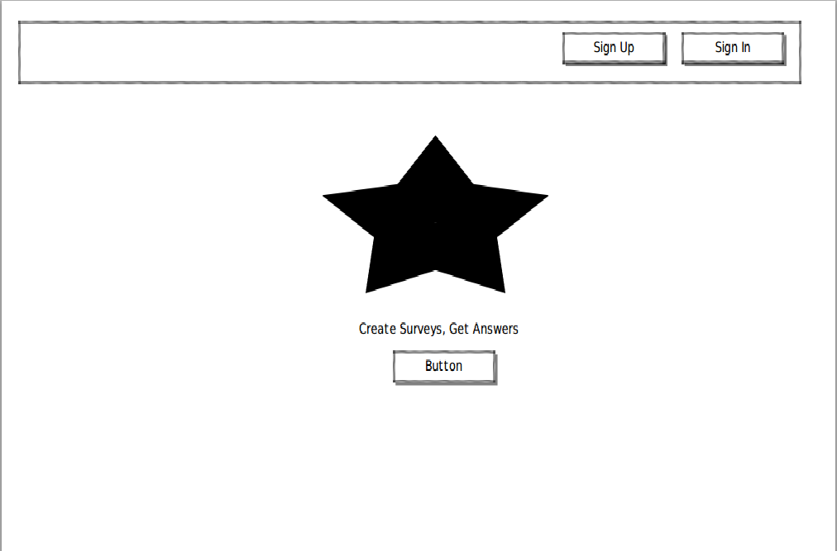

**List of Survey Pages**

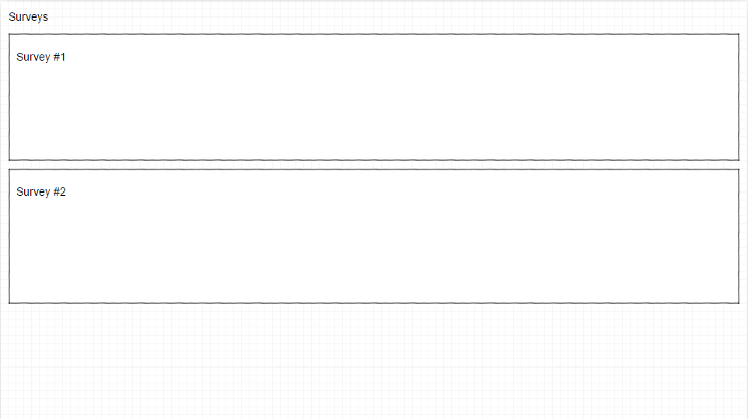

**Create Survey Page**

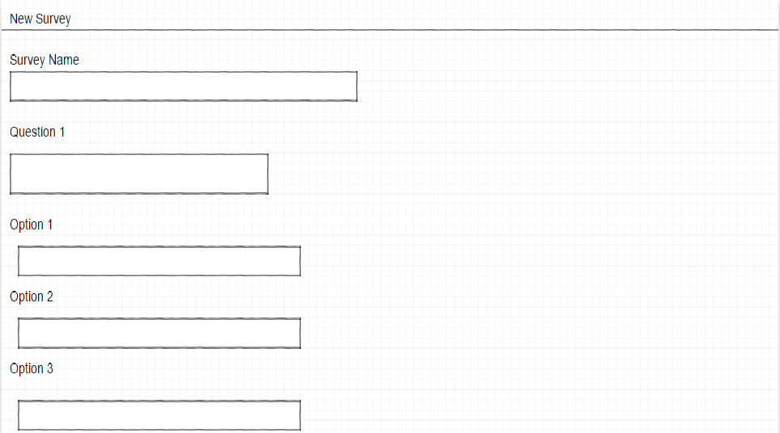

**Sign In**

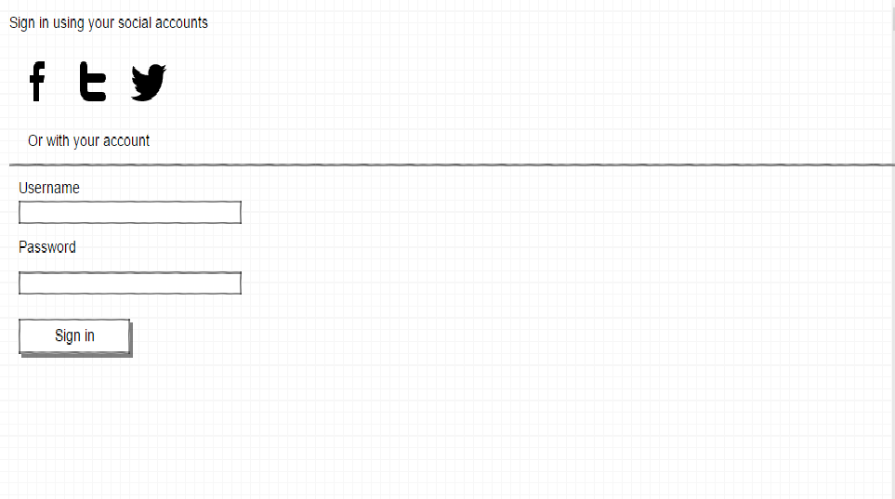

**Sign Up**

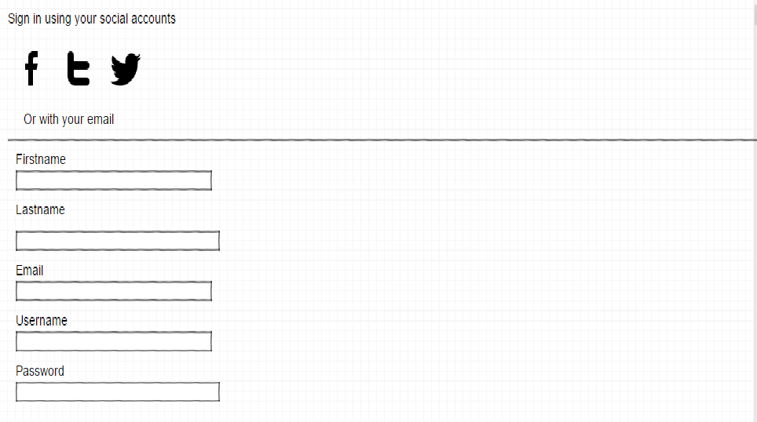

**Screen Shot walk-through:**

**Home Page**

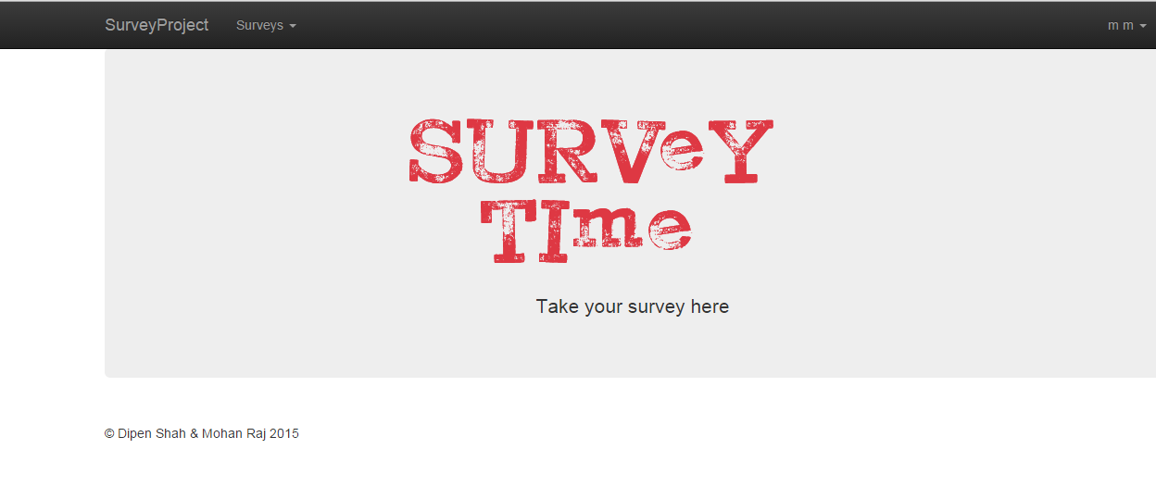

**Sign Up Page**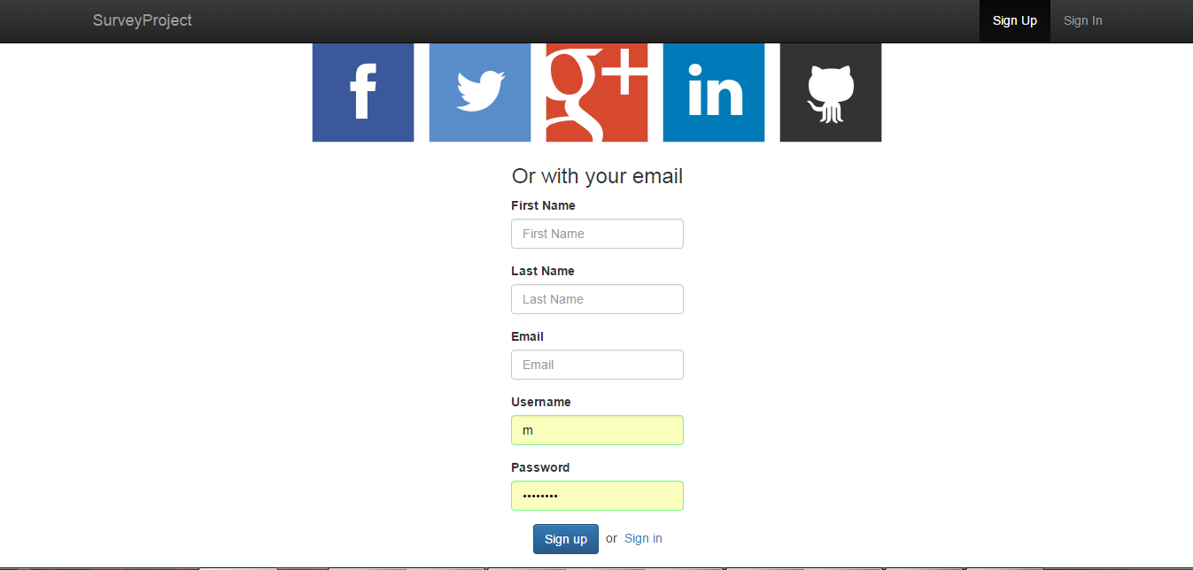

**Sign In Page**

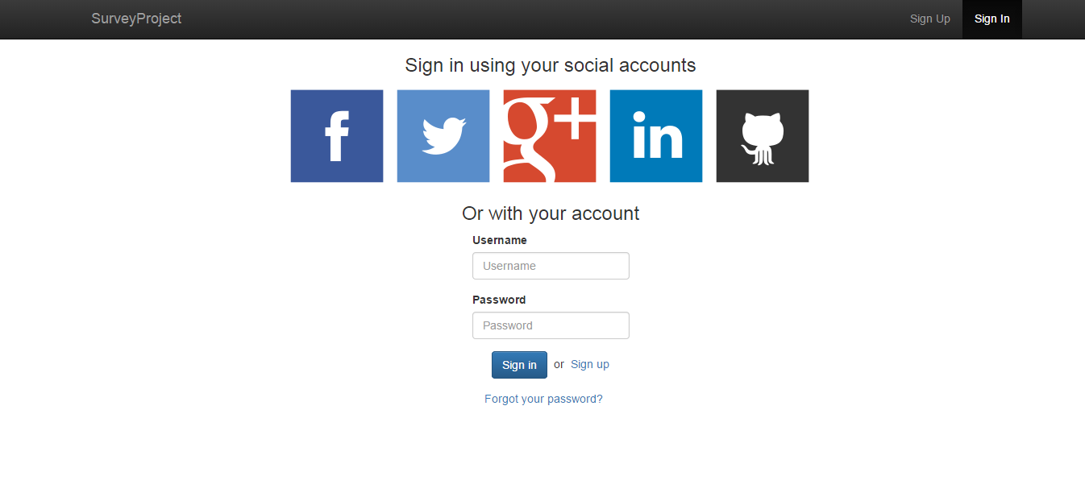

**List of Survey**

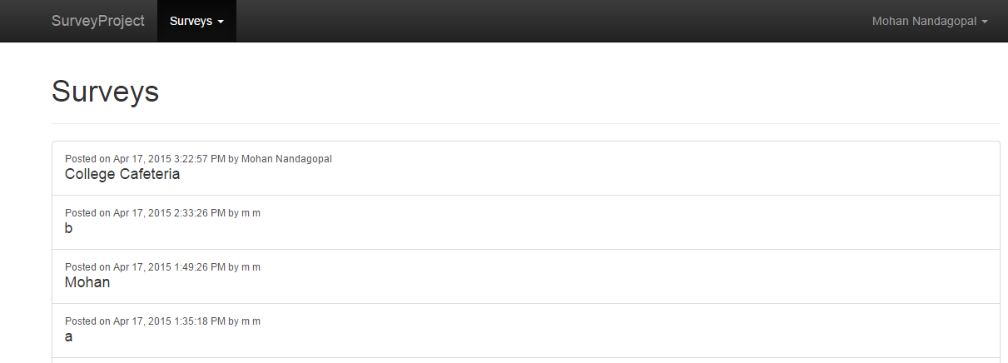

**Create New Survey**

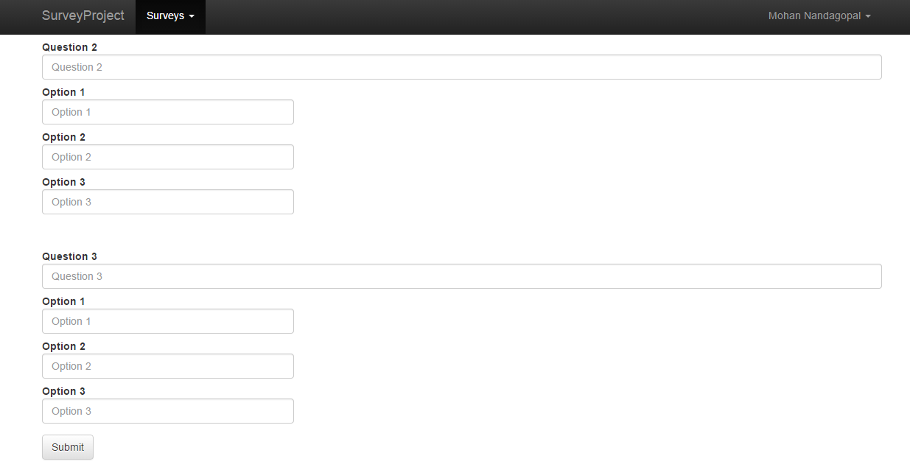

**Survey Answers**

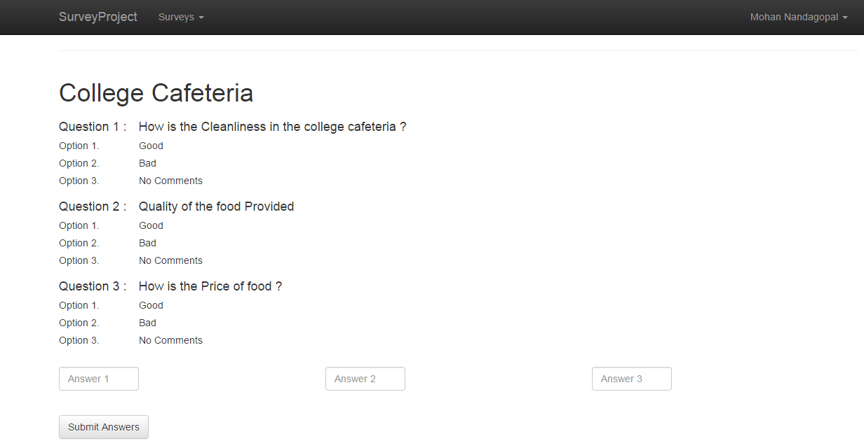

**Color Scheme**

Site follows a color scheme consisting of white, blue, black and light gray.

|  |  |  |  |
| --- | --- | --- | --- |
| **Color Name** | **Color Sample** | **Hex Value** | **Section** |
| White |  | #FFFFFF | Site background, Button and Nav bar text |
| Very Light Gray |  | #F2F2F2 | Panels and Bread crumbs |
| Black |  | #000000 | Nav Bar background and Page text |
| Sea Blue |  | #008CBA | Buttons and Links |