Since several days, I am surprised to not see any modelling studies of the covid-19 outbreak in low-income countries, particularly in Africa. Especially, we can make the assumption that the age distribution (pyramidal) and the different social structure (that affect contacts intensity and structure) in most of African countries compared to Europe / Asia / North America may strongly impact the dynamic of COVID-19. I used a simple SIR age structured model (I didn’t invent anything) to study the impact of age structure and contact matrix (that give the mean number of contact between each age classes in one day) on R0 (the basic reproductive number, i.e. the expected number *of* cases directly generated by one case in a susceptible population).

$$\frac{dS_{i}}{dt}=-βS_{i}\sum_{j}{C_{ij}}{I_{j}}/{N_{j}}$$

$$\frac{dI_{i}}{dt}=+βS_{i}\sum_{j}{C_{ij}}{I_{j}}/{N_{j}}-γI_{i}$$

$$\frac{dR_{i}}{dt}=+γI_{i}$$

*Where β is the probability of transmission on contact, i and j are indices of age classes, γ is the recovery rate. C is the contact matrix. Nj is the population in age j.*

Colleagues from my lab estimated the R0 in France before lockdown to be 2.5 (that is close to what was found in China). From this value, we can estimate the probability of transmission on contact (taking into account the contact matrix and age distribution in France) that I found to be 0.0127.

*Let λ be the largest eigenvalue of the matrix M where M has elements:*

$$M_{ij}=C_{ij}{f_{i}}/{f_{j}}$$

*Where fi and fj are frequencies of age classes i and j, respectively.*

*We have:*

$$β= \frac{R0}{λ}γ$$

*And:*

$$R0= \frac{β}{γ}λ$$

*Where R0 is the basic reproductive number.*

I used this probability of transmission on contact to estimate R0 (in absence of any intervention) in 146 country (for which both contact matrix and age distribution were available). I mapped the results:

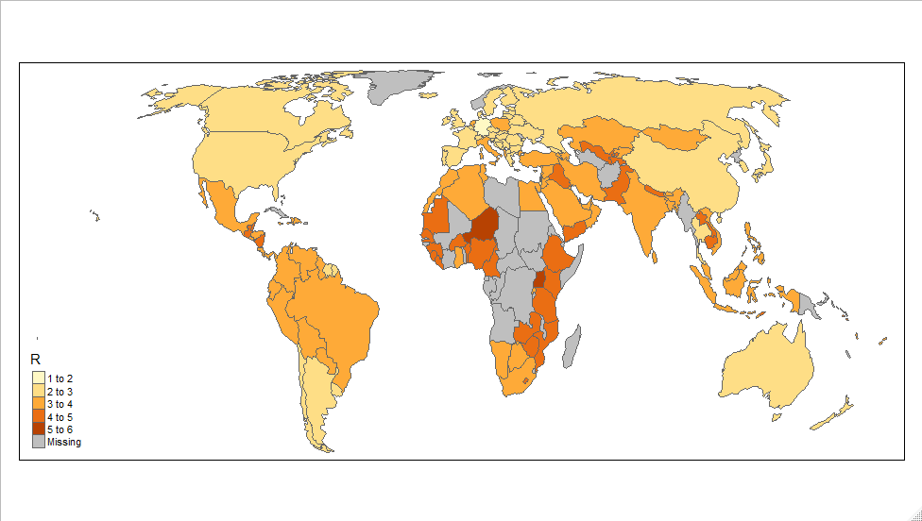

I also calculated R0 for all countries based on the method used by ETE team in their first report to have a picture of the current R0 in the world (based on published data of confirmed cased). The map is below:

