МИНОБРНАУКИ РОССИИ
САНКТ-ПЕТЕРБУРГСКИЙ ГОСУДАРСТВЕННЫЙ ЭЛЕКТРОТЕХНИЧЕСКИЙ УНИВЕРСИТЕТ
«ЛЭТИ» ИМ. В.И. УЛЬЯНОВА (ЛЕНИНА)
Кафедра МО ЭВМ

ОТЧЕТ
по лабораторной работе №5
по дисциплине «WEB-технологии»
Тема: Модуль администрирования приложения “Биржа акций”

Студент гр. 6304 |  | Виноградов К.А.
Преподаватель |  | Беляев С.А.

Санкт-Петербург 2018

Цель работы.
Целью работы является изучение основ языка TypeScript и особенностей применения фреймворка Angular для разработки web-приложений.

Ход работы
Сам сервер написан на основе express. Логирование работы осуществляется с помощью Winston. Взаимодействие с клиентом осуществляется в файле router.ts
Клиентская часть состоит из нескольких компонентов
- Компонент акций — для вывода информации о акциях
- Компонент брокеров — предназначен для вывода информации о брокерах
- Навигационная панель — отвечает за навигацию
- Панель контроля— за создание и редактирование акций и брокеров

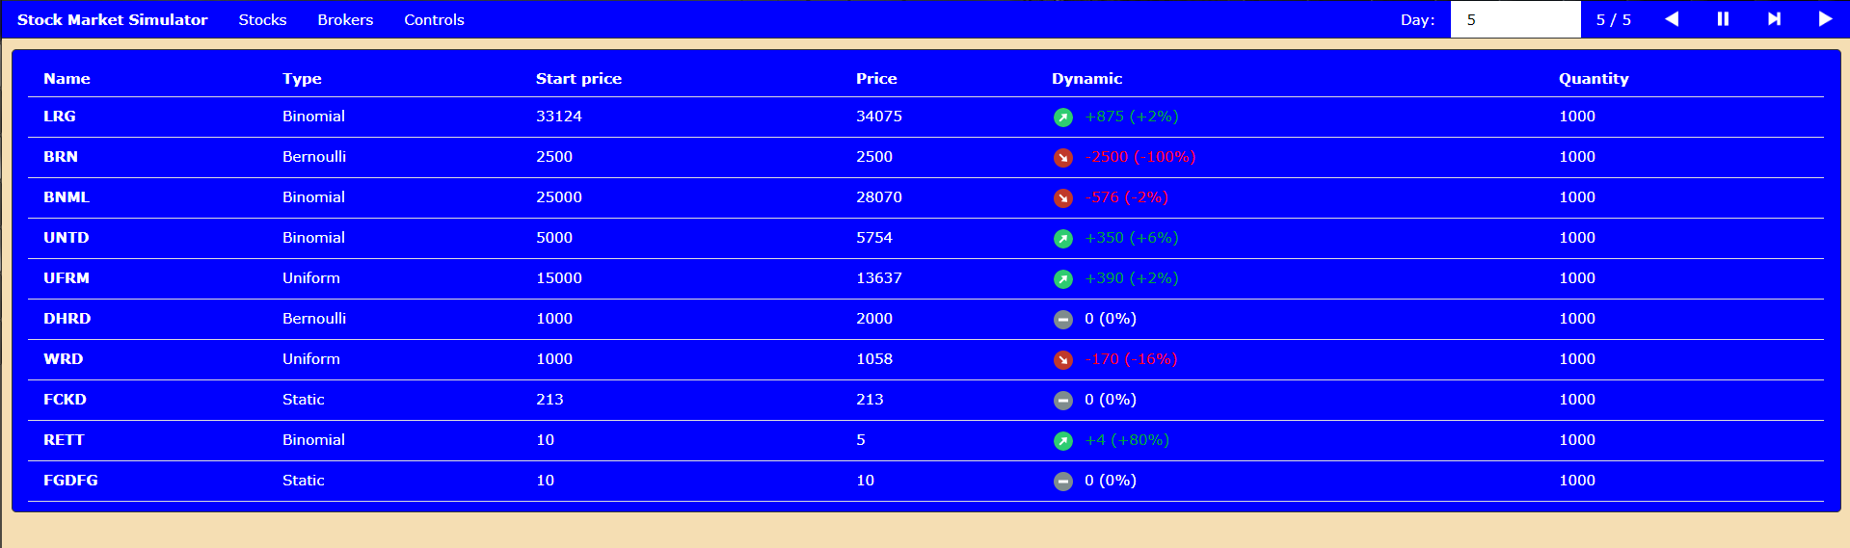
Рисунок 1 – Страница акций
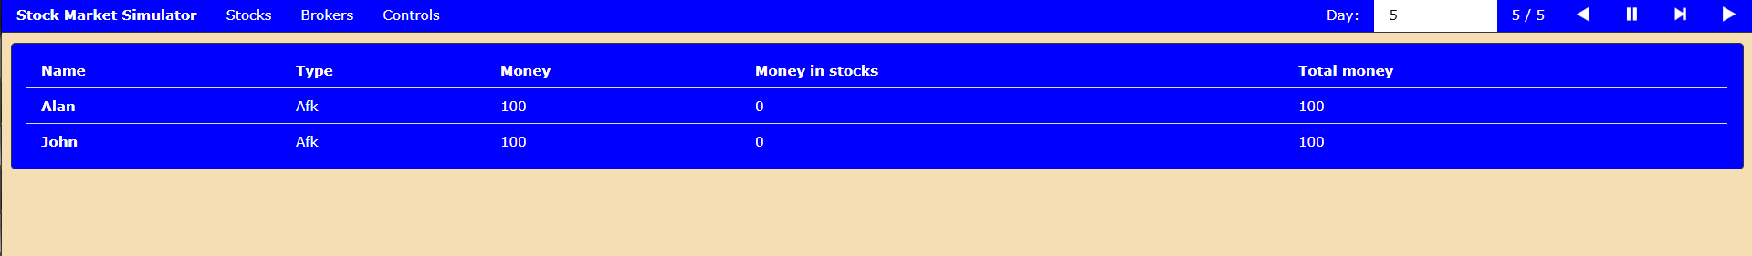
Рисунок 2 – Страница брокеров
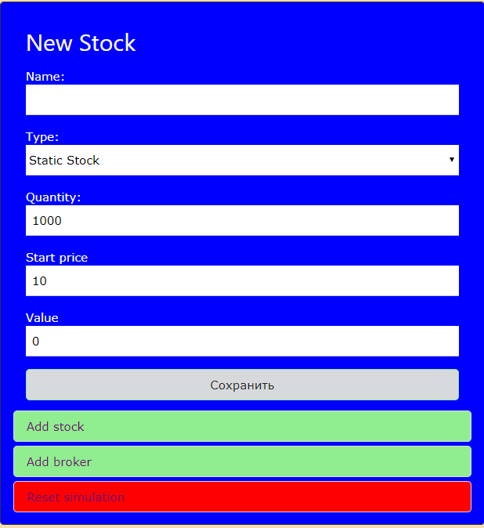
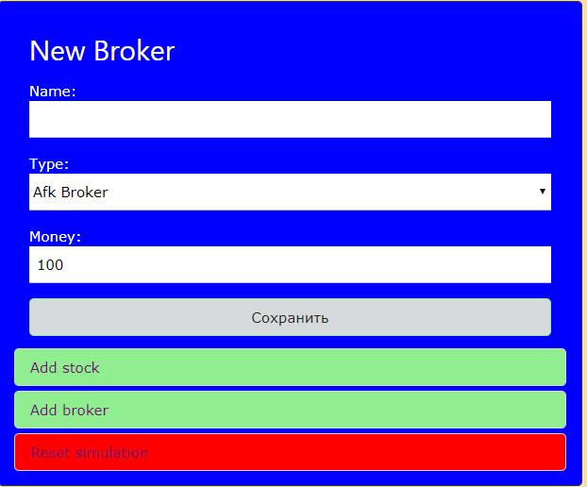
Рисунок 4 – Добавление акций и брокеров

Компоненты акций и брокеров расположены каждый на отельной странице, тогда как навигационная и панель и панель контроля не занимают отдельных страниц.

Вывод
Написано клиент-серверное приложение на языке TypeScript, где клиент использует фреймворк Angular.

ПРИЛОЖЕНИЕ А
ФАЙЛ BROKERS_COMPONENT.HTML
<div *ngIf="!brokers">
<img src="assets/loading.gif" class="loading_image">
</div>
<div *ngIf="brokers">
<div class="w3-row">
<div class="w3-col s12" [ngClass]="{
'm8': selectedBroker || controls_toggled,
'm12': !selectedBroker && !controls_toggled
}">
<div class="content">
<table class="w3-table w3-bordered">
<thead>
<tr>
<th>Name</th>
<th>Type</th>
<th>Money</th>
<th>Money in stocks</th>
<th>Total money</th>
</tr>
</thead>
<tr *ngFor="let broker of brokers" [ngClass]="{
'w3-blue-gray' : broker===selectedBroker
}" (click)="onSelect(broker)">
<th>{{broker.name}}</th>
<td>{{broker.type}}</td>
<td>{{broker.money}}</td>
<td>{{broker.money_in_stocks}}</td>
<td>{{broker.total_money}}</td>
</tr>
</table>
</div>
</div>
<div class="w3-col s12 m4" *ngIf="selectedBroker">
<div class="w3-display-container content">
<h2>Information</h2>
<span (click)="selectedBroker = null"
class="w3-button w3-display-topright">&times;</span>
<label>Name:</label>
<input [(ngModel)]="selectedBroker.name" class="w3-input" (change)="onChange()" [ngClass]="{
'w3-margin-bottom': unique_names,
'w3-red': !unique_names
}">
<label class="warning w3-margin-bottom" *ngIf="!unique_names">Names must be unique <br></label>
<label>Type:</label>
<select class="w3-select w3-margin-bottom" [(ngModel)]="selectedBroker.type"
[attr.disabled]="isEditable ? disabled : '' " (change)="onChange()">
<option *ngFor="let example_broker of brokers_info" value={{example_broker.type}}>
{{example_broker.name}}
</option>
</select>
<button class="red_button w3-block" (click)="onDelete()">Delete</button>
</div>
</div>
<div class="w3-col s12 m4" *ngIf="controls_toggled">
<app-controls></app-controls>
</div>
</div>
</div>

ПРИЛОЖЕНИЕ Б
ФАЙЛ BROKERS_COMPONENT.TS
import { Component, OnInit } from '@angular/core';
import {Broker, Market, MarketService} from '../market.service';
import {ComponentSyncService} from '../component-sync.service';
@Component({
selector: 'app-brokers',
templateUrl: './brokers.component.html',
styleUrls: ['./brokers.component.less']
})
export class BrokersComponent implements OnInit {
brokers: Broker[];
brokers_info: Broker[];
market: Market;
selectedBroker: Broker;
isEditable: boolean;
unique_names: boolean;
controls_toggled: boolean;
constructor(private marketService: MarketService, private componentSync: ComponentSyncService) { }
async ngOnInit() {
this.market = await this.marketService.getMarket();
const market_info = await this.marketService.getMarketInfo();
this.isEditable = true;
this.unique_names = true;
const self = this;
this.marketService.update_callback = function (new_market: Market) {
self.market = new_market;
self.brokers = new_market.brokers;
if (self.selectedBroker){
for (let i = 0; i < self.brokers.length; i++) {
if (self.selectedBroker.name === self.brokers[i].name){
self.selectedBroker = self.brokers[i];
break;
}
}
}
};
this.componentSync.controls_toggle_callback = function (new_toggle: boolean) {
self.controls_toggled = new_toggle;
if (new_toggle) {
self.selectedBroker = null;
}
};
this.brokers = this.market.brokers;
this.brokers_info = market_info.brokers;
console.log(this.brokers);
}
onSelect(broker: Broker) {
if (this.controls_toggled) {
this.componentSync.toggle_controls();
}
this.selectedBroker = broker;
}
onChange() {
this.unique_names = this.marketService.check_broker_unique_names(this.selectedBroker, this.market);
if (this.unique_names) {
this.marketService.commit_broker_change(this.selectedBroker, this.market);
}
}
onDelete() {
this.marketService.delete_broker(this.selectedBroker, this.market);
this.selectedBroker = null;
}
}

ПРИЛОЖЕНИЕ В
ФАЙЛ CONTROLS_COMPONENT.HTML
<div class="w3-display-container w3-bar-block content">
<div class="w3-bar-item" *ngIf="action === 'new_stock'">
<h2>New Stock</h2>
<label>Name:</label>
<input class="w3-input w3-margin-bottom" [(ngModel)]="creating_stock.name"[ngClass]="{
'w3-margin-bottom': unique_names,
'w3-red': !unique_names
}">
<label class="warning w3-margin-bottom" *ngIf="!unique_names">Names must be unique <br></label>
<label>Type:</label>
<select class="w3-select w3-margin-bottom" [(ngModel)]="creating_stock.type"
(change)="get_req_params()">
<option *ngFor="let example_stock of stocks_info" value={{example_stock.type}}>
{{example_stock.name}}
</option>
</select>
<label>Quantity:</label>
<input class="w3-input w3-margin-bottom" type="number" [(ngModel)]="creating_stock.quantity">
<label>Start price</label>
<input class="w3-input w3-margin-bottom" [(ngModel)]="creating_stock.start_price">
<div *ngFor="let param of creating_stock.params; let i = index">
<label>{{param.text}}</label>
<input [(ngModel)]="creating_stock.params[i].value" class="w3-input w3-margin-bottom">
</div>
<button class="w3-block white_button" (click)="saveStock()">Сохранить</button>
</div>
<div class="w3-bar-item" *ngIf="action === 'new_broker'">
<h2>New Broker</h2>
<label>Name:</label>
<input class="w3-input w3-margin-bottom" [(ngModel)]="creating_broker.name" [ngClass]="{
'w3-margin-bottom': unique_names,
'w3-red': !unique_names
}">
<label class="warning w3-margin-bottom" *ngIf="!unique_names">Names must be unique <br></label>
<label>Type:</label>
<select class="w3-select w3-margin-bottom" [(ngModel)]="creating_broker.type">
<option *ngFor="let example_broker of brokers_info" value={{example_broker.type}}>
{{example_broker.name}}
</option>
</select>
<label>Money:</label>
<input class="w3-input w3-margin-bottom" [(ngModel)]="creating_broker.money">
<button class="w3-block white_button" (click)="saveBroker()">Сохранить</button>
</div>
<button class="w3-bar-item black_button" (click)="onToggleNewStock()">Add stock</button>
<button class="w3-bar-item black_button" (click)="onToggleNewBroker()">Add broker</button>
<button class="w3-bar-item red_button">Reset simulation</button>
</div>

ПРИЛОЖЕНИЕ Г
ФАЙЛ CONTROLS_COMPONENT.TS
import { Component, OnInit } from '@angular/core';
import {Broker, Market, MarketService, Stock} from '../market.service';
@Component({
selector: 'app-controls',
templateUrl: './controls.component.html',
styleUrls: ['./controls.component.less']
})
export class ControlsComponent implements OnInit {
private market_info;
private stocks_info: Stock[];
private creating_stock: Stock;
private creating_broker: Broker;
private unique_names: boolean;
private action: string;
private brokers_info: Broker[];
constructor(private marketService: MarketService) { }
async ngOnInit() {
this.market_info = await this.marketService.getMarketInfo();
this.stocks_info = this.market_info.stocks;
this.brokers_info = this.market_info.brokers;
this.creating_stock = JSON.parse(JSON.stringify(this.stocks_info[0]));
this.creating_broker = JSON.parse(JSON.stringify(this.brokers_info[0]));
this.creating_stock.name = '';
this.creating_broker.name = '';
this.action = '';
this.unique_names = true;
this.get_req_params();
console.log(this.stocks_info);
}
onToggleNewStock() {
if (this.action === 'new_stock') {
this.action = '';
} else {
this.action = 'new_stock';
}
}
onToggleNewBroker() {
if (this.action === 'new_broker') {
this.action = '';
} else {
this.action = 'new_broker';
}
}
get_req_params() {
if (this.creating_stock) {
for (let i = 0; i < this.stocks_info.length; i++) {
if (this.creating_stock.type === this.stocks_info[i].type) {
this.creating_stock.params = this.stocks_info[i].params;
for (let k = 0; k < this.creating_stock.params.length; k++) {
this.creating_stock.params[k].value = 0;
}
console.log(this.creating_stock.params);
}
}
}
}
async saveStock() {
this.action = '';
const market = await this.marketService.getMarket();
this.unique_names = this.marketService.check_stocks_unique_names(this.creating_stock, market);
if (this.unique_names) {
this.marketService.commit_stock_change(this.creating_stock, market);
}
}
async saveBroker() {
this.action = '';
const market = await this.marketService.getMarket();
this.unique_names = this.marketService.check_broker_unique_names(this.creating_broker, market);
if (this.unique_names) {
this.marketService.commit_broker_change(this.creating_broker, market);
}
}
}

ПРИЛОЖЕНИЕ Д
ФАЙЛ NAVBAR_COMPONENT.HTML
<div class="w3-top w3-bar main_navbar">
<b class="w3-bar-item">Stock Market Simulator</b>
<a class="w3-bar-item w3-button" routerLink="/stocks">Stocks</a>
<a class="w3-bar-item w3-button" routerLink="/brokers">Brokers</a>
<button class="w3-bar-item w3-button" (click)="onControlsToggle()">Controls</button>
<img src="assets/icons/forward.png" class="w3-bar-item w3-button w3-right">
<img src="assets/icons/next.png" class="w3-bar-item w3-button w3-right" (click)="onNext()">
<img src="assets/icons/pause.png" class="w3-bar-item w3-button w3-right">
<img src="assets/icons/back.png" class="w3-bar-item w3-button w3-right" (click)="onBack()">
<div class="w3-bar-item w3-right">{{day}} / {{max_day}}</div>
<input type="number" class="w3-bar-item w3-right" style="width: 7%" [(ngModel)]="day" (change)="updateDay()">
<label class="w3-bar-item w3-right">Day:</label>
</div>

ПРИЛОЖЕНИЕ Е
ФАЙЛ NAVBAR_COMPONENT.TS
import { Component, OnInit } from '@angular/core';
import {MarketService} from '../market.service';
import {ComponentSyncService} from '../component-sync.service';
@Component({
selector: 'app-navbar',
templateUrl: './navbar.component.html',
styleUrls: ['./navbar.component.less']
})
export class NavbarComponent implements OnInit {
day: number;
max_day: number;
onControlsToggle() {
this.componentSync.toggle_controls();
}
onShowStocks(){
this.componentSync.setView('stocks');
}
onShowBrokers(){
this.componentSync.setView('brokers');
}
constructor(private marketService: MarketService, private componentSync: ComponentSyncService) { }
ngOnInit() {
this.day = 0;
this.max_day = 0;
}
async onNext() {
await this.marketService.forward();
this.day = this.marketService.day;
this.max_day = this.marketService.max_day;
}
async onBack() {
await this.marketService.back();
this.day = this.marketService.day;
this.max_day = this.marketService.max_day;
}
async updateDay() {
console.log(this.day);
await this.marketService.go_to_day(this.day);
console.log('finished');
this.day = this.marketService.day;
this.max_day = this.marketService.max_day;
}
}

ПРИЛОЖЕНИЕ Ё
ФАЙЛ STOCK_COMPONENT.HTML
<div *ngIf ="!stocks">
<img src="assets/loading.gif" class="loading_image">
</div>
<div *ngIf="stocks">
<div class="w3-row">
<div class="w3-col s12" [ngClass]="{
'm8': selectedStock || controls_toggled,
'm12': !selectedStock && !controls_toggled
}">
<div class="content">
<table class="w3-table w3-bordered">
<thead>
<tr>
<th>Name</th>
<th *ngIf="!selectedStock && !controls_toggled">Type</th>
<th *ngIf="!selectedStock && !controls_toggled">Start price</th>
<th>Price</th>
<th>Dynamic</th>
<th>Quantity</th>
</tr>
</thead>
<tr *ngFor="let stock of stocks" [ngClass]="{
'w3-blue-gray' : stock===selectedStock
}"
(click)="onSelect(stock)">
<th>{{stock.name | uppercase}}</th>
<td *ngIf="!selectedStock && !controls_toggled">{{stock.type}}</td>
<td *ngIf="!selectedStock && !controls_toggled">{{stock.start_price}}</td>
<td>{{stock.price}}</td>
<td [ngClass]="{
'price_up': stock.dynamic > 0,
'price_down': stock.dynamic < 0
}">
<div class="small_price_img">
<img src="assets/icons/up.png" *ngIf="stock.dynamic > 0">
<img src="assets/icons/down.png" *ngIf="stock.dynamic < 0">
<img src="assets/icons/stable.png" *ngIf="stock.dynamic == 0">
</div>
{{stock.dynamic_text}} ({{stock.dynamic_percent_text}})
</td>
<td>{{stock.available_quantity}}</td>
</tr>
</table>
</div>
</div>
<div class="w3-col s12 m4" *ngIf="selectedStock">
<div class=" w3-display-container content">
<h2>Information </h2>
<span (click)="selectedStock = undefined"
class="w3-button w3-display-topright">&times;</span>
<div class="price_container">
<div class="price_img">
<img src="assets/icons/up.png" *ngIf="selectedStock.dynamic > 0">
<img src="assets/icons/down.png" *ngIf="selectedStock.dynamic < 0">
<img src="assets/icons/stable.png" *ngIf="selectedStock.dynamic == 0">
</div>
<span class="price_text" [ngClass]="{
'price_up': selectedStock.dynamic > 0,
'price_down': selectedStock.dynamic < 0
}">{{selectedStock.price}} </span>
<span class="price_dynamic_text" [ngClass]="{
'price_up': selectedStock.dynamic > 0,
'price_down': selectedStock.dynamic < 0
}">{{selectedStock.dynamic_text}} ({{selectedStock.dynamic_percent_text}})
</span>
</div>
<label>Name:</label>
<input [(ngModel)]="selectedStock.name" class="w3-input" (change)="onChange()"
[ngClass]="{
'w3-margin-bottom': unique_names,
'w3-red': !unique_names
}">
<label class="warning w3-margin-bottom" *ngIf="!unique_names">Names must be unique <br></label>
<label>Type:</label>
<select class="w3-select w3-margin-bottom" [(ngModel)]="selectedStock.type"
[attr.disabled]="isEditable ? disabled : '' " (change)="onChange()">
<option *ngFor="let example_stock of stocks_info" value={{example_stock.type}}>
{{example_stock.name}}
</option>
</select>
<div *ngFor="let param of selectedStock.params; let i = index">
<label>{{param.text}}</label>
<input [(ngModel)]="selectedStock.params[i].value" class="w3-input w3-margin-bottom"
[attr.disabled]="isEditable ? disabled : '' " (change)="onChange()">
</div>
<button class="red_button w3-block" (click)="onDelete()">Delete</button>
</div>
</div>
<div class="w3-col s12 m4" *ngIf="controls_toggled">
<app-controls></app-controls>
</div>
</div>
</div>

ПРИЛОЖЕНИЕ Ж
ФАЙЛ STOCK_COMPONENT.TS
import {Component, OnInit} from '@angular/core';
import * as $ from 'jquery';
import {Market, MarketService, Stock} from '../market.service';
import {FormBuilder, FormGroup, Validators} from '@angular/forms';
import {ComponentSyncService} from '../component-sync.service';
@Component({
selector: 'app-stocks',
templateUrl: './stocks.component.html',
styleUrls: ['./stocks.component.less']
})
export class StocksComponent implements OnInit {
stocks: Stock[];
stocks_info: Stock[];
market: Market;
selectedStock: Stock;
isEditable: boolean;
unique_names: boolean;
controls_toggled: boolean;
constructor(private marketService: MarketService, private componentSync: ComponentSyncService) {
}
async ngOnInit() {
console.log('init');
this.market = await this.marketService.getMarket();
const market_info = await this.marketService.getMarketInfo();
this.unique_names = true;
this.isEditable = true;
const self = this;
this.marketService.update_callback = function (new_market: Market) {
self.market = new_market;
self.stocks = new_market.stocks;
if (self.selectedStock) {
for (let i = 0; i < self.stocks.length; i++) {
if (self.selectedStock.name === self.stocks[i].name) {
self.selectedStock = self.stocks[i];
break;
}
}
}
self.isEditable = self.marketService.is_editable;
};
this.componentSync.controls_toggle_callback = function (new_toggle: boolean) {
self.controls_toggled = new_toggle;
if (new_toggle) {
self.selectedStock = null;
}
};
this.stocks = this.market.stocks;
this.stocks_info = market_info.stocks;
console.log(this.stocks);
}
onChange() {
this.unique_names = this.marketService.check_stocks_unique_names(this.selectedStock, this.market);
if (this.unique_names) {
this.marketService.commit_stock_change(this.selectedStock, this.market);
}
}
onSelect(stock: Stock) {
if (this.controls_toggled){
this.componentSync.toggle_controls();
}
this.selectedStock = stock;
}
onDelete() {
this.marketService.delete_stock(this.selectedStock, this.market);
this.selectedStock = null;
}
}

ПРИЛОЖЕНИЕ
ФАЙЛ APP_MODULE.TS
import { BrowserModule } from '@angular/platform-browser';
import { NgModule } from '@angular/core';
import {FormsModule, ReactiveFormsModule} from '@angular/forms';
import { AppRoutingModule } from './app-routing.module';
import { AppComponent } from './app.component';
import { NavbarComponent } from './navbar/navbar.component';
import { StocksComponent } from './stocks/stocks.component';
import { StockInfoComponent } from './stock-info/stock-info.component';
import {SidebarModule} from 'ng-sidebar';
import { ControlsComponent } from './controls/controls.component';
import { BrokersComponent } from './brokers/brokers.component';
@NgModule({
declarations: [
AppComponent,
NavbarComponent,
StocksComponent,
StockInfoComponent,
ControlsComponent,
BrokersComponent,
],
imports: [
BrowserModule,
AppRoutingModule,
FormsModule,
ReactiveFormsModule,
SidebarModule.forRoot(),
],
providers: [],
bootstrap: [AppComponent]
})
export class AppModule { }

ПРИЛОЖЕНИЕ
ФАЙЛ APP_ROUTING_MODULE.TS
import { NgModule } from '@angular/core';
import { Routes, RouterModule } from '@angular/router';
import {BrokersComponent} from './brokers/brokers.component';
import {StocksComponent} from './stocks/stocks.component';
const routes: Routes = [
{ path: 'brokers', component: BrokersComponent },
{ path: 'stocks', component: StocksComponent }
];
@NgModule({
imports: [RouterModule.forRoot(routes)],
exports: [RouterModule]
})
export class AppRoutingModule { }

ПРИЛОЖЕНИЕ
ФАЙЛ MARKER_SERVICE.TS
import { Injectable } from '@angular/core';
import * as $ from 'jquery';
export interface Stock {
dynamic_percent_text: string;
dynamic_text: string;
name: string;
type: string;
start_price: number;
dynamic: number;
price: number;
available_quantity: number;
quantity: number;
params: {
name: string,
text: string,
value: number
}[];
}
export interface Broker {
name: string;
money: number;
type: string;
money_in_stocks: number;
total_money: number;
stocks: Stock[];
}
export interface Market {
stocks: Stock[];
brokers: Broker[];
}
@Injectable({
providedIn: 'root'
})
export class MarketService {
constructor() {
this._day = 0;
this._max_day = 0;
}
private last_market: Market;
private market_info: Market;
private last_market_day: number;
private _max_day: number;
private _day: number;
private _update_callback: ((new_market: Market) => void);
static getStockPercentDynamicText(stock: Stock): string {
if (stock.dynamic > 0) {
return `+${Math.trunc (stock.dynamic / stock.price * 100)}%`;
}
return `${Math.trunc (stock.dynamic / stock.price * 100)}%`;
}
static getStockDynamicText(stock: Stock): string {
if (stock.dynamic > 0) {
return `+${stock.dynamic}`;
}
return `${stock.dynamic}`;
}
async getMarket(day: number = this._day) {
console.log(`Getting market ${day}`);
if ((this.last_market_day === day) && (this.last_market)) {
console.log(`Getting last market ${day}`);
return this.last_market;
}
let _market: Market;
await $.ajax({
url: `http://localhost:3000/market/${day}`,
method: 'GET',
crossDomain: true,
}
).then(function (market) {
_market = JSON.parse(market);
});
_market.stocks.forEach((stock) => {
stock.dynamic_text = MarketService.getStockDynamicText(stock);
stock.dynamic_percent_text = MarketService.getStockPercentDynamicText(stock);
});
this.last_market = _market;
return _market;
}
async getMarketInfo() {
if (this.market_info) {
return this.market_info;
}
let _market: Market;
await $.ajax({
url: `http://localhost:3000/market_info`,
method: 'GET',
crossDomain: true,
}
).then(function (market) {
_market = JSON.parse(market);
});
this.market_info = _market;
return _market;
}
commit_stock_change(stock, market) {
let i: number;
for (i = 0; i < market.stocks.length; i++) {
if (stock.name === market.stocks[i].name) {
break;
}
}
const obj = {
stock: stock,
stock_params: stock.params,
id: i
};
$.ajax({
url: 'http://localhost:3000/stock',
method: 'PUT',
crossDomain: true,
data: obj
}).then(async (res) => {
const _market = await this.getMarket();
this.call_update(_market);
});
}
commit_broker_change(broker, market) {
let i: number;
for (i = 0; i < market.brokers.length; i++) {
if (broker.name === market.brokers[i].name) {
break;
}
}
const obj = {
broker: broker,
id: i
};
$.ajax({
url: 'http://localhost:3000/broker',
method: 'PUT',
crossDomain: true,
data: obj
}).then(async (res) => {
const _market = await this.getMarket();
this.call_update(_market);
});
}
delete_stock(stock, market) {
let i: number;
for (i = 0; i < market.stocks.length; i++) {
if (stock.name === market.stocks[i].name) {
break;
}
}
$.ajax({
url: `http://localhost:3000/stock/${i}`,
method: 'DELETE',
crossDomain: true,
}).then(async (res) => {
const _market = await this.getMarket();
this.call_update(_market);
});
}
delete_broker(broker, market) {
let i: number;
for (i = 0; i < market.brokers.length; i++) {
if (broker.name === market.brokers[i].name) {
break;
}
}
$.ajax({
url: `http://localhost:3000/broker/${i}`,
method: 'DELETE',
crossDomain: true
}).then(async (res) => {
const _market = await this.getMarket();
this.call_update(_market);
});
}
check_stocks_unique_names(stock, market): boolean {
let unique_names = true;
for (let i = 0; i < market.stocks.length; i++) {
unique_names = unique_names && (stock.name !== market.stocks[i].name ||
stock === market.stocks[i]);
}
return unique_names;
}
check_broker_unique_names(broker, market): boolean {
let unique_names = true;
for (let i = 0; i < market.brokers.length; i++) {
unique_names = unique_names && (broker.name !== market.brokers[i].name ||
broker === market.brokers[i]);
}
return unique_names;
}
get is_editable() {
return this._day === this._max_day;
}
async forward() {
await this.go_to_day(++this._day);
}
async back() {
await this.go_to_day(--this._day);
}
async go_to_day(day: number = this._day) {
console.log(`Going to ${day}`);
if (day < 0) {
day = 0;
return;
}
if (day > this._max_day) {
this._max_day = day;
}
this._day = day;
const new_market = await this.getMarket();
console.log('Starting callback');
this.call_update(new_market);
console.log(`Gone`);
}
get max_day(): number {
return this._max_day;
}
get day(): number {
return this._day;
}
set update_callback(value) {
this._update_callback = value;
}
private call_update(new_market: Market) {
this._update_callback(new_market);
}
}

