МИНОБРНАУКИ РОССИИ
САНКТ-ПЕТЕРБУРГСКИЙ ГОСУДАРСТВЕННЫЙ ЭЛЕКТРОТЕХНИЧЕСКИЙ УНИВЕРСИТЕТ
«ЛЭТИ» ИМ. В.И. УЛЬЯНОВА (ЛЕНИНА)
Кафедра МО ЭВМ

ОТЧЕТ
по лабораторной работе №6
по дисциплине «WEB-технологии» Тема: Покупка и продажа акций

Студент гр. 6304 |  | Виноградов К.А.
Преподаватель |  | Беляев С.А.

Санкт-Петербург 2018

Цель работы.
Целью работы является изучение возможностей применения библиотеки React (https://reactjs.org/) для разработки интерфейсов пользователя web- приложений.

Ход работы
К серверу добавлены сокеты для обработки подключений участников торгов.
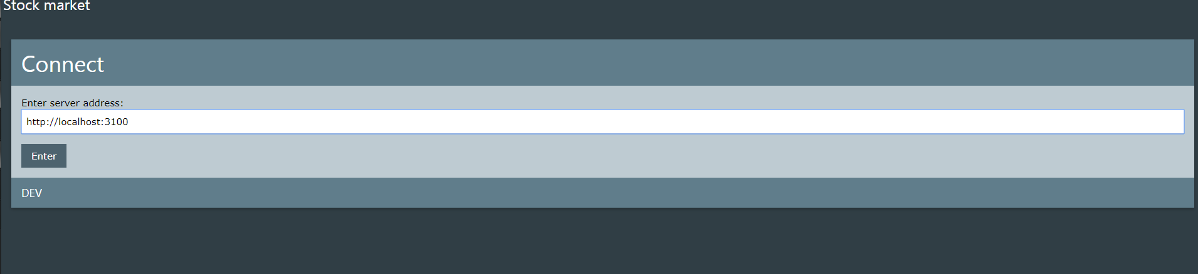
Рисунок 1 - Подключение
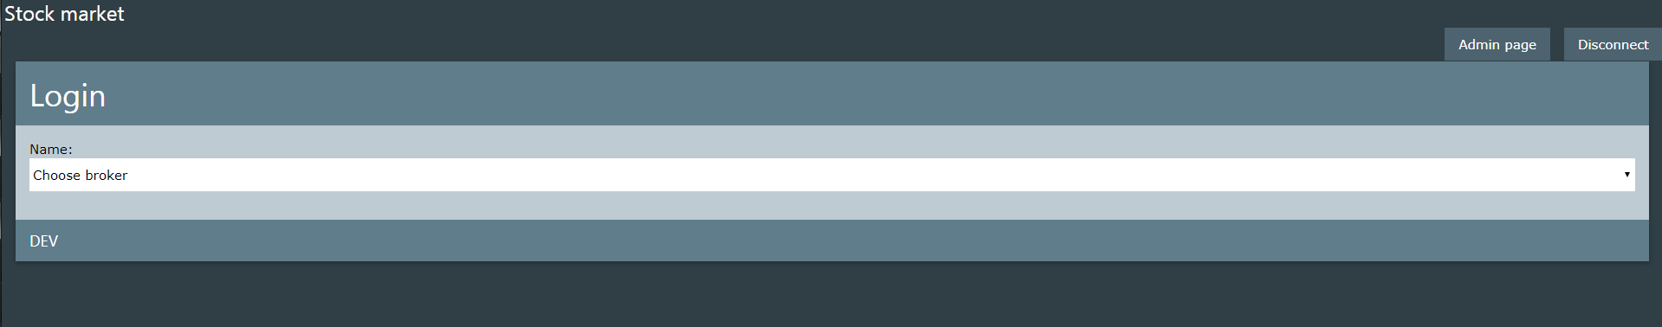
Рисунок 2 – Выбор участника тогргов
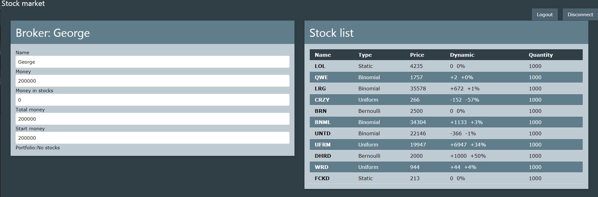
Рисунок 3 – Страница участника

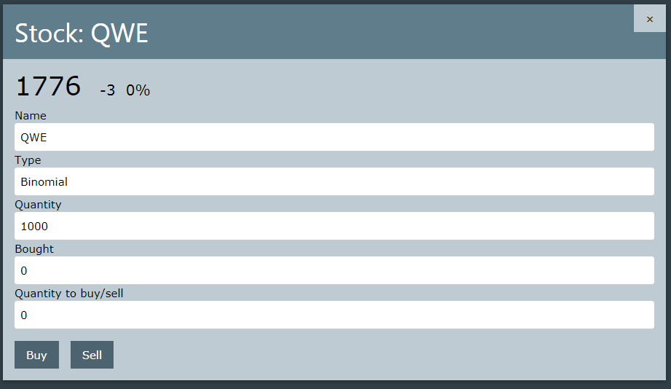
Рисунок 4 – Информация об акции
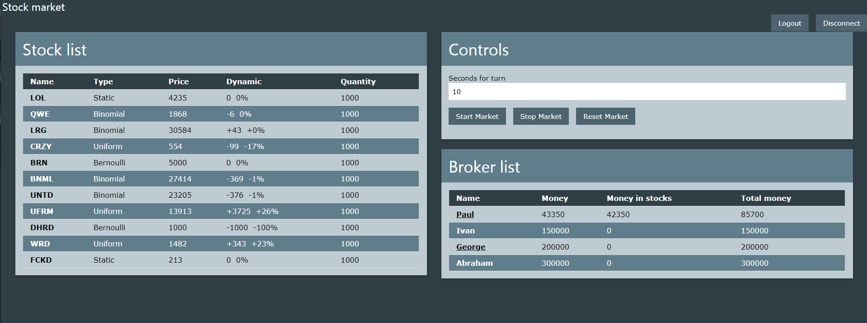
Рисунок 5 – Страница администратора
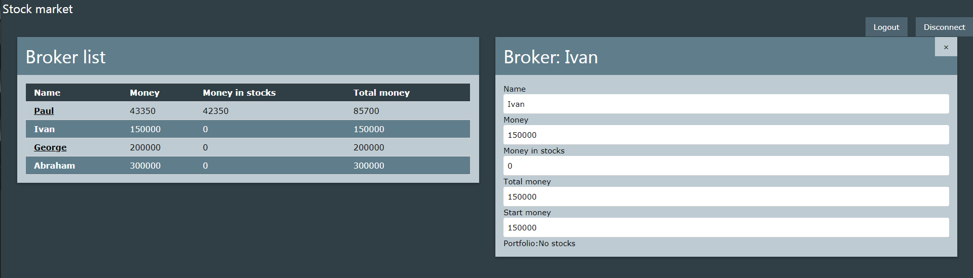
Рисунок 6 – Информация об участнике

Вывод
Написано приложение на React, позволяющее осуществлять сложное взаимодействие с сервером. Изучены особенности применения этого фреймворка для разработки программ.

ПРИЛОЖЕНИЕ А
ФАЙЛ ADMIN.JS
import React, { Component } from 'react';
import $ from 'jquery';
import { Card, HalfWidth } from '../page/structural'
import { StockList } from '../stocks/stock_list'
import { StockInfo } from '../stocks/stock_info'
import { BrokerList } from '../brokers/broker_list'
import { BrokerInfo } from '../brokers/broker_info'
import { AdminControls } from './admin_controls'
import '../style.css'
export class AdminPage extends Component {
constructor() {
super();
this.state = {
stock: null,
broker: null,
}
this.handleStockClick = this.handleStockClick.bind(this);
this.handleBrokerClick = this.handleBrokerClick.bind(this);
this.handleCloseInfo = this.handleCloseInfo.bind(this);
}
componentWillMount() {
if (this.props.socket) {
this.props.socket.json.emit("connected", { "name": 'Admin' });
}
}
handleStockClick(stock) {
this.setState({
stock: stock
})
}
handleBrokerClick(broker) {
this.setState({
broker: broker
})
}
handleCloseInfo() {
this.setState({
stock: null,
broker: null
})
}
render() {
function renderBrokerList() {
return (
<Card header='Broker list'>
<BrokerList market={this.props.market} onBrokerClick={this.handleBrokerClick} />
</Card>
)
}
function renderStockList() {
return (
<Card header='Stock list'>
<StockList market={this.props.market} onStockClick={this.handleStockClick} />
</Card>
)
}
function renderControls() {
return (
<Card header='Controls'>
<AdminControls socket={this.props.socket} />
</Card>
)
}
function renderBrokerInfo() {
return (
<Card header={'Broker: ' + this.state.broker.name} onClose={this.handleCloseInfo}>
<BrokerInfo broker={this.state.broker} market={this.props.market} />
</Card>
)
}
function renderStockInfo() {
return (
<Card header={'Stock: ' + this.state.stock.name} onClose={this.handleCloseInfo}>
<StockInfo stock={this.state.stock} />
</Card>
)
}
let left_side;
let right_side;
if (this.state.broker) {
left_side = (renderBrokerList.bind(this))();
right_side = (renderBrokerInfo.bind(this))();
}
else if (this.state.stock) {
left_side = (renderStockList.bind(this))();
right_side = (renderStockInfo.bind(this))();
}
else {
left_side = (renderStockList.bind(this))();
right_side = (
<div>
{(renderControls.bind(this))()}
{(renderBrokerList.bind(this))()}
</div>
);
}
return (
<div className='w3-row'>
<HalfWidth>
{left_side}
</HalfWidth>
<HalfWidth>
{right_side}
</HalfWidth>
</div>
)
}
}

ПРИЛОЖЕНИЕ Б
ФАЙЛ ADMIN_CONTROLS.JS
import React, { Component } from 'react';
import '../style.css'
export class AdminControls extends Component {
constructor(props){
super(props);
if (props.socket == null){
alert('Where is ur socket, dude?')
}
this.state = {
interval: 10
}
this.handleStartMarket = this.handleStartMarket.bind(this);
this.handleStopMarket = this.handleStopMarket.bind(this);
this.handleResetMarket = this.handleResetMarket.bind(this);
this.handleIntervalChange = this.handleIntervalChange.bind(this);
}
handleStartMarket() {
this.props.socket.json.emit('start_market', {interval: this.state.interval});
}
handleStopMarket() {
this.props.socket.json.emit('stop_market');
}
handleResetMarket() {
this.props.socket.json.emit('reset_market');
}
handleIntervalChange(e) {
this.setState({
interval: parseInt(e.target.value)
})
}
render() {
const button_class = 'w3-button w3-bar-item w3-theme-d2 w3-margin-right w3-margin-bottom';
return (
<div>
<label>Seconds for turn</label>
<input type='number' className='w3-input' onChange={this.handleIntervalChange}
value={this.state.interval} />
<div className='w3-bar w3-margin-top'>
<button className={button_class} onClick={this.handleStartMarket}>Start Market</button>
<button className={button_class} onClick={this.handleStopMarket}>Stop Market</button>
<button className={button_class} onClick={this.handleResetMarket}>Reset Market</button>
</div>
</div>
)
}
}

ПРИЛОЖЕНИЕ В
ФАЙЛ BROKER_INFO.JS
import React, { Component } from 'react';
import { Portfolio } from './portfolio';
import '../style.css';
export class BrokerInfo extends Component {
constructor(){
super();
this.onStockClick = this.onStockClick.bind(this);
}
onStockClick(stock, index){
if (this.props.onStockClick){
this.props.onStockClick(stock, index);
}
}
render() {
const input_class = 'w3-input w3-white w3-round';
return (
<div>
<label>Name</label>
<input className={input_class} value={this.props.broker.name} disabled />
<label>Money</label>
<input className={input_class} value={this.props.broker.money} disabled />
<label>Money in stocks</label>
<input className={input_class} value={this.props.broker.money_in_stocks} disabled />
<label>Total money</label>
<input className={input_class} value={this.props.broker.total_money} disabled />
<label>Start money</label>
<input className={input_class} value={this.props.broker.start_money} disabled />
<Portfolio broker={this.props.broker} market={this.props.market} onStockClick={this.onStockClick} />
</div>
)
}
}

ПРИЛОЖЕНИЕ Г
ФАЙЛ BROKER_LIST.JS
import React, { Component } from 'react';
import '../style.css'
export class BrokerList extends Component {
onBrokerClick(broker, index){
this.props.onBrokerClick(broker);
}
render() {
return (
<table className='w3-table w3-border w3-bordered w3-striped'>
<thead>
<tr className='w3-theme-d5'>
<th>Name</th>
<th>Money</th>
<th>Money in stocks</th>
<th>Total money</th>
</tr>
</thead>
<tbody>
{this.props.market.brokers.map((broker, index) => {
let rowClass = index % 2 == 0 ? 'w3-theme-l3 w3-hover-deep-orange' : 'w3-theme w3-hover-deep-orange'
let nameClass= broker.online ? 'underline' : '';
return (
<tr className={rowClass} key={broker.name} onClick={this.onBrokerClick.bind(this, broker, index)}>
<th className={nameClass}>{broker.name}</th>
<td>{broker.money}</td>
<td>{broker.money_in_stocks}</td>
<td>{broker.total_money}</td>
</tr>
)
})}
</tbody>
</table>
)
}
}

ПРИЛОЖЕНИЕ Д
ФАЙЛ PORTFOLIO.JS

import React, { Component } from 'react';
import { StockList } from '../stocks/stock_list'
import '../style.css'
export class Portfolio extends Component {
constructor() {
super();
this.getBrokerStocks = this.getBrokerStocks.bind(this);
this.onStockClick = this.onStockClick.bind(this);
}
getBrokerStocks() {
let res = []
this.props.broker.stocks.forEach((stock) => {
this.props.market.stocks.forEach((market_stock) => {
if (stock.name === market_stock.name) {
let stock_in_market = JSON.parse(JSON.stringify(market_stock))
stock_in_market.quantity_bought = stock.quantity;
res.push(stock_in_market);
}
})
});
return res;
}
onStockClick(stock, index){
if (this.props.onStockClick){
this.props.onStockClick(stock, index);
}
}
render() {
let portfolio = this.getBrokerStocks();
let table;
if (portfolio.length > 0){
table = <StockList market={{ stocks: portfolio }} onStockClick={this.onStockClick} />
}
else{
table = 'No stocks'
}
return (
<div>
<label>Portfolio:</label>
{table}
</div>
)
}
}

ПРИЛОЖЕНИЕ Е
ФАЙЛ ADRESS.JS

import React, { Component } from 'react';
import { Card } from '../page/structural';
import '../style.css';
export class AddressInput extends Component {
constructor(props) {
super(props);
this.onAddressInput = this.onAddressInput.bind(this);
this.handleChange = this.handleChange.bind(this);
this.onMockAddress = this.onMockAddress.bind(this);
this.state = {
address: 'http://localhost:3000'
}
}
onAddressInput() {
this.props.onAddress(this.state.address);
}
onMockAddress() {
this.props.onAddress('%_MOCK_%');
}
handleChange(e) {
this.setState({
address: e.target.value
})
console.log(e.target.value)
}
render() {
const button_class = 'w3-button w3-bar-item w3-theme-d2 w3-margin-right';
return (
<Card header='Connect' footer='DEV'>
<div>
<label>Enter server address:</label>
<input className='w3-input w3-margin-bottom' onChange={this.handleChange} value={this.state.address} />
<div className='w3-bar'>
{this.state.address != '' &&
<button className={button_class} onClick={this.onAddressInput}>Enter</button>
}
</div>
</div>
</Card>
)
}
}

ПРИЛОЖЕНИЕ Ё
ФАЙЛ ERROR.JS

import React, { Component } from 'react';
import '../style.css';
export function ErrorPage() {
return (
(
<div className='w3-card w3-white'>
<center>
<p>ERROR</p>
</center>
</div>
)
)
}

ПРИЛОЖЕНИЕ Ж
ФАЙЛ LOADING.JS
import React, { Component } from 'react';
import { FullWidthCard } from '../page/structural'
import '../style.css';
export function LoadingPage() {
return (
(
<div className='w3-card w3-white'>
<center>
<p>LOADING</p>
</center>
</div>
)
)
}

ПРИЛОЖЕНИЕ З
ФАЙЛ LOGIN.JS
import React, { Component } from 'react';
import { Card } from '../page/structural';
import '../style.css';
export class Login extends Component {
constructor(props) {
super(props);
this.state = {
user_chosen: ''
}
this.onUserInput = this.onUserInput.bind(this)
this.onUserLogin = this.onUserLogin.bind(this)
}
onUserInput(e) {
this.setState({
user_chosen: e.target.value
})
}
onUserLogin(e) {
this.props.onLogin(this.state.user_chosen)
}
render() {
return (
<Card header='Login' footer='DEV'>
<div>
<label>Name:</label>
<select className='w3-select w3-margin-bottom' defaultValue=''
onChange={this.onUserInput}>
<option value='' disabled>Choose broker</option>
{this.props.market.brokers.map(
function (broker, index) {
return <option value={broker.name} key={broker.name}>{broker.name}</option>
}
)}
</select>
{this.state.user_chosen &&
<button className='w3-button w3-theme-d2' onClick={this.onUserLogin}>Login</button>
}
</div>
</Card>
)
}
}

ПРИЛОЖЕНИЕ И
ФАЙЛ HAH.JS
const App = () => (
<div>
<Header />
<Main />
</div>
)

ПРИЛОЖЕНИЕ Й
ФАЙЛ HEADER.JS

import React, { Component } from 'react';
import '../style.css';
export class Header extends Component {
constructor() {
super()
}
render() {
const button_class = 'w3-button w3-theme-d2 w3-margin-left'
return (
<div className='w3-top'>
<div className='w3-bar w3-theme-d1'>
</div>
<h3 className='w3-bar-item header'>Stock market</h3>
<div className='w3-bar-item w3-right'>
{this.props.loggedIn && this.props.isConnected &&
<button className={button_class}
onClick={this.props.onLogout}>
Logout
</button>
}
{!this.props.loggedIn && this.props.isConnected &&
<button className={button_class}
onClick={this.props.onAdmin}>
Admin page
</button>
}
{this.props.isConnected &&
<button className={button_class}
onClick={this.props.onDisconnect}>
Disconnect
</button>
}
</div>
</div>
)
}
}

ПРИЛОЖЕНИЕ К
ФАЙЛ STRUCTURAL.JS

import React, { Component } from 'react';
import '../style.css';
export function MainContent(props) {
return (
<div className='w3-container main_content'>
{props.children}
</div>
)
}
export function Card(props) {
return (
<div>
<div className='w3-card w3-theme-l3 w3-display-container w3-animate-top'>
{(props.onClose != undefined) &&
<span className="w3-button w3-display-topright" onClick={props.onClose}>×</span>
}
<header className='w3-container w3-theme'>
{props.header && <h1>{props.header}</h1>}
</header>
<div className='card_content'>
{props.children}
</div>
<footer className='w3-container w3-theme'>
{props.footer && <h5>{props.footer}</h5>}
</footer>
</div>
<br />
</div>
)
}
export function HalfWidth(props) {
return (
<div className='w3-container w3-col s12 m6'>
{props.children}
</div>
)
}

ПРИЛОЖЕНИЕ Л
ФАЙЛ DYNAMIC.JS

import React, { Component } from 'react';
import '../style.css'
function getStockPercentDynamicText(stock) {
if (stock.dynamic > 0) {
return `+${Math.trunc(stock.dynamic / stock.price * 100)}%`;
}
return `${Math.trunc(stock.dynamic / stock.price * 100)}%`;
}
function getStockDynamicText(stock) {
if (stock.dynamic > 0) {
return `+${stock.dynamic}`;
}
return `${stock.dynamic}`;
}
export function Dynamic(props) {
return (
<div>
{getStockDynamicText(props.stock)} {'\u00A0'}
{getStockPercentDynamicText(props.stock)}
</div>
)
}
export function LargeDynamic(props) {
return (
<div className='price_container'>
<span className='price_text'>
{props.stock.price} {'\u00A0'}
</span>
<span className='price_dynamic_text'>
{getStockDynamicText(props.stock)} {'\u00A0'}
{getStockPercentDynamicText(props.stock)}
</span>
</div>
)
}

ПРИЛОЖЕНИЕ М
ФАЙЛ STOCK_INFO.JS
import React, { Component } from 'react';
import { Dynamic, LargeDynamic } from './dynamic';
import '../style.css'
export class StockInfo extends Component {
render() {
const input_class = 'w3-input w3-white w3-round';
return (
<div>
<LargeDynamic stock={this.props.stock} />
<label>Name</label>
<input className={input_class} disabled value={this.props.stock.name} />
<label>Type</label>
<input className={input_class} disabled value={this.props.stock.type} />
<label>Quantity</label>
<input className={input_class} disabled value={this.props.stock.quantity} />
</div>
)
}
}

ПРИЛОЖЕНИЕ Н
ФАЙЛ STOCK_LIST.JS

import React, { Component } from 'react';
import { Dynamic } from './dynamic'
import '../style.css'
//props: stocks, onStockClick(name)
export class StockList extends Component {
onStockClick(stock, index) {
this.props.onStockClick(stock)
}
render() {
return (
<table className='w3-table w3-border w3-bordered w3-striped'>
<thead>
<tr className='w3-theme-d5'>
<th>Name</th>
<th>Type</th>
<th>Price</th>
<th>Dynamic</th>
<th>Quantity</th>
</tr>
</thead>
<tbody>
{this.props.market.stocks.map((stock, index) => {
let rowClass = index % 2 == 0 ? 'w3-theme-l3 w3-hover-deep-orange' : 'w3-theme w3-hover-deep-orange'
return (
<tr className={rowClass} key={stock.name} onClick={this.onStockClick.bind(this, stock, index)}>
<th>{stock.name}</th>
<td>{stock.type}</td>
<td>{stock.price}</td>
<td>
<Dynamic stock={stock} />
</td>
<td>{stock.quantity_bought || stock.quantity}</td>
</tr>
)
})}
</tbody>
</table>
)
}
}

ПРИЛОЖЕНИЕ О
ФАЙЛ USER.JS

import React, { Component } from 'react';
import { BrokerInfo } from '../brokers/broker_info'
import { HalfWidth, Card } from '../page/structural'
import { StockList } from '../stocks/stock_list'
import { UserStockInfo } from './user_stock_info'
import '../style.css'
export class UserPage extends Component {
constructor() {
super();
this.onStockClick = this.onStockClick.bind(this);
this.state = {
stock: null,
show_left: true
}
this.onStockClick = this.onStockClick.bind(this);
this.onPortfolioStockClick = this.onPortfolioStockClick.bind(this);
this.onCloseStockInfo = this.onCloseStockInfo.bind(this);
}
componentWillMount(){
this.props.socket.json.emit('connected', {'name': this.props.broker.name});
}
onStockClick(stock, index) {
this.setState({
stock: stock,
show_left: true
})
}
onPortfolioStockClick(stock, index) {
this.setState({
stock: stock,
show_left: false
})
}
onCloseStockInfo() {
this.setState({
stock: null
})
}
render() {
function renderStockList() {
return (
<Card header='Stock list'>
<StockList market={this.props.market} onStockClick={this.onStockClick} />
</Card>
)
}
function renderBrokerInfo() {
return (
<Card header={'Broker: ' + this.props.broker.name}>
<BrokerInfo broker={this.props.broker} market={this.props.market} onStockClick={this.onPortfolioStockClick} />
</Card>
)
}
function renderStockInfo() {
return (
<Card header={'Stock: ' + this.state.stock.name} onClose={this.onCloseStockInfo}>
<UserStockInfo stock={this.state.stock} broker={this.props.broker}
socket={this.props.socket} onClose={this.onCloseStockInfo} />
</Card>
)
}
let left_side;
let right_side;
if (!this.state.stock) {
left_side = (renderBrokerInfo.bind(this))();
right_side = (renderStockList.bind(this))();
}
else {
if (this.state.show_left) {
left_side = (renderStockInfo.bind(this))();
right_side = (renderStockList.bind(this))();
}
else {
left_side = (renderBrokerInfo.bind(this))();
right_side = (renderStockInfo.bind(this))();
}
}
return (
<div className='w3-row'>
<HalfWidth>
{left_side}
</HalfWidth>
<HalfWidth>
{right_side}
</HalfWidth>
</div>
)
}
}

ПРИЛОЖЕНИЕ П
ФАЙЛ USER_STOCK_INFO.JS
import React, { Component } from 'react';
import { StockInfo } from '../stocks/stock_info'
import '../style.css'
export class UserStockInfo extends Component {
constructor() {
super();
this.handleBuy = this.handleBuy.bind(this);
this.handleSell = this.handleSell.bind(this);
this.handleQuantityChange = this.handleQuantityChange.bind(this);
this.state = {
quantity: 0
}
}
handleBuy() {
this.props.socket.json.emit('buy_deal', {
'broker_name': this.props.broker.name,
'stock_name': this.props.stock.name,
'quantity': this.state.quantity
})
this.props.onClose();
}
handleSell() {
this.props.socket.json.emit('sell_deal', {
'broker_name': this.props.broker.name,
'stock_name': this.props.stock.name,
'quantity': this.state.quantity
})
this.props.onClose();
}
handleQuantityChange(e) {
this.setState({
quantity: e.target.value
})
}
render() {
const input_class = 'w3-input w3-white w3-round';
const button_class = 'w3-button w3-bar-item w3-theme-d2 w3-margin-right';
return (
<div>
<StockInfo stock={this.props.stock} />
<label>Bought</label>
<input className={input_class} value={this.props.stock.quantity_bought || 0} />
<label>Quantity to buy/sell</label>
<input className={input_class} value={this.state.quantity || 0}
onChange={this.handleQuantityChange} />
<div className='w3-bar w3-margin-top'>
<button className={button_class} onClick={this.handleBuy}>Buy</button>
<button className={button_class} onClick={this.handleSell}>Sell</button>
</div>
</div>
)
}
}

ПРИЛОЖЕНИЕ Р
ФАЙЛ INFO.JS
import React, { Component } from 'react';
import $ from 'jquery';
import { render } from 'react-dom';
import { Login } from './login/login'
import { LoadingPage } from './login/loading';
import { AddressInput } from './login/address'
import { ErrorPage } from './login/error';
import { Header } from './page/header'
import { getMockMarket } from './mock_market';
import { MainContent } from './page/structural'
import { UserPage } from './user/user'
import { AdminPage } from './admin/admin'
import { BrowserRouter } from 'react-router-dom';
import './style.css';
import * as io from 'socket.io-client'
import * as ReactDOM from "react-dom";
class App extends Component {
constructor() {
super();
this.state = {
market: null,
isLoading: true,
user_name: '',
address: ''
}
this.socket = null;
this.handleLogin = this.handleLogin.bind(this);
this.handleLogout = this.handleLogout.bind(this);
this.handleAdmin = this.handleAdmin.bind(this);
this.getInfo = this.getInfo.bind(this);
this.getMockInfo = this.getMockInfo.bind(this);
this.findBrokerByName = this.findBrokerByName.bind(this);
this.handleAddress = this.handleAddress.bind(this);
this.handleDisconnect = this.handleDisconnect.bind(this);
this.setUpSocket = this.setUpSocket.bind(this);
this.updateInfo = this.updateInfo.bind(this);
}
componentWillMount() {
this.setState({ isLoading: false });
document.body.className = 'w3-theme-d5'
}
getInfo(address) {
$.ajax({
url: address + '/market/',
method: 'GET',
crossDomain: true,
}).then(function (market) {
let _market = JSON.parse(market);
this.setState({
market: _market,
isLoading: false
});
this.setUpSocket(address);
}.bind(this)
).catch((err) => {
if (typeof (err) == 'string')
alert(err);
else
alert(JSON.stringify(err));
this.setState({
isLoading: false
})
})
}
updateInfo() {
$.ajax({
url: this.state.address + '/market/',
method: 'GET',
crossDomain: true,
}).then(function(market) {
let _market = JSON.parse(market);
this.setState({
market: _market,
});
}.bind(this)
).catch((err)=>{
if (typeof (err) == 'string')
alert(err);
else
alert(JSON.stringify(err));
})
}
getMockInfo() {
setTimeout(function () {
this.setState({
market: getMockMarket(),
isLoading: false
})
}.bind(this), 1000)
}
setUpSocket(address) {
this.socket = io.connect(address);
this.socket.on('market_update', ()=>{
this.updateInfo();
})
}
findBrokerByName(name) {
let _broker;
this.state.market.brokers.forEach((broker) => {
if (broker.name === name)
_broker = broker;
});
return _broker;
}
handleLogin(new_login) {
this.setState({
user_name: new_login
})
}
handleLogout() {
this.setState({
user_name: ''
})
}
handleAdmin() {
this.setState({
user_name: '%_ADMIN_%'
})
}
handleAddress(address) {
this.setState({
address: address,
isLoading: true
})
if (address == '%_MOCK_%') {
this.getMockInfo();
}
else {
this.getInfo(address);
}
}
handleDisconnect() {
this.setState({
market: null,
isLoading: false,
user_name: '',
address: ''
})
this.socket.disconnect();
}
render() {
let content;
if (this.state.address === '') {
content = <AddressInput onAddress={this.handleAddress} />
}
else if (this.state.isLoading) {
content = <LoadingPage />
}
else if (!this.state.market) {
content = <ErrorPage />
}
else if (this.state.user_name) {
if (this.state.user_name != '%_ADMIN_%')
content = <UserPage market={this.state.market} broker={this.findBrokerByName(this.state.user_name)} socket={this.socket} />
else
content = <AdminPage market={this.state.market} socket={this.socket} />
}
else {
content = <Login market={this.state.market} onLogin={this.handleLogin} />
}
return (
<div>
<Header loggedIn={this.state.user_name != ''} isConnected={this.state.market != null}
onLogout={this.handleLogout} onAdmin={this.handleAdmin} onDisconnect={this.handleDisconnect} />
<MainContent>
{content}
</MainContent>
</div>
);
}
}
render(<App />, document.getElementById('root'));

