**МИНОБРНАУКИ РОССИИ**

**Санкт-Петербургский государственный**

**электротехнический университет**

**«ЛЭТИ» им. В.И. Ульянова (Ленина)**

**Кафедра МО ЭВМ**

отчет

**по лабораторной работе №1**

**по дисциплине «Сети и Телекоммуникации»**

Тема: IP-адресация

|  |  |  |
| --- | --- | --- |
| Студент гр. 6304 |  | Виноградов К.А. |
| Преподаватель |  | Фирсов М.А. |

Санкт-Петербург

2018

**Цель работы.**

Изучение и практическое освоение основ адресации, разрешения физических адресов и простейшей маршрутизации в IP-сетях.

**Задание.**

Порядок выполнения работы:

1. Исправить структуру сети (если это необходимо), обеспечив коррект­ную доставку кадров на физическом уровне.

2. Задать IP-адреса, маски подсети и шлюзы по умолчанию для всех уз­лов сети, чтобы обеспечить корректную доставку Echo-запроса от K1 к K2 и Echo-ответа обратно. Обосновать свои установки.

3. Выполнить Echo-запрос с K1 на K2. Посмотреть вывод программы.

4. Добавить статическую запись ARP для K3 на K1 (или для ближайшего к К1 маршрутизатора, находящегося между К3 и К1). Подождать устаревания ARP-таблиц и выполнить Echo-запрос с K1 на K3. Объяснить результат.

5. Выполнить Echo-запрос на IP-адрес 200.100.0.1 c K1. Объяснить вы­вод программы.

6. Выполнить Echo-запросы с K1 и K2 на все узлы сети. Убедиться, что Echo-ответы приходят.

Вариант 2. Файл со схемой сети: lab1_var2.jfst. Сеть между маршрутизаторами OFF_R и R2: 136.15.0.0. Компьютер BIG BOSS имеет IP-адрес 136.15.32.1. Компьютер M_CH_S имеет IP-адрес 10.10.0.2. Сеть между маршрутизаторами R2 и M_CH_S_Router: 192.178.0.0. Обозначения в задании: K1 – BIG BOSS, K2 – M_CH_S, K3 – OFFICE1_pc4.

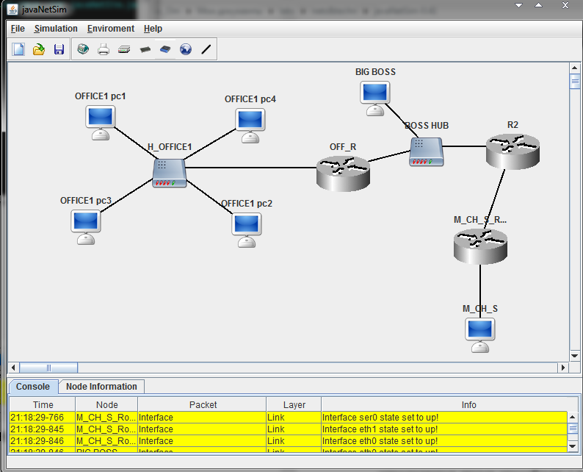

Рисунок 1 – Начальная конфигурация

**Основные теоретические положения.**

IP (Internet Protocol) – протокол сетевого уровня стека TCP/IP; согласно протоколу IP у каждого узла сети есть IP-адрес (адреса), что обеспечивает возможность пересылки пакетов между любыми узлами сети. Пересылка в глобальной сети (между сетями) выполняется маршрутизаторами на сетевом уровне, а в локальном сегменте сети доставка пакета до адресата выполня­ется на канальном уровне, по физическому адресу.

Каждый компьютер в сети TCP/IP имеет адреса двух типов: физический (или локальный) и IP-адрес. Физический адрес узла определяется техноло­гией построения отдельной сети, в которую входит данный узел. Для узлов, входящих в локальные сети, – это МАС-адрес сетевого адаптера или порта маршрутизатора. Такие адреса назначаются производителями оборудования и являются уникальными адресами, поскольку управляются централизовано.

Адрес IPv4 состоит из 4 байт. Этот адрес используется на сетевом уровне. Он назначается администратором во время конфигурирования ком­пьютеров и маршрутизаторов. IP-Адрес состоит из двух частей: номера сети и номера узла. Номер сети определяет конкретную физическую сеть, а номер узла определяет конкретную рабочую станцию, сервер и пр., включенную в сеть. Подсеть – это физический сегмент TCP/IP сети, в котором использу­ются IP-адреса с общим номером сети.

Номер узла в протоколе IP назначается независимо от физического ад­реса узла. Деление IP-адреса на поле номера сети и номера узла – гибкое, и граница между этими полями может устанавливаться произвольно. Узел мо­жет входить в несколько IP-сетей. В этом случае узел должен иметь не­сколько IP-адресов (по числу сетевых связей). Таким образом, IP-адрес характеризует не отдельный компьютер или маршрутизатор, а сетевой интерфейс (физический или виртуальный).

Какая часть IP-адреса относится к номеру сети, а какая – к номеру узла, определяется двумя способами: с помощью классов (классовая адресация) или с помощью масок подсети (бесклассовая адресация). В настоящее время бесклассовая нумерация се­тей преобладает. Чтобы получить адрес сети, зная IP-адрес и маску подсети, необходимо применить к ним операцию поразрядной конъюнкции.

**Ход работы.**

1) Удаляем маршрутизатор R2, т. к. иначе выполнение задания будет невозможным, используя доступные возможности настройки сети и соединяем M_CH_S_Router и BOSS HUB.

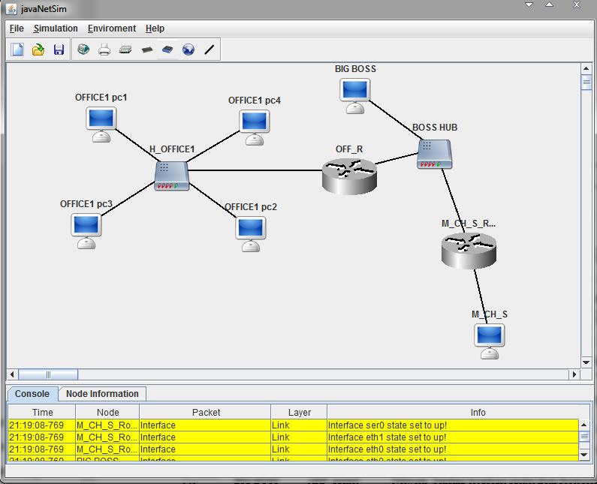

Рисунок 2 — Настроенная сеть

2) Теперь необходимо расставить маски подсетей и шлюзы по умолчанию, таким образом, чтобы каждый маршрутизатор предоставлял доступ в другие подсети, а т.к. их теперь два, то в качестве шлюзов по умолчанию поставим адрес интерфейса другого маршрутизатора, находящегося в той же подсети. Полностью конфигурация сети показана в табл. 1.

Таблица 1 – настройки узлов сети

|  |  |  |
| --- | --- | --- |
| Узел | Интерфейс eth0 | Интерфейс eth1 |
| OFFICE1 pc1 | IP: 148.92.97.1  Subnet Mask: 255.255.0.0  Gateway: 148.92.98.1 | - |
| OFFICE1 pc2 | IP: 148.92.96.2  Subnet Mask: 255.255.0.0  Gateway: 148.92.98.1 |  |
| OFFICE1 pc3 | IP: 148.92.96.1  Subnet Mask: 255.255.0.0  Gateway: 148.92.98.1 |  |
| OFFICE1 pc4 | IP: 148.92.97.2  Subnet Mask: 255.255.0.0  Gateway: 148.92.98.1 |  |
| BIG BOSS | IP: 136.15.32.1  Subnet Mask: 255.255.0.0  Gateway: 136.15.63.254 | - |
| M_CH_S | IP: 10.10.0.2  Subnet Mask: 255.0.0.0  Gateway: 10.10.0.3 | - |
| M_CH_S_Router | IP: 10.10.0.3  Subnet Mask: 255.0.0.0  Gateway: 136.15.63.254 | IP: 136.15.63.250  Subnet Mask: 255.255.0.0  Gateway: 136.15.63.254 |
| OFF_R | IP: 148.92.98.1  Subnet Mask: 255.255.0.0  Gateway: 136.15.63.250 | IP: 136.15.63.254  Subnet Mask: 255.255.0.0  Gateway: 136.15.63.250 |

3) Пошлем echo-запрос с BIG BOSS на M_CH_S. Ответ пришел.

|  |  |  |  |  |
| --- | --- | --- | --- | --- |
| 21:22:55-782 | BIG BOSS | Echo Request Packet | Network | Created Echo Request packet to 10.10.0.2 |
| 21:22:55-782 | BIG BOSS | ARP Discovery Packet | DataLink | Created ARP discovery packet to source MAC address for IP 136.15.63.254 |
| 21:22:55-782 | BIG BOSS | ARP_packet | Network | Sending broadcast packet from ProtocolStack. |
| 21:22:55-782 | BIG BOSS | Ethernet Packet | Link | Sending packet from interface 1C:BB:B7:29:6A:85 |
| 21:22:55-826 | OFF_R | Ethernet Packet | Link | Recieved and accepted packet at interface 60:4A:48:C6:69:B2 |
| 21:22:55-827 | OFF_R | ARP_packet | Network | ProtocolStack received packet from local Interface. |
| 21:22:55-827 | OFF_R | ARP_packet | Network | Confirmed Packet is for this Network Layer Device. |
| 21:22:55-827 | OFF_R | ARP Response Packet | DataLink | Created ARP Response packet to 136.15.32.1 |
| 21:22:55-827 | OFF_R | ARP_packet | Network | Sending packet from ProtocolStack (to 136.15.32.1). |
| 21:22:55-827 | OFF_R | Ethernet Packet | Link | Sending packet from interface 60:4A:48:C6:69:B2 |
| 21:22:55-827 | BIG BOSS | Ethernet Packet | Link | Recieved and accepted packet at interface 1C:BB:B7:29:6A:85 |
| 21:22:55-827 | BIG BOSS | ARP_packet | Network | ProtocolStack received packet from local Interface. |
| 21:22:55-827 | BIG BOSS | ARP_packet | Network | Confirmed Packet is for this Network Layer Device. |
| 21:22:55-827 | M_CH_S_Router | Ethernet Packet | Link | Recieved and dropped packet at interface 7B:70:33:BA:71:71 |
| 21:22:55-827 | M_CH_S_Router | Ethernet Packet | Link | Recieved and accepted packet at interface 7B:70:33:BA:71:71 |
| 21:22:55-827 | M_CH_S_Router | ARP_packet | Network | ProtocolStack received packet from local Interface. |
| 21:22:55-827 | BIG BOSS | ICMP_packet | Network | Sending packet from ProtocolStack (to 136.15.63.254). |
| 21:22:55-827 | BIG BOSS | Ethernet Packet | Link | Sending packet from interface 1C:BB:B7:29:6A:85 |
| 21:22:55-828 | OFF_R | Ethernet Packet | Link | Recieved and accepted packet at interface 60:4A:48:C6:69:B2 |
| 21:22:55-828 | OFF_R | ICMP_packet | Network | ProtocolStack received packet from local Interface. |
| 21:22:55-828 | OFF_R | ICMP_packet | Network | Packet Received: Network Layer Device is Routable forwarding packet. |
| 21:22:55-828 | OFF_R | ARP Discovery Packet | DataLink | Created ARP discovery packet to source MAC address for IP 136.15.63.250 |
| 21:22:55-828 | OFF_R | ARP_packet | Network | Sending broadcast packet from ProtocolStack. |
| 21:22:55-828 | OFF_R | Ethernet Packet | Link | Sending packet from interface 60:4A:48:C6:69:B2 |
| 21:22:55-828 | BIG BOSS | Ethernet Packet | Link | Recieved and accepted packet at interface 1C:BB:B7:29:6A:85 |
| 21:22:55-828 | BIG BOSS | ARP_packet | Network | ProtocolStack received packet from local Interface. |
| 21:22:55-828 | M_CH_S_Router | Ethernet Packet | Link | Recieved and accepted packet at interface 7B:70:33:BA:71:71 |
| 21:22:55-828 | M_CH_S_Router | ARP_packet | Network | ProtocolStack received packet from local Interface. |
| 21:22:55-828 | M_CH_S_Router | ARP_packet | Network | Confirmed Packet is for this Network Layer Device. |
| 21:22:55-828 | M_CH_S_Router | ARP Response Packet | DataLink | Created ARP Response packet to 136.15.63.254 |
| 21:22:55-828 | M_CH_S_Router | ARP_packet | Network | Sending packet from ProtocolStack (to 136.15.63.254). |
| 21:22:55-828 | M_CH_S_Router | Ethernet Packet | Link | Sending packet from interface 7B:70:33:BA:71:71 |
| 21:22:55-828 | OFF_R | Ethernet Packet | Link | Recieved and accepted packet at interface 60:4A:48:C6:69:B2 |
| 21:22:55-828 | OFF_R | ARP_packet | Network | ProtocolStack received packet from local Interface. |
| 21:22:55-828 | OFF_R | ARP_packet | Network | Confirmed Packet is for this Network Layer Device. |
| 21:22:55-828 | BIG BOSS | Ethernet Packet | Link | Recieved and dropped packet at interface 1C:BB:B7:29:6A:85 |
| 21:22:55-829 | OFF_R | ICMP_packet | Network | Forwarding packet from ProtocolStack(to 136.15.63.250). |
| 21:22:55-829 | OFF_R | Ethernet Packet | Link | Sending packet from interface 60:4A:48:C6:69:B2 |
| 21:22:55-829 | BIG BOSS | Ethernet Packet | Link | Recieved and dropped packet at interface 1C:BB:B7:29:6A:85 |
| 21:22:55-829 | M_CH_S_Router | Ethernet Packet | Link | Recieved and accepted packet at interface 7B:70:33:BA:71:71 |
| 21:22:55-829 | M_CH_S_Router | ICMP_packet | Network | ProtocolStack received packet from local Interface. |
| 21:22:55-829 | M_CH_S_Router | ICMP_packet | Network | Packet Received: Network Layer Device is Routable forwarding packet. |
| 21:22:55-829 | M_CH_S_Router | ARP Discovery Packet | DataLink | Created ARP discovery packet to source MAC address for IP 10.10.0.2 |
| 21:22:55-829 | M_CH_S_Router | ARP_packet | Network | Sending broadcast packet from ProtocolStack. |
| 21:22:55-829 | M_CH_S_Router | Ethernet Packet | Link | Sending packet from interface 13:5E:B8:32:90:57 |
| 21:22:55-829 | M_CH_S | Ethernet Packet | Link | Recieved and accepted packet at interface AF:A9:BD:AD:B9:17 |
| 21:22:55-829 | M_CH_S | ARP_packet | Network | ProtocolStack received packet from local Interface. |
| 21:22:55-829 | M_CH_S | ARP_packet | Network | Confirmed Packet is for this Network Layer Device. |
| 21:22:55-829 | M_CH_S | ARP Response Packet | DataLink | Created ARP Response packet to 10.10.0.3 |
| 21:22:55-829 | M_CH_S | ARP_packet | Network | Sending packet from ProtocolStack (to 10.10.0.3). |
| 21:22:55-829 | M_CH_S | Ethernet Packet | Link | Sending packet from interface AF:A9:BD:AD:B9:17 |
| 21:22:55-829 | M_CH_S_Router | Ethernet Packet | Link | Recieved and accepted packet at interface 13:5E:B8:32:90:57 |
| 21:22:55-829 | M_CH_S_Router | ARP_packet | Network | ProtocolStack received packet from local Interface. |
| 21:22:55-829 | M_CH_S_Router | ARP_packet | Network | Confirmed Packet is for this Network Layer Device. |
| 21:22:55-829 | M_CH_S_Router | ICMP_packet | Network | Forwarding packet from ProtocolStack(to 10.10.0.2). |
| 21:22:55-830 | M_CH_S_Router | Ethernet Packet | Link | Sending packet from interface 13:5E:B8:32:90:57 |
| 21:22:55-830 | M_CH_S | Ethernet Packet | Link | Recieved and accepted packet at interface AF:A9:BD:AD:B9:17 |
| 21:22:55-830 | M_CH_S | ICMP_packet | Network | ProtocolStack received packet from local Interface. |
| 21:22:55-830 | M_CH_S | ICMP_packet | Network | Confirmed Packet is for this Network Layer Device. |
| 21:22:55-830 | M_CH_S | Echo Reply Packet | Network | Created Echo Reply packet to 136.15.32.1 |
| 21:22:55-830 | M_CH_S | ICMP_packet | Network | Sending packet from ProtocolStack (to 10.10.0.3). |
| 21:22:55-830 | M_CH_S | Ethernet Packet | Link | Sending packet from interface AF:A9:BD:AD:B9:17 |
| 21:22:55-830 | M_CH_S_Router | Ethernet Packet | Link | Recieved and accepted packet at interface 13:5E:B8:32:90:57 |
| 21:22:55-830 | M_CH_S_Router | ICMP_packet | Network | ProtocolStack received packet from local Interface. |
| 21:22:55-830 | M_CH_S_Router | ICMP_packet | Network | Packet Received: Network Layer Device is Routable forwarding packet. |
| 21:22:55-830 | M_CH_S_Router | ARP Discovery Packet | DataLink | Created ARP discovery packet to source MAC address for IP 136.15.32.1 |
| 21:22:55-830 | M_CH_S_Router | ARP_packet | Network | Sending broadcast packet from ProtocolStack. |
| 21:22:55-830 | M_CH_S_Router | Ethernet Packet | Link | Sending packet from interface 7B:70:33:BA:71:71 |
| 21:22:55-830 | OFF_R | Ethernet Packet | Link | Recieved and accepted packet at interface 60:4A:48:C6:69:B2 |
| 21:22:55-830 | OFF_R | ARP_packet | Network | ProtocolStack received packet from local Interface. |
| 21:22:55-830 | BIG BOSS | Ethernet Packet | Link | Recieved and accepted packet at interface 1C:BB:B7:29:6A:85 |
| 21:22:55-830 | BIG BOSS | ARP_packet | Network | ProtocolStack received packet from local Interface. |
| 21:22:55-830 | BIG BOSS | ARP_packet | Network | Confirmed Packet is for this Network Layer Device. |
| 21:22:55-830 | BIG BOSS | ARP Response Packet | DataLink | Created ARP Response packet to 136.15.63.250 |
| 21:22:55-830 | BIG BOSS | ARP_packet | Network | Sending packet from ProtocolStack (to 136.15.63.250). |
| 21:22:55-831 | BIG BOSS | Ethernet Packet | Link | Sending packet from interface 1C:BB:B7:29:6A:85 |
| 21:22:55-831 | OFF_R | Ethernet Packet | Link | Recieved and dropped packet at interface 60:4A:48:C6:69:B2 |
| 21:22:55-831 | M_CH_S_Router | Ethernet Packet | Link | Recieved and accepted packet at interface 7B:70:33:BA:71:71 |
| 21:22:55-831 | M_CH_S_Router | ARP_packet | Network | ProtocolStack received packet from local Interface. |
| 21:22:55-831 | M_CH_S_Router | ARP_packet | Network | Confirmed Packet is for this Network Layer Device. |
| 21:22:55-831 | M_CH_S_Router | ICMP_packet | Network | Forwarding packet from ProtocolStack(to 136.15.32.1). |
| 21:22:55-831 | M_CH_S_Router | Ethernet Packet | Link | Sending packet from interface 7B:70:33:BA:71:71 |
| 21:22:55-831 | OFF_R | Ethernet Packet | Link | Recieved and dropped packet at interface 60:4A:48:C6:69:B2 |
| 21:22:55-831 | BIG BOSS | Ethernet Packet | Link | Recieved and accepted packet at interface 1C:BB:B7:29:6A:85 |
| 21:22:55-831 | BIG BOSS | ICMP_packet | Network | ProtocolStack received packet from local Interface. |
| 21:22:55-831 | BIG BOSS | ICMP_packet | Network | Confirmed Packet is for this Network Layer Device. |
| 21:22:55-831 | BIG BOSS | Echo Reply Packet | Network | Echo reply packet received from 10.10.0.2 |
| 21:22:55-831 | M_CH_S_Router | Ethernet Packet | Link | Recieved and dropped packet at interface 7B:70:33:BA:71:71 |

4) Добавим статическую запись ARP для OFFICE1 pc4 на BIG BOSS. Так как запись статическая, то не устаревает. Значит даже по истечении строка устаревания таблиц, запись останется, а echo-запрос дойдет.

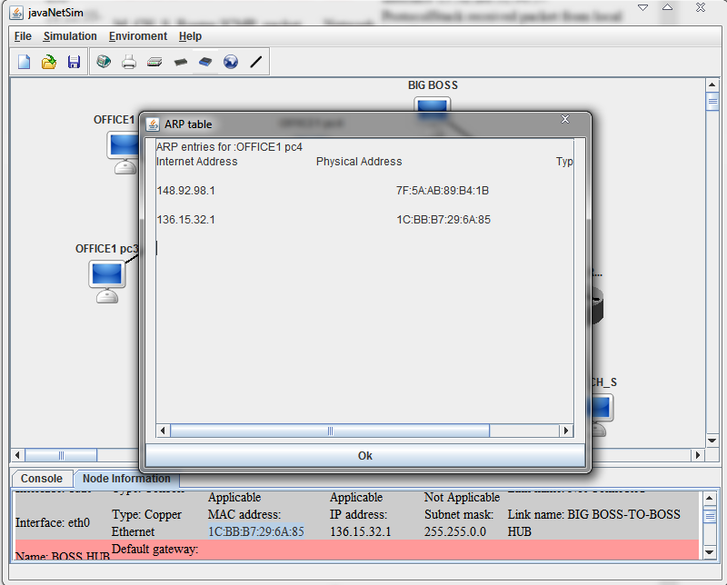

Рисунок 3 — ARP таблица

|  |  |  |  |  |
| --- | --- | --- | --- | --- |
| 21:28:17-711 | BIG BOSS | Echo Request Packet | Network | Created Echo Request packet to 148.92.97.2 |
| 21:28:17-712 | BIG BOSS | ARP Discovery Packet | DataLink | Created ARP discovery packet to source MAC address for IP 136.15.63.254 |
| 21:28:17-712 | BIG BOSS | ARP_packet | Network | Sending broadcast packet from ProtocolStack. |
| 21:28:17-712 | BIG BOSS | Ethernet Packet | Link | Sending packet from interface 1C:BB:B7:29:6A:85 |
| 21:28:17-712 | OFF_R | Ethernet Packet | Link | Recieved and accepted packet at interface 60:4A:48:C6:69:B2 |
| 21:28:17-712 | OFF_R | ARP_packet | Network | ProtocolStack received packet from local Interface. |
| 21:28:17-713 | OFF_R | ARP_packet | Network | Confirmed Packet is for this Network Layer Device. |
| 21:28:17-713 | OFF_R | ARP Response Packet | DataLink | Created ARP Response packet to 136.15.32.1 |
| 21:28:17-713 | OFF_R | ARP_packet | Network | Sending packet from ProtocolStack (to 136.15.32.1). |
| 21:28:17-713 | OFF_R | Ethernet Packet | Link | Sending packet from interface 60:4A:48:C6:69:B2 |
| 21:28:17-713 | BIG BOSS | Ethernet Packet | Link | Recieved and accepted packet at interface 1C:BB:B7:29:6A:85 |
| 21:28:17-714 | BIG BOSS | ARP_packet | Network | ProtocolStack received packet from local Interface. |
| 21:28:17-714 | BIG BOSS | ARP_packet | Network | Confirmed Packet is for this Network Layer Device. |
| 21:28:17-714 | M_CH_S_Router | Ethernet Packet | Link | Recieved and dropped packet at interface 7B:70:33:BA:71:71 |
| 21:28:17-714 | M_CH_S_Router | Ethernet Packet | Link | Recieved and accepted packet at interface 7B:70:33:BA:71:71 |
| 21:28:17-715 | M_CH_S_Router | ARP_packet | Network | ProtocolStack received packet from local Interface. |
| 21:28:17-715 | BIG BOSS | ICMP_packet | Network | Sending packet from ProtocolStack (to 136.15.63.254). |
| 21:28:17-715 | BIG BOSS | Ethernet Packet | Link | Sending packet from interface 1C:BB:B7:29:6A:85 |
| 21:28:17-715 | OFF_R | Ethernet Packet | Link | Recieved and accepted packet at interface 60:4A:48:C6:69:B2 |
| 21:28:17-715 | OFF_R | ICMP_packet | Network | ProtocolStack received packet from local Interface. |
| 21:28:17-716 | OFF_R | ICMP_packet | Network | Packet Received: Network Layer Device is Routable forwarding packet. |
| 21:28:17-716 | OFF_R | ARP Discovery Packet | DataLink | Created ARP discovery packet to source MAC address for IP 148.92.97.2 |
| 21:28:17-716 | OFF_R | ARP_packet | Network | Sending broadcast packet from ProtocolStack. |
| 21:28:17-716 | OFF_R | Ethernet Packet | Link | Sending packet from interface 7F:5A:AB:89:B4:1B |
| 21:28:17-716 | OFFICE1 pc4 | Ethernet Packet | Link | Recieved and accepted packet at interface 90:5C:B2:40:B3:5F |
| 21:28:17-717 | OFFICE1 pc4 | ARP_packet | Network | ProtocolStack received packet from local Interface. |
| 21:28:17-717 | OFFICE1 pc4 | ARP_packet | Network | Confirmed Packet is for this Network Layer Device. |
| 21:28:17-717 | OFFICE1 pc4 | ARP Response Packet | DataLink | Created ARP Response packet to 148.92.98.1 |
| 21:28:17-717 | OFFICE1 pc4 | ARP_packet | Network | Sending packet from ProtocolStack (to 148.92.98.1). |

5) Отправим echo-запрос на несуществующий в сети IP-адрес 200.100.0.1 c BIG BOSS. Пакет, не найдя адреса, застрял между маршрутизаторами до конца времени жизни, переходя от шлюза к шлюзу.

|  |  |  |  |  |
| --- | --- | --- | --- | --- |
| 21:29:42-147 | BIG BOSS | Echo Request Packet | Network | Created Echo Request packet to 200.100.0.1 |
| 21:29:42-147 | BIG BOSS | ICMP_packet | Network | Sending packet from ProtocolStack (to 136.15.63.254). |
| 21:29:42-147 | BIG BOSS | Ethernet Packet | Link | Sending packet from interface 1C:BB:B7:29:6A:85 |
| 21:29:42-147 | OFF_R | Ethernet Packet | Link | Recieved and accepted packet at interface 60:4A:48:C6:69:B2 |
| 21:29:42-147 | OFF_R | ICMP_packet | Network | ProtocolStack received packet from local Interface. |
| 21:29:42-147 | OFF_R | ICMP_packet | Network | Packet Received: Network Layer Device is Routable forwarding packet. |
| 21:29:42-147 | OFF_R | ICMP_packet | Network | Forwarding packet from ProtocolStack(to 136.15.63.250). |
| 21:29:42-147 | OFF_R | Ethernet Packet | Link | Sending packet from interface 60:4A:48:C6:69:B2 |
| 21:29:42-147 | BIG BOSS | Ethernet Packet | Link | Recieved and dropped packet at interface 1C:BB:B7:29:6A:85 |
| 21:29:42-147 | M_CH_S_Router | Ethernet Packet | Link | Recieved and accepted packet at interface 7B:70:33:BA:71:71 |
| 21:29:42-147 | M_CH_S_Router | ICMP_packet | Network | ProtocolStack received packet from local Interface. |
| 21:29:42-147 | M_CH_S_Router | ICMP_packet | Network | Packet Received: Network Layer Device is Routable forwarding packet. |
| 21:29:42-147 | M_CH_S_Router | ICMP_packet | Network | Forwarding packet from ProtocolStack(to 136.15.63.254). |
| 21:29:42-147 | M_CH_S_Router | Ethernet Packet | Link | Sending packet from interface 7B:70:33:BA:71:71 |
| 21:29:42-147 | OFF_R | Ethernet Packet | Link | Recieved and accepted packet at interface 60:4A:48:C6:69:B2 |
| 21:29:42-147 | OFF_R | ICMP_packet | Network | ProtocolStack received packet from local Interface. |
| 21:29:42-147 | OFF_R | ICMP_packet | Network | Packet Received: Network Layer Device is Routable forwarding packet. |
| …………… |  |  |  |  |
| 21:29:42-160 | BIG BOSS | Ethernet Packet | Link | Recieved and dropped packet at interface 1C:BB:B7:29:6A:85 |
| 21:29:42-160 | M_CH_S_Router | Ethernet Packet | Link | Recieved and accepted packet at interface 7B:70:33:BA:71:71 |
| 21:29:42-160 | M_CH_S_Router | ICMP_packet | Network | ProtocolStack received packet from local Interface. |
| 21:29:42-160 | M_CH_S_Router | ICMP_packet | Network | Packet Received: Network Layer Device is Routable forwarding packet. |
| 21:29:42-160 | M_CH_S_Router | ICMP_packet | Network | Forwarding packet from ProtocolStack(to 136.15.63.254). |
| 21:29:42-160 | M_CH_S_Router | Ethernet Packet | Link | Sending packet from interface 7B:70:33:BA:71:71 |
| 21:29:42-160 | OFF_R | Ethernet Packet | Link | Recieved and accepted packet at interface 60:4A:48:C6:69:B2 |
| 21:29:42-160 | OFF_R | ICMP_packet | Network | ProtocolStack received packet from local Interface. |
| 21:29:42-160 | OFF_R | ICMP_packet | Network | Packet Received: Network Layer Device is Routable forwarding packet. |
| 21:29:42-160 | OFF_R | ICMP_packet | Network | Forwarding packet from ProtocolStack(to 136.15.63.250). |
| 21:29:42-160 | OFF_R | Ethernet Packet | Link | Sending packet from interface 60:4A:48:C6:69:B2 |
| 21:29:42-160 | BIG BOSS | Ethernet Packet | Link | Recieved and dropped packet at interface 1C:BB:B7:29:6A:85 |
| 21:29:42-160 | M_CH_S_Router | Ethernet Packet | Link | Recieved and accepted packet at interface 7B:70:33:BA:71:71 |
| 21:29:42-160 | M_CH_S_Router | ICMP_packet | Network | ProtocolStack received packet from local Interface. |
| 21:29:42-160 | M_CH_S_Router | ICMP_packet | Network | Packet Received: Network Layer Device is Routable forwarding packet. |
| 21:29:42-160 | M_CH_S_Router | ICMP_packet | Network | Forwarding packet from ProtocolStack(to 136.15.63.254). |
| 21:29:42-160 | M_CH_S_Router | Ethernet Packet | Link | Sending packet from interface 7B:70:33:BA:71:71 |
| 21:29:42-160 | OFF_R | Ethernet Packet | Link | Recieved and accepted packet at interface 60:4A:48:C6:69:B2 |
| 21:29:42-160 | OFF_R | ICMP_packet | Network | ProtocolStack received packet from local Interface. |
| 21:29:42-160 | OFF_R | ICMP_packet | Network | Packet Received: Network Layer Device is Routable forwarding packet. |
| 21:29:42-160 | OFF_R | ICMP_packet | Network | Forwarding packet from ProtocolStack(to 136.15.63.250). |
| 21:29:42-160 | OFF_R | Ethernet Packet | Link | Sending packet from interface 60:4A:48:C6:69:B2 |
| 21:29:42-160 | BIG BOSS | Ethernet Packet | Link | Recieved and dropped packet at interface 1C:BB:B7:29:6A:85 |
| 21:29:42-160 | M_CH_S_Router | Ethernet Packet | Link | Recieved and accepted packet at interface 7B:70:33:BA:71:71 |
| 21:29:42-160 | M_CH_S_Router | ICMP_packet | Network | ProtocolStack received packet from local Interface. |
| 21:29:42-160 | M_CH_S_Router | ICMP_packet | Network | Packet Received: Network Layer Device is Routable forwarding packet. |
| 21:29:42-160 | M_CH_S_Router | ICMP_packet | Network | Forwarding packet from ProtocolStack(to 136.15.63.254). |
| 21:29:42-160 | M_CH_S_Router | Ethernet Packet | Link | Sending packet from interface 7B:70:33:BA:71:71 |
| 21:29:42-160 | OFF_R | Ethernet Packet | Link | Recieved and accepted packet at interface 60:4A:48:C6:69:B2 |
| 21:29:42-160 | OFF_R | ICMP_packet | Network | ProtocolStack received packet from local Interface. |
| 21:29:42-160 | OFF_R | ICMP_packet | Network | Packet Received: Network Layer Device is Routable forwarding packet. |
| 21:29:42-160 | OFF_R | ICMP_packet | Network | Forwarding packet from ProtocolStack(to 136.15.63.250). |
| 21:29:42-161 | OFF_R | Ethernet Packet | Link | Sending packet from interface 60:4A:48:C6:69:B2 |
| 21:29:42-161 | BIG BOSS | Ethernet Packet | Link | Recieved and dropped packet at interface 1C:BB:B7:29:6A:85 |
| 21:29:42-161 | M_CH_S_Router | Ethernet Packet | Link | Recieved and accepted packet at interface 7B:70:33:BA:71:71 |
| 21:29:42-161 | M_CH_S_Router | ICMP_packet | Network | ProtocolStack received packet from local Interface. |

6) Для того, чтобы удостовериться в правильности настроек сети, отправим с BIG BOSS и M_CH_S echo-запросы на все узлы сети. Ответы получены. Результат на рис. 4-16.

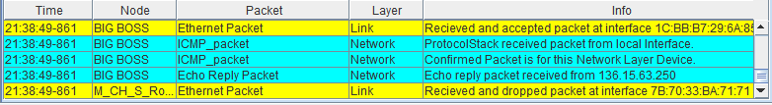

Рисунок 4 – результат запроса с BIG BOSS на M_CH_S_Router

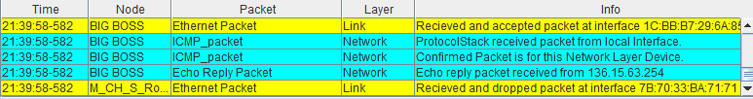

Рисунок 5 – результат запроса с BIG BOSS на OFF_R

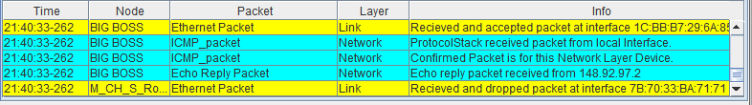

Рисунок 6 – результат запроса с BIG BOSS на PC_OFFICE1 pc4

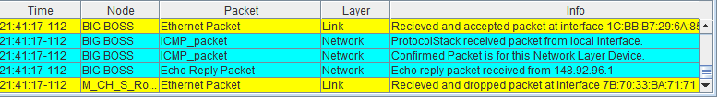

Рисунок 7 – результат запроса с BIG BOSS на PC_OFFICE1 pc3

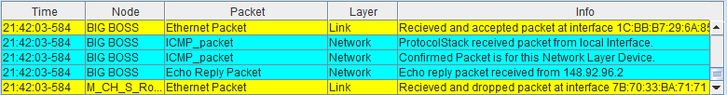

Рисунок 8 – результат запроса с BIG BOSS на PC_OFFICE1 pc2

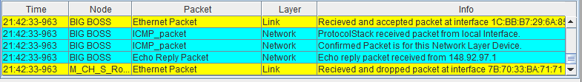

Рисунок 9 – результат запроса с BIG BOSS на PC_OFFICE1 pc1

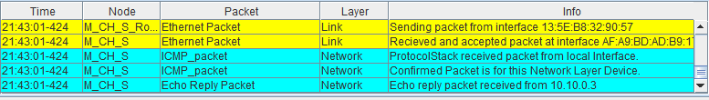

Рисунок 10 – результат запроса с M_CH_S на M_CH_S_Router

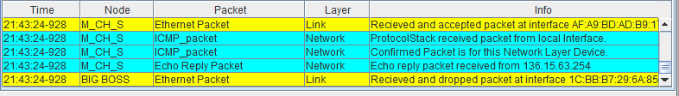

Рисунок 11 – результат запроса с M_CH_S на OFF_R

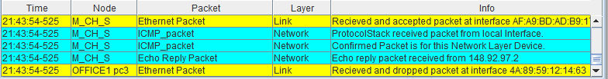

Рисунок 12 – результат запроса с M_CH_S на PC_OFFICE1 pc4

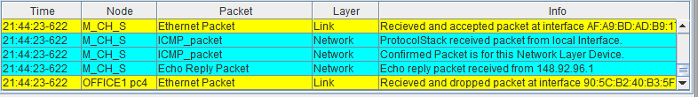

Рисунок 13 – результат запроса с M_CH_S на PC_OFFICE1 pc3

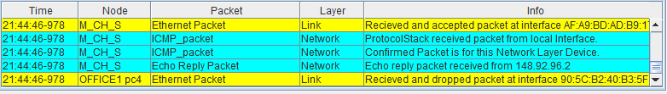

Рисунок 14 – результат запроса с M_CH_S на PC_OFFICE1 pc2

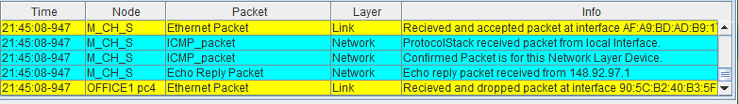

Рисунок 15 – результат запроса с M_CH_S на PC_OFFICE1 pc1

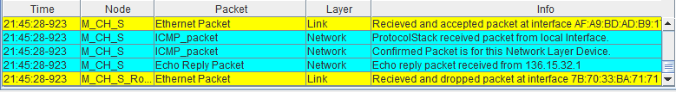

Рисунок 16 – результат запроса с M_CH_S на BIG BOSS

**Вывод.**

В ходе данной работы было изучены и освоены на практике основы адресации, разрешения физических адресов и простейшей маршрутизации в IP-сетях.