
Kutaisi International University
Management School
Bachelor of Science (BSc) in Management.

Tengizi Naneishvili

Testing the Explanatory Power of CAPM under High- and Low-Volatility Market Conditions

The thesis is completed for obtaining the academic degree of Bachelor of Management.

Supervised by
Prof. Dr. Sebastian Hain
Kutaisi, 2026

I, Tengizi Naneishvili , declare that this thesis is my own original work and does not contain any material previously published, submitted for publication, or presented for defense by other authors, unless properly referenced or cited in accordance with academic standards.
Tengizi Naneishvili
2026

Abstract
This thesis examines whether the explanatory power of the Capital Asset Pricing Model (CAPM) differs between low-volatility and high-volatility market periods. CAPM is still one of the most widely used models in finance because it provides a simple way to connect asset returns with systematic market risk. However, previous research has also shown that the model does not always perform equally well in practice, especially when beta is assumed to remain constant over long periods.
The main idea of this thesis is that market conditions may affect how well CAPM explains returns. Calm market periods and turbulent periods can differ in terms of uncertainty, investor behaviour, risk perception, and the degree to which assets move together with the broader market. Because of this, the thesis does not rely only on one full-sample CAPM regression. Instead, it compares the model’s performance across low-volatility and high-volatility regimes.
The empirical analysis uses monthly data from the Kenneth French Data Library. The dependent assets are the Fama-French 10 industry portfolios, while the market excess return and risk-free rate are taken from the Fama-French Research Data Factors file. The sample period runs from July 1963 to December 2024. Market regimes are defined using the 12-month rolling standard deviation of the market excess return. Months above the median rolling volatility are classified as high-volatility periods, while the remaining months are classified as low-volatility periods. Separate OLS CAPM regressions are estimated for the full sample, low-volatility periods, and high-volatility periods for each industry portfolio.
The results show that CAPM’s explanatory power is higher during high-volatility periods for all ten industry portfolios. Average adjusted R-squared increases from 0.564 in low-volatility periods to 0.666 in high-volatility periods. This suggests that the market factor explains industry portfolio returns more strongly during turbulent market conditions. Beta estimates also differ across regimes, but the direction of change is not the same for every industry. Overall, the findings suggest that CAPM performance is state-dependent, while beta instability appears to be industry-specific rather than uniform.

Table of Contents
1. Introduction
1.1 Background and Motivation
1.2 Problem Statement
1.3 Research Question and Objectives
1.4 Scope and Contribution
1.5 Structure of the Thesis
2. Theoretical Background and Literature Review
2.1 CAPM as the Baseline Risk-Return Model
2.2 Alpha, Beta, and Explanatory Power
2.3 Empirical Limitations of CAPM
2.4 Beta Instability and Time Variation
2.5 Volatility Regimes and Conditional CAPM Logic
2.6 Adaptive Markets Hypothesis
2.7 Literature Gap
3. Methodology
3.1 Research Design
3.2 Data and Sample Selection
3.3 Return Calculation and Excess Returns
3.4 Volatility Regime Construction
3.5 CAPM Regression Specification
3.6 Comparison Criteria

3.8 Analytical Expectations

4. Empirical Results
4.1 Descriptive Overview and Regime Split
4.2 Full-Sample CAPM Results
4.3 Low- and High-Volatility Comparison
4.4 Beta Stability Across Regimes
4.5 Alpha Results
5. Discussion
5.1 Interpretation of the Main Finding
5.2 Comparison with Abdymomunov and Morley (2011)
5.3 Theoretical Implications
5.4 Practical Meaning and Limitations
5.5 Limitations and Future Research
6. Conclusion
References
Appendices

1. Introduction

1.1 Background and Motivation
The Capital Asset Pricing Model (CAPM) is one of the best-known models in finance because it gives a simple explanation of how risk and return should be connected. The model argues that investors should be rewarded for systematic risk, meaning the part of risk that cannot be removed through diversification. In empirical work, this systematic risk is measured by beta, which shows how strongly an asset or portfolio moves with the market.
This simplicity is the reason CAPM is still useful. It is easy to explain, easy to estimate, and still appears in finance courses, company valuation, portfolio analysis, and performance evaluation. However, the same simplicity also creates problems. A single market factor may not always be enough to explain returns, and the relationship between beta and return may not be stable across all periods.
The starting point of this thesis is the idea that CAPM may not perform equally well in every market environment. Financial markets move through calm periods and more stressful periods. During calm periods, returns may follow the broad market in a more stable way. During turbulent periods, uncertainty increases and investors may react more strongly to news, risk, and liquidity concerns. Because of this, it is reasonable to ask whether CAPM explains returns differently in low-volatility and high-volatility periods.
The thesis therefore uses CAPM as the main empirical model but does not treat its performance as fixed. Instead, it compares CAPM results across two market regimes. The purpose is not to prove that CAPM is right or wrong in a general sense. The question is narrower: whether the model's explanatory power changes when market volatility is low compared with when it is high.
The Adaptive Markets Hypothesis is used as theoretical support for this logic. Lo (2004, 2005) argues that market efficiency and financial relationships may change as investors adapt to different environments. This does not mean that the thesis tests the Adaptive Markets Hypothesis directly. It only means that the idea of changing market conditions gives a useful background for asking whether CAPM behaves differently across volatility regimes.

1.2 Problem Statement
In the standard empirical CAPM regression, the excess return of an asset is explained by the excess return of the market. If the model works well, the market factor should explain a meaningful part of the movement in asset excess returns, and the regression intercept, alpha, should be close to zero. In practice, this is not always the case. Many empirical studies have shown that CAPM often leaves part of returns unexplained.
One problem is that a usual CAPM test often estimates one regression over the full sample period. This assumes that the relationship between an asset and the market is stable across the whole period. For long samples, this can be a strong assumption. An industry portfolio may not react to the market in the same way during a financial crisis as it does during a calm expansion. If that is true, then one full-sample beta may hide important differences.
The problem addressed in this thesis is therefore not only that CAPM has limitations, but that these limitations may depend on market conditions. If the model performs better in one regime than another, then CAPM's usefulness should be discussed in a more conditional way. This is important because CAPM is still used in practical finance, even though its empirical weaknesses are well known.

1.3 Research Question and Objectives
The central research question of the thesis is:
To what extent does the explanatory power of the CAPM differ between low-volatility and high-volatility market periods?
To answer this question, the thesis follows several objectives:
- explain the theoretical foundation of CAPM and the role of beta, alpha, and adjusted R-squared;
- review empirical literature on CAPM limitations, especially weak explanatory power, non-zero alpha, and beta instability;
- justify the use of volatility regimes as a simple way to separate calm and turbulent market periods;
- construct low- and high-volatility periods using 12-month rolling market volatility and a median split;
- estimate separate CAPM regressions for the Fama-French 10 industry portfolios in each regime;
- compare adjusted R-squared, alpha, and beta estimates across the two regimes.

1.4 Scope and Contribution
The scope of the thesis is deliberately limited. It does not try to build a new asset-pricing model. It also does not estimate advanced models such as GARCH, Markov switching, or multi-factor regressions. Those methods are relevant in the literature, but they would shift the focus away from the main research question. For this thesis, a simpler method is more appropriate because the main goal is comparison, not forecasting volatility or creating a new model.
The empirical focus was changed from individual U.S. stocks to Fama-French 10 industry portfolios. This is an important change, but it strengthens the thesis. Individual stocks create a serious problem over long historical periods because many companies did not exist, were not publicly traded, were delisted, merged, or changed in ways that make long-run comparison difficult. Industry portfolios avoid much of this problem because they provide continuous monthly portfolio returns over a long historical period.
This change also allows the thesis to study a much longer sample. Instead of being limited to a recent period such as 2014 to today, the final empirical analysis uses monthly data from July 1963 to December 2024. This longer sample includes several different market environments, including inflationary periods, recessions, financial crises, the dot-com period, the global financial crisis, the COVID-19 shock, and recent post-pandemic volatility. This makes the volatility-regime comparison more meaningful.
The contribution is practical and focused. Prior literature has already discussed CAPM theory, empirical failures, beta instability, conditional CAPM models, and volatility regimes. This thesis brings these ideas into a simple empirical design. It asks whether the same CAPM regression gives different explanatory results when the market is calm compared with when it is volatile.

1.5 Structure of the Thesis
Chapter 1 introduces the research topic, motivation, research question, and scope. Chapter 2 reviews the theoretical and empirical literature connected to CAPM, alpha, beta instability, volatility regimes, conditional CAPM logic, and the Adaptive Markets Hypothesis. Chapter 3 explains the methodology, including the data source, sample period, volatility regime construction, and regression specification. Chapter 4 presents the empirical results. Chapter 5 discusses the findings in relation to the literature and explains their meaning. Chapter 6 concludes the thesis and outlines limitations and possible future research.

2. Theoretical Background and Literature Review

2.1 CAPM as the Baseline Risk-Return Model
CAPM was developed by Sharpe (1964) and Lintner (1965) and became one of the central models in modern finance. The main idea is that expected return should be related to systematic market risk. In the CAPM framework, investors are not compensated for all risk. They are compensated for the part of risk that cannot be diversified away. This is why beta is the key risk measure in the model.
The basic CAPM relationship can be written as:
E(Ri) = Rf + beta_i [E(Rm) - Rf]
where E(Ri) is the expected return on asset i, Rf is the risk-free rate, E(Rm) is the expected market return, and beta_i measures the sensitivity of the asset to the market. In empirical work, this relationship is usually tested with realized excess returns. The basic time-series regression becomes:
Ri,t - Rf,t = alpha_i + beta_i (Rm,t - Rf,t) + epsilon_i,t
This regression is simple but powerful. It allows the researcher to estimate beta, test whether alpha is close to zero, and measure how much of the return variation is explained by the market factor. For this reason, CAPM remains a useful starting point even when the model is known to have limitations.

2.2 Alpha, Beta, and Explanatory Power
Three outputs are especially important in this thesis: beta, alpha, and adjusted R-squared. Beta measures the sensitivity of an industry portfolio's excess return to the market excess return. A beta above one means that the portfolio tends to move more than the market. A beta below one means that the portfolio is less sensitive to market movements. For example, defensive industries such as Utilities often have lower betas, while more cyclical industries such as Durables or High Technology may have higher betas.
Alpha is the intercept in the CAPM regression. In a strict CAPM interpretation, alpha should be zero. A positive alpha means that the asset or portfolio earned more than the model predicts, after controlling for market risk. A negative alpha means that it earned less than predicted. In this thesis, alpha is not used to claim investment skill. It is used as a model diagnostic: if alpha is large and statistically significant, CAPM is leaving something important unexplained.
Adjusted R-squared is used as the main measure of explanatory power. It shows how much of the variation in industry excess returns is explained by the market excess return, adjusted for the number of explanatory variables. Since all regressions in this thesis use the same simple CAPM specification, adjusted R-squared is easy to compare across regimes. If adjusted R-squared is higher in one regime, then the market factor explains more of the industry portfolio's return variation in that regime.

2.3 Empirical Limitations of CAPM
Although CAPM is theoretically elegant, its empirical performance has often been questioned. Fama and French (2004) argue that the empirical record of CAPM is weak enough to create serious problems for many applications of the model. One issue is that beta alone does not always explain differences in average returns. Other factors, such as size, value, momentum, and profitability, may also matter.
Black, Jensen, and Scholes (1972) also provide early evidence that the traditional form of CAPM does not fully describe the structure of security returns. Their work shows that high-beta and low-beta assets do not always behave exactly as the basic CAPM predicts. This type of evidence does not make CAPM useless, but it does show that the model is too simple to explain every return pattern.
Roll (1977) adds another important criticism. He argues that testing CAPM is difficult because the true market portfolio is not observable. In theory, the market portfolio should include all risky assets, not only common stocks. In practice, researchers usually use a stock market index or a broad stock market factor as a proxy. This means that empirical CAPM tests are always partly tests of the chosen market proxy.
For this thesis, these limitations are acknowledged but not solved. The purpose is not to defend CAPM as a complete model. Instead, the thesis asks a narrower question: whether the model's explanatory power changes across volatility regimes when the same market factor and the same regression method are used consistently.

2.4 Beta Instability and Time Variation
A key assumption in many simple CAPM tests is that beta is stable. However, several studies suggest that beta may change over time. Blume (1975) studies regression tendencies in beta estimates and shows that beta estimates are not perfectly stable. Fabozzi and Francis (1978) also argue that beta coefficients may behave as random coefficients rather than fixed parameters. This is important because a full-sample regression can hide changes in market sensitivity.
If beta is not stable, then a single beta estimate may be misleading. A portfolio may be defensive in one period and more market-sensitive in another. This matters especially when the sample includes both calm and crisis periods. The logic of this thesis follows that concern. Instead of assuming that one beta is enough for the entire period, it estimates separate betas in low- and high-volatility market regimes.
Jagannathan and Wang (1996) provide a conditional CAPM framework in which beta and expected market risk premium can vary over time. Their work is more advanced than the approach used in this thesis, but it supports the general idea that the unconditional CAPM may fail if the relationship between beta and the market risk premium changes across states of the economy.

2.5 Volatility Regimes and Conditional CAPM Logic
Market volatility is a natural way to define different market environments. In simple terms, volatility measures how strongly returns fluctuate. A low-volatility period is usually calmer and more stable, while a high-volatility period is usually more uncertain and stressful. Schwert (1989) shows that stock market volatility changes over time and is related to broader economic conditions, although no single factor fully explains its movement.
Abdymomunov and Morley (2011) are especially relevant for this thesis because they study time variation of CAPM betas across market volatility regimes. They use a two-state Markov-switching model and allow beta and the market risk premium to vary between low- and high-volatility states. Their results suggest strong evidence of beta variation across volatility regimes, and they find that time-varying betas help explain portfolio returns better than the unconditional CAPM, especially when market volatility is high.
The current thesis is much simpler than Abdymomunov and Morley (2011). It does not estimate a Markov-switching model, and it does not formally test a conditional CAPM. Instead, it uses rolling volatility and a median split to divide the sample into two regimes. This method is less advanced, but it is transparent and reproducible. For a bachelor thesis, that is a strength rather than a weakness.

2.6 Adaptive Markets Hypothesis
The Adaptive Markets Hypothesis gives broader theoretical support to the idea that financial relationships may change over time. Lo (2004, 2005) argues that market efficiency is not fixed. It depends on environmental conditions, competition, investor behavior, and adaptation. In this view, markets are not always perfectly efficient or permanently inefficient. They evolve as participants learn and react to changing conditions.
This thesis does not test the Adaptive Markets Hypothesis directly. There is no behavioral survey, evolutionary model, or formal AMH test. Instead, AMH is used as a background idea. It supports the possibility that a model like CAPM may perform differently in different environments. If investors behave differently in high-volatility periods than in low-volatility periods, then the relationship between market risk and returns may also change.

2.7 Literature Gap
The literature already contains many advanced studies on CAPM limitations, conditional CAPM models, beta instability, volatility, and market regimes. The gap addressed here is more modest and practical. The thesis applies a simple volatility-regime comparison to long-run U.S. industry portfolio data. It asks whether CAPM explanatory power differs between low- and high-volatility periods using a method that is easy to understand, reproduce, and discuss.
This gap is suitable for bachelor-level research because it avoids overcomplication while still connecting to a serious academic discussion. The thesis does not claim to solve the CAPM debate. It only contributes evidence on whether the model behaves differently across volatility regimes when tested with long-run industry portfolio data.

3. Methodology

3.1 Research Design
The research design is quantitative and empirical. The thesis estimates CAPM regressions and compares the results across market volatility regimes. The structure is intentionally simple: first the data are cleaned, then excess returns are calculated, then volatility regimes are defined, and finally the CAPM regressions are estimated separately for different regimes.
The empirical design follows three main stages. First, a full-sample CAPM regression is estimated for each of the ten industry portfolios. This gives a benchmark result for the unconditional CAPM. Second, the sample is divided into low-volatility and high-volatility months using a 12-month rolling standard deviation of market excess returns. Third, separate CAPM regressions are estimated for each industry portfolio in each regime. The comparison focuses on adjusted R-squared, alpha, and beta.

3.2 Data and Sample Selection
The thesis uses data from the Kenneth French Data Library. Two files are used. The first file is the 10 Industry Portfolios dataset, which provides monthly returns for ten U.S. industry portfolios. The second file is the Fama-French Research Data Factors file, which provides the market excess return (Mkt-RF) and the risk-free rate (RF).
The ten industry portfolios are Consumer Non-Durables, Consumer Durables, Manufacturing, Energy, High Technology, Telecommunications, Shops, Healthcare, Utilities, and Other. In the original dataset, these are abbreviated as NoDur, Durbl, Manuf, Enrgy, HiTec, Telcm, Shops, Hlth, Utils, and Other. The analysis keeps the original labels in tables and figures because they match the data source.
The sample period runs from July 1963 to December 2024. The starting date is chosen because it creates a long post-1963 sample that works consistently with the Fama-French factor data. After the 12-month rolling volatility measure is calculated, the usable regression sample begins in June 1964 and ends in December 2024. This gives 727 monthly observations for the regression sample.
Using industry portfolios instead of individual stocks is an important methodological choice. It avoids the survivorship and data availability problems that would occur when trying to follow selected individual stocks over many decades. It also keeps the thesis focused on portfolio-level CAPM performance, which is common in asset-pricing research.

3.3 Return Calculation and Excess Returns
The original Fama-French files report returns in percentages. Before running the regressions, all return variables are converted into decimal form. For example, a return of 2.50 percent is converted to 0.025.
For each industry portfolio, the excess return is calculated as:
Industry Excess Return = Industry Portfolio Return - RF
The market excess return is taken directly from the Fama-French factor file as Mkt-RF. This is useful because the market return is already expressed in excess of the risk-free rate. Therefore, the CAPM regression can be estimated directly using industry excess returns as the dependent variable and Mkt-RF as the independent variable.

3.4 Volatility Regime Construction
Market volatility regimes are constructed using the 12-month rolling standard deviation of Mkt-RF. This means that for each month, volatility is calculated based on the market excess returns over the previous 12 months, including the current month. The first 11 months are lost because there are not enough prior observations to calculate a 12-month standard deviation.
After calculating the rolling volatility measure, the median value is used as the cutoff. Months with rolling volatility above the median are classified as high-volatility months. Months with rolling volatility below or equal to the median are classified as low-volatility months. This creates a clear and balanced split between the two regimes.
In the final dataset, the median 12-month rolling volatility is 0.0406. The regime split produces 364 low-volatility months and 363 high-volatility months. This nearly equal split is useful because it avoids comparing one very large group with one very small group.
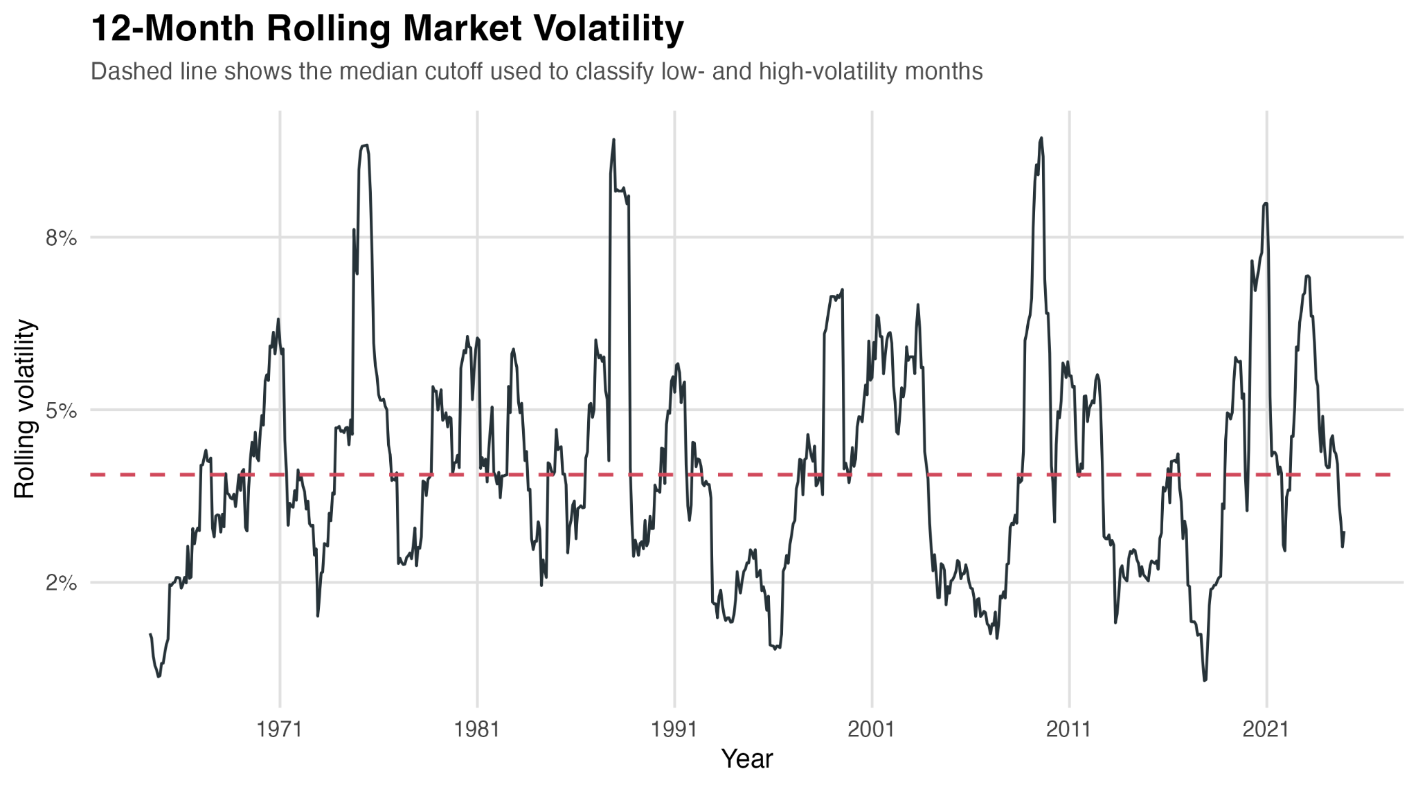
Figure 1. 12-month rolling market volatility and median cutoff.

3.5 CAPM Regression Specification
For each industry portfolio, the following time-series CAPM regression is estimated:
Ri,t - Rf,t = alpha_i + beta_i (Mkt-RF)t + epsilon_i,t
where Ri,t - Rf,t is the excess return of industry portfolio i in month t, Mkt-RF is the market excess return, alpha_i is the regression intercept, beta_i is the portfolio's market sensitivity, and epsilon_i,t is the error term.
The regression is estimated using ordinary least squares (OLS). For each industry, three regressions are estimated: one full-sample regression, one regression using only low-volatility months, and one regression using only high-volatility months. Since there are ten industry portfolios and three regressions for each portfolio, the analysis produces 30 CAPM regressions in total.

3.6 Comparison Criteria
The main comparison criteria are adjusted R-squared, beta, and alpha. Adjusted R-squared is the primary measure of explanatory power. It shows how much of the variation in industry excess returns is explained by the market excess return. The main research question is answered by comparing adjusted R-squared between low- and high-volatility regimes.
Beta is used to examine market sensitivity. If beta changes substantially between regimes, then the industry's exposure to market risk is not stable. This does not automatically mean CAPM fails, but it does suggest that a single full-sample beta can hide regime-specific behavior.
Alpha is used as an additional model diagnostic. If alpha is statistically significant, then the model leaves abnormal returns unexplained. In this thesis, alpha is interpreted carefully. The focus is not on investment performance, but on whether the CAPM regression leaves systematic unexplained return patterns.

3.7 Reliability, Limitations, and Reproducibility
The methodology is designed to be reproducible. The raw data files are public, the cleaning procedure is straightforward, and the R script used for the analysis can be saved together with the cleaned dataset and output tables. This makes it possible to check the results and repeat the analysis if needed.
There are also limitations. First, the analysis uses industry portfolios rather than individual stocks. This improves data consistency but means the results are portfolio-level findings, not company-level findings. Second, the volatility regimes are based on a median split. This is transparent, but it is also simple and does not estimate hidden market states like a Markov-switching model. Third, the thesis uses only the single-factor CAPM. It does not test whether Fama-French multi-factor models would perform better. These limitations are acceptable because the thesis is focused on a clear bachelor-level research question.

3.8 Hypotheses and Expected Interpretation
The thesis begins from a simple expectation: if market conditions matter, CAPM results should not be identical in low- and high-volatility periods. This does not require CAPM to be correct in every detail. It only requires that the strength of the relationship between industry excess returns and the market excess return may change when the market environment changes.
The first hypothesis is that CAPM explanatory power differs across volatility regimes. In practical terms, this means that adjusted R-squared should not be the same in low- and high-volatility periods. The direction of the difference is not forced in advance. Before running the analysis, it would be reasonable to expect either outcome. CAPM might perform better in calm periods because relationships are more stable, or it might perform better in turbulent periods because market-wide risk becomes more dominant. For this reason, the empirical part is designed as a comparison rather than as a proof of one expected result.
The second hypothesis is that beta estimates are not perfectly stable across regimes. If industries have different business models, demand sensitivity, and exposure to macroeconomic risk, then their market sensitivity may change differently when volatility rises. Cyclical industries may become more exposed to the market in stressful periods, while defensive industries may become relatively less exposed. This is why beta is interpreted industry by industry rather than only through the average beta across all portfolios.
The third expectation concerns alpha. If CAPM performs well within a regime, alpha should be close to zero and statistically insignificant. However, alpha is treated as a secondary diagnostic in this thesis. The main reason is that alpha can be affected by many things that are outside the simple CAPM framework, including omitted factors, industry-specific effects, and sampling variation. Therefore, the final interpretation relies mostly on adjusted R-squared and beta changes, while alpha is used to check whether there are strong abnormal return patterns left unexplained.
Overall, the empirical analysis is interpreted cautiously. A higher adjusted R-squared does not mean that CAPM is theoretically perfect. It only means that, in that regime, the market excess return explains a larger share of industry portfolio return variation. Similarly, changing beta estimates do not prove a full conditional asset-pricing model, but they do show that the simple full-sample CAPM may hide regime-specific differences.
4. Empirical Results
4.1 Descriptive Overview and Regime Split
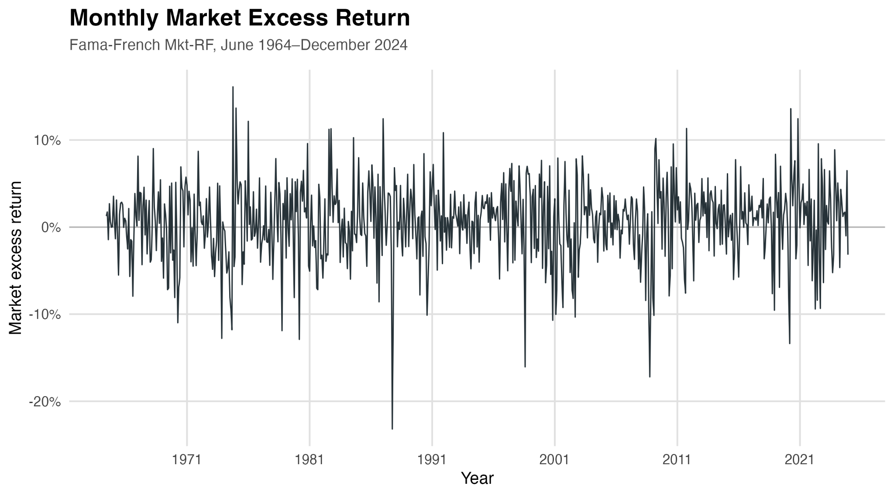
Figure 2. Monthly market excess return over the usable sample period.
Figure 2 provides a descriptive view of the monthly market excess return. The graph is not used directly to classify regimes, but it helps show why a volatility-based design is relevant. The sample includes several large positive and negative market movements, and these movements are not evenly distributed across time. This supports the idea that the market environment changes across the sample rather than remaining constant.

4. Empirical Results

4.1 Descriptive Overview and Regime Split
The final dataset contains monthly observations from July 1963 to December 2024. After the 12-month rolling volatility measure is calculated, the usable regression sample runs from June 1964 to December 2024. This leaves 727 monthly observations for the CAPM regressions.
The volatility regime split is nearly balanced. There are 364 low-volatility months and 363 high-volatility months. The median 12-month rolling volatility is 0.0406, and this median is used as the cutoff between the two regimes. This setup makes the comparison between regimes cleaner because both groups contain almost the same number of observations.
Table 1. Summary of main regime comparison results.
Metric | Value
Average adjusted R-squared - Low volatility | 0.5642
Average adjusted R-squared - High volatility | 0.6664
Average adjusted R-squared difference | 0.1022
Industries with higher adjusted R-squared in high volatility | 10.0000
Average beta - Low volatility | 0.9452
Average beta - High volatility | 0.9357
Average beta difference | -0.0095
Industries with higher beta in high volatility | 3.0000

4.2 Full-Sample CAPM Results
The full-sample CAPM regressions show that the market factor explains a meaningful share of return variation for most industry portfolios. The beta estimates are statistically significant across all industries. In the R output, the beta p-values appear as 0 after rounding, but this should not be interpreted as exactly zero. It means that the p-values are extremely small.
The strongest full-sample fit appears in Manufacturing, with an adjusted R-squared of 0.872. Other also has a high adjusted R-squared of 0.858. Shops and High Technology also show strong explanatory power, with adjusted R-squared values of 0.758 and 0.748. Utilities has the lowest full-sample adjusted R-squared at 0.340, which is consistent with the idea that defensive sectors may be less closely tied to broad market movements.
Table 2. Full-sample CAPM regression results.
Industry | Alpha (%) | Alpha p-value | Beta | Adj. R2 | N
NoDur | 0.190 | 0.037 | 0.774 | 0.672 | 727
Durbl | -0.050 | 0.779 | 1.242 | 0.576 | 727
Manuf | -0.009 | 0.888 | 1.039 | 0.872 | 727
Enrgy | 0.140 | 0.426 | 0.864 | 0.407 | 727
HiTec | 0.015 | 0.900 | 1.226 | 0.748 | 727
Telcm | -0.017 | 0.887 | 0.784 | 0.558 | 727
Shops | 0.123 | 0.199 | 1.003 | 0.758 | 727
Hlth | 0.203 | 0.079 | 0.819 | 0.587 | 727
Utils | 0.165 | 0.185 | 0.531 | 0.340 | 727
Other | -0.048 | 0.523 | 1.099 | 0.858 | 727

4.3 Low- and High-Volatility Comparison
The main finding of the thesis is clear: CAPM explanatory power is higher in high-volatility periods for all ten industry portfolios. Average adjusted R-squared increases from 0.564 in low-volatility periods to 0.666 in high-volatility periods. The average increase is 0.102. This directly answers the research question: CAPM explanatory power differs meaningfully across volatility regimes, and in this sample it is stronger during high-volatility periods.
This result is visible in both the table and the figures. The largest increase appears in Energy, where adjusted R-squared rises from 0.242 in low-volatility periods to 0.478 in high-volatility periods. High Technology also shows a large increase, from 0.607 to 0.794. Shops increases from 0.662 to 0.793. These results suggest that during turbulent periods, industry portfolio returns move more closely with the market factor.
Table 3. Adjusted R-squared comparison between volatility regimes.
Industry | Low Adj. R2 | High Adj. R2 | High - Low
Enrgy | 0.242 | 0.477 | 0.235
HiTec | 0.607 | 0.794 | 0.187
Shops | 0.662 | 0.793 | 0.130
Utils | 0.276 | 0.370 | 0.095
Telcm | 0.493 | 0.584 | 0.092
NoDur | 0.621 | 0.693 | 0.072
Durbl | 0.528 | 0.589 | 0.060
Hlth | 0.551 | 0.610 | 0.059
Other | 0.818 | 0.872 | 0.054
Manuf | 0.843 | 0.881 | 0.038

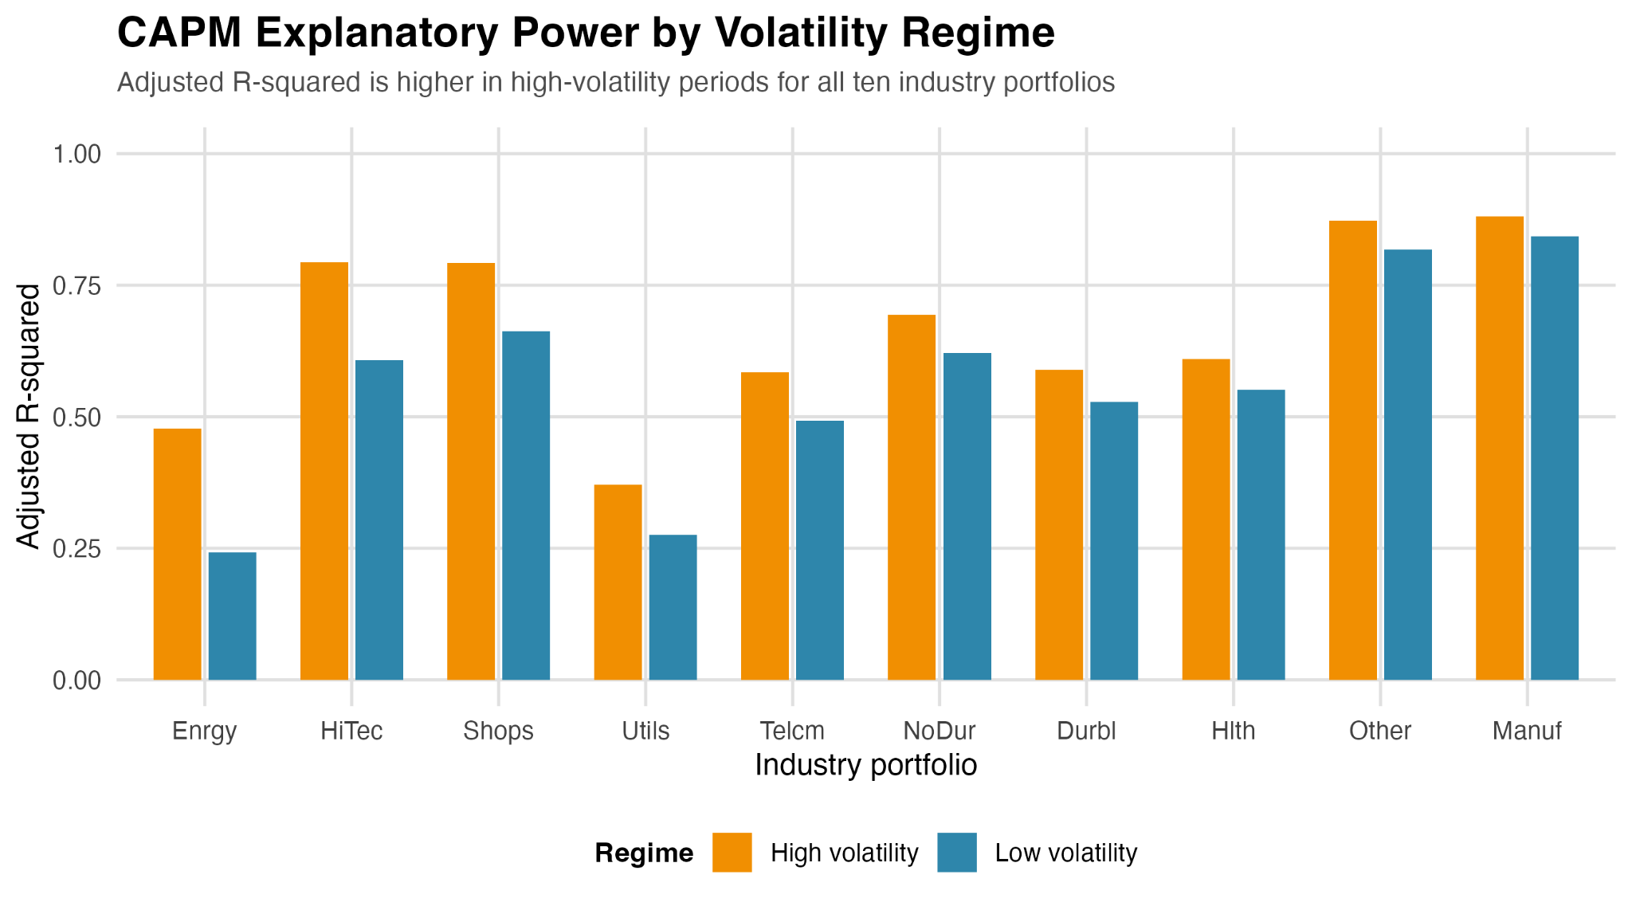
Figure 2. CAPM explanatory power by volatility regime.
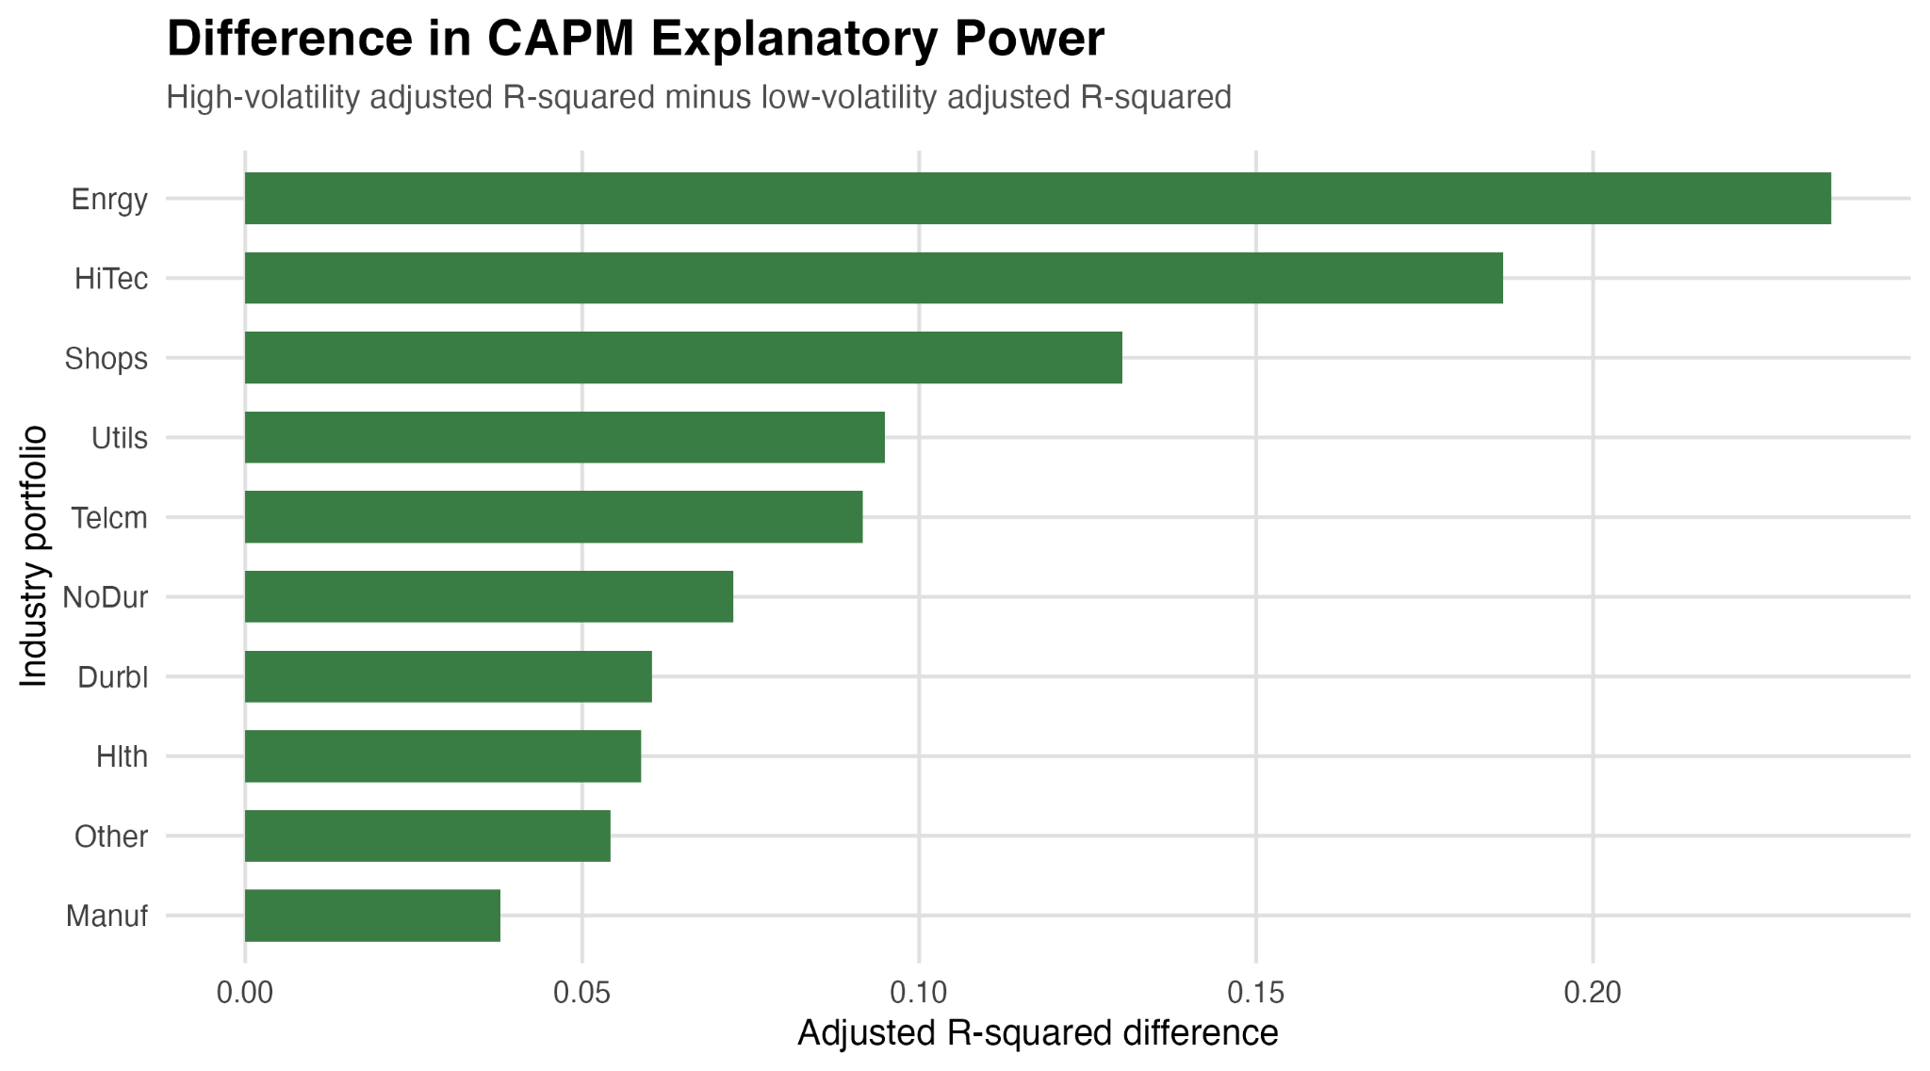
Figure 3. Difference in CAPM explanatory power: high-volatility adjusted R-squared minus low-volatility adjusted R-squared.

4.4 Beta Stability Across Regimes
The beta results are more mixed than the adjusted R-squared results. Average beta is almost the same across regimes: 0.945 in low-volatility periods and 0.936 in high-volatility periods. Therefore, it would be wrong to say that betas generally increase in high-volatility periods. The better interpretation is that betas change across regimes, but the direction depends on the industry.
Three industries have higher beta in high-volatility periods: Energy, High Technology, and Consumer Durables. Energy beta increases from 0.762 to 0.894, High Technology beta increases from 1.134 to 1.254, and Consumer Durables beta increases from 1.139 to 1.270. These industries are more cyclical, so it makes sense that they become more sensitive to market movements during turbulent periods.
Several other industries have lower beta in high-volatility periods. Healthcare beta decreases from 0.949 to 0.780, Consumer Non-Durables decreases from 0.831 to 0.756, Telecommunications decreases from 0.831 to 0.771, and Utilities decreases from 0.570 to 0.519. These industries are often more defensive, so their market sensitivity may fall relative to cyclical sectors during stressful periods.
Table 4. Beta comparison between volatility regimes.
Industry | Low Beta | High Beta | High - Low
Enrgy | 0.762 | 0.894 | 0.132
HiTec | 1.134 | 1.254 | 0.120
Shops | 1.012 | 0.999 | -0.013
Utils | 0.570 | 0.519 | -0.051
Telcm | 0.831 | 0.771 | -0.060
NoDur | 0.831 | 0.756 | -0.075
Durbl | 1.139 | 1.270 | 0.132
Hlth | 0.949 | 0.780 | -0.169
Other | 1.148 | 1.085 | -0.063
Manuf | 1.076 | 1.028 | -0.048

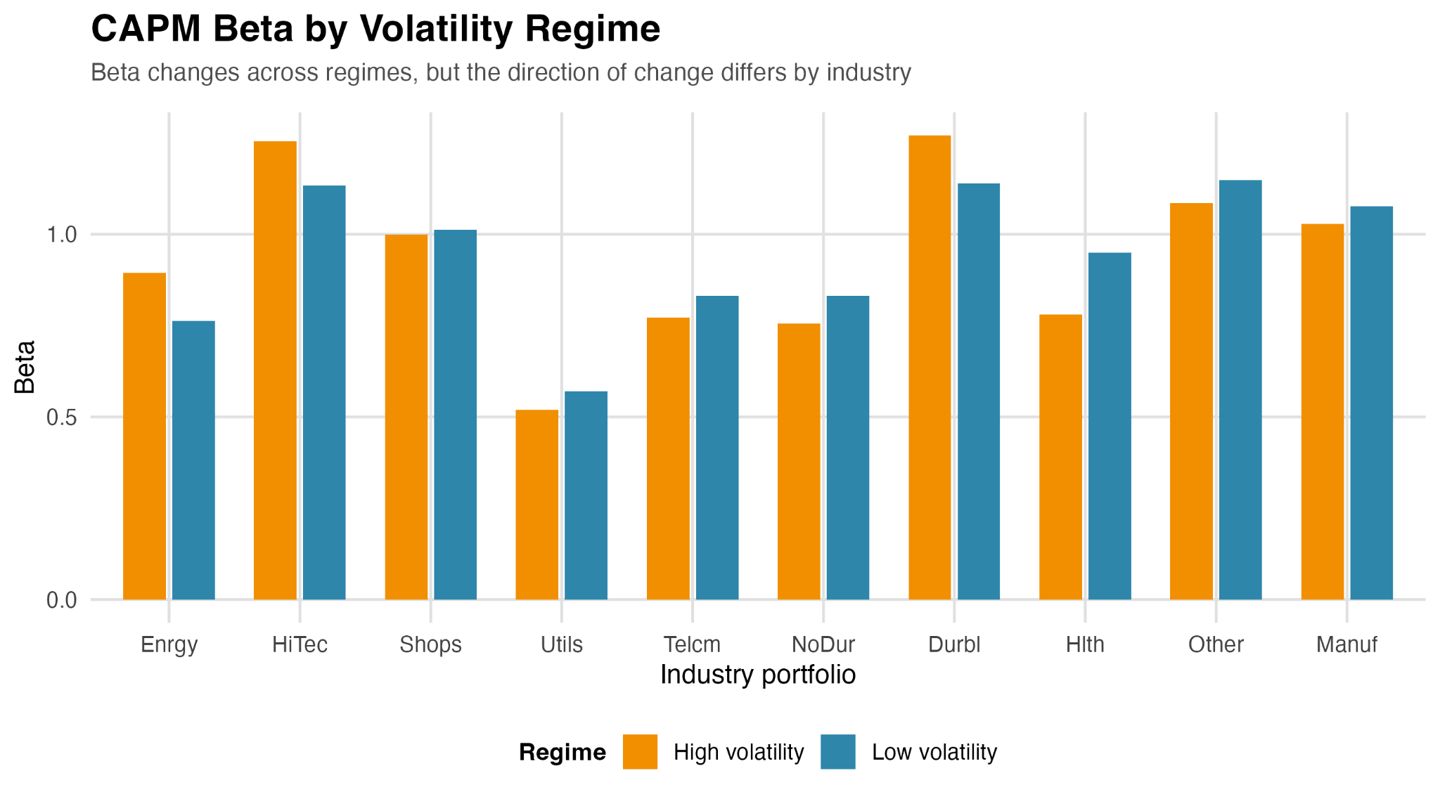
Figure 4. CAPM beta by volatility regime.

4.5 Alpha Results
The alpha results are less strong than the adjusted R-squared results. Most alpha estimates are not statistically significant at the 5 percent level. This means that, for most industries and regimes, CAPM does not leave large statistically significant abnormal returns unexplained. In that sense, the alpha evidence is not the main driver of the thesis findings.
There are a few interesting cases. Consumer Non-Durables has a statistically significant full-sample alpha at the 5 percent level. Shops in the high-volatility regime has an alpha p-value close to 0.05, and Consumer Non-Durables in the high-volatility regime is also somewhat close to significance. However, these are not enough to claim a broad pattern of abnormal returns. The safer interpretation is that alpha evidence is limited, while adjusted R-squared and beta differences provide the stronger evidence of regime dependence.

5. Discussion

5.1 Interpretation of the Main Finding
The main finding is that CAPM explains industry portfolio returns better during high-volatility periods. This result may seem surprising at first. One might expect CAPM to perform better in calm markets because relationships are more stable. However, the data show the opposite: when market volatility is high, the market factor explains more of the movement in industry portfolio excess returns.
A possible explanation is that during turbulent periods, market-wide forces dominate industry-specific movements. Investors may become more focused on systematic risk, macroeconomic news, liquidity, and uncertainty. As a result, industry portfolios may move more together with the market. When this happens, a single market factor can explain a larger share of return variation. This would explain why adjusted R-squared is higher in high-volatility periods for every industry in the sample.
At the same time, the beta results show that not all industries react in the same way. Cyclical industries become more market-sensitive, while several defensive industries become less market-sensitive. This is important because it shows that regime dependence is not just a simple increase in beta across all portfolios. The market explains more during high-volatility periods, but the industry-level response is different across sectors.

5.2 Comparison with Abdymomunov and Morley (2011)
The findings are broadly consistent with Abdymomunov and Morley (2011), but the comparison must be made carefully. Their study uses a two-state Markov-switching conditional CAPM. They jointly model market and portfolio returns and allow beta and the market risk premium to vary between low- and high-volatility regimes. Their empirical findings suggest strong evidence of time variation in betas across volatility regimes, and they report that time-varying betas help explain portfolio returns better than the unconditional CAPM, especially when market volatility is high.
This thesis reaches a similar broad conclusion with a much simpler method. It does not estimate a Markov-switching model and does not formally test the conditional CAPM. Instead, it uses a 12-month rolling volatility measure, a median split, and separate OLS regressions. Even with this simpler design, the results point in the same general direction: CAPM performance is not constant across market conditions, and the model explains returns more strongly during high-volatility periods.
The important difference is that this thesis cannot claim to replicate Abdymomunov and Morley (2011). Their model is more advanced, and their portfolio set is different. The correct conclusion is that the findings are consistent with their broader logic. Both studies suggest that a single unconditional CAPM can hide important regime-specific behavior.

5.3 Theoretical Implications
The results support the idea that CAPM should be interpreted conditionally. The model is not equally explanatory in all environments. In this thesis, the market factor has stronger explanatory power during high-volatility periods, which suggests that systematic market risk becomes more dominant when uncertainty is high.
The findings also fit the broader Adaptive Markets Hypothesis logic. If market participants adapt to changing conditions, then the strength of risk-return relationships may change over time. The thesis does not prove AMH, but it is consistent with the idea that financial relationships are environment-dependent rather than permanently fixed.

5.4 Practical Meaning and Limitations
For practical finance, the results suggest that using one full-sample beta or one full-sample CAPM fit may be too simple. A beta estimated across a long period may combine different market environments and therefore hide changes in risk exposure. This matters for cost of capital estimation, portfolio risk analysis, and performance evaluation.
However, the limitations should be stated clearly. First, the analysis uses industry portfolios, not individual stocks. This makes the results cleaner but less company-specific. Second, the volatility-regime method is simple. A median split is transparent, but it does not identify regimes as precisely as a Markov-switching model. Third, the thesis only tests the single-factor CAPM. It does not compare CAPM with Fama-French three-factor, five-factor, or momentum models. Finally, the results are based on U.S. industry portfolios, so they may not apply in the same way to other countries or asset classes.

5.5 Limitations and Future Research
The first limitation is the use of industry portfolios instead of individual stocks. This was a deliberate choice because it makes the long sample possible and avoids survivorship problems. Still, industry portfolios are more diversified than individual companies. This means the results may look cleaner than they would for single stocks. Individual firms can have firm-specific news, management changes, mergers, bankruptcies, and business model shifts that are partly averaged out in portfolio returns.
The second limitation is the use of a median split to define regimes. The median split is transparent and easy to reproduce, but it is also mechanical. It does not know whether a certain month is economically a crisis month or only statistically above the sample median. More advanced studies can use Markov-switching models, GARCH models, VIX-based regimes, or recession indicators. Those methods may identify market states more precisely, but they would also make the thesis much more complex.
The third limitation is that the thesis uses the single-factor CAPM only. This is intentional because the research question is about CAPM, not about building the best possible factor model. However, it also means that the thesis does not test whether the Fama-French three-factor, five-factor, or momentum models would explain returns better in either regime. A natural extension would be to repeat the same regime split and compare CAPM with multi-factor models.
The fourth limitation concerns statistical testing of differences. This thesis compares adjusted R-squared, beta estimates, and alpha p-values across regimes. It does not formally test whether the differences in adjusted R-squared are statistically significant across dependent samples. For a bachelor thesis, the comparison is enough to answer the main research question, but future research could use formal tests, bootstrapping, or rolling-window analysis to examine whether the observed differences are statistically robust.
Future research could also examine whether the result is stable across different sample periods. For example, the analysis could be repeated separately for 1964-1989, 1990-2007, and 2008-2024. This would show whether the high-volatility result is driven mainly by a few crisis episodes or whether it is more general. Another extension would be to use international industry portfolios and test whether the same pattern appears outside the United States.
A final extension would be to connect the empirical findings more directly to economic interpretation. The current thesis shows that CAPM explanatory power is higher in high-volatility periods, but it does not fully explain why this happens. Future work could connect the result to correlations, liquidity, investor risk aversion, macroeconomic shocks, or sector-level fundamentals. This would move the project from a clear empirical comparison toward a broader explanation of market behavior.

6. Conclusion
This thesis examined whether the explanatory power of CAPM differs between low-volatility and high-volatility market periods. The analysis used monthly U.S. industry portfolio data from the Kenneth French Data Library, covering July 1963 to December 2024. Market regimes were defined using the 12-month rolling standard deviation of the market excess return and a median split. Separate OLS CAPM regressions were estimated for the full sample, low-volatility months, and high-volatility months for each of the ten industry portfolios.
The results show that CAPM explanatory power is clearly regime-dependent. Adjusted R-squared is higher during high-volatility periods for all ten industry portfolios. On average, adjusted R-squared increases from 0.564 in low-volatility periods to 0.666 in high-volatility periods. This suggests that the market factor explains industry portfolio returns more strongly during turbulent market conditions.
Beta estimates also differ across regimes, but the direction of change depends on the industry. Energy, High Technology, and Consumer Durables have higher betas in high-volatility periods, while several other industries have lower betas. This means that beta instability exists, but it is not uniform. Different industries react differently to changing market volatility.
The alpha results are less conclusive. Most alpha estimates are not statistically significant at the 5 percent level, so the thesis does not find strong evidence of abnormal returns across most industries and regimes. The strongest evidence comes from adjusted R-squared and beta differences rather than alpha significance.
Overall, the thesis finds that CAPM performs better in high-volatility periods in terms of explanatory power. This result is broadly consistent with conditional CAPM literature and especially with the logic of Abdymomunov and Morley (2011), although the method used here is simpler. The main conclusion is not that CAPM is universally correct or incorrect, but that its empirical performance depends on the market environment.

References
Abdymomunov, A., & Morley, J. C. (2011). Time variation of CAPM betas across market volatility regimes. Applied Financial Economics, 21(19), 1463-1478. https://doi.org/10.1080/09603107.2011.577010
Ang, A., Hodrick, R. J., Xing, Y., & Zhang, X. (2006). The cross-section of volatility and expected returns. Journal of Finance, 61(1), 259-299. https://doi.org/10.1111/j.1540-6261.2006.00836.x
Black, F., Jensen, M. C., & Scholes, M. (1972). The capital asset pricing model: Some empirical tests. In M. C. Jensen (Ed.), Studies in the theory of capital markets (pp. 79-121). Praeger.
Blume, M. E. (1975). Betas and their regression tendencies. Journal of Finance, 30(3), 785-795. https://doi.org/10.1111/j.1540-6261.1975.tb01850.x
Campbell, J. Y., & Hentschel, L. (1992). No news is good news: An asymmetric model of changing volatility in stock returns. Journal of Financial Economics, 31(3), 281-318. https://doi.org/10.1016/0304-405X(92)90037-X
Fabozzi, F. J., & Francis, J. C. (1978). Beta as a random coefficient. Journal of Financial and Quantitative Analysis, 13(1), 101-116. https://doi.org/10.2307/2330525
Fama, E. F., & French, K. R. (2004). The capital asset pricing model: Theory and evidence. Journal of Economic Perspectives, 18(3), 25-46. https://doi.org/10.1257/0895330042162430
Fama, E. F., & MacBeth, J. D. (1973). Risk, return, and equilibrium: Empirical tests. Journal of Political Economy, 81(3), 607-636. https://doi.org/10.1086/260061
Jagannathan, R., & Wang, Z. (1996). The conditional CAPM and the cross-section of expected returns. Journal of Finance, 51(1), 3-53. https://doi.org/10.1111/j.1540-6261.1996.tb05201.x
Jensen, M. C. (1968). The performance of mutual funds in the period 1945-1964. Journal of Finance, 23(2), 389-416. https://doi.org/10.1111/j.1540-6261.1968.tb00815.x
Lintner, J. (1965). The valuation of risk assets and the selection of risky investments in stock portfolios and capital budgets. Review of Economics and Statistics, 47(1), 13-37. https://doi.org/10.2307/1924119
Lo, A. W. (2004). The adaptive markets hypothesis: Market efficiency from an evolutionary perspective. Journal of Portfolio Management, 30(5), 15-29.
Lo, A. W. (2005). Reconciling efficient markets with behavioral finance: The adaptive markets hypothesis. Journal of Investment Consulting, 7(2), 21-44.
Pettengill, G. N., Sundaram, S., & Mathur, I. (1995). The conditional relation between beta and returns. Journal of Financial and Quantitative Analysis, 30(1), 101-116. https://doi.org/10.2307/2331255
Roll, R. (1977). A critique of the asset pricing theory's tests: Part I. On past and potential testability of the theory. Journal of Financial Economics, 4(2), 129-176. https://doi.org/10.1016/0304-405X(77)90009-5
Schwert, G. W. (1989). Why does stock market volatility change over time? Journal of Finance, 44(5), 1115-1153. https://doi.org/10.1111/j.1540-6261.1989.tb02647.x
Sharpe, W. F. (1964). Capital asset prices: A theory of market equilibrium under conditions of risk. Journal of Finance, 19(3), 425-442. https://doi.org/10.1111/j.1540-6261.1964.tb02865.x

Appendices

Appendix A. Complete Regression Result Summary
Table A1. CAPM regression results for full sample and both volatility regimes.
Industry | Regime | Alpha (%) | Alpha p-value | Beta | Adj. R2 | N
NoDur | Full sample | 0.190 | 0.037 | 0.774 | 0.672 | 727
NoDur | Low volatility | 0.113 | 0.281 | 0.831 | 0.621 | 364
NoDur | High volatility | 0.258 | 0.085 | 0.756 | 0.693 | 363
Durbl | Full sample | -0.050 | 0.779 | 1.242 | 0.576 | 727
Durbl | Low volatility | -0.207 | 0.233 | 1.139 | 0.528 | 364
Durbl | High volatility | 0.128 | 0.685 | 1.270 | 0.589 | 363
Manuf | Full sample | -0.009 | 0.888 | 1.039 | 0.872 | 727
Manuf | Low volatility | -0.018 | 0.806 | 1.076 | 0.843 | 364
Manuf | High volatility | -0.007 | 0.946 | 1.028 | 0.881 | 363
Enrgy | Full sample | 0.140 | 0.426 | 0.864 | 0.407 | 727
Enrgy | Low volatility | 0.194 | 0.371 | 0.762 | 0.242 | 364
Enrgy | High volatility | 0.104 | 0.707 | 0.894 | 0.477 | 363
HiTec | Full sample | 0.015 | 0.900 | 1.226 | 0.748 | 727
HiTec | Low volatility | 0.097 | 0.511 | 1.134 | 0.607 | 364
HiTec | High volatility | -0.050 | 0.792 | 1.254 | 0.794 | 363
Telcm | Full sample | -0.017 | 0.887 | 0.784 | 0.558 | 727
Telcm | Low volatility | 0.052 | 0.704 | 0.831 | 0.493 | 364
Telcm | High volatility | -0.095 | 0.623 | 0.771 | 0.584 | 363
Shops | Full sample | 0.123 | 0.199 | 1.003 | 0.758 | 727
Shops | Low volatility | -0.049 | 0.675 | 1.012 | 0.662 | 364
Shops | High volatility | 0.294 | 0.053 | 0.999 | 0.793 | 363
Hlth | Full sample | 0.203 | 0.079 | 0.819 | 0.587 | 727
Hlth | Low volatility | 0.173 | 0.209 | 0.949 | 0.551 | 364
Hlth | High volatility | 0.209 | 0.259 | 0.780 | 0.610 | 363
Utils | Full sample | 0.165 | 0.185 | 0.531 | 0.340 | 727
Utils | Low volatility | 0.164 | 0.270 | 0.570 | 0.276 | 364
Utils | High volatility | 0.159 | 0.428 | 0.519 | 0.370 | 363
Other | Full sample | -0.048 | 0.523 | 1.099 | 0.858 | 727
Other | Low volatility | -0.059 | 0.498 | 1.148 | 0.818 | 364
Other | High volatility | -0.046 | 0.708 | 1.085 | 0.872 | 363

Appendix B. Data and Reproducibility Notes
The empirical analysis was conducted in RStudio. The project folder contains the raw Fama-French data files, the cleaned long dataset, the R script used for the analysis, exported regression result tables, and exported figures. The key data files are the 10 Industry Portfolios file and the Fama-French Research Data Factors file. The key output files are the CAPM regression results, the low-high volatility comparison table, summary statistics, and the figures used in this thesis draft.
The analysis can be reproduced by reading the raw CSV files, keeping monthly observations, filtering the sample to July 1963-December 2024, converting percentage returns to decimals, calculating industry excess returns, calculating 12-month rolling volatility of Mkt-RF, applying the median split, and estimating the OLS regressions described in Chapter 3.

Appendix C. Variable Definitions
- Date: Monthly observation in YYYYMM format. The regression sample begins in June 1964 after the 12-month rolling volatility measure is calculated.
- Industry portfolio returns: Monthly returns for the Fama-French 10 industry portfolios. The original dataset reports returns in percentages, which are converted into decimals before analysis.
- RF: Monthly risk-free rate from the Fama-French Research Data Factors file. It is subtracted from each industry portfolio return to calculate industry excess returns.
- Mkt-RF: Market excess return from the Fama-French Research Data Factors file. This is the independent variable in the CAPM regressions.
- Rolling volatility: The 12-month rolling standard deviation of Mkt-RF. It is used to classify each month into a low- or high-volatility regime.
- Volatility regime: A categorical variable equal to High volatility when rolling volatility is above the median and Low volatility otherwise.
- Alpha: The intercept from the CAPM regression. It measures the average excess return not explained by the market factor.
- Beta: The slope coefficient from the CAPM regression. It measures the sensitivity of the industry portfolio to the market excess return.
- Adjusted R-squared: The main measure of explanatory power in the thesis. It shows how much of the return variation is explained by the market factor after adjustment for model size.

