SALES PERFORMANCE ANALYSIS
Excel-Based Data Analysis and Dashboard Project

Prepared by
Nnaji-Nnamdi-David
Tools Used
Microsoft Excel • PivotTables • Pivot Charts • Excel Formulas • Dashboard Development
Project Period
2013–2015
Date
October 2026

Table of Contents
1. Project Overview................................................... 3
2. Business Problem ................................................ 3
3. Project Objectives ................................................ 4
4. Business Questions ............................................. 4
5. Dataset Description ............................................. 5
6. Data Cleaning and Preparation ............................6
7. Data Analysis Methodology ................................. 7
8. Sales Analysis and Findings ................................7
9. Dashboard Development .....................................11
10. Key Insights ...................................................... 12
11. Recommendations ............................................ 12
12. Conclusion ........................................................ 13
13. Limitations ......................................................... 13
14. Tools and Skills Demonstrated .......................... 13
15. Appendix ............................................................ 14

1. Project Overview
This project involved analyzing historical sales data using Microsoft Excel to transform transactional records into meaningful business insights. The analysis focused on evaluating revenue performance across different regions, salespeople, product types, years, and months.
The dataset contained sales transactions recorded between 2013 and 2015. Each transaction included details such as year, month, product type, salesperson, region, sales value, units sold, and order number.
The dataset was reviewed and prepared prior to analysis. Excel PivotTables and charts were then used to summarize the data, identify sales patterns, and evaluate performance across the different business dimensions. A dashboard was subsequently developed to provide a consolidated visual view of key performance indicators and sales trends.
The dataset contained 444 transactions, representing 2,322,594 units sold and total sales revenue of 3,254,576.95. The Central region generated the highest revenue, while Parker recorded the highest sales among the salespeople. Ice Cream was the highest-revenue product type, 2014 recorded the highest annual revenue, and April generated the highest revenue among the months represented in the dataset.

2. Business Problem
Sales records provide important information about a company’s revenue, product performance, regional sales activities, and the contributions of individual salespeople. However, raw sales data can be difficult to interpret and may not clearly reveal important trends or patterns.
This project therefore focuses on organizing, analyzing, and interpreting the available sales data to provide useful answers to key business questions, including:
• What was the total revenue generated within the period covered by the dataset?
• How are sales distributed among the different regions?
• Which salespeople made the greatest contribution to total sales?
• Which product categories recorded the highest sales?
• How has sales performance changed from one year to another?
• Which months experienced the highest and lowest sales activities?
• What important trends or patterns can be identified to guide future sales planning and decision-making?

3. Project Objectives
- Examine the structure and quality of the sales dataset.
- Organize the sales information for analysis.
- Calculate total sales revenue.
- Determine the total number of units sold.
- Determine the total number of transactions.
- Analyze revenue by region.
- Analyze revenue by salesperson.
- Analyze revenue by product type.
- Compare sales performance across years.
- Analyze monthly revenue performance.
- Identify the highest-performing categories.
- Create charts that communicate the findings clearly.
- Develop a sales-performance dashboard.
- Generate useful business insights from the analysis.

4. Business Questions

Overall Performance
1. What is the total revenue generated?
- How many units were sold?
- How many transactions were recorded?

4.2 Regional Analysis
- Which region generated the highest revenue?
- Which region generated the lowest revenue?
- How is revenue distributed across the regions?

4.3 Salesperson Analysis
- Which salesperson generated the highest revenue?
- Which salesperson generated the lowest revenue?
- How does revenue compare across salespeople?

4.4 Product Analysis
- Which product type generated the highest revenue?
- Which product type generated the lowest revenue?
- How does revenue compare across product types?

4.5 Time Analysis
- Which year generated the highest revenue?
- Which month generated the highest revenue?
- How did revenue change across the analyzed years?

5. Dataset Description
The raw dataset was provided in an Excel workbook named sales_raw-dataset.xlsx. The dataset contains 444 sales transaction records and 8 columns.
Field | Description
Year | Year in which the transaction occurred
Month | Month in which the transaction occurred
Type | Type of product sold
Salesperson | Salesperson responsible for the transaction
Region | Geographic sales region
Sales | Revenue generated from the transaction
Units | Number of units sold
Order # | Unique transaction/order identifier

Attribute | Value
Number of transactions | 444
Number of columns | 8
Years | 2013, 2014, 2015
Product types | 4
Salespeople | 5
Regions | 4
Recorded months | 7

Product types represented:
- Ice Cream
- Frozen Yogurt
- Popsicles
- Tasty Treats
Regions represented:
- Central
- North
- South
- West
Salespeople represented:
- Bishop
- Lee
- Parker
- Pullen
- Watson
Months represented:
- January
- February
- March
- April
- May
- November
- December

6. Data Cleaning and Preparation

6.1 Checking Missing Values
All eight columns were checked for missing values. The final dataset contained 0 missing values across all eight fields.

6.2 Checking Duplicate Records
The dataset was checked for duplicate rows. The analysis identified 0 exact duplicate rows, so no duplicate records needed to be removed.

6.3 Checking Order Numbers
There were 444 unique order numbers across 444 records, indicating a one-to-one relationship between the recorded transaction rows and their order numbers in the supplied dataset.

6.4 Data Types
Field | Data Type
Year | Integer
Month | Text
Type | Text
Salesperson | Text
Region | Text
Sales | Decimal/Number
Units | Integer
Order # | Integer

6.5 Sales Calculation
The completed workbook contains calculated sales values. In several rows, the Sales field is calculated using the Units field multiplied by a factor of 1.5.
Sales = Units × 1.5
For example: 1,597 units × 1.5 = 2,395.50 sales.

7. Data Analysis Methodology
The analysis followed the workflow below:
Raw Sales Data ↓
Data Inspection ↓
Data Quality Checks ↓
Data Preparation ↓
PivotTables ↓
Revenue Summaries ↓
Charts ↓
Dashboard ↓
Business Insights
The main analytical metric was Sales/Revenue. Revenue was analyzed across region, salesperson, product type, year, and month. Additional performance indicators included total sales, total units, and total transactions.

8. Sales Analysis and Findings

8.1 Overall Sales Performance
KPI | Result
Total Sales | 3,254,576.95
Total Units | 2,322,594
Total Transactions | 444
Average Sales per Transaction | 7,330.13

The dataset recorded total revenue of 3,254,576.95 across 444 transactions. The average revenue per transaction was approximately 7,330.13.

8.2 Regional Sales Performance
Region | Revenue
Central | 1,391,555.30
North | 760,122.80
West | 596,929.90
South | 505,968.95
Total | 3,254,576.95

Central generated the highest revenue at 1,391,555.30, while South generated the lowest at 505,968.95. Central contributed approximately 42.8% of total revenue.

See Appendix C — Regional Analysis for the supporting PivotTable and chart.
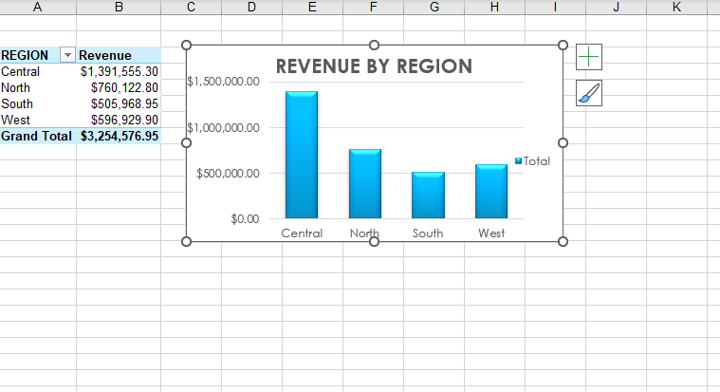

8.3 Salesperson Performance
Salesperson | Revenue
Parker | 760,122.80
Lee | 740,578.40
Watson | 650,976.90
Bishop | 596,929.90
Pullen | 505,968.95
Total | 3,254,576.95

Parker generated the highest revenue at 760,122.80, while Pullen recorded the lowest at 505,968.95.
See Appendix D — Salesperson Analysis for the supporting PivotTable and chart.
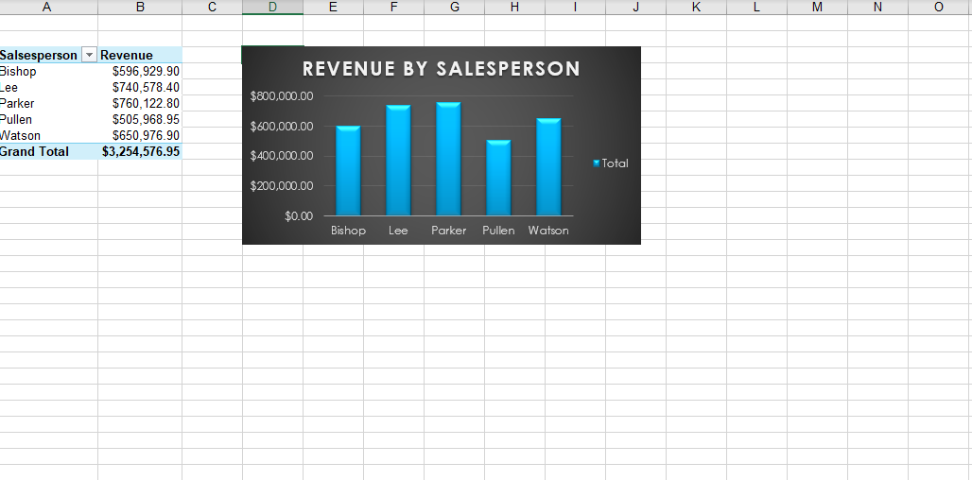

8.4 Product Type Performance
Product Type | Revenue
Ice Cream | 1,379,573.20
Tasty Treats | 840,113.65
Frozen Yogurt | 650,077.50
Popsicles | 384,812.60
Total | 3,254,576.95

Ice Cream generated the highest revenue at 1,379,573.20, accounting for approximately 42.4% of total revenue. Popsicles generated the lowest revenue at 384,812.60.
See Appendix E — Product Analysis for the supporting PivotTable and chart.
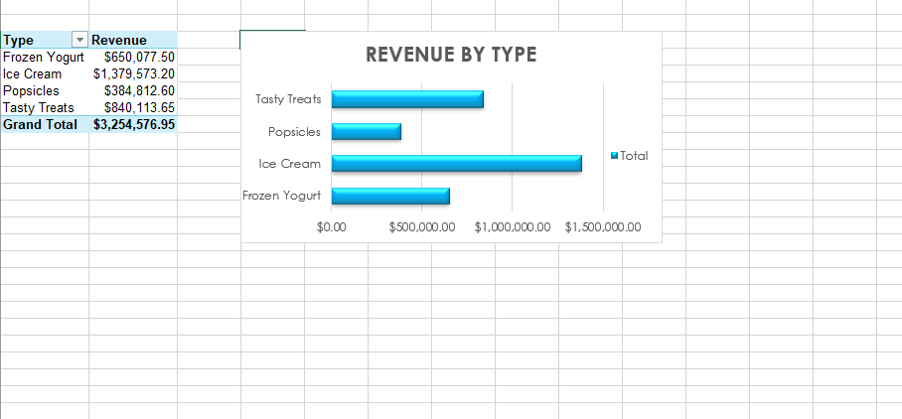

8.5 Yearly Sales Performance
Year | Revenue
2013 | 1,008,662.75
2014 | 1,138,686.00
2015 | 1,107,228.20
Total | 3,254,576.95

2014 generated the highest annual revenue at 1,138,686.00. Revenue increased from 2013 to 2014 by approximately 12.9% and declined by approximately 2.8% from 2014 to 2015.
See Appendix F — Yearly Analysis for the supporting PivotTable and chart.
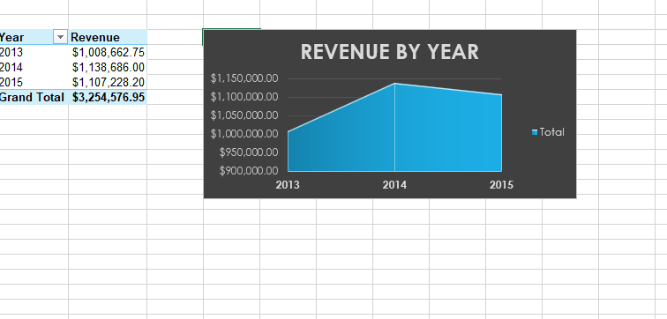

8.6 Monthly Sales Performance
Month | Revenue
April | 640,494.40
February | 521,344.75
January | 513,336.00
May | 428,512.40
March | 423,204.70
November | 383,151.70
December | 344,533.00

April recorded the highest revenue at 640,494.40, while December was the lowest among the recorded months at 344,533.00.
Important limitation: only seven months appear in the dataset. June through October have no records, so the monthly analysis should be interpreted as an analysis of the recorded months rather than a complete 12-month trend.
See Appendix G — Monthly Analysis for the supporting PivotTable and chart.
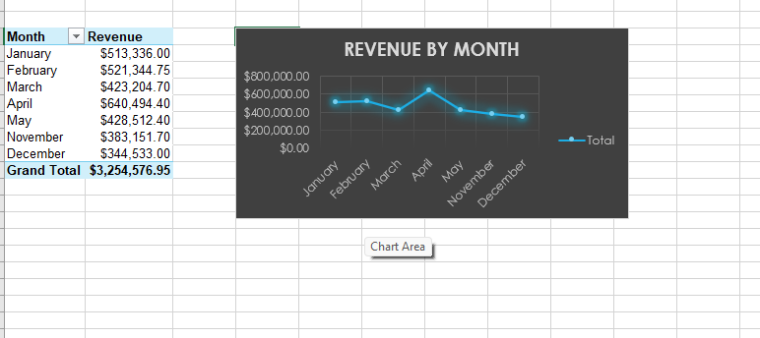

9. Dashboard Development
A dedicated dashboard was created in sales-performance-dashboard.xlsx. The dashboard consolidates the major findings into a single visual interface, combining key performance indicators with revenue analysis by month, year, region, salesperson, and product type.

9.1 Dashboard KPIs
KPI | Value
Total Sales | 3,254,576.95
Total Units | 2,322,594
Total Transactions | 444

9.2 Dashboard Visualizations
- REVENUE
- REVENUE BY YEAR
- REVENUE BY REGION
- REVENUE BY SALESPERSON
- REVENUE BY TYPE

9.3 Dashboard Purpose
The dashboard was designed to reduce the need to manually examine individual tables. It allows users to quickly identify total revenue, total units, transaction volume, regional performance, salesperson performance, product performance, annual performance, and monthly revenue patterns.

See Appendix H — Final Dashboard for the complete dashboard view.
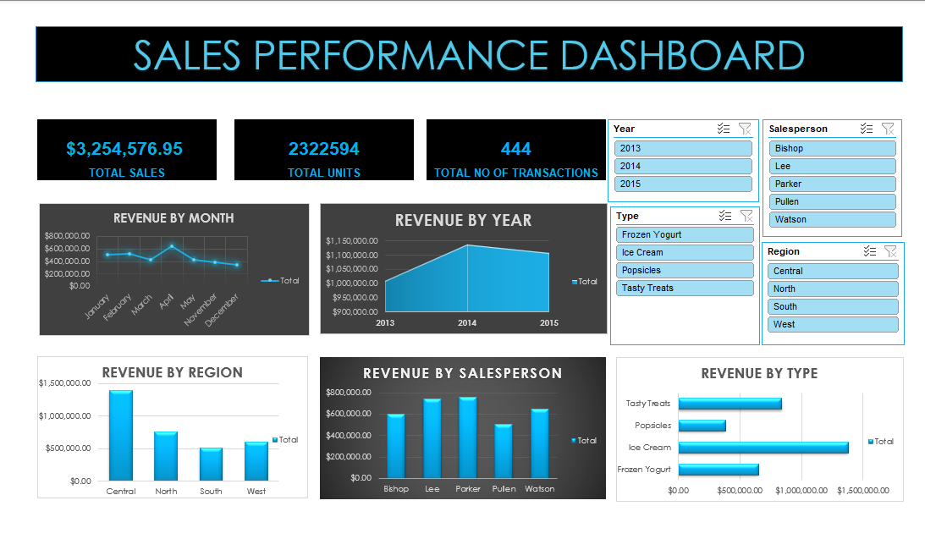

10. Key Insights
Overall Revenue — The dataset generated total sales of 3,254,576.95 across 444 transactions.
Central Region — The Central region generated the highest revenue, 1,391,555.30, representing approximately 42.8% of total revenue.
Salesperson Performance — Parker generated the highest revenue among the five salespeople, 760,122.80.
Product Performance — Ice Cream was the highest-revenue product type at 1,379,573.20, representing approximately 42.4% of total revenue.
Annual Performance — 2014 generated the highest annual revenue at 1,138,686.00.
Monthly Performance — April was the highest-performing recorded month at 640,494.40.

11. Recommendations
Examine the Central Region — Because Central generated the largest share of revenue, management could investigate the customer, product, salesperson, and transaction factors contributing to its performance.
Investigate Lower-Performing Regions — The South region recorded the lowest revenue. Further analysis could determine whether this relates to transaction volume, customer count, product mix, sales coverage, or market conditions.
Monitor Product Performance — Ice Cream generated substantially more revenue than the other product categories. Its demand, inventory, pricing, and regional performance should be monitored while lower-performing products are investigated.
Review Salesperson Performance — Differences in salesperson revenue could be examined alongside transaction count, units sold, average transaction value, customer count, and region to provide greater context.
Investigate Monthly Patterns — April generated the highest revenue among recorded months. Further information on promotions, seasonality, customer behavior, and product availability could help explain this pattern.

12. Conclusion
This project demonstrated how Microsoft Excel can be used to transform raw sales transaction data into meaningful business information. The analysis examined 444 transactions covering 2013–2015 and included product types, salespeople, regions, sales revenue, units sold, months, and order numbers.
The analysis produced several important findings. Total sales amounted to 3,254,576.95, while total units sold reached 2,322,594. The Central region generated the highest revenue, Parker was the highest-revenue salesperson, and Ice Cream was the highest-revenue product type. At the annual level, 2014 produced the highest revenue, while April was the highest-performing recorded month.
The completed dashboard provides a consolidated visual representation of these results and demonstrates how Excel can be used not only for calculations but also for business analysis and data visualization.

13. Limitations
Incomplete Monthly Coverage — The dataset contains records for only seven months: January, February, March, April, May, November, and December. June through October have no records.
Limited Business Variables — The dataset does not include customer information, marketing expenditure, cost of goods sold, profit, discounts, inventory, or competitor information.
Historical Dataset — The analysis is based on historical records from 2013–2015 and therefore describes the supplied historical data.
Limited Context for Performance Differences — The dataset shows differences between regions, salespeople, and products but does not establish the reasons behind those differences.

14. Tools and Skills Demonstrated

14.1 Tools Used
- Microsoft Excel
- Excel formulas
- PivotTables
- PivotCharts
- Excel Dashboard
- Data sorting and filtering
- Data validation/checking

14.2 Skills Demonstrated
- Data inspection
- Data quality checking
- Duplicate checking
- Missing-value checking
- Data-type verification
- Revenue analysis
- Comparative analysis
- Time-based analysis
- KPI calculation
- Data visualization
- Dashboard design
- Business insight generation
- Report writing

15. Appendix
The following appendices provide supporting screenshots from the Excel workbook, including the raw data, analysis outputs, and final dashboard.

Appendix A — Raw Dataset
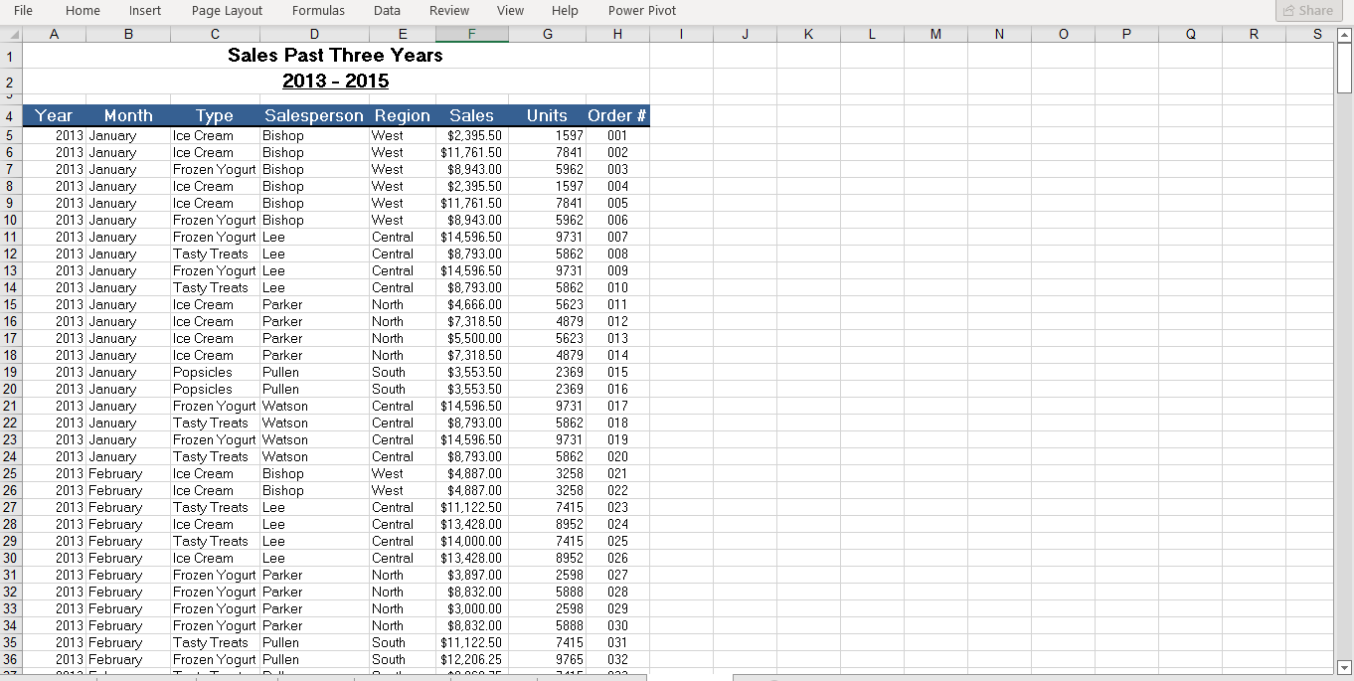
Appendix B — Prepared Sales Data
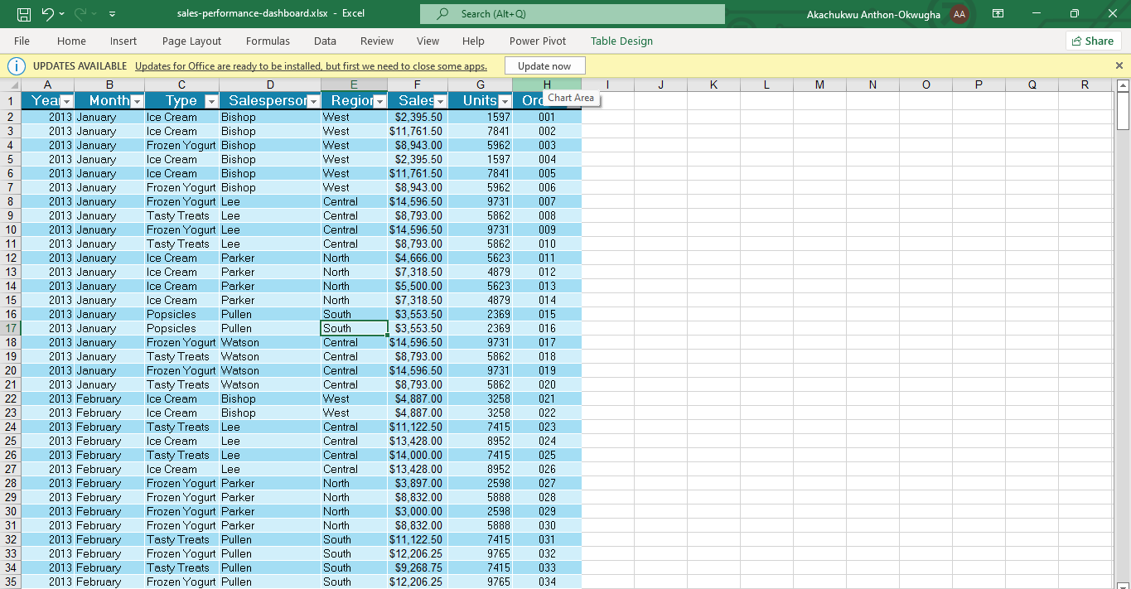

Appendix C — Regional Analysis
Appendix D — Salesperson Analysis
Appendix E — Product Analysis

Appendix F — Yearly Analysis

Appendix G — Monthly Analysis

Appendix H — Final Dashboard

