Guesty-Style PMS: UI/UX Design Spec (Clariva)

UI/UX Spec: Building a Guesty-Style PMS Platform
Purpose: Page-by-page feature breakdown + system-level UX logic for designing a property management platform replica

How to Think About This Product Before Designing Screens
Before laying out pages, it helps to fix the three user roles the UI has to serve, because every screen either belongs to one of these or bridges two of them:
- Operator/Host — the primary user, manages listings, guests, money
- Agents – similar UI as the primary owner
- Guest — the person staying, touches only booking + pre/post-stay screens (eg catalogues, upsell services)

Concurrent roles as investments comes in:
- Field Staff (cleaners, maintenance) — task-only, mobile-first, minimal UI
- Property Owner — read-only visibility into their own property’s performance

One Data Model, Many Lenses

1. Site/App Map (Top-Level Structure)
Auth (Login/Signup/Onboarding)
└── Main App Shell (persistent left nav + top bar)
├── Dashboard (home)
├── Inbox (Unified Messaging)
├── Calendar (Multi-Calendar)
├── Reservations
├── Listings
├── Guests and Agents (CRM)(high synchronization)
├── Tasks & Operations
├── Channels (Distribution)(later feature)
├── Pricing & Revenue(later feature)
├── Financials & Payments(later feature)
├── Owners(later feature)
├── Reports & Analytics
├── Automations & Integrations
├── Marketplace (later feature)
├── Settings
└── Guest-facing booking site + Guest App
└── (Separate) Mobile field-staff app(later feature)

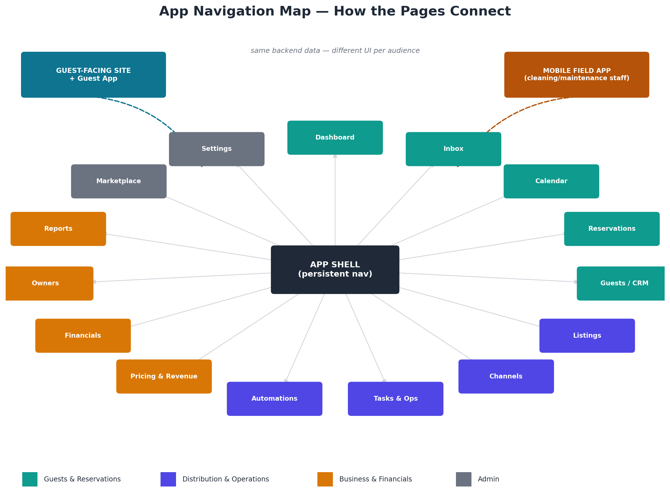
App Navigation Map

2. Page-by-Page Feature Breakdown

2.1 Login / Onboarding
Purpose: Get a new operator from signup to a working, connected account.
- Email/password + SSO login
- Multi-step onboarding wizard: business size → create dashboard and catalogue, listings upload or connect first channel (OAuth to Airbnb/Booking.com/Vrbo) → import existing listings → invite team members/agents
- Progress indicator (checklist style) that persists on the dashboard until complete
- Empty states everywhere else in the app should route back to whatever onboarding step is incomplete

2.2 Dashboard (Home)
Purpose: One-glance operational summary; the daily “what needs my attention” screen. Features:
- KPI strip: occupancy rate, upcoming check-ins/outs(synced from calendar), unread messages/reports count
- Task alerts (overdue cleanings, concierge tasks)
- Booking trend mini-chart
- Recent guest messages preview (deep-links to Inbox)
- Today’s arrivals/departures list
- Quick actions: add listing, create reservation, message guest
UX link: Every number here is a shortcut — clicking “unread messages” jumps to Inbox filtered to unread; clicking “overdue tasks” jumps to Tasks filtered to overdue. The dashboard should contain zero unique data — everything on it exists in full elsewhere; it’s a filtered/aggregated lens on the rest of the app.

2.3 Inbox (Unified Messaging)
Purpose: Central hub for all guest communication regardless of channel. Features:
- Threaded conversation list (like email), with channel-source icon (Airbnb, WhatsApp, SMS, direct)
- Filters: unread, needs response, by listing, by channel, by date
- Message composer with saved reply templates / snippets
- Guest context sidebar (pulls from CRM: past stays, notes, reservation details) shown alongside every thread
- Direct chat with guest
- AI-suggested reply / auto-translate
- Status tags (new inquiry, booked, checked-in, checked-out)
UX link: Clicking a guest’s name in any thread opens their CRM profile (2.6) in a side panel, not a new page — avoids breaking the conversation flow. Each thread is tied to a Reservation ID, so a “view reservation” button jumps to 2.5.

2.4 Calendar (Multi-Calendar)
Purpose: Visual, editable source of truth for availability and bookings across every listing/channel. Features:
- Grid view: rows = listings, columns = dates
- Color-coded bars per channel (Airbnb orange, Booking.com blue, direct green, etc.)
- Drag to block/unblock dates, drag to extend/shorten a stay
- Click a booking bar → opens Reservation detail panel
- Bulk-edit mode (select multiple dates across multiple listings to change price/availability at once)
- Toggle: Calendar view vs. List view vs. Pricing-overlay view (shows nightly rate under each date)
UX link: This is the most “central” screen in the app — it should be reachable in one click from Dashboard, Reservations, and Listings. Editing a rate here should reflect instantly (or near-instantly with a sync-status indicator) in Channels (2.8) since that’s what actually pushes to Airbnb/Booking.com.

2.5 Reservations
Purpose: Full record and lifecycle management of individual bookings. Features:
- List/table of all reservations: guest name, dates, listing, channel, status, amount
- Filters: upcoming, in-progress, past, cancelled
- Reservation detail page: guest info, payment status, special requests, assigned tasks (cleaning after checkout), messages thread embedded
- Manual reservation creation (for direct/offline bookings)
- Cancel/modify/refund actions
UX link: A reservation detail page is a hub screen — it should surface live links to: the guest’s CRM profile, the Inbox thread, the listing, the payment record, and any tasks generated from this booking (e.g., turnover cleaning). Designing this page well is what makes the “everything connected” feeling work.

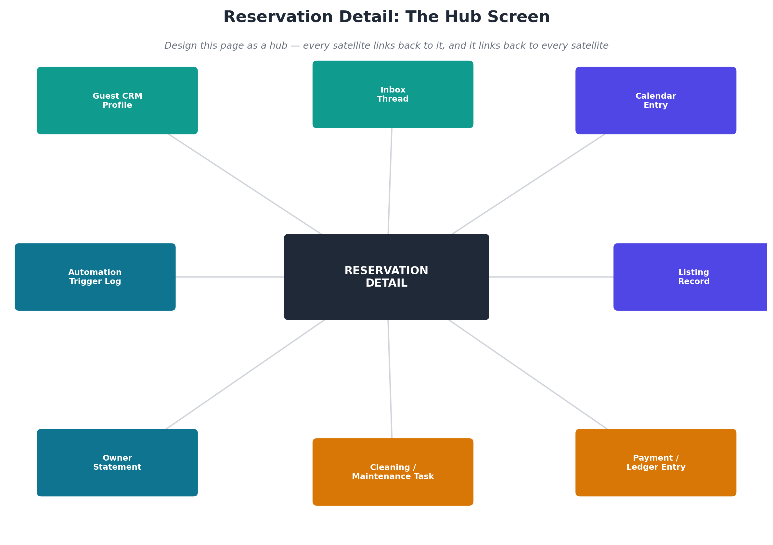
Reservation Detail Hub

2.6 Guests (CRM)
Purpose: Guest relationship history independent of any single booking. Features:
- Guest directory: search/filter by name, tags, stay count, lifetime value
- Guest profile: contact info, ID verification status, all past/upcoming reservations, notes, tags (VIP, problem guest, repeat guest), communication history
- Segmentation for marketing (e.g., “guests who stayed 2+ times” → export for a direct-booking email campaign)
UX link: Every guest name anywhere in the app (Inbox, Calendar, Reservations) should be a clickable entry point into this profile — this is the “identity layer” that ties conversations and bookings together into a person.

2.7 Listings
Purpose: Manage the actual property inventory — content, photos, amenities, house rules. Features:
- Listing directory (grid of property cards with thumbnail, name, status, sync health)
- Listing editor: photos, description, amenities, house rules, pricing base rules, calendar rules (min stay, check-in/out times)
- Per-channel content override (e.g., different title on Airbnb vs. Booking.com)
- Multi-unit configuration (if one property = multiple bookable units/rooms)
- Sync status per channel (green/red indicator + last synced timestamp)
UX link: This page is the “source content” that Channels (2.8) distributes and Calendar (2.4) schedules. Any edit here should show a “publishing to channels…” status so the operator trusts that changes actually propagate — this trust signal is core to the whole product’s value prop.

2.8 Channels (Distribution / Channel Manager)
Purpose: Manage OTA connections and see distribution health. Features:
- Connected channel list (Airbnb, Booking.com, Vrbo, Google Vacation Rentals, etc.) with connect/disconnect
- Per-channel sync status and error log (e.g., “rate mismatch on Listing X”)
- Channel-specific settings (commission %, cancellation policy mapping)
- New channel marketplace/discovery
UX link: This is largely a “plumbing” page — most users should rarely need it after initial setup. Its main UX job is surfacing sync errors loudly (via a notification badge in the main nav) so problems don’t go unnoticed, since a broken sync directly risks double-bookings.

2.9 Tasks & Operations
Purpose: Coordinate cleaning, maintenance, and inspections. Features:
- Task board (kanban: To Do / In Progress / Done) or calendar view
- Auto-generated tasks (e.g., cleaning task auto-created on every checkout)
- Manual task creation, assignment to staff, due date/time
- Task templates (standard cleaning checklist)
- Staff-facing simplified mobile view (this is where the separate mobile app comes in)
UX link: Tasks are generated from Reservations (checkout triggers cleaning) and consumed by the mobile field app, which should be a stripped-down version of this same data — just “my tasks today,” with photo upload for completion proof, nothing else.

2.10 Pricing & Revenue
Purpose: Set and optimize nightly rates. Features:
- Base price + rules editor (weekday/weekend, seasonal, min/max)
- Dynamic pricing toggle (AI-suggested rates based on demand/competitor data) with override capability
- Rate calendar (visual, similar to 2.4 but pricing-focused)
- Performance-vs-price chart (did raising price reduce bookings?)
UX link: This should feel like an extension of the Calendar (2.4), not a separate mental model — ideally the same calendar grid with a toggle between “availability view” and “pricing view.”

2.11 Financials & Payments(LF)
Purpose: Money in, money out. Features:
- Payment ledger: charges, payouts, refunds, chargebacks, per reservation
- Payment method/processor settings
- Invoicing (for direct bookings)
- Trust accounting view (if managing owner funds — separates operator revenue from owner-held funds)
UX link: Every line item here should trace back to a Reservation ID — this page is essentially “Reservations, filtered to the money view.” Consistent ID-linking across pages is what prevents the product from feeling like disconnected modules.

2.12 Owners(LF)
Purpose: Owner-facing transparency (for PMCs managing properties on behalf of owners). Features:
- Owner directory, each linked to their properties
- Owner Portal (a separate, restricted view of Dashboard/Financials/Reports scoped to only their property) — statements, payout history, occupancy performance
- Automated statement generation/export
UX link: This is the clearest example of “same data, different role” — the Owner Portal should literally reuse the Reports and Financials components, just pre-filtered and permission-locked to one owner’s properties, with editing disabled.

2.13 Reports & Analytics(LF)
Purpose: Aggregate performance insight across the whole portfolio. Features:
- Revenue, occupancy, ADR (average daily rate), RevPAR dashboards
- Channel performance comparison
- Custom report builder / export (CSV, PDF)
- Date-range and property/portfolio filters
UX link: This is the “zoomed out” version of the Dashboard (2.2) — Dashboard = today’s snapshot, Reports = historical/comparative deep dive. Keep the visual language (chart types, colors) consistent between them so users recognize the metrics.

2.14 Automations
Purpose: Let operators define rules instead of doing things manually. Features:
- Rule builder: trigger → condition → action (e.g., “On booking confirmed → send welcome message 3 hours later”)
- Template library (common automations: check-in instructions, review requests, cleaning triggers)
- Automation activity log (what fired, when, on which reservation)
UX link: This page is the “control panel” behind behavior that shows up elsewhere — a message sent by automation should still appear in the Inbox thread (2.3) tagged as “automated,” and a task created by automation should appear in Tasks (2.9) tagged the same way. Never let automated actions be invisible outside this page — that erodes trust.

2.15 Marketplace(LF) & Integrations
Purpose: Extend the platform with third-party tools. Features:
- Browsable directory of integrations (smart locks, pricing tools, accounting software)
- Connect/configure flow per integration
- API key management / developer docs link (for the Open API)

2.16 Settings
Purpose: Account, team, and billing administration. Features:
- Team members & role-based permissions (who can see Financials vs. just Tasks)
- Notification preferences
- Company profile / branding (for white-labeled guest-facing surfaces)

2.17 Guest-Facing Booking Website/Page
Purpose: Direct booking channel (separate from the operator app). Features:
- Property search/browse
- Listing detail page (photos, amenities, reviews, calendar availability)
- Booking flow: dates → guest info → payment
- Guest account/login for managing their own bookings
UX link: Bookings made here create a Reservation (2.5) tagged “Direct” channel, flow into the same Calendar (2.4) as any OTA booking, and trigger the same Automations (2.14) — this page should feel like just another “channel” from the system’s point of view, even though it’s operator-owned.

2.18 Guest App (Post-Booking Page)
Purpose: Serve the guest during their stay. Features:
- Check-in instructions, digital key/access code (ties to LocksManager)
- Local recommendations, upsells (early check-in, late checkout)
- In-stay messaging (feeds into the same Inbox thread as 2.3, just from the guest’s side)
- Digital guidebook / house manual

3. System-Level UX Principles That Tie It All Together
- One data model, many lenses. A reservation is a reservation everywhere — in the Calendar it’s a bar, in Financials it’s a ledger line, in the agents, its an updated information, in the Guest App it’s a checklist. Design your component library so the “reservation card” is one reusable component with display variants, not five different things built separately.
- Every entity is a hyperlink. Guest names, listing names, reservation IDs — anywhere they appear, they should be clickable and land on that entity’s detail page. This is what makes a complex system feel navigable instead of like a filing cabinet.
- Status and sync trust signals everywhere. Because this product’s core value is “everything stays in sync automatically,” the UI needs constant, low-friction confirmation that sync is happening (small “synced 2 min ago” labels, colored dots) — silence reads as failure in this category.
- Progressive disclosure by portfolio size. A 1-listing host and a 500-listing enterprise shouldn’t see the same density of UI. Consider designing the nav/dashboard to adapt — collapse Enterprise Hub, multi-brand switchers, and advanced automation for small accounts; surface them only as the account grows (mirrors Guesty’s Lite/Pro/Enterprise tiering at the product level, not just the pricing level).
- Automation is the connective tissue, not a side feature. Almost every page description above references automations firing into it. Design the rule-builder early and think of every other page as both a possible trigger source and a possible action target for automations.
- Three distinct visual “modes” for Four roles. The operator app (dense, data-heavy), the agent app( synced with the operators, data- heavy), the field-staff mobile app (sparse, task-only, big touch targets), and the guest-facing app/site (warm, marketing-style, photo-forward) should intentionally look and feel different even though they share a backend — don’t force one design system to serve all three without adaptation.

4. Suggested Build Order (If Prototyping)
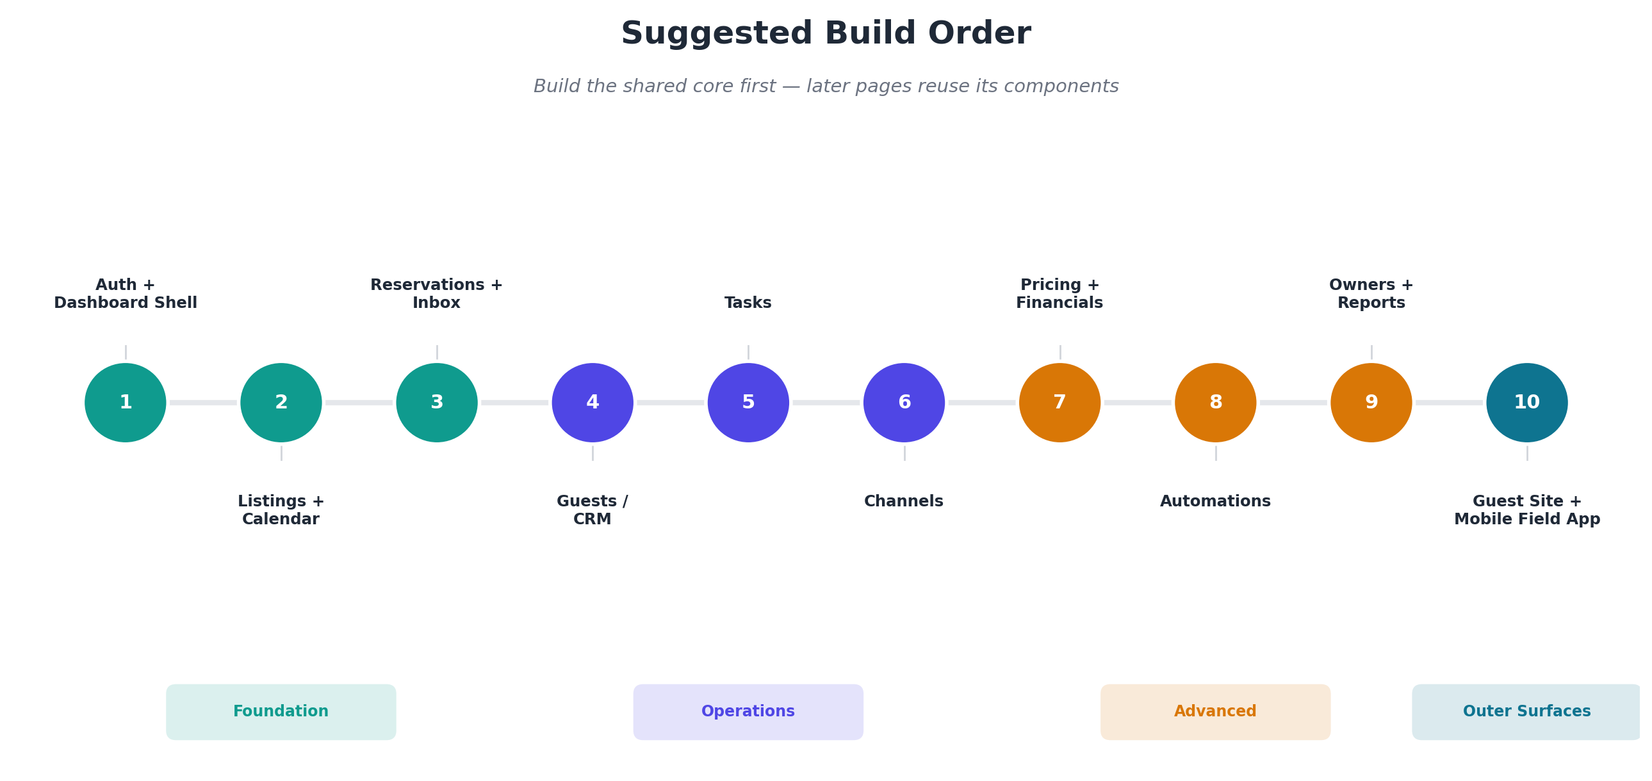
Suggested Build Order
- Auth + Dashboard shell (establishes nav and role structure)
- Listings + Calendar (core inventory and availability — nothing else works without this)
- Reservations + Inbox (the daily-use loop)
- Guests/CRM (ties messaging and bookings to identity)
- Tasks (operational layer)
- Channels (distribution — can be mocked/stubbed early since real OTA integration is complex)
- Pricing/Revenue + Financials
- Automations (once enough trigger points exist to make it meaningful)
- Owners + Reports (reuse components from steps 1–8)
- Guest-facing site/app + mobile field app (separate surfaces, build last since they consume the same backend)

