**Back reflation of the laser light from trapping objective :**

In this experiments, the image of the back reflected Laser light from trapping objective is saved for different collar adjustments. The objective is then moved over a range around the smallest Laser spot size.

The goal is to find the smallest pattern made by back-reflected laser light. This means at that specific collar, the trap is tightest along optical axis (direction of propagation)

The collars correct for the thickness of the coverslip to avoid spherical aberration.

However, at other collars than the thickness of the coverslip, there might be spherical aberration present, we think the resulting tighter focus will decrease the z shift during the puling experiment.

**Analysis:**

The images of the back-reflected light are saved as tiff files for each collar while the focus of the trapping objective changes. I will use Matlab to analyze the size of the images.

**Challenges:**

Around objective positions close to the smallest spot size there are also image of two parallel lines in the middle of the image that should be taken into account.



These lines result in overestimation of the size of the pattern in y direction. To address this issue, the bottom part of the image (rows between 400 and 480 are averages for intensities for all columns and the result is subtracted from the whole image) The resulting image is shown bellow:

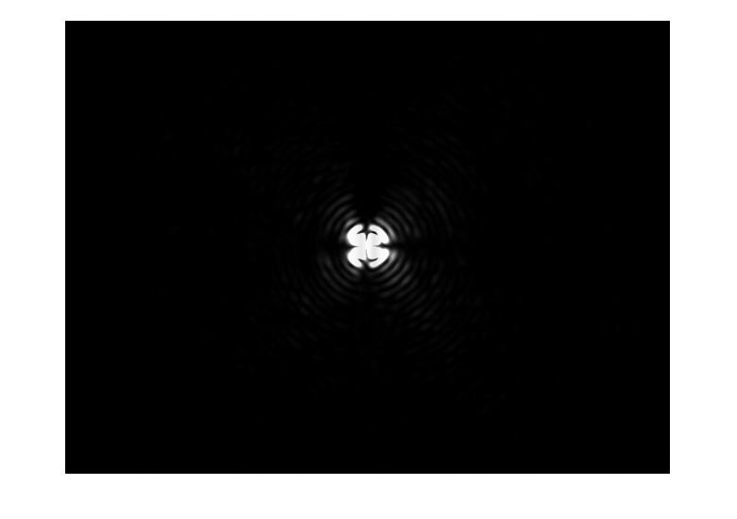

**Method:**

The image is read in Matlab (the intensity for each pixel) and the intensities are summed along each column of pixels (same x positions) and also along each row (same y positions) and they are plotted vs. x or y positions.

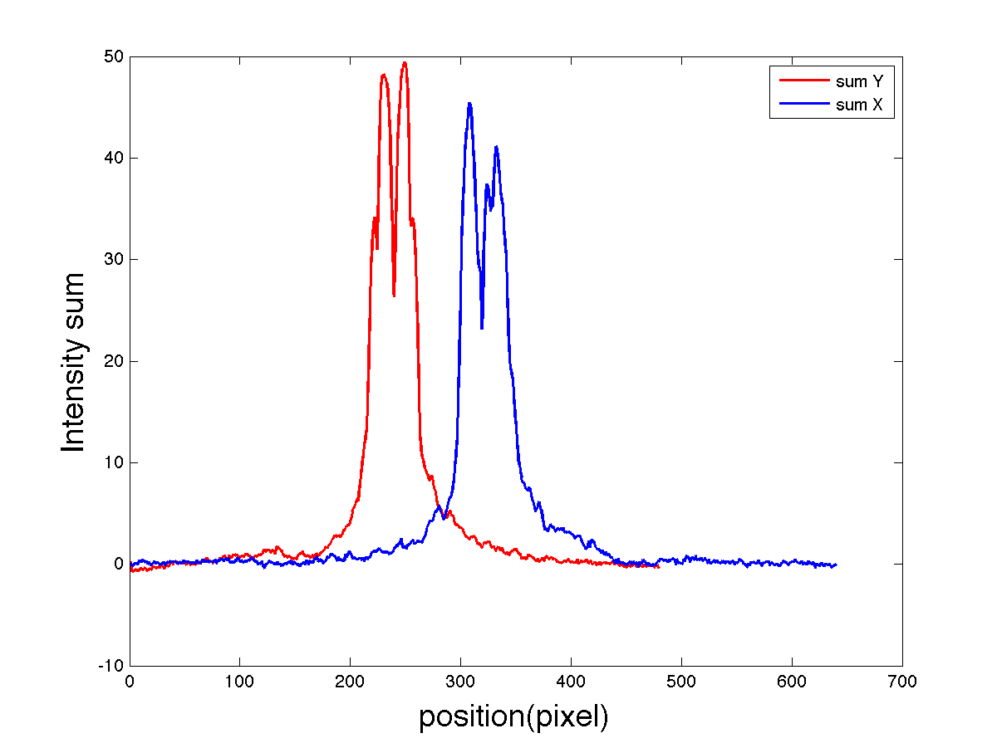

Plot above indicates the size of the Laser spot. For example, the plot above is for collar 0.14 and the objective position reading is at 25volts.

Now compare three images: objective far, middle and close to the coverslip surface that gives the resulting patterns.

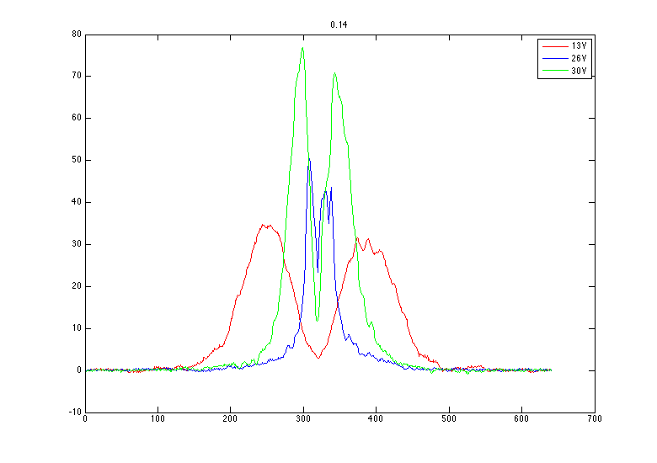

So, you can see that for blue curve the spot size is the smallest. See the corresponding images below:

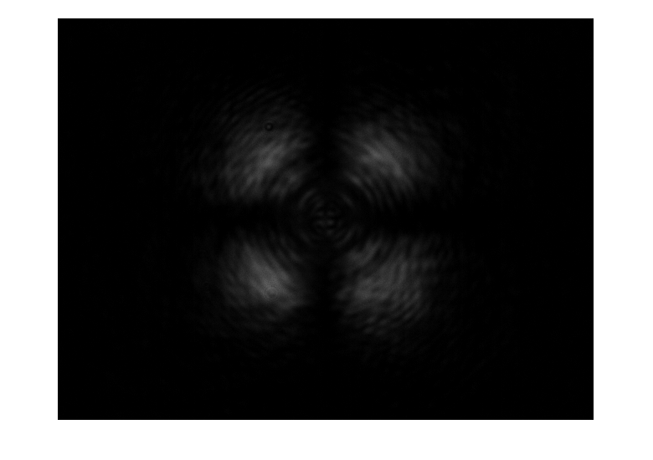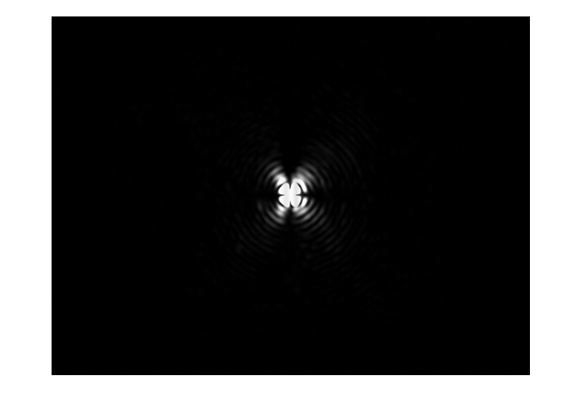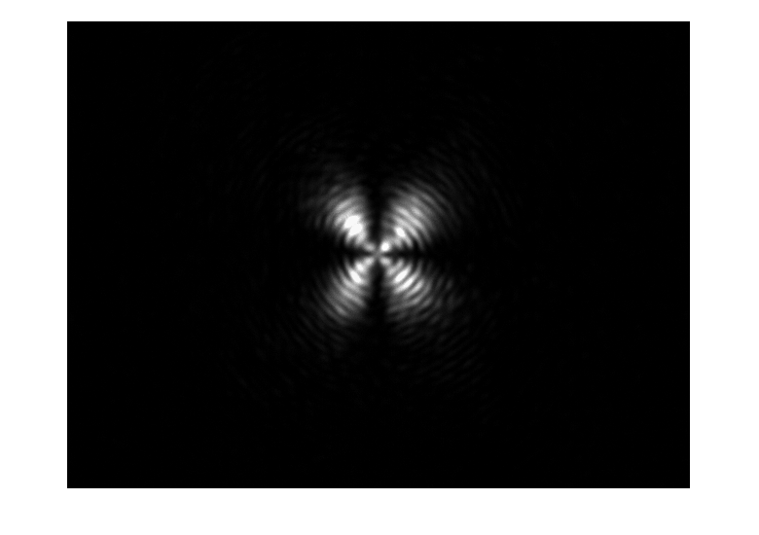

13V

26V

30V