

**Title** Survive Alone

**Tag line** “Home Alone with guns ”

**Your name** The Heavenly Pandas

**Genre** Survival/ Rogue Like

**Platform** PC

**Market** Teens/ horror fans/ survival fans

**Setting** Post apocalyptic suburb/ cityscape

*Logo or Box Art*

**Plays like** Dead Frontier meets Rogue-like

*Popular Game A Popular Game B or twist*

**Mechanics**

1. Medium paced Combat 3. RNG loot

2. Top down rogue like levels 4. Skill based progression

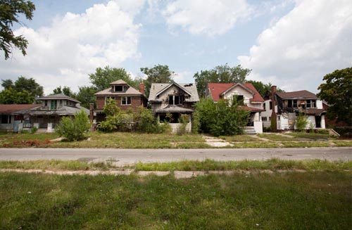

1.

**Reference** **Art**

Post apocalyptic suburb aesthetic

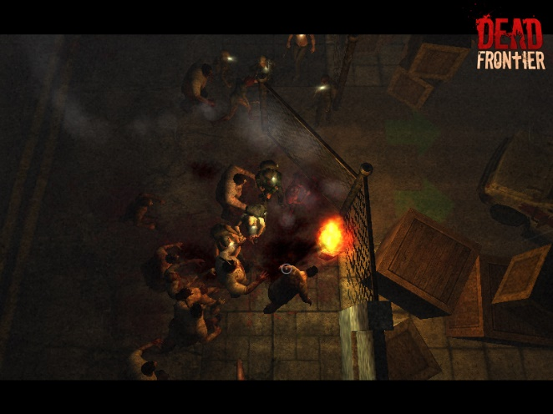

**2**.

**Reference** **Art**

Top down zombie combat from Dead Frontier

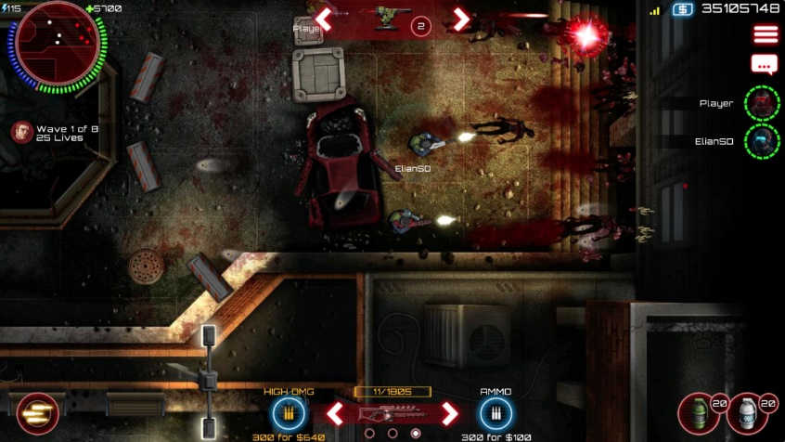

SAS Zombie Assault 4 for more top down shooter style

3.

**Reference** **Art**

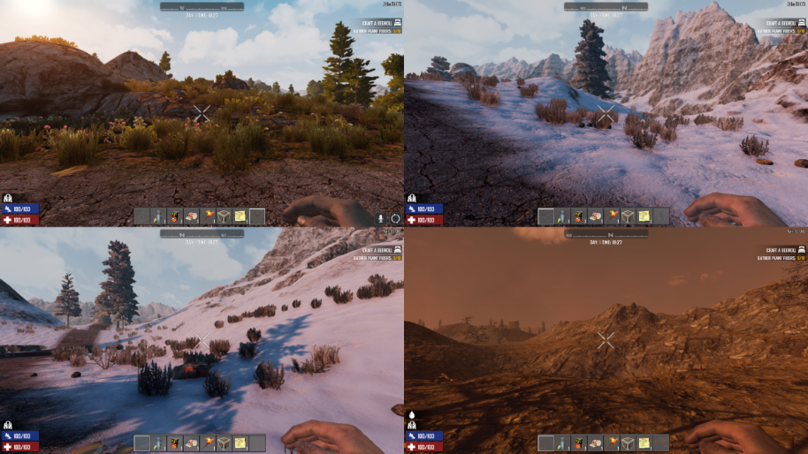

4.

7 Days to Die barren environment

**Reference** **Art**

**Related Games**

1. Dead Frontier Neil Yates, Creaky Corpse LTD Browser/PC 2008

*Title Publisher or Developer Genre/Platform Year*

Free to play, originally a browser based survival zombie game. The players fight zombie hordes together and travel to safe points spread throughout levels. Players can use a variety of weapons and armour to survive. There are classes that affect skills and weapons. In safe areas players can upgrade and do business.

2. Killing Floor Tripwire Interactive PC 2005

*Title Publisher or Developer Genre/Platform Year*

Cooperative first person shooter of up to 6 players in which everyone spawns into a closed map and has to survive waves of zombie attacks ultimately ending in a boss battle with a harder and larger zombie. Players have a choice of different classes which determines the type of weapons that that player can use. Zombie kills reward cash, or “dosh” that the player uses to buy upgrades in between waves.

3. 7 Days to Die The Fun Pimps PC 2013

*Title Publisher or Developer Genre/Platform Year*

The player spawns into a randomly generated world with multiple biomes in which they have to survive for as long as possible. There are survival mechanics like thirst and hunger, and the players are vulnerable to injury and illness. There is simple building for shelter. There is a tool creation and degradation system. There is an ex machina type event after 7 days with a massive zombie attack.

4. Rogue A.I. Design/ Epyx Old systems 1980

*Title Publisher or Developer Genre/Platform Year*

The player explores an unmapped dungeon that is generated for each playthrough. The goal is to fight towards the bottom level then come back upwards with the treasure. Enemies become progressively harder to defeat. Inspired most other randomly generated games to come after.

Mechanical Analysis

Character will spawn into a closed area with enemy spawns around the map. The view will be top-down with a focus on medium paced combat. Aesthetic wise, the setting will look like a slightly post apocalyptic suburban neighborhood, or a cityscape depending on the level chosen. There will be some reaction based inputs required, mostly with enemies getting close and attacking. Defeating enemies and looting objects in the world will drop loot that can be used to upgrade your attacks, armour or can be used to heal the character. In between levels, which will be after the wave of enemies is killed, the player will be able to upgrade themselves for the next wave.