Question 1

K=50

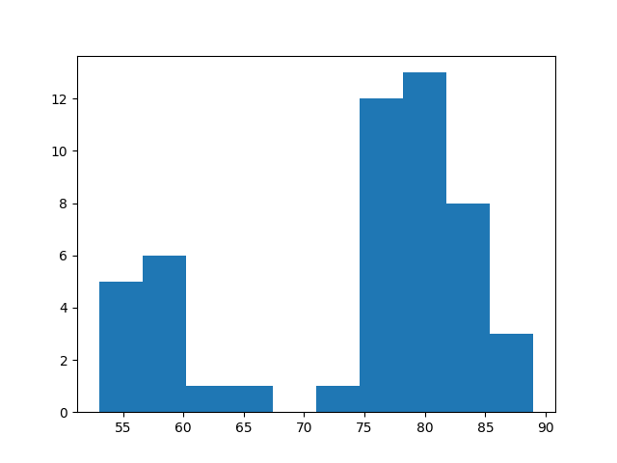

k = 200

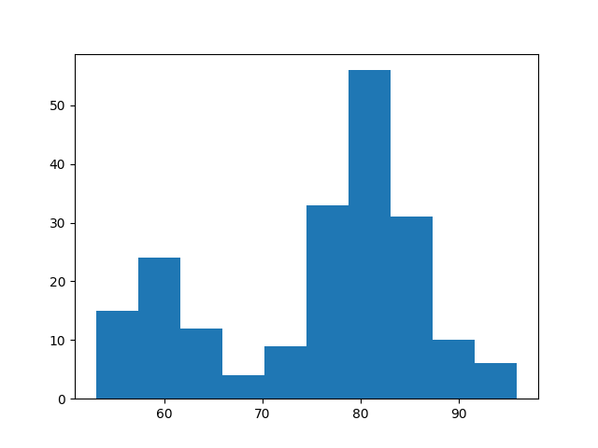

K=1000

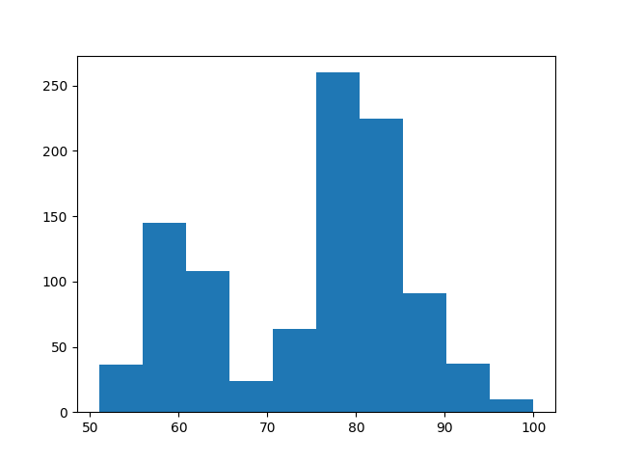

K = 5000

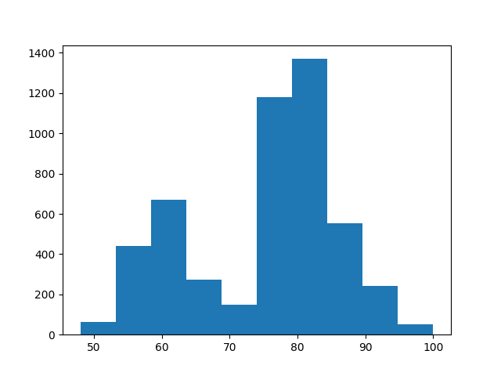

K = 10000

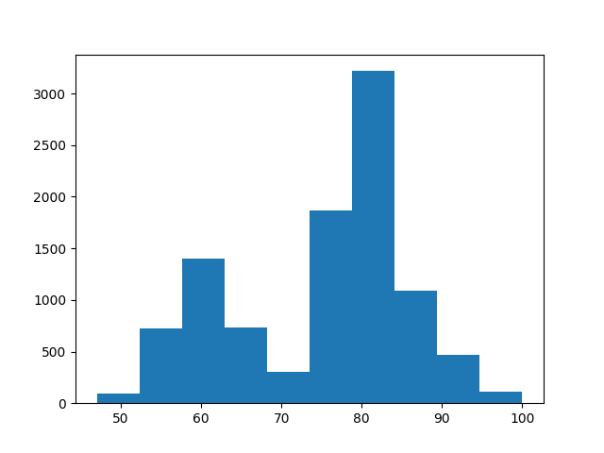

As the number of samples increases the number of empty bins decreases and there are more values in each bin predictably. However, the range where most of the data is found remains the same which is around 80.

Question 5:

1000 points

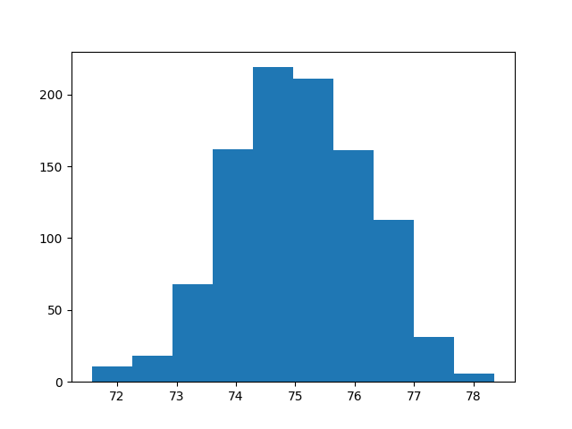

The mean would be something around 75 since most of the data is concentrated there. The variance would simply be mx-min which is 78-72=6

10000 points

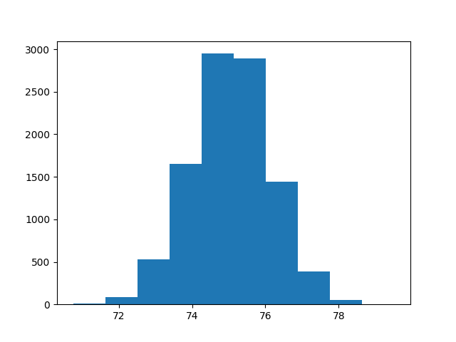

The mean in this again would be around 75 which is pretty close to the real mean of 75.06

