Data set 1

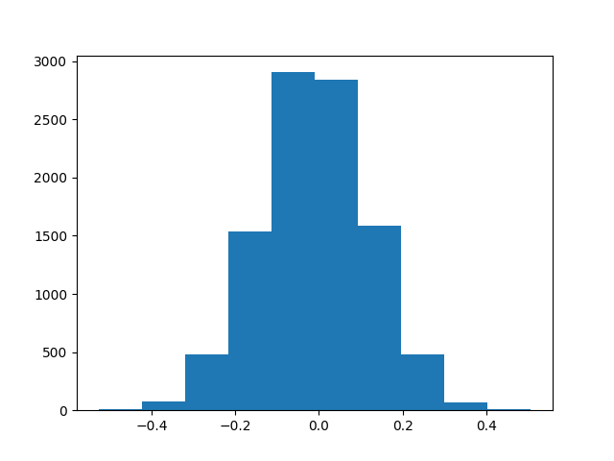

The mean for this is very close to the actual mean of the dataset. The mean would be around 0 and the real mean is -0.01.

Data set 2

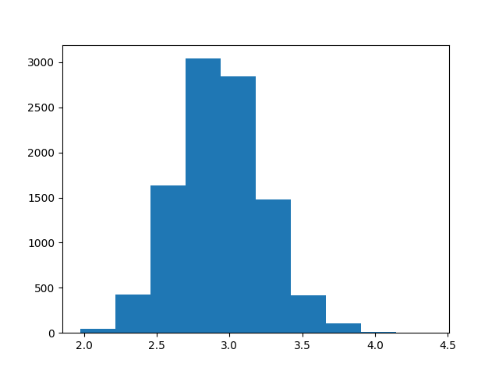

The mean for this is very close to the actual mean of the dataset. The mean would be around 2.7 and the real mean is 2.93.

Data set 3

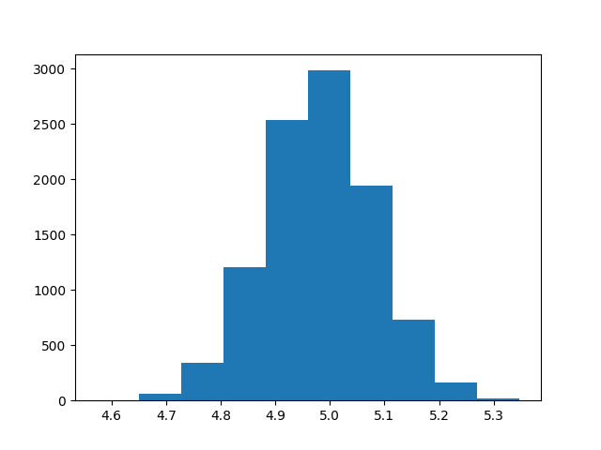

The mean for this is very close to the actual mean of the dataset. The mean would be around 5 and the real mean is 4.97.

