Question 1:

1 a) yT = -5.03742984308e-16

yF = -2.36847578587e-16

b) 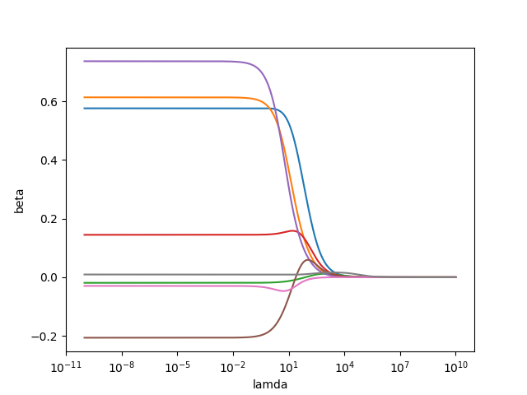

c)

