将程序修改一下，变为能输出运行时间的代码。新的代码如下，此时是两个子进程：删去输出的的printf函数。
#include <stdlib.h>
#include <stdio.h>
#include <sys/time.h>
#include <sys/types.h>
#include <unistd.h>
#include <sys/wait.h>

#define M 4096
int version = 1;
int matrixOriginal[M][M];
int matrixDes[M][M];

void produce(int row, int column)
{
int i;
for (i = 0; i < M; i++)
matrixDes[row][column] += matrixOriginal[row][i] * matrixOriginal[i][column];
}

int main()
{
int i, j;

// 初始化矩阵
for (i = 0; i < M; i++)
for (j = 0; j < M; j++)
{
matrixOriginal[i][j] = 1;
matrixDes[i][j] = 0;
}

struct timeval start, end;
double time_use;

// 记录开始时间
gettimeofday(&start, NULL);

int child;
int from, to;
child = fork();

if (child > 0) // 父进程计算后 M/2 行
{
from = M / 2;
to = M;
for (i = from; i < to; i++)
for (j = 0; j < M; j++)
produce(i, j);

wait(NULL); // 等待子进程完成前半部分
}
else if (child == 0) // 子进程计算前 M/2 行
{
from = 0;
to = M / 2;
for (i = from; i < to; i++)
for (j = 0; j < M; j++)
produce(i, j);
exit(0); // 子进程完成退出
}

// 父进程等待所有计算完成后输出结果
if (child > 0)
{
// 记录结束时间
gettimeofday(&end, NULL);
time_use = (end.tv_sec - start.tv_sec) * 1000000 + (end.tv_usec - start.tv_usec);

printf("Matrix multiplication finished.\n");
printf("Execution time: %.3f seconds\n", time_use / 1000000.0);

}

return 0;
}

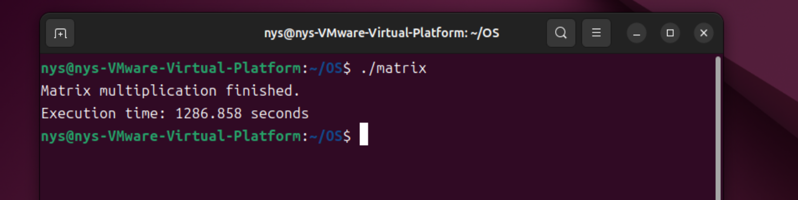
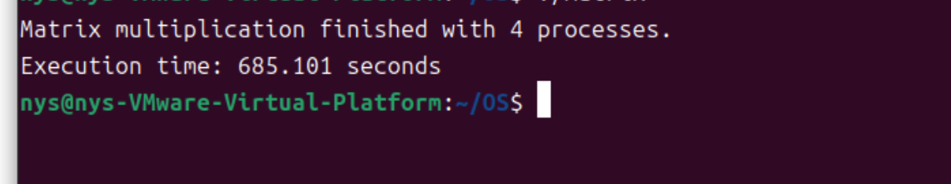
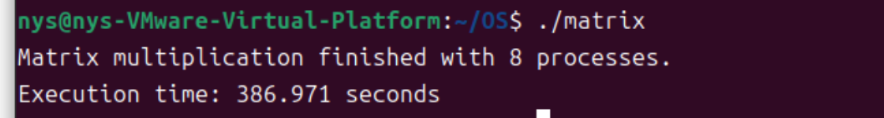
使用思考题1的转置之后的程序的运行速度大大提升：代码如下：
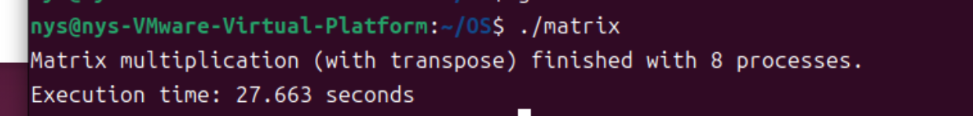
#include <stdlib.h>
#include <stdio.h>
#include <sys/time.h>
#include <sys/types.h>
#include <unistd.h>
#include <sys/wait.h>
#include <sys/mman.h>

#define M 4096
#define NPROC 8 // 使用 8 个进程
int version = 1;

/* 用共享内存承载矩阵，索引方式与原来一致 */
int (*matrixOriginal)[M];
int (*matrixDes)[M];
int (*matrixTrans)[M]; // 新增：转置矩阵（共享内存）

/* 修改点：乘法改为与转置矩阵做点乘 */
void produce(int row, int column)
{
int i;
int sum = 0;
for (i = 0; i < M; i++)
sum += matrixOriginal[row][i] * matrixTrans[column][i]; // 使用转置后的行
matrixDes[row][column] = sum;
}

int main()
{
int i, j;

/* 共享内存分配 */
size_t bytes = (size_t)M * (size_t)M * sizeof(int);
matrixOriginal = mmap(NULL, bytes, PROT_READ | PROT_WRITE,
MAP_SHARED | MAP_ANONYMOUS, -1, 0);
matrixDes = mmap(NULL, bytes, PROT_READ | PROT_WRITE,
MAP_SHARED | MAP_ANONYMOUS, -1, 0);
matrixTrans = mmap(NULL, bytes, PROT_READ | PROT_WRITE,
MAP_SHARED | MAP_ANONYMOUS, -1, 0);
if (matrixOriginal == MAP_FAILED || matrixDes == MAP_FAILED || matrixTrans == MAP_FAILED) {
perror("mmap");
return 1;
}

// 初始化矩阵
for (i = 0; i < M; i++)
for (j = 0; j < M; j++) {
matrixOriginal[i][j] = 1;
matrixDes[i][j] = 0;
matrixTrans[i][j] = 0; // 先清零，稍后写入转置
}

struct timeval start, end;
double time_use;

// 记录开始时间
gettimeofday(&start, NULL);

/* 先进行整体转置：matrixTrans[j][i] = matrixOriginal[i][j] */
for (i = 0; i < M; i++)
for (j = 0; j < M; j++)
matrixTrans[j][i] = matrixOriginal[i][j];

/* —— 8 个子进程 —— */
pid_t pids[NPROC];
for (int k = 0; k < NPROC; k++) {
pid_t pid = fork();
if (pid < 0) {
perror("fork");
return 1;
}
if (pid == 0) { // 第 k 个子进程
int from = (M * k) / NPROC; // 整除安全切分
int to = (M * (k + 1)) / NPROC; // 最后一个进程自然到 M
for (i = from; i < to; i++)
for (j = 0; j < M; j++)
produce(i, j);
_exit(0);
} else {
pids[k] = pid;
}
}

// 父进程等待所有子进程
for (int k = 0; k < NPROC; k++)
waitpid(pids[k], NULL, 0);

// 记录结束时间
gettimeofday(&end, NULL);
time_use = (end.tv_sec - start.tv_sec) * 1000000.0 + (end.tv_usec - start.tv_usec);

printf("Matrix multiplication (with transpose) finished with %d processes.\n", NPROC);
printf("Execution time: %.3f seconds\n", time_use / 1000000.0);

// 释放共享内存
munmap(matrixOriginal, bytes);
munmap(matrixDes, bytes);
munmap(matrixTrans, bytes);

return 0;
}

