**Rules for journal papers**

The document provides updated formatting rules for the electronic journal “Physical-Chemical Kinetics in Gas Dynamics”, which are valid from May, 1, 2015.

**The main changes concern the design of the first page.**

***The first page should contain:***

* Title of the article (entered in Sentence case)
* a list of authors,
* affiliation address,
* e-mail address
* annotations
* The main results of the paper - it can be a drawing, graphics, formulas, tables.

***See at the page below how the first article page should look like.***

The text of *Headers and Footers* of a paper is filled in by the Editorial Board, when the article is ready for publication.

The further chapters describe recommended formats and styles, which authors should follow, while preparing their articles for publication in the electronic journal.

Manual for Articles Formatting in Electronic Journal “Physical-Chemical Kinetics   
in Gas Dynamics”

First Author (First\_Name (or Initial) Last\_Name)1, Second Author2

*1* *Affiliation, City, Province, Postal Code, Country*

*2 Affiliation, City, Province, Postal Code, Country*

[email@server.name](mailto:email@server.name)

Abstract

This document gives the formatting instructions for the Electronic Journal “Physical-Chemical Kinetics in Gas Dynamics”. It is recommended that this document be used as a template in the preparation of your manuscript. Use this document as a template if you are using Microsoft Word 2007 or Word 97-2003. Otherwise, use this document as a set of instructions.

On the first page under an abstract text as illustration it is possible to place a picture, or table, or formula from the article, most brightly expressing main results of the paper. For example:

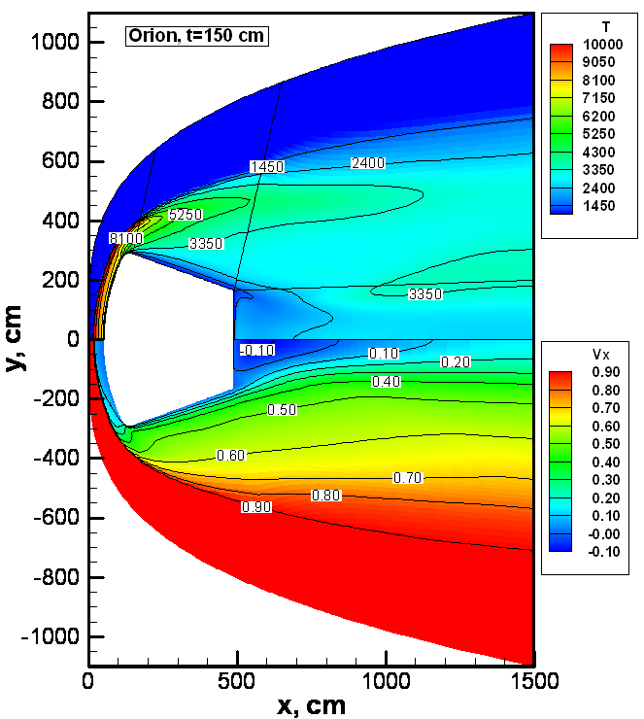 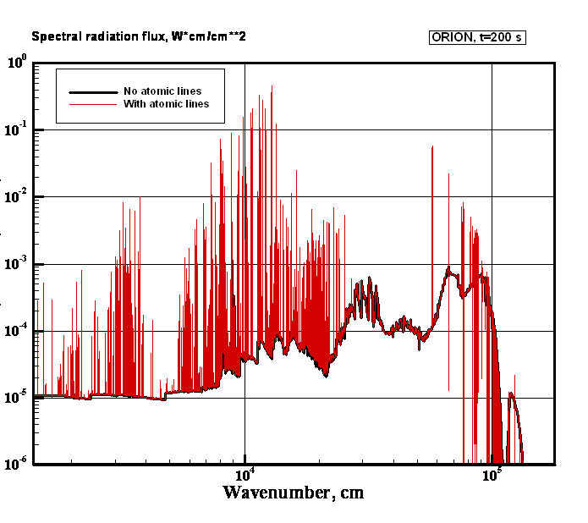

Translational temperature and longitudinal velocity for spacecraft Orion at *t*=150 с (from the left). Spectral radiation heat flux in the stagnation point with and without atomic lines for spacecraft Orion at *t*=150 с (from the right)

|  |  |  |  |  |  |  |  |  |  |  |  |  |  |  |  |  |  |  |  |  |  |
| --- | --- | --- | --- | --- | --- | --- | --- | --- | --- | --- | --- | --- | --- | --- | --- | --- | --- | --- | --- | --- | --- |
| Trajectory points for PATFINDER   |  |  |  |  |  | | --- | --- | --- | --- | --- | | Time, s | , g/cm3 | , erg/cm3 | , km/s | , K | | 40 |  | 1.660 | 7.496 | 122 | | 42 |  | 2.462 | 7.490 | 129 | | 52 |  | 15.56 | 7.364 | 143 | |  |

Manual for Articles Formatting in Electronic Journal “Physical-Chemical Kinetics   
in Gas Dynamics”

First Author (First\_Name (or Initial) Last\_Name)1, Second Author2

*1* *Affiliation, City, Province, Postal Code, Country*

*2 Affiliation, City, Province, Postal Code, Country*

[email@server.name](mailto:email@server.name)

Abstract

This document gives the formatting instructions for papers in the Electronic Journal “Physical-Chemical Kinetics in Gas Dynamics”. The document includes a set of styles and illustrates their implementation.

# 1. Format, style and content

1.1. Page size

In preparing an article, you should expect to print it on A4 sheet of paper, (297 mm×210 mm) and comply with the rules described below. We recommend this document as a template for MS Word users.

**1.2. First page**

**Title of the article:** Sentence case letters Times New Roman, Bold font size 22 pt, centered. Indent before and after the title - 12 pt, between-line spacing - single.

Author’s Name: (Times New Roman, Bold 14 pt font size, line spacing - spacing after 12 pt, centered); affiliated organization, address, e-mail (Times New Roman, Italic, 12 pt font, centered).

In the case of several authors, their names are written in a row, separated by commas and aligned to the center (line spacing - single). If the authors represent different organizations, after the author's name affixed superscript with the line number, in which the name of the organization will be represented.

1.3.Annotation

Abstract is presented in Russian and English. Before the heading “Annotation” (Times New Roman, Bold font size 12 pt) put interval 18 pt, after - 6 pt. Annotation text font - Times New Roman size 11 points.

Abstract text should have indention of 1 sm from the edge of the main text (as in the Abstract text above) .

Complex mathematical expressions are not recommended for use in annotation.

# 2. Format, style and content

The text should be formatted in one column, page size A4 margins of 20 mm (left, right, top, bottom). The text is typed in Times New Roman 12 pt. Position tab - 1 sm. Line spacing - single. For paragraphs of text, including formulas objects line spacing is exactly 14 pt.

Numerical values of quantities, chemical elements presented in this paper, should be typed in regular font, and the functions and variables - italic. A dot is recommended as a separator between the integer and fractional part of the number. . For example, .; ; .

Physical constants and criterial parameters (eg, Knudsen number, Prandtl, Taylor, etc.) should be typed in regular font (Kn, Pr, Ta, etc.). Temperature in Kelvin denote the Latin capital letter K.

2.1. The section and subsection headings of the article

Section headings should be typed in font Times New Roman, Bold 14-point, the line has a protrusion 1 pt, left alignment. Sub headings should be typed in font Times New Roman, Bold 12 point, the line has a protrusion 1 pt, left alignment. Interval before the title bar is 12 pt, the interval after the title bar -6 pt. Heading "Introduction" is numbered 1.

2.2. Formulas

The formula editor MathType or Microsoft Equation are recommended to use for inserting formulas. The following settings should be installed: elements of the formula (except for numbers of chemical elements and physical constants) are performed in italics; for Greek letters and symbols - Symbol, for the other elements - Times New Roman. Character size: normal - 12 pt, Large index - 8 pt, small index - 6 points, a major symbol - 18 pt, small symbol - 12 pt.

If the values are used in formulas, denoted by the letters (Greek Alpha-vit) and (Latin alphabet), for ease of reading should be replaced for the Latin font Times New Roman (Italic) to the font Century Schoolbook (Italic).

To write the partial derivative symbol is used (not Italic), total derivative written in Times New Roman (not Italic) (for example, ).

If the formula is inserted into the selected row, it should be centered on the page, spacing before and after the line is 6 pt. Equation number is placed on the right edge of the text in parentheses.

Use the proposed template below to enter a formula. Double-click to activate MathType, then enter your formula instead of the current one.

, (1)

 (2)

2.3. Making tables

Tables should be placed into the paper after they are mentioned in the text. All tables are numbered. References to tables in the text are as follows - Table N.

Table is centered on the page. The heading “Table N” performed font Times New Roman, Italic, font size 12 points. Title aligned to the right edge of the table, the interval before heading - 12 pt. Font size for tabular data - 11 points.

The text following the table is indented "before" 12 pt.

Table N

The table name is typed in regular font Times New Roman, Bold (11 nm), and is aligned with the width of the table; spacing before and after the name - 6 pt

|  |  |  |  |  |  |
| --- | --- | --- | --- | --- | --- |
| № п.п. | *t*, s | *H*, km | , m/s | , erg/cm3 | *T*∞, K |
| 1 | 150 | 83.0 | 7700. | 3.37 | 187 |
| 2 | 200 | 78.2 | 7700. | 14.2 | 202 |
| 3 | 300 | 65.6 | 7000. | 100. | 232 |
| 4 | 400 | 65.6 | 6200. | 100. | 232 |
| 5 | 500 | 57.1 | 5200. | 324. | 255 |
| 6 | 600 | 42.8 | 3000. | 1980. | 258 |

The text after the table (12 pt spacing before).

2.4. Examples of figures design

Figure is recommended to place in the text after the paragraph, in which it is mentioned. All figures are numbered. References to figures in the text are as follows - Fig. N.

Figure is located in the center of the page. Interval before - is12 pt, after - 6 pt.

Fig1

Fig. N. Text pattern - Times New Roman font size 11 pt; interval - just 12.6 nm; margins at the top - 3 pt., 12 pt below - .; width alignment pattern (much width); point at the end of the signature is not put.

If you want to post a few pictures side by side, it is convenient to embed captions in the table cell. Below are the options for such a placement. If necessary, copy these blanks in your article and insert the dates of your graphics and captions.

FireII_t=1634s_Axial_T_Tv FireII_t=1634s_Axial_Xs

|  |  |
| --- | --- |
| Fig. 2 The caption | Fig. 3 The caption |

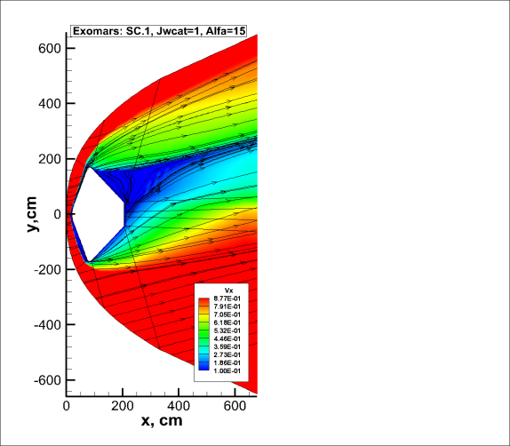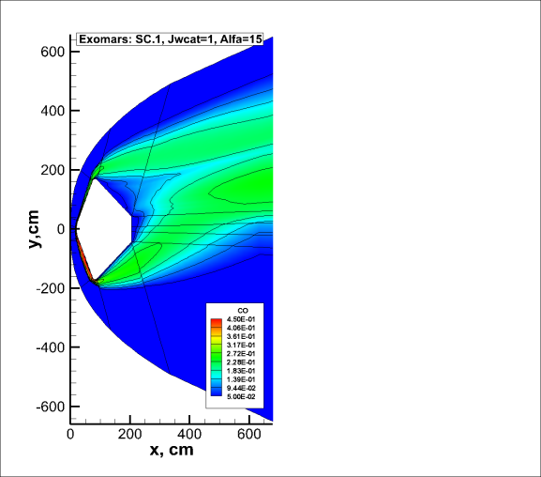

|  |  |
| --- | --- |
| *a* | *b* |

Fig. 4. The caption - description of case a), case b)

You can use the text color illustration. The format of figures should allow movement in the text and their size changing.

3.5. Page numbering, headers and footers

Do not change the Headers and Footers, they will be added to the editorial board at the official publication of the article. Page numbers are at the bottom center, starting from the 1st page (font Times New Roman, 12 point).

3.6. Bibliographical references

The list of references is given at the end of the article and should be made as a numbered list (see. Example of the references at the end). The references in the text are given in square brackets [1, 2].

For online resources links give the full path address with the title. , If possible, indicate also the author and year of publication in the Internet.

3.7. Footnotes

Footnotes should be numbered in Arabic numbers. Footnotes placed at the end of the current page. Footnotes should be typed font size of 9 points.

# 4. Conclusion

This document is an example of an article to be published in the electronic journal “Physical-Chemical Kinetics in Gas Dynamics” The offered here styles will help authors to format documents in proper way. You can use this document as your article template or just copy styles and forms into your own document.

# Application

Application should be placed before the section "Acknowledgements and links to grants."

# Acknowledgements and links to grants

If you want to refer to grants that support the work done by you or to express gratitude to someone, do it at the end of the article before the bibliographic references.

# References

1. Physical and Chemical Processes in Gas Dynamics: Physical and Chemical Kinetics and Thermodynamics. Vol.2. Progress in Astronautics and Aeronautics. Vol.197, 2004.