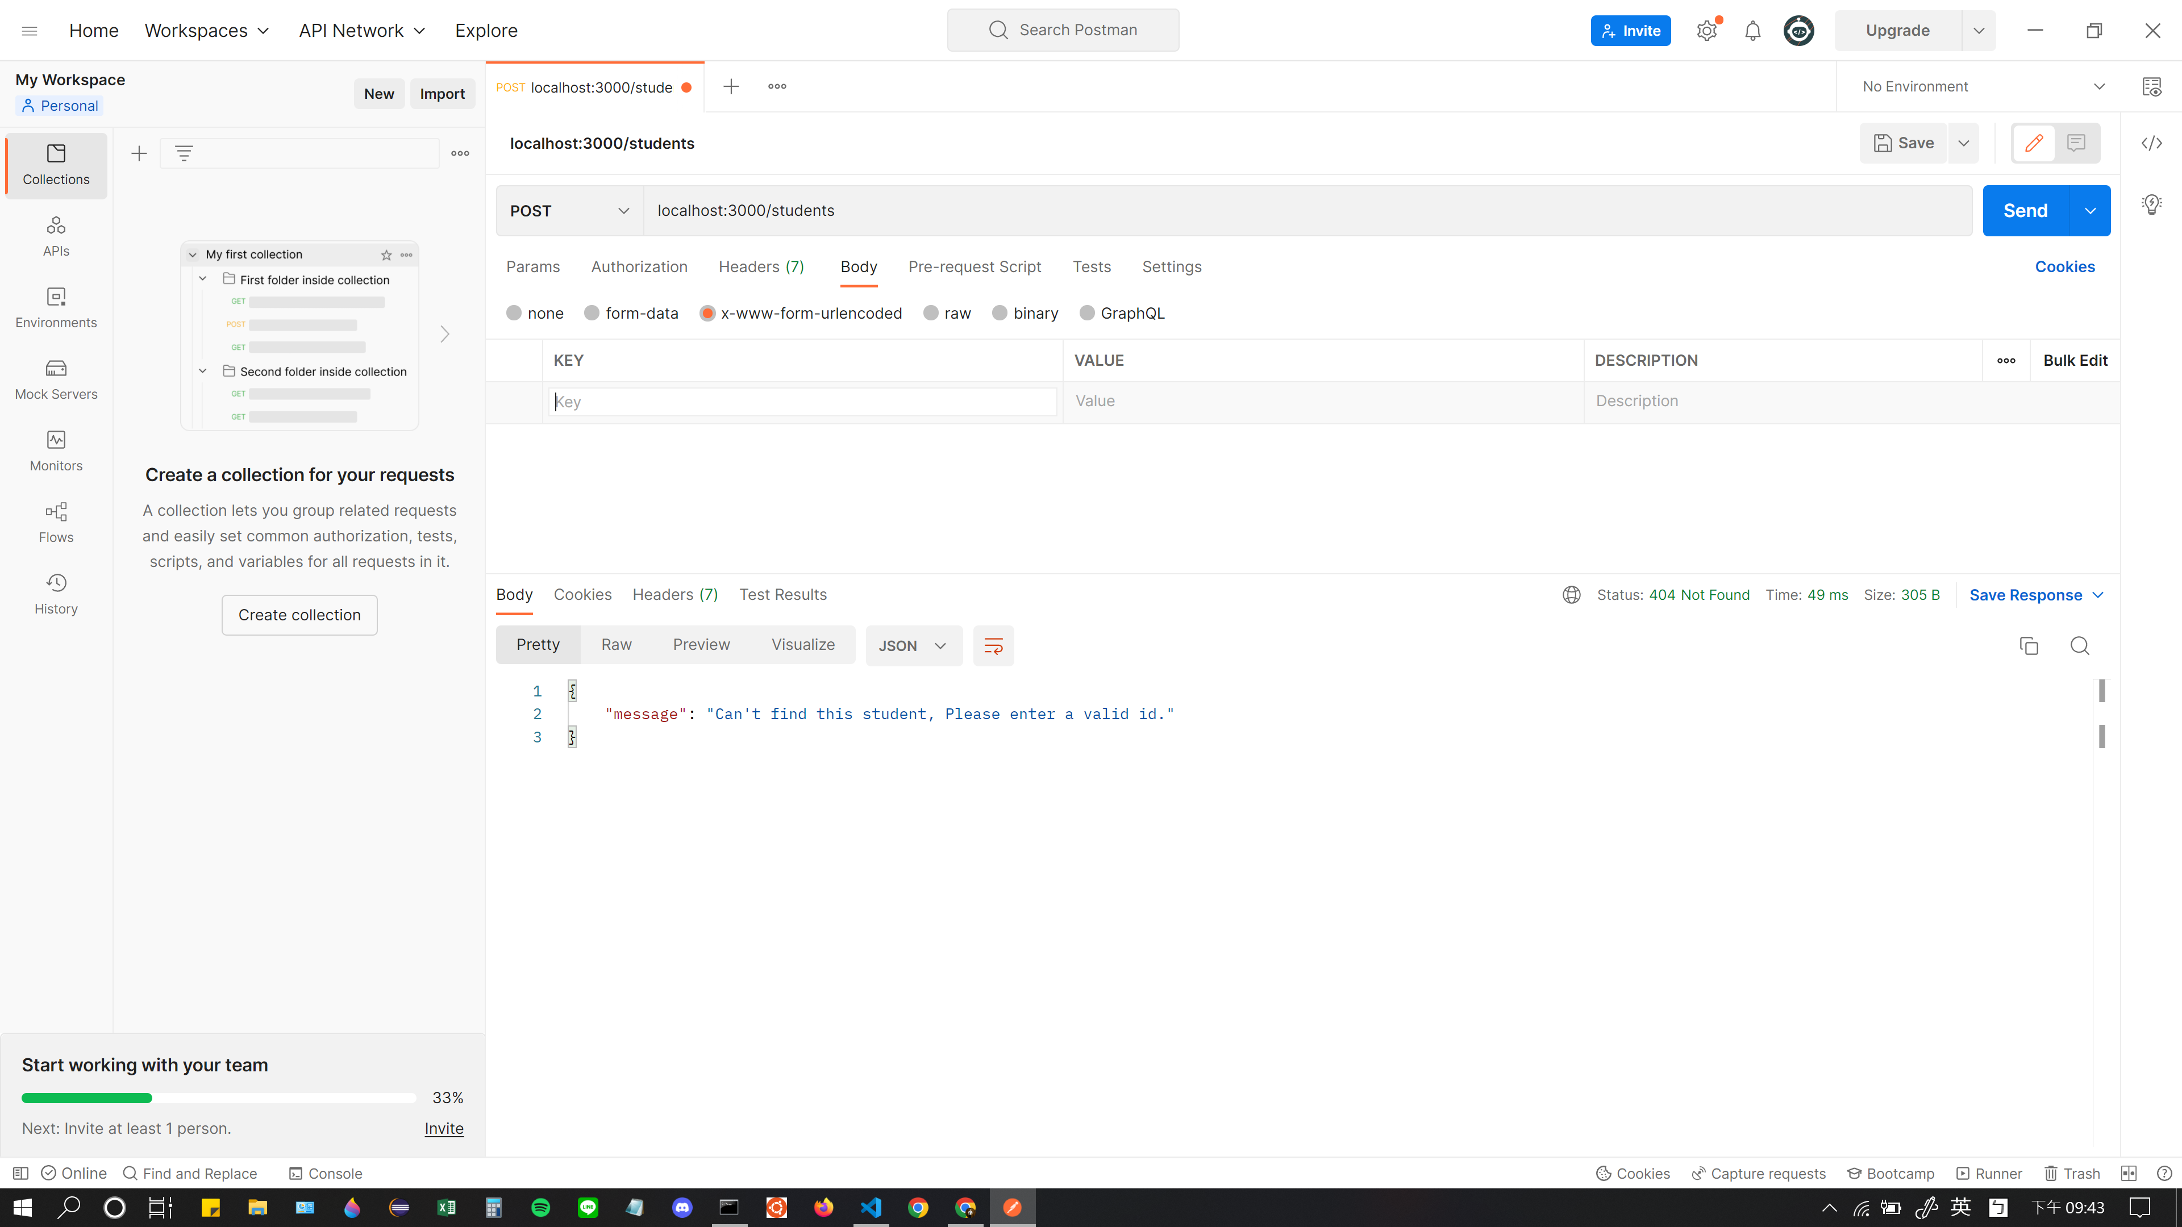

要送post request帶有一些要輸入的值的時候

要記得點選這個x-www-form-urlencoded

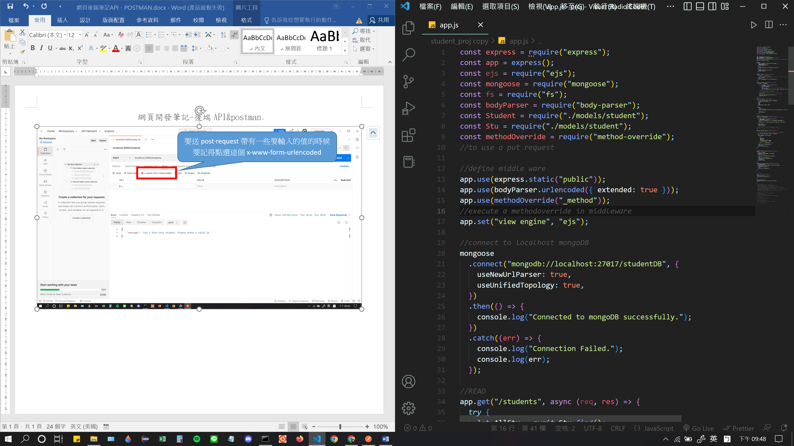

就跟我們middleware寫的bodyparser有對應到!

<https://stackoverflow.com/questions/37555031/why-does-json-return-a-promise>

# [Why does .json() return a promise?](https://stackoverflow.com/questions/37555031/why-does-json-return-a-promise)

Why does response.json return a promise?

Because you receive the response as soon as all headers have arrived. Calling .json() gets you another promise for the body of the http response that is yet to be loaded. See also Why is the response object from JavaScript fetch API a promise?.

Why do I get the value if I return the promise from the then handler?

Because that's how promises work. The ability to return promises from the callback and get them adopted is their most relevant feature, it makes them chainable without nesting.

You can use

fetch(url).then(response =>

response.json().then(data => ({

data: data,

status: response.status

})

).then(res => {

console.log(res.status, res.data.title)

}));

or any other of the approaches to access previous promise results in a .then() chain to get the response status after having awaited the json body.

<https://ithelp.ithome.com.tw/articles/10218444>

https://ithelp.ithome.com.tw/articles/10215567