National University of Singapore

School of Computing

CS2105  **Tutorial 1** Answer paper

***To students:***

Please cooperate with your tutors towards a fruitful and enriching learning experience.

Please be reminded that submission deadline of **assignment 0** is **next Monday (31 Aug 2020) 6pm**.

1. **[KR, Chapter 1, P6]** Consider two hosts, A and B, connected by a single link of rate ***R*** bps. Suppose that the two hosts are separated by ***m*** meters, and suppose the propagation speed along the link is ***s*** meters/sec. Host A is to send a packet of size ***L*** bits to Host B.
2. Express the propagation delay, ***dprop***, in terms of ***m*** and ***s***.

**dprop = m/s sec**

1. Determine the transmission time of the packet, ***dtrans***, in terms of ***L*** and ***R***.

**dtrans = L/R sec**

1. Ignoring processing and queuing delays, obtain an expression for the end-to-end delay ***dend-to-end***.

**dend-to-end = dprop + dtrans sec**

1. Suppose Host A begins to transmit the packet at time t = 0. At time t = ***dtrans***, where is the last bit of the packet?

**The last bit just leaves Host A**

1. Suppose ***dprop*** is greater than ***dtrans***. At time t = ***dtrans***, where is the first bit of the packet?

**The first bit is flowing in the link and has not reached host B**

1. Suppose ***dprop*** is less than ***dtrans***. At time t = ***dtrans***, where is the first bit of the packet?

**The first bit has already reached host B**

1. Suppose ***s*** = 2.5 x 108, ***L*** = 120 bits, and ***R*** = 56 kbps. Find the distance ***m*** so that ***dprop*** equals ***dtrans***.

**m = (L/R) x s = 120 x 2.5 x 108 / (56 x 103) = 535714.2857 meters**

1. A packet switch receives a packet and determines the outbound link to which the packet should be forwarded. When the packet arrives, one other packet is halfway done being transmitted on this outbound link and four other packets are waiting to be transmitted. Packets are transmitted continuously in order of arrival. Suppose all packets are 1,500 bytes and the link rate is 2 Mbps.
2. What is the queuing delay for the packet?

**The arriving packet must first wait for the link to transmit 4.5*1500 bytes = 6,750 bytes or 54,000 bits.** **Since bits are transmitted at 2 Mbps, the queuing delay is 27 msec.**

1. More generally, what is the queuing delay when all packets have length ***L*** (bits), the transmission rate is ***R***, ***x*** bits of the currently-being-transmitted packet have been transmitted, and ***n*** packets are already in the queue?

**Generally, the queuing delay is $\frac{nL + (L - x)}{R}$.**

1. **[Modified from KR, Chapter 1, P31]** In modern packet-switched networks, including the Internet, the source host segments long, application-layer messages (for example, an image or a music file) into smaller packets and sends the packets into the network. The receiver then reassembles the packets back into the original message. We refer to this process as *message segmentation*. Figure 1.27 illustrates the end-to-end transport of a message with and without message segmentation.

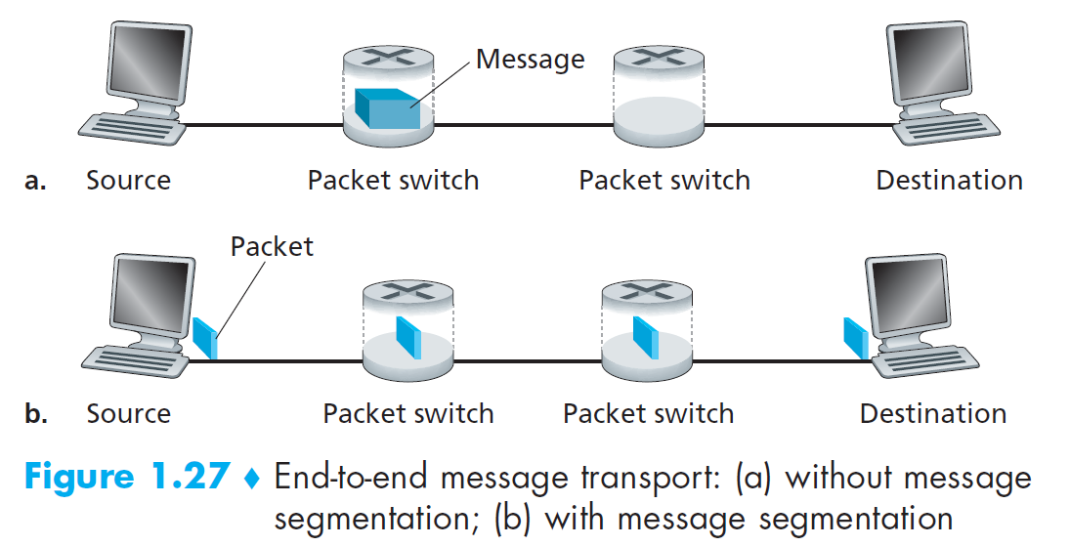

Consider a message that is 8 x 106 bits long that is to be sent from source to destination. Suppose each link in the figure is 2 Mbps. Ignore propagation, queuing, and processing delays.

1. Consider sending the message from source to destination ***without*** message segmentation. How long does it take to move the message from the source host to the first packet switch (router)?

**Time for source to send out the message = 8 x 106 / 2 x 106 = 4 sec. Since we assume no propagation delay, packet reaches the first switch at t = 4 sec.**

1. Following a), what is the total time to move the message from source host to destination host? Keeping in mind that each switch uses store-and-forward packet switching.

**The 1st switch needs to receive the entire message (at t = 4 sec) before it starts forwarding the packet onto the outgoing link. So does the 2nd switch.**

**With store-and-forward switching, the total time to move the message from source host to destination host = 4 + 4 + 4 = 12 sec.**

1. Now suppose that the message is segmented into 800 packets, with each packet being 10,000 bits long. How long does it take to move the first packet from source host to the first switch? When the first packet is being sent from the first switch to the second switch, the second packet is being sent from the source host to the first switch. At what time will the second packet be fully received at the first switch?

**Time to send the 1st packet to the 1st switch = 10000 / 2 x 106 = 5 msec. The source starts sending the 2nd packet at t = 5 msec. It takes another 5 msec to send this packet to the 1st switch. Time when the 2nd packet reaches the 1st switch is therefore 5 + 5 = 10 msec.**

1. How long does it take to move the file from source host to destination host when message segmentation is used? Compare this result with your answer in part b) and comment.

**The 1st packet reaches destination at t = 15 msec. After that, every 5 milliseconds, one more packet arrives at the destination. Thus, time the 800th packet reaches the destination = 15 + 799 x 5 = 4010 msec = 4.01 sec.**

**It can be seen that end-to-end delay in using message segmentation (4.01 sec) is significantly less than sending a big file as one message (12 sec).**

1. In addition to reducing delay, what are reasons to use message segmentation?
2. **Without message segmentation, if bit errors are not tolerated and there is a single bit error, the whole message has to be retransmitted (rather than a single packet).**
3. **Without message segmentation, huge packets (containing HD videos, for example) are sent into the network. Routers have to accommodate these huge packets. Smaller packets have to queue behind enormous packets and suffer unfair delays.**
4. Discuss the drawbacks of message segmentation.
5. **Packets have to be put in sequence at the destination (network may re-order packets).**
6. **Message segmentation results in many smaller packets. Each packet needs to carry packet header of size tens of bytes (e.g. to specific destination address and port number). This is the header overhead of each packet to be discussed in later lectures.**
7. There are $N$ devices to be connected. There can be either 0 or 1 link between any 2 devices.
8. What is the minimum number of links needed to connect all devices?

$N$**-1 links. Organize all devices into a tree topology, chain topology or star topology.**

1. What is the maximum number of links that can be used to connect all devices?

$N$**x ($N$-1) / 2 links. All devices connect to all other devices directly. This is known as mesh topology.**

1. What are the pros and cons of the network topologies in part a) and b)?

**a): Simple topology but failure of a single node or link partitions network. Also it tends to have longer paths between 2 nodes.**

**b): Most robust topology, 1 hop distance between all nodes, but is most expensive.**