National University of Singapore

School of Computing

CS2105  **Tutorial 1** Question paper

***To students:***

Please cooperate with your tutors towards a fruitful and enriching learning experience.

Please be reminded that submission deadline of **assignment 0** is **Sunday (29 Aug 2021) 23.59**.

1. **[KR, Chapter 1, P6]** Consider two hosts, A and B, connected by a single link of rate ***R*** bps. Suppose that the two hosts are separated by ***m*** meters, and suppose the propagation speed along the link is ***s*** meters/sec. Host A is to send a packet of size ***L*** bits to Host B.
2. Express the propagation delay, ***dprop***, in terms of ***m*** and ***s***.
3. Determine the transmission time of the packet, ***dtrans***, in terms of ***L*** and ***R***.
4. Ignoring processing and queuing delays, obtain an expression for the end-to-end delay ***dend-to-end***.
5. Suppose Host A begins to transmit the packet at time t = 0. At time t = ***dtrans***, where is the last bit of the packet?
6. Suppose ***dprop*** is greater than ***dtrans***. At time t = ***dtrans***, where is the first bit of the packet?
7. Suppose ***dprop*** is less than ***dtrans***. At time t = ***dtrans***, where is the first bit of the packet?
8. Suppose ***s*** = 2.5 x 108, ***L*** = 120 bits, and ***R*** = 56 kbps. Find the distance ***m*** so that ***dprop*** equals ***dtrans***.
9. A packet switch receives a packet and determines the outbound link to which the packet should be forwarded. When the packet arrives, one other packet is halfway done being transmitted on this outbound link and four other packets are waiting to be transmitted. Packets are transmitted in order of arrival. Suppose all packets are 1,500 bytes and the link rate is 2 Mbps.
10. What is the queuing delay for the packet?
11. More generally, what is the queuing delay when all packets have length ***L*** (bits), the transmission rate is ***R***, ***x*** bits of the currently-being-transmitted packet have been transmitted, and ***n*** packets are already in the queue?
12. **[Modified from KR, Chapter 1, P31]** In modern packet-switched networks, including the Internet, the source host segments long, application-layer messages (for example, an image or a music file) into smaller packets and sends the packets into the network. The receiver then reassembles the packets back into the original message. We refer to this process as *message segmentation*. Figure 1.27 below illustrates the end-to-end transport of a message with and without message segmentation.

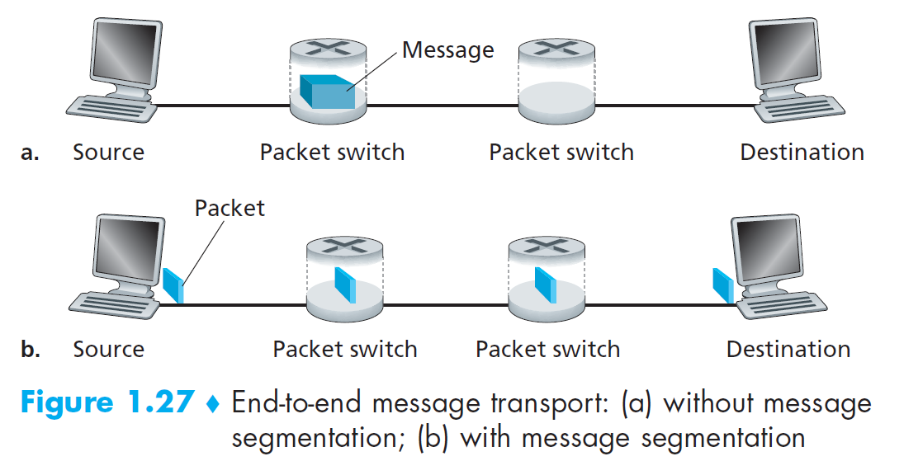

Consider a message that is 8 x 106 bits long that is to be sent from source to destination. Suppose each link in the figure is 2 Mbps. Ignore propagation, queuing, and processing delays.

1. Consider sending the message from source to destination ***without*** message segmentation. How long does it take to move the message from the source host to the first packet switch (router)?
2. Following a), what is the total time to move the message from source host to destination host? Keeping in mind that each switch uses store-and-forward packet switching.
3. Now suppose that the message is segmented into 800 packets, with each packet being 10,000 bits long. How long does it take to move the first packet from source host to the first switch? When the first packet is being sent from the first switch to the second switch, the second packet is being sent from the source host to the first switch. At what time will the second packet be fully received at the first switch?
4. How long does it take to move the file from source host to destination host when message segmentation is used? Compare this result with your answer in part b) and comment.
5. In addition to reducing delay, what are reasons to use message segmentation?
6. Discuss the drawbacks of message segmentation.
7. There are *N* devices to be connected. There can be either 0 or 1 link between any 2 devices.
8. What is the minimum number of links needed to connect all devices?
9. What is the maximum number of links that can be used to connect all devices?
10. What are the pros and cons of the network topologies in part a) and b)?