National University of Singapore

School of Computing

CS2105  **Tutorial 6** Answer paper

1. **[Modified from KR, Chapter 4, P21]** Consider the network setup in the following figure. Suppose that the ISP assigns the router the address 24.34.112.235 and that the network address (i.e. network prefix) of this home network is 192.168.1/24.

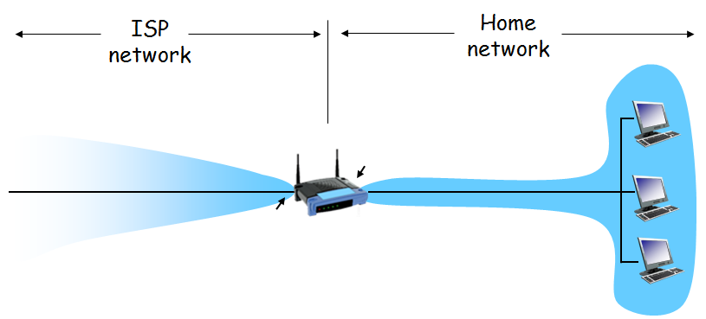

**192.168.1.5**

**192.168.1.9**

**192.168.1.2**

**192.168.1.1**

24.34.112.235

1. Give an example IP address assignment to all interfaces in this home network.
2. Suppose each host has two ongoing TCP connections, all to port 80 of a server at 128.119.40.86. Provide example corresponding entries in the NAT translation table.

|  |  |
| --- | --- |
| **NAT Translation Table** | |
| **WAN side** | **LAN side** |
| **24.34.112.235, 3000** | **192.168.1.5, 2105** |
| **24.34.112.235, 4000** | **192.168.1.5, 2106** |
| **24.34.112.235, 5000** | **192.168.1.2, 2105** |
| **24.34.112.235, 6000** | **192.168.1.2, 2108** |
| **24.34.112.235, 7000** | **192.168.1.9, 4000** |
| **24.34.112.235, 8000** | **192.168.1.9, 5000** |

1. **[Modified from KR, Chapter 4, P19]** Consider sending a 1500-byte IP datagram into a link that has an MTU of 500 bytes. Suppose the original datagram is stamped with the identification number 422. Also assume that IP header is 20 bytes long.
2. How many fragments will be generated?

**Data (segment) length = 1500 – 20 = 1480 (due to 20 bytes IP header)**

**Maximum size of data in each fragment = 500 – 20 = 480**

**Number of fragments = $\left\lceil 1480/480\right\rceil$ = 4**

1. What is the length of each fragment (including IP header)?

**1st – 3rd fragments have length 500. 4th fragment has length 60.**

1. What are the values of *identification number*, *offset* and *flag* in each fragment?

|  |  |  |  |
| --- | --- | --- | --- |
| **Fragments** | **ID Number** | **Offset** | **Flag** |
| **1** | **422** | **0** | **1** |
| **2** | **422** | **60** | **1** |
| **3** | **422** | **120** | **1** |
| **4** | **422** | **180** | **0** |

1. **[CS2105 Final Exam, April 2006]** The following diagram shows a simple network topology with 4 nodes. The links in the diagram are labeled with the cost of each link. The nodes run distance vector routing protocol. The protocol has terminated, and each node knows the cost of the minimum cost path to every other node.

z

20

w

y

3

x

3

7

6

2

The following table shows an incomplete distance vector table at node x. Fill in the missing distance vectors.

|  |  |  |  |  |
| --- | --- | --- | --- | --- |
|  | **cost to w** | **cost to x** | **cost to y** | **cost to z** |
| **from x** | **3** | **0** | **3** | **5** |
| **from y** | **6** | **3** | **0** | **2** |
| **from z** | **8** | **5** | **2** | **0** |

1. Wireshark: IP

Do the following:

1. Start up Wireshark and begin packet capture.
2. Start up the Terminal and execute the following command:

ping [www.google.com](http://www.google.com) (Windows)

OR

Ping [www.google.com](http://www.google.com) -c 4 (Linux/mac)

1. Stop Wireshark packet capture.
2. Type in “icmp” into the display ﬁlter speciﬁcation window, then select Apply.

Answer the following questions:

1. Within the IP packet header, what is the value in the upper layer protocol ﬁeld?

**Ans: ICMP.**

1. Which ﬁelds in the IP datagram always change from one datagram to the next within this series of ICMP messages sent by your computer?

**Ans: Identiﬁcation and Checksum.**