Q1

#include<bits/stdc++.h>

using namespace std;

int main(){

int n; cin >> n;

int arr[n];

for(auto & a : arr) cin >> a;

int k; cin >> k;

int count{0}, prod{1};

for(int i = 0; i<n; i++){

prod = 1;

for(int j = i; j<n; j++){

prod *= arr[j];

if(prod >= k) break;

count++;

}

}

cout << count;

}

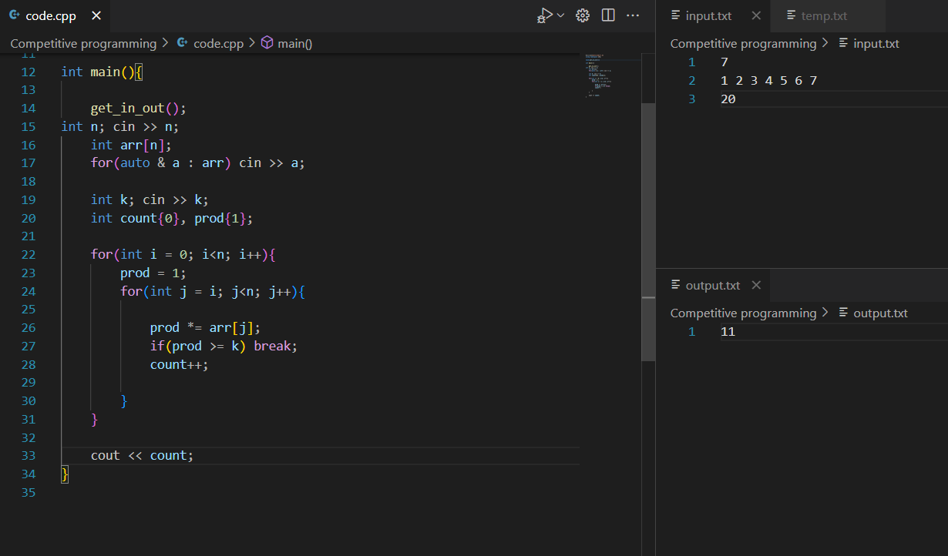

Q2

#include<bits/stdc++.h>

using namespace std;

int main(){

string s; cin >> s;

int c{0}, m{-1000000000};

bool flipped = false;

for(int i = 0; i<s.length(); i++){

m = max(m, c);

c = 0;

flipped = false;

for(int j = i; j< s.length() ;j++){

if(s[j] == '1'){

c++;

continue;

}

else if(s[j] == '0' && !flipped){

c++;

flipped = true;

continue;

}else if(s[j] == '0'){

break;

}

}

}

cout << m;

}

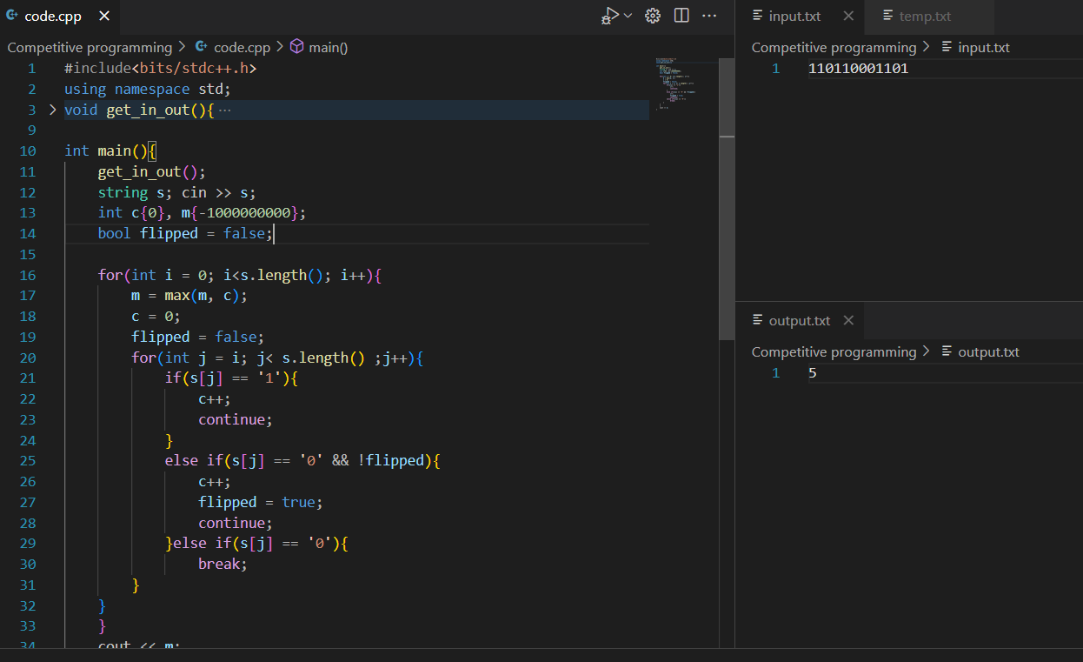

Q3

#include<bits/stdc++.h>

using namespace std;

int main() {

int n;

cin >> n;

int arr[n];

for (auto& a : arr) cin >> a;

int k;

cin >> k;

vector<int> max_Array;

int m = 0, sum = 0, count = 0;

for (int i = 0; i < n; i++) {

sum = 0;

count = 0;

vector<int> temp;

for (int j = i; j < n; j++) {

sum += arr[j];

temp.push_back(arr[j]);

count++;

if (sum == k) {

if (count > m) {

m = count;

max_Array = temp;

}

}

}

}

cout << m << endl;

for (auto& a : max_Array) cout << a << " ";

return 0;

}

